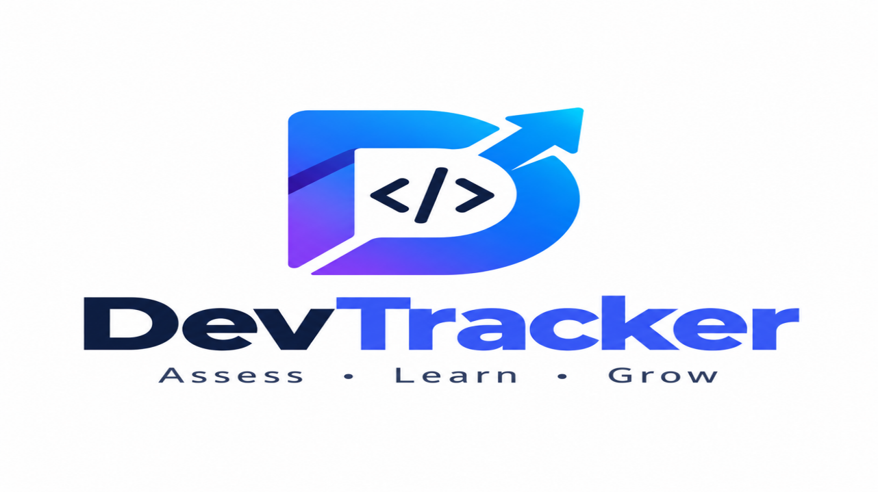

Official project name : DevTracker
Project sponsor : Technology Innovation and Entrepreneurship Center (TIEC)

Project manager : 2x Mohammed Ahmed
Purpose of the project : We develop smart digital solutions to get a real rating for junior developers

Business case:
- Difficulty to get an accurate rate for junior developer with Ai ability to write a great code.
- Junior developers depend on Ai without understanding code.
- There are lots of sources to learn which leads to dispersion and unclear roadmaps.

Key deliverables :
DevTracker is a Platform for windows , Linux and mac

Project milestones:
- Requirements are complete and specifications by 1 / 11 / 2026
- Design : Implement system design architecture to be suitable for client by 1 / 5 / 2027
- Tesr : Testing system by 1 / 6 / 2027
- Product operational : Software is in use by 20 / 6 / 2027

Project resources:
Team members: 2 backend developers and 2 frontend developer
Hardware: 4 laptops and server
Software: Software licenses (Editors : phpstorm , ….)

Budget:
Budget allocated for this project is 250000 L.E

Constraints:
- Project must be completed by 20 / 6 / 2027 in specified budget
- 50% of budget for needed hardware components
- 25% of budget will be paid before start

Risks:

Execution risks:
- Team misunderstand project requirements
- Used technology isn’t suitable for clients
- Team conflict
- Final project doesn’t meet customer expectations
- Budget runout before project completion
- Deadline runout before project completion

Quality risks:
- Ai cheating
- Assigning low quality or non-updated course.
- Slow code execution speed or server down time in live coding

Project scope
Product Scope Description:

- Platform allows junior developers to assess their technical skills in different fields and choose what field they prefer and complete assessments based on required skills for this field
- Provides projects to rate developer ability to solve problems
- System evaluates user’s understanding the code by questions and live coding to evaluate developer’s problem solving skill and understanding of programming concepts are used
- Based on assessment results Platform generates learning roadmap for developer if it needed
- User can track his improving
- After complete assessments developer can earn certificates that document the kills he has demonstrated
- Platform has Ai model to make it up-to-date with latest technology

Criteria:

- System provides technical tests and practical tasks
- System evaluate code understanding
- System generates suitable roadmaps
- Platform provides developer’s level tracking and show results
- System provides skill-based certificate

Delivrables:
- Project plan
- Software System with Ai model (Platform)

Exclusions:

What project will achieve :
- Rating junior developer’s skills
- Proving roadmap to help developers to improve
- Proving developer level tracking
- System produces the largest possible number of skilled developers
- Advanced-level training
What project won’t achieve:
- System doesn’t offer employment opportunities
- System isn’t for beginners or provides training from zero

Constraints:
- Project must be completed by 20 / 6 / 2027 in specified budget
- 50% of budget for needed hardware components
- 25% of budget will be paid before start

Project Assumptions:
1. Every task ends in its deadline.
2. System will be very fast and easy to use by different categories.
3. Hardware and software compatibility.
• Resource availability.
4. solve problems in risks
5. Users have basic programming knowledge.
6. The platform provides accurate skill assessments.
7. Learning resources are available.
8. The system remains reliable and easy to use.

