Ansible : Creating first playbook
- Go to Ubuntu and install ansible as (sudo apt install ansible)
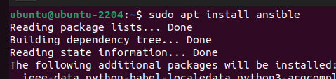
- Check ansible version as : (ansible –version)
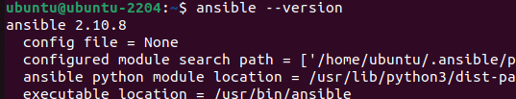
- Create a directory
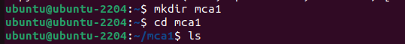
- Create ansible file as:
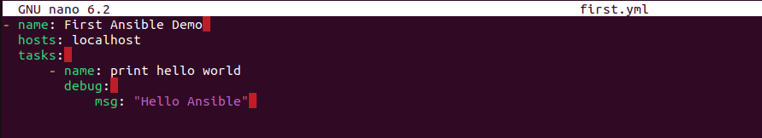
- Exit from editor by pressing Ctlr+o, Enter and then Ctrl+x
- You can view the file content using cat command
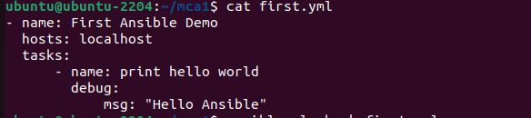
- Update the above file and run it to display Ubuntu details.
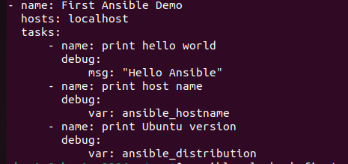
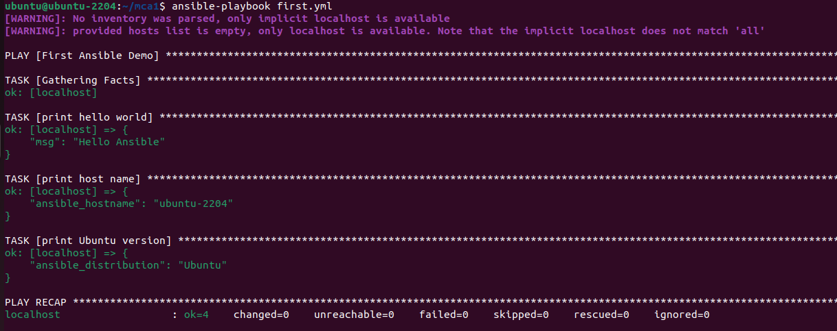
Install and run apache using Playbook as:
- Creating simple yml for apache
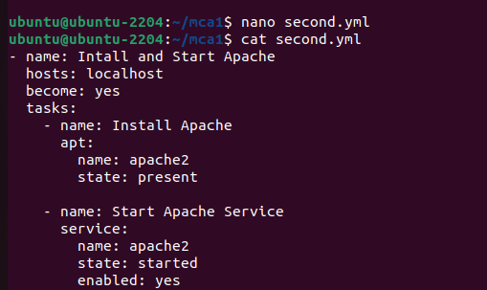
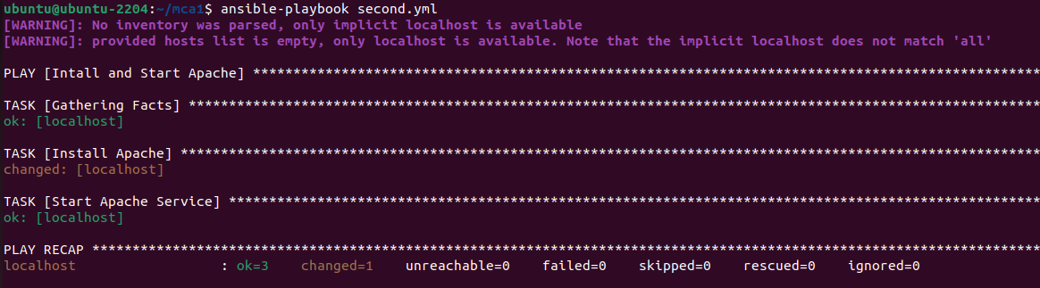
- Checking apache details using following command:
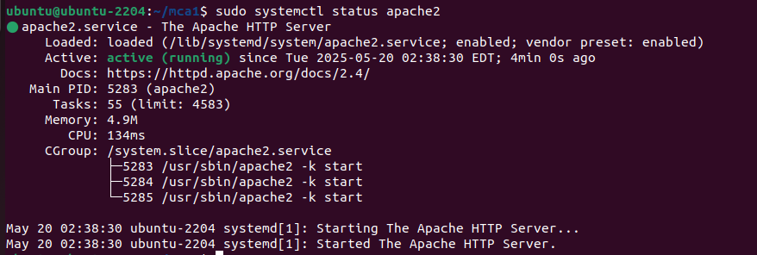

Playbook for infrastructure as code: (Running HTML file)
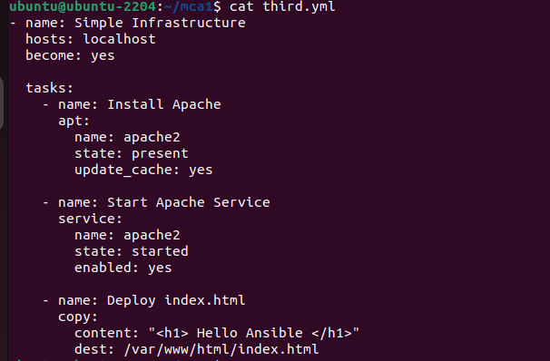
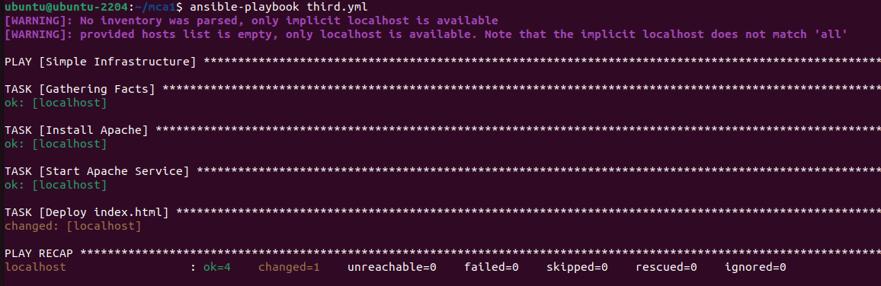
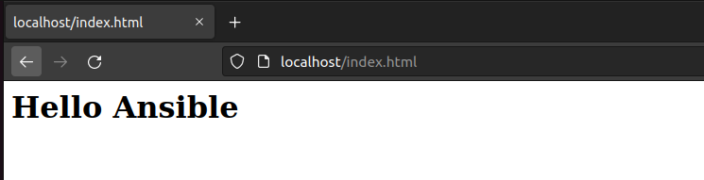

Playbook for Application Deployment (Running PHP file)
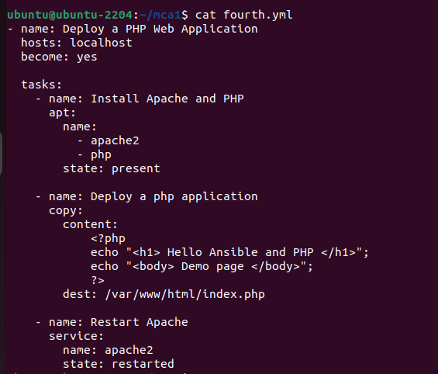
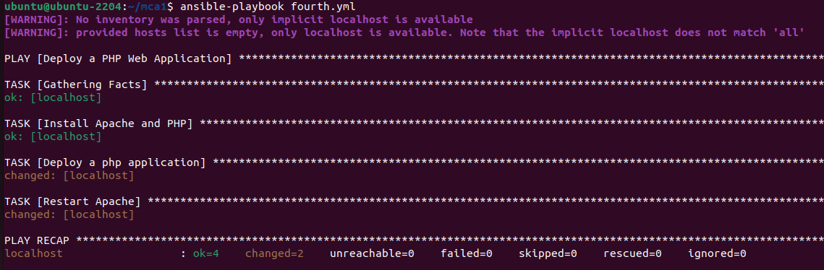
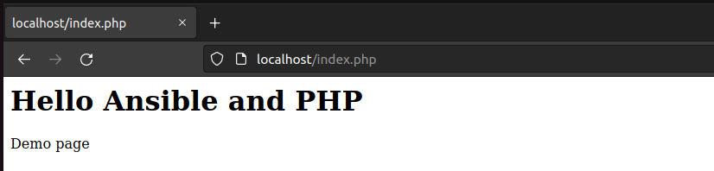

Playbook for running Java file:
Install jdk and jre by using the following commands:
sudo apt install openjdk-21-jdk-headless
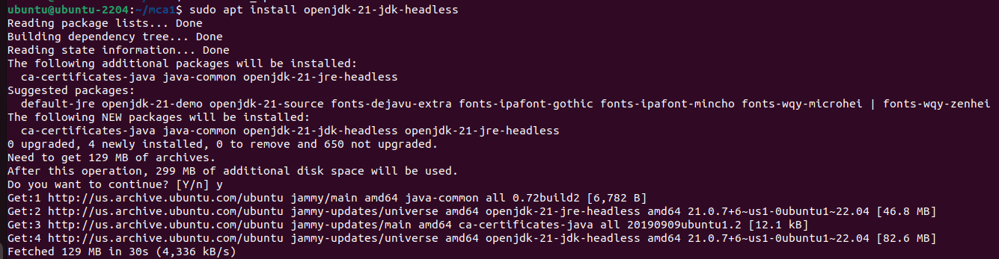
sudo apt install openjdk-21-jre-headless
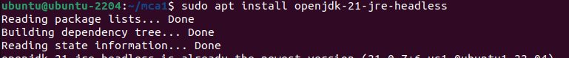
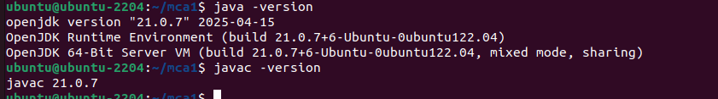
Running java Program
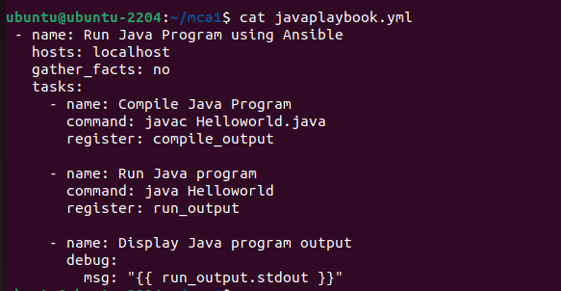
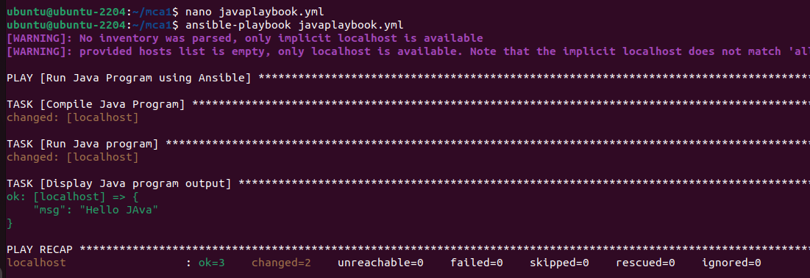

Pull Demo
