- Create docker container
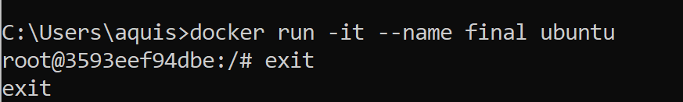

- Go to Docker Engine and Start and Exec “final” container
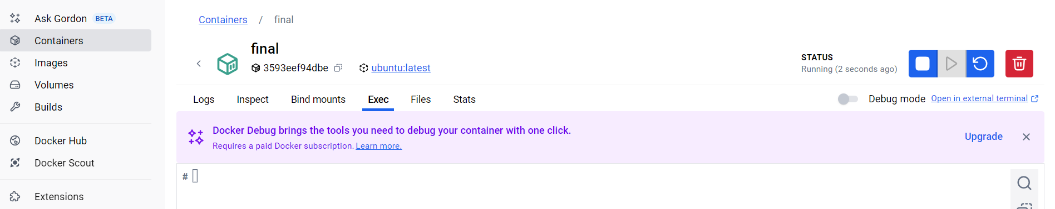
- Check if container is running using command “Docker ps”
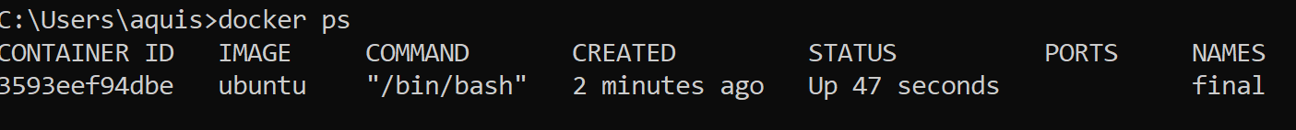

- Create one txt file 🡪 say file1.txt

- Copy file1.txt into container “final”
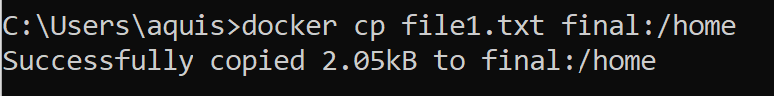

- Check whether file is copied or not
  - Using command
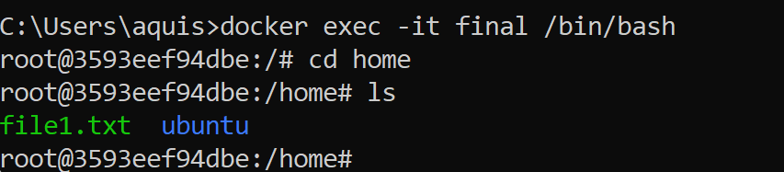

  - Using engine
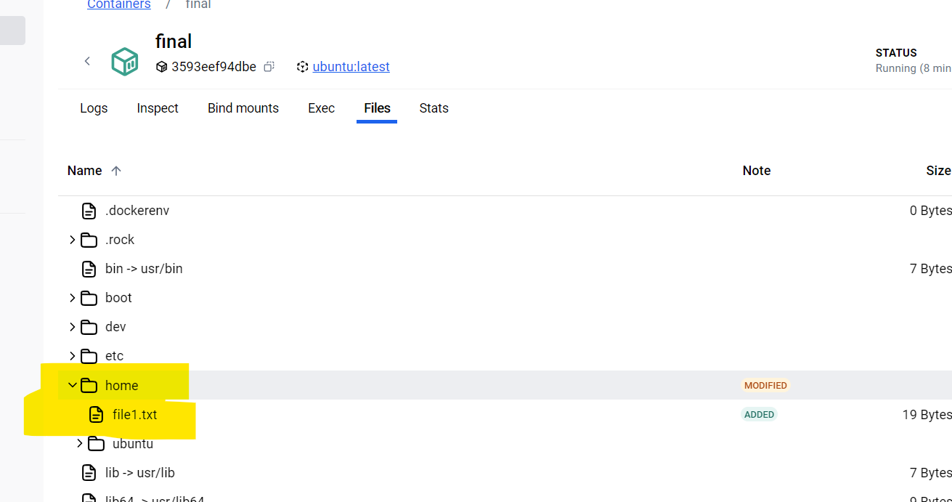
- We can also create directory and copy into container final
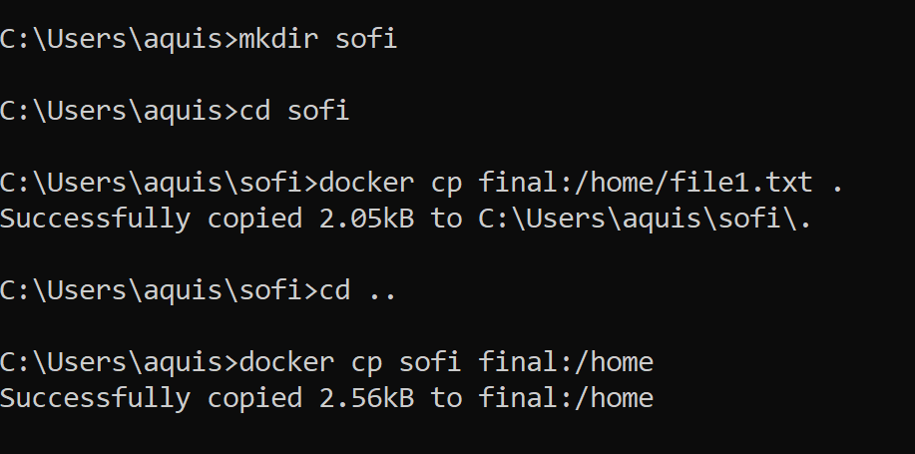

- Check sofi directory into “Docker engine”
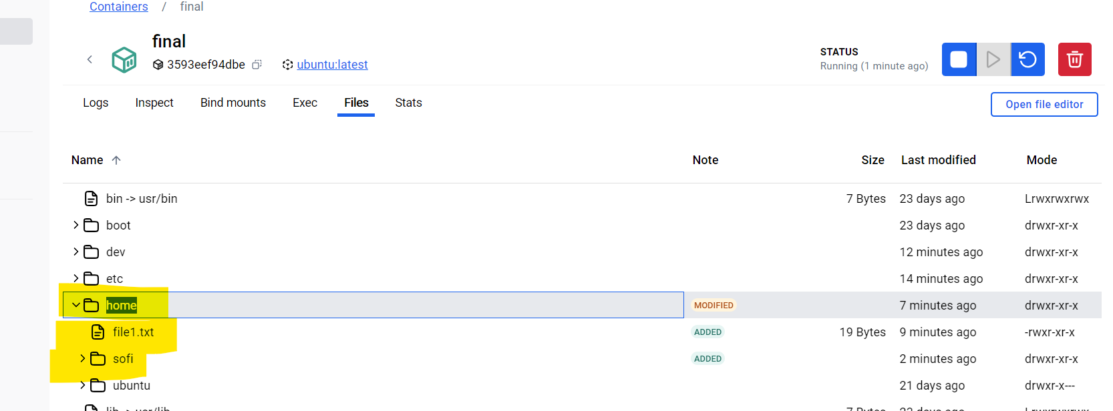

Manage Web Application on Docker engine (Create Web site file on Host)

Create Project Folder and go to that folder
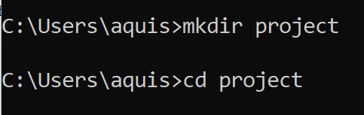

Create HTML File and save it into “Project Folder” from system
notepad index.html

<!DOCTYPE html>
<html>
<head>
<title>My Docker Web App</title>
</head>
<body>
<h1>Hello from Docker 🚀</h1>
<p>This is my first Docker container</p>
</body>
</html>
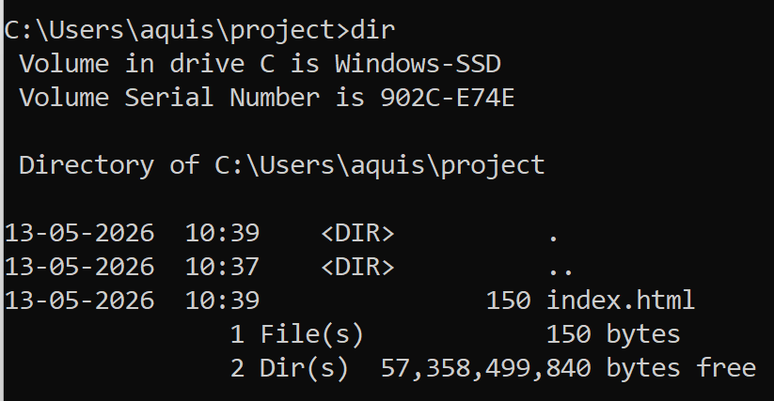

Create Dockerfile (with no .txt extension) it’s a docker file.. Give filename as Dockerfile only
notepad Dockerfile
Paste this:
FROM nginx:latest
COPY index.html /usr/share/nginx/html/index.html

If it is showing .txt file then you can rename it by using command
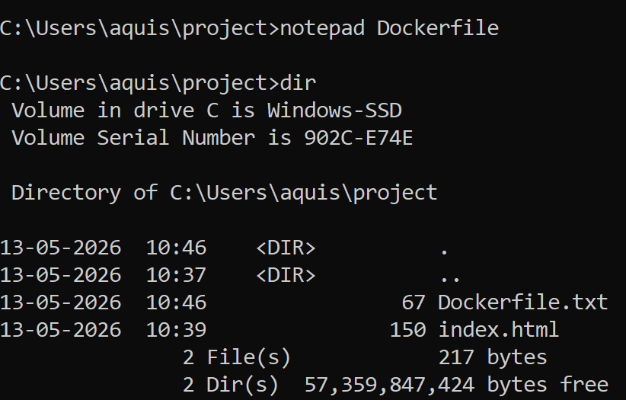
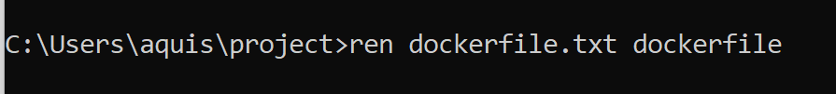

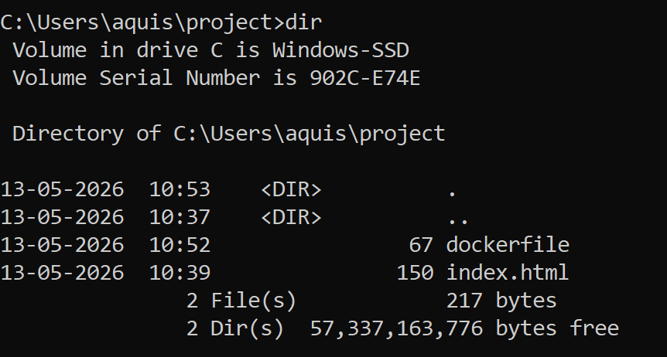

Build docker image
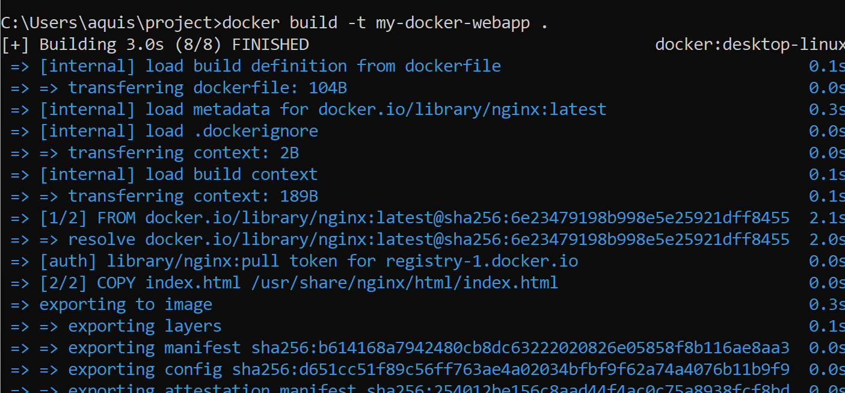

Check if image is created using “docker image” command
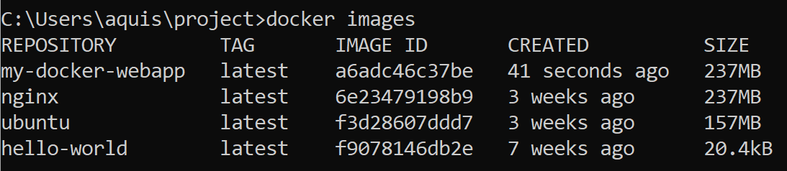

Now run the container
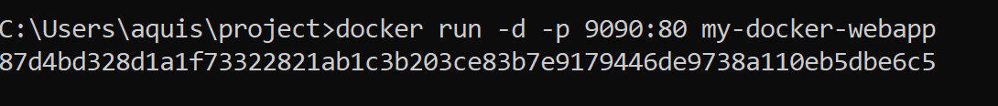

Check if the container is running
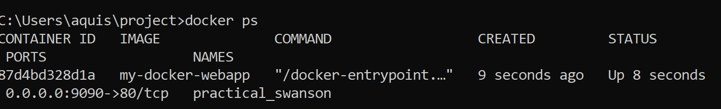

Open any browser and type:
http://localhost:9090

