E-COMMERCE SALES ANALYSIS AND DATA VISUALIZATION

Project Report
Project Title: E-Commerce Sales Analysis and Data Visualization Using Python
Project Domain: Data Analytics and Visualization
Tools and Technologies: Python, Pandas, NumPy, Matplotlib, Seaborn, Jupyter Notebook, Visual Studio Code
Dataset: Online Retail Dataset

1. ABSTRACT
E-Commerce has become an important part of the modern business world. Online shopping platforms generate large amounts of transaction data every day. Analyzing this data helps businesses understand customer purchasing behavior, product performance, sales trends, and revenue generation.
The main objective of this project is to analyze an Online Retail dataset using Python and create meaningful visualizations to understand e-commerce sales performance.
The project uses Python libraries such as Pandas, NumPy, Matplotlib, and Seaborn for data processing, analysis, and visualization. The dataset contains information about invoices, stock codes, product descriptions, quantities, invoice dates, unit prices, customer IDs, and countries.
Various visualizations are created, including monthly sales trends, top-selling products, country-wise revenue, revenue distribution, and correlation analysis.
The results help identify important sales patterns, understand product demand, and observe revenue contributions from different countries. This project demonstrates how data analytics and visualization can convert raw transaction data into useful business insights.
2. INTRODUCTION
E-Commerce refers to buying and selling products and services through online platforms. With the growth of internet usage and digital payment systems, online retail businesses have expanded significantly.
Every online transaction generates valuable data. This data can be analyzed to understand customer preferences, identify popular products, measure business performance, and improve decision-making.
However, raw datasets are often large and may contain missing values, duplicate records, and inconsistent information. Therefore, data cleaning and preprocessing are important steps before performing analysis.
In this project, the Online Retail dataset is analyzed using Python. Different statistical techniques and visualization methods are applied to understand sales performance.
The project focuses on transforming raw retail transaction data into meaningful information through data analysis and graphical representation.
3. PROBLEM STATEMENT
E-commerce businesses generate a large amount of transaction data, but understanding this data manually is difficult and time-consuming.
Without proper analysis, businesses may face challenges in identifying their best-selling products, understanding monthly revenue trends, comparing country-wise sales performance, and recognizing unusual transaction patterns.
Therefore, there is a need for a data analysis system that can process retail transaction data and present useful information through statistical analysis and visualizations.
This project addresses this problem by using Python-based data analytics techniques to analyze online retail transactions and generate meaningful business insights.
4. OBJECTIVES
The main objectives of this project are:
- To analyze an Online Retail transaction dataset using Python.
- To perform data cleaning and preprocessing.
- To identify and handle missing values and duplicate records.
- To calculate revenue from transaction data.
- To analyze monthly sales trends.
- To identify the top 10 products based on quantity sold.
- To analyze revenue generated by different countries.
- To understand transaction revenue distribution.
- To study relationships between numerical variables using correlation analysis.
- To represent analytical results using meaningful visualizations.

5. DATASET DESCRIPTION
The project uses the Online Retail dataset, which contains transaction records from an online retail business.
The dataset contains the following columns:
Column Name | Description
InvoiceNo | Unique invoice number for each transaction
StockCode | Product identification code
Description | Name or description of the product
Quantity | Number of products purchased
InvoiceDate | Date and time of the transaction
UnitPrice | Price of one product
CustomerID | Unique customer identification number
Country | Country where the customer is located
Dataset Statistics:
- Total Records: 541,909
- Total Columns: 8
- Missing values in Description: 1,454
- Missing values in CustomerID: 135,080
- Duplicate Records: 5,268
The dataset contains transaction information that helps analyze sales performance, product demand, and customer purchasing patterns.

6. TECHNOLOGIES USED
6.1 Python
Python is the main programming language used in this project. It provides powerful libraries for data analysis and visualization.
6.2 Pandas
Pandas is used for loading, organizing, cleaning, filtering, and analyzing structured datasets.
6.3 NumPy
NumPy is used for numerical operations and mathematical calculations.
6.4 Matplotlib
Matplotlib is used to create graphs such as line charts, bar charts, and histograms.
6.5 Seaborn
Seaborn is used to create attractive statistical visualizations, including correlation heatmaps.
6.6 Jupyter Notebook
Jupyter Notebook provides an interactive environment for writing Python code, executing analysis, and displaying results.
6.7 Visual Studio Code
Visual Studio Code is used as the development environment to manage project files, execute Python scripts, and organize the project structure.

7. PROJECT METHODOLOGY
The project follows a systematic data analysis process.
Step 1: Data Collection
The Online Retail Excel dataset is loaded into Python using the Pandas library.
Step 2: Data Exploration
The dataset is examined using functions such as head(), info(), describe(), shape, and columns to understand its structure and statistical properties.
Step 3: Data Cleaning
Missing values and duplicate records are identified. Data preprocessing is performed to prepare the dataset for further analysis.
Step 4: Feature Creation
A Revenue column is calculated using the following formula:
Revenue = Quantity × UnitPrice
This column helps calculate the total transaction value.
Step 5: Exploratory Data Analysis
Different analytical operations are performed to understand product sales, country-wise revenue, and monthly transaction patterns.
Step 6: Data Visualization
Matplotlib and Seaborn are used to generate different charts and graphical representations.
Step 7: Result Interpretation
The generated visualizations are examined to identify important patterns and business insights.
8. DATA CLEANING AND PREPROCESSING
Data cleaning is an important stage of this project because raw datasets may contain missing values, duplicate records, and unusual transaction values.
The initial analysis identified the following missing values:
- Description: 1,454 missing values.
- CustomerID: 135,080 missing values.
The dataset also contained 5,268 duplicate records.
Data preprocessing was performed to prepare the transaction records for analysis. The cleaned dataset was saved as ecommerce_cleaned.csv for further operations.
The original dataset was preserved separately as Online Retail.xlsx.
The cleaned dataset was then used for revenue calculations and visualization tasks.
9. EXPLORATORY DATA ANALYSIS AND VISUALIZATION
Several visualizations were created to understand different aspects of the online retail business.
9.1 Monthly E-Commerce Sales Trend
A line chart was created to analyze monthly revenue changes over time.
The chart displays revenue from December 2010 to December 2011.
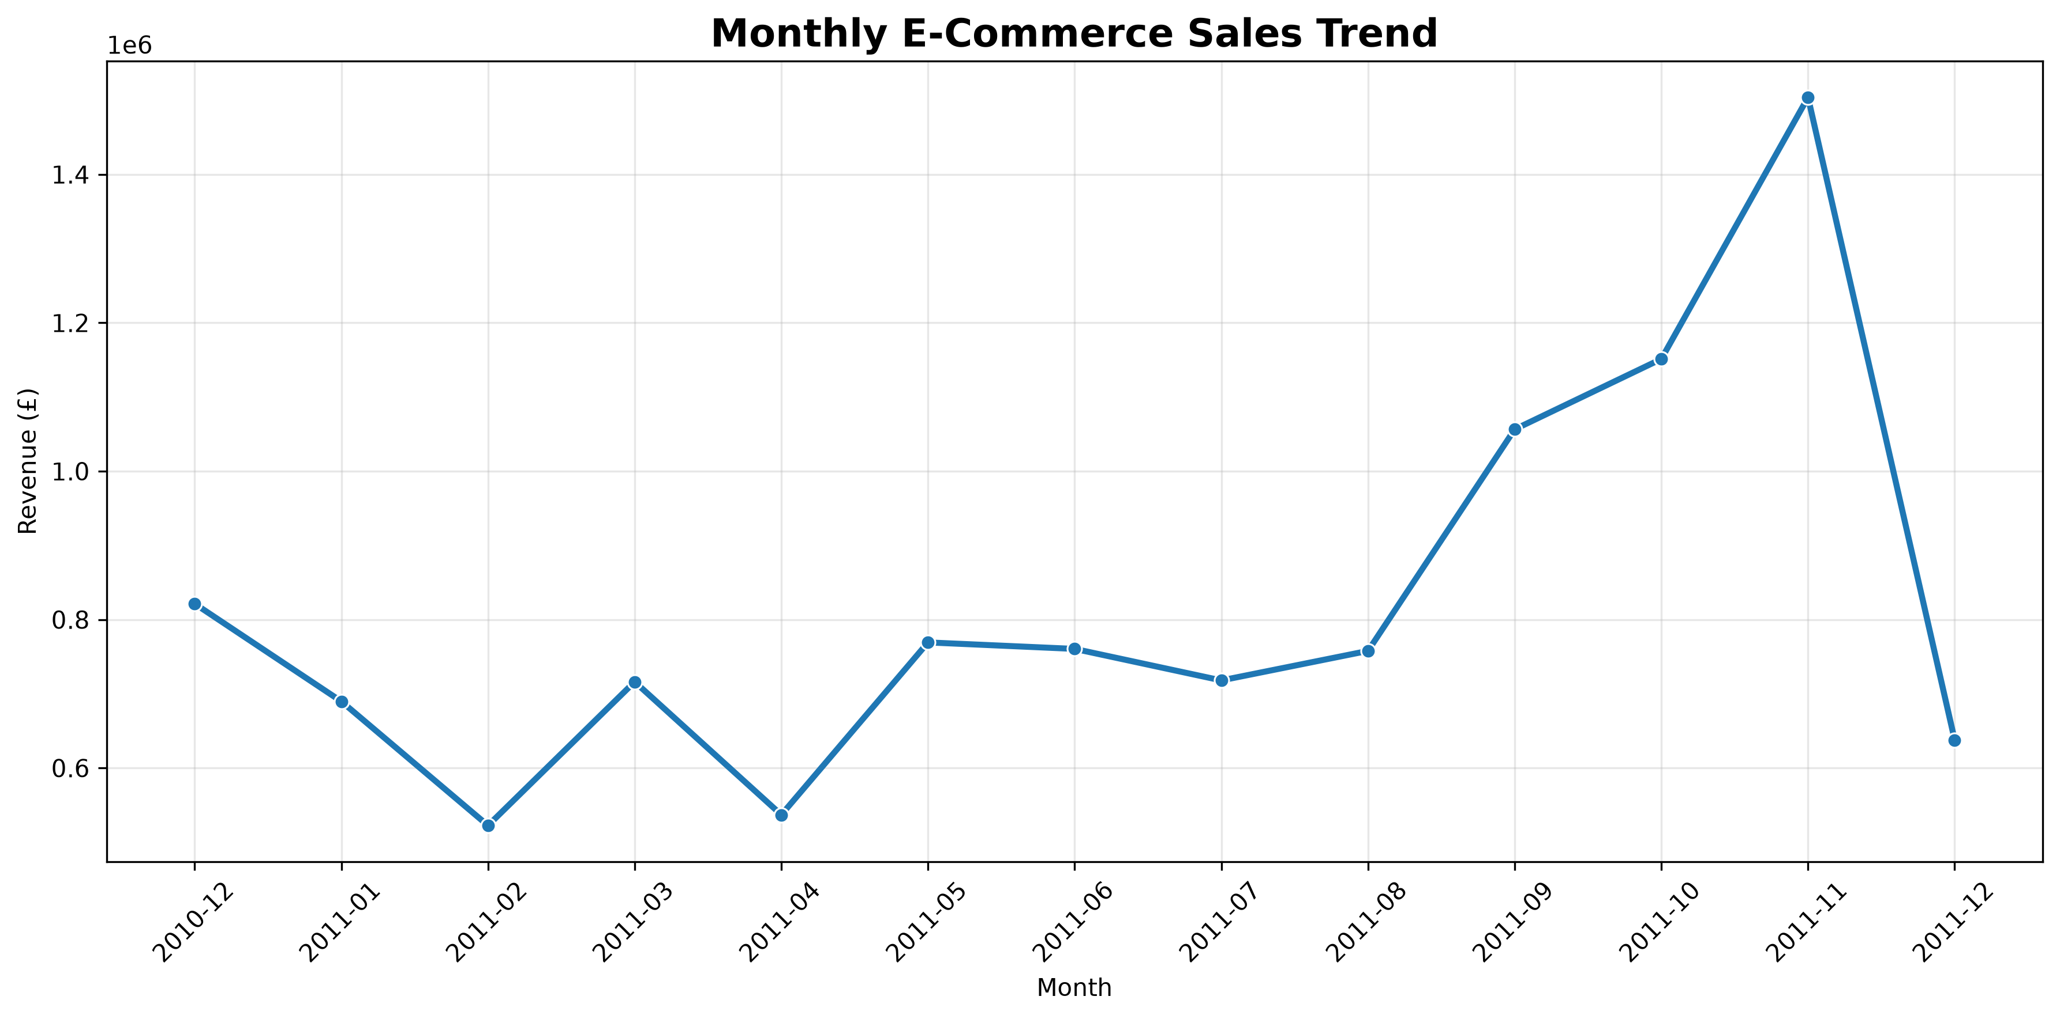
Observations:
- Revenue changes across different months.
- Higher revenue is observed during September, October, and November 2011.
- November 2011 shows the highest monthly revenue in the displayed chart.
- February and April show comparatively lower revenue.
- The visualization helps identify monthly sales fluctuations.
This analysis helps businesses understand seasonal patterns and plan their sales activities.
9.2 Top 10 Products Analysis
A horizontal bar chart was created to identify the top-selling products based on total quantity sold.
The chart represents the quantity of products sold and compares their sales performance.
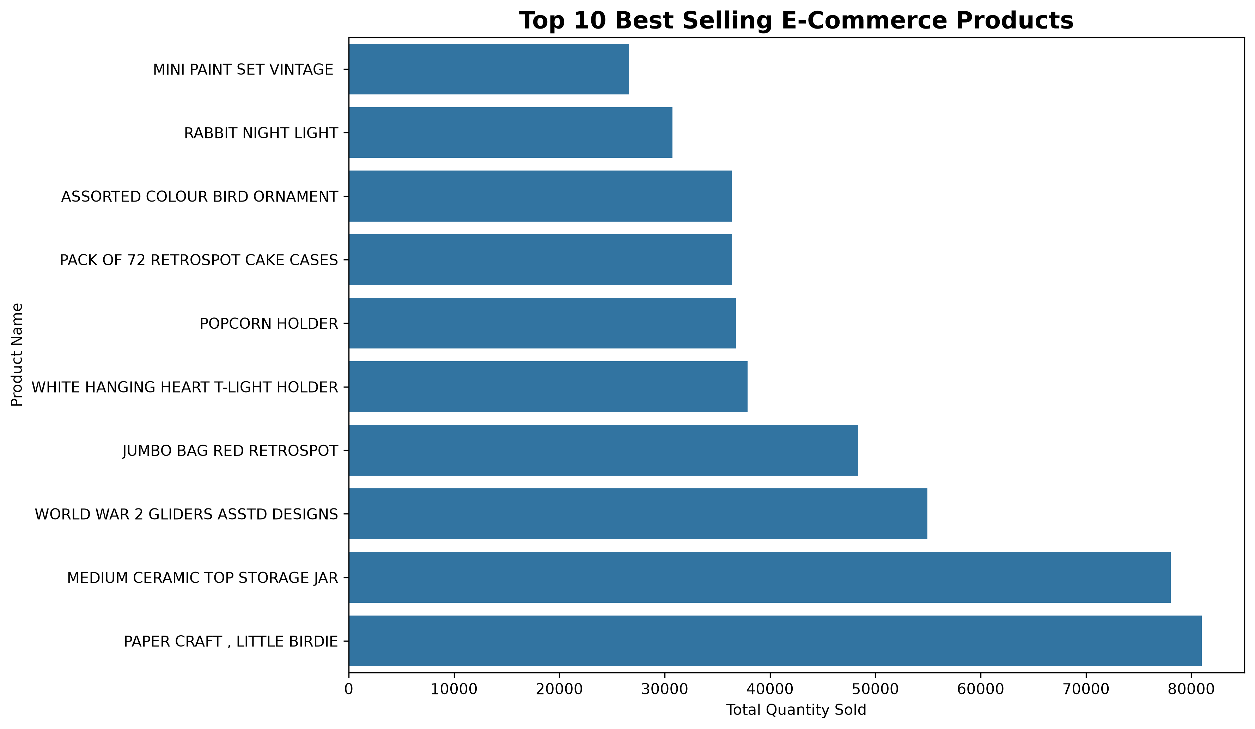
Observations:
- PAPER CRAFT, LITTLE BIRDIE appears among the products with the highest quantity sold.
- MEDIUM CERAMIC TOP STORAGE JAR also shows high product demand.
- WORLD WAR 2 GLIDERS ASSORTED DESIGNS has significant sales quantity.
- Different products show different levels of customer demand.
This visualization helps businesses identify products that generate high sales volume and understand product popularity.

9.3 Country-wise Revenue Analysis
A horizontal bar chart was created to compare total revenue generated by different countries.
The analysis identifies the United Kingdom as the country with the largest revenue contribution.
Some of the revenue values obtained from the analysis are:
Country | Total Revenue (£)
United Kingdom | 9,001,744.094
Netherlands | 285,446.340
EIRE | 283,140.520
Germany | 228,678.400
France | 209,625.370
Australia | 138,453.810
Spain | 61,558.560
Switzerland | 57,067.600
Belgium | 41,196.340
Sweden | 38,367.830
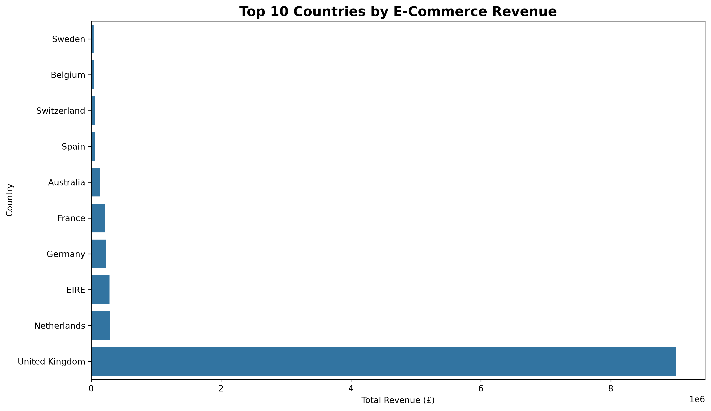
Observations:
- The United Kingdom contributes the largest share of the displayed country-wise revenue.
- The Netherlands and EIRE are also important contributors.
- Germany and France show considerable revenue generation.
- Revenue contributions differ significantly across countries.
This analysis helps understand the geographical distribution of business revenue.
9.4 E-Commerce Transaction Revenue Distribution
A histogram with a density curve was created to understand the distribution of transaction revenue.
The chart represents transaction revenue on the X-axis and the number of transactions on the Y-axis.
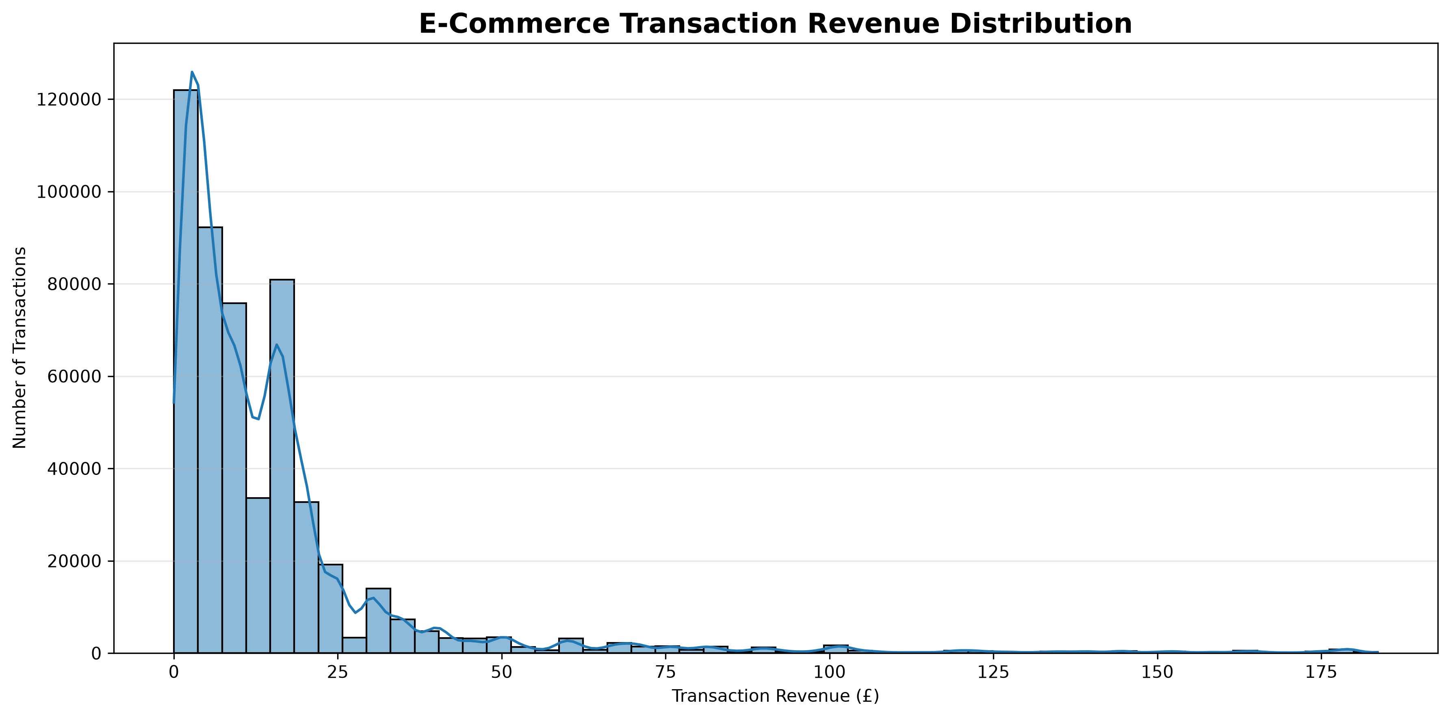
Observations:
- Most transaction revenue values are concentrated in the lower range.
- The distribution is positively skewed.
- A smaller number of transactions have comparatively high revenue values.
- Some transactions appear as high-value observations.
This visualization helps understand transaction patterns and identify unusually high transaction values.
9.5 Correlation Heatmap
A correlation heatmap was created using Seaborn to study relationships between Quantity, UnitPrice, and Revenue.
The correlation values observed were:
Variables | Correlation
Quantity and UnitPrice | Approximately 0.00
Quantity and Revenue | 0.91
UnitPrice and Revenue | 0.14
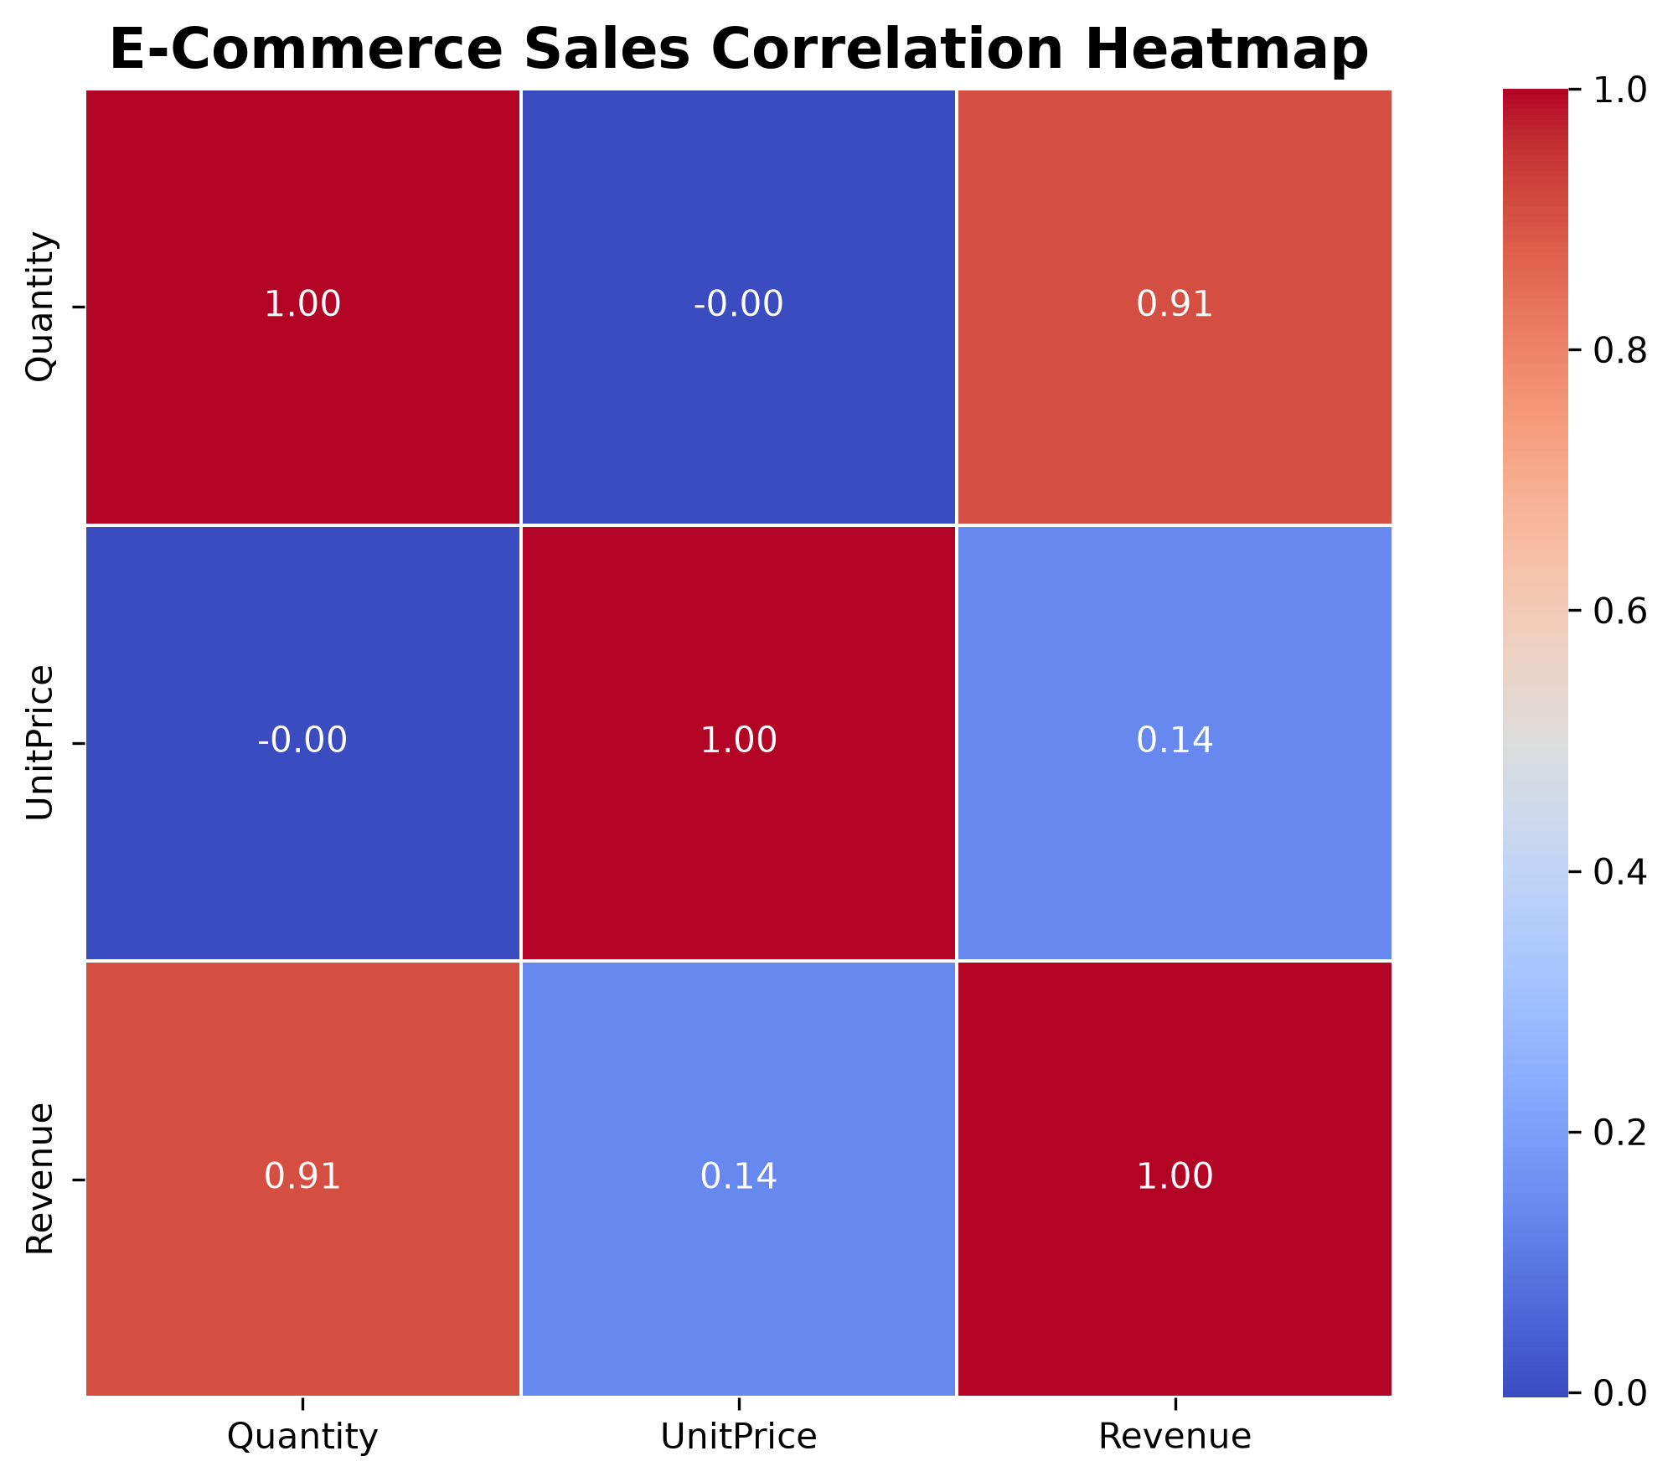
Observations:
- Quantity and Revenue show a strong positive correlation.
- UnitPrice and Revenue show a relatively weak positive correlation.
- Quantity and UnitPrice have almost no linear correlation.
The heatmap helps understand how numerical variables are related to each other.
10. KEY FINDINGS
Based on the analysis performed, the following findings were identified:
- The dataset contains 541,909 transaction records and 8 columns.
- Missing values were identified in Description and CustomerID.
- A total of 5,268 duplicate records were identified during initial exploration.
- The United Kingdom generated the highest revenue among the displayed countries.
- November 2011 recorded the highest monthly revenue in the generated monthly sales chart.
- PAPER CRAFT, LITTLE BIRDIE appears as one of the highest-selling products by quantity.
- Most transaction revenue values are concentrated in the lower range.
- Quantity has a strong positive correlation with Revenue.
11. APPLICATIONS OF THE PROJECT
This project can be useful in several business areas:
- Retail business performance analysis.
- Product demand identification.
- Monthly sales monitoring.
- Revenue comparison across countries.
- Customer purchasing behavior analysis.
- Business planning and decision-making.
- Sales trend monitoring.
12. ADVANTAGES
- Easy analysis of large transaction datasets.
- Saves time compared to manual analysis.
- Provides clear graphical representations.
- Helps identify product demand.
- Supports revenue analysis.
- Uses open-source Python libraries.
- Provides meaningful insights from raw data.
13. LIMITATIONS
- The analysis depends on the quality and completeness of the available dataset.
- Missing customer information may limit customer-level analysis.
- Historical transaction data does not necessarily represent current market conditions.
- The project focuses mainly on descriptive analysis and visualization.
- The results depend on the preprocessing and filtering applied to the dataset.
14. FUTURE ENHANCEMENTS
The project can be extended with additional analytical and machine learning techniques.
Possible future enhancements include:
- Customer segmentation using K-Means clustering.
- Sales forecasting using machine learning algorithms.
- Customer purchasing pattern analysis.
- Product recommendation systems.
- Interactive dashboards using Power BI or Tableau.
- RFM analysis for customer segmentation.
- Real-time sales monitoring and reporting.
These improvements can make the project more useful for advanced business analytics.
15. CONCLUSION
The E-Commerce Sales Analysis and Data Visualization project successfully demonstrates how Python can be used to analyze online retail transaction data.
The project involved loading the dataset, exploring its structure, identifying missing values and duplicate records, preparing the data, calculating revenue, and generating different visualizations.
The analysis provided useful information about monthly sales trends, top-selling products, country-wise revenue distribution, transaction revenue patterns, and relationships between numerical variables.
The visualizations helped convert a large collection of transaction records into understandable graphical information.
Overall, this project demonstrates the importance of data cleaning, exploratory data analysis, and visualization in understanding e-commerce business performance. It also provides a foundation for future work involving predictive analytics, customer segmentation, and machine learning.
16. REFERENCES
- Python Official Documentation – https://www.python.org/doc/
- Pandas Documentation – https://pandas.pydata.org/docs/
- NumPy Documentation – https://numpy.org/doc/
- Matplotlib Documentation – https://matplotlib.org/stable/
- Seaborn Documentation – https://seaborn.pydata.org/
- Jupyter Notebook Documentation – https://jupyter.org/documentation
- Online Retail Dataset – UCI Machine Learning Repository.

