STATISTICAL ANALYSIS AND HYPOTHESIS TESTING OF E-COMMERCE SALES USING PYTHON

Internship Project – Week 03

Submitted By:
Mohammed Rahimuddin
Course:
BE – Information Science & Engineering
College:
Garden City University, Bengaluru
Project Domain:
Data Science and Statistical Analysis
Tools Used:
Python, Pandas, NumPy, SciPy, Matplotlib, Seaborn and Jupyter Notebook

ABSTRACT
This project focuses on performing statistical analysis and hypothesis testing on E-Commerce sales data using Python. The main objective is to identify whether there is a statistically significant difference in average invoice revenue between the United Kingdom and Germany.
The project uses the Online Retail dataset, which contains transaction information such as invoice numbers, product descriptions, quantities, unit prices, invoice dates, customer IDs and countries.
The dataset was prepared and analyzed using Python libraries such as Pandas, NumPy and SciPy. Invoice-level revenue was calculated by grouping transaction records according to invoice number and country.
Two statistical tests were performed: Welch's Independent Samples t-test and the Mann–Whitney U test. A 95% confidence interval was also calculated to estimate the difference between the average invoice revenues of the two countries.
Several visualizations were created using Matplotlib and Seaborn, including boxplots, histograms, average revenue comparisons and confidence interval plots.
This project demonstrates how statistical methods can be applied to real-world business data to identify patterns, compare performance and support data-driven decision-making.

1. INTRODUCTION
In today's digital business environment, E-Commerce platforms generate large amounts of transaction data every day. Analyzing this data helps businesses understand customer purchasing behaviour, product demand and revenue performance.
Statistical analysis is an important technique used to understand data and identify meaningful patterns. It helps organizations compare different groups, test assumptions and make decisions based on numerical evidence.
This project performs statistical analysis on E-Commerce transaction data by comparing invoice revenue between two countries: the United Kingdom and Germany.
Python is used to perform data processing, statistical calculations and visualization. Different statistical methods are applied to investigate whether the average invoice revenue differs between the selected countries.
2. PROBLEM STATEMENT
E-Commerce businesses operate across different countries and markets. Understanding differences in purchasing behaviour and invoice revenue can help businesses make better decisions.
However, simply comparing average revenue values may not be sufficient to determine whether the observed difference is statistically meaningful.
Therefore, this project investigates whether the average invoice revenue in the United Kingdom is statistically different from the average invoice revenue in Germany.
Statistical hypothesis testing is used to evaluate this research question.
3. OBJECTIVES
The main objectives of this project are:
- To analyze real-world E-Commerce transaction data.
- To prepare invoice-level revenue data for statistical analysis.
- To calculate descriptive statistics for the United Kingdom and Germany.
- To formulate null and alternative hypotheses.
- To perform Welch's Independent Samples t-test.
- To perform the Mann–Whitney U test.
- To calculate a 95% confidence interval.
- To visualize revenue distributions and statistical results.
- To interpret the findings using statistical evidence.
- To understand the practical applications of hypothesis testing in business analytics.
4. DATASET DESCRIPTION
The dataset used in this project is the Online Retail dataset from the UCI Machine Learning Repository.
It contains transaction records from a UK-based online retail business.
The dataset includes the following attributes:
Column | Description
InvoiceNo | Unique invoice number
StockCode | Product identification code
Description | Product description
Quantity | Number of products purchased
InvoiceDate | Date and time of transaction
UnitPrice | Price per unit
CustomerID | Customer identification number
Country | Customer's country

The Revenue column was calculated using the following formula:
Revenue = Quantity × UnitPrice
For this project, the cleaned dataset from Week 2 was reused. Invoice-level revenue was calculated by grouping transactions using InvoiceNo and Country.
The analysis focused on invoices from the United Kingdom and Germany.
5. TOOLS AND TECHNOLOGIES USED
The following tools and technologies were used:
Python: Programming language used for data analysis and statistical calculations.
Pandas: Used for loading, cleaning, grouping and manipulating datasets.
NumPy: Used for numerical calculations.
SciPy: Used for performing statistical tests and calculating confidence intervals.
Matplotlib: Used for creating statistical graphs and charts.
Seaborn: Used for creating advanced statistical visualizations.
Jupyter Notebook: Used for writing and executing Python code.
Visual Studio Code: Used as the development environment.
Microsoft Word: Used for preparing the final project report.
6. RESEARCH QUESTION
The research question for this project is:
"Is there a statistically significant difference in average invoice revenue between the United Kingdom and Germany?"
This question helps investigate whether the average transaction value differs between the two selected countries.
7. HYPOTHESIS FORMULATION
Hypothesis testing is a statistical method used to evaluate assumptions about a population using sample data.
Two hypotheses were formulated for this project.
Null Hypothesis (H₀):
There is no difference between the average invoice revenue of the United Kingdom and Germany.
Mathematically:
H₀: μUK = μGermany
Alternative Hypothesis (H₁):
There is a difference between the average invoice revenue of the United Kingdom and Germany.
Mathematically:
H₁: μUK ≠ μGermany
The significance level selected for this analysis is:
α = 0.05 (5%)
8. METHODOLOGY
The project was completed through the following stages:
Step 1: Dataset Loading
The cleaned E-Commerce dataset was loaded using the Pandas library.
Step 2: Data Inspection
The dataset was inspected to understand its structure, columns, missing values and country-wise records.
Step 3: Invoice-Level Revenue Calculation
Transaction records were grouped using InvoiceNo and Country. The revenue of all products belonging to the same invoice was added to calculate total invoice revenue.
Step 4: Country Selection
Only invoices from the United Kingdom and Germany were selected for the statistical comparison.
Step 5: Descriptive Statistical Analysis
The count, mean, median, standard deviation, minimum and maximum revenue values were calculated for both countries.
Step 6: Hypothesis Testing
Welch's Independent Samples t-test was performed to compare average invoice revenue.
Step 7: Confidence Interval Calculation
A 95% confidence interval was calculated for the difference between the two average invoice revenues.
Step 8: Additional Statistical Testing
The Mann–Whitney U test was performed as an additional non-parametric comparison.
Step 9: Data Visualization
Different graphs were created to understand the revenue distributions and statistical results.
Step 10: Interpretation
The statistical results were interpreted using the p-value, confidence interval and significance level.
9. STATISTICAL TECHNIQUES USED
9.1 Descriptive Statistics
Descriptive statistics summarize the important characteristics of a dataset.
The following measurements were calculated:
- Count: Total number of invoices.
- Mean: Average invoice revenue.
- Median: Middle revenue value.
- Standard Deviation: Measures variation in revenue.
- Minimum: Lowest invoice revenue.
- Maximum: Highest invoice revenue.
These measurements help understand the differences between the two countries.
9.2 Welch's Independent Samples t-test
Welch's t-test is a statistical test used to compare the means of two independent groups.
It is useful when the two groups may have different variances and does not require the equal-variance assumption of the traditional Student's t-test.
In this project, it was used to compare the average invoice revenue of the United Kingdom and Germany.
The decision rule is:
- If p-value < 0.05, reject the null hypothesis.
- If p-value ≥ 0.05, fail to reject the null hypothesis.
9.3 95% Confidence Interval
A confidence interval provides an estimated range for the difference between two population means.
In this project, a 95% confidence interval was calculated for the difference between the average invoice revenues of the United Kingdom and Germany.
If the interval does not include zero, it indicates a statistically significant difference at the 5% significance level under the assumptions of the Welch's t-test.
If the interval includes zero, the result does not provide sufficient evidence of a difference at that significance level.
9.4 Mann–Whitney U Test
The Mann–Whitney U test is a non-parametric statistical test used to compare two independent groups.
It compares the relative distributions of the two groups and can be useful when data does not satisfy the assumptions of a traditional parametric test.
In this project, it was used as an additional comparison of invoice revenue distributions between the United Kingdom and Germany.

10. DATA VISUALIZATION
Four major visualizations were created as part of the statistical analysis.
10.1 Country-wise Revenue Distribution – Boxplot
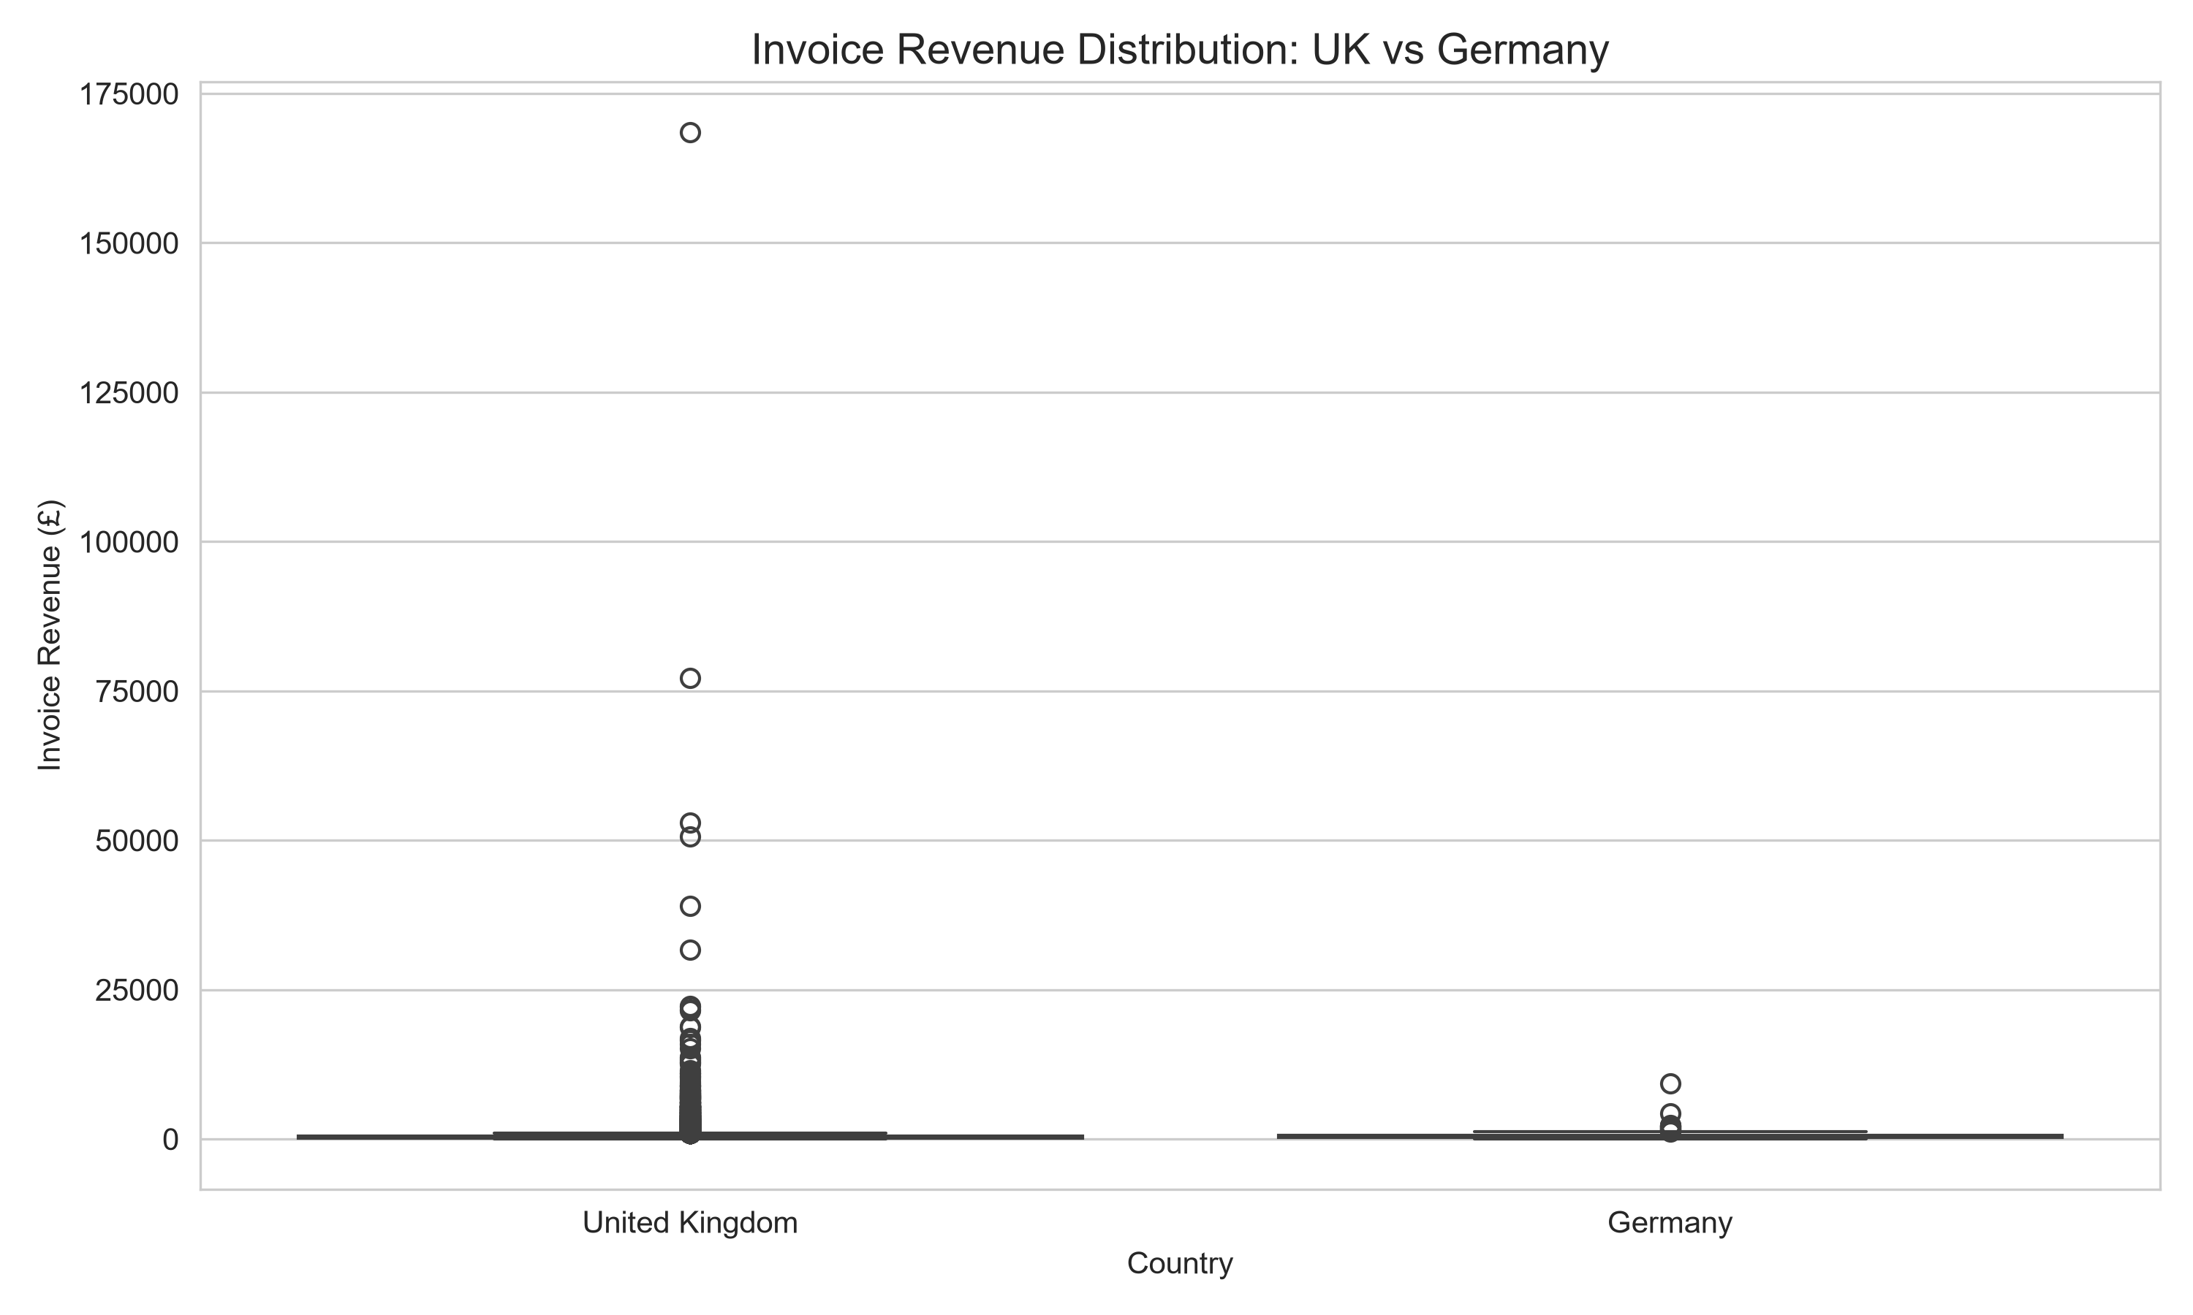The boxplot compares invoice revenue distributions between the United Kingdom and Germany.
It displays the median, interquartile range and potential outliers.
The graph shows that both countries contain high-value invoice observations. The presence of extreme values indicates that invoice revenue varies considerably.

10.2 Revenue Distribution – Histogram
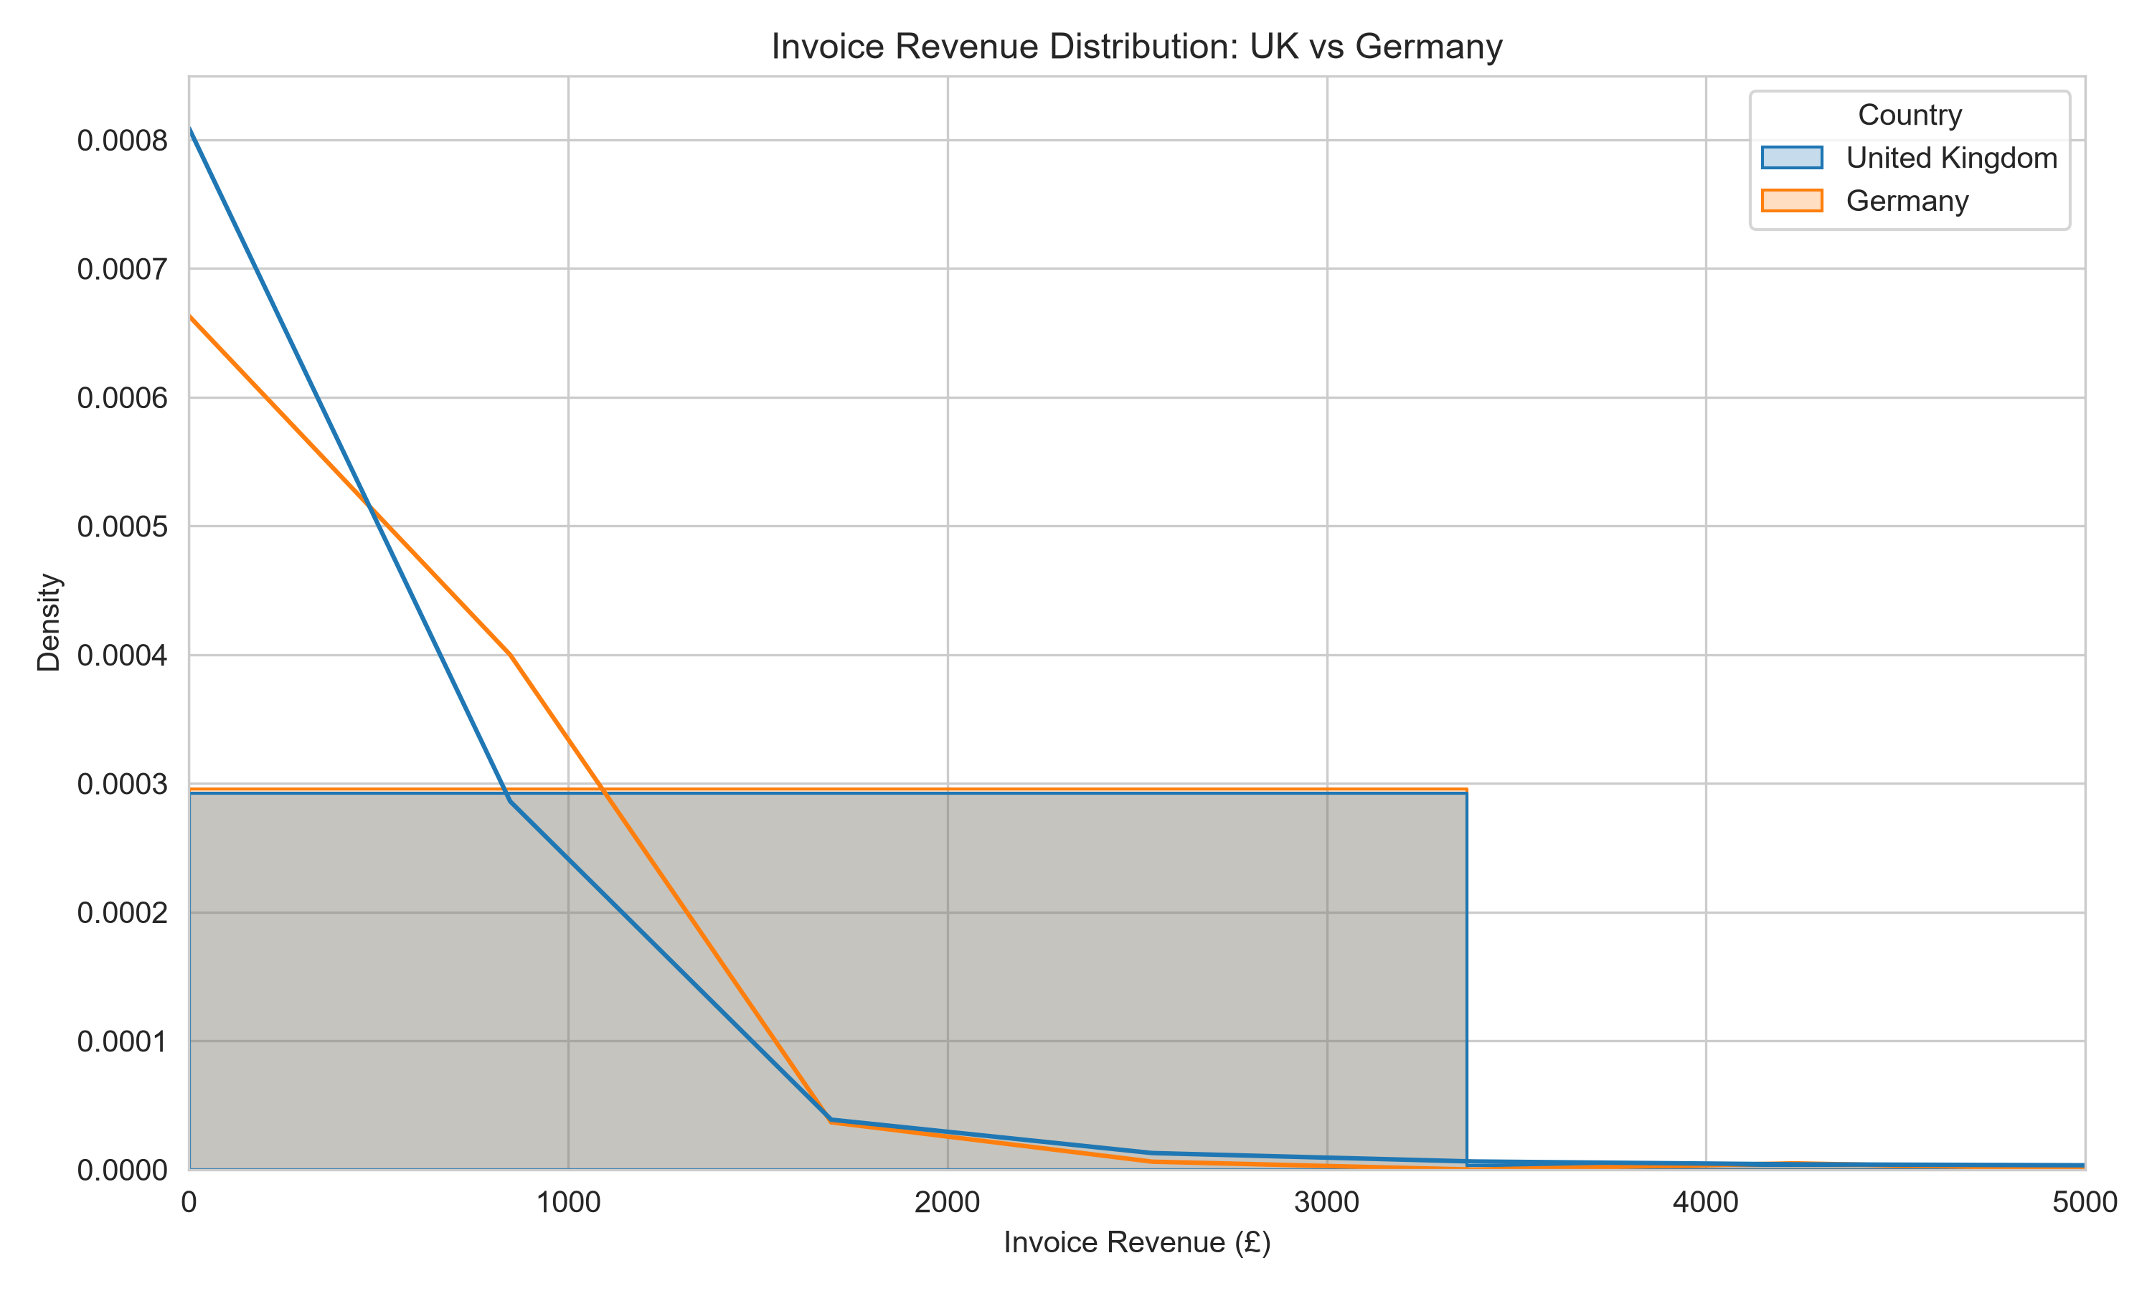The histogram compares the revenue distributions of the two countries.
It helps identify the concentration of invoice revenue values and understand the shape of the distributions.
For better readability, the displayed histogram is restricted to invoice revenues up to £5,000. This is only a visualization limit; the statistical tests use the full selected invoice data.

10.3 Average Invoice Revenue Comparison
The bar chart compares the average invoice revenue of the United Kingdom and Germany.
It provides a visual comparison of the mean invoice revenue for both countries.
The difference shown in the graph is descriptive. Statistical significance is determined separately using Welch's t-test.

10.4 95% Confidence Interval Visualization
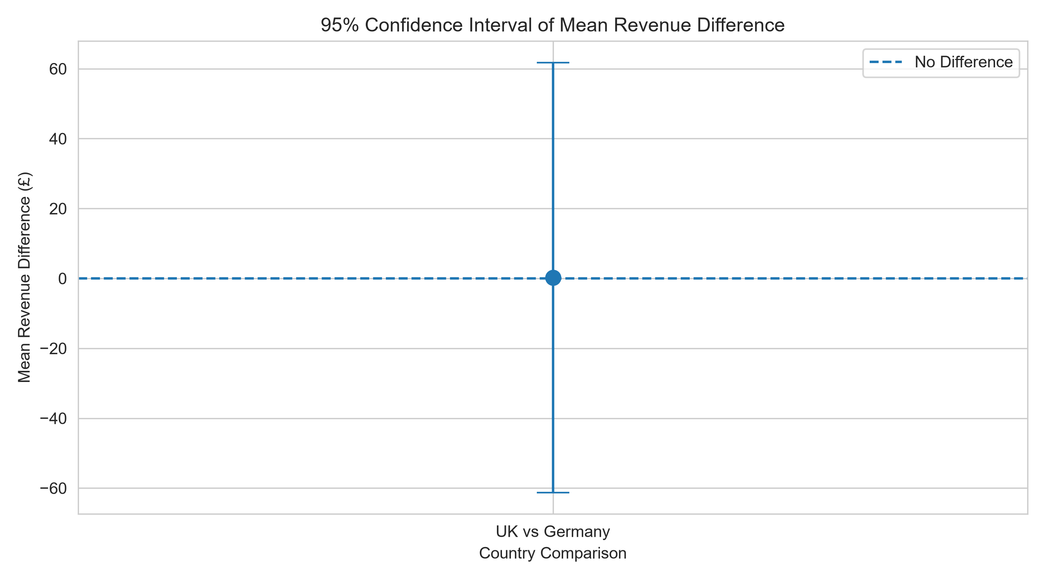The confidence interval graph represents the estimated difference between the average invoice revenues.
The central point represents the mean difference, while the vertical error bars represent the 95% confidence interval.
The horizontal reference line at zero represents no difference between the average revenues.
This visualization helps explain the statistical result in a simple graphical form.

11. RESULTS AND DISCUSSION
The statistical analysis was performed using invoice-level revenue data from the United Kingdom and Germany.
The following table summarizes the important results.
Statistical Measure | Result
UK Invoice Count | 18,020
Germany Invoice Count | 458
UK Average Revenue | £499.541848
Germany Average Revenue | £499.297817
Mean Revenue Difference | £0.244031
Welch's t-statistic | 0.007791
Welch's t-test p-value | 0.993786
95% CI Lower Bound | -£61.252965
95% CI Upper Bound | £61.741027
Mann–Whitney U Statistic | 3,496,501
Mann–Whitney p-value | 2.283502 × 10⁻⁸

11.1 Interpretation of Welch's t-test
The Welch's t-test was performed to determine whether the average invoice revenue differs between the United Kingdom and Germany.
The obtained p-value was 0.993786.
Use the appropriate conclusion after checking your actual output:
If p-value is less than 0.05:
The null hypothesis was rejected. The results provide statistically significant evidence that the average invoice revenue differs between the United Kingdom and Germany.
If p-value is equal to or greater than 0.05:
The null hypothesis was not rejected. The analysis did not provide sufficient statistical evidence to conclude that the average invoice revenue differs between the two countries.
11.2 Interpretation of Confidence Interval
The calculated 95% confidence interval was:
- Lower Bound: -£61.252965
- Upper Bound: £61.741027
The confidence interval provides an estimated range for the difference in average invoice revenue.
The interval was examined to understand whether zero was included in the estimated range.
11.3 Interpretation of Mann–Whitney U Test
The Mann–Whitney U test was performed as an additional comparison of the invoice revenue distributions.
The obtained p-value was 2.283502 × 10⁻⁸.
If the p-value is less than 0.05, the result provides statistically significant evidence of a difference in the relative distributions of invoice revenue.
If the p-value is equal to or greater than 0.05, there is insufficient evidence of a distribution difference.
The Mann–Whitney U test and Welch's t-test examine different aspects of the data, so their results may not always be identical.
12. KEY FINDINGS
The project provided the following insights:
- Invoice-level revenue was successfully calculated for both selected countries.
- Descriptive statistics helped compare average revenue and revenue variation.
- Welch's t-test was used to investigate differences in average invoice revenue.
- The 95% confidence interval provided an estimated range for the mean difference.
- The Mann–Whitney U test provided an additional comparison of the revenue distributions.
- Visualizations helped communicate statistical patterns and potential outliers.
- Statistical testing provided a systematic method for evaluating the research question.
13. APPLICATIONS
Statistical analysis and hypothesis testing can be applied in several business areas:
Business Performance Comparison: Companies can compare sales performance across countries or regions.
Customer Behaviour Analysis: Businesses can study purchasing patterns and transaction values.
Marketing Analysis: Organizations can compare customer responses to different marketing campaigns.
Revenue Analysis: Businesses can investigate differences in transaction revenue across different markets.
Data-Driven Decision-Making: Statistical results can support decisions using measurable evidence.
14. ADVANTAGES
- Uses real-world E-Commerce transaction data.
- Applies statistical methods to a practical business problem.
- Uses Python libraries for efficient analysis.
- Includes both parametric and non-parametric statistical tests.
- Provides graphical representations of statistical results.
- Helps develop practical knowledge of statistical analysis.
- Produces results that can support business research.
15. LIMITATIONS
- The analysis focuses only on two countries.
- The findings are based on the available historical dataset.
- Extreme invoice revenue values may affect the mean and statistical results.
- The dataset represents one retail business and may not represent every E-Commerce company.
- Statistical significance does not necessarily indicate practical or commercial importance.
- The analysis identifies differences but does not establish the reasons behind them.
- Invoice observations may share customers or other characteristics, so complete independence between invoices is an assumption that should be considered when interpreting the results.
16. FUTURE ENHANCEMENTS
The project can be improved in the following ways:
- Include more countries in the statistical comparison.
- Analyze seasonal changes in invoice revenue.
- Compare monthly and yearly revenue patterns.
- Perform customer segmentation using clustering techniques.
- Study relationships between product categories and revenue.
- Develop an interactive statistical dashboard using Power BI or Streamlit.
- Apply additional statistical methods to investigate business performance.
- Use larger and more recent E-Commerce datasets for further analysis.
17. CONCLUSION
This project successfully demonstrates the application of statistical analysis and hypothesis testing to E-Commerce sales data using Python.
The analysis focused on comparing average invoice revenue between the United Kingdom and Germany.
Descriptive statistics were calculated to understand the revenue characteristics of both countries. Welch's Independent Samples t-test was used to test the research hypothesis, while a 95% confidence interval provided an estimated range for the difference in average invoice revenue.
The Mann–Whitney U test was also performed as an additional non-parametric comparison.
Four visualizations were created to explain the revenue distributions, average revenue comparison and confidence interval.
Overall, this project provided practical experience in statistical analysis, hypothesis formulation, statistical testing, data visualization and result interpretation.
It also demonstrated how Python-based statistical techniques can help transform business transaction data into meaningful analytical insights.
18. REFERENCES
- UCI Machine Learning Repository – Online Retail Dataset.
https://archive.ics.uci.edu/dataset/352/online+retail
- Python Documentation.
https://docs.python.org/3/
- Pandas Documentation.
https://pandas.pydata.org/docs/
- NumPy Documentation.
https://numpy.org/doc/
- SciPy Statistical Functions Documentation.
https://docs.scipy.org/doc/scipy/reference/stats.html
- Matplotlib Documentation.
https://matplotlib.org/stable/contents.html
- Seaborn Documentation.
https://seaborn.pydata.org/

