WEEK 4: MACHINE LEARNING MODEL DEVELOPMENT AND EVALUATION

Titanic Survival Prediction Using Logistic Regression

Technology Used: Python
Machine Learning Algorithm: Logistic Regression
Dataset: Titanic Passenger Dataset
Dataset Size: 891 rows × 11 columns

1. ABSTRACT
This project focuses on developing and evaluating a machine learning classification model using Python. The Titanic passenger dataset was selected to predict whether a passenger survived or did not survive based on different passenger characteristics.
The dataset contains information such as passenger class, gender, age, number of siblings or spouses, number of parents or children, fare, and port of embarkation. Logistic Regression was selected as the machine learning algorithm because it is a simple, interpretable, and suitable algorithm for binary classification problems.
The data was prepared and categorical variables were converted into numerical form. The dataset was divided into training and testing sets using an 80:20 split. The model was trained using the training dataset and evaluated using accuracy, precision, recall, F1-score, confusion matrix, and ROC-AUC score.
The Logistic Regression model achieved an accuracy of 80.45% and an ROC-AUC score of 84.43%. The results show that the model can effectively identify survival patterns in the Titanic dataset.

2. INTRODUCTION
Machine Learning is a branch of Artificial Intelligence that enables computers to learn patterns from data and make predictions without being explicitly programmed for every situation.
Classification is one of the important machine learning tasks where the objective is to assign data observations to predefined categories. In this project, classification is used to predict whether a Titanic passenger survived or did not survive.
The Titanic dataset is a well-known dataset used for learning and demonstrating machine learning techniques. It contains passenger information that can be used to understand the factors associated with survival.
In this project, Python and Scikit-learn were used to develop a Logistic Regression model. Different evaluation metrics and visualizations were used to understand the performance of the model.

3. PROBLEM STATEMENT
The objective of this project is to develop a machine learning model that can predict the survival status of Titanic passengers using passenger-related information.
The model should learn patterns from historical passenger data and classify each passenger into one of two categories:
- 0 – Did Not Survive
- 1 – Survived
The performance of the model is then evaluated using standard classification metrics.

4. OBJECTIVES
The main objectives of this project are:
- To understand and prepare the Titanic dataset.
- To identify suitable features for machine learning.
- To preprocess categorical data into numerical format.
- To divide the dataset into training and testing datasets.
- To develop a Logistic Regression classification model.
- To train the model using the training dataset.
- To generate predictions using the test dataset.
- To evaluate the model using accuracy, precision, recall, and F1-score.
- To generate a confusion matrix for detailed classification analysis.
- To evaluate the model using the ROC curve and ROC-AUC score.
- To analyze the importance of different features.
- To identify limitations and possible improvements.

5. DATASET DESCRIPTION
The Titanic dataset used in this project contains 891 passenger records and 11 columns.
The columns are:
Column | Description
PassengerId | Unique passenger identification number
Survived | Survival status of the passenger
Pclass | Passenger class
Name | Passenger name
Sex | Passenger gender
Age | Passenger age
SibSp | Number of siblings/spouses aboard
Parch | Number of parents/children aboard
Ticket | Ticket number
Fare | Passenger fare
Embarked | Port of embarkation
The target variable is:
Survived
where:
- 0 = Did Not Survive
- 1 = Survived

6. DATA QUALITY CHECK
Before developing the model, the dataset was checked for missing values.
The analysis showed that there were no missing values in the dataset.
Column | Missing Values
PassengerId | 0
Survived | 0
Pclass | 0
Name | 0
Sex | 0
Age | 0
SibSp | 0
Parch | 0
Ticket | 0
Fare | 0
Embarked | 0
Therefore, no missing-value imputation was required.

7. FEATURE SELECTION
The following features were selected for model development:
- Pclass
- Sex
- Age
- SibSp
- Parch
- Fare
- Embarked
The columns PassengerId, Name, and Ticket were not used as model features because they are identification or text-based fields and are not directly suitable for this classification model.
The target variable was:
Survived
After categorical encoding, the final model contained 8 numerical features.

8. DATA PREPROCESSING
The Titanic dataset contained categorical variables such as Sex and Embarked.
Machine learning algorithms require numerical input, so categorical variables were converted into numerical representation using one-hot encoding.
The following transformations were performed:
- Sex → Sex_male
- Embarked → Embarked_Q and Embarked_S
The drop_first=True option was used to avoid unnecessary redundancy between encoded categories.
After preprocessing, the feature dataset contained:
891 rows × 8 features

9. TRAIN-TEST SPLIT
The dataset was divided into training and testing sets.
An 80:20 split was used.
Dataset | Records
Training Dataset | 712
Testing Dataset | 179
Total | 891
The training dataset was used to train the Logistic Regression model, while the testing dataset was used to evaluate its performance on unseen data.
A random_state of 42 was used to make the experiment reproducible.

10. MACHINE LEARNING ALGORITHM
10.1 Logistic Regression
Logistic Regression was selected as the classification algorithm for this project.
Logistic Regression is a supervised machine learning algorithm commonly used for binary classification problems. It estimates the probability that an observation belongs to a particular class.
In this project, the two classes are:
- Did Not Survive
- Survived
The model learns the relationship between passenger characteristics and survival status from the training data.
The advantages of Logistic Regression include:
- Simple to implement
- Easy to interpret
- Efficient for binary classification
- Suitable for relatively small datasets
- Provides probability-based predictions

11. MODEL TRAINING
The Logistic Regression model was trained using the 712 training records.
The model used the following features:
- Pclass
- Age
- SibSp
- Parch
- Fare
- Sex_male
- Embarked_Q
- Embarked_S
After training, the model was used to generate predictions for the 179 testing records.

12. MODEL EVALUATION
Several evaluation metrics were used to measure the performance of the model.
The final results are:
Evaluation Metric | Result
Accuracy | 80.45%
Precision | 79.31%
Recall | 66.67%
F1-Score | 72.44%
ROC-AUC | 84.43%

13. ACCURACY
The Logistic Regression model achieved an accuracy of:
80.45%
Accuracy represents the proportion of total predictions that were correctly classified.
This means that approximately 80 out of every 100 passengers in the testing dataset were classified correctly.
The result indicates that the model provides reasonably good overall classification performance.

14. PRECISION
The model achieved a precision of:
79.31%
Precision measures how many of the passengers predicted as survivors actually survived.
A precision of 79.31% indicates that the model's positive predictions were reasonably reliable.

15. RECALL
The model achieved a recall of:
66.67%
Recall measures how many of the passengers who actually survived were correctly identified by the model.
The recall is lower than the precision, which indicates that the model missed some passengers who actually survived.

16. F1-SCORE
The model achieved an F1-score of:
72.44%
The F1-score provides a balance between precision and recall.
The result indicates that the model provides a reasonable balance between correctly identifying survivors and avoiding incorrect positive predictions.

17. CONFUSION MATRIX
The confusion matrix obtained from the test dataset was:
[[98 12]
[23 46]]
The matrix can be interpreted as follows:
 | Predicted Did Not Survive | Predicted Survived
Actual Did Not Survive | 98 | 12
Actual Survived | 23 | 46
Interpretation
- 98 passengers were correctly predicted as not surviving.
- 12 passengers were incorrectly predicted as survivors.
- 23 passengers who actually survived were incorrectly predicted as not surviving.
- 46 passengers were correctly predicted as survivors.
The confusion matrix shows that the model performs better at identifying passengers who did not survive than passengers who survived.
[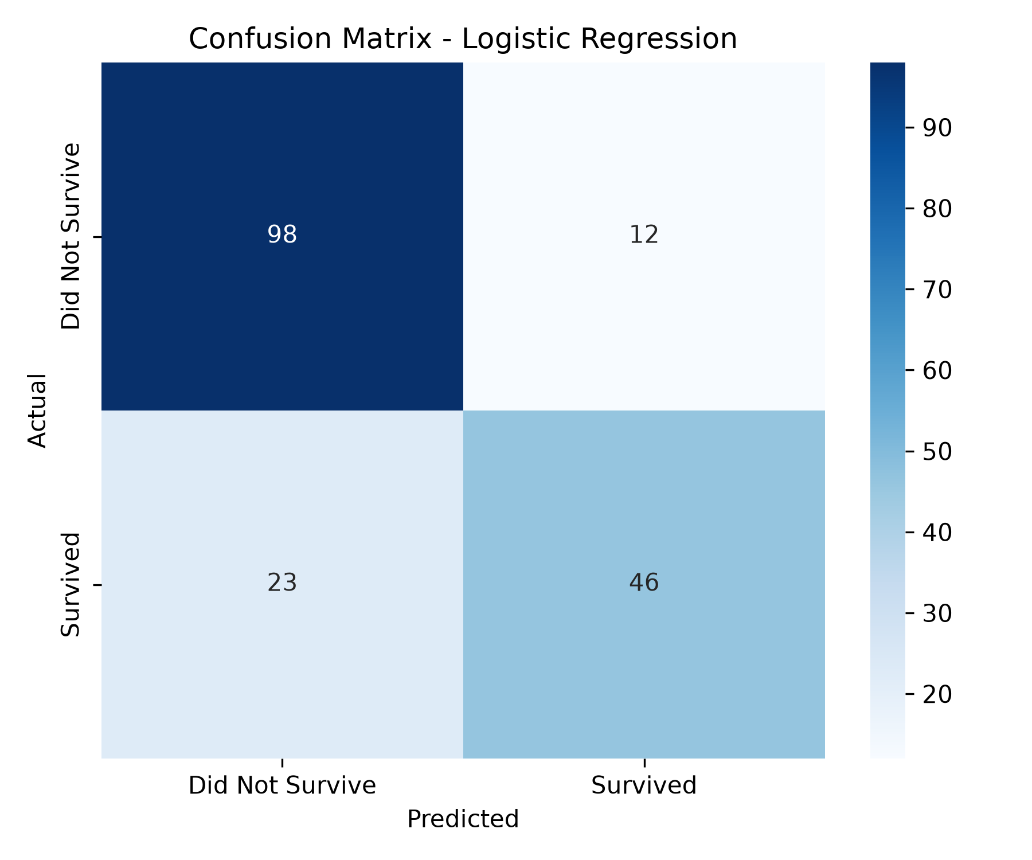
18. ROC CURVE AND AUC
The ROC curve was generated to evaluate the model's ability to distinguish between the two classes.
The obtained ROC-AUC score was:
0.8443
or approximately:
84.43%
An AUC value closer to 1 indicates better classification ability, while a value close to 0.5 represents performance similar to random classification.
The obtained score of 0.8443 indicates that the Logistic Regression model has good discriminatory ability.
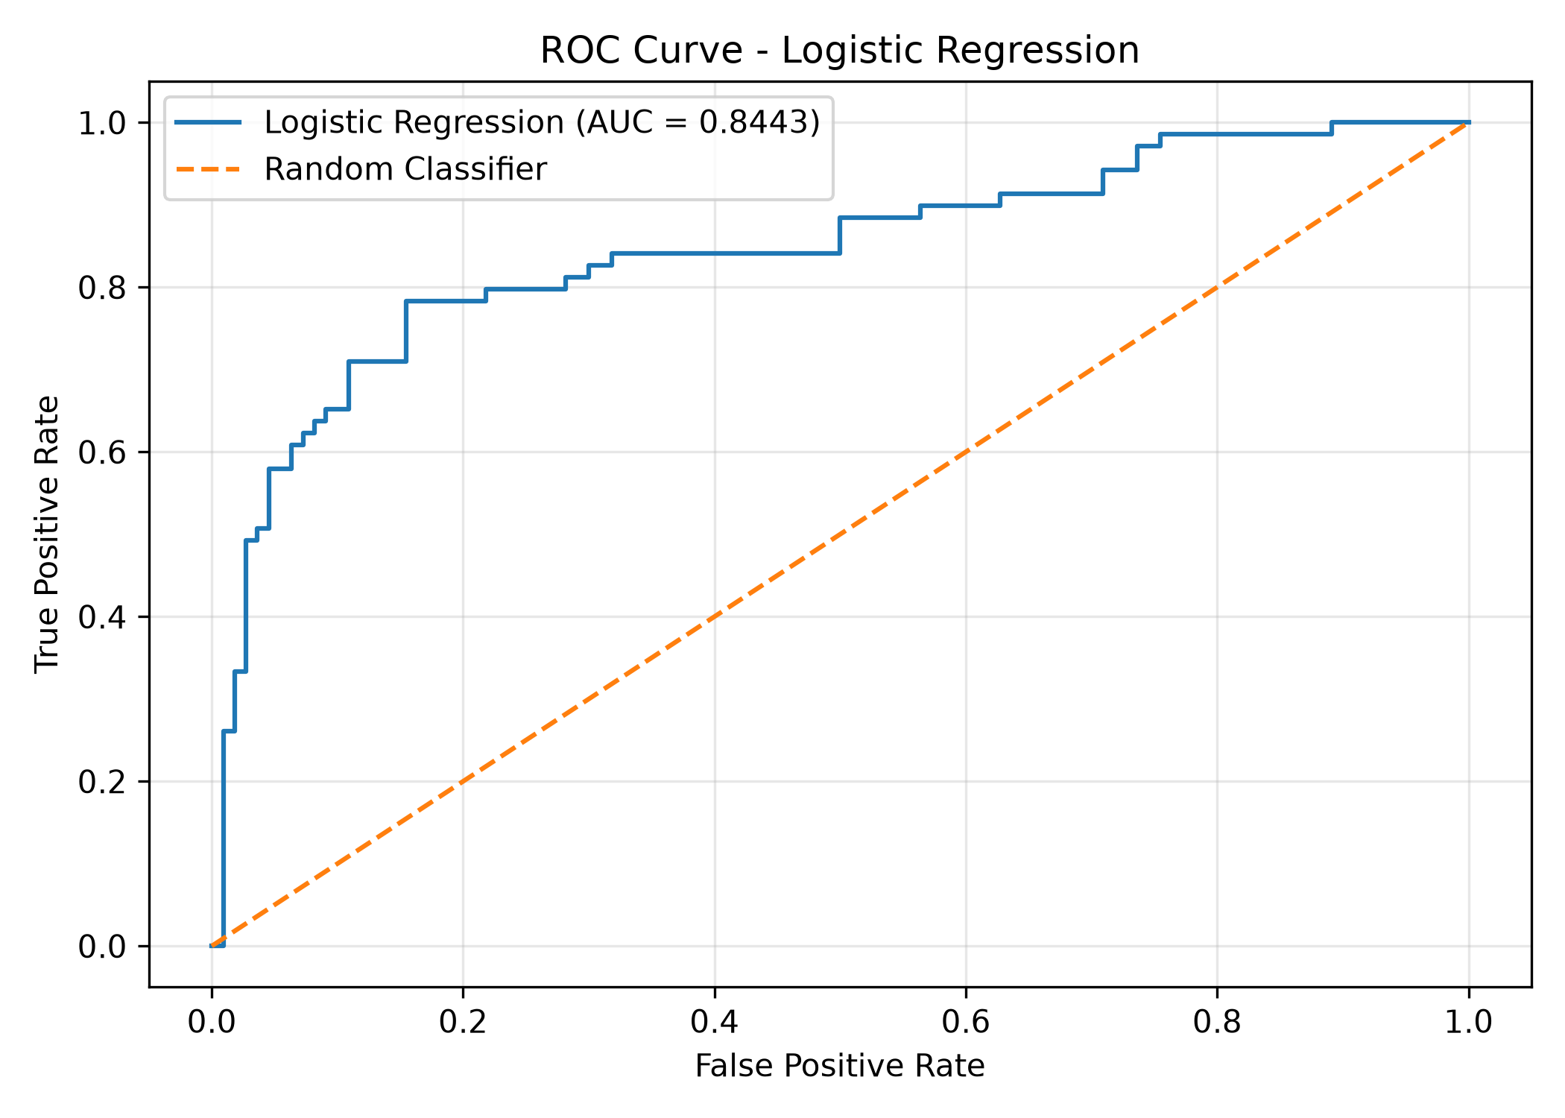
19. FEATURE IMPORTANCE ANALYSIS
Feature importance was analyzed using the coefficients of the Logistic Regression model.
The feature coefficient visualization showed that some variables had a stronger influence on the model's predictions than others.
The most noticeable coefficient was associated with Sex_male, followed by Pclass.
The coefficient for Sex_male was strongly negative, indicating a lower predicted probability of survival for male passengers compared with the reference gender category.
Pclass also had a negative coefficient, showing that passenger class was an important factor in the prediction.
Other variables such as Age, Fare, Parch, SibSp, and embarkation-related variables had comparatively smaller effects.
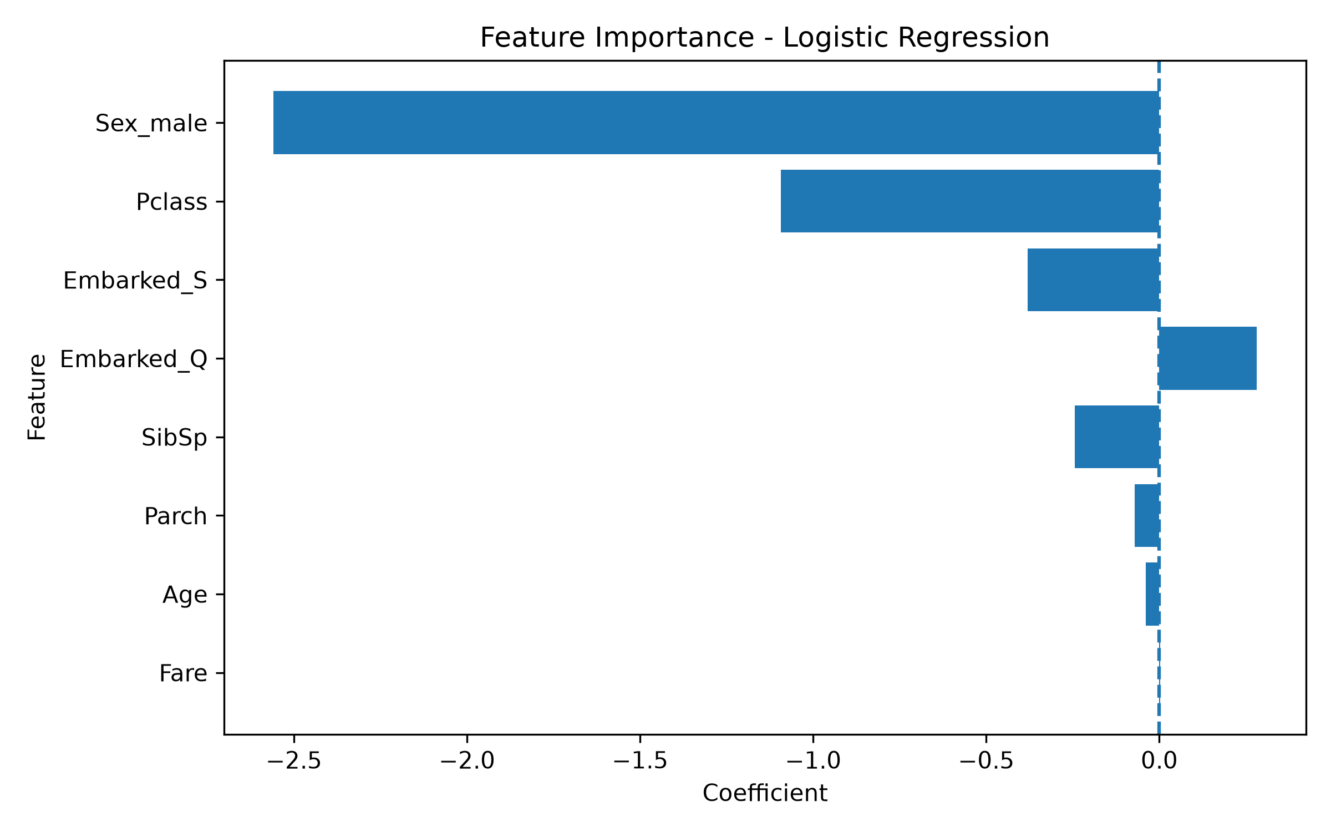
20. CLASSIFICATION REPORT
The detailed classification report is shown below:
Class | Precision | Recall | F1-Score | Support
Did Not Survive | 0.81 | 0.89 | 0.85 | 110
Survived | 0.79 | 0.67 | 0.72 | 69
Accuracy | — | — | 0.80 | 179
Macro Average | 0.80 | 0.78 | 0.79 | 179
Weighted Average | 0.80 | 0.80 | 0.80 | 179
The classification report confirms that the model performs particularly well in identifying passengers who did not survive, with a recall of 0.89 for that class.

21. RESULTS AND DISCUSSION
The Logistic Regression model achieved an overall accuracy of 80.45%, demonstrating reasonable predictive performance.
The precision of 79.31% indicates that the model generally makes reliable positive predictions. However, the recall of 66.67% shows that some actual survivors were not identified correctly.
The F1-score of 72.44% provides a balanced measure of precision and recall.
The ROC-AUC score of 84.43% indicates that the model has good ability to distinguish between surviving and non-surviving passengers.
The confusion matrix also shows that the model correctly classified 98 non-survivors and 46 survivors.
Overall, the model demonstrates that passenger characteristics such as gender and passenger class have an important relationship with survival prediction.

22. LIMITATIONS
Although the model achieved reasonable performance, there are several limitations:
- The dataset contains only historical Titanic passenger information.
- Logistic Regression assumes a relatively simple relationship between features and the target.
- The model may not capture complex non-linear relationships.
- Some potentially useful information from fields such as Name and Ticket was not directly used.
- The recall for the Survived class was only 66.67%, meaning some survivors were incorrectly classified.
- The model was evaluated using a single train-test split rather than extensive cross-validation.
- The results depend on the quality and characteristics of the selected dataset.

23. FUTURE ENHANCEMENTS
The project can be improved in several ways.
- Compare Logistic Regression with Decision Tree, Random Forest, and other classification algorithms.
- Apply cross-validation for more reliable evaluation.
- Perform hyperparameter tuning.
- Use additional feature engineering.
- Extract useful information from passenger names and ticket numbers.
- Handle class imbalance using suitable techniques if necessary.
- Experiment with ensemble learning methods.
- Build a simple web application for real-time survival prediction.
- Compare multiple models using accuracy, F1-score, and ROC-AUC.
- Deploy the best-performing model as a prediction service.

24. CONCLUSION
This project successfully developed a machine learning classification model for predicting Titanic passenger survival using Python and Logistic Regression.
The dataset contained 891 passenger records and 11 columns. After selecting relevant features and converting categorical variables into numerical form, the data was divided into training and testing datasets using an 80:20 ratio.
The Logistic Regression model achieved an accuracy of 80.45%, precision of 79.31%, recall of 66.67%, and F1-score of 72.44%. The model also achieved a ROC-AUC score of 84.43%.
The confusion matrix and ROC curve provided additional information about the model's classification performance. Feature coefficient analysis showed that gender and passenger class had relatively strong influence on the model's predictions.
Overall, the project demonstrates the complete machine learning workflow, including data preparation, feature selection, preprocessing, model training, prediction, evaluation, visualization, and interpretation. The results indicate that Logistic Regression can provide a useful baseline model for Titanic survival classification.

25. TECHNOLOGIES AND LIBRARIES USED
Programming Language
- Python
Libraries
- Pandas
- NumPy
- Scikit-learn
- Matplotlib
- Seaborn
Development Environment
- Visual Studio Code
- Jupyter Notebook
Machine Learning Algorithm
- Logistic Regression

26. PROJECT OUTPUTS
The project generated the following important outputs:
Week4_Machine_Learning/
│
├── data/
│ └── cleaned_titanic.csv
│
├── notebooks/
│ └── titanic_ml_model.ipynb
│
├── visualizations/
│ ├── confusion_matrix.png
│ ├── roc_curve.png
│ └── feature_importance.png
│
└── report/
├── model_evaluation_results.csv
└── final_report_week04.docx

27. REFERENCES
- Scikit-learn Documentation – Logistic Regression and Model Evaluation.
- Pandas Documentation – Data Manipulation and Analysis.
- Matplotlib Documentation – Data Visualization.
- Seaborn Documentation – Statistical Data Visualization.
- Titanic Dataset – Publicly available machine learning dataset.

