AIRLINE FLIGHT DELAY ANALYSIS
Python EDA • MySQL • Power BI | 5 airlines, 8 cities, 2024 data

5,000  Total flights | 16.84 min  Avg arrival delay | 82%  Load factor | ₹4.31bn  Revenue
Key Findings
- Weather is the biggest driver: Storm flights average 39 min delay vs 15 min in clear weather (2.6x).
- SpiceJet is the weakest: highest delay (21 min arrival) and highest cancellation rate (3.18%).
- IndiGo leads: most flights (1,780), best punctuality (14.7 min), lowest cancellations (0.84%) and top revenue (₹1.55bn).
- Evenings are riskiest: delays build through the day, peaking at 9 PM (25 min) and 7 PM (24 min).
- Delays do not hurt ratings: all airlines sit near 3.7/5 and rating has ~0.01 correlation with delay.
- Load factor is steady: about 81-82% for every airline, so capacity use is not a differentiator.
Power BI Dashboard
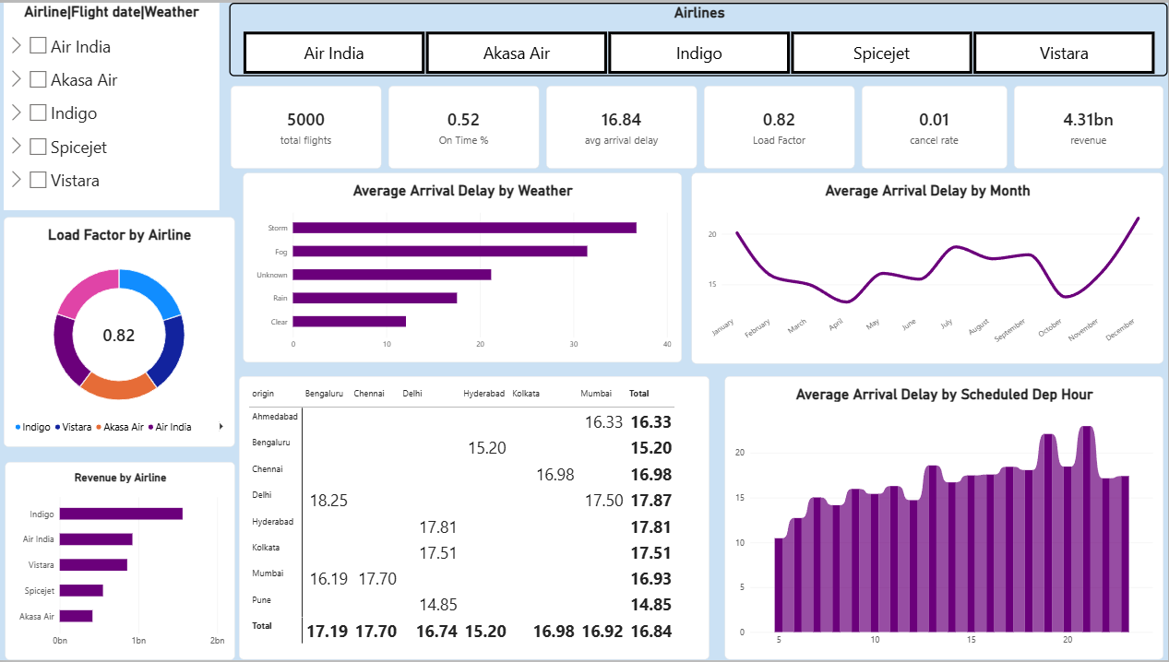
Interactive dashboard: KPIs, weather, monthly and hourly delay trends, route matrix

Python EDA
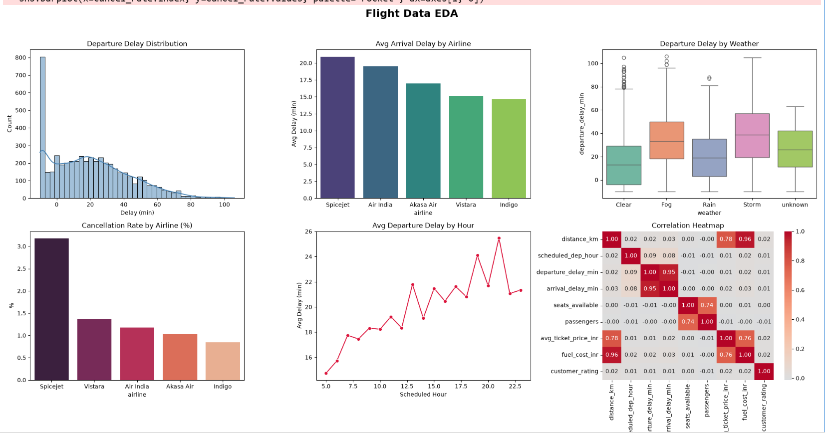
Delay distribution, airline and weather comparison, hourly trend, correlation heatmap
Departure and arrival delay are almost the same signal (r = 0.95), and distance drives fuel cost (r = 0.96) and ticket price (r = 0.78).
MySQL Analysis
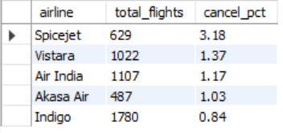  Cancellation rate by airline | 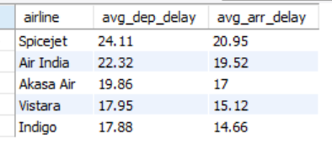  Avg departure & arrival delay
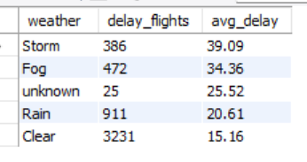  Delay by weather | 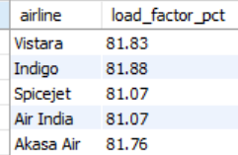  Load factor by airline
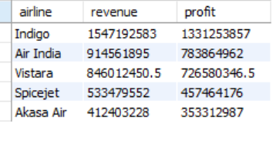  Revenue & profit (₹) | 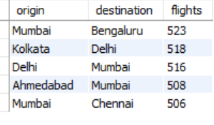  Top 5 busiest routes
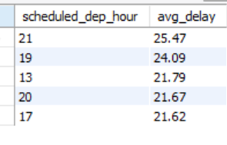  Worst departure hours | 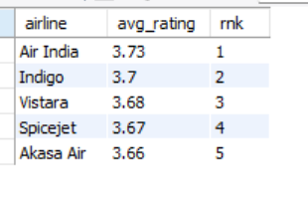  Customer rating by airline
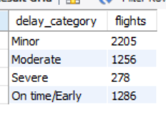  Delay categories | 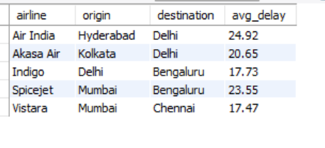  Most delayed route per airline
Recommendations
- Cut evening delays: add buffer time or extra ground crew for 7-9 PM departures.
- Weather plan: pre-plan rebooking and slot swaps for fog and storm days.
- Fix SpiceJet and weak routes: start with Hyderabad-Delhi (Air India) and Mumbai-Bengaluru (SpiceJet).
Prepared by Mohammed Rizwan | Tools: Python, MySQL, Power BI

