EXPERIMENT 4
Data Modelling and Form Design for a Business Application in Zoho Creator
Library Book Issue Request Form — Basic Fields Use Case

Submitted by
Mohammed Saajid Khan. M A
Register Number: 241401056

Aim
To design a data model and build a business application form in Zoho Creator for managing library book issue requests, and to demonstrate the creation of form fields, the linking of related forms, and the generation of report data from submitted records.

Procedure
1. Log in to Zoho Creator and create a new application titled “Library Book Issue Management”.
2. Create the first form, “Member Profile”, and add fields to capture member details such as Member Name, Register/Roll Number, Member Type, Email Address, Contact Number, and Hostel/Residential Address.
3. Create the second form, “Book Issue Request”, and establish a lookup relationship with the Member Profile form using the Member field so that member records can be linked to each book request.
4. Add the remaining fields to the Book Issue Request form, including Book Category, Subject Areas of Interest, Number of Copies, Purpose of Borrowing, Preferred Issue Date, Preferred Collection Time, Agree to Library Rules, Request Status, and Processed By.
5. Configure field properties in the form builder, such as field link names, choice values for radio/checkbox fields, mandatory validation, and data privacy (PII) settings.
6. Preview and fill out the Book_Issue_Request_Form with sample member and request data, and submit the form.
7. View the submitted record in the Book_Issue_Request_Form Report to verify that the data has been captured and stored correctly.

Data Model
The application uses two related forms. The Member Profile form stores the core identity and contact details of a library member, while the Book Issue Request form captures the details of each book request raised by a member. The two forms are connected through a lookup field (Member) in the Book Issue Request form, which references a record in the Member Profile form. This one-to-many relationship allows a single member to raise multiple book issue requests while keeping member information centralised and consistent.
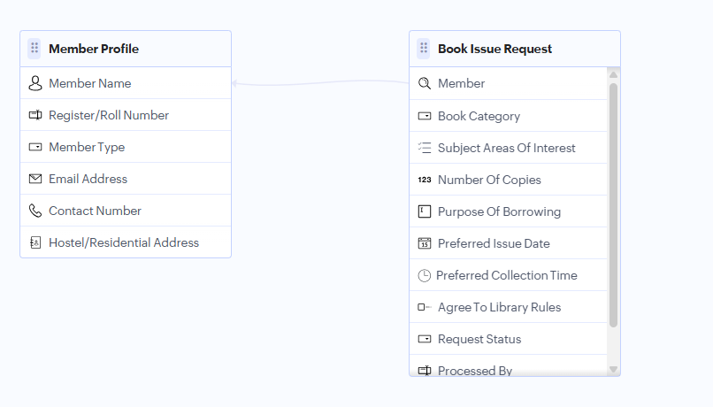
Fig. 1 — Data model showing the Member Profile and Book Issue Request forms and their lookup relationship
Form | Key Fields | Purpose
Member Profile | Member Name, Register/Roll Number, Member Type, Email Address, Contact Number, Hostel/Residential Address | Stores master data for each library member
Book Issue Request | Member (lookup), Book Category, Subject Areas Of Interest, Number Of Copies, Purpose Of Borrowing, Preferred Issue Date, Preferred Collection Time, Agree To Library Rules, Request Status, Processed By | Captures each book request linked to a member

Explanation of Screenshots
The following screenshots illustrate the complete workflow: configuring the input fields in the Zoho Creator form builder, the resulting live form as seen by a user, and the output data captured after submission.
1. Input — Zoho Form Creator Fields
The form builder view below shows the field palette on the left (Basic Fields such as Name, Email, Phone, Date, Radio, Checkbox, etc.) used to design the Book_Issue_Request_Form. The centre panel lists all the fields added to the form, including Member_Name, Register_Roll_Number, Member_Type, Contact_number, Hostel_Residential_Address, book_category, Subject_Areas_Of_Interest, Number_Of_Copies, Purpose_Of_Borrowing, Preferred_Issue_Date, Preferred_Collection_Time, and Agree_To_Library_Rules. The right panel shows the Field Properties for the selected Agree_To_Library_Rules field — its field link name, answer choices, validation (Mandatory), data privacy (PII), and visibility settings.
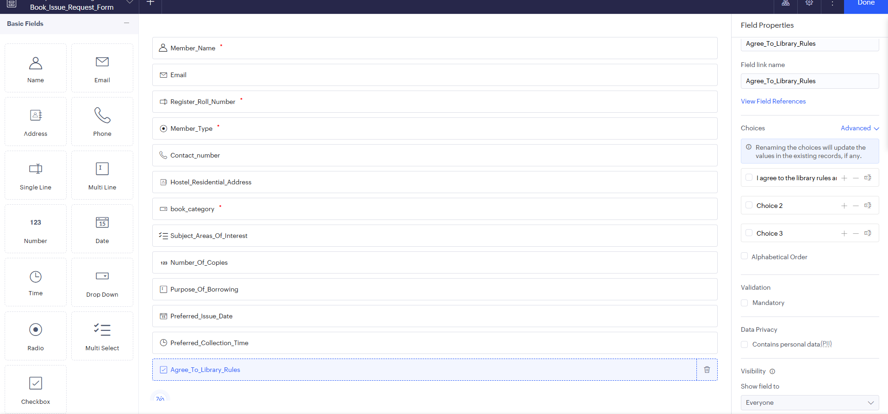
Fig. 2 — Zoho Creator form builder: field palette, form fields, and field properties panel
2. The Form
Once designed, the Book_Issue_Request_Form is filled out by an end user. The first part of the live form (Member Details and Contact Details) captures the member's name, register/roll number, member type (Student/Faculty/Staff), email, contact number, and hostel/residential address.
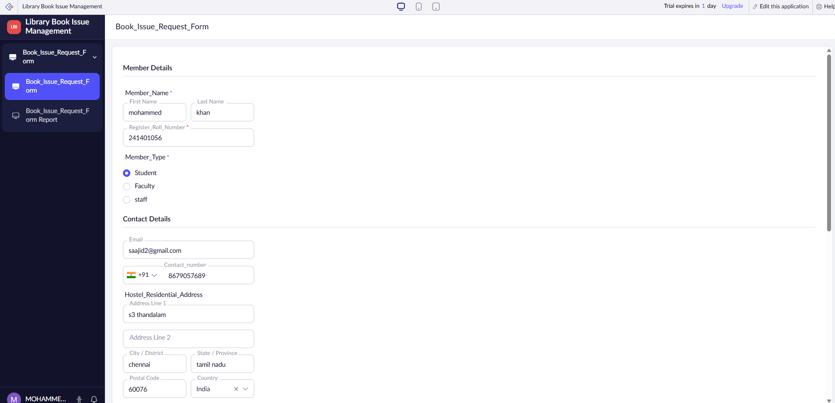
Fig. 3 — Book_Issue_Request_Form: Member Details and Contact Details sections
The second part of the form (Section and Scheduling & Acknowledgement) captures the book category, subject areas of interest, number of copies, purpose of borrowing, preferred issue date and collection time, and the member's acknowledgement of the library rules before submission.
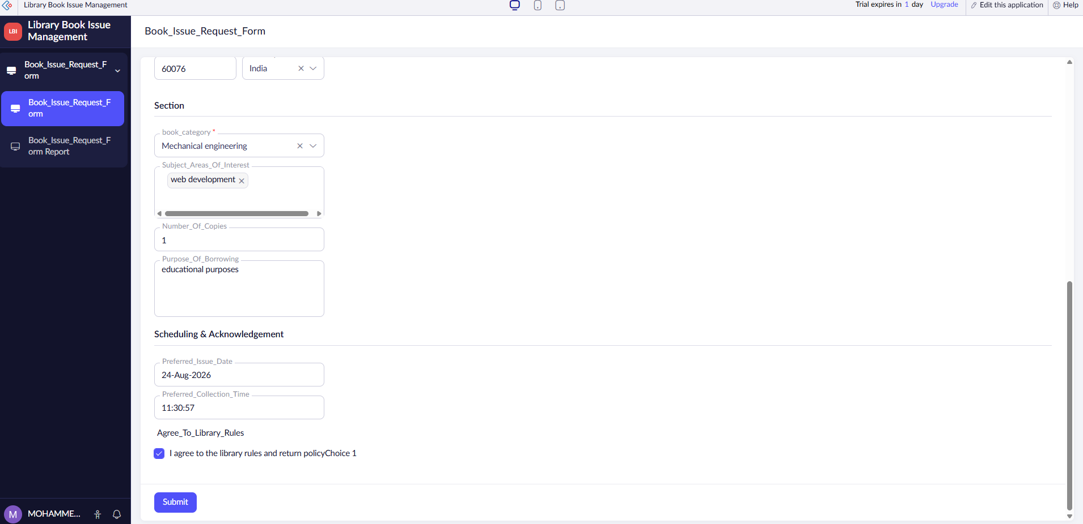
Fig. 4 — Book_Issue_Request_Form: Section and Scheduling & Acknowledgement, with Submit button
3. Output Data
After the form is submitted, the record appears in the Book_Issue_Request_Form Report, confirming that the data has been stored correctly in the application. The report below displays the submitted record for member “mohammed khan” (Register Number 241401056, Student), including email, contact number, hostel/residential address, and book category.
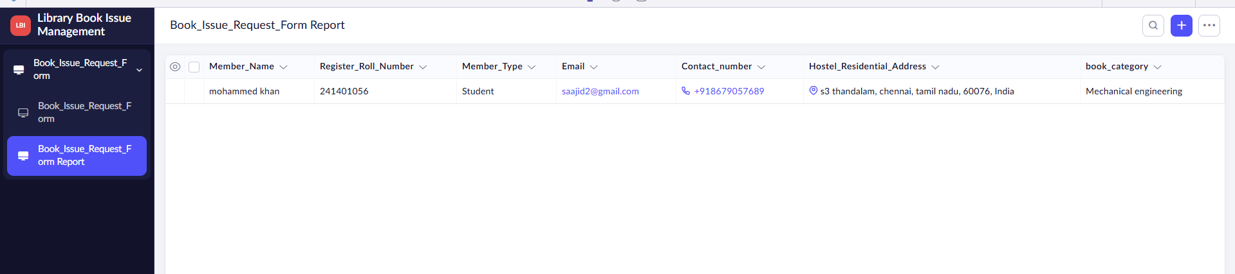
Fig. 5 — Book_Issue_Request_Form Report showing the submitted record

Result
A data model with two related forms, Member Profile and Book Issue Request, was successfully designed in Zoho Creator. The Book_Issue_Request_Form was built with appropriate field types and validations, tested by submitting sample data, and the submitted record was verified in the corresponding report, thereby demonstrating a working business application.

