SIMATS ENGINEERING (SAVEETHA SCHOOL OF ENGINEERING) Department of Computer Science and Engineering
CO1 ASSESSMENT TOOL 2 – Agile Sprint Planning & User Story Workshop
Course Code: | CSA10 / CSA1063 | Course Title: | Software Engineering
CO Assessed: | CO1 | Assessment: | Assessment Tool 2 Agile Sprint Planning & User Story Workshop
Weightage: | 20% | Total Marks: | 25
CO1 Statement: | Apply advanced methodologies and agile project management techniques to manage software projects effectively
Student Name: | Mohammed Shariff.G | Reg. No.: | 192425378
Date: | 27-07-2026 | Duration: | 60 minutes

Code of Conduct
I Mohammed Shariff.G/192425378 certify that this submission is my original work and that I have adhered to the guidelines specified for this assessment. I understand that any violation of academic integrity rules will result in disciplinary action. Signature of the Student:mohammedshariff

Annexure A – Agile Sprint Planning & User Story Workshop
1. Identify the Project Vision and Stakeholders
❖ Define the project's vision, objectives, and identify all key stakeholders involved. Project Vision
The Fraud Detection and Financial Transaction Monitoring System is designed to improve the security of digital financial transactions by identifying suspicious activities in real time using intelligent monitoring techniques. The system continuously analyzes transactions, detects unusual behavior, generates instant alerts, and supports financial institutions in preventing fraud before financial losses occur.
The project aims to provide a secure, reliable, scalable, and user-friendly platform that protects customers, improves regulatory compliance, and enhances trust in digital banking services. Project Objectives
• Detect fraudulent financial transactions in real time.
• Monitor customer transaction patterns continuously.
• Generate instant fraud alerts for suspicious activities.
• Reduce financial losses caused by fraudulent transactions.
Stakeholder | Roles and Responsibilities
Customers | Perform secure financial transactions and receive fraud alerts.
Bank Administrators | Manage users, monitor system performance, and configure security policies.
Fraud Investigation Team | Analyze suspicious transactions and verify fraud cases.
Bank Employees | Review flagged transactions and communicate with customers.
Financial Institutions | Use the system to reduce fraud risks and financial losses.
System Administrator | Maintain servers, databases, security, and backups.
Software Development Team | Design, develop, test, and maintain the application.
Government & Regulatory Authorities | Ensure compliance with financial regulations and audit requirements.

2. Create Epics and User Stories
❖ Break down the requirements into Epics and formulate well-structured User Stories using the format:
As a <user>, I want <feature>, so that <benefit>.
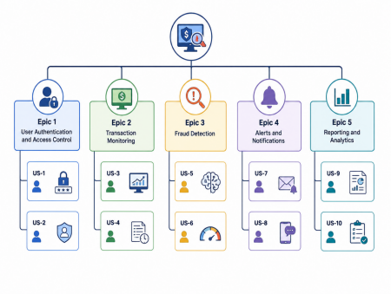Epic 1 – User Authentication & Secure Access
User Story 1
As a customer, I want to securely log into my account so that my financial information remains protected.
User Story 2
As a bank administrator, I want role-based access control so that only authorized users can access sensitive information.
Epic 2 – Transaction Monitoring
User Story 3
As the monitoring system, I want to continuously analyze financial transactions so that suspicious activities can be detected immediately.
User Story 4
As a bank employee, I want to monitor customer transactions so that abnormal activities can be identified quickly.
Epic 3 – Fraud Detection
User Story 5
As the fraud detection engine, I want to identify unusual transaction patterns so that fraudulent activities can be prevented.
User Story 6
As a fraud analyst, I want to review suspicious transactions so that I can determine whether fraud has occurred.
Epic 4 – Alert & Notification System
User Story 7
As a customer, I want to receive instant fraud alerts so that I can verify unauthorized transactions immediately.
User Story 8
As a bank administrator, I want to receive high-priority fraud notifications so that immediate action can be taken.
Epic 5 – Reporting & Analytics
User Story 9
As a bank manager, I want detailed fraud reports so that fraud trends can be analyzed. User Story 10
As an auditor, I want access to transaction logs so that compliance requirements can be verified. 3. Define Acceptance Criteria
❖ Write clear and measurable acceptance criteria for each selected user story using the Given–When–Then format or equivalent.
User Story 1
Given the customer has valid credentials
When the customer logs into the system
Then secure access should be granted.
User Story 3
Given a financial transaction is initiated
When the system analyzes the transaction
Then suspicious transactions should be flagged immediately.
User Story 5
Given abnormal transaction behavior is detected
When fraud rules are triggered
Then the transaction should be marked as suspicious.
User Story 7
Given a suspicious transaction is detected
When fraud is suspected
Then the customer should receive an instant notification.
4. Prioritize the Product Backlog
❖ Organize and prioritize the product backlog based on business value, customer needs, and project dependencies.
Priority | Product Backlog Item | Business Value
High | User Login & Authentication | Very High
High | Real-Time Transaction  Monitoring | Very High
High | Fraud Detection Engine | Very High
High | Fraud Alert Notification | High
Medium | Transaction History | Medium
Medium | Fraud Investigation | Medium
Medium | ^{Dashboard}Report Generation | Medium
Low | Data Analytics Dashboard | Low
Low | Audit Logs | Low
Low | System Settings | Low

Sprint Backlog (Sprint 1)
User Story | Development Tasks | User Story
Secure Login | Design login page, authentication, password encryption | Secure Login
Transaction Monitoring | Create transaction module, validate transactions | Transaction Monitoring
Fraud Detection | Implement fraud detection rules, risk calculation | Fraud Detection
Alert System | SMS/Email notifications, alert dashboard | Alert System
Transaction Database | Design database tables and transaction storage | Transaction Database

5. Plan the Sprint Backlog
❖ Select high-priority user stories for the first sprint and divide them into actionable development tasks.
User Story Story Points Justification
Secure Login 3 Simple authentication functionality
Transaction Monitoring 8 Continuous monitoring and validation require higher effort
Fraud Detection Engine 13 Complex business logic and fraud analysis
Alert Notification 5 Integration with notification services
Reporting Module 5 Report generation and visualization

Estimation Technique
Fibonacci Sequence (1, 2, 3, 5, 8, 13)
Reason:
➢ Industry-standard Agile estimation technique.
➢ Suitable for measuring development complexity.
➢ Helps estimate implementation effort accurately.
➢ Considers uncertainty and technical difficulty.
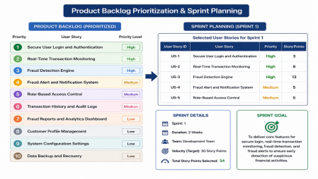6. Estimate Effort Using Story Points
❖ Assign story points to each selected user story using an appropriate estimation technique (e.g., Fibonacci sequence or Planning Poker) and justify your estimates.
➢ Secure User Login and Authentication – 3 Story Points
o Simple implementation of user login and password validation.
o Low complexity with basic security features.
➢ Role-Based Access Control – 5 Story Points
o Implementation of different user roles and permissions.
o Moderate complexity due to access restrictions.
➢ Real-Time Transaction Monitoring – 8 Story Points
o Continuous monitoring of financial transactions.
o Requires transaction validation and activity tracking.
o Higher complexity because of real-time processing.
➢ Fraud Detection Engine – 13 Story Points
o Detects suspicious transaction patterns.
o Calculates fraud risk scores.
o Most complex module due to fraud analysis logic and decision-making rules. ➢ Fraud Alert and Notification System – 5 Story Points
o Sends instant alerts for suspicious transactions.
o Supports notifications for customers and bank administrators.
➢ Fraud Reports and Analytics Dashboard – 8 Story Points
o Generates fraud reports and statistical summaries.
o Displays fraud trends and transaction analytics.
Justification for Story Point Estimation
➢ The Fibonacci sequence is widely used in Agile software development.
➢ It estimates the relative complexity of each user story rather than the actual development time.
➢ It helps prioritize high-value features during sprint planning.
➢ It improves workload distribution among team members.
➢ It considers implementation effort, technical complexity, uncertainty, and project risk.
7. Present the Sprint Goal and Expected Deliverables
❖ Define a clear sprint goal and describe the expected sprint deliverables, including the features to be completed at the end of the sprint.
Sprint Goal
The main goal of Sprint 1 is to develop the basic features of the Fraud Detection and Financial Transaction Monitoring System. During this sprint, the team will create a secure login system, monitor financial transactions, detect suspicious activities, and send fraud alerts to users. By the end of the sprint, the system should have a working prototype with the main functions.
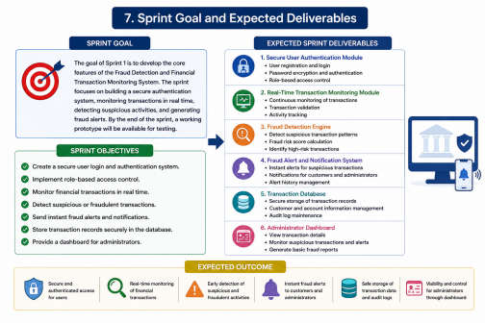
Sprint Objectives
• Create a secure user login system.
• Monitor financial transactions in real time.
• Detect suspicious or fraudulent transactions.
• Send alerts when fraud is detected.
• Store transaction details safely in the database.
• Provide a simple dashboard for administrators.
Expected Sprint Deliverables
At the end of Sprint 1, the following features will be completed:
• Secure user login and authentication.
• Role-based access for customers and administrators.
• Real-time transaction monitoring.
• Fraud detection for suspicious transactions.
• Instant fraud alert notifications.
• Secure storage of transaction records.

