SIMATS ENGINEERING (SAVEETHA SCHOOL OF ENGINEERING) Department of Computer Science and Engineering
CO2 ASSESSMENT TOOL 1 – Scenario-Based Requirement Analysis
Course Code: | CSA10 / CSA1063 | Course Title: | Software Engineering
CO Assessed: | CO2 | Assessment: | Assessment Tool 2 – Scenario-Based Requirement Analysis
Weightage: | 20% | Total Marks: | 25
CO2 Statement: | Perform detailed requirements analysis, design scalable architectures, and prioritize features with a focus on cross-disciplinary skills
Student Name: | G.MOHAMMED SHARIFF | Reg. No.: | 192425378
Date: | 03/08/2026 | Duration: | 60 minutes

Code of Conduct
I MOHAMMED SHARIFF/192425378 certify that this submission is my original work and that I have adhered to the guidelines specified for this assessment. I understand that any violation of academic integrity rules will result in disciplinary action. Signature of the Student: MOHAMMED SHARIFF

Annexure A – Scenario-Based Requirement Analysis
Study and Analyze the Scenario
1.1 Business Domain
The proposed system belongs to the Education domain and focuses on enhancing digital learning through Artificial Intelligence (AI). Traditional Learning Management Systems (LMS) provide standardized learning content to all students without considering individual learning abilities, preferences, or academic performance. The proposed AI-Based Learning Management System with Personalized Learning Recommendations aims to overcome these limitations by utilizing AI and Machine Learning techniques to analyze student behaviour, learning patterns, assessment results, and engagement levels. Based on this analysis, the system delivers personalized learning recommendations, enabling students to learn more effectively while assisting educators in monitoring progress and improving teaching strategies.
1.2 Problem Description
The rapid adoption of online education has significantly increased the use of Learning Management Systems; however, most existing platforms provide identical learning materials and assessments to every student regardless of their individual learning pace, strengths, or weaknesses. This one-size-fits-all approach often leads to reduced student engagement, lower academic performance, and inefficient learning experiences. Teachers also face challenges in continuously monitoring student progress and identifying learners who require additional academic support.
1.3 System Objectives
The primary objective of the proposed AI-Based Learning Management System is to develop an intelligent and adaptive educational platform that delivers personalized learning experiences while improving the overall efficiency of teaching and learning processes.
The specific objectives are:
• Develop an AI-driven Learning Management System that provides personalized learning recommendations for every student.
• Analyze student performance, learning behaviour, and engagement using Artificial Intelligence techniques.
• Recommend appropriate learning resources, quizzes, assignments, and study plans based on individual learning needs.
• Improve student academic performance through adaptive and personalized learning strategies. • Enable teachers to monitor student progress using real-time dashboards and learning analytics. • Automate routine academic activities such as assessment evaluation, recommendation generation, and progress tracking.
1.4 Existing Challenges
• Uniform learning content is delivered to all students regardless of their learning capabilities. • Lack of personalized recommendations based on academic performance.
• Limited real-time monitoring of student progress and engagement.
• Difficulty for teachers in identifying slow learners and providing timely intervention. • Manual evaluation and progress tracking increase faculty workload.
• Low student motivation due to non-adaptive learning environments.
• Limited use of educational data for intelligent decision-making.
• Poor scalability in handling increasing users and learning data.
1.5 Stakeholders
Students
Students are the primary users of the system. They access learning materials, receive AI-based recommendations, complete assessments, submit assignments, and monitor their academic progress through personalized dashboards.
Teachers/Faculty Members
Teachers create and manage courses, upload learning resources, conduct assessments, monitor student performance, and provide academic guidance using AI-generated insights.
Administrators
Administrators manage users, courses, permissions, reports, system configurations, and ensure smooth operation of the platform.
AI Recommendation Engine
The AI engine analyzes learning behaviour, academic performance, assessment results, and engagement data to generate personalized learning recommendations.
Institution Management
Institution management monitors overall academic performance, evaluates institutional outcomes, supports strategic decision-making, and ensures compliance with educational standards.
1. Identify Functional and Non-Functional Requirements
• List all functional requirements required by the proposed system.
• Identify suitable non-functional requirements such as performance, security, reliability, usability, scalability, maintainability, and availability.
2. Identify Actors and Use Cases
• Identify all primary and secondary actors interacting with the system.
• List the major use cases associated with each actor.
• Draw a Use Case Diagram representing the interactions between actors and the system.
3. Prepare the Software Requirement Specification (SRS)
Develop an SRS document containing:
• Introduction
• Problem Description
• Scope of the System
• Functional Requirements
• Non-Functional Requirements
• Use Case Descriptions
• Data Requirements
• External Interface Requirements
• System Features
4. Identify Assumptions and Constraints
• List the assumptions considered while developing the system.
• Identify technical, operational, economic, legal, and time-related constraints affecting the project.
5. Validate Requirement Completeness and Consistency
• Verify whether all stakeholder requirements have been addressed.
• Check for ambiguity, redundancy, inconsistency, and missing requirements. STUDY & ANALYZE
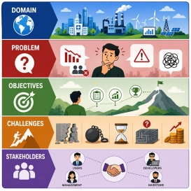
2. Identify Functional and Non-Functional Requirements
2.1 Functional Requirements
FR1. User Registration and Authentication
The system shall allow students, teachers, and administrators to register and securely log in using unique credentials.
FR2. User Profile Management
The system shall enable users to create, update, and manage their personal profiles, including academic information, learning preferences, contact details, and account settings.
FR3. Course Enrollment and Management
The system shall allow students to enroll in available courses while enabling teachers and administrators to create, update, assign, and organize course information efficiently.
FR4. Learning Content Management
Teachers shall be able to upload, modify, organize, and manage learning resources such as lecture notes, presentations, videos, assignments, and reference materials for students.
FR5. AI-Based Personalized Learning Recommendations
The system shall analyze students' learning behavior, and learning preferences using Artificial Intelligence to recommend personalized study materials, practice exercises, quizzes, and learning paths.
FR6. Assignment Submission and Evaluation
The system shall enable teachers to create assignments and students to submit them online. Teachers shall evaluate submissions, provide feedback, and publish grades through the platform.
FR7. Online Assessments and Quizzes
The system shall support online quizzes, examinations, automated grading for objective questions, result generation, and detailed performance analysis.
FR8. Progress Tracking and Performance Analytics
The system shall continuously monitor student attendance, assignment completion, quiz performance, course progress, and overall academic achievement through interactive dashboards and analytical reports.
FR9. Notifications and Alerts
The system shall automatically notify users about assignment deadlines, examination schedules, newly uploaded learning resources, AI recommendations, grades, and important announcements.
FR10. Dashboard and Report Generation
The system shall provide customized dashboards for students, teachers, and administrators along with graphical reports that support academic monitoring and informed decision-making.
FR11. User and Role Management
Administrators shall manage user accounts, assign roles and permissions, monitor system activities, and maintain institutional records through a centralized administration panel.
2.2 Non-Functional Requirements
Performance
The system shall provide fast response times, support multiple concurrent users, and process AI recommendations efficiently without affecting overall system performance.
Security
The system shall ensure secure authentication, role-based authorization, encrypted password storage, HTTPS communication, secure APIs, database encryption, audit logging, and regular security updates to protect sensitive educational information.
Reliability
system shall operate consistently with minimum downtime, provide accurate AI generated maintain data integrity, and ensure continuous availability of learning resources.
Availability
The platform shall be accessible 24×7 with high system uptime, automatic backup mechanisms, and disaster recovery strategies to ensure uninterrupted learning services.
Scalability
The system shall efficiently accommodate increasing numbers of students, teachers, courses, learning resources, and AI processing requirements without significant degradation in performance.
Maintainability
The software shall follow modular architecture, coding standards, proper documentation, reusable components, and simplified maintenance practices to support future enhancements and bug fixes.
Usability
The system shall provide an intuitive, responsive, and user-friendly interface that enables users with different technical skill levels to easily access learning resources and system features.
Compatibility
The platform shall be compatible with multiple operating systems, modern web browsers, tablets, and mobile devices to ensure seamless accessibility across different platforms.
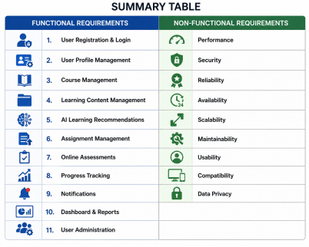
3. Identify Actors and Use Cases
3.1 Primary Actors
1. Student
The student is the primary user of the system. Students register, log in, enroll in courses, access learning materials, receive AI-based learning recommendations, submit assignments, take quizzes, and monitor their academic progress.
2. Teacher
Teachers create and manage courses, upload learning resources, conduct assessments, evaluate assignments, monitor student performance through dashboards, and provide personalized academic guidance.
3. Administrator
The administrator manages user accounts, assigns roles and permissions, maintains courses, generates reports, monitors system performance, and ensures secure and smooth operation of the platform.
3.2 Secondary Actors
1. AI Recommendation Engine
Analyzes student learning behavior, assessment results, and progress to generate personalized learning recommendations.
2. Database Server
Stores and retrieves user information, course content, assessments, grades, recommendations, and reports securely.
3. Email/Notification Service
Sends notifications regarding assignments, quizzes, announcements, deadlines, grades, and personalized learning recommendations.
3.3 Major Use Cases
UC1. User Registration
Allows new users to create an account by providing the required information.
UC2. User Login
Authenticates users and grants secure access according to their assigned roles.
UC3. Manage Courses
Allows teachers and administrators to create, update, and organize courses and learning materials.
UC4. AI Personalized Recommendations
Analyzes student performance and recommends suitable learning resources, quizzes, and study plans.
UC5. Submit Assignments
Allows students to submit assignments online while teachers evaluate and provide feedback.
UC6. Online Assessment
Enables students to attend quizzes and examinations, with automatic evaluation where applicable.
UC7. Track Progress
Displays academic performance, learning progress, attendance, and AI-generated insights through dashboards.
UC8. Generate Reports
Generates academic reports, performance analytics, and administrative reports for teachers and administrators.

Actor | Main Use Cases
Student | Register, Login, View Courses, Receive AI Recommendations, Submit Assignments, Take Quizzes, View Progress
Teacher | Manage Courses, Upload Materials, Evaluate Assignments, Monitor Student Progress, Generate Reports
Administrator | Manage Users, Manage Courses, Generate Reports, Maintain System
AI  Recommendation Engine | Analyze Learning Data, Generate Personalized Recommendations
Database Server | Store and Retrieve System Data
Notification Service | Send Alerts, Assignment Reminders, Grades, and Announcements

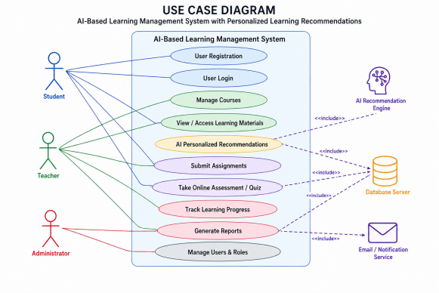
4. Software Requirement Specification (SRS)
4.1 Introduction
Purpose
The purpose of the proposed AI-Based Learning Management System with Personalized Learning Recommendations is to develop an intelligent educational platform that enhances teaching and learning through Artificial Intelligence. The system provides personalized learning recommendations based on students' academic performance, learning behavior, and preferences while supporting teachers and administrators with efficient course management, assessments, and analytical reporting.
Scope
The proposed system supports students, teachers, and administrators throughout the learning process. It enables user authentication, course management, online learning, AI-based recommendations, assessments, assignment submission, progress tracking, report generation, and administrative management through a secure and scalable web-based platform.
Intended Users
• Students
• Teachers/Faculty Members
• Administrators
• Institution Management
4.2 Problem Description
Traditional Learning Management Systems provide identical learning resources to all students regardless of their learning abilities and academic performance. They lack intelligent mechanisms for personalized learning, resulting in lower engagement, ineffective learning experiences, and difficulty for teachers in monitoring student progress.
4.3 Scope of the System
The proposed system covers the complete digital learning process, including student registration, course enrollment, learning content management, AI-based personalized recommendations, online assessments, assignment submission, progress monitoring, report generation, and user administration. The platform is designed to support secure, scalable, and efficient educational services for institutions of different sizes.
4.4 Functional Requirements
Requirement ID | Functional Requirement
FR1 | User Registration and Authentication
FR2 | User Profile Management
FR3 | Course Enrollment and Management
FR4 | Learning Content Management
FR5 | AI-Based Personalized Learning Recommendations
FR6 | Assignment Submission and Evaluation
FR7 | Online Assessments and Quizzes
FR8 | Progress Tracking and Analytics
FR9 | Notifications and Alerts
FR10 | Dashboard and Report Generation
FR11 | User and Role Management

4.5 Non-Functional Requirements
Requirement | Description
Performance | Fast response time and efficient processing
Security | Secure authentication, encryption, RBAC
Reliability | High availability with minimal downtime
Scalability | Supports increasing users and data
Maintainability | Modular and easy to update
Usability | Simple and user-friendly interface
Compatibility | Works on web and mobile platforms
Availability | 24×7 system access
Data Privacy | Protects confidential educational information

4.6 Use Case Descriptions
UC1 – User Login
Actor: Student, Teacher, Administrator
Description: Allows users to securely access the system using valid credentials. Precondition: User account exists.
Postcondition: User is redirected to the respective dashboard.
UC2 – Course Management
Actor: Teacher, Administrator
Description: Create, update, assign, and organize courses and learning materials. Precondition: User has management privileges.
Postcondition: Course information is updated.
UC3 – AI Personalized Recommendation
Actor: Student
Description: AI analyzes learning behavior and recommends personalized learning resources. Precondition: Student has learning history.
Postcondition: Personalized recommendations are displayed.
UC4 – Online Assessment
Actor: Student, Teacher
Description: Students attend quizzes while teachers create and evaluate assessments. Precondition: Assessment is available.
Postcondition: Results are stored and displayed.
UC5 – Progress Monitoring
Actor: Student, Teacher
Description: Displays academic progress, attendance, assignment completion, and AI insights. Precondition: Student activity exists.
Postcondition: Progress dashboard is updated.
UC6 – Report Generation
Actor: Administrator, Teacher
Description: Generates academic reports and performance analytics.
Precondition: Required data is available.
Postcondition: Reports are generated successfully.
4.7 Data Requirements
Student Information
• Student ID
• Name
• Email
• Learning Preferences
• Course Enrollment
• Academic Performance
Teacher Information
• Teacher ID
• Department
• Courses
• Learning Resources
Course Information
• Course ID
• Course Name
• Syllabus
• Learning Materials
Assessment Data
• Quiz Results
• Assignment Marks
• Attendance
• Performance Reports
AI Recommendation Data
• Learning Pattern
• Recommendation History
• Performance Analysis
4.8 External Interface Requirements User Interface
Responsive web-based interface with dashboards for students, teachers, and administrators.
Hardware Interface
Desktop, Laptop, Tablet, Smartphone.
Software Interface
• Web Browser
• Database Server
• AI Recommendation Engine
• Email Notification Service
Communication Interface
HTTPS, Secure APIs, Internet Connectivity.
4.9 System Features
• Secure User Authentication
• AI-Based Personalized Learning
• Course Management
• Learning Content Management
• Assignment Submission
• Online Assessment
• Progress Tracking
• Performance Analytics
• Dashboard Management
• Report Generation
• Notification System
• User & Role Management
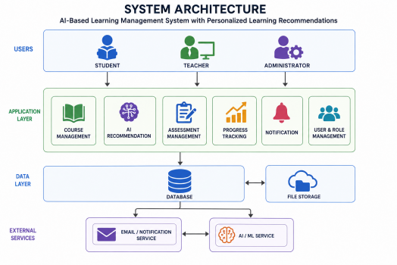
5. Identify Assumptions and Constraints
5.1 Assumptions
A1. Internet Connectivity
It is assumed that all users have a stable internet connection to access the AI-Based Learning Management System.
A2. Registered Users
It is assumed that students, teachers, and administrators have valid accounts with appropriate role-based permissions.
A3. AI Model Availability
It is assumed that the AI recommendation engine is properly trained using historical learning data to generate accurate personalized recommendations.
A4. Cloud Database Availability
It is assumed that the database server is continuously available for secure storage and retrieval of academic information.
A5. Device Compatibility
It is assumed that users access the system using devices such as desktops, laptops, tablets, or smartphones with modern web browsers.
A6. Learning Data Availability
It is assumed that sufficient student learning activities, assessment scores, and interaction data are available for the AI model to perform effective analysis.
A7. Institutional Support
It is assumed that the educational institution provides the necessary infrastructure, technical support, and policies for successful implementation.
5.2 Constraints
Technical Constraints
• Requires reliable internet connectivity.
• Depends on AI model accuracy and quality of training data.
• Limited by server capacity, storage, and processing power.
• Requires compatibility with multiple browsers and operating systems.
Operational Constraints
• Teachers and students require training to use the system effectively.
• Regular maintenance is necessary for smooth operation.
• User adoption may vary across different institutions.
Economic Constraints
• Development, deployment, cloud hosting, AI infrastructure, and maintenance involve significant costs.
• Periodic software upgrades and licensing may increase operational expenses. Legal Constraints
• The system must comply with educational data privacy regulations.
• Student information must remain confidential and securely stored.
• Copyright and intellectual property laws must be followed for learning resources. Time Constraints
• The project must be completed within the allocated development schedule. • Testing, AI model training, deployment, and user training should be completed before implementation.
Resource Constraints
• Availability of skilled software developers, AI engineers, testers, and project managers may affect development timelines.

Assumptions | Constraints
Internet Availability | Technical Constraints
Registered Users | Operational Constraints
AI Model Availability | Economic Constraints
Cloud Database | Legal Constraints
Device Compatibility | Time Constraints
Learning Data Availability | Resource Constraints
Institutional Support | Infrastructure Limitations

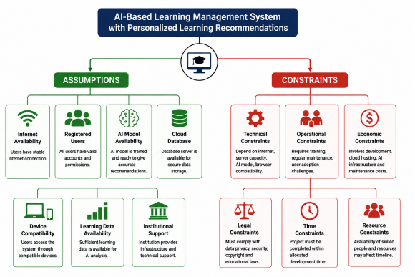
6. Validate Requirement Completeness and Consistency
6.1 Requirement Completeness
The proposed AI-Based Learning Management System satisfies the major functional and non-functional requirements identified during requirement analysis. The system includes comprehensive features such as user authentication, course management, AI-based personalized learning recommendations, assignment management, online assessments, progress tracking, reporting, notifications, and administrative control. These requirements collectively address the needs of students, teachers, administrators, and institution management while supporting the overall objectives of the system.
6.2 Requirement Consistency
The identified requirements are consistent with the project objectives and do not conflict with one another. Each functional requirement supports a specific business process, while the non-functional requirements ensure system quality, security, scalability, reliability, and usability. The requirements collectively contribute to developing a secure, efficient, and intelligent learning management platform.
6.3 Ambiguity Analysis
The requirements have been defined using clear and precise language to minimize ambiguity. Each requirement specifies a distinct system function or quality attribute, ensuring that developers, testers, and stakeholders have a common understanding of the expected system behavior. Clear terminology reduces misunderstandings during system development and testing.
6.4 Redundancy Analysis
The requirement specification has been reviewed to eliminate duplicate or overlapping requirements. Similar functionalities have been consolidated into single well-defined requirements, improving readability, maintainability, and implementation efficiency while reducing development complexity.
6.5 Missing Requirements
Although the proposed requirements cover the core functionalities of the system, several advanced features can be considered for future implementation:
• AI-powered chatbot for academic assistance.
• Predictive analytics for identifying at-risk students.
• Mobile application support for Android and iOS.
6.6 Suggested Improvements
• Improve AI recommendation accuracy using advanced machine learning models. • Integrate learning analytics for better academic decision-making.
• Enhance system security using multi-factor authentication and advanced encryption. • Implement cloud-based auto-scaling to improve performance during peak usage.
Summary Table
Validation Aspect | Result
Requirement  Completeness | All major functional and non-functional requirements are covered.
 | Requirement Consistency Requirements are consistent with system objectives and stakeholder needs.
Ambiguity Analysis | Requirements are clearly defined with minimal ambiguity.
Redundancy Analysis | Duplicate requirements have been eliminated.
Missing Requirements | Advanced AI features, mobile support, and third-party integrations can be added.
 | Suggested Improvements Enhance AI accuracy, security, scalability, analytics, and user experience.

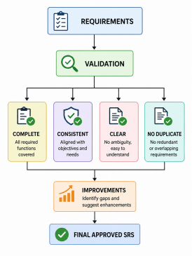
Rubrics for Calculation
Criteria | Excellent (4 Marks) | Good (3 Marks) | Satisfactory (2 Marks) | Needs  Improvement (1 Mark)
Scenario  Understanding and Problem  Analysis (30%) | Demonstrates  thorough  understanding of the scenario, stakeholders, objectives, and  business context with clear analysis. | Demonstrates good understanding with minor omissions. | Basic  understanding with limited  analysis. | Poor  understanding; major aspects  missing or  incorrect.
Functional and Non-Functional Requirement Identification (25%) | Clearly identifies  comprehensive,  accurate, and well  classified functional and non-functional requirements. | Identifies most  requirements with minor classification errors. | Identifies only basic  requirements;  several  omissions. | Requirements are incomplete, inaccurate, or  poorly classified.
Actor  Identification and Use Case Modelling  (20%) | Correctly identifies all relevant actors and use cases; use case  diagram is complete, accurate, and follows UML standards. | Most actors and use cases identified; diagram has minor errors. | Limited actors/ use cases  identified;  diagram partially correct. | Actors/use cases missing or  incorrect;  diagram absent or inaccurate.
Software  Requirement Specification  (SRS)  Documentation (15%) | SRS is well-structured, complete,  professionally  organized, and  includes all required sections. | SRS is organized with minor missing sections or  formatting issues. | SRS includes  only essential  sections with  limited detail. | SRS is  incomplete,  poorly  organized, or  lacks essential components.
Assumptions, Constraints,  and  Requirement Validation  (10%) | Clearly identifies  realistic assumptions and constraints;  validates requirements for completeness,  consistency, and  ambiguity with  appropriate  justification. | Identifies most  assumptions and constraints;  validation is  adequate. | Limited  assumptions/  constraints;  validation is  superficial. | Assumptions,  constraints, and validation are  missing or  incorrect.

Criteria | Mark
Scenario Understanding and Problem Analysis (30%) | /5
Functional and Non-Functional Requirement Identification (25%) | /5
Actor Identification and Use Case Modelling (20%) | /5
Software Requirement Specification (SRS) Documentation (15%) | /5
Assumptions, Constraints, and Requirement Validation (10%) | /5
TOTAL | /25

