HUMAN FOLLOWING ROBOT

November 2023

## Abstract

The integration of robotics and automation has been a pivotal advancement in various fields, offering solutions to enhance efficiency and convenience. This project presents the design and implementation of a Human Following Robot (HFR) utilizing ultrasonic and IR sensors, an Arduino microcontroller, motor drive, and a four-wheel drive system. The primary objective is to create an intelligent and adaptive robot capable of autonomously tracking and following a human target in real-time.

The core components include ultrasonic sensors for obstacle detection and avoidance, IR sensors for precise human tracking, and an Arduino microcontroller to process sensory input and control the robot's movements. The motor drive system, coupled with four wheels, ensures smooth and dynamic locomotion, allowing the robot to navigate diverse environments seamlessly.

The ultrasonic sensors are strategically positioned to detect obstacles in the robot's path, prompting the robot to adjust its trajectory to avoid collisions. Simultaneously, IR sensors are employed to identify and track a human target, ensuring accurate and responsive following behaviour.

The control algorithm integrates sensor data to make informed decisions about the robot's movement, balancing the need for efficient following with obstacle avoidance. The Arduino microcontroller processes this data in real-time, orchestrating the motor drive system to execute precise manoeuvres.

This HFR project contributes to the realm of autonomous robotics, showcasing the practical application of sensor fusion and control systems. The adaptability and intelligence of the robot make it suitable for various scenarios, such as indoor navigation or assistance in crowded environments. The successful implementation of this project demonstrates the potential of integrating multiple sensors and control mechanisms to achieve sophisticated robotic behaviour in a real-world setting.

## Introduction

In recent years, the integration of robotics and automation has played a transformative role in various industries, ranging from manufacturing to healthcare. Autonomous robots, equipped with advanced sensors and intelligent control systems, are increasingly being developed to perform diverse tasks, contributing to increased efficiency and convenience. This project focuses on the creation of a Human Following Robot (HFR) that combines ultrasonic and infrared (IR) sensors, an Arduino microcontroller, motor drive, and a four-wheel drive system to enable autonomous tracking and following of a human target.

The concept of a Human Following Robot holds significant potential for applications in crowded environments, security surveillance, and assistance to individuals with mobility challenges. By utilizing a combination of sensors, the robot can intelligently navigate its surroundings, avoiding obstacles while maintaining close proximity to a designated human target.

The key components of the project include ultrasonic sensors for obstacle detection, IR sensors for precise human tracking, an Arduino microcontroller for real-time data processing, and a motor drive system with four wheels to facilitate dynamic movement. The integration of these technologies allows the robot to respond adaptively to its environment, providing a sophisticated and practical solution to the challenge of human following in real-world scenarios.

This introduction sets the stage for understanding the significance of the HFR project in the context of autonomous robotics. As technology continues to advance, the development of intelligent robots capable of human interaction and assistance becomes increasingly relevant. The subsequent sections will delve into the specific components, design considerations, and implementation details of the Human Following Robot, offering insights into the engineering and innovation behind this exciting project.

## System design

The design of the Human Following Robot (HFR) involves the integration of several key components, including sensors, a microcontroller, a motor drive system, and wheels. Each component plays a crucial role in enabling the robot to autonomously follow a human target while navigating its environment intelligently.

### Design Specifications

### Microcontroller

**Arduino Microcontroller:**

* **Purpose:** Central processing unit for sensor data and motor control.
* **Functionality:** The Arduino board receives input from ultrasonic and IR sensors, processes the data, and determines the robot's movements. It sends commands to the motor drive system based on the tracked human target and obstacle information.

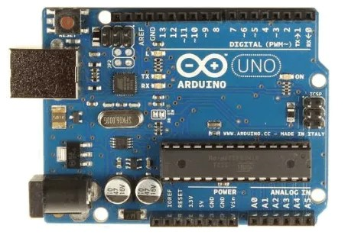

Figure 1: Arduino UNO

**2. Infrared (IR) Sensors:**

* **Purpose:** Human target detection and tracking.
* **Placement:** Front-facing to focus on the target.
* **Functionality:** IR sensors detect infrared radiation emitted by the human body. The robot processes the sensor data to identify and track the human target.

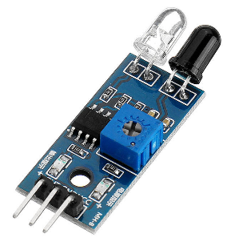

Figure 2: IR Sensor

**3. Ultrasonic sensors:**

* **Purpose:** Obstacle detection and avoidance.
* **Placement:** Positioned on the front, sides, and possibly the rear of the robot.
* **Functionality:** Ultrasonic sensors emit sound waves and measure the time it takes for the waves to bounce back. By calculating the distance between obstacles, the robot can adjust its path to avoid collisions.

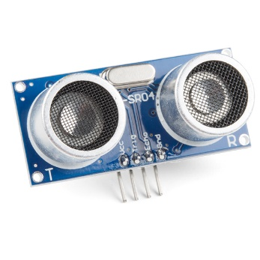

Figure 3: Servo Motor

**4. Motor Drive System:**

* **Purpose:** Drives the movement of the robot.
* **Configuration:** Four-wheel drive system for stability and maneuverability.
* 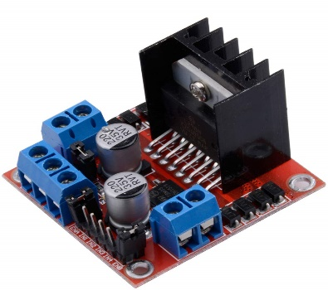**Functionality:** The motor drive system interprets commands from the Arduino to control the speed and direction of the robot. It allows precise and dynamic movements, enabling the robot to follow a human target smoothly.

Figure 4: Motor drive

**5. Power supply:**

* **Source:** Battery or external power supply.
* **Considerations:** Ensure an adequate power supply to support continuous operation and movement. The power supply should be lightweight and portable.

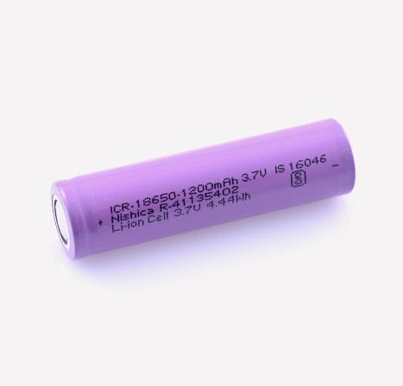

Figure 5: Battery

### Implemented Code

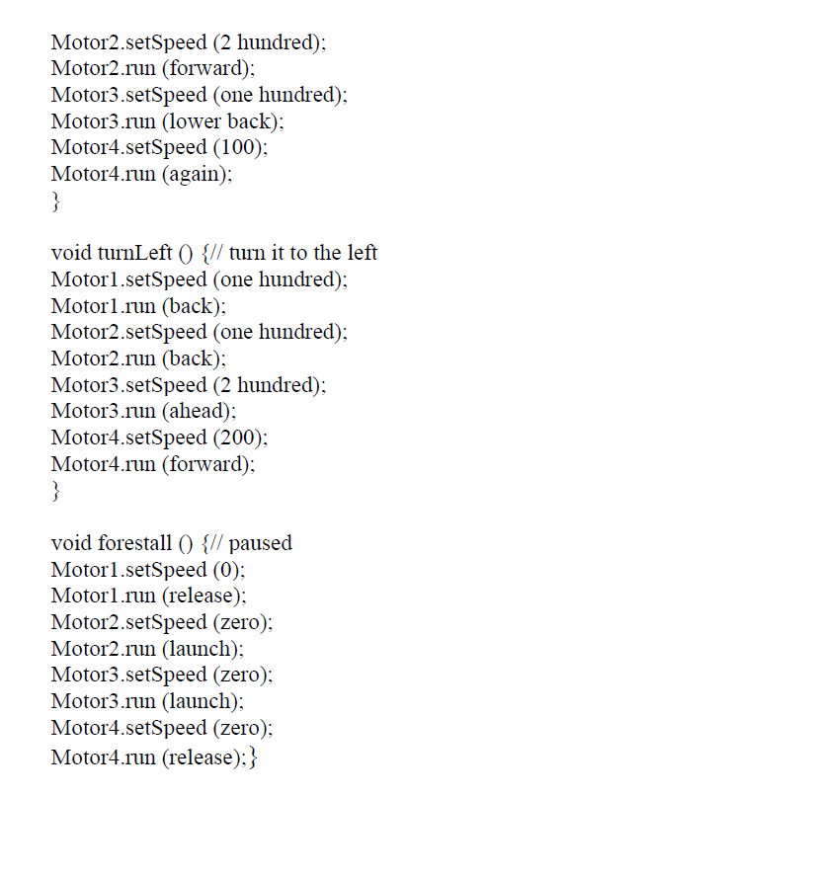

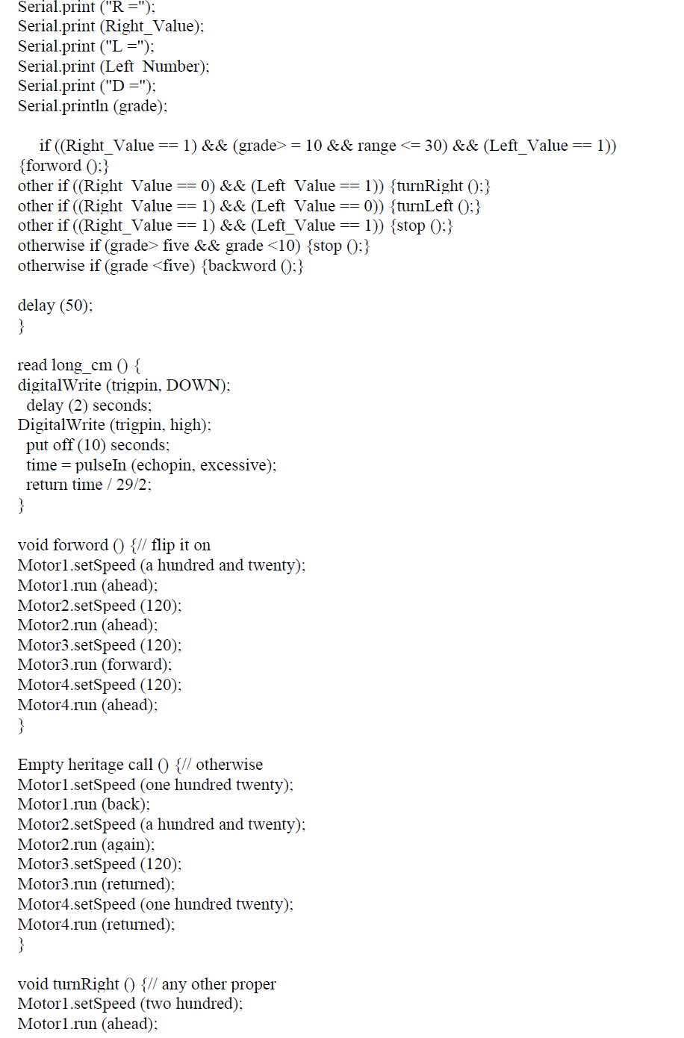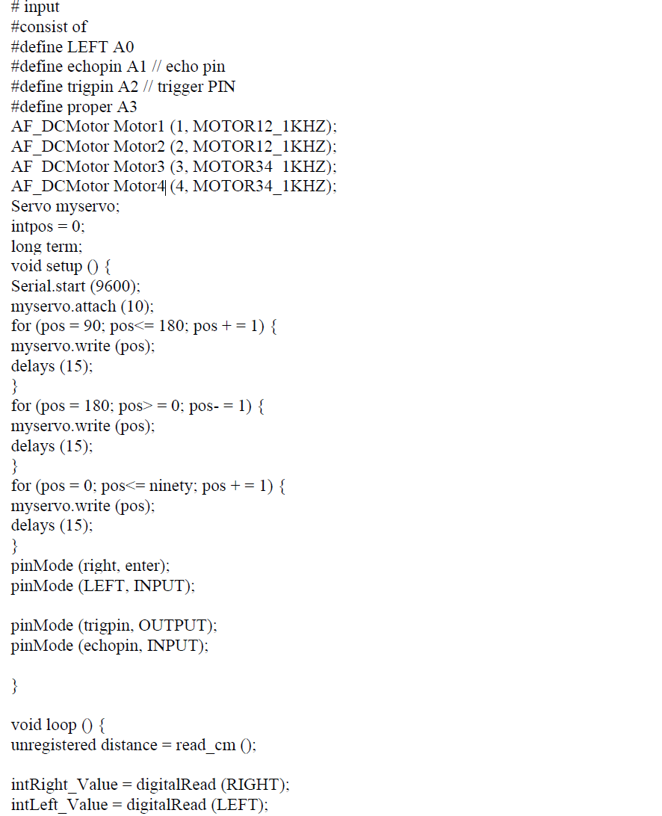

# RESULTS

The Human-Following Robot project aimed to create a mobile robot capable of autonomously detecting and following a human target using an Arduino microcontroller, ultrasonic sensor, IR sensor, motor drive, and a four-wheeled chassis. The successful completion of the project involved the integration of various hardware components, development of control algorithms, and thorough testing.

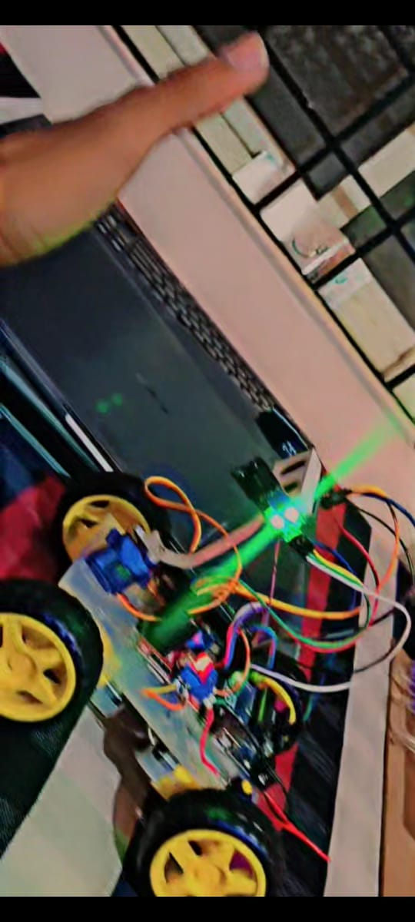 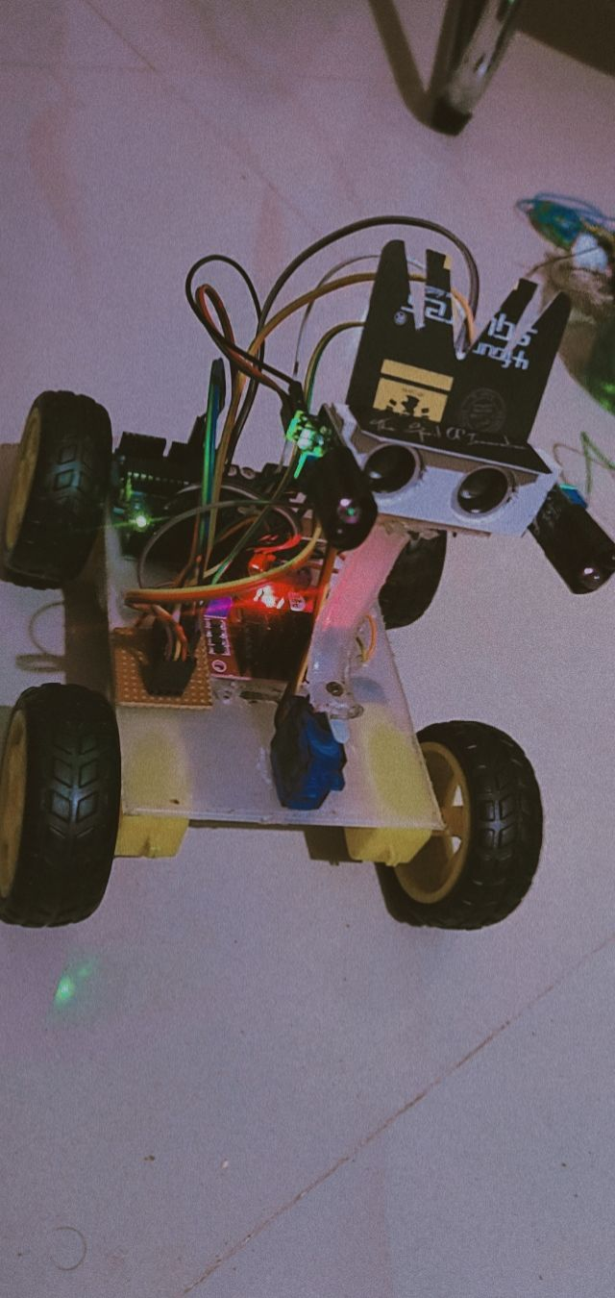

(a) (b)

Figure 8: (a)Open function, (b)Moving function

# CONCLUSION

The successful implementation of the prototype of the human robotic following is illustrated on this paper. This robotic has no longer only the capacity to discover but additionally the next ability. Throughout the prototype it was additionally saved in thoughts that the operation of the robotic need to be as a success as possible.

Assessments are completed in special conditions to discover errors inside the set of rules and to correct them.

The distinct sensors related to the robot supplied extra gain. A human-based robot is a automobile system this is capable of stumble on, circulate, and trade the robot's position at the problem inside the best manner to stay in its path. This project makes use of Arduino, an engine of different varieties of sensors to attain its aim.

The venture challenged the group to collaborate, connect, and growth know-how of electrical device, machinery systems, and their integration with systems.

Robots designed to track a person the usage of an Arduino microcontroller. It could comply with someone.

# REFERENCES

[1]. K. Morioka, J.-H. Lee, and H. Hashimoto, "A human-based mobile robot with a distributed sensor network," IEEE Trans. Electron., Vol. 51, nxa. 1, pp. 229-237, Feb. 2004.

[2]. Y. Matsumoto and A. Zelinsky, "A real-time face-to-face robot interaction system," 1999 IEEE International Conference on Systems, Man, and Cybernetics, 1999. IEEE SMC '99 Conference Proceedings, 1999, vol. 2, pages 830-835 volume.2.

[3]. T. Yoshimi, M. Nishiyama, T. Sonoura, H. Nakamoto, S. Tokura, H. Sato, F. Ozaki, N. Matsuhira, and H. Mizoguchi, “Vision Based Target Detection Detection Development,” 2006 IEEE / RSJ International Conference on Intelligent Robots and Systems, 2006, pp. 5286–5291.

[4]. H. Takemura, N. Zentaro, and H. Mizoguchi, “Human development based on the idea of following the cellular robots module within / outside the departmental environment,” 2009 IEEE International Conference on Robotics and Biomimetics (ROBIO), 2009, pp.

[5]. Muhammad Sarmad Hassan, MafazWali Khan, Ali Fahim Khan, “Design and Development of a Human Traffic”, 2015, Student Research Paper Conference, Vol-2, No-15.

[6]. N. Bellotto and H. Hu, "Multisensor integration of human robot interactions," IEEE J. Intell. Cybern.Syst., Vol. 1, no. 1, p. 1, 2005.