Project Design Phase-II
Data Flow Diagram & User Stories

Date | 1 November 2026
Team ID | Mohammed Sukhawala
Project Name | Global Olympic Sports Performance Analysis
Maximum Marks | 4 Marks

Data Flow Diagrams:
A Data Flow Diagram (DFD) is a traditional visual representation of the information flows within a system. A neat and clear DFD can depict the right amount of the system requirement graphically. It shows how data enters and leaves the system, what changes the information, and where data is stored.
DFD Symbol Legend
Symbol | Name | Description
Oval / Rounded  shape | External Entity | A person, organization, or system outside the project that sends or receives data (e.g., Customer, Payment Gateway).
Rectangle with  numbered header | Process | An activity that transforms incoming data into outgoing data (e.g., Validate Request, Process Order).
Rectangle (solid fill, no number) | Data Store | A place where data is held for later use (e.g., Customer Database, Inventory).
Labeled arrow | Data Flow | The movement of data between entities, processes, and data stores, labeled with what data is being passed.

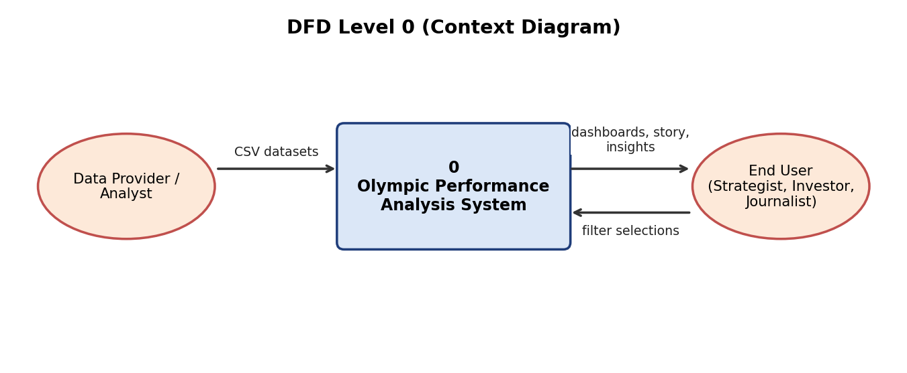

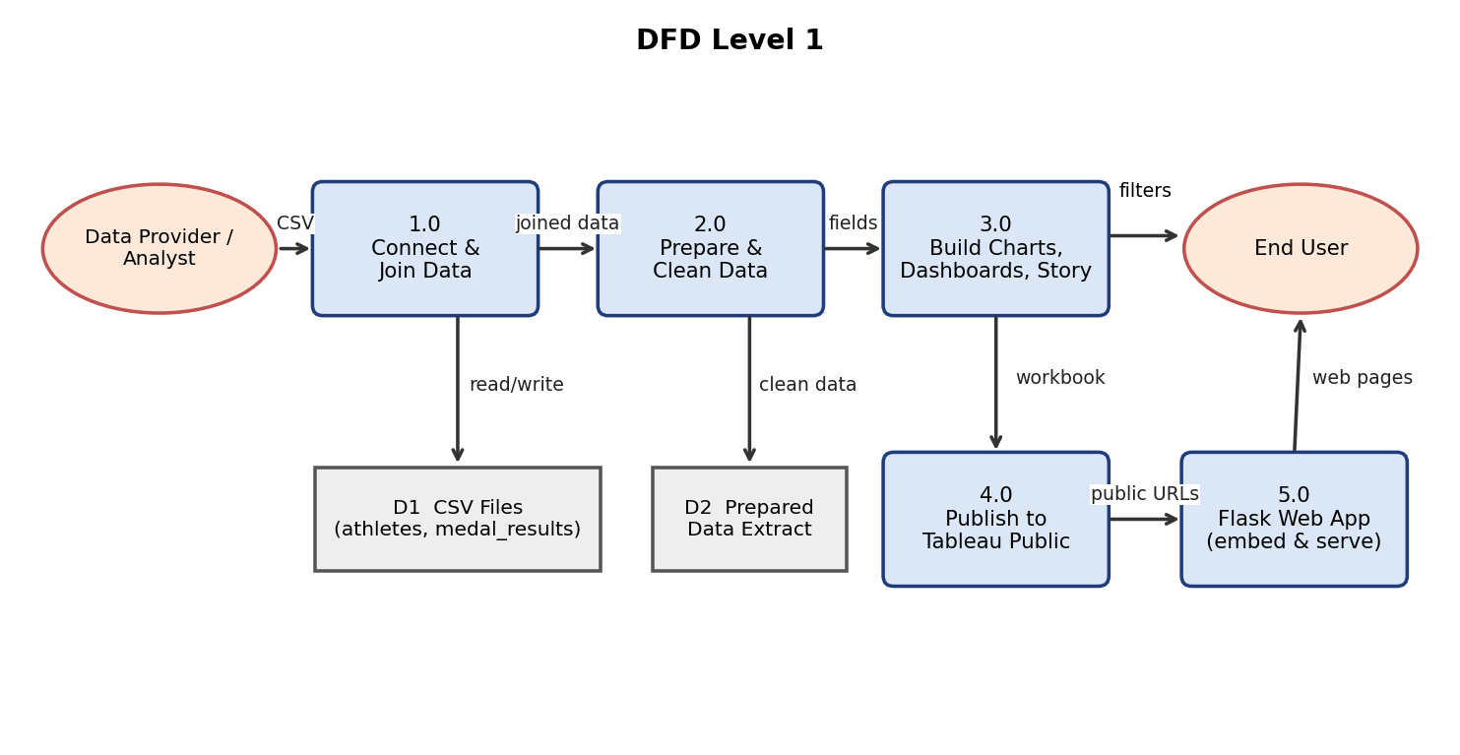
Figure: DFD Level 0 (above) and Level 1 (below) for the Olympic Performance Analysis system. D1 and D2 are data stores.

User Stories
Use the below template to list all the user stories for the product.
User Type | Functional Requirement (Epic) | User Story Number | User Story / Task | Acceptance criteria | Priority | Release
Sports Strategist (Priya) | Medal Performance Analysis | USN-1 | As a strategist, I can view the total medals of every country in a bar chart so I can compare my country with top performers. | Chart shows all 60 countries sorted by medals; labels are visible | High | Sprint-1
Sports Strategist (Priya) | Medal Performance Analysis | USN-2 | As a strategist, I can see average medals per athlete by sport category so I can choose where to invest. | All 10 sport categories appear sorted from highest to lowest | High | Sprint-2
Investment Analyst (Carlos) | Investment Efficiency | USN-3 | As an analyst, I can view investment against medals for each country so I can find over-performers. | Bubble chart shows each country with investment, medals and region colour | High | Sprint-2
Investment Analyst (Carlos) | Regional Analysis | USN-4 | As an analyst, I can see the medal share of each region so I can guide grant distribution. | Pie chart shows 5 regions with medal totals | Medium | Sprint-2
Data Journalist (William) | Trend Analysis | USN-5 | As a journalist, I can see total medals for every Games from 1992 to 2026 so I can describe how totals changed. | Chart shows 18 Games coloured by Summer and Winter | High | Sprint-1
Data Journalist (William) | Story Telling | USN-6 | As a journalist, I can step through a 6-scene Tableau Story so I can explain the findings to viewers. | Story has 6 scenes with a caption on each | Medium | Sprint-3
All users | Filtering | USN-7 | As a user, I can filter dashboards by Season so I can compare Summer and Winter Games. | Charts update when Summer or Winter is selected | High | Sprint-2
All users | Filtering | USN-8 | As a user, I can filter the regional dashboard by Region so I can focus on one region. | Charts update when a region is chosen | Medium | Sprint-2
All users | Dashboards | USN-9 | As a user, I can click a bar or bubble and see the other charts update. | Use as Filter works between charts on a dashboard | Medium | Sprint-2
Web user | Web Access | USN-10 | As a web user, I can open the home page and use the menu to go to each dashboard and the story. | Menu links Home, Dashboard 1, Dashboard 2 and Story work | High | Sprint-3
Web user | Web Access | USN-11 | As a web user, I can view the embedded Tableau dashboards inside the Flask website without signing in. | Embedded views load on /dashboard1, /dashboard2 and /story | High | Sprint-3
Administrator (Developer) | Maintenance | USN-12 | As an administrator, I can update the Tableau Public links in app.py so the website shows the newest published version. | Changing a link in the VIZ dictionary updates the page after restart | Low | Sprint-4

