Project Design Phase-I
Solution Architecture

Date | 1 November 2026
Team ID | Mohammed Sukhawala
Project Name | Global Olympic Sports Performance Analysis
Maximum Marks | 4 Marks

Solution Architecture:
Solution architecture is a complex process – with many sub-processes – that bridges the gap between business problems and technology solutions. Its goals are to:
- Find the best tech solution to solve existing business problems.
- Describe the structure, characteristics, behavior, and other aspects of the software to project stakeholders.
- Define features, development phases, and solution requirements.
- Provide specifications according to which the solution is defined, managed, and delivered.

Solution Architecture Diagram:
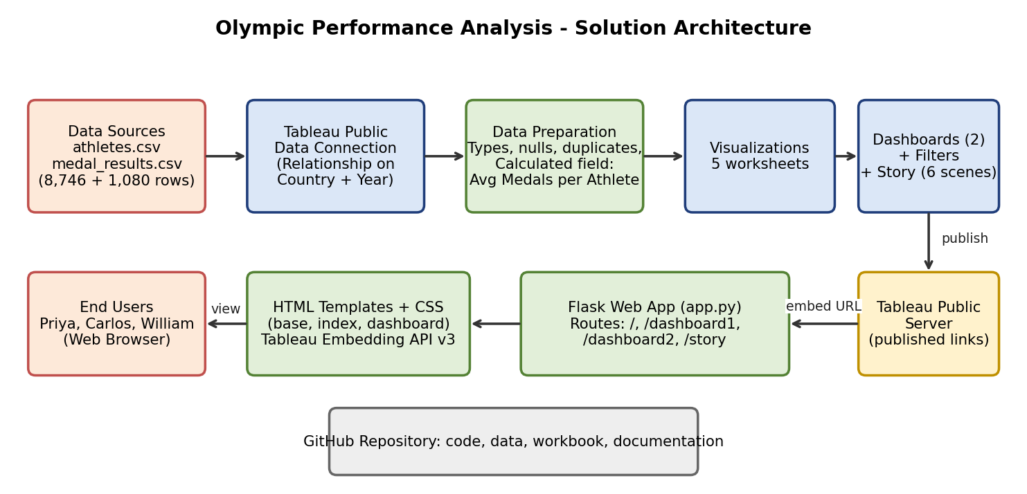

Component Description Table
Component Name | Description / Role in Architecture | Technology Used
Data Sources | Two CSV files: athletes.csv (8,746 athlete records) and medal_results.csv (1,080 country-per-Games records with medals, host country, region and investment). | CSV files (synthetic data)
Data Connection and Preparation | Both files are connected in Tableau with a relationship on Country and Year; types, nulls and duplicates are checked and the Avg Medals per Athlete field is created. | Tableau Desktop / Tableau Public
Visualizations | Five worksheets: Medals by Country, Medals Trend, Investment vs Medals, Medals by Region, Avg Medals by Sport Category. | Tableau Public
Dashboards and Story | Two interactive dashboards with Season and Region filters, plus a 6-scene story with captions. | Tableau Public
Publishing | The workbook is published to Tableau Public, which gives a public link for each dashboard and the story. | Tableau Public server
Web Application | Flask routes /, /dashboard1, /dashboard2 and /story render HTML templates that embed the published views. | Python, Flask, HTML, CSS, Tableau Embedding API v3
Version Control | Code, data, workbook and documentation are stored and shared in a GitHub repository. | Git, GitHub

