Results
Output Screenshots
Date | 1 November 2026
Team ID | Mohammed Sukhawala
Project Name | Olympic Performance Analysis
Maximum Marks | 2 Marks

The screenshots below are taken from the project GitHub repository (docs/screenshots). They show the Tableau dashboards and story and the Flask website that embeds them.
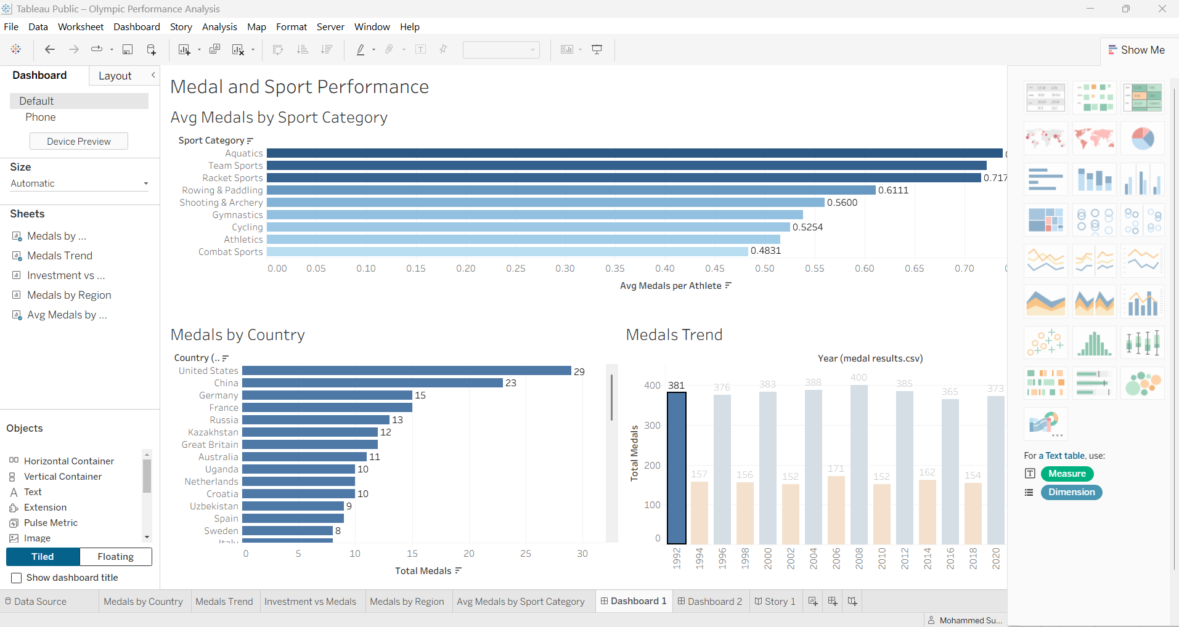
Figure 1: Tableau Dashboard 1 - Medal and Sport Performance (medals by sport category, medals by country, medals trend)
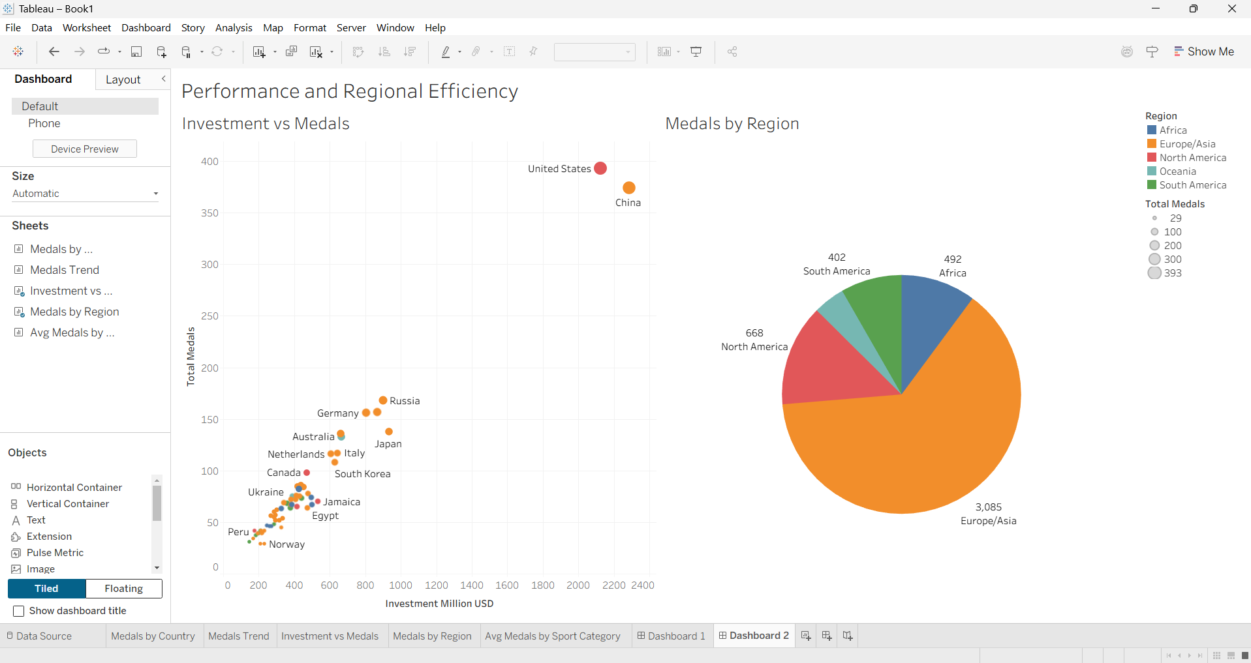
Figure 2: Tableau Dashboard 2 - Performance and Regional Efficiency (investment vs medals, medals by region)
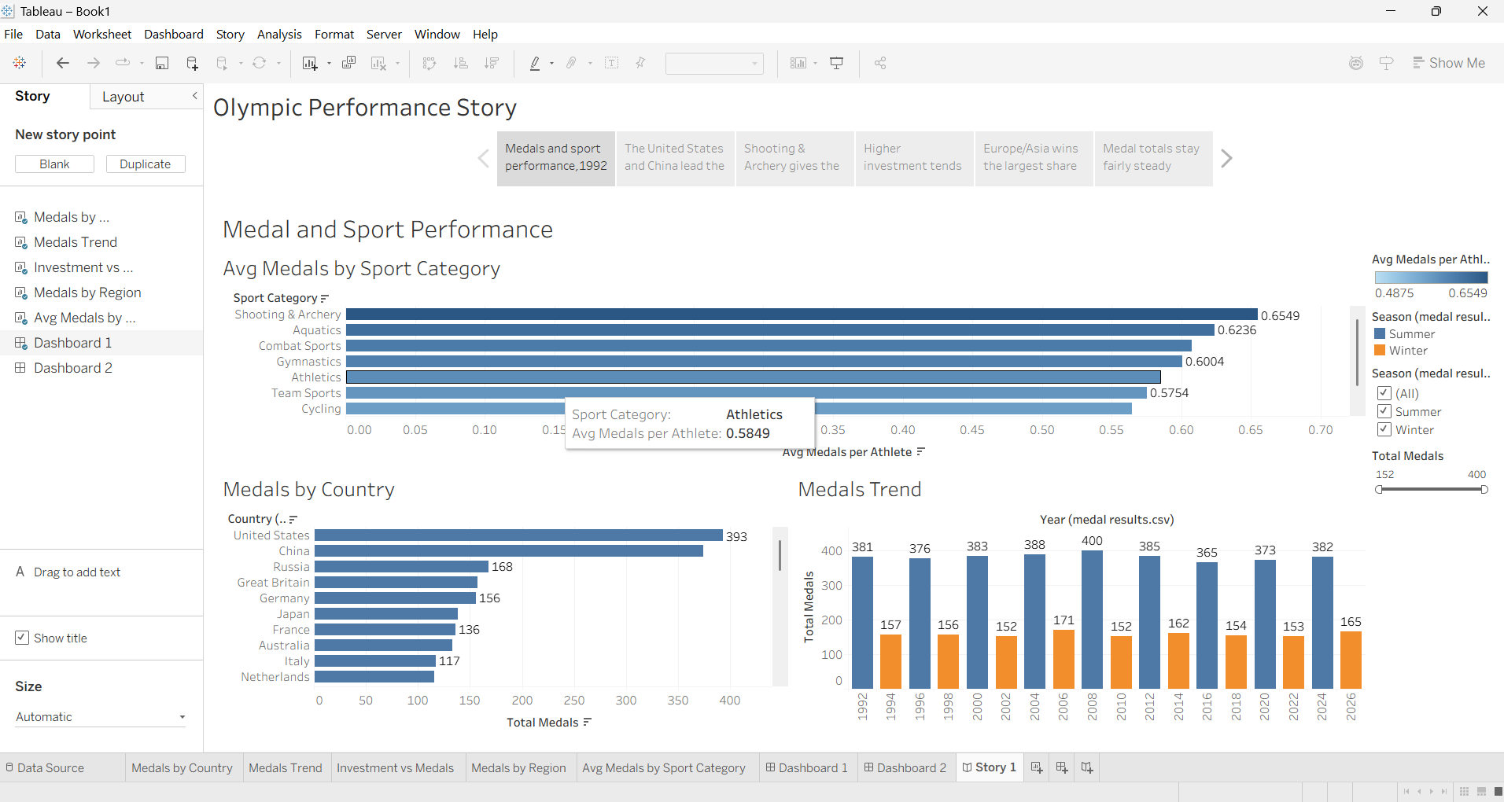
Figure 3: Tableau Story - Olympic Performance Story (6 story points)
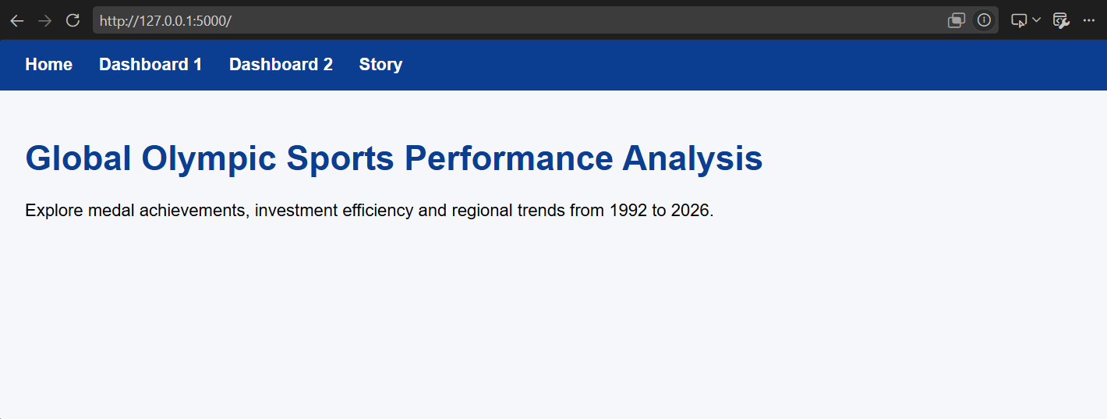
Figure 4: Flask website - Home page
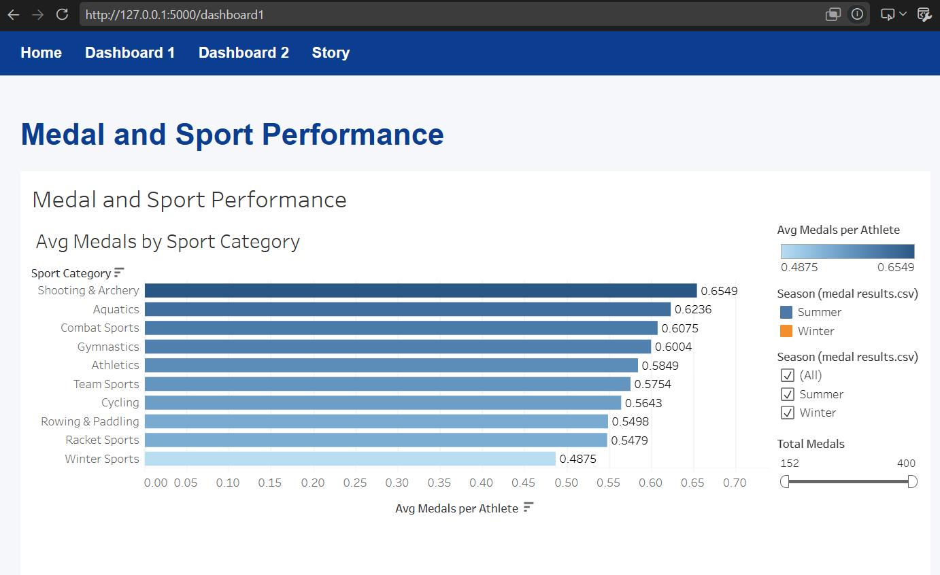
Figure 5: Flask website - Dashboard 1 (top part)
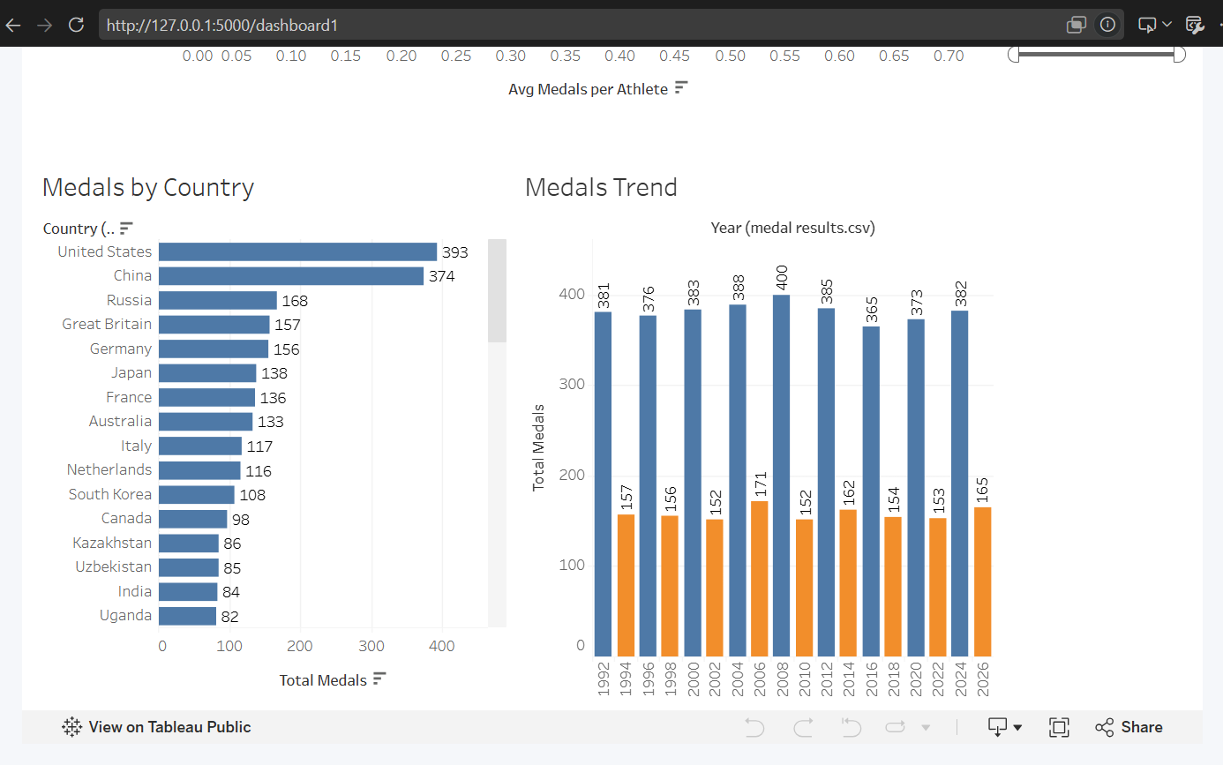
Figure 6: Flask website - Dashboard 1 (bottom part)
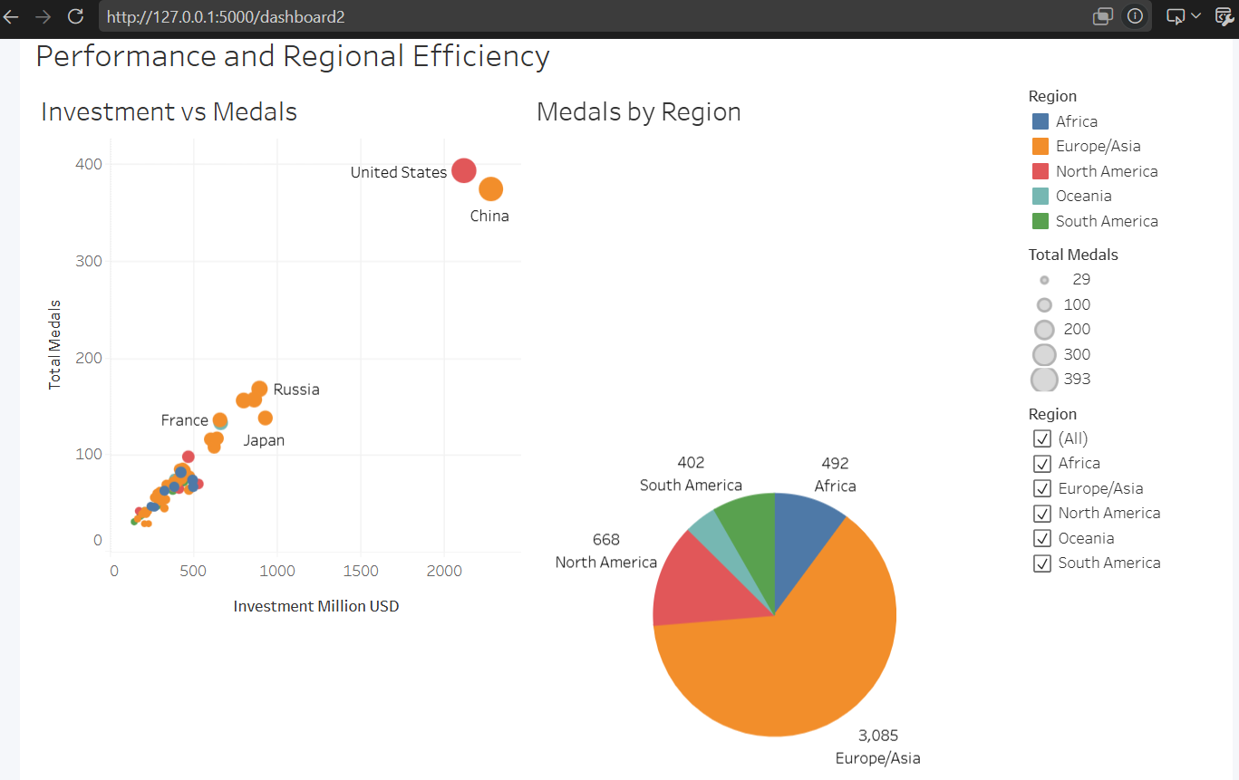
Figure 7: Flask website - Dashboard 2
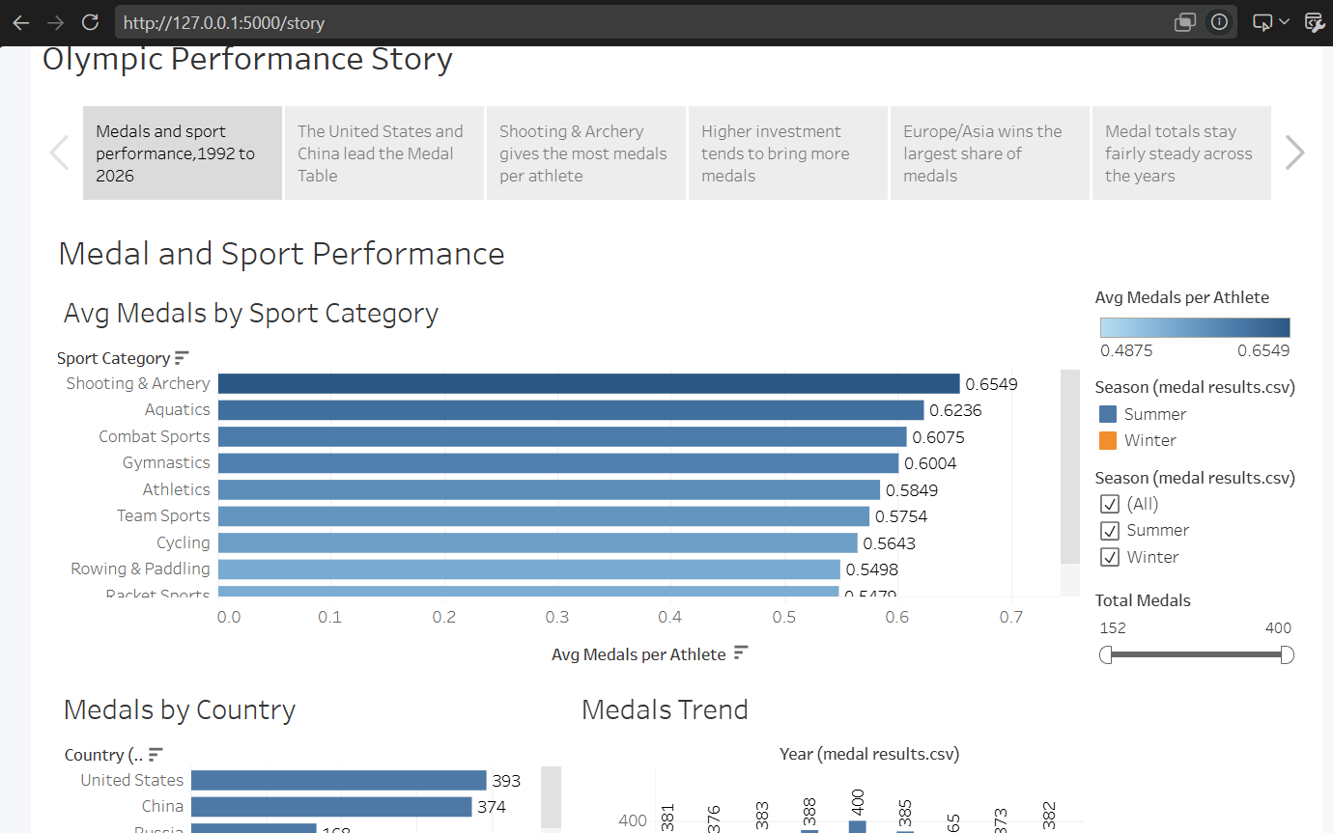
Figure 8: Flask website - Story page

