**Student Grade Tracker GUI – Screenshots**

1. **Subject & Student Info Input Form**

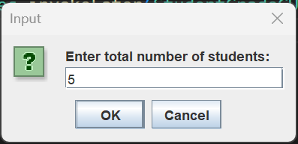

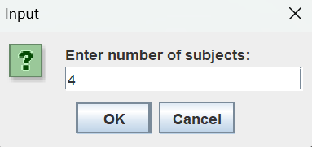

1. **Marks Entry Section**

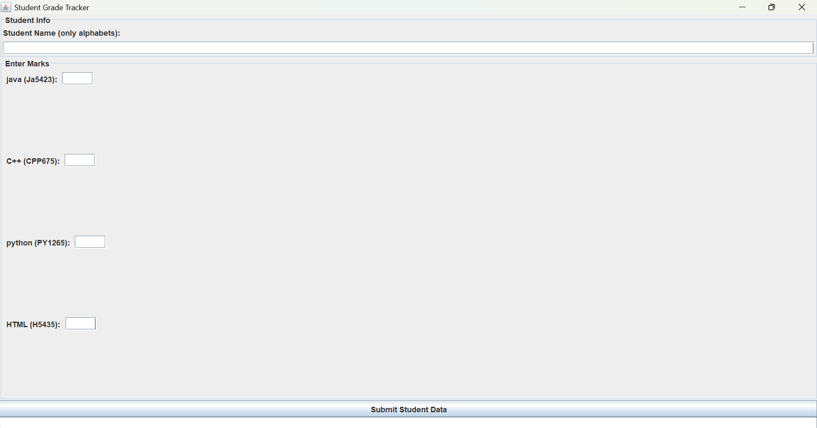

1. **Final Report Output**

