INTERNSHIP APPLICATION TRACKER

SOFTWARE ENGINEERING LABORATORY
Subject code – 25PC2CS202

COURSE BASED PROJECT

Done By
Roll No –Names of Team



Computer Science and Engineering department

2nd Year, 1st semester

DECLARATION

The course-based project titled ‘INTERNSHIP APPLICATION TRACKER’ has been executed under the Guidance of <<>>, Assistant Professor, <<>>, Assistant Professor, as per the academic requirements at VNR VJIET. To the best of our knowledge, we were able to design and implement, while understanding the key concepts of the subject, Software Engineering. We are indebted to the support and motivation extended by HOD and faculty of the department, in completing our project.

Team:
Roll No – Names of Team

INDEX

S.No. | Topic | Pg.No.
1. | Problem Statement | 5
2. | Abstract | 6
3. | Introduction | 7
4. | Objectives | 8
5. | Software and Tools Required | 9
6. | HLD | 11
7. | UML Diagrams | 20

PROBLEM STATEMENT
Navigating the internship application process is overwhelming for students and recent graduates. Candidates routinely apply to dozens or even hundreds of positions across many different channels, such as LinkedIn, Handshake, company career pages and email referrals. Without a single place to record these applications, important details are scattered across browser bookmarks, spreadsheets, notes and crowded email inboxes, and many applications slip through the cracks.
The consequences are practical and costly. Application deadlines are missed because nobody is reminding the candidate that a date is approaching. Interview video links, interviewer names and preparation notes get lost in email threads just when they are needed most. Candidates also lack clarity on which stage of the pipeline (resume screening, online assessment, interview rounds) needs their attention next, and they have no organised view of overall progress, such as how many applications are active, how many have turned into interviews, and what fraction has resulted in offers.
Traditional tools such as spreadsheets and handwritten lists are time-consuming to maintain, prone to human error, offer no automatic alerts, and give no insight into job-search performance. A modern solution must store every application and interview in one structured, private workspace, track each opportunity from wishlist to final offer, warn the candidate about approaching and overdue deadlines, and turn the raw records into meaningful statistics. The Internship Application Tracker has been developed to provide exactly this centralised, secure and easy-to-use workspace for every candidate.

ABSTRACT
The process of applying for internships involves tracking many applications, deadlines, assessments and interview rounds at the same time. Managing this information manually is error-prone and often results in missed deadlines and lost interview details. This project presents the Internship Application Tracker, a full-stack web application that gives students and graduates a centralised, private workspace to manage their entire internship search from the wishlist stage through to the final offer.
The system is built with Java 21 and Spring Boot 3.2.5 on the backend, using Spring Web for REST APIs, Spring Data JPA with Hibernate for persistence, Spring Security 6 for authentication and Spring Validation for input checking. Data is stored in a MySQL 8 relational database consisting of three related tables: users, applications and interviews. The frontend is a responsive single-page style interface built with HTML5, CSS3, Bootstrap 5.3.3 and vanilla JavaScript, which communicates with the backend asynchronously through the fetch API and visualises progress using Chart.js.
Key features include full CRUD management of applications with search, filtering, sorting and pagination; an eight-stage status workflow (Wishlist, Applied, Online Assessment, Interview Scheduled, Interview Completed, Offer Received, Rejected, Withdrawn); scheduling of multiple interview rounds per application with dates, meeting links, interviewer names, notes and outcomes; automatic deadline countdowns and overdue warnings for dates within seven days; and a dashboard that reports key performance indicators, a status-distribution doughnut chart and a 30-day application-trend line chart. Passwords are protected with BCrypt hashing, sessions are managed by Spring Security, and every candidate can access only his or her own records. The project follows a clean layered architecture and is verified with JUnit 5 and MockMvc tests that run against an in-memory H2 database.

INTRODUCTION
Internships have become an essential stepping stone between academic study and a professional career. To secure one, students often submit a large number of applications through different platforms, each with its own deadline, selection process and communication channel. Keeping track of who was contacted, which stage each application has reached and what is due next quickly becomes a task in itself, and the common tools used for it, such as notebooks, spreadsheets and email folders, were never designed for this purpose.
A good tracking system must do more than store a list of company names. It has to capture the full context of every opportunity (role, description, work mode, location, stipend, priority and notes), model the different stages of the selection process, keep interview details together with the application they belong to, and proactively remind the candidate about dates that matter. It should also help the candidate learn from the process by showing how applications are distributed across stages and how many of them convert into interviews and offers.
This project introduces the Internship Application Tracker, a web application developed using the Spring Boot framework, MySQL and a Bootstrap-based frontend. The backend exposes a secured REST API organised into authentication, application, interview and dashboard modules, while the browser interface consumes this API to present forms, tables, modals and interactive charts. The application is designed around a clean layered architecture (controller, service, repository, entity, DTO and exception packages), which keeps responsibilities separate and makes the code easy to extend and test.
Security and privacy are treated as core requirements. Each user registers an account, passwords are stored only as BCrypt hashes, and all application and interview records are linked to their owner so that candidates cannot see each other’s data. By combining organised record keeping, deadline alerts and data-driven insights in one platform, the Internship Application Tracker reduces stress, prevents missed opportunities and supports better decisions during the internship search.

OBJECTIVES

1. To Provide Centralised Organisation of Applications
Consolidate all application metadata (role, job description, company URL and website, location, work mode, employment type, stipend, priority and notes) in one place so that nothing is scattered across platforms.

2. To Support Milestone Tracking Across the Pipeline
Support multi-stage progression through the statuses Wishlist, Applied, Online Assessment, Interview Scheduled, Interview Completed, Offer Received, Rejected and Withdrawn, with a quick status-change option.

3. To Coordinate Multiple Interview Rounds
Track any number of interview rounds per application, storing the date and time, mode, video link, interviewer name, preparation notes and outcome of each round.

4. To Deliver Proactive Deadline Alerts
Provide automated countdowns and overdue warnings for deadlines falling within the next seven days, and list upcoming interviews in chronological order.

5. To Offer Data-Driven Insights
Visualise application velocity, status distribution and success rate through KPI cards and interactive Chart.js dashboards (doughnut and line charts).

6. To Secure and Isolate Candidate Data
Implement registration, login and logout with BCrypt password hashing and Spring Security session authorisation so that each candidate can access only his or her own records.

7. To Enable Fast Search, Filtering and Pagination
Allow users to search and filter applications dynamically on multiple criteria with sorting and pagination, using JPA Specifications to build flexible queries.

8. To Build a Responsive and User-Friendly Interface
Use Bootstrap 5 and vanilla JavaScript to create an accessible, responsive interface with modals, icons and real-time updates that works across screen sizes.

9. To Ensure a Maintainable and Testable Architecture
Apply a clean layered architecture with DTOs, centralised exception handling and automated JUnit 5 / MockMvc tests on an in-memory H2 database, so that the system is reliable and easy to extend.

SOFTWARE AND TOOLS REQUIRED

Backend: Java 21 with Spring Boot 3.2.5
Java 21 (LTS) is the core programming language and Spring Boot 3.2.5 is the framework that wires the application together. Spring Boot provides auto-configuration, an embedded web server and a single executable JAR, so the whole application, including the static frontend, runs on port 8080 without a separate web server.

Spring Web, Spring Data JPA, Spring Security and Spring Validation
Spring Web builds the REST controllers. Spring Data JPA with Hibernate maps Java entities to MySQL tables and supports custom queries and dynamic Specification filters. Spring Security 6 handles authentication, session management and URL authorisation. Spring Validation (Jakarta constraints) enforces rules on incoming request payloads.

Database: MySQL 8.x with MySQL Connector/J
MySQL is the relational database used for production and local development. It stores the users, applications and interviews tables with foreign keys and indexes. MySQL Connector/J is the official JDBC driver used by the application at runtime.

Test Database: H2 (In-Memory)
H2 is used only in the test scope. It lets the automated tests run quickly and in isolation without touching the live MySQL database.

Frontend: HTML5, CSS3 and Bootstrap 5.3.3
HTML5 and CSS3 provide the semantic page structure and styling. Bootstrap 5.3.3 supplies the responsive grid, components and accessible modals, and Bootstrap Icons 1.11.3 provides the visual iconography.

Frontend Logic: Vanilla JavaScript (ES6+) and Chart.js 4.4.2
Plain JavaScript performs asynchronous communication with the REST API using fetch, manages page state and updates the DOM in real time. Chart.js 4.4.2 renders the doughnut chart for status distribution and the line chart for the 30-day application trend.

Build Tool: Apache Maven
Maven manages dependencies and the build lifecycle through pom.xml (Spring Boot parent 3.2.5, Java 21). The application can be run with mvn spring-boot:run or packaged with mvn clean package into internship-application-tracker-1.0.0.jar.

Testing: JUnit 5, MockMvc and Spring Security Test
spring-boot-starter-test provides JUnit 5 and MockMvc for unit and integration testing of the controllers and services, and spring-security-test supports testing of authenticated requests. Postman is used for manual verification of the REST endpoints.

IDE and Database Tools: Visual Studio Code and MySQL Workbench
Visual Studio Code with the Extension Pack for Java and the Spring Boot Extension Pack is the primary development environment. MySQL Workbench or the MySQL command-line client is used to create the schema and inspect data.

Version Control: Git
Git tracks changes to the source code. A .gitignore file keeps build output (target/), IDE settings, operating-system files, log files and the local .env file with database credentials out of the repository.

Maven Dependencies (from pom.xml)
Dependency (artifactId) | Scope | Purpose
spring-boot-starter-web | compile | REST controllers, embedded Tomcat, JSON handling and static content
spring-boot-starter-data-jpa | compile | JPA / Hibernate persistence and Spring Data repositories
spring-boot-starter-security | compile | Authentication, BCrypt, session management, URL authorisation
spring-boot-starter-validation | compile | Jakarta Bean Validation for request DTOs
mysql-connector-j | runtime | JDBC driver for MySQL 8
h2 | test | In-memory database for automated tests
spring-boot-starter-test | test | JUnit 5, MockMvc, Mockito, AssertJ
spring-security-test | test | Helpers for testing secured endpoints

HIGH-LEVEL DESIGN (HLD)

6.1 Project Overview

Purpose
The purpose of this section is to define the high-level design of the Internship Application Tracker, a web-based platform that centralises the management of internship applications, interview rounds, deadlines and job-search analytics. It outlines the system architecture, the key components, the data model and the main workflows, and serves as a reference for development, testing and future enhancement.

Audience
This High-Level Design is intended for the following stakeholders:
- Development Team – to guide the system architecture, module design and technology stack implementation.
- Quality Assurance Team – to derive test cases and verify compliance with the functional and non-functional requirements.
- End Users – students and graduates who use the application to organise their internship search.
- Faculty / Evaluators – to review the design decisions and the application of software engineering principles.

Design Process
The design of the Internship Application Tracker followed a structured approach:
- Requirement Analysis – identified the pain points of manual tracking (missed deadlines, lost interview details, no view of progress) and derived the required features: application management, status workflow, interview coordination, alerts and analytics.
- Technology Evaluation – selected Java 21 and Spring Boot 3.2.5 for a robust, well-supported backend, MySQL 8 for reliable relational storage, and Bootstrap with vanilla JavaScript for a lightweight frontend that needs no separate build step. H2 was chosen for fast, isolated tests.
- Layered Architecture Design – organised the code into config, controller, service, repository, entity, dto and exception packages to separate concerns and isolate each user’s data.
- Data Modelling – designed three related tables (users, applications, interviews) with foreign keys, cascading deletes and indexes on frequently queried columns.
- Implementation and Verification – implemented the modules iteratively and verified them with JUnit 5 / MockMvc tests and manual Postman requests.

6.2 Requirements
The requirements of the Internship Application Tracker are summarised below.

Functional Requirements
- Register a new account, log in, log out and view the authenticated user’s profile.
- Create, view, update and delete internship applications with all descriptive metadata.
- List applications with search, filtering, sorting and pagination.
- Change the status of an application quickly (for example to Offer Received).
- Schedule, update and delete multiple interview rounds for each application.
- Show deadline countdowns and overdue warnings for dates within seven days.
- Present KPI counts, status distribution, a 30-day application trend and upcoming interviews on a dashboard.

Non-Functional Requirements
- Security – BCrypt password hashing, session-based authentication and per-user data isolation.
- Usability – responsive, accessible interface that works on desktop and mobile browsers.
- Performance – pagination and database indexes on email, user_id, company_name, status, deadline and interview_date.
- Reliability and Integrity – foreign-key constraints, cascading rules and centralised exception handling.
- Maintainability and Testability – layered architecture, DTOs and automated tests on an in-memory database.
- Portability – runs on any operating system with JDK 21 and MySQL 8.x.

Proposed Solution
To address these requirements, the Internship Application Tracker is developed as a web-based platform using the following approach:
- Centralised Application Management – a single private workspace for all applications and interviews, with an eight-stage status workflow.
- Proactive Alerts – deadline countdowns and overdue warnings computed by the dashboard service.
- Insight Dashboard – KPI cards and Chart.js visualisations of status distribution and 30-day submission velocity.
- Secure REST Architecture – Spring Boot REST APIs protected by Spring Security sessions, with BCrypt-hashed passwords.
- Layered, Testable Code Base – clear separation of controllers, services, repositories, entities and DTOs.

Capacity Planning
The following figures are approximate estimates based on stated assumptions (average row sizes and typical usage); they are intended for planning and should be validated against real data.
Item | Assumption / Estimate
User record | ≈ 0.5 KB per user (name, email, password hash, timestamp)
Application record | ≈ 2 KB per application (metadata plus job description and notes text)
Interview record | ≈ 1 KB per interview round (details, link, notes, outcome)
Index overhead | ≈ 50 % on top of table data

Scenario | Users / Applications / Interviews | Estimated MySQL Storage
Small deployment (e.g. one class) | 100 / 5,000 / 10,000 | ≈ 20 MB data, ≈ 30 MB with indexes
Large deployment (institution-wide) | 10,000 / 500,000 / 1,000,000 | ≈ 2 GB data, ≈ 3 GB with indexes

The current version stores no file attachments (resumes and cover letters are listed as a future enhancement), so database storage is the only significant capacity concern. Pagination keeps response sizes small even for users with very large numbers of applications.

6.3 Architecture

Design
The Internship Application Tracker adopts a clean layered architecture. The browser-based client communicates with the Spring Boot backend through REST endpoints that exchange JSON. Spring Security guards every protected route, the controller layer handles HTTP concerns, the service layer contains business rules, the repository layer talks to MySQL through Spring Data JPA, and a global exception handler converts errors into consistent responses (Fig 6.1).
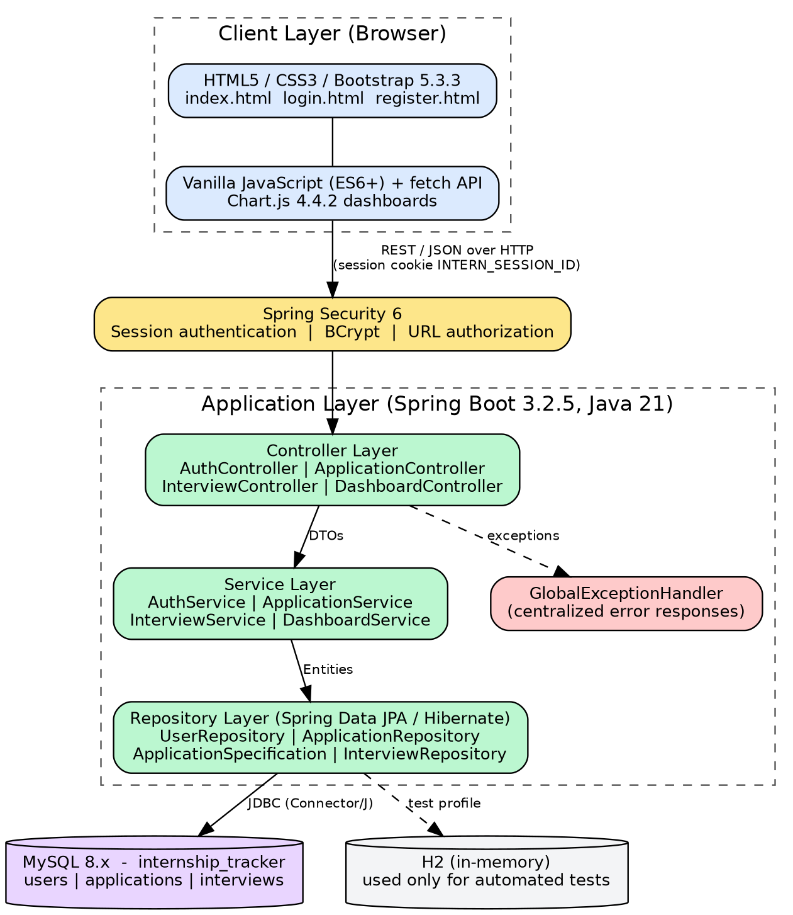
Fig 6.1: System architecture of the Internship Application Tracker

Package Structure
The base package is com.internshiptracker. Each package has a single responsibility:
Package | Contents and Responsibility
InternshipTrackerApplication | Spring Boot bootstrap entry point
config | SecurityConfig (session and URL authorisation), CustomUserDetailsService (user lookup), UserPrincipal (UserDetails implementation)
controller | AuthController, ApplicationController, InterviewController, DashboardController – REST endpoints
service | AuthService, ApplicationService, InterviewService, DashboardService – business logic, ownership checks, KPI aggregation
repository | UserRepository, ApplicationRepository, ApplicationSpecification (dynamic multi-predicate queries), InterviewRepository
entity | User, Application, Interview and the enums ApplicationStatus, WorkMode, Priority, InterviewMode, InterviewOutcome
dto | Request/response payloads such as RegisterRequest, LoginRequest, ApplicationRequest, ApplicationResponse, InterviewRequest, DashboardSummaryResponse, StatusDistributionDto, ApplicationTrendDto, UpcomingDeadlineDto, ApiResponse, ErrorResponse
exception | GlobalExceptionHandler, ResourceNotFoundException, BadRequestException, UnauthorizedException

Database Design
The database internship_tracker contains three interconnected tables: users, applications and interviews. A user owns many applications and an application contains many interviews (Fig 6.2).
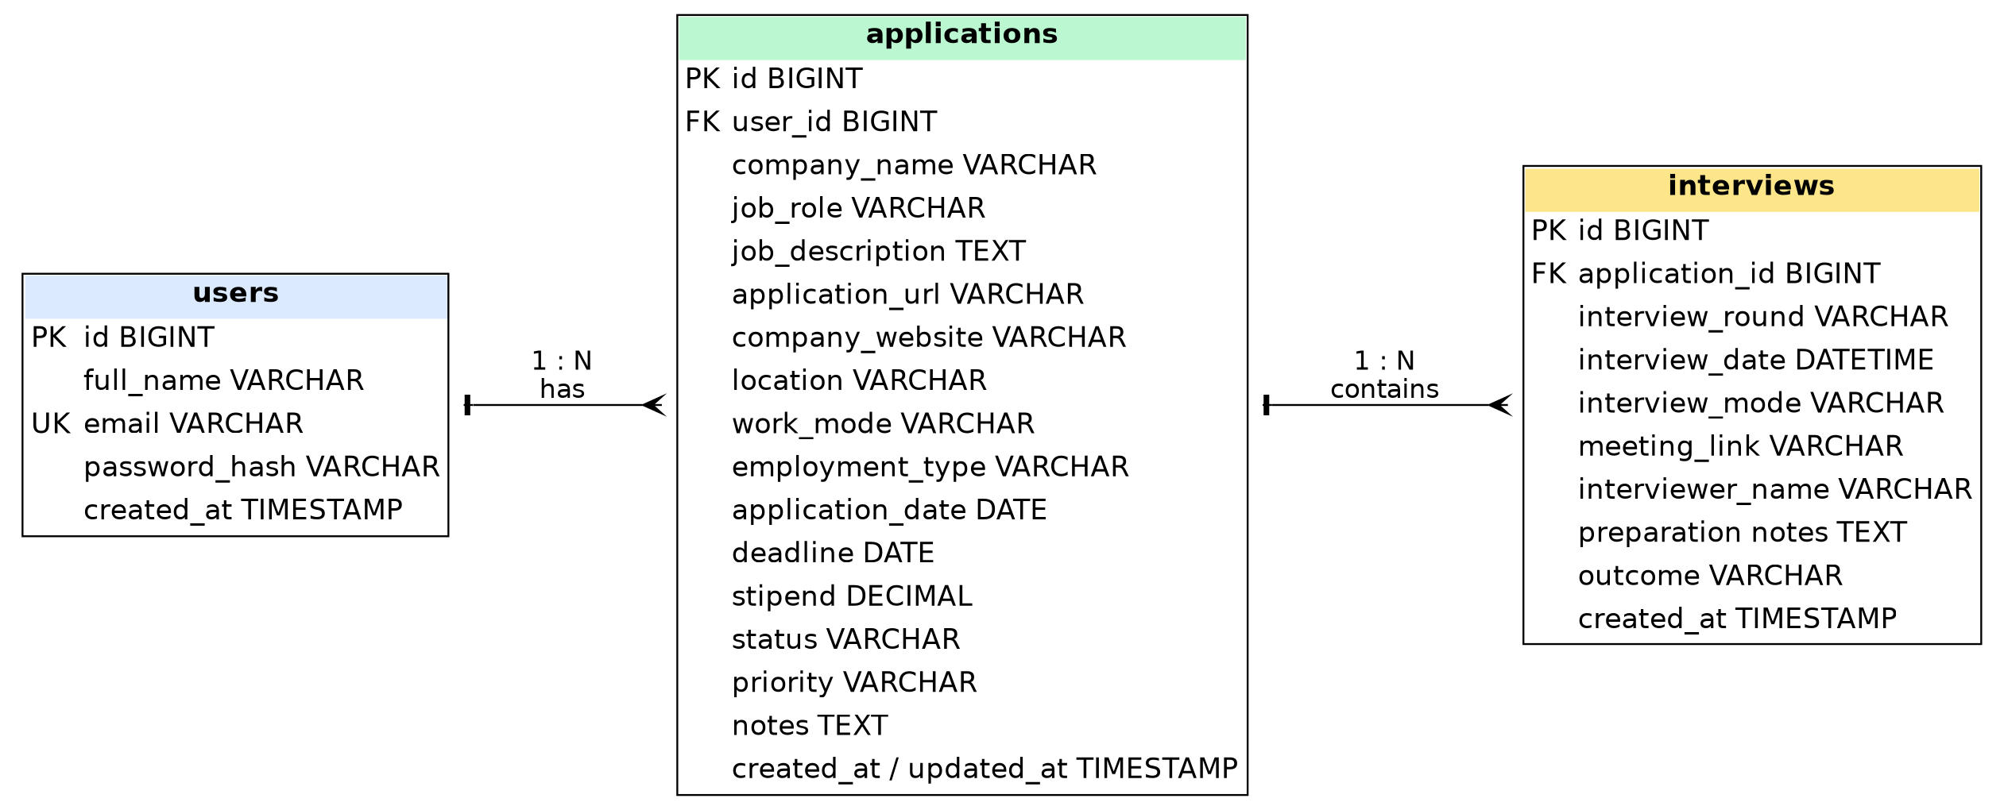
Fig 6.2: Entity-relationship diagram of the internship_tracker database
- Deleting a User cascades and deletes all related applications and their interviews.
- Deleting an Application cascades and deletes all scheduled interviews.
- Foreign key constraints prevent orphaned records; email is unique.
- Indexes are established on email, user_id, company_name, status, deadline and interview_date.

REST API Design
All endpoints return JSON. Public endpoints are limited to registration and login; every other endpoint requires an authenticated session.
Method | Endpoint | Description | Access
POST | /api/auth/register | Register a new user account | Public
POST | /api/auth/login | Log in and obtain an active session | Public
POST | /api/auth/logout | Invalidate session and clear context | Protected
GET | /api/auth/me | Fetch the authenticated user’s profile | Protected
GET | /api/applications | List applications (search, filter, pagination, sort) | Protected
GET | /api/applications/{id} | Get application details by ID | Protected
POST | /api/applications | Create a new internship application | Protected
PUT | /api/applications/{id} | Update an existing application | Protected
PATCH | /api/applications/{id}/status | Quick status change | Protected
DELETE | /api/applications/{id} | Delete application (cascades to interviews) | Protected
GET | /api/applications/{appId}/interviews | List interview rounds of an application | Protected
POST | /api/applications/{appId}/interviews | Schedule a new interview round | Protected
PUT | /api/interviews/{id} | Update interview round, notes or outcome | Protected
DELETE | /api/interviews/{id} | Delete an interview round | Protected
GET | /api/dashboard/summary | KPI counts, total applications, offers, success rate | Protected
GET | /api/dashboard/status-distribution | Counts per status (doughnut chart) | Protected
GET | /api/dashboard/application-trends | 30-day submission velocity (line chart) | Protected
GET | /api/dashboard/upcoming-deadlines | Deadlines in the next 7 days and overdue | Protected
GET | /api/dashboard/upcoming-interviews | Upcoming scheduled interviews in order | Protected

Version
Component | Version
Java (JDK) | 21 (LTS) – java.version property in pom.xml
Spring Boot | 3.2.5 (spring-boot-starter-parent)
Spring Security | 6.x (managed by Spring Boot 3.2.5)
Maven | 3.8 or higher
MySQL Server / Connector/J | 8.x / version managed by Spring Boot
H2 Database | In-memory, test scope only
Bootstrap / Bootstrap Icons | 5.3.3 / 1.11.3
Chart.js | 4.4.2
Application artifact | internship-application-tracker-1.0.0.jar

Configuration
Database credentials and server settings are supplied through environment variables (documented in the .env.example file) or in application.properties. The real .env file is excluded from version control by .gitignore.
Variable | Purpose / Example
PORT | Server port (8080)
SPRING_DATASOURCE_URL | jdbc:mysql://localhost:3306/internship_tracker?createDatabaseIfNotExist=true&useSSL=false&allowPublicKeyRetrieval=true&serverTimezone=UTC
SPRING_DATASOURCE_USERNAME | MySQL user (root)
SPRING_DATASOURCE_PASSWORD | MySQL password (placeholder: your_mysql_password_here)
SPRING_JPA_HIBERNATE_DDL_AUTO | Schema management mode (update)
SPRING_JPA_SHOW_SQL | Log generated SQL (false)

Access
- Session-based authentication: after login the browser holds the INTERN_SESSION_ID session cookie, which is sent with every API call.
- URL authorisation in SecurityConfig: registration and login are public; all other /api routes are protected.
- Ownership checks in the service layer ensure that a user can read or change only his or her own applications and interviews.
- Unauthenticated users are redirected to login.html when opening the application.

Hardware and Platform Requirements
Hardware Requirements (development / small deployment):
Component | Minimum | Recommended
Processor | Intel Core i3 or AMD Ryzen 3 | Intel Core i5 / Ryzen 5 or higher
RAM | 4 GB | 8 GB or higher
Storage | 20 GB free disk space | 256 GB SSD or higher
Display | 13” HD monitor | 15.6” Full HD monitor
Internet | Stable broadband connection | High-speed connection (10 Mbps and above)

Platform Requirements:
- Frontend platform: HTML5, CSS3, Bootstrap and JavaScript; runs on any modern web browser (Chrome, Firefox, Edge).
- Backend platform: Java 21 runtime (the build is configured for Java 21) and Maven 3.8+; served by the embedded web server of Spring Boot on port 8080.
- Database platform: MySQL Server 8.x running locally on port 3306, or on a hosted server.
- Operating system: Windows, Linux or macOS; the project documentation targets Windows with PowerShell.
- Other tools: Visual Studio Code with the Java and Spring Boot extension packs, MySQL Workbench, Postman and Git.

System Connectivity
- Client–server architecture: the browser (HTML, JavaScript) communicates with the Spring Boot application using REST APIs over HTTP on port 8080.
- The frontend pages (index.html, login.html, register.html) are served by the same Spring Boot application, so no separate frontend server is needed.
- The backend connects to MySQL through JDBC (MySQL Connector/J) on port 3306.
- Session cookies (INTERN_SESSION_ID) carry the authenticated session between browser and server.
- Automated tests use an in-memory H2 database and never connect to the live MySQL database.

6.4 Standards

Security Standards
- Passwords are hashed with BCrypt and never stored in plain text.
- Spring Security session management protects all non-public routes.
- Jakarta validation constraints are enforced on every request payload.
- All records are linked to an owner, providing per-user data isolation.
- Credentials are supplied through environment variables, and the .env file is excluded from Git.

Authorization and Login
- Only registration and login are public; all other endpoints require an authenticated session.
- Unauthorised access results in an error response (UnauthorizedException) or a redirect to the login page.
- Access to a record that belongs to another user is rejected, so no foreign data is exposed.

Coding and Error-Handling Standards
- Clean layered architecture with strict separation of controller, service and repository code.
- DTOs are used for requests and responses so that entities are never exposed directly.
- GlobalExceptionHandler returns consistent ErrorResponse payloads for ResourceNotFoundException, BadRequestException and UnauthorizedException.

Disaster Recovery (Recommended Practices)
- Take regular backups of the internship_tracker database using mysqldump or MySQL Workbench export.
- Use Git for source control and rollbacks; the repository excludes build output and secrets.
- Keep application logs for troubleshooting and recovery.

6.5 Support
- Development support: the README documents the architecture, setup, API and testing steps; Maven provides repeatable builds.
- Deployment support: run with mvn spring-boot:run, or package with mvn clean package -DskipTests and start java -jar target/internship-application-tracker-1.0.0.jar.
- User support: the application is available at http://localhost:8080/ and redirects to index.html or login.html; new users create an account on register.html.

6.6 Future Enhancements
- Resume and cover-letter attachment management (file storage or S3 integration).
- Automated email or calendar synchronisation (Google Calendar / Outlook iCal invitations).
- Company ratings and crowd-sourced salary benchmarks.
- AI-powered job-description analysis and resume keyword optimisation tips.

UML DIAGRAMS
Use Case Diagram:
The candidate (student or graduate) is the only actor. After registering and logging in, the actor can manage applications and interviews and consult the dashboard.
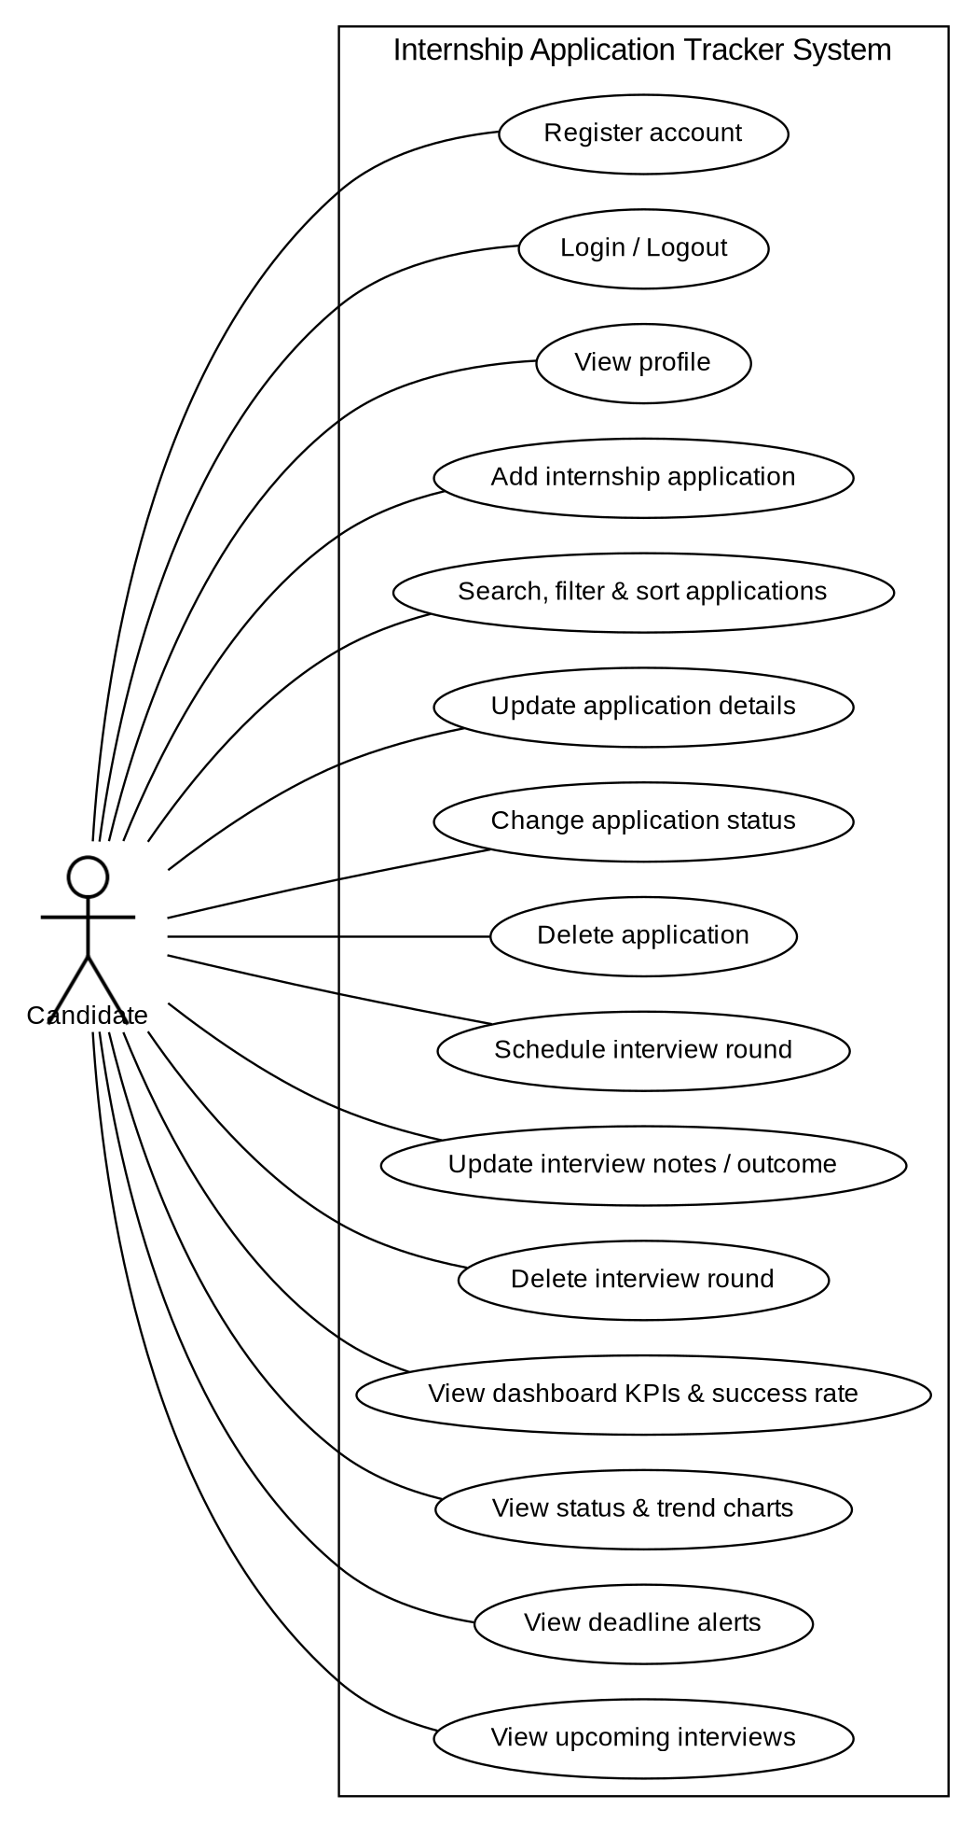
Fig 7.1: Use case diagram
Class Diagram:
The domain model consists of the entities User, Application and Interview and the enumerations that describe their attributes.
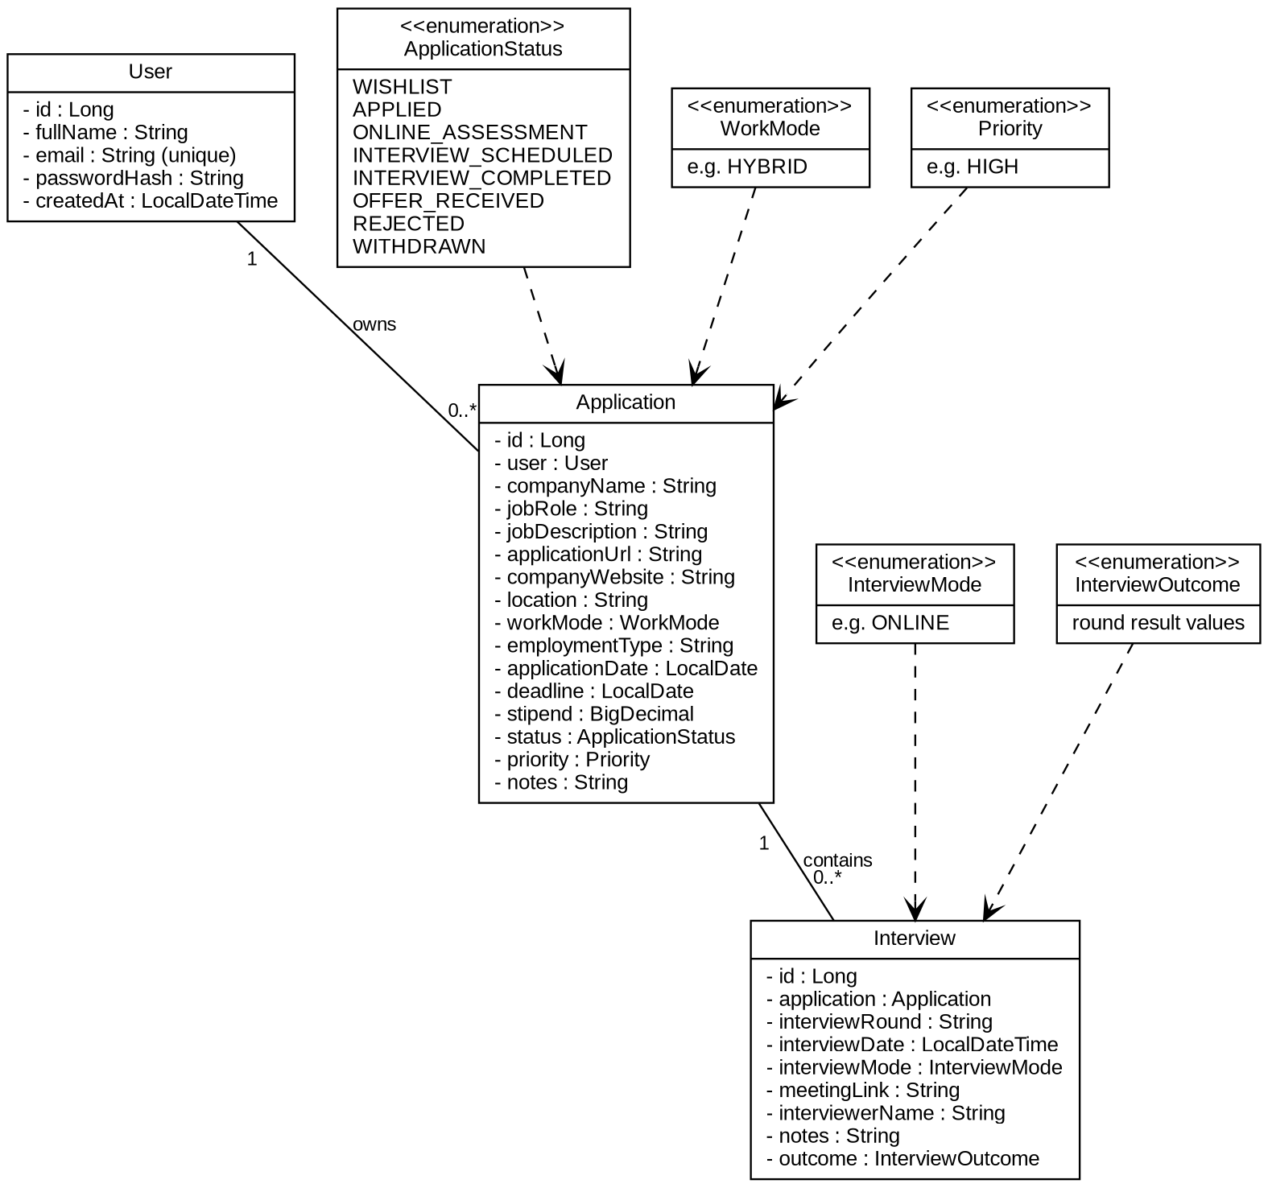
Fig 7.2: Class diagram (domain model)
The layered structure below shows how controllers delegate to services, which use repositories.
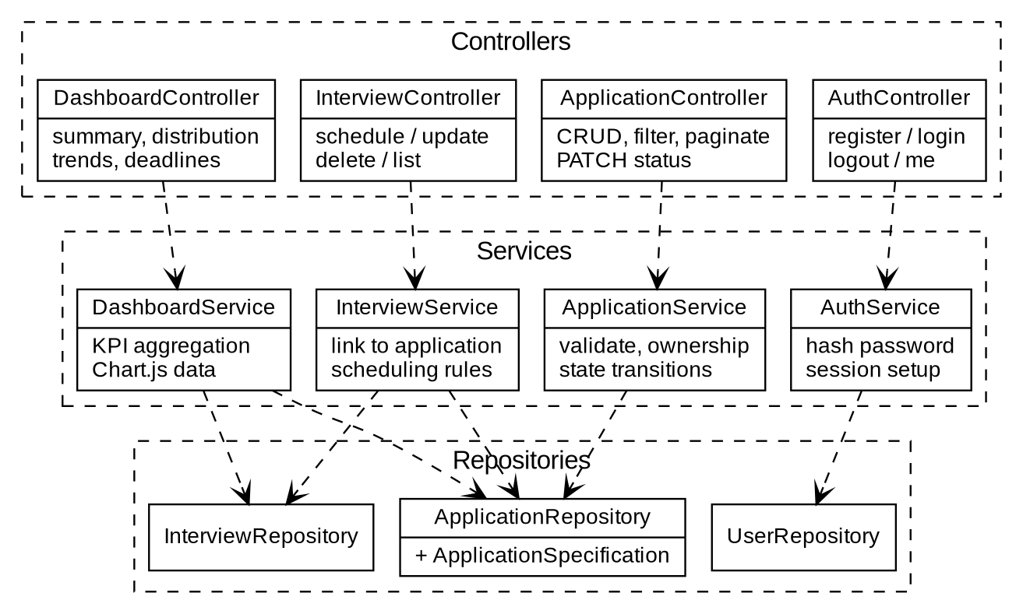
Fig 7.3: Class diagram (controller, service and repository layers)
Sequence Diagrams:
1. User Authentication (Registration, Login and Logout)
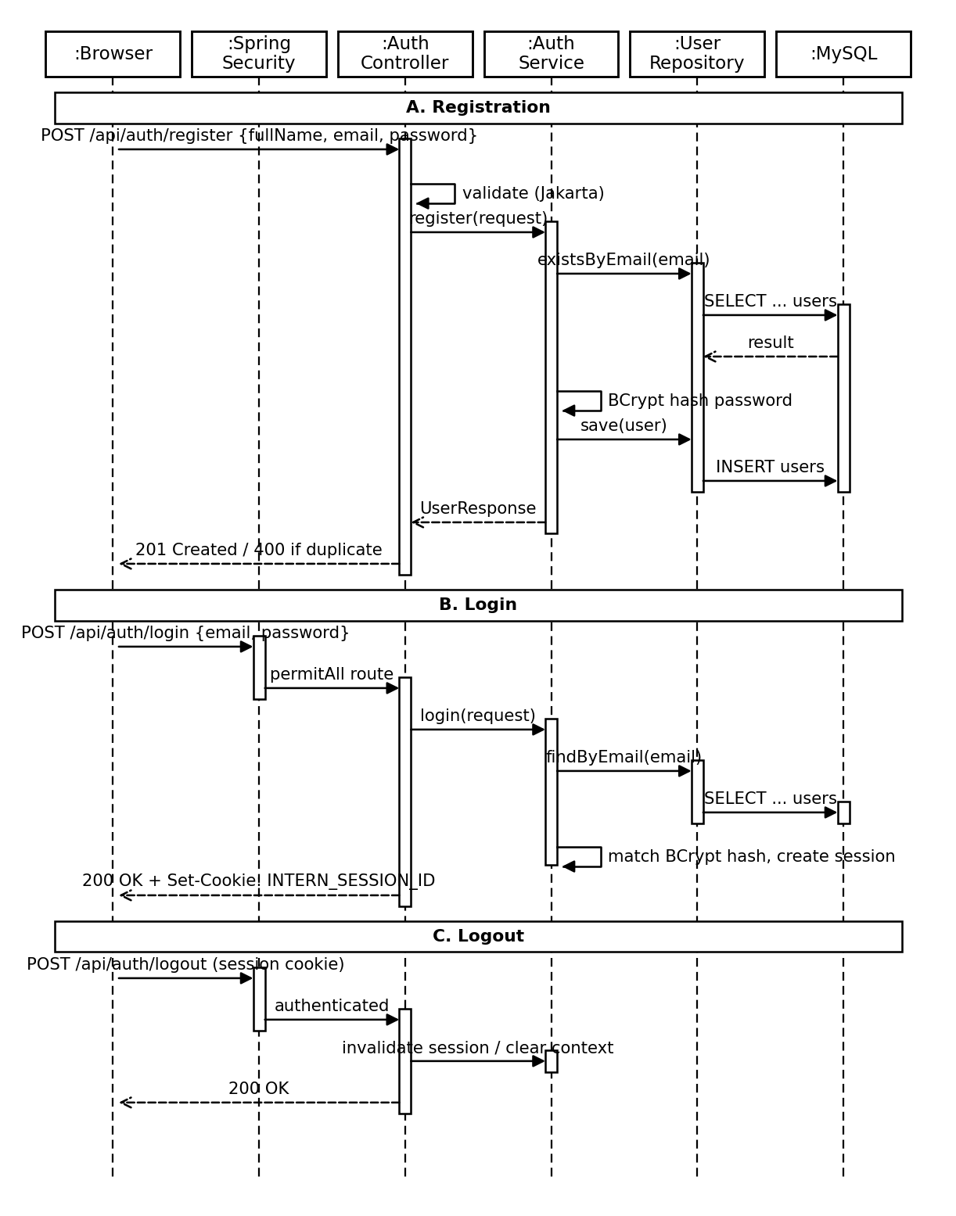
Fig 7.4: Sequence diagram – user authentication
2. Application, Interview and Dashboard Management
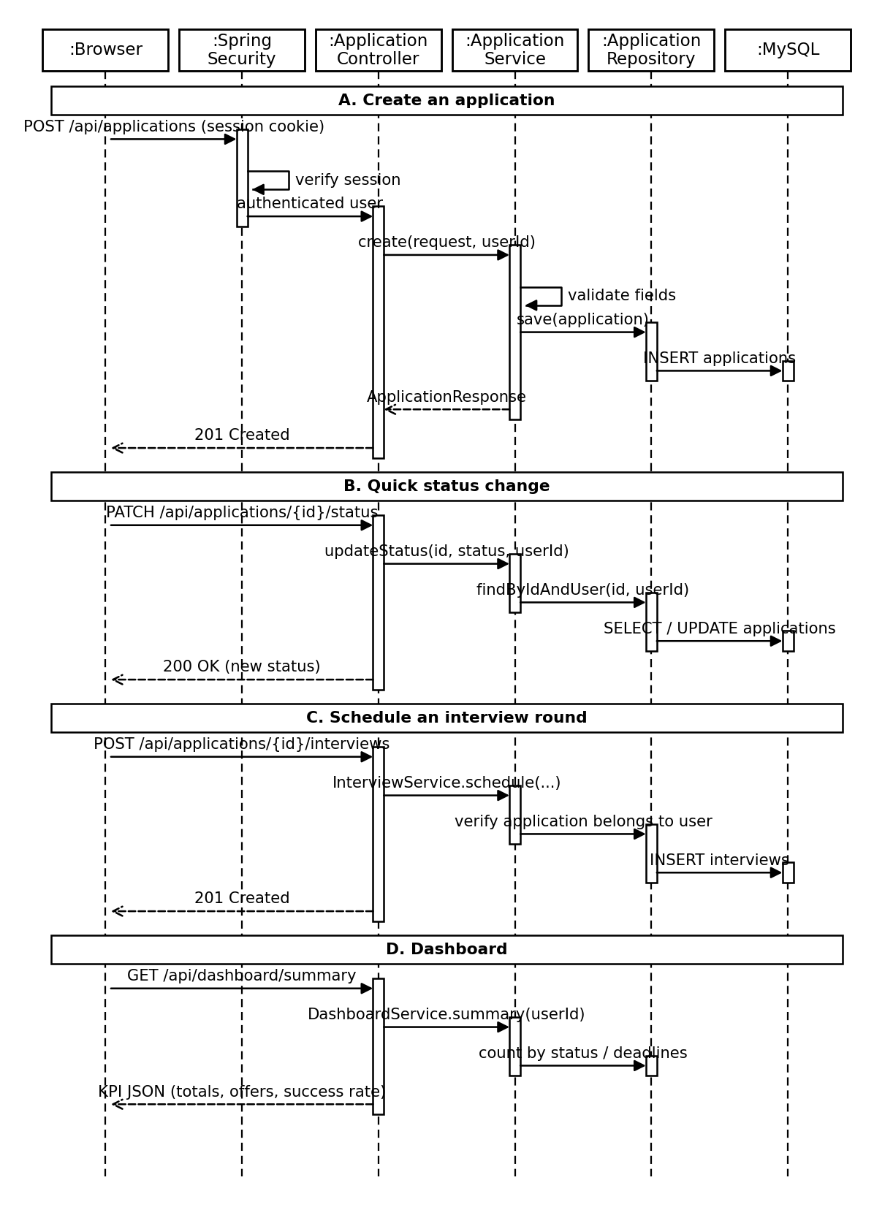
Fig 7.5: Sequence diagram – application, interview and dashboard management
Activity Diagrams:
1. User Authentication
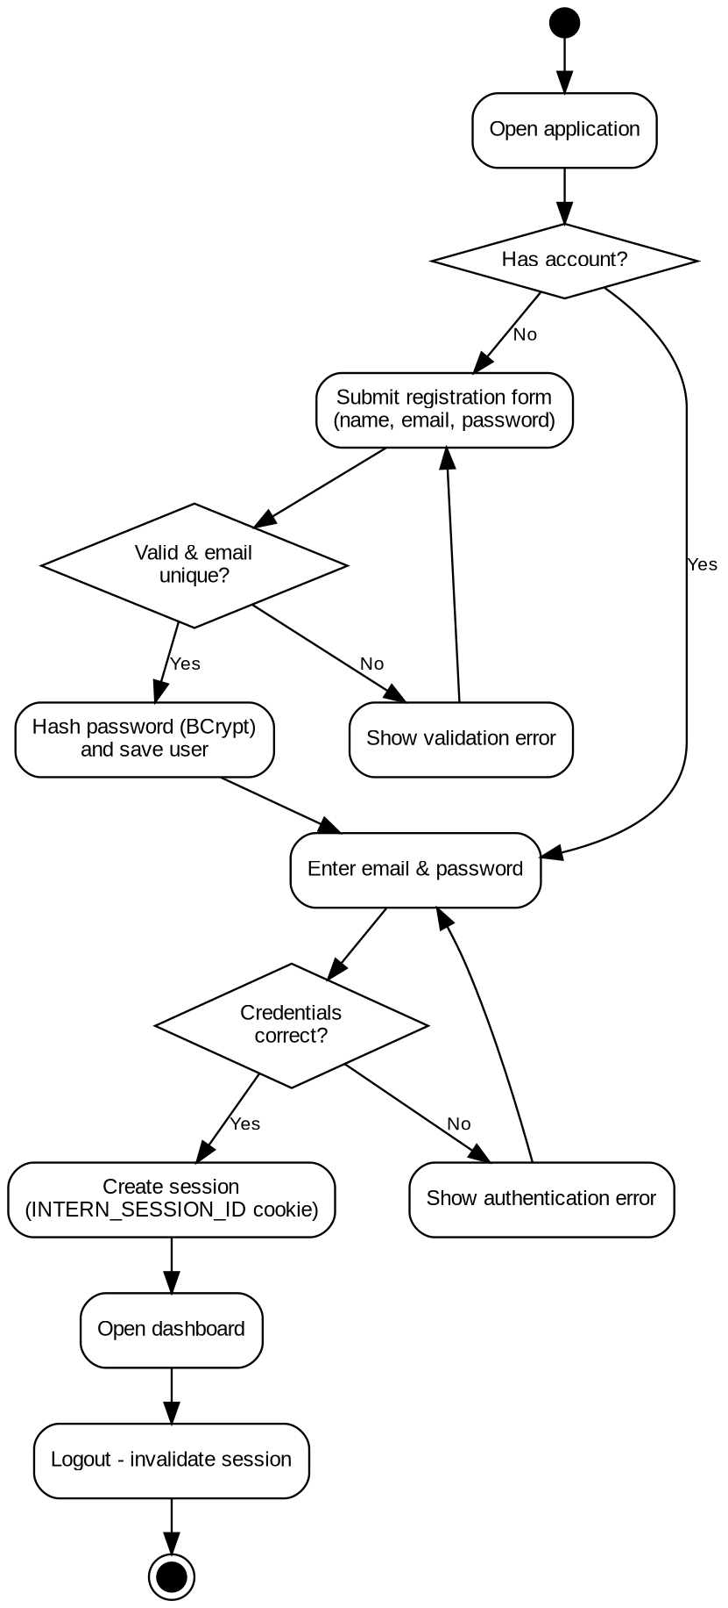
Fig 7.6: Activity diagram – user authentication
2. Application and Interview Management
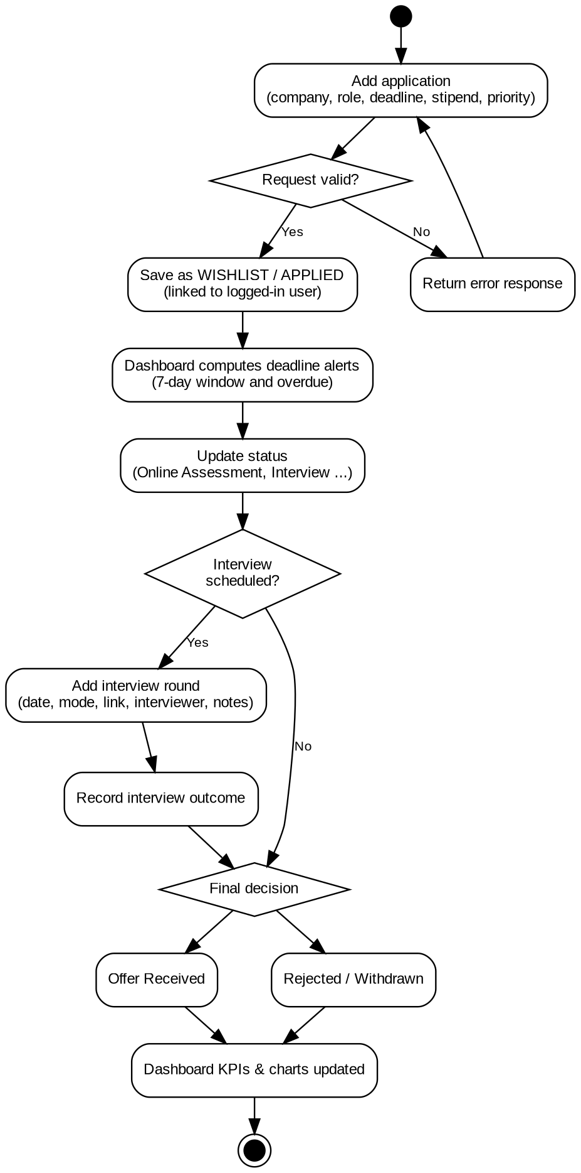
Fig 7.7: Activity diagram – application and interview management
State Chart Diagrams:
1. Application Status Lifecycle
A typical progression of an application through the eight statuses. The quick status-change endpoint allows the candidate to move an application directly to the status that matches reality.
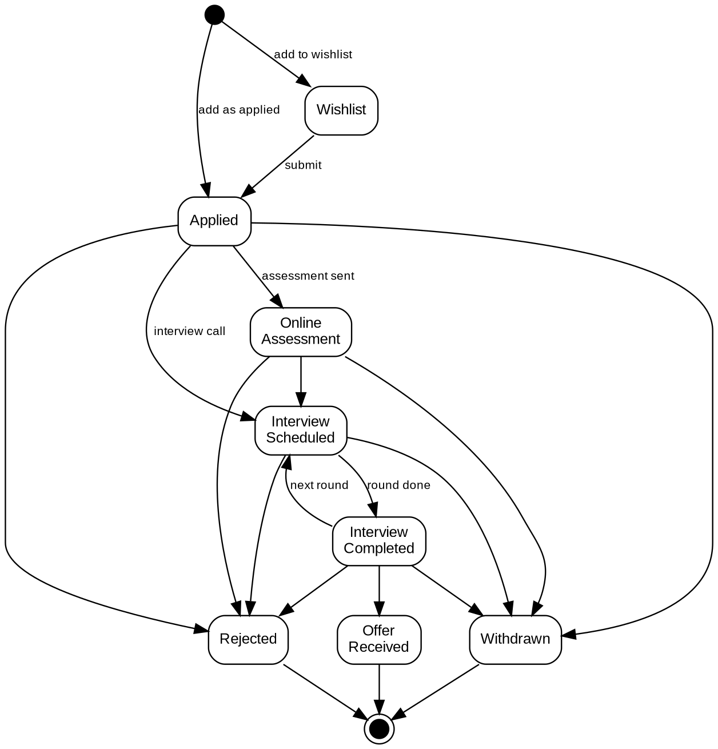
Fig 7.8: State chart – application status lifecycle
2. User Session Lifecycle
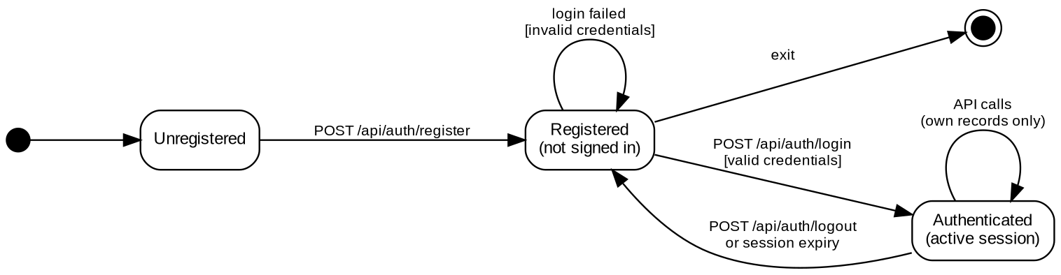
Fig 7.9: State chart – user session lifecycle

