1. Find players who are all-rounders, have more than 100 runs, and a bowling economy rate less than 6:
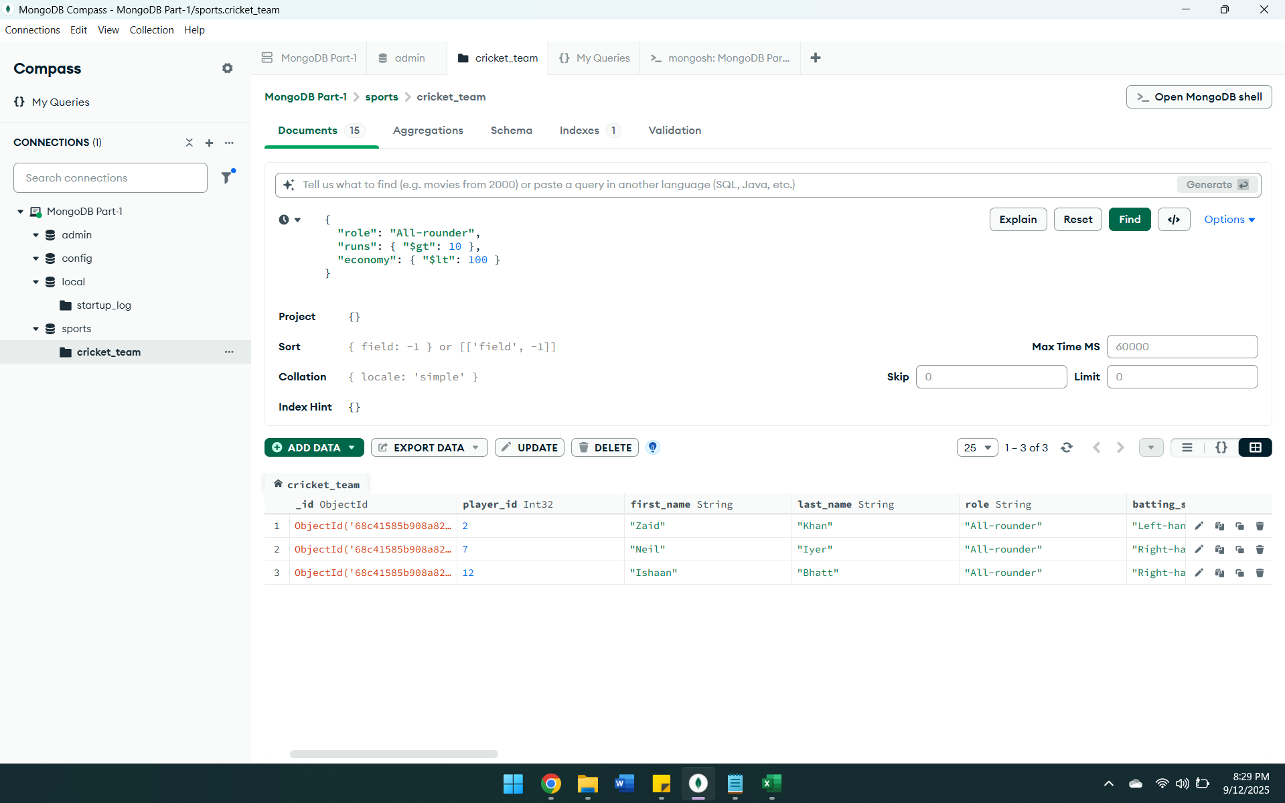
2. Find players who have played more than 100 matches and have a batting strike rate between 90 and 120:
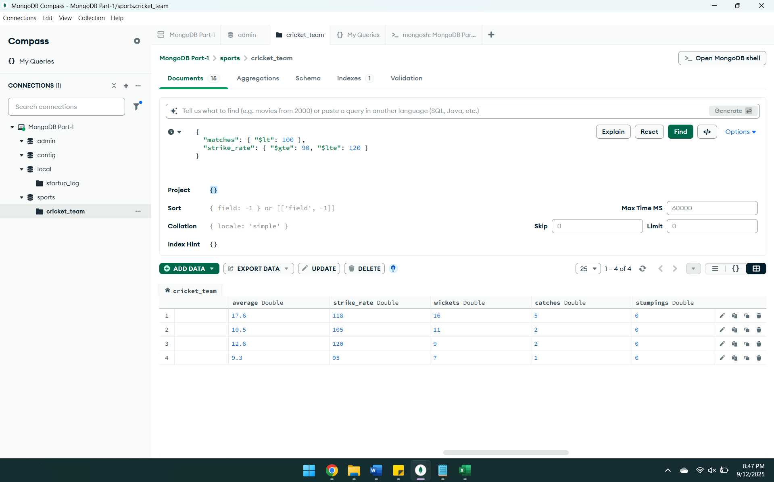
3. Find players who are not available but have a yo-yo score greater than 15:
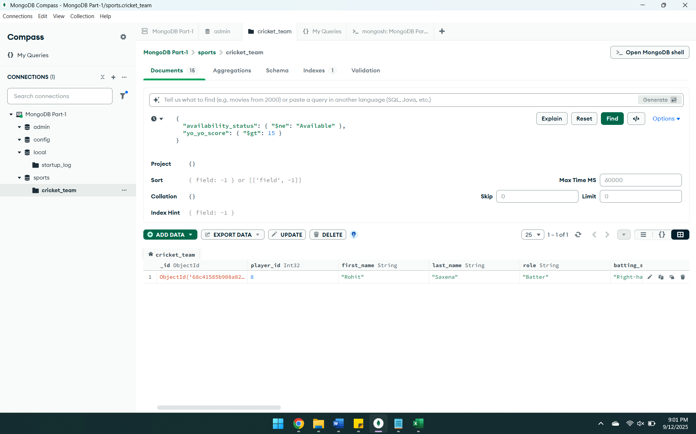
4. Find players whose first name starts with "Sa" and have scored more than 20 runs:
