**TASKS**

**Objective Questions**:

**1. What is the total no. of tables present in the data?**

* The dataset consists of the single worksheet named data which contains only **1** **table** with 28028 rows (including the header row) and 35 columns in total.

**2. What is the total no. of attributes present in the data?**

* The dataset contains **35 original attributes**. After creating **7** **helper attributes** for analysis, the total number of attributes present in the data is **42**.

**3. The data consists of some inconsistent and missing values so ensure that the data used for further analysis is cleaned?**

* Reviewed all dataset columns for inconsistencies and missing values.
* Cleaned issues using Excel functions like PROPER() and TRIM().
* Used functions such as COUNTA(UNIQUE()) and COUNTBLANK() to determine unique and blank values.
* Applied filters to identify distinct values and check anomalies.
* Standardized data types (Text, Number, Date, or Custom) for accuracy.
* Corrected rows with blanks by labeling missing values as N/A where applicable.
* Applied custom formulas to replace missing values and handle blank fields.
* Columns that underwent both data-type changes and further cleaning include:  
  **_id (A), user (B), chatStatus (C), guru (D), guruName (E), gid (F), uid (G), consultationType (H), website (I), refundStatus (J), isWhiteListUser (K), chatSeconds (L), queue (M), freeCall (N), freeChat (O), createdAt (P), updatedAt (Q), __v (R), statementEntryId (S), chatStartTime (T), chatEndTime (U), callChannel (W), callIvrType (X), callStatus (Y), callSid (Z), astrologerCallStatus (AB), region (AF), userCallStatus (AG), rating (AI).**
* Helper/derived columns such as **callDate (AJ), callDay (AK), callHour (AL), callMonth (AM), callYear (AN), callBinaryRepresentation (AO), and chatBinaryRepresentation (AP)** required only data-type adjustments.
* Other original columns such as **timeDuration (V), amount (AA), astrologerOnCallDuration (AC), astrologersEarnings (AD), netAmount (AE), and userOnCallDuration (AH)** were standardized by setting appropriate data types only.

**4. What is the change in daily call volume day by day and also find the average daily call volume.**

* Steps to Analyse Change in Daily Call Volume and Calculate the Average:
* Step 1: Create two helper columns:

callDay (AK) using =TEXT(P2,"dddd") to extract weekdays.

callBinaryRepresentation (AO) using =IF(OR(H2="Call",H2="Public_Live_Call",H2="Complementary"),1,0) to mark calls with 1.

* Step 2: Generate a PivotTable with callDay as Rows and the Sum of callBinaryRepresentation as Values to get total calls per weekday (Refer Fig. 1 – PivotTable4, Fig. 2 – Chart 4).
* Step 3: Compute daily change as the difference between consecutive days (e.g., Monday – Sunday).
* Step 4: Calculate the **average daily call volume** using the formula:  
  =ROUND((COUNTIF(H:H,"Call")+COUNTIF(H:H,"Complementary")+COUNTIF(H:H,"Public_Live_Call"))/COUNTA(UNIQUE(AJ2:AJ28028)),2)
* 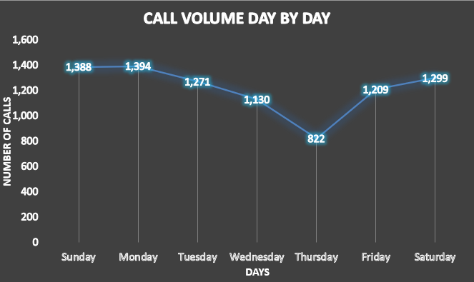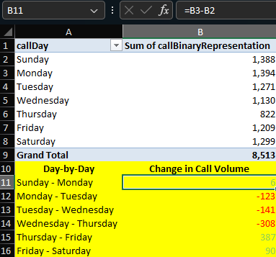Step 5: The result was **250.38 calls/day (Refer Fig. 3).**

**Fig. 1 – PivotTable4 Fig. 2 – Chart 4**

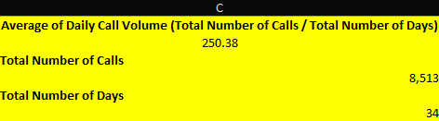

**Fig. 3 – Average of Daily Call Volume**

**5. Which months experienced the highest and lowest call volumes?**

* Steps to Identify Months with Highest and Lowest Call Volumes:
* Step 1: Create a helper column callDate (AJ) using the formula =DATE(YEAR(P2), MONTH(P2), DAY(P2)) from the createdAt (P) column in ISO 8601 format to enable automatic monthly grouping in the PivotTable.
* Step 2: Use the count of consultationType (H) as Values, excluding *Chat* through filters, and adjust number formatting for clarity.
* Step 3: Generate a PivotTable (Fig. 4) and PivotChart (Fig. 5).
* Step 4: From the results:
  + **December 2023 had the highest call volume (8,095 calls).**
  + **January 2024 had the lowest call volume (418 calls).**
* 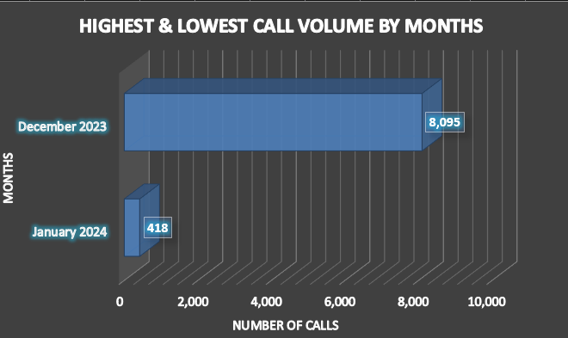Step 5: The total number of calls across both months was 8,513 calls.

.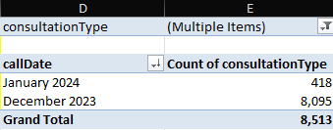

**Fig. 4 – PivotTable5 Fig. 5 – Chart 5**

**6. What is the total operational cost for that month?**

* Steps to Analyse Total Operational Cost for the Months:
* Step 1: Use the helper column callDate (AJ) to group the data by months in the PivotTable.
* Step 2: Place callDate (AJ) in the Rows field so values are automatically aggregated as months.
* Step 3: Add the sum of astrologersEarnings (AD) in the Values field to get the total operational cost.
* Step 4: The results showed:
  + **December 2023 → ₹93,786.16**
  + **January 2024 → ₹5,360.41**
  + **Combined total → ₹99,146.57**
* Step 5: Represent the analysis using PivotTable6 (Fig. 6) in the PivotTables worksheet of the *Astrosage_Analysis.xlsx* workbook, and the corresponding PivotChart (Chart 6, Fig. 7) in the All_Charts worksheet.

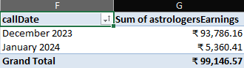

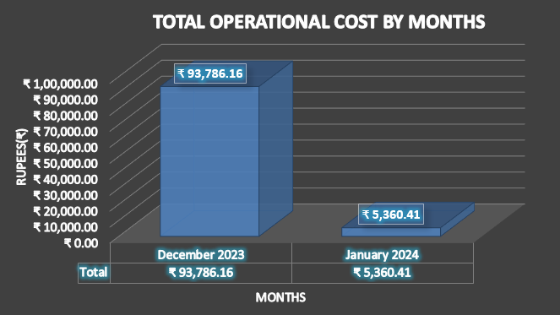**Fig. 6 – PivotTable6**

**Fig. 7 – Chart 6**

**7. What is the average number of calls handled per agent per day?**

* To calculate the average number of calls handled per agent per day, the following steps were performed:
* Step 1: Calculate Total Number of Calls

Formula:  
=(COUNTIF(Cleaned_Data!H:H,"Call")+COUNTIF(Cleaned_Data!H:H,"Complementary")+COUNTIF(Cleaned_Data!H:H,"Public_Live_Call"))  
Result: 8513

* Step 2: Calculate Total Number of Days  
  Formula:  
  =COUNTA(UNIQUE(Cleaned_Data!AJ2:AJ28028))  
  Result: 34
* Step 3: Calculate Total Number of Agents  
  Formula:  
  =COUNTA(UNIQUE(Cleaned_Data!D2:D28028))  
  Result: 133
* Step 4: Calculate Average Number of Calls Per Day  
  Formula:  
  =ROUND((COUNTIF(Cleaned_Data!H:H,"Call")+COUNTIF(Cleaned_Data!H:H,"Complementary")+COUNTIF(Cleaned_Data!H:H,"Public_Live_Call"))/COUNTA(UNIQUE(Cleaned_Data!AJ2:AJ28028)), 2)  
  Calculation: 8513 / 34 = 250.38
* Step 5: Calculate Average Number of Calls Per Agent Per Day  
  Formula:  
  =((COUNTIF(Cleaned_Data!H:H,"Call")+COUNTIF(Cleaned_Data!H:H,"Complementary")+COUNTIF(Cleaned_Data!H:H,"Public_Live_Call"))/COUNTA(UNIQUE(Cleaned_Data!AJ2:AJ28028)))/COUNTA(UNIQUE(Cleaned_Data!D2:D28028))  
  Calculation: 250.38 / 133 = 1.88
* Final Result: **The** **Average Number of Calls Handled Per Agent Per Day** **is** **1.88**.
* This calculation is illustrated in Fig. 8 – Average Number of Calls Per Agent Per Day.

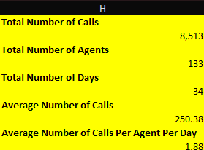

**Fig. 8 – Average Number of Calls Per Agent Per Day**

**8. How many repeat callers are there, and what percentage of total calls do they represent?**

* To determine the number of repeat callers, the following steps were performed:
* Step 1: Calculate Total Calls

Using consultationType (H) → 8,513 calls.

* Step 2: Calculate Total Users

Using uid (G) for unique users → 10,344 users.

* Step 3: Filter for Callers Only

Created a PivotTable filtering consultationType to include only Call, Public_Live_Call, and Complementary.

Result: 3,631 callers.

* Step 4: Count User Calls

In PivotTable, uid was added again to count the number of times each user called.

* Step 5: Classify Callers

Helper column formula:  
=IF(count>1,"Repeat","One-Time")

Result: 2,353 One-Time callers and **1,278 Repeat callers.**

Summarized in PivotTable and visualized using column chart (Refer Fig. 9, Fig. 10).

* Step 6: Percentage Breakdown

Out of 8,513 total calls:

3,631 calls (42.65%) were one-time calls.

**4,882 calls (57.35%) were** **repeat calls**.

* This indicates 57.35% of calls were repeats, while only 42.65% were one-time calls.
* Final Result: Findings were illustrated in a PivotChart (Pie Chart, Refer Fig. 14).

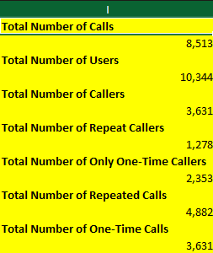

**Fig. 9 – Total Number of Repeat Callers**

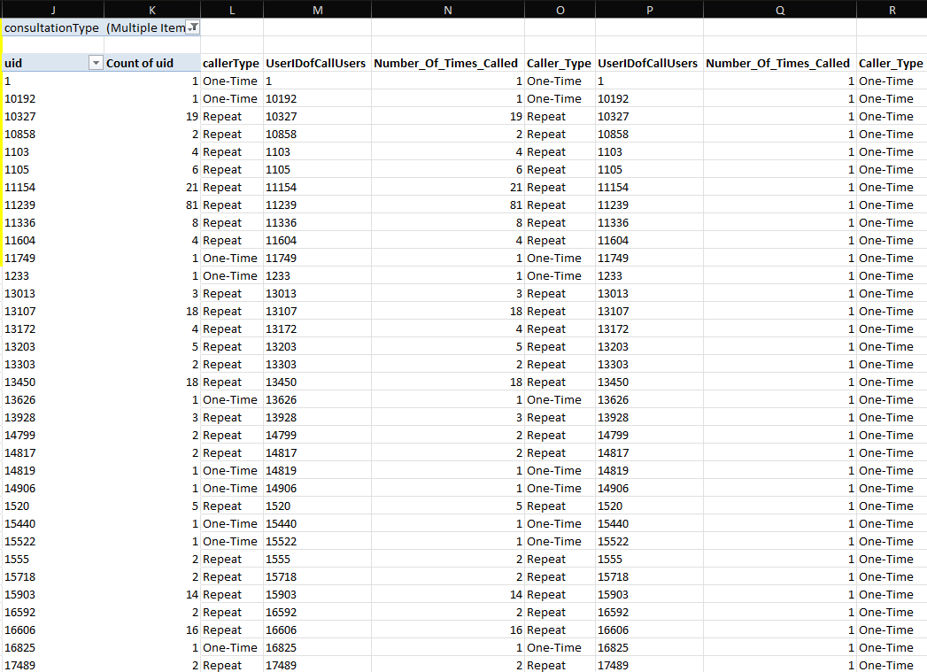

**Fig. 10 – PivotTable8(1) (Not the complete PivotTable, since it contains 3635 rows)**

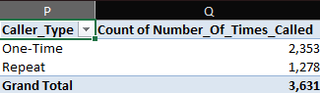

**Fig. 11 – PivotTable8(2)**

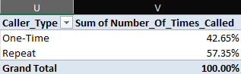

**Fig. 12 – PivotTable8(3)**

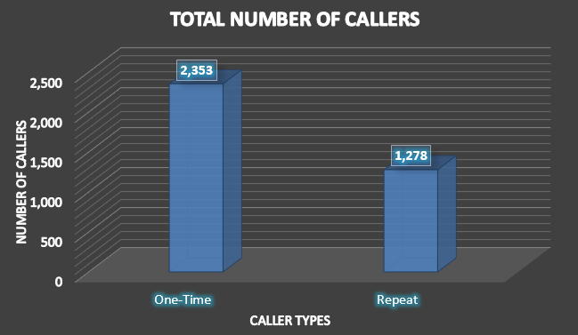

**Fig. 13 – Chart 8(2)**

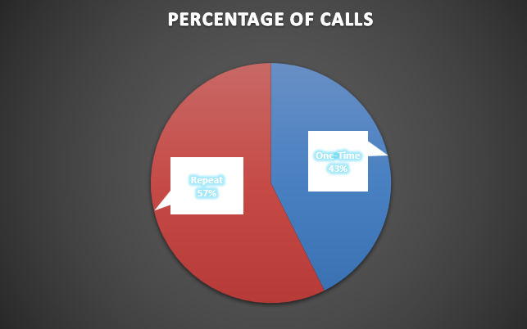

**Fig. 14 – Chart 8(3)**

**9. What are the total sales generated by the call centre for each product category?**

* Steps to calculate the total sales generated by the call centre for each product category:
* Step 1: Create PivotTable

Rows: consultationType (H) → Call, Chat, Public_Live_Call, Complementary.

Values: amount (AA) with aggregation set to SUM.

* Step 2: Sales Generated

**Call: ₹1,68,520.62**

**Chat: ₹45,494.68**

**Public_Live_Call: ₹50.60**

**Complementary: ₹0.00**

* Step 3: Visualization

Results represented using PivotTable (Fig. 15) and PivotChart (Fig. 16).

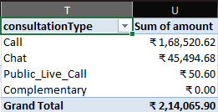

**Fig. 15 – PivotTable9**

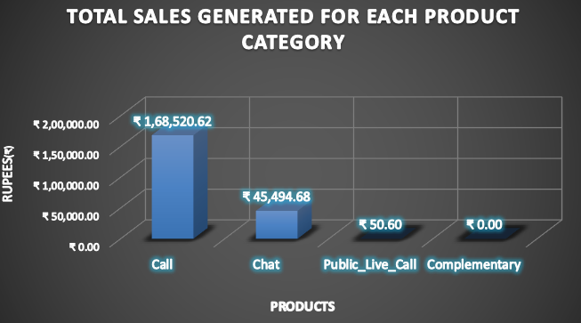

**Fig. 16 – Chart 9**

**10. How many calls were made for each user ID & guru ID?**

* Steps to Analyse Number of Calls for User ID and Guru ID:
* For User ID:
  + Step 1: Take the complete dataset as the source data.
  + Step 2: Create a PivotTable for User ID.
  + Step 3: Apply a filter to exclude only "Chat" from the consultationType (H) column.
  + Step 4: Take the uid (G) column as Rows.
  + Step 5: Take the consultationType (H) column as Values and set the aggregate to Count.
  + Step 6: This will display the number of calls made by each User ID **(Refer Fig. 17).**
  + Step 7: Generate a corresponding PivotChart **(Refer Fig. 18).**
* For Guru ID:
  + Step 1: Use the same source dataset.
  + Step 2: Create a PivotTable for Guru ID.
  + Step 3: Apply the filter to exclude "Chat" from the consultationType (H) column.
  + Step 4: Take the gid (F) column as Rows.
  + Step 5: Take the consultationType (H) column as Values and set the aggregate to Count.
  + Step 6: This will display the number of calls made to each Guru ID **(Refer Fig. 19).**
  + Step 7: Generate a corresponding PivotChart **(Refer Fig. 20).**

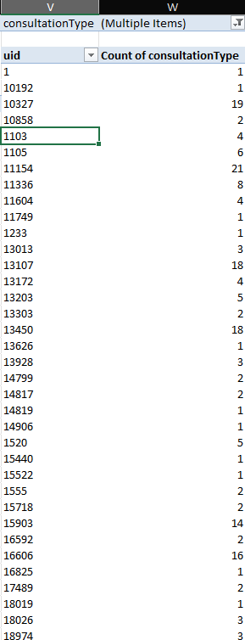

**Fig. 17 – PivotTable10(1) (Not the complete PivotTable, since it contains 3635 rows)**

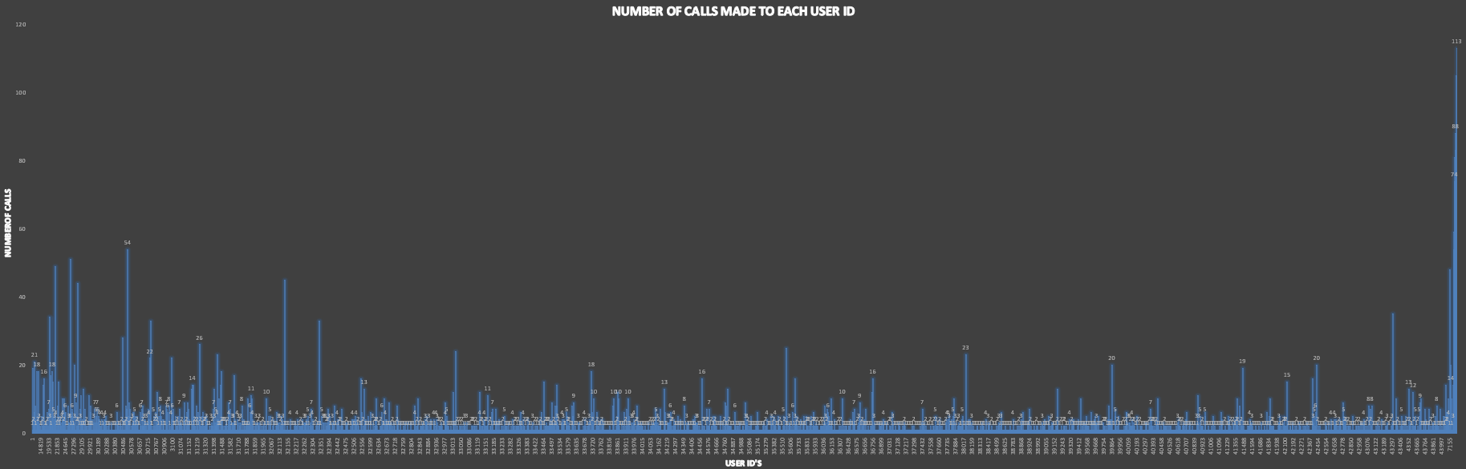

**Fig. 18 – Chart 10(1) (Since it contains 3635 User ID’s Clear PivotChat is not Possible)**

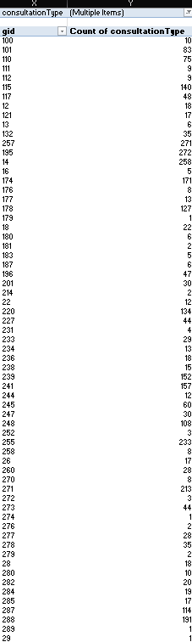

**Fig. 19 – PivotTable10(2) (Not the complete PivotTable, since it contains 112 rows)**

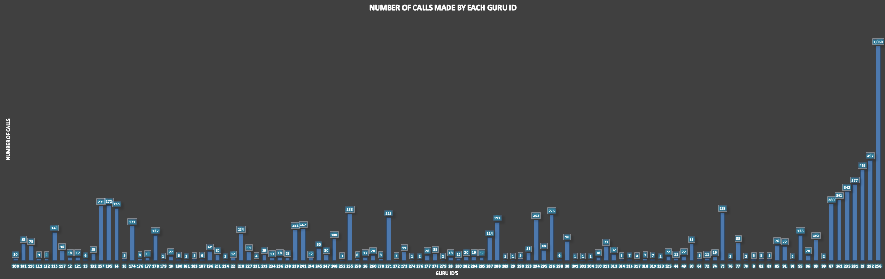

**Fig. 20 – Chart 10(2)**

**11. What is the correlation between call duration and customer satisfaction?**

* Steps to Find Correlation Between Call Duration and Customer Satisfaction:
* Step 1: Select the userOnCallDuration (AH) column from the dataset.
* Step 2: Select the ratings (AI) column from the dataset.
* Step 3: Plot a Scatter Plot (XY) chart using these two columns.
* Step 4: Use the built-in function CORREL() to calculate the correlation between the two columns.
* Step 5: Observe the correlation value, which in this case is **-0.0002024514**.
* Step 6: Since the value is close to 0, it indicates that **there is little to no correlation between the two columns** (Refer Fig. 21 & 22).

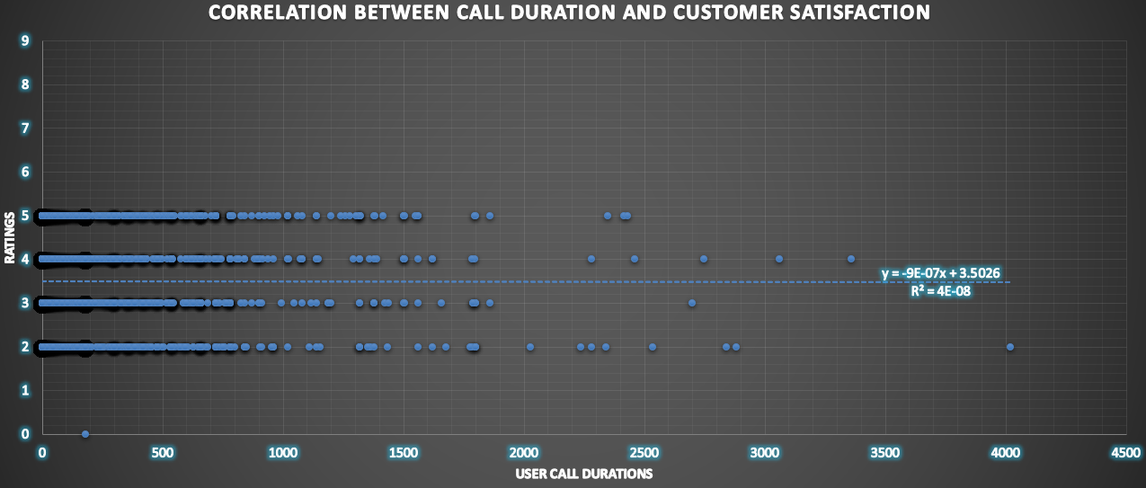

**Fig. 21 – Chart 11**

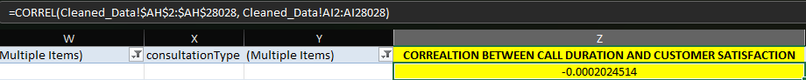

**Fig. 22 – Correlation Between Call Duration and Customer Satisfaction**

**12. Which guru has the highest and lowest customer satisfaction scores?**

* Steps to Analyse Gurus with Highest and Lowest Customer Satisfaction Scores:
* For Highest Ratings:
  + Step 1: Create a PivotTable using the complete dataset as the source data.
  + Step 2: Place the guruName (E) column in the Rows field.
  + Step 3: Place the rating (AI) column in the Values field and set the aggregate to Average.
  + Step 4: Identify the Gurus with the highest rating, which in this case **was 7.5, achieved by two Gurus — Astro Pujaa Rai and Tarot Mystical.**
  + Step 5: Apply a Value Filter to the PivotTable to display the Top 2 (Refer Fig. 23 & 24).
* For Lowest Ratings:
  + Step 1: Create another PivotTable using the same source data, Rows, and Values fields.
  + Step 2: Check for Gurus with the lowest rating, which in this case was **0.0, held by only one Guru — Tarot Rittika.**
  + Step 3: Apply a Value Filter to display records equal to 0 (Refer Fig. 25 & 26).

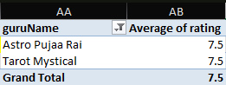

**Fig. 23 – PivotTable12(1)**

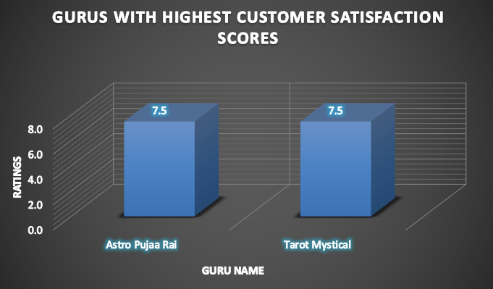

**Fig. 24 – Chart 12(1)**

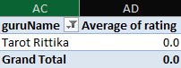

**Fig. 25 – PivotTable12(2)**

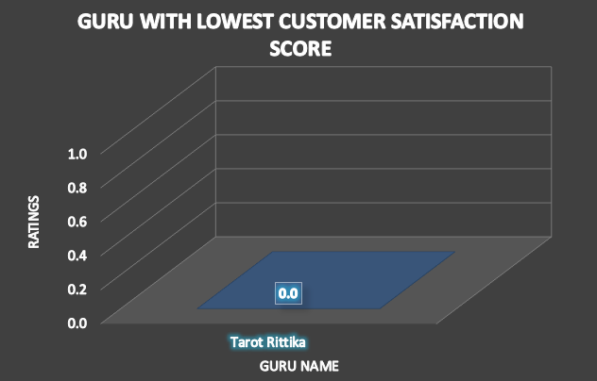

**Fig. 26 – Chart 12(2)**

**13. What is average customer satisfaction score by months?**

* Steps to Analyse Average Customer Satisfaction Score by Months:
* Step 1: Create a PivotTable using the complete dataset as the source data.
* Step 2: Place the callDate (AJ) column in the Rows field; the dates will automatically group by months.
* Step 3: Place the rating (AI) column in the Values field and set the aggregate to Average.
* Step 4: Obtain the average customer satisfaction scores as the values, which in this case are:
  + **December 2023: 2.95**
  + **January 2024: 2.68** (Refer Fig. 27 & 28).

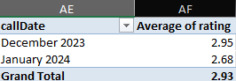

**Fig. 27 – PivotTable13**

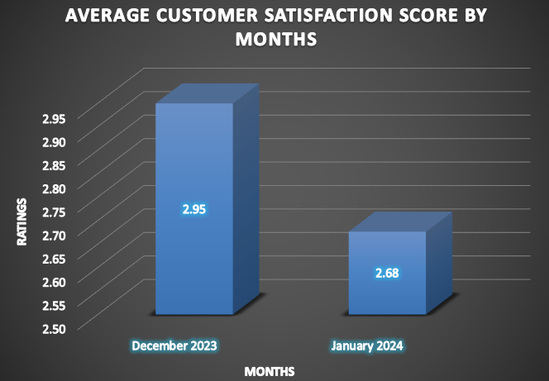

**Fig. 28 – Chart 13**

**14. How many categorical columns are there in the data? [Search about categorical and continuous data, and try to answer this question].**

* There are a total of 35 columns (attributes) excluding the 7 derived attributes (helper columns) out of 35 columns **17 are Continuous Columns (attributes):**

_id(A), _user (B), guru (D), gid (F), uid (G), createdAt (P), updatedAt (Q), statementEntryId (S), chatStartTime (T), chatEndTime (U), timeDuration (V), callSid (Z), amount (AA), astrologerOnCallDuration (AC), astrologersEarnings (AD), netAmount (AE), rating (AI).

* And **18 are Categorical Columns (attributes):**

chatStatus (C), guruName (E), consultationType (H), website (I), refundStatus (J), isWhiteListUser (K), chatSeconds (L), queue (M), freeCall (N), freeChat (O), __v (R), callChannel (W), callIvrType (X), callStatus (Y), astrologerCallStatus (AB), region (AF), userCallStatus (AG), userOnCallDuration (AH).

**Subjective Questions**:

1. **Should the investment be used to hire more agents, improve training programs, or upgrade call centre technology?**

**Ans) I. Approach:**

* Conducted a three-step analysis to identify the best investment area:

1. **Hiring More Agents:**

* Checked average calls/chats handled per agent per day to assess workload and need for additional manpower.

1. **Improving Training Programs:**

* Evaluated average customer satisfaction score of each agent to determine training needs.

1. **Upgrading Call Centre Technology:**

* Analysed success rate of calls/chats by comparing completed vs. failed/incomplete/not answered interactions.

**II. Insights/Analysis:**

* **Average Calls/Chats per Agent per Day:**
* Total Calls = COUNTIF(H:H,"Call")+COUNTIF(H:H,"Complementary")+COUNTIF(H:H,"Public_Live_Call") → **8,513**
* Total Chats = COUNTIF(H:H,"Chat") → **19,514**
* Unique Agents = COUNTA(UNIQUE(D2:D28028)) → **133**
* Unique Days = COUNTA(UNIQUE(AJ2:AJ28028)) → **34**
* Formula: (Total Calls + Total Chats) / (Total Agents * Total Days)
* Calculation: (8513 + 19514) / (133 * 34) = **6.20** (Refer Fig. 29).

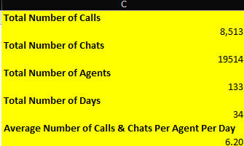

**Fig. 29 – Average Number of Calls & Chats Per Agent Per Day**

* **Average Customer Satisfaction per Agent:**
* PivotTable with guruName (E) as Rows and ratings (AI) as Values (Aggregate: Average).
* Out of 148 agents, **65 agents (44%)** had an average score of ≤ 3/8 (Refer Fig. 30 & 31).

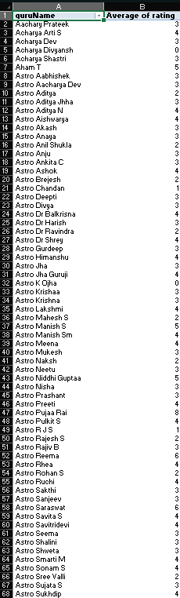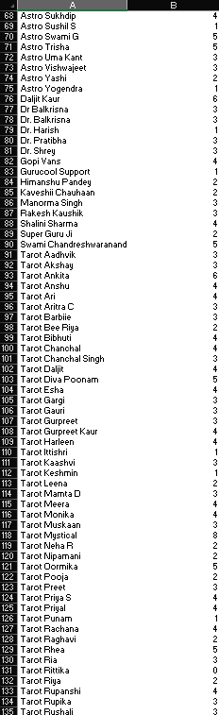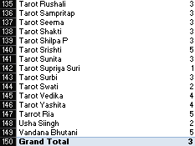

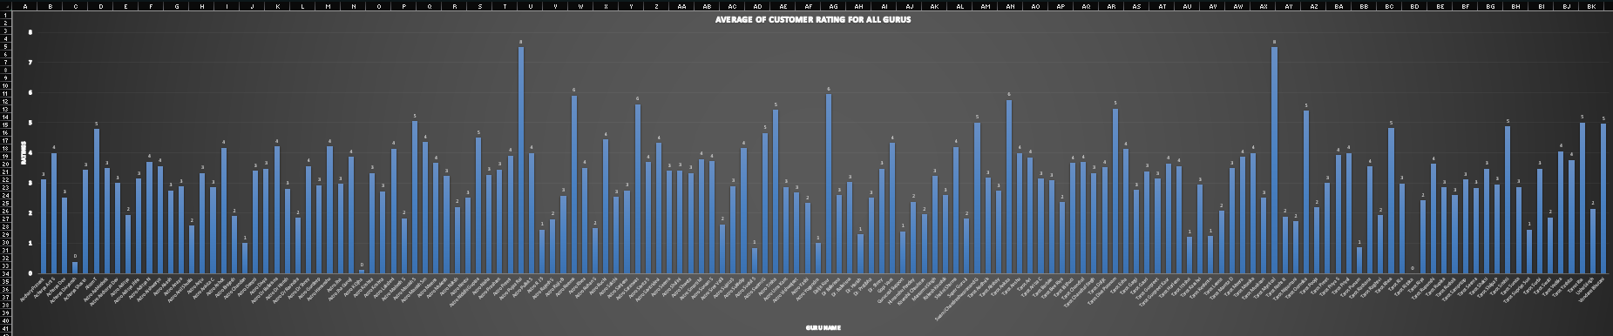**Fig. 30 – PivotTable14**

**Fig. 31 – Chart 14**

* **Success Rate of Calls:**
* PivotTable with consultationType (H) filter (excluding Chat), callStatus (Y) as Rows, and Count of callStatus (Y) as Values (Show % of Grand Total).
* Out of 8,513 calls:
  + **3,398 (40%)** → Completed/Successful
  + **5,115 (60%)** → Unsuccessful (busy, failed, incomplete, no-answer) (Refer Fig. 32 & 33).

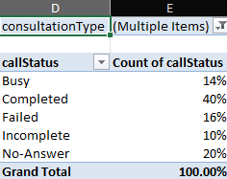 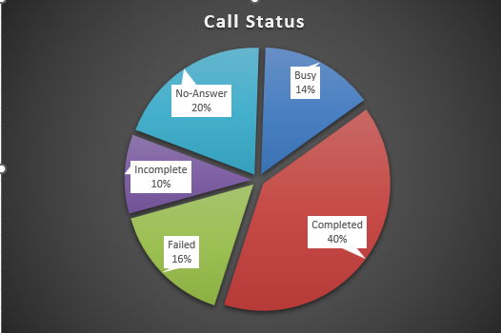 **Fig. 32 – PivotTable15** **Fig. 33 – Chart 15**

* **Success Rate of Chats:**
* PivotTable with consultationType (H) filter (only Chat), chatStatus (C) as Rows, and Count of chatStatus (C) as Values (Show % of Grand Total).
* Out of 19,514 chats:
  + **5,535 (28%)** → Completed/Successful
  + **13,979 (72%)** → Unsuccessful (failed, incomplete, pending, started) (Refer Fig. 34 & 35).

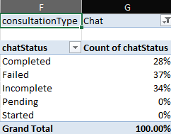 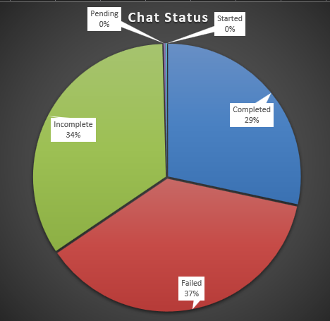

**Fig. 34 – PivotTable16** **Fig. 35 – Chart 16**

**III. Recommendations/Suggestions:**

* **Hiring More Agents:**
* Average workload per agent = **6.20 interactions/day** (calls + chats).
* No signs of burnout/overburden.
* Current staffing levels are sufficient.
* **Improving Training Programs:**
* **44% of agents** have an average satisfaction score ≤ 3/8.
* Indicates poor service quality and inconsistent customer support.
* Strongly recommend structured training to improve:
  + Communication skills
  + Subject knowledge
  + Problem-solving abilities

Training will directly enhance customer experience and satisfaction.

* **Upgrading Call Centre Technology:**
* **Low success rates:** 40% (calls), 28% (chats).
* Failures due to technical issues (busy, failed, incomplete, pending).
* Reflects unreliable system.
* Recommend investment in:
  + Better call routing
  + Robust chat platforms
  + Improved connectivity
* Priority upgrade to increase reliability, efficiency, and success rates.
* **Conclusion:**
* Hiring more agents is **not urgent**.
* **Critical priorities:** Training + Technology upgrade.
* These will improve:
  + Customer interaction quality
  + Service efficiency
  + Customer satisfaction
  + Conversions and overall performance.

1. **What are the potential risks of each investment option (hiring, training, technology upgrades), and how can they be mitigated?**

**Ans)** **I. Approach:**

* We assessed potential risks of each investment option through a structured dataset analysis:
* **Hiring:**
* Measured average calls/chats per agent per day to assess workload.

1. **Training:**

* Reviewed agent CSAT scores to identify service gaps.

1. **Technology Upgrades:**

* Analysed call/chat success rates to evaluate system reliability.

**II. Insights/Analysis:**

1. **Hiring:**

* Average workload per agent per day = **6.20 interactions** (8,513 calls + 19,514 chats / 133 agents × 34 days) → indicates no overburden (Fig. 36).



**Fig. 36 – Average Number of Calls & Chats Per Agent Per Day**

1. **Training:**

* Out of **148 agents**, **65 (44%)** had an average customer satisfaction score ≤ 3/8 (Figs. 37 & 38).

**Fig. 37 – PivotTable14**



**Fig. 38 – Chart 14**

1. **Technology Upgrades:**

* **Calls:** Only **40%** (3,398/8,513) were successful; **60% failed** (Fig. 39 & 40).
* **Chats:** Only **28%** (5,535/19,514) were successful; **72% failed** (Figs. 41 & 42).

**Fig. 39 – PivotTable15** **Fig. 40 – Chart 15**



**Fig. 41 – PivotTable16** **Fig. 42 – Chart 16**

**III. Recommendations/Suggestions:**

1. **Hiring:**

* **Risks:** Unnecessary hiring may cause underutilization, idle agents, and higher costs.
* **Mitigation:** Track utilization; hire only if sustained peak loads occur, ideally via on-demand/part-time staffing.

1. **Training:**

* **Risks:** Generic training may waste resources if it doesn’t address actual weaknesses.
* **Mitigation:** Target low-performing agents; design skill-focused training (empathy, tone, problem-solving) and measure post-training improvements.

1. **Technology Upgrades:**

* **Risks:** High costs, long timelines, and potential mismatch with real issues.
* **Mitigations:** Use a phased rollout with pilot testing; start with small upgrades (queue management, call routing). Leverage PivotTables and status breakdowns to guide improvements and track results.

1. **How does AstroSage's call center performance compare to AstroGuru's average call volume, customer satisfaction, and agent performance? Will you use any aggregation function or a visualization here to solve the problem?**

**Ans) I. Approach:**

* **AstroGuru** - Dataset unavailable; attempted online research but found limited information. Relied on public reviews and ratings for performance insights.
* **AstroSage -** Full dataset available; performance assessed using detailed company data.

**II. Insights/Analysis:**

**AstroSage:**

* **Average Call Volume:**
* Total Calls =
* =(COUNTIF(H:H,"Call")+COUNTIF(H:H,"Complementary")+COUNTIF(H:H,"Public_Live_Call")) → **8,513**
* Total Days = =COUNTA(UNIQUE(AJ2:AJ28028)) → **34**
* Average Call Volume = =ROUND(Total Calls/Total Days,2) = **8513/34 = 250.38** (Fig. 43).

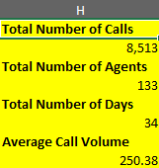

**Fig. 43 – Average Call Volume**

* **Customer Satisfaction:**
* PivotTable: Rows = guruName (E), Values = Average of rating (AI)
* Overall satisfaction (Grand Total) = **2.93/10** (Fig. 44).

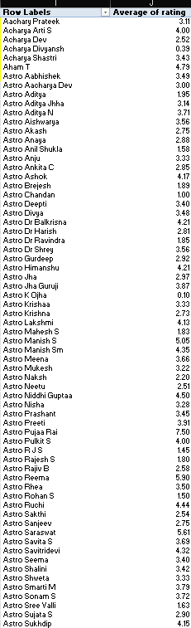 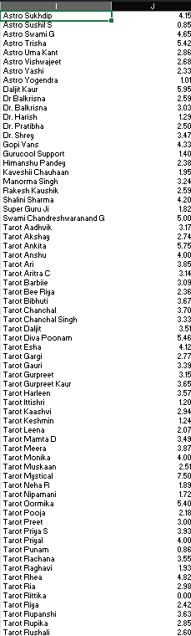 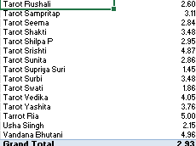

**Fig. 44 – PivotTable17**

* **Agent Performance:**
* Total Agents = =COUNTA(UNIQUE(D2:D28028)) → **133**
* Avg. Calls/Day = =ROUND(Total Calls/Total Days,2) = **250.38**
* Avg. Calls/Agent/Day = =(Total Calls/Total Days)/Total Agents = **250.38/133 = 1.88** (Fig. 45).

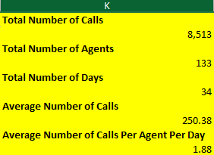

**Fig. 45 – Average Number of Calls Per Agent Per Day**

|  |  |  |
| --- | --- | --- |
| **Metric** | **AstroSage (From Excel Dataset)** | **AstroGuru (From Online Reviews)** |
| **Average Call Volume** | 250.38 | Not available (Couldn’t get data online) |
| **Customer Satisfaction** | 2.93/8 | 3.9/5 (From Google Play Ratings) |
| **Agent Performance** | 1.88 Calls Per Agent Per Day | Not Available (Couldn’t get data online) |
| **Reviews (Additional)** | Mixed Reviews (Due to High Call Failure, Poor Guru Ratings) | Mostly Positive (Due to Accurate Predictions) |

**AstroSage vs AstroGuru**

**III. Recommendations/Suggestions:**

* **AstroSage:**
* **Call Volume:** Improve prediction accuracy to boost conversions and optimize agent utilization.
* **Customer Satisfaction:** Launch targeted training (soft skills, empathy, solution-oriented handling, accurate predictions) to address service quality gaps.
* **Agent Productivity:** Reduce idle time with upgraded call-center technology to maintain motivation and efficiency.
* **Technology:** Invest in call stability, better UI, response tracking, and optimized routing to reduce failed/incomplete calls.
* **Benchmarking:** Study AstroGuru’s strengths (high ratings, positive reviews) and adopt best practices to enhance AstroSage’s performance.
* **Feedback:** Implement review prompts, chat surveys, and quick resolution systems for real-time customer feedback and experience improvement.

1. **How can the call centre improve its handling of peak call periods to ensure high customer satisfaction? Mention the functionality you will use for giving the suggestions, will it be any aggregated function or a visualization?**

**Ans) I. Approach:**

* To identify peak call hours, we use the helper column **callHour (AL)**, extracted from **createdAt (P)**. A **PivotTable and PivotChart** are created to visualize call distribution across hours and pinpoint peak periods.
* Once peak hours are identified, we analyze **call status** during those periods, comparing percentages of successful vs. incomplete/failed/no-answer calls. This highlights performance gaps and supports targeted recommendations to improve handling in high-demand hours.

**II. Insights/Work:**

* 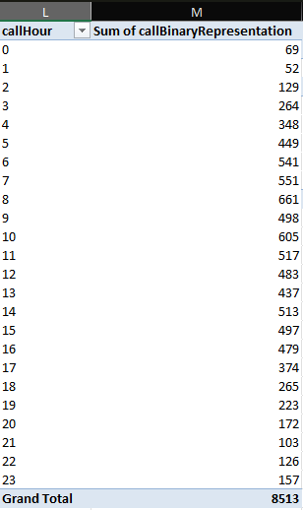**Peak Hours:** Using a PivotTable with callHour (AL) and callBinaryRepresentation (AO), 8 AM was identified as the peak period (Fig. 46 & 47).

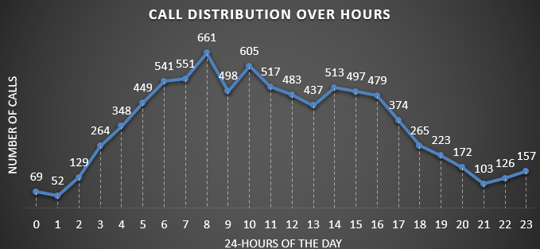**Fig. 46 – PivotTable18**

**Fig. 47 – Chart 18**

* 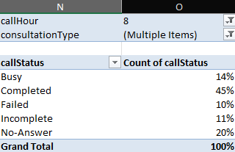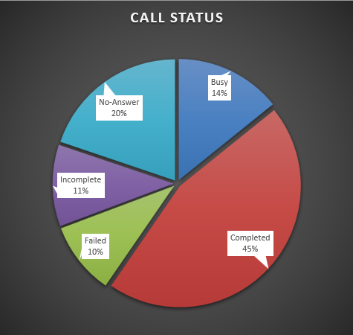**Call Performance:** At 8 AM, PivotTables/Charts with **callStatus (Y)** showed the share of successful vs. failed/incomplete calls (Fig. 48 & 49).

**Fig. 48 – PivotTable19 Fig. 49 – Chart 19**

* 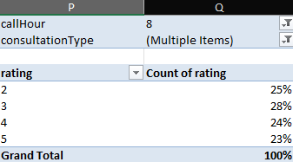**Customer Ratings:** Ratings during 8 AM were analyzed via PivotTable/Chart using rating (AI), showing distribution of satisfaction levels (Fig. 50 & 51).

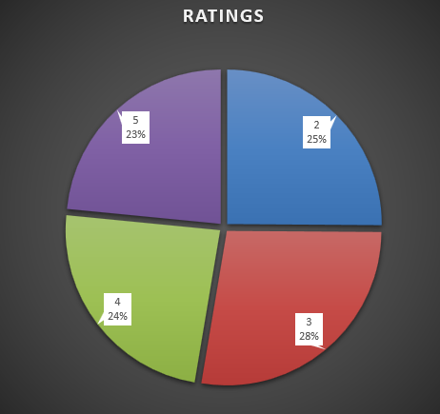

**Fig. 50 – PivotTable20 Fig. 51 – Chart 20**

* 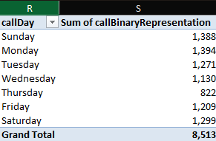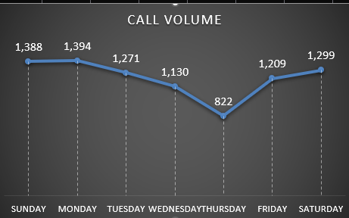**Day-wise Volume:** Weekly call patterns were reviewed with PivotTable/Chart for days of the week (Fig. 52 & 53).

**Fig. 52 – PivotTable21 Fig. 53 – Chart 21**

**III. Recommendations/Suggestions:**

* **Peak Hours (Fig. 47):** Increase agent availability between 5 AM–4 PM; avoid breaks during these hours. Use IVR menus to route/hold calls and reduce wait times.
* **Day-wise Load (Fig. 53):** Prepare for heavier traffic on Mondays, Sundays & Saturdays. Schedule training/maintenance during Wednesdays & Thursdays (low-traffic).
* **Call Success Rate (Fig. 49):** With only 45% successful calls at 8 AM, upgrade call center technology (routing, stability, infrastructure) to improve completion rates.
* **Customer Ratings (Fig. 50):** Low ratings (2–5/10) suggest dissatisfaction. Enhance prediction accuracy and provide targeted training (empathy, problem-solving, communication).
* **Proactive Alerts:** Send weekly alerts to customers with projected high-volume days, helping them plan and avoid missed calls.

1. **Based on historical data, what strategic initiatives should be prioritized to improve efficiency and customer satisfaction?**

**Ans) I. Approach:**

* Historical analysis shows peak calls between 5 AM–4 PM, with the heaviest load at 8 AM, but only 45% success rate and low customer ratings (2–5/10).
* Customer satisfaction suffers due to failed/incomplete calls and agent idleness during off-peak hours.
* Benchmarking AstroGuru reveals AstroSage’s gaps in prediction accuracy, agent soft skills, and technology infrastructure.

**II. Insights/Work:**

* **Peak Call Periods**
* Created a PivotTable with callHour (AL) as Rows and callBinaryRepresentation (AO) as Values (aggregation: Sum) to identify peak call hours (Refer Fig. 54).
* Generated a corresponding PivotChart for visual representation of peak periods (Refer Fig. 55).



**Fig. 54 – PivotTable18**

**Fig. 55 – Chart 18**

* **Customer Ratings During Peak Period (8 AM)**
* Used a PivotTable and PivotChart to analyse customer satisfaction (Refer Fig. 56 & 57).
* PivotTable setup:
  + callHour (AL) and consultationType (H) in Filters
  + rating (AI) in Rows and Values (aggregation: Count)
  + Displayed as % of Grand Total to show distribution of ratings during peak calls.

**Fig. 56 – PivotTable20 Fig. 57 – Chart 20**

**III. Recommendations/Suggestions:**

**Strategic Initiatives:**

1. **Optimize Workforce Allocation:**

* Increase agent availability during peak hours to reduce wait times.
* Rebalance schedules to minimize idle time during low-volume periods.

1. **Upgrade Call Center Technology:**

* Invest in call stability, routing, and tracking systems to reduce failed/incomplete calls.
* Enhance user interface and response tracking to improve agent efficiency.

1. **Enhance Prediction Accuracy & Quality of Consultations:**

* Train agents using data insights for more accurate predictions and higher customer trust.
* Utilize AI tools to better match customers with appropriate gurus/agents.

1. **Targeted Training & Skill Development:**

* Conduct specialized training on empathy, solution-oriented communication, and soft skills.
* Implement regular coaching and performance reviews for continuous improvement.

1. **Customer Feedback & Benchmarking:**

* Capture real-time feedback via surveys and issue-resolution pathways.
* Benchmark service processes against AstroGuru’s performance to identify best practices.

1. **What can be the key factors contributing to high customer satisfaction scores, and how can these be leveraged to improve overall performance? What is the basis for suggestions? And mention how you decide if satisfaction score affects the ratings.**

**Ans) I. Factors Contributing to High Customer Satisfaction Scores:**

* **Successful completion of calls/chats:** Customers who experience smooth, uninterrupted interactions are more likely to give higher ratings.
* **Agent performance:** High-performing agents with better ratings (from earlier analysis) consistently deliver quality service, empathy, and effective problem-solving.
* **Efficient handling during peak hours:** Agents who can manage queries effectively even during heavy traffic periods contribute positively to satisfaction.
* **Prediction accuracy:** Accurate horoscope/personalized guidance builds trust and improves satisfaction scores.

**II. Insights/Work:**

* **Analysis of High Satisfaction Scores:**
* Created a PivotTable with **consultationType** (Calls, Public_Live_Call, Complementary) and excluded Chats.
* Filtered **ratings** column to include only **5** (high satisfaction).
* Placed **callStatus** in rows and values (Count, % of Grand Total) to analyze outcomes: completed, failed, no-answer, incomplete (Refer Fig. 58).
* 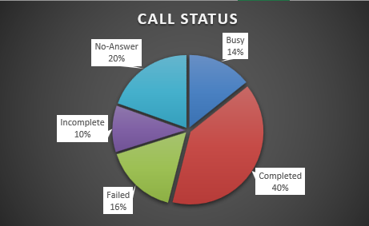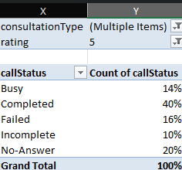Generated a corresponding PivotChart (Refer Fig. 59) for visual interpretation of patterns.

**Fig. 58 – PivotTable24 Fig. 59 – Chart 24**

* **Guru Performance Analysis:**
* PivotTable with guruName in rows and ratings in values (Average) to calculate average satisfaction per guru (Fig. 60).
* PivotChart generated to visualize top 10 gurus by average rating (Fig. 61).
* Top performers: Astro Pujaa Rai & Tarot Mystical (7.5), Daljit Kaur (5.95), Astro Reema (5.90); others range between 5.05–5.75.
* Highlights agents consistently contributing to higher customer satisfaction.

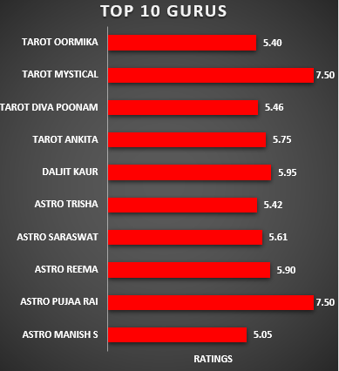 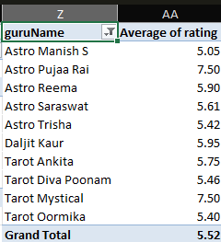

**Fig. 60 - PivotTable25 Fig. 61 – Chart 25**

**III. Recommendations/Suggestions:**

* **Improve Call Completion Rates:**
* Invest in call-routing systems, queue management, and network stability to reduce failed or dropped calls.
* Higher completion rates directly improve customer satisfaction.
* **Enhance Agent Training:**
* Use high-rated agents as benchmarks for targeted training programs.
* Focus on empathy, communication, and solution-oriented approaches.
* **Peak Hour Optimization:**
* Implement flexible staffing schedules for 8 AM–4 PM, the period with highest call volumes.
* Ensure effective query handling to maintain satisfaction during peak hours.
* **Promote Best Practices of Top Agents:**
* Document strategies of top performers (e.g., Astro Pujaa Rai, Tarot Mystical).
* Replicate these approaches across the team.
* **Leverage Feedback Mechanisms:**
* Use post-call/chat surveys and feedback forms to capture customer sentiment immediately.
* Analysing this feedback helps refine training and operational practices.

**IV. Basis for Suggestions:**

* Derived from historical data analysis of call completion rates, agent ratings, and peak-hour performance.

**V. Link Between Satisfaction Scores & Ratings:**

* Higher satisfaction scores typically correspond to better customer ratings, indicating that service quality directly influences feedback.

1. **How should the call centre balance the workload among agents to ensure optimal performance and avoid burnout? Mention your approach and spreadsheet function for your answer.**

**Ans) I. Approach:**

* Identify total calls handled by each agent to detect workload distribution.
* Analyse total chats handled by each agent for similar imbalances.
* Highlight overburdened agents vs. underutilized agents to identify potential burnout, fatigue, and decreased motivation.
* Recommend workload balancing to ensure fair utilization, sustained performance, and agent well-being.

**II. Insights/Work:**

* **Call Distribution Analysis:**
* **PivotTable:** GuruName in rows, callBinaryRepresentation in values; sorted descending and filtered for Top 30 gurus (Fig. 62).
* PivotChart generated for visual comparison (Fig. 63).
* **Insight:** Small set of gurus handle majority of calls → indicates workload concentration and need for balanced allocation.

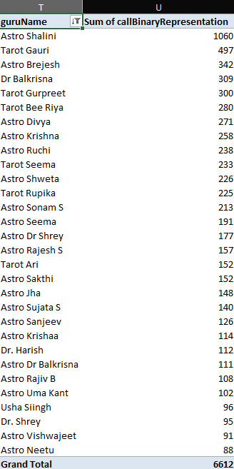

**Fig. 62 – PivotTable22**

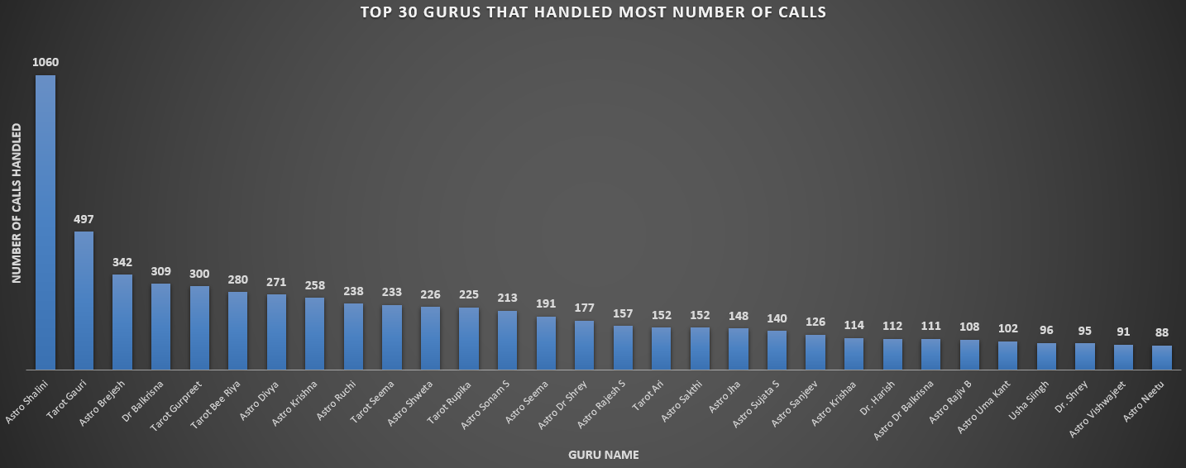

**Fig. 63 – Chart 22**

* **Chat Distribution Analysis:**
* **PivotTable:** GuruName in rows, chatBinaryRepresentation in values; sorted descending and filtered for Top 30 gurus (Fig. 64).
* PivotChart generated for visual comparison (Fig. 65).
* **Insight:** Small set of gurus handle majority of chats → highlights imbalance and opportunities for more equitable chat assignments.

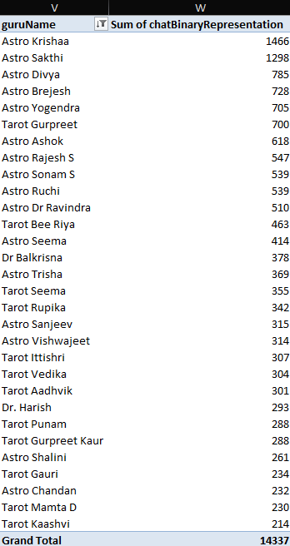

**Fig. 64 – PivotTable23**

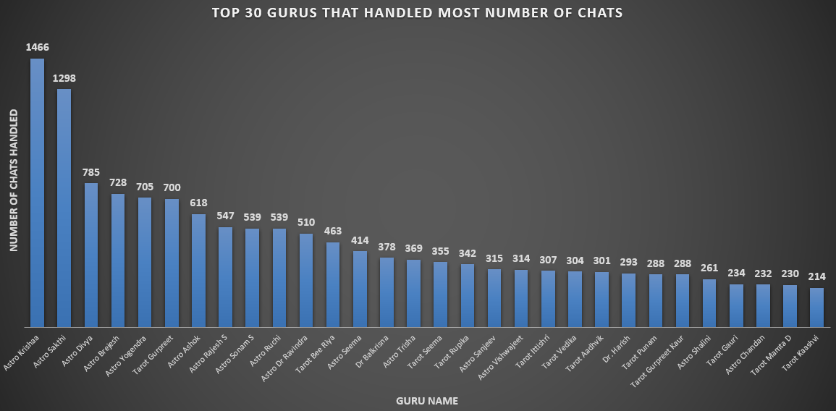

**Fig. 65 – Chart 23**

**III. Recommendations/Suggestions:**

1. **Smart Call Routing:**

* Implement Automated Call Distribution (ACD) for even call routing.
* Use round-robin assignment to avoid overloading specific agents.

1. **Shift Optimization:**

* Align schedules with peak hours (5 AM–4 PM) for adequate coverage.
* Rotate agents between high and low-volume shifts to maintain balance.

1. **Skill-Based Allocation:**

* Route complex queries to experienced agents; spread routine queries across the team.
* Cross-train underutilized agents to share workload more effectively.

1. **Performance Monitoring:**

* Track calls/chats per agent continuously to ensure fair distribution.
* Use real-time dashboards to detect overload and redistribute tasks quickly.

1. **Customer Preference Handling:**

* Allow preferential agent requests only up to a manageable percentage.
* Balance preferences with fair workload distribution across the team.

**Workload Insights & Targeted Actions:**

* **Calls (Figures 58 & 59):**
  + 77% of calls (6,612 out of 8,513) handled by Top 30 agents.
  + Example: Astro Shalini (1,060 calls) vs. Tarot Gauri (497) and Astro Brejesh (342).
  + Risks: burnout of high-performers, disengagement of underutilized agents.
  + Recommendations:
    - Redistribute workload evenly.
    - Train lower-engagement gurus to improve handling capacity.
    - Incentivize top performers with recognition/rewards.
    - Optimize scheduling to balance top agent availability during peak times.
* **Chats (Figures 60 & 61):**
  + 73% of chats (14,337 out of 19,514) handled by Top 30 agents.
  + Example: Astro Neetu (1,466 chats) and Astro Shalini (1,298 chats) = 2,764 chats together.
  + Steep workload drop after top 2 highlights imbalance.
  + Recommendations:
    - Balance chat routing among mid-tier and lower-engagement gurus.
    - Provide training/mentorship from high performers to underutilized agents.
    - Introduce monitoring & incentive schemes to promote equitable participation.
    - Align top gurus with peak demand periods and spread non-peak workload across others.

1. **What new technologies or tools could be implemented to enhance call centre operations and customer services?**

* Based on the previously analysed data & insights, the technologies or tools to be implemented are:

1. **AI-powered chatbots & virtual assistants** – Automate routine queries, reduce agent workload, and provide instant 24/7 support.
2. **Advanced CRM with analytics** – Give agents real-time customer insights for more personalized and efficient service.
3. **Cloud-based contact centre solutions** – Ensure scalability, flexibility, and remote accessibility.
4. **Speech analytics & sentiment analysis** – Monitor customer emotions, identify pain points, and improve service quality.
5. **Omnichannel platforms** – Integrate phone, email, chat, and social media for seamless customer experiences.
6. **Workforce management software** – Optimize agent scheduling, performance tracking, and resource allocation.

**Additional Recommendations/Suggestions:**

* Upgrade systems with automated call routing, interactive menus, and real-time dashboards → reduces failed/incomplete calls and boosts productivity.
* Avoid unnecessary hiring – each agent currently handles ~1.88 calls/day; inefficiencies lie in process, not manpower.
* Provide personalized performance dashboards for gurus → track ratings, response times, and feedback to drive self-improvement.
* Introduce micro-training programs (20–30 min weekly) for underperforming gurus → focus on empathy, communication, and clarity to uplift service quality at low cost.

1. **What metrics should be included in final dashboard to comprehensively view call centre performance and guide investment decisions?**

* Key metrics to include in the final dashboard for a comprehensive view of call centre performance and investment decisions:

1. **Total Calls Receiverd** **(8,513)** – Tracks the overall workload managed by agents. This helps assess whether current staffing levels are sufficient and whether resources are being effectively utilized.
2. **Call Completion Rate (40%)** – Compares the number of completed calls with the total number of calls and chats initiated. This highlights service reliability, identifies drop-off issues, and allows comparison between consultation types (calls vs. chats).
3. **Average Customer Satisfaction Score (2.93/8)** – Measures customer happiness and trust in the service provided. This metric is crucial as high satisfaction directly translates into better retention, stronger loyalty, and positive word of mouth.
4. **Total Revenue Generated** **(₹2,14,065.90)** – Shows the total profit earned by the company through calls and chats. It reflects the financial sustainability of the operations and indicates whether the business model is profitable.
5. **Profit%** **(53.68%)** – Indicates profitability after accounting for operational costs. Monitoring this ensures revenue growth is balanced with expenses, supporting sustainability and efficient resource use.
6. **How would you allocate a 1 crore rupee investment to optimize operational efficiency, enhance customer satisfaction, and boost profitability, and what analysis-based recommendations would you offer to support this?**

* Allocate the ₹1 crore investment across technology, training, and hiring to maximize efficiency, satisfaction, and profitability with data-driven decisions:

1. **Technology Upgrades (₹50 Lakhs – 50%):**

* This is the most significant investment, as technology directly addresses the twin challenges of high call volumes and customer dissatisfaction. Funds will be used for:
  + - AI-powered chatbots to instantly resolve routine queries, reducing agent workload.
    - Predictive analytics to forecast peak demand and ensure better staffing allocation.
    - 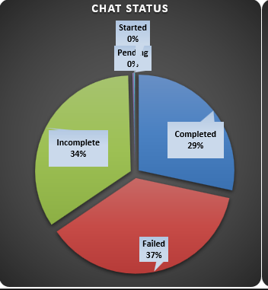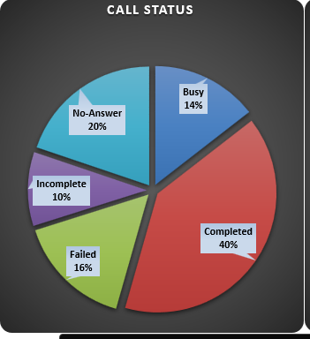Use speech analytics and call monitoring to improve quality, cut wait times, enhance accuracy, and boost overall efficiency and customer experience.

**Fig. 66 – Chart 15 Fig. 67 – Chart 16**

1. **Agent Training & Development (₹30 Lakhs – 30%):**

* Training is critical because underperformance by some agents has a direct impact on customer ratings and brand trust. This budget will focus on:
  + Skill-building workshops to improve communication, empathy, and astrological expertise.
  + Mentorship programs where high-performing agents guide lower-rated colleagues.
  + Micro-learning modules (short online lessons) for continuous improvement without disrupting workflows.
  + These initiatives will uplift average agent ratings, increase customer trust, and create a culture of consistent service quality.

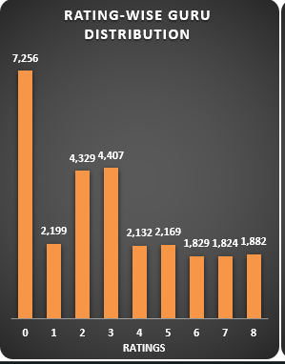

**Fig. 68 – DASHBOARD 7**

1. **Strategic Hiring (₹20 Lakhs – 20%):**

* Data indicates that agent utilization is low on average but spikes heavily during peak hours, causing customer frustration. This portion of the budget will be used to:
  + Hire part-time agents to cover peak periods cost-effectively.
  + Recruit full-time astrologically certified agents to enhance service authenticity and build credibility.
  + Maintain a flexible workforce model to balance costs while ensuring availability.  
    This targeted hiring strategy ensures resources are optimized, customer demand is met, and profitability is not eroded by overstaffing.

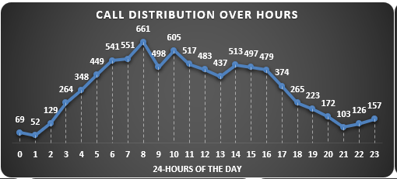

**Fig. 69 – Chart 18**

* **Overall Recommendation:**
* **Technology (50%)** – drive efficiency and automation.
* **Training (30%)** – enhance agent skills and ratings.
* **Hiring (20%)** – reduce workload and improve availability.
* Together, these steps reduce wait times, improve satisfaction, and create a scalable foundation for long-term growth and profitability.