**Project Name. Diabetes Prediction**

**Made by. Mohammed Fadhel Dr. Ahlam Al-Hamdani**

**Project Overview:**

This project aims to develop a predictive model using artificial intelligence to determine whether a person has diabetes or not. This is done by utilizing historical data stored in a dataset called "diabetes.csv". The dataset contains nine columns representing the input features (X Features) and one column representing the output (Y Output), which indicates whether the person has diabetes.

The data was preprocessed by cleaning and analyzing it to ensure the quality of inputs used in the model. Afterward, two different algorithms were applied to predict the person's health condition:

1. **Decision Tree**
2. **Logistic Regression**

The goal of the model is to provide accurate predictions based on the available features

**Libraries that used:**

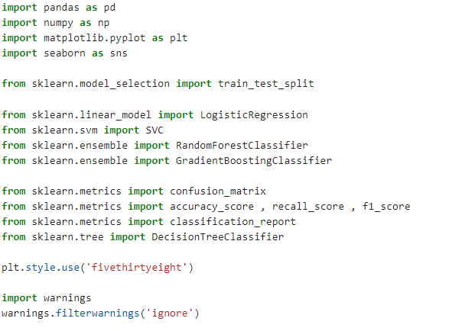

**Open dataset:**



