Mhammad Kazem Rajabi

The Image dataset consists of **43** classes (Unique traffic sign images).

Training Set has **34799** Images , Test set has **12630** images and the validation set has **4410** images.

Divide deta set to train set and test set:

import pickle

training_file = "train.pickle"

testing_file = "test.pickle"

validation_file = "valid.pickle"

with open(training_file, mode='rb') as file:

    train = pickle.load(file)

with open(testing_file, mode='rb') as file:

    test = pickle.load(file)

with open(validation_file, mode='rb') as file:

    valid = pickle.load(file)

X_train, y_train = train['features'], train['labels']

X_test, y_test = test['features'], test['labels']

X_valid , y_valid = valid['features'], valid['labels']

And the size of each data set is :

34799

12630

4410

(32, 32, 3)

43

Number of data in each class:

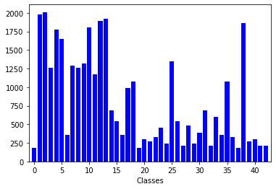

Some part of data for example:

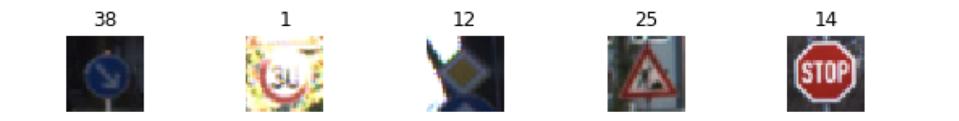

Data Augmentation(rotation and translation):

def augmentation(image):

    rows= image.shape[0]

    cols = image.shape[1]

    # rotation

    M_rot = cv2.getRotationMatrix2D((cols/2,rows/2),10,1)

    # Translation

    M_trans = np.float32([[1,0,3],[0,1,6]])

    img = cv2.warpAffine(image,M_rot,(cols,rows))

    img = cv2.warpAffine(img,M_trans,(cols,rows))

    img = cv2.bilateralFilter(img,9,75,75)

    return img

Incereasing data set in each class to 3000:

X_after_augmentation = []

Y_after_augmentation = []

for i in range(0,classes):

    class_records = np.where(y_train==i)[0].size

    max_records = 3000

    if class_records != max_records:

        add_number_data = max_records - class_records

        samples = X_train[np.where(y_train==i)[0]]

        X_aug = []

        Y_aug = [i] * add_number_data

        for x in range(add_number_data ):

            img = samples[x % class_records]

            trans_img = augmentation(img)

            X_aug.append(trans_img)

        X_train_final = np.concatenate((X_train_final, X_aug), axis=0)

        y_train_final = np.concatenate((y_train_final, Y_aug))

        Y_after_augmentation = Y_after_augmentation + Y_aug

        X_after_augmentation = X_after_augmentation + X_aug

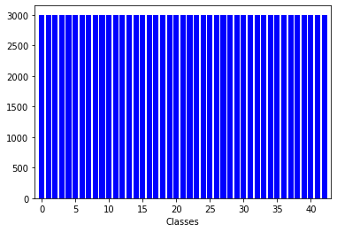

After augmentation:

34799

129000

34799

129000

Some sample of new data-set:

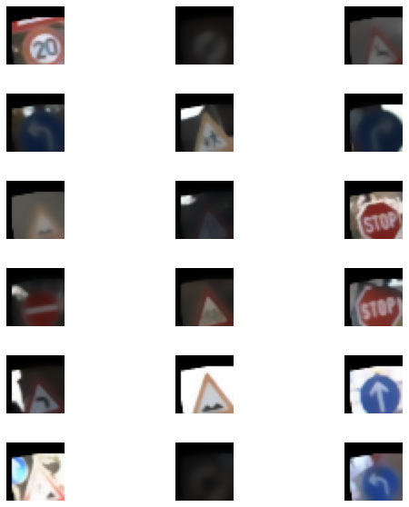

Convertin new data-set to appropriate shape:

X_train_aug = X_train_final.reshape(len(X_train_final), 32,32,3).astype('float32')

X_valid_aug = X_valid.reshape(len(X_valid), 32,32,3).astype('float32')

y_train_aug = keras.utils.to_categorical(y_train_final, classNumber)

y_valid_aug = keras.utils.to_categorical(y_valid, classNumber)

print(X_train_aug.shape)

print(y_train_aug.shape)

print(X_valid_aug.shape)

print(y_valid_aug.shape)

(129000, 32, 32, 3)

(129000, 43)

(4410, 32, 32, 3)

(4410, 43)

Build cnn:

model_conv = Sequential()

model_conv.add(Conv2D(32, kernel_size=(3, 3),activation='relu', input_shape=(32, 32, 3)))

model_conv.add(Conv2D(128, kernel_size=(3, 3), activation='relu'))

model_conv.add(MaxPooling2D(pool_size=(2, 2)))

model_conv.add(Conv2D(128, kernel_size=(3, 3), activation='relu'))

model_conv.add(MaxPooling2D(pool_size=(2, 2)))

model_conv.add(Dropout(0.5))

model_conv.add(Conv2D(128, kernel_size=(3, 3), activation='relu'))

model_conv.add(MaxPooling2D(pool_size=(2, 2)))

model_conv.add(Dropout(0.5))

model_conv.add(Flatten())

model_conv.add(Dense(128, activation='relu'))

model_conv.add(Dropout(0.5))

model_conv.add(Dense(classNumber, activation='softmax'))

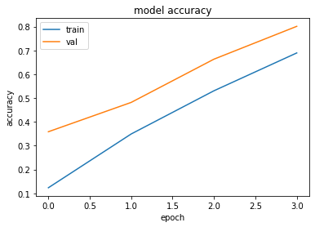 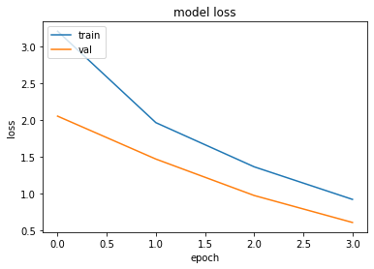

loss- 0.41

accuracy- 0.90

adding gray scale to data-set to achive better result:

def gray_scale(image):

    return cv2.cvtColor(image, cv2.COLOR_RGB2GRAY)

gray_images_data = list(map(gray_scale, X_train_final))

print(local_histo.shape)

%matplotlib inline

f_show, a_show = plt.subplots(6,3, figsize=(8, 8))

f_show.subplots_adjust(hspace = 1, wspace=.001)

a_show = a_show.ravel()

for i in range(18):

    index = np.random.randint(0, len(gray_images_data))

    image = gray_images_data[index]

    a_show[i].axis('off')

    a_show[i].imshow(image,cmap='gray')

    a_show[i].set_title(y_train_final[index])

sample of data after adding gray scale:

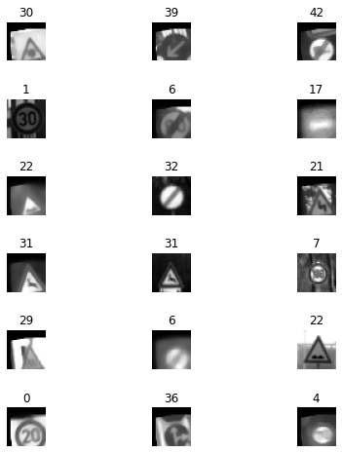

In the next step I add Histogram Equalization to data-set:

def histo_equalize(image):

    kernel = morp.disk(30)

    img_local = rank.equalize(image, selem=kernel)

    return img_local

local_histo = np.array(list(map(histo_equalize, gray_images_data)))

print(local_histo.shape)

%matplotlib inline

f_show, a_show = plt.subplots(6,3, figsize=(8, 8))

f_show.subplots_adjust(hspace =1, wspace=.001)

a_show = a_show.ravel()

for i in range(18):

    index = np.random.randint(0, len(local_histo))

    image = local_histo[index]

    a_show[i].axis('off')

    a_show[i].imshow(image,cmap = 'gray')

The shape of out data-set:

(129000, 1024)

(4410, 1024)

(129000, 43)

(4410, 43)

CNN model: model_conv2 = Sequential()

model_conv2.add(Conv2D(32, kernel_size=(3, 3),activation='relu', input_shape=(32, 32, 1)))

model_conv2.add(Conv2D(128, kernel_size=(3, 3), activation='relu'))

model_conv2.add(MaxPooling2D(pool_size=(2, 2)))

model_conv2.add(Conv2D(128, kernel_size=(3, 3), activation='relu'))

model_conv2.add(MaxPooling2D(pool_size=(2, 2)))

model_conv2.add(Dropout(0.25))

model_conv2.add(Conv2D(128, kernel_size=(3, 3), activation='relu'))

model_conv2.add(MaxPooling2D(pool_size=(2, 2)))

model_conv2.add(Dropout(0.5))

model_conv2.add(Flatten())

model_conv2.add(Dense(128, activation='relu'))

model_conv2.add(Dropout(0.5))

model_conv2.add(Dense(classNumber, activation='softmax'))

so with these changes I get better results:

loss- 0.21

accuracy- 0.94