Problem 4.1:

Give five different path names for the file/etc/passwd.(Hint: Think about the direc-tory entries ‘‘.’’ and ‘‘..’’.

**Answer:**

1. ../passwd

2. ./passwd

3. etc/passwd

4. ./etc/passwd

5. ../etc/passwd

Problem 4.6:

Some operating systems provide a system call rename to give a file a new name. Is there any difference at all between using this call to rename a file and just copying the file to a new file with the new name, followed by deleting the old one?

**Answer:**

By copying, renaming, and deleting new blocks are allocated and can therefore also lead to more unintended consequences. Simply renaming the file will just alter the directory entry of the file.

Problem 4.16:

Consider the i-node shown in Fig. 4-13. If it contains 10 direct addresses and these were 8 bytes each and all disk blocks were 1024 KB, what would the largest possible file be?

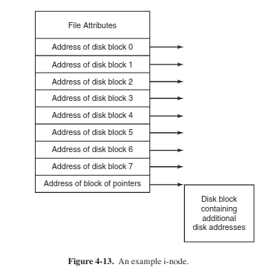

**Answer:**

The maximum file size is 138 KB

Problem 4.20:

Two computer science students, Carolyn and Elinor, are having a discussion about i-nodes. Carolyn maintains that memories have gotten so large and so cheap that when a file is opened, it is simpler and faster just to fetch a new copy of the i-node into the i-node table, rather than search the entire table to see if it is already there. Elinor dis-agrees. Who is right?

**Answer:**

Elinor is right. Carolyn’s stance would create problems during modifications of existing files. Problems of synchronization between competing inodes for the same file would result in loss of information.

Problem 4.25:

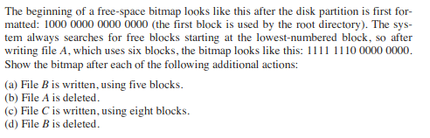

**Answer:**

a) 1111 1111 1111 0000

b) 1000 0001 1111 0000

c) 1111 1111 1111 1100

b) 1111 1110 0000 1100

Problem 5.17:

How much cylinder skew is needed for a 7200-RPM disk with a track-to-track seek time of 1 msec? The disk has 200 sectors of 512 bytes each on each track.

**Answer:**

7200RPM = 120RPS --> 1 rotation = 1000/120 msec

(1000/120)/ 200 sectors = 1/24 msec

24 sectors passed / 1 msec --> Cylinder skew should be 24

Problem 5.18:

A disk rotates at 7200 RPM. It has 500 sectors of 512 bytes around the outer cylinder. How long does it take to read a sector?

**Answer:**

# of rotations of the disk/sec = 7200/60 = 120 RPS

One rotation = 0.00833 sec / 1000 = 8.33 msec

It takes 8.33 msec to read a sector.

Problem 5.28:

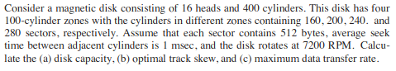

Variables:

heads = 16

cylinders = 400

zones = 4, cylinder/zone = 100

z1 = 160, z2 = 200, z3 = 240, z4 = 280

capacity/sector = 512 bytes

avg seek time = 1 msec

speed = 7200 rpm

**Answer:**

a) Disk Capacity

z1 capacity = 16 x 100 x 160 x 512 = 131072000 bytes

z2 capacity = 16 x 100 x 200 x 512 = 163840000 bytes

z3 capacity = 16 x 100 x 240 x 512 = 196608000 bytes

z4 capacity = 16 x 100 x 280 x 512 = 229376000 bytes

disk capacity = 720896000 bytes

b)Optimal track skew

for z1 = 19.2 sectors

for z2 = 24 sectors

for z3 = 28.8 sectors

for z4 = 33.6 sectors

c) Max data transfer rate = read/write operation in the last zone, z4

rps = 7200 / 60 = 120 rps

data transfer rate in z4 = sectors x rps x capacity/sector

= 280 x 120 x 512

= 17,203,000 bytes/sec