Low-Level Design (LLD) – EA Agent

Contents
Objective 2
Scope Summary 2
Architecture Overview 3
Document Knowledge Base (Vector DB) 4
Agents to be Developed 5
Implementation Plan (5 Months) 6
Month 1: Foundation Setup & Environment Readiness 6
Month 2: Backend & Core AI Orchestration Development 6
Month 3: Agent Development – Phase 1 7
Month 4: Agent Development – Phase 2 8
Month 5: Integration, Testing & Productionization 8
Resource Planning Summary 9
Deliverables Summary 9
Sequence Flow 10
Prerequisites & Dependencies 11
Out of Scope 15

Objective
The primary objective of this initiative is to automate enterprise architecture governance using a multi-agent AI system.
By loading existing application documents, blueprints, and RBI/WAF policies into a Vector Database (Azure AI Search), the system will enable dynamic retrieval and AI-based reasoning to ensure compliance, standardization, and risk management across Yes Bank’s technology landscape.
This AI-driven approach will reduce manual review effort, accelerate architecture approvals, and improve regulatory compliance with RBI and MeitY mandates.

Scope Summary
In Scope (Phase 1) | Out of Scope (Phase 1) | Planned for Phase 2
Design and implementation of the Enterprise Architecture Agentic AI platform in Azure. | Integration with Promethean (Yes Bank EA Tool). | Integration with Promethean EA Tool via APIs for automated submission ingestion and report synchronization.
Azure infrastructure setup — Resource Groups, VNets, Subnets, Key Vault, Azure AI Search, Azure OpenAI, and Blob Storage. | Custom LLM fine-tuning on Yes Bank’s internal architecture review data. | LLM fine-tuning using anonymized Yes Bank datasets for higher contextual accuracy.
Development of 10 AutoGen-based AI agents: Template, Demographics, Sizing, API Validation, Tech Stack, Port & Connectivity, IS Policy, Tiering, Architecture, and Formatting. | Cross-cloud compliance validation (AWS, OCI). | Implementation of adaptive AI feedback and learning system.
Implementation of Retrieval-Augmented Generation (RAG) pipeline using Azure AI Search for context retrieval. | Continuous learning feedback loop and self-improving agent retraining.

Architecture Overview
The solution is designed as a cloud-native, modular system deployed entirely in Microsoft Azure.
It consists of a frontend ReactJS/Streamlit web application and a FastAPI backend that communicates with Azure AI Search and Azure OpenAI models.
The system uses AutoGen, an agent orchestration framework that enables multiple specialized AI agents to collaborate — each performing validation, reasoning, or formatting tasks.
Security and compliance are ensured through:
- Private Endpoints
- Managed Identities
- Azure Key Vault
- Centralized Monitoring via App Insights and Log Analytics.

Landing Zone Architecture
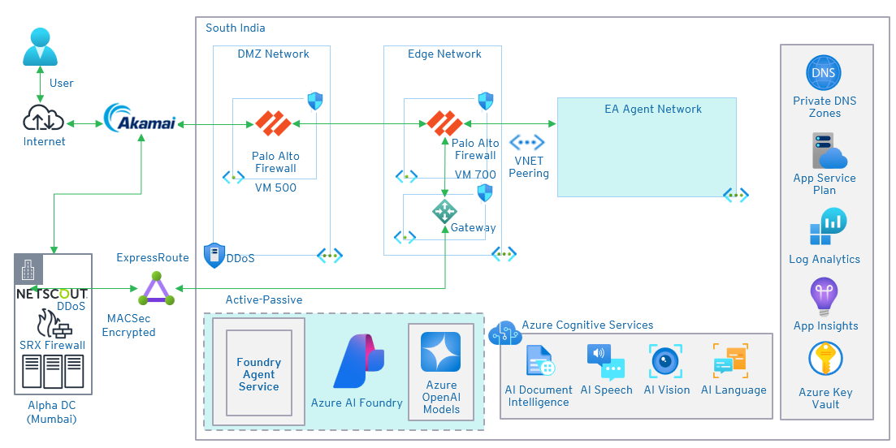

EA Agent Network Architecture
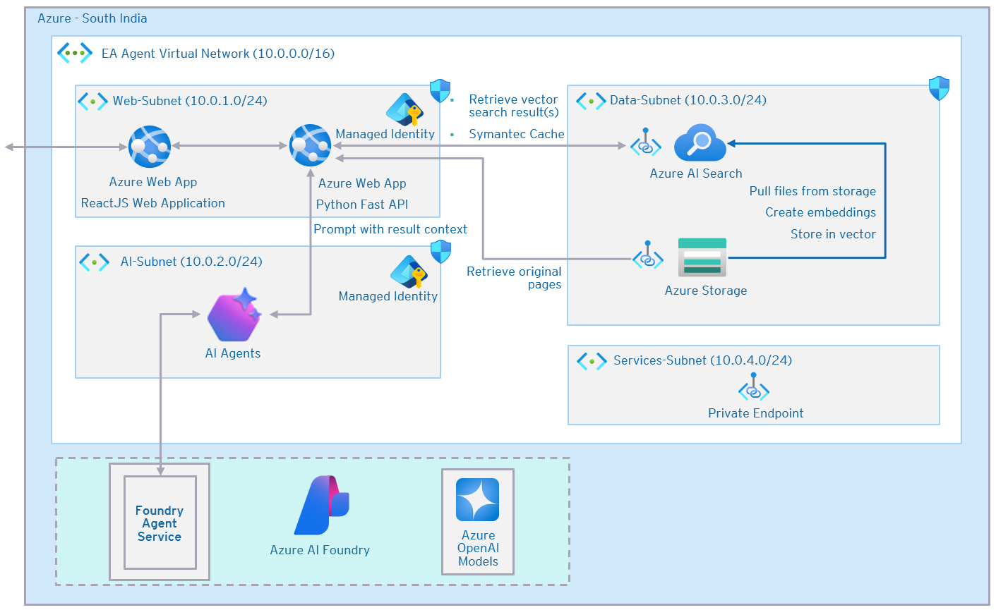

Document Knowledge Base (Vector DB)
The Document Knowledge Base is the foundation of the Agentic AI System.
It holds regulatory, architectural, and operational documents converted into vector embeddings and indexed in Azure AI Search.
This enables semantic retrieval of information and context-based reasoning by LLMs.
Knowledge Base Categories:
- RBI Guidelines and Policies:
Includes cybersecurity framework, IT outsourcing norms, DR/BCP policies, and data governance rules.
- WAF Documents:
Define hosting rules, data segregation policies, and perimeter security requirements.
- Blueprints and Reference Architectures:
Enterprise-approved architectural patterns (3-tier, event-driven, microservices, serverless).
- Best Practices and Security Baselines:
Cloud configuration guidelines, encryption standards, and compliance mappings.
- Risk and Compliance Policies:
Risk rating, assessment, and mitigation procedures for regulatory readiness.
- Solution Council Documents:
Governance documents covering review checkpoints and approval workflows.
- Technology & Open-Source Policies:
Approved tech stack, software versions, licensing rules, and OSS usage governance.
Each document type is tagged with metadata (category, applicability, approval level, version, owner) to optimize retrieval accuracy within the RAG workflow.

Agents to be Developed
The application uses ten specialized agents, orchestrated via AutoGen, each responsible for distinct validation or generation functions.
They work collaboratively, sharing context through a centralized orchestration pipeline.
Agent | Functionality
Template Agent | Auto-generates and populates the base JSON/metadata template for new architecture submissions.
Demographics Agent | Captures contextual details like business unit, hosting region, and data classification.
Sizing Agent | Validates compute and storage sizing against internal benchmarks and cost efficiency rules.
API Validation Agent | Checks compliance of REST/GraphQL endpoints with API governance standards and security baselines.
Tech Stack Agent | Validates use of approved frameworks, libraries, middleware, and runtime environments.
Port & Connectivity Agent | Verifies allowed inbound/outbound ports and secure network topology alignment.
IS Policy Agent | Ensures compliance with Information Security policies—encryption, IAM, DLP, and vulnerability controls.
Tiering Agent | Validates the DR/HA configurations and backup tiers as per SLA requirements.
Architecture Agent | Performs holistic EA validation against RBI, WAF, and bank-level governance standards.
Formatting Agent | Ensures document consistency in structure, terminology, and formatting for audit readiness.

Implementation Plan (5 Months)

Month 1: Foundation Setup & Environment Readiness
Phase
Establish the foundational Azure environment, secure configurations, and document ingestion pipelines required for the AI platform.
Prerequisites
- Enterprise Architecture design and LLD approved by Yes Bank’s EA Council
- Azure subscription with required RBAC roles and network connectivity
- Security clearance for use of Azure AI services
- Access to bank’s RBI, WAF, and internal Blueprint documentation
- Storage container and metadata tagging convention finalized
Detailed Activities
- Finalize and freeze LLD with design diagrams and security validations
- Deploy Azure resources: Resource Groups, VNets, Subnets, and Private DNS zones
- Configure Key Vault, AI Search, Storage Account, and Managed Identities
- Upload RBI, WAF, Blueprint, and policy documents into Blob Storage
- Generate embeddings and create indexes in Azure AI Search
- Validate private endpoint connectivity and restricted access
- Execute initial vector retrieval and accuracy tests
Deliverables
- Approved LLD and design baseline
- Deployed Azure Infrastructure with security controls
- Populated and verified Vector Database
- Infrastructure Readiness Certificate

Month 2: Backend & Core AI Orchestration Development
Phase
Build the AI backend engine, RAG pipeline, and orchestration logic to interact with Azure AI Search and OpenAI models.
Prerequisites
- Functional Azure AI Search index with document embeddings
- Azure OpenAI endpoint and API access provisioned
- FastAPI environment ready (App Service / Container Registry)
- Test architecture data prepared for validation
Detailed Activities
- Develop FastAPI backend for orchestration, validation, and LLM interaction
- Implement Retrieval-Augmented Generation (RAG) workflow using Azure AI Search
- Integrate Azure OpenAI model for reasoning and contextual response synthesis
- Configure AutoGen Controller Agent for task orchestration
- Implement error handling, retries, and observability hooks
- Conduct backend integration and unit testing for context retrieval and validation logic
Deliverables
- Working FastAPI backend connected to Azure AI services
- Fully functional RAG pipeline
- AutoGen orchestration base layer ready
- Integration test report and observability logs

Month 3: Agent Development – Phase 1
Phase
Develop and validate the initial set of three specialized agents and integrate them into the orchestration workflow.
Prerequisites
- Backend APIs functional and stable
- JSON schema for template validation finalized
- Metadata tagging of documents completed
- Access to approved application blueprints for testing
Detailed Activities
- Develop Template Agent, Demographics Agent, and Sizing Agent
- Define prompt templates and response schemas for each agent
- Integrate AutoGen orchestration to enable inter-agent communication
- Build validation logic and JSON schema enforcement
- Perform integration and regression testing across agents
- Validate output with test data and capture baseline accuracy
Deliverables
- 3 functional agents integrated (Template, Demographics, Sizing)
- RAG + orchestration validated for early-stage pipeline
- Prompt templates and schemas finalized
- Agent testing reports published

Month 4: Agent Development – Phase 2
Phase
Build advanced agents focusing on API validation, tech stack compliance, network configuration, and security policies.
Prerequisites
- Successful completion of Phase 1 agent testing
- Availability of internal IS Policy, API governance, and tech stack guidelines
- Access to Azure AI Foundry workspace
- Test data representing diverse application architectures
Detailed Activities
- Develop API Validation, Tech Stack, Port & Connectivity, and IS Policy Agents
- Integrate Azure AI Foundry for dynamic model selection
- Implement agent collaboration and task dependency resolution
- Conduct compliance tests on real architecture submissions
- Generate validation reports and scoring accuracy statistics
Deliverables
- 4 additional agents operational and integrated
- Adaptive model selection implemented via AI Foundry
- Multi-agent collaboration validated end-to-end
- Compliance testing and benchmarking completed

Month 5: Integration, Testing & Productionization
Phase
Finalize the platform by integrating all agents, developing the frontend UI, and performing end-to-end system validation and deployment.
Prerequisites
- All agents (10 total) developed and tested
- Production Azure subscription and networking approved
- Security and InfoSec clearance for production release
- Finalized KPIs and acceptance criteria for UAT
Detailed Activities
- Develop frontend interface using ReactJS or Streamlit for AI review dashboard
- Integrate backend APIs, agent orchestration, and reporting modules
- Conduct full E2E RAG pipeline validation (document ingestion → validation → report)
- Perform performance testing, UAT
- Integrate Azure Application Insights and Log Analytics for observability
- Conduct final Go-Live readiness review and deploy to production
Deliverables
- Fully integrated and production-ready EA Agentic AI Platform
- Monitoring, logging, and observability configured
- Production Go-Live completed successfully
- Handover, KT, and documentation finalized

Resource Planning Summary
Role | Skillset | Count | Duration (Months) | Allocation | Responsibilities
Cloud Architect | Azure Infra, Security, Networking | 1 | 1–5 | 20% | Infra design, policy compliance, deployment strategy
AI Engineer | Azure AI, LangChain, AutoGen | 1 | 1–5 | 100% | Orchestration, RAG pipeline, embedding tuning
AI Engineer | Azure AI, LangChain, AutoGen | 1 | 1-5 | 100% | Orchestration, RAG pipeline, embedding tuning
Python/Frontend Developer | FastAPI, API Integration, ReactJS / Streamlit | 1 | 1-5 | 100% | Backend logic, validation modules
Data Engineer | Vector embedding, Data prep | 1 | 1–5 | 20% | Data ingestion, preprocessing, indexing

Deliverables Summary
- Azure-hosted EA Agentic AI platform
- Ten AutoGen-powered validation agents
- Centralized Vector Database with embedded RBI/WAF/Blueprint content
- Automated compliance and validation reports
- Integrated observability (App Insights, Log Analytics)
- Security-hardened production deployment
- User training and operational documentation

Sequence Flow
The sequence diagram documents the end-to-end runtime interaction between the user (submitter), frontend, backend, orchestrator (controller), agents, retrieval services (Azure AI Search), reasoning models (Azure OpenAI / Foundry), and report-store. It explains message ordering, where decisions are made, how tasks are fanned-out to agents, how agent results are aggregated, and how final reports are generated and returned to the user.
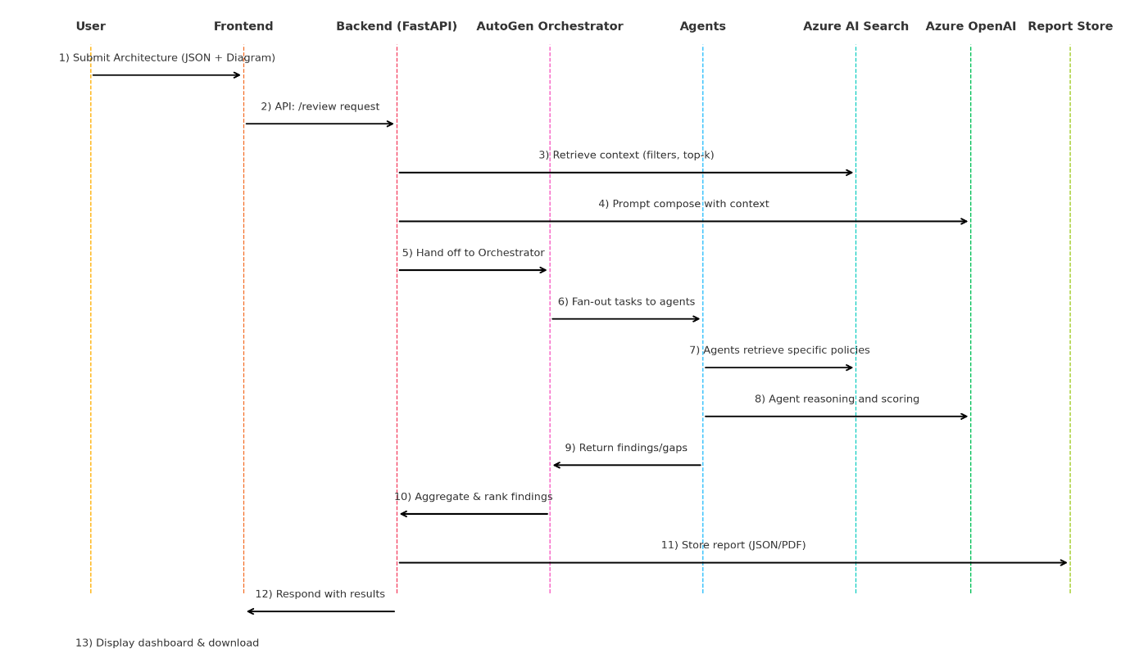
- Submit Architecture — User uploads architecture package (JSON + diagrams) via Frontend.
- API Call — Frontend calls Backend POST /review (includes metadata, auth token).
- Pre-check & Auth — Backend validates input schema, checks user RBAC, and stores raw submission (audit log).
- Orchestration Request — Backend forwards normalized request to the Orchestrator (controller agent) with submission ID and context hints (owner, sensitivity).
- Context Retrieval — Orchestrator invokes Azure AI Search (Retriever) with filters (category, top-k, recency, approval level) to fetch relevant documents and supporting evidence.
- Prompt Composition — Orchestrator composes prompts: injects retrieved context, submission snippet, and agent instructions; selects model profile (via Azure Foundry rules).
- Fan-out / Dispatch — Orchestrator fans out tasks to the required Agents (parallel where independent), passing the composed prompt and references to source documents (document ids).
  - Example parallel tasks: Sizing Agent, API Validation Agent, IS Policy Agent.
- Agent Retrieval (if needed) — Each Agent may independently call the Retriever for deeper, agent-specific context (narrow queries).
- Agent Reasoning — Agents call Azure OpenAI/Foundry (selected model) to analyze, score, and produce findings (structured JSON: findings, severity, references, remediation).
- Agent Response — Agents send back findings to Orchestrator. Each agent includes provenance metadata (which doc ids used, confidence score, timestamp).
- Aggregation & Scoring — Orchestrator aggregates agent outputs, resolves conflicts (priority rules), computes an overall compliance score, ranks issues, and assigns owners/suggested SLAs.
- Report Generation — Orchestrator composes final report (JSON for system, PDF for auditors), attaches evidence (document snippets), and writes report to Report Store.
- Backend Notification / Callback — Orchestrator notifies Backend that review is complete (with report ID).
- Frontend Update — Backend informs Frontend that results are ready; User is notified.
- User Action — User views report, can acknowledge, assign remediation, or re-submit after fixes.

Prerequisites & Dependencies
The following items must be made available and approved by Yes Bank prior to the initiation of project execution. These prerequisites cover infrastructure access, documentation, governance approvals, and security compliance necessary for deployment within Yes Bank’s cloud environment.

A. Documentation & Policy Inputs
All these documents form the knowledge base for the RAG (Retrieval-Augmented Generation) model and are required to be stored and embedded in Azure AI Search.
Category | Documents Required from Yes Bank | Purpose / Usage
Regulatory Policies | - RBI Guidelines for Cloud Adoption & IT Outsourcing  - RBI Cybersecurity Framework for Banks  - RBI Risk Governance & BCM (Business Continuity Management) circulars | These documents will be embedded in VectorDB to validate regulatory compliance.
Cloud Security Framework (WAF) | - Yes Bank’s WAF Guidelines for Cloud Hosting  - Cloud Risk Assessment templates  - Application onboarding SOP for cloud services | Used to verify adherence to internal hosting and perimeter security standards.
MeitY & Data Residency Guidelines | - MeitY Data Localization Policy  - Cloud Service Compliance Mandates | Used by IS Policy Agent for data location and residency validation.
Architecture Blueprints | - Standard reference architectures (3-Tier, Event-driven, Serverless, Microservices, Data Platform, Integration Layer, etc.)  - Architecture Review templates | Loaded into vector DB for contextual comparison and pattern validation.
Information Security Policies | - IS Policy Handbook (Encryption, IAM, Key Management, DLP)  - Approved Software & Open-Source List  - Vulnerability & Patch Management Guidelines | Used by IS Policy and Tech Stack Agents for validation.
Network & Connectivity Standards | - Network Zoning & Firewall Configuration Document  - Approved Port Matrix (Inbound/Outbound) | Used by Port & Connectivity Agent for validation.
Disaster Recovery & Backup Policy | - DR Tiering & Backup SLA Policy  - Business Impact Analysis templates | Used by Tiering Agent to validate recovery and backup configurations.
API & Integration Standards | - API Gateway configuration standards  - REST/GraphQL policy document  - OpenAPI templates | Used by API Validation Agent for compliance verification.
Technology Governance | - Approved Tech Stack Matrix (Languages, Runtimes, Frameworks, Middleware)  - End-of-Life (EOL) and End-of-Support (EOS) Policy  - DevOps CI/CD Governance Framework | Used by Tech Stack Agent and Architecture Agent for validation and recommendations.
Internal Blueprint Approval Docs | - Solution Council Process Flow  - Architecture Review Board Checklist  - Exception Approval Templates | Used for context building and to automate compliance checks.

Note: All documents should be provided in machine-readable format (PDF, DOCX, or TXT) for embedding into Azure AI Search and vectorization.

B. Azure Environment & Access Requirements
To build and deploy the platform, Yes Bank needs to provision access in its Azure environment (production and/or sandbox) or grant temporary access in EY’s controlled Azure tenant during development.
Requirement | Description | Purpose / Responsibility
Azure Subscription | Dedicated subscription (or sub-resource group) for AI POC/Deployment | Hosting the AI components (App Services, Search, Storage, OpenAI)
Azure Active Directory Access | Temporary Contributor access for project leads  Read/Write access for DevOps pipeline automation | Resource creation, RBAC configuration, and Managed Identity setup
Azure Key Vault | Pre-created vault with bank-managed keys | Securely store secrets, API keys, and certificates
Azure Virtual Network (VNet) | Network with subnets for Web App, AI Search, OpenAI, and Storage (via private endpoints) | Ensure traffic isolation and internal-only communication
Private DNS Zone & NSG Rules | Configured to allow name resolution for private endpoints | Required for private service-to-service connectivity
Azure Blob Storage Account | Dedicated container for storing all documents (policies, blueprints, submissions) | Vector embedding source and report archive
Azure AI Search | Cognitive Search instance with vector capabilities enabled | RAG context store for all embedded documents
Azure OpenAI / Azure AI Foundry Access | Model access to GPT-5o/ GPT-4o-mini / Phi-3-mini (depending on bank’s approval)  Model access to text-embedding-ada-002 (depending on bank’s approval) | Model reasoning, creating embeddings and orchestration layer
App Service / Container Registry | FastAPI backend and Stream lit frontend hosting | Application deployment environment
Azure Log Analytics Workspace | Linked to all services (App Insights, Search, OpenAI) | Monitoring and observability
Azure DevOps / GitHub Enterprise Access/ Bitbucket | Repo creation rights, pipeline runner permissions | CI/CD automation for deployment

C. Security and Governance Tool Integration (Yes Bank-Managed)
The following Yes Bank-managed enterprise tools must be integrated or referenced as part of the platform’s governance and security controls. These tools ensure adherence to the bank’s security, identity, and compliance policies.
- Security Information and Event Management (SIEM – IBM QRadar)
- All security logs, API access events, and authentication traces from Azure App Services, AI Search, OpenAI, and Key Vault will be forwarded to QRadar.
- QRadar will be used for real-time correlation, anomaly detection, and compliance reporting.
- Integration will be performed via Azure Monitor → Log Analytics → QRadar connector.
- Access and Role Management System
- All Azure RBAC assignments for users, groups, and managed identities must be raised through ARMS.
- This ensures compliance with Yes Bank’s least-privilege and segregation-of-duties (SoD) policies.
- Each request will undergo approval by Cloud Governance and InfoSec before provisioning in Azure AD.

D. Environment Readiness Validation Checklist
Before starting Month 1 implementation, all the following checkpoints must be green ✅:
Category | Checkpoint | Status
Data | All required policy and architecture documents uploaded | ☐
Azure Access | EY team can log in to Azure portal using Yes Bank tenant credentials | ☐
Networking | Private endpoints configured and reachable across subnets | ☐
AI Services | Azure AI Search and Azure OpenAI provisioned | ☐
Storage | Blob containers created and write-access tested | ☐
Security | Managed Identities and Key Vault configured | ☐
Monitoring | Log Analytics workspace linked to all deployed resources | ☐
Governance | ARC approval sign-off received | ☐

D. Additional Notes
- Yes Bank will own the Azure resources, and EY will operate under temporary contributor roles with restricted access.
- All document ingestion and embeddings will be performed within Yes Bank’s network boundary—no data leaves the tenant.
- The environment must comply with Yes Bank’s data classification and encryption policies (AES-256 / TLS 1.2).

Out of Scope
The integration with Yes Bank’s Enterprise Architecture tool, Promethean, is considered out of scope for the current Phase 1 of the Agentic AI implementation.
During Phase 1, the focus will remain entirely on building the core Agentic AI platform, which includes document ingestion, vector database setup, agent orchestration, and compliance validation workflows within the Azure environment.
The Promethean integration, which involves connecting the AI platform with Yes Bank’s existing Enterprise Architecture repository for automated submission intake, validation triggers, and synchronization of compliance reports, will not be implemented in this phase.
This integration requires additional dependencies such as:
  - Access to Promethean’s internal APIs and authentication mechanisms
  - Alignment with Yes Bank’s EA governance workflows
  - API gateway and service registration approvals from the internal Cloud Governance Board
Given these dependencies, this integration will be taken up as part of Phase 2 (Enhancement and Integration Phase) once the base platform and agents are fully operational and approved for production use.
In summary, Phase 1 delivers a self-contained AI-driven validation engine, while Promethean integration and automation workflows will be addressed during Phase 2.

Advanced Features and Enhancements
Feature | Description | Planned in Phase
Auto-Learning Feedback Loop | Continuous reinforcement of the AI model based on reviewer feedback and post-implementation outcomes. | Phase 2
Cross-Cloud Compliance Validation | Extension of validation rules for AWS and OCI architectures. | Phase 2
Workflow Automation via EA Portal | Direct task routing, escalation, and approval workflows inside the EA portal (Promethean). | Phase 2
LLM Fine-Tuning with Bank Data | Training custom models on Yes Bank’s anonymized historical architecture reviews. | Phase 2

Operational Boundaries
- The current release focuses on AI-driven validation and report generation hosted entirely within Azure.
- Integration with Promethean EA Tool will be implemented only after finalization of Promethean’s API interfaces and authentication policies.
- No external data movement outside Yes Bank’s Azure tenant will occur in Phase 1.
- All dashboards and reports will remain within the AI platform’s frontend; no synchronization with third-party portals until Phase 2.

