2. MVCC (Multiversion Concurrency Control) – Comprehensive Explanation
Introduction
Modern databases often have many users or applications accessing the same data simultaneously. In such environments, handling concurrent transactions becomes challenging. Traditional concurrency control methods, like locking, prevent conflicts but often create performance bottlenecks. To overcome these issues, many relational databases (PostgreSQL, MySQL InnoDB, Oracle, and CockroachDB) use MVCC – Multiversion Concurrency Control.

MVCC allows multiple versions of a record to exist at the same time, enabling readers and writers to access data concurrently without blocking each other. It is essential for maintaining data consistency, isolation, and performance in high-traffic applications.

The Problem MVCC Solves
In databases, multiple transactions can read and write the same data at the same time. Without proper management, this can lead to issues like:
- Dirty Reads – Reading data that has been changed by an uncommitted transaction.
- Non-Repeatable Reads – Reading the same row twice in a transaction returns different values because another transaction modified it.
- Phantom Reads – New rows inserted by another transaction appear unexpectedly in query results.
- Lock Contention – Multiple transactions waiting for locks on the same row can create bottlenecks, reducing throughput.
Traditional databases often rely on row-level or table-level locks. Locks prevent conflicts but reduce concurrency, especially in read-heavy workloads where many users want to query the same data simultaneously. MVCC was introduced to allow high concurrency without blocking readers or writers, solving these problems elegantly.

How MVCC Works
The core idea of MVCC is simple but powerful: don’t overwrite existing data. Instead, when a transaction modifies a record, the database creates a new version of that record. Each transaction sees a consistent snapshot of the database as it existed when the transaction started.
1. Versioning
Each row in the database has metadata attached, such as:
- Transaction ID (TXID) – Identifies which transaction created the row.
- Version timestamp – Indicates when the row was created or modified.
- Visibility rules – Determine which version is visible to a particular transaction.

When a transaction reads a row:
- It only sees the version of the row that was committed before the transaction started.
- If another transaction updates the row while the first transaction is running, the reader does not see the new version until it is committed.

When a transaction updates a row:
- The database does not overwrite the old row.
- It creates a new row version with updated values.
- Old versions remain temporarily to allow other transactions to continue reading.

2. Transaction Snapshots
Each transaction operates on a snapshot of the database:
- Snapshot contains the committed state at the time the transaction started.
- Reads never block writes, and writes never block reads.
- The database ensures that each transaction sees a consistent and isolated view.

For example, consider a Users table:
ID | Name | Balance
1 | Rahul | 1000
- Transaction T1 starts and reads Rahul’s balance → sees 1000
- Transaction T2 deposits 500 to Rahul’s balance → creates a new version with 1500
- T1 still sees 1000 until it commits or ends
- T2 sees 1500
This guarantees isolation and consistency without using locks for reads.

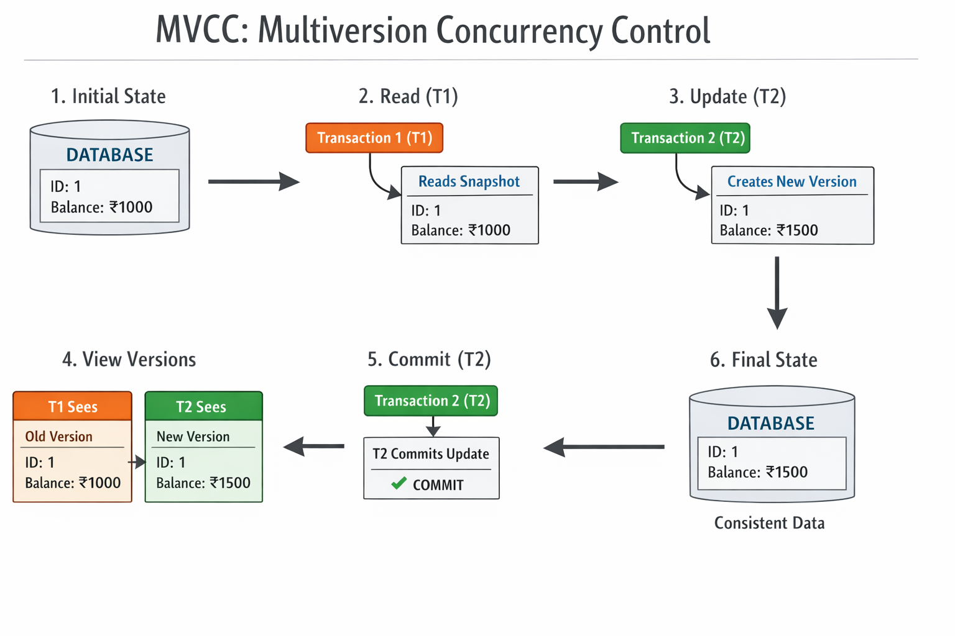

MVCC vs Traditional Locking
Feature | Locking (Traditional) | MVCC (Multiversion)
Read Operation | Blocks if row is locked | Non-blocking, sees snapshot
Write Operation | Requires exclusive lock | Creates new version
Concurrency | Limited, can cause bottlenecks | High, multiple transactions run simultaneously
Performance | Slower with many users | Optimized for read-heavy workloads
Data Integrity | Needs careful lock management | Automatically ensures consistent snapshot

How MVCC Maintains ACID Properties
MVCC is tightly linked to transaction isolation and supports the ACID principles:
- Atomicity – Each transaction is all-or-nothing. MVCC tracks versions so uncommitted changes do not affect other transactions.
- Consistency – The database remains consistent; only valid versions are visible to transactions.
- Isolation – Each transaction sees a consistent snapshot; one transaction does not interfere with another.
- Durability – Once committed, changes persist permanently in the database.
MVCC supports different isolation levels like READ COMMITTED or REPEATABLE READ, allowing developers to choose a trade-off between strict isolation and performance.

Garbage Collection in MVCC
Because MVCC creates multiple versions of rows, old versions accumulate over time. To manage this, databases implement garbage collection:
- Old versions no longer visible to any active transaction are removed.
- Reduces storage usage and improves performance.
- Example: PostgreSQL uses VACUUM to clean up outdated versions.
- In CockroachDB, background processes automatically handle version cleanup.

Advantages of MVCC
- High Concurrency – Many users can read and write at the same time.
- Non-Blocking Reads – Readers never wait for writers.
- Consistent Snapshots – Transactions see the database in a consistent state.
- Better Performance for Read-Heavy Workloads – Especially important for analytics or reporting.
- Improved Isolation – Reduces read-write conflicts automatically.

Challenges of MVCC
- Storage Overhead – Multiple versions increase storage usage.
- Garbage Collection Complexity – Requires efficient cleaning of old versions.
- Write-Heavy Workloads – Performance can degrade if too many updates create many versions.
- Complex Implementation – Maintaining snapshots and version visibility requires sophisticated database logic.

Key Takeaways
- MVCC allows multiple users to work on the database simultaneously without blocking each other.
- It creates multiple versions of data instead of overwriting it.
- Readers see a consistent snapshot, while writers can make changes in parallel.
- Supports ACID transactions and improves performance for read-heavy workloads.
- Used in modern databases like PostgreSQL, MySQL (InnoDB), CockroachDB, and Oracle.
- Essential for applications where high concurrency and data integrity are critical.

Analogy
Think of a library:
- Each book has multiple copies (versions).
- Readers can read one copy without interfering with someone editing another copy.
- Librarians track which version is the latest, and old copies are eventually archived or removed.
- This ensures everyone gets correct information without waiting.

Scenario: Two Users Updating the Same Data Simultaneously
Let’s say we have a table Accounts:
ID | Balance
1 | 1000
Two transactions start at the same time:
- Transaction T1: User A wants to deposit 500
- Transaction T2: User B wants to deposit 300

Step-by-Step Process in MVCC
- Transaction T1 starts
  - T1 reads the current version of the row: Balance = 1000
  - MVCC gives T1 a snapshot of the database at this moment.
- Transaction T2 starts simultaneously
  - T2 also reads the same row: Balance = 1000
  - T2 sees its own snapshot, independent of T1.
- T1 updates the row
  - T1 creates a new version of the row: Balance = 1500
  - The old version (Balance = 1000) is still visible to T2, because T2’s snapshot started before T1 committed.
- T2 updates the row
  - T2 creates another new version based on the snapshot it sees (Balance = 1000)
  - This version shows Balance = 1300
  - Now there are two uncommitted versions: one from T1 and one from T2
- Commit Process
  - MVCC ensures transaction isolation.
  - The first transaction to commit (say T1) succeeds. The second transaction (T2) will check for write conflicts.
  - If T2 detects that the row has been modified since its snapshot, it may roll back or retry to ensure consistency.
- Final Consistent State
  - After conflict resolution, the database keeps a single consistent version:
    - IfT2retries, it reads the latest Balance (1500), then applies its update (+300) → Balance = 1800

