WAL (Write-Ahead Logging) in PostgreSQL
Introduction
Write-Ahead Logging is PostgreSQL's mechanism for ensuring data integrity and durability. The core principle is simple: before any change is written to the actual data files, it must first be recorded in the WAL log. This "write ahead" guarantee means that even if the system crashes mid-operation, PostgreSQL can recover by replaying the log — nothing is ever truly lost.
In PostgreSQL, data integrity and durability are critical. Modern applications require that once a transaction is committed, its effects are permanent, even in case of a system crash, power failure, or hardware issue. To guarantee this, PostgreSQL uses WAL, or Write-Ahead Logging, as a central component of its transaction durability mechanism.
Write-Ahead Logging (WAL) is a technique where all changes to the database are first written to a log before they are applied to the actual database files. This ensures that PostgreSQL can always recover committed transactions in case of failures, maintaining ACID properties (Atomicity, Consistency, Isolation, Durability).

Why WAL Exists
PostgreSQL could, in theory, write changes directly to the data files on disk. However, doing so has several problems:
- Crash Recovery
If the system crashes after partially writing data to disk, the database may become inconsistent. WAL ensures there is a record of every change that can be replayed to restore consistency.
- Durability Guarantee (ACID)
The D in ACID requires that committed transactions survive crashes. WAL writes the changes to a log before committing, so PostgreSQL can replay them after recovery.
- Efficient Disk I/O
Writing directly to multiple data files can be slow and fragmented. WAL allows PostgreSQL to sequentially append changes to a single log file, which is much faster than random writes.
- Point-in-Time Recovery (PITR)
WAL provides a mechanism to restore the database to any point in time by replaying logs, making it useful for backups, disaster recovery, or testing.
How WAL Works — Step by Step
- A transaction begins. The user runs INSERT, UPDATE, DELETE, etc.
- Changes are made in memory. PostgreSQL modifies pages in its shared buffer cache — nothing hits disk yet.
- WAL records are generated. Every change produces a WAL record describing what changed (not the full page, just the delta). These records go into the WAL buffer in memory.
- On COMMIT, WAL is flushed to disk. Before the transaction is confirmed to the client, PostgreSQL flushes the WAL buffer to the WAL segment files on disk (pg_wal/ directory). This is the critical durability step.
- The client gets confirmation. Only now does PostgreSQL tell the client "your transaction succeeded."
- Data files are written later. The background writer and checkpointer eventually flush the modified buffer pages to the actual heap/index files — this is called a checkpoint.
This sequence means: the WAL is always ahead of the actual data files, hence "write-ahead."

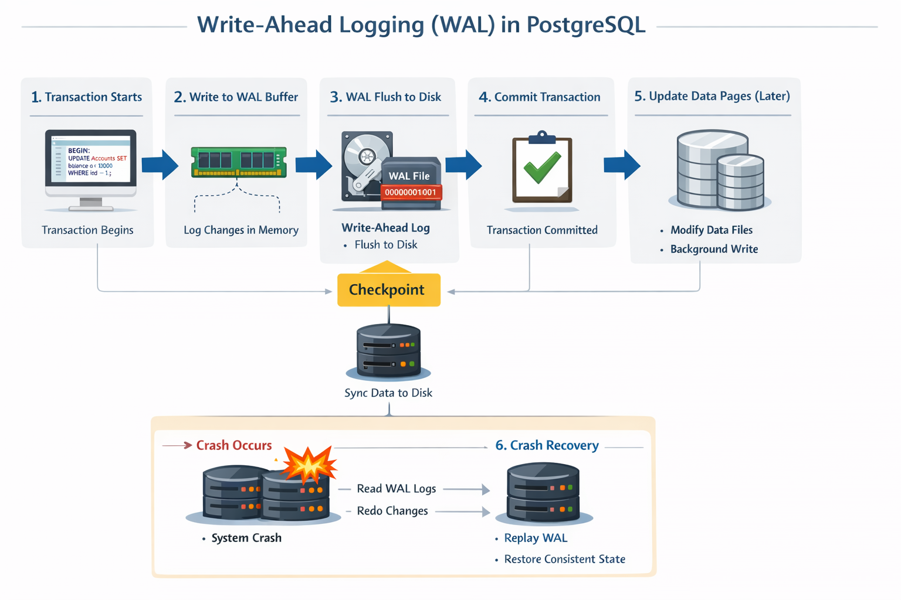
Components of WAL in PostgreSQL
- WAL Segment Files
  - PostgreSQL stores WAL as sequential 16MB log files (default).
  - Each segment contains multiple WAL records.
  - Segments are written continuously and rotated.
- WAL Buffers
  - In-memory buffers temporarily hold WAL records before flushing.
  - Buffer size is controlled by the parameter wal_buffers.
- WAL Writer Process
  - A background process that periodically flushes WAL buffers to disk.
  - Helps reduce synchronous I/O overhead for each transaction.
- WAL Archive
  - For Point-in-Time Recovery (PITR), WAL segments can be archived to a safe location using archive_command.
  - Archived logs allow replaying changes after restoring a backup.

WAL Segments and the pg_wal Directory
WAL is stored in fixed-size files called segments (16 MB by default, configurable). They live in $PGDATA/pg_wal/ and are named with a 24-character hexadecimal string encoding the timeline and segment number (e.g., 000000010000000000000001).
PostgreSQL writes to these files sequentially, cycling through them. Old segments are either deleted, archived, or reused depending on configuration.

Checkpoints
A checkpoint is the moment when PostgreSQL guarantees that all WAL changes up to a certain point (the checkpoint LSN) have been flushed to the actual data files. After a checkpoint, WAL records before that point are no longer needed for crash recovery.
Checkpoints are triggered by:
- Time (checkpoint_timeout, default 5 minutes)
- WAL volume (max_wal_size, default 1 GB)
- Manual CHECKPOINT command
Frequent checkpoints = faster recovery but higher I/O during operation. Infrequent checkpoints = less I/O overhead but longer crash recovery time.
WAL and Crash Recovery
When PostgreSQL restarts after a crash, it checks whether the data files are consistent with the last checkpoint. If not, it replays WAL records from the last checkpoint forward, reapplying every change until the WAL is exhausted. This brings the database back to a consistent state automatically — no manual intervention needed.

WAL Archiving
For point-in-time recovery (PITR) and long-term backup, WAL segments can be archived to external storage (S3, NFS, etc.) as they're completed. With a base backup plus a continuous WAL archive, you can restore the database to any point in time — not just the last checkpoint.
Key config parameters:
- archive_mode = on
- archive_command = 'cp %p /archive/%f'

WAL and Replication
WAL is the backbone of PostgreSQL replication. In streaming replication, standby servers connect to the primary and receive WAL records in real time, replaying them to stay in sync. In logical replication, WAL records are decoded into logical changes (INSERT/UPDATE/DELETE) and streamed to subscribers.

This is why replication lag is measured in LSNs — it's literally how far behind the standby is in replaying the WAL stream.

