Credit Card Fraud Detection Using Machine Learning with Imbalance-Aware Evaluation and Explainability
Mohan Mekala
Bachelor of Computer Science (Hons), INTI International University, Malaysia
Student Exchange Programme 2026 · Student ID I26043589
I26043589@student.newinti.edu.my
Supervisor: Dr. Zeyad Ahmed, Senior Lecturer
zeyad.abdulhameed@newinti.edu.my

Abstract—Card fraud is a rare-event problem: in the benchmark used here fewer than 0.6% of transactions are fraudulent, so a classifier that never raises an alarm is more than 99% accurate. This paper compares Logistic Regression, Random Forest and XGBoost, against a majority-class reference, on the simulated credit-card transaction task (sparknov) of the 2022 Fraud Dataset Benchmark under an imbalance-aware protocol: chronological validation, leakage-safe preprocessing, stratified five-fold cross-validation scored by PR-AUC, decision thresholds chosen on validation data only, and a single evaluation on the official 20,000-transaction test set containing 91 frauds. XGBoost was selected on validation PR-AUC (0.703). On the test set it reached a PR-AUC of 0.679, a ROC-AUC of 0.995, a recall of 0.736 and a precision of 0.558 at its tuned threshold. Random Forest scored slightly higher on PR-AUC (0.696) and F1 (0.712 vs. 0.635), but a paired bootstrap interval for the difference included zero, and both ensembles far exceeded Logistic Regression (PR-AUC 0.208). Tuning the threshold on validation data raised F1 for every model, whereas class weighting did not improve PR-AUC. SHAP attributed the selected model’s scores mainly to transaction amount and merchant category. For computational reasons, models were fitted on a stratified 30% subsample with a reduced hyperparameter grid. A Python implementation and a Google Colab notebook reproduce every result, and a command-line prototype scores new transactions.
Keywords—credit card fraud, class imbalance, cost-sensitive learning, threshold tuning, Random Forest, XGBoost, SMOTE, explainable AI, SHAP
I. Introduction
Card payments now cover a large share of everyday spending, from supermarket tills to subscription services and online marketplaces. Every authorized payment passes through a chain of banks, processors and merchants, and each link is a potential point of attack. Stolen card numbers, account takeover and card-not-present fraud allow criminals to make purchases that the genuine cardholder never approved. Issuers respond by scoring transactions automatically and routing the suspicious ones to analysts or to additional customer verification.
Building such a scoring model is not an ordinary classification exercise. Fraud is rare, and the rarity distorts almost every standard habit of model evaluation. A rule that labels every transaction as legitimate has an accuracy equal to one minus the fraud rate. On the test data of this study the rule is 99.545% accurate while catching no fraud, and a tuned Logistic Regression is less accurate (99.115%) even though it catches half of the frauds. Accuracy, the metric most students reach for first, is therefore close to meaningless here.
A useful fraud model must instead be judged by how many fraud cases it catches (recall), how many of its alarms are genuine (precision) and how the two trade off as the alarm threshold moves. These quantities depend on the decision threshold as much as on the learning algorithm, which means that threshold choice is part of the model and must be made with the same care as hyperparameter tuning.
Fraud labels also arrive with a delay, fraudsters change tactics when they are blocked, and the features that predict fraud in one period may weaken in the next. A model that looks strong on a randomly shuffled test set may degrade quickly in deployment. Finally, decisions about blocking a card or questioning a customer affect people directly, so analysts and regulators increasingly expect a model to explain why a transaction was flagged.
This project responds to these issues with a deliberately simple and transparent comparison. It asks one main question: when Logistic Regression, Random Forest and XGBoost are trained and evaluated under the same imbalance-aware protocol on a fixed public benchmark, how do they compare at detecting fraudulent transactions? Three research questions follow from it:
- RQ1. How do the three models compare on fraud-sensitive metrics, namely precision, recall, F1-score and PR-AUC?
- RQ2. How much do class weighting, training-only resampling and validation-based threshold selection change the precision–recall trade-off compared with an untuned model at a threshold of 0.5?
- RQ3. Which features have the greatest influence on the selected model’s fraud scores according to SHAP, and are those influences plausible?
The scope is intentionally narrow. The project does not identify individual offenders, estimate monetary loss, model cardholder behavior over time or claim that a benchmark score will transfer to a live payment network. Its objectives are to:
- Select a public fraud benchmark that meets the course requirement of publication in 2020–2026 and document its provenance, licence and prior use.
- Profile the data, measure the class imbalance and check data quality before any model is fitted.
- Build a preprocessing pipeline in which every learned transformation, including resampling, is fitted on training data only.
- Compare a majority-class reference and three learners under a single split and a single, pre-declared selection rule.
- Tune hyperparameters with stratified cross-validation, choose thresholds on validation data and use the test partition exactly once.
- Interpret the selected model with SHAP and package it as a command-line prototype.
- Report limitations honestly and state which uses the evidence does and does not support.
The contribution is not a novel algorithm. It is an integrated and reproducible evaluation design that keeps model selection, threshold selection and final testing strictly separate, reports minority-class metrics rather than a single accuracy figure, and links each prediction to an explanation. The remainder of the paper reviews related work (Section II), describes the data (Section III), preprocessing (Section IV), experimental design (Section V), models and training (Section VI), the prototype (Section VII), the results (Section VIII), discussion (Section IX) and conclusions (Section X). The appendices give metric definitions, reproducibility details, the formal training algorithm and model equations, calibration and drift monitoring, threshold economics, an error-analysis plan, the ablation results, candidate features, a risk register, a glossary and data-governance procedures.
II. Literature Review
A. Fraud detection as a data-mining problem
Ngai et al. surveyed data-mining research on financial fraud and organized it by fraud type and technique [2]. Their framework separates credit card fraud from insurance, securities and corporate fraud and shows that classification models such as logistic models, decision trees and neural networks dominate the card-fraud literature. More recently, Sulaiman et al. reviewed machine-learning methods specifically for card fraud and argued that the reported performance of a method depends heavily on the dataset, the handling of imbalance and the choice of evaluation metric [1]. Bolton and Hand, writing from a statistical perspective, stressed that fraud data are unusual in three ways at once: the classes are extremely unbalanced, labels arrive late and are sometimes wrong, and the adversary adapts to whatever detection method is deployed [13]. All of these reviews support the starting assumption of this project: a fraud score has no meaning unless the data, split and metric are reported alongside it.
B. Class imbalance and resampling
Imbalance affects both learning and evaluation. During learning, a model that minimizes average error is rewarded for ignoring the minority class. Two families of remedies exist. Cost-sensitive learning increases the penalty for misclassifying minority examples, usually through class weights. Data-level methods change the training distribution, either by discarding majority examples or by adding minority examples. SMOTE, proposed by Chawla et al., creates synthetic minority examples by interpolating between a minority point and one of its nearest minority neighbors [10].
Afriyie et al. compared Logistic Regression, Random Forest and Decision Tree classifiers on card transactions and found that balancing the training data changed the relative performance of the models [3]. Gupta et al. examined several balancing techniques on unbalanced fraud data and showed that no single technique is best in every setting [4]. A methodological warning runs through this literature: if resampling is applied before the data are split, synthetic points derived from future test cases leak into training and inflate the reported scores. This project treats training-only resampling as a non-negotiable rule.
C. Tree ensembles and boosting
Random Forest, introduced by Breiman, trains many decision trees on bootstrap samples and random subsets of features and averages their votes [12]. The randomness decorrelates the trees and reduces variance, which makes the method robust on noisy tabular data. Gradient boosting builds trees sequentially, each one fitted to the errors of the current ensemble. XGBoost, by Chen and Guestrin, adds regularization, efficient handling of sparse data and a parameter for weighting the positive class, and it has become a standard baseline for structured data [11].
Leevy et al. compared binary classifiers with one-class (anomaly-detection) methods on credit card fraud data and reported that supervised binary classifiers performed better when reliable labels were available [5]. This supports framing the present task as supervised classification. Plakandaras et al. applied an automated machine-learning system to card fraud and explored how automatic model and hyperparameter search behaves on highly imbalanced data [6], which is relevant to the grid search used here. Across these studies, however, splits, metrics and dataset versions differ, so their numbers cannot simply be lined up against each other.
D. Explainability in financial models
Lundberg and Lee unified several attribution methods under the SHAP framework, which assigns each feature an additive contribution to an individual prediction based on Shapley values from cooperative game theory [7]. Averaging the magnitude of these contributions over many predictions gives a global ranking of feature influence, and plotting them by feature value shows the direction of the effect. Biswas et al. applied SHAP to several card-fraud classifiers and showed how explanations can make model decisions easier to audit [8]. In this project SHAP is used to inspect the selected model, with the caution that attributions describe what the model learned, not what causes fraud.
E. Evaluation under imbalance
Davis and Goadrich showed that a model dominates another in ROC space if and only if it dominates in precision–recall space, but that the two curves can give very different impressions of how good a model is when positives are rare [14]. Saito and Rehmsmeier later demonstrated experimentally that precision–recall plots are more informative than ROC plots on imbalanced data, because ROC curves stay optimistic when false positives are numerous in absolute terms but small relative to the negative class [15]. These two studies are the reason this project selects models on PR-AUC rather than ROC-AUC.
F. Probability calibration
A score is calibrated when, among transactions given a score of 0.3, about 30% are actually fraudulent. Niculescu-Mizil and Caruana found that common learners differ widely in calibration: boosted trees and maximum-margin methods tend to push scores toward the extremes, whereas logistic models are usually better calibrated [16]. Dal Pozzolo et al. showed that undersampling the majority class in fraud data distorts the posterior probability in a predictable way and derived a correction [17]. Calibration matters whenever a score is shown to an analyst as a probability or used in a cost calculation, so it is examined in Appendix K.
G. Benchmarks and comparability
Grover et al. introduced the Fraud Dataset Benchmark (FDB) in 2022 to standardize access to public fraud datasets and to provide fixed train and test splits [9]. Standard splits matter because they allow different studies to be compared directly. Much earlier work instead created its own random split of the European dataset, which makes cross-paper comparison unreliable. Selecting an FDB task therefore serves two purposes: it satisfies the course recency requirement, and it improves comparability with later work. The sparknov task in particular has since been used for label-noise research [18] and adversarial-robustness benchmarking [19].
H. Research gap and position of this project
Three weaknesses recur in student-scale and some published fraud studies. First, accuracy or ROC-AUC is reported as the headline metric even though both can look excellent when minority-class performance is poor. Second, the decision threshold is left at 0.5, or is tuned after inspecting test results. Third, resampling or feature scaling is applied to the whole dataset before splitting. This project addresses all three: it leads with PR-AUC and minority-class metrics, selects thresholds on validation data only and confines every fitted transformation to training folds. It adds SHAP explanations and a working prototype. It does not attempt to improve on published leaderboards.
I. Summary of related work
Table I summarizes the sources and how each is used. Published values serve as context only and should be compared with this project’s numbers only after confirming that the same dataset version, split and metric definitions were used.
TABLE I.
Related Studies and Their Use in This Paper
Study | Main approach | Use in this paper
Bolton & Hand (2002) [13] | Statistical review of fraud detection | Characteristics of fraud data
Niculescu-Mizil & Caruana (2005) [16] | Calibration of common learners | Calibration analysis
Davis & Goadrich (2006) [14] | Relationship of PR and ROC curves | Metric choice
Ngai et al. (2011) [2] | Classification framework and literature review | Background taxonomy of fraud detection
Dal Pozzolo et al. (2015) [17] | Calibration after undersampling | Resampling side effects
Saito & Rehmsmeier (2015) [15] | PR vs. ROC on imbalanced data | Justifies PR-AUC selection
Sulaiman et al. (2022) [1] | Review of ML for card fraud | Imbalance and evaluation context
Plakandaras et al. (2022) [6] | Automated model selection on imbalanced data | Tuning and model-selection context
Grover et al. (2022) [9] | Fraud Dataset Benchmark with fixed splits | Candidate dataset source
Afriyie et al. (2023) [3] | LR, RF and DT with data balancing | Model set; effect of balancing
Gupta et al. (2023) [4] | Comparison of balancing techniques | Training-only resampling design
Leevy et al. (2023) [5] | Binary vs. one-class classification | Justifies supervised formulation
Biswas et al. (2023) [8] | Fraud classifiers with SHAP | Closest explainability reference
Tittelfitz (2023) [18] | FPR estimation under label noise | Prior study on sparknov
Zeng et al. (2026) [19] | Adversarial-robustness benchmark | Prior study on Sparkov; PR-AUC

III. Dataset Collection and Understanding
A. Problem formulation
Each transaction x is described by a vector of features and carries a label y ∈ {0, 1}, where 1 denotes fraud. A model produces a score s(x) ∈ [0, 1] that increases with the estimated risk of fraud, and a threshold t converts the score into a decision: the transaction is flagged when s(x) ≥ t. Fraud is the positive class throughout. Separating the score from the decision is central to the design, because the same model can serve a cautious or an aggressive fraud policy simply by moving t.
B. Selected dataset
The assignment requires a public benchmark dataset published during 2020–2026 with at least three prior studies that use it. This project uses the sparknov task of the Fraud Dataset Benchmark (FDB), released in 2022 by Grover et al. [9]. FDB gathers nine public fraud datasets behind one Python loader and supplies fixed training and test partitions. The sparknov task is built from the Kaggle dataset Credit Card Transactions Fraud Detection published by Shenoy on 5 August 2020 under a CC0 public-domain licence [21]; the transactions were produced with the Sparkov data generator [20] for 1,000 customers and 800 merchants [9]. Both the source release (2020) and the benchmark release (2022) therefore fall inside the required window. FDB uses the source training file unchanged and builds its test set by randomly down-sampling the source test file to 20,000 rows [21], [9]. The data were loaded with the FDB Python loader, so this project uses exactly the official FDB training and test partitions. In the FDB version the timestamps run from about September 2020 to February 2022 (Fig. 1). Unlike the anonymized European dataset, its features are interpretable, including transaction amount, merchant category, customer gender, city population and location, and it carries timestamps and customer identifiers, which makes a chronological evaluation possible [9].
Three published studies use this task. Grover et al. introduced it and reported baseline ROC-AUC values for several learners and AutoML systems [9]. Tittelfitz used it to study false-positive-rate estimation for fraud models under label noise [18]. Zeng et al. included Sparkov in FraudBench, a 2026 benchmark of adversarial robustness for financial fraud models that, like this project, uses PR-AUC as its primary metric [19]. Table II summarizes the task’s published properties together with the values measured in this run.
TABLE II.
Profile of the FDB sparknov Data
Property | Value
Dataset | Credit Card Transactions Fraud Detection (Sparkov) [21]; FDB key sparknov [9]
Source release / licence | 5 Aug. 2020, Kaggle; CC0 public domain [21]
Benchmark release | FDB, 2022 [9]
Training partition | 1,296,675 rows; 0 exact duplicates; 0 missing values
Test partition | 20,000 rows; 91 frauds (0.455%)
Fraud rate, training | 0.578% (fitting rows), 0.583% (validation rows)
Numeric inputs (7) | amt, zip, lat, long, city_pop, merch_lat, merch_long
Categorical inputs (3) | category, gender, state
Excluded columns | cc_num, first, last, street, city, job, dob, EVENT_ID, ENTITY_ID, ENTITY_TYPE, LABEL_TIMESTAMP
Prior studies using task | Grover et al. [9]; Tittelfitz [18]; Zeng et al. [19]

C. Background dataset and scale of imbalance
The European credit-card dataset used in many earlier studies contains 284,807 transactions, of which 492 (0.172%) are fraudulent, described by 28 anonymized principal components, elapsed time and amount [5]. Its transactions date from 2013, so it serves here only as background on the scale of imbalance. For sparknov, the FDB summary table lists a 5.70% training fraud rate [9], but the rate measured in this run was 0.58% (Table II), consistent with the roughly 0.6% reported for the source data [19]; the 5.70% entry appears to be a typographical error.
D. Exploratory analysis
The training partition contained no missing values and no exact duplicate rows. Fig. 1 (top) compares transaction amounts on a logarithmic scale. Legitimate amounts form a broad distribution with most mass between about US$5 and US$150, whereas fraudulent amounts concentrate in narrow bands near US$20, around US$300 and between about US$800 and US$1,000. This separation anticipates the dominance of the amount feature in the SHAP analysis (Section VIII-F). Fig. 1 (bottom) shows the weekly fraud rate across the training data: it fluctuates between roughly 0.1% and 1.6% without a sustained trend, but week-to-week variation is large, which supports taking the validation partition chronologically rather than at random. All of these summaries were computed on training data only.
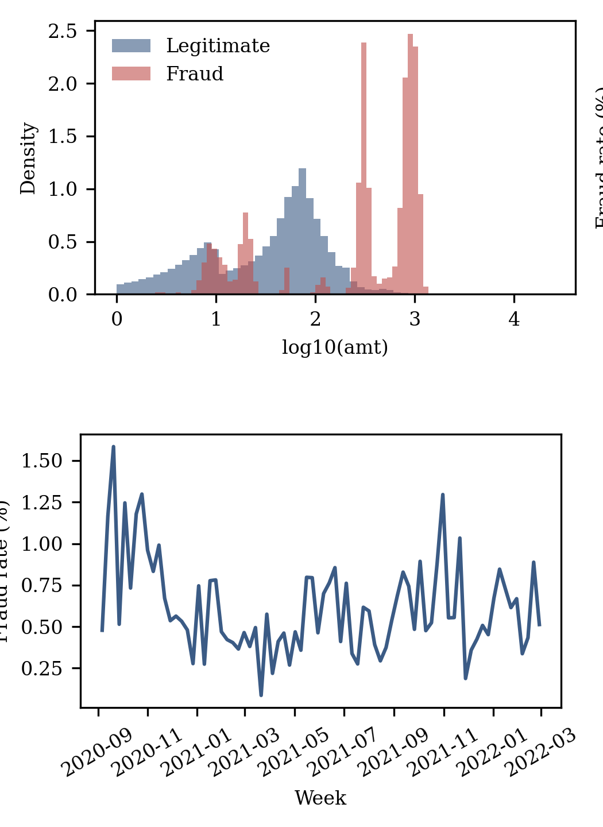
Fig. 1. Transaction amount by class (top) and weekly fraud rate (bottom) in the sparknov training data.
IV. Data Preprocessing and Feature Engineering
A. Integrity checks
Data were loaded with pandas and validated before use. The checks confirm that the label column exists and contains only the values 0 and 1, that the expected feature columns are present with consistent types, and that no column is entirely constant. Missing values are counted per column. Exact duplicate rows are counted; if they are removed, removal happens before splitting so that identical records cannot appear in both training and test data. Every check writes its result to a log so that the data state behind each experiment is documented.
B. Imputation, encoding and scaling
Numeric gaps were filled with the training-set median, which is robust to the heavy right tail typical of transaction amounts. Categorical gaps received an explicit “missing” category, because the absence of a value can itself be informative in fraud data. Categorical variables were one-hot encoded, with categories unseen during training ignored at prediction time. FDB already removes merchant names and transaction numbers. The remaining identifier and personal columns (card number, first and last name, street, city, job, date of birth and FDB’s event and entity identifiers) were excluded, leaving seven numeric and three categorical inputs (Table II). The ZIP code was kept as a numeric input; this imposes an arbitrary order on postal codes, which tree models can partly work around by splitting on ranges, and is noted as a limitation.
Logistic Regression is sensitive to feature scale, so its numeric inputs were standardized to zero mean and unit variance. Transaction amount may additionally be log-transformed to reduce skew. Tree-based models split on thresholds and are unaffected by monotonic rescaling, so they receive unscaled numeric features. Feature engineering is kept minimal: the aim is a fair comparison of learners, not a feature-engineering contest, so no derived features were added.
C. Leakage controls
Leakage occurs when information that would not be available at prediction time influences training. Resampling can be applied in two orders. When SMOTE is run on the full dataset before splitting, synthetic fraud points are interpolated from cases that later land in the test set, so the test set is no longer independent. When the data are split first and SMOTE is run inside each training fold, validation and test data remain untouched.
To enforce the correct order, imputation, encoding, scaling, resampling and the classifier are combined in one imbalanced-learn pipeline. The pipeline is refitted from scratch inside each cross-validation fold, and resampling steps are skipped automatically at prediction time. If the data have a time order, no feature uses information from transactions later than the one being scored. The fitted pipeline is saved as a single object so that the transformations applied at prediction time are identical to those learned during training.
V. Dataset Splitting and Experimental Design
A. Partitions
The training data are the 1,296,675 rows of the official FDB training partition, and the test data are the official FDB test partition of 20,000 transactions, which was set aside until the final evaluation. FDB provides no validation partition, so one was carved chronologically: the training rows were sorted by timestamp, the earliest 85% (1,102,173 rows, up to 3 December 2021) were used for fitting and cross-validation, and the latest 15% (194,502 rows) formed the validation partition. To keep the grid search within Google Colab’s time limits, a stratified 30% subsample of the fitting rows (330,651 transactions, 1,912 frauds) was used for cross-validation and model fitting; the validation and test partitions were used in full. All models share the same partitions and the random seed 42.
B. Validation and test discipline
The protocol is fixed before any test result is seen:
- Hyperparameters are chosen by stratified 5-fold cross-validation on the training partition, scored by average precision (PR-AUC).
- Each tuned pipeline is refitted on the full training partition and scored on the validation partition.
- Each model’s decision threshold is chosen from validation predictions only.
- The selected model is the one with the highest validation PR-AUC.
- The test partition is used once to report every model with frozen settings and thresholds.
- If a non-selected model scores higher on test data, the selection is not revised; revising it would make the test set a second validation set and bias the final estimate upward.
C. Why PR-AUC drives selection
ROC-AUC measures how well a model ranks fraud above legitimate transactions, but its false-positive rate is divided by the very large number of legitimate transactions, so even thousands of false alarms barely move the curve. PR-AUC replaces the false-positive rate with precision, which directly reflects the share of alarms that are genuine. Its chance level equals the fraud prevalence rather than 0.5 [14], [15]. Appendix B shows the difference on the test results. Selecting on PR-AUC therefore aligns model choice with the analyst’s real concern: how much useful fraud each review slot will find.
VI. Model Selection and Training
A. Reference and candidate algorithms
The majority-class reference labels every transaction legitimate. It establishes the floor for each metric and makes the accuracy paradox visible in the results tables.
Logistic Regression models the log-odds of fraud as a weighted sum of the standardized features. It is fast, well understood and its coefficients can be read directly, which makes it the natural transparent baseline. Its weakness is that it can only draw linear decision boundaries unless interactions are engineered by hand.
Random Forest averages the predictions of many decision trees, each grown on a bootstrap sample with a random subset of features considered at every split [12]. It captures nonlinear effects and interactions automatically, and the option class_weight = balanced_subsample reweights classes within each bootstrap sample.
XGBoost adds trees one at a time, each fitted to the gradient of the loss with respect to the current ensemble’s predictions, and regularizes tree complexity to limit overfitting [11]. Its scale_pos_weight parameter multiplies the loss on positive examples, a direct form of cost-sensitive learning for imbalanced data.
B. Hyperparameter search
Each learner was tuned by grid search over the values in Table III, using stratified 5-fold cross-validation on the fitting subsample and average precision (PR-AUC) as the score. The broader grid originally planned (up to 24 settings per learner) was reduced to fit Colab’s time limits. The reduced grid still varies regularization strength or tree depth and, for every learner, the class-imbalance parameter. In the fitting subsample, N_neg/N_pos was 171.9. The grid searches took 0.8 min for Logistic Regression, 41.3 min for Random Forest and 3.7 min for XGBoost.
TABLE III.
Hyperparameter Search Space Used
Model | Hyperparameter | Values searched
Logistic Regression | C (inverse regularization) | 0.1, 1
 | class_weight | None, balanced
Random Forest | n_estimators | 200
 | max_depth | None, 20
 | min_samples_leaf | 1
 | class_weight | balanced, balanced_subsample
XGBoost | learning_rate | 0.05, 0.1
 | max_depth | 5, 7
 | n_estimators | 300
 | scale_pos_weight | 1, 171.9 (N_neg / N_pos)

C. Imbalance handling
Two strategies are compared, and both touch training data only. The first is cost-sensitive learning through class_weight or scale_pos_weight, which raises the penalty for missing fraud without altering the data. The second is resampling with random oversampling or SMOTE [10]. In SMOTE, each synthetic fraud point lies on the line segment between an existing fraud case and one of its nearest fraud neighbors. Because the synthetic points fill gaps inside the existing fraud region rather than duplicating points exactly, the model is encouraged to learn a broader fraud region instead of memorizing individual cases.
SMOTE has drawbacks. It can place synthetic points in regions that overlap legitimate traffic, and, like undersampling [17], it shifts predicted probabilities upward, so scores from a resampled model should not be read as calibrated probabilities. For that reason the resampling experiment is reported separately from the class-weighting experiment, and thresholds are always re-selected on unresampled validation data.
D. Threshold tuning
A model’s score becomes a decision only once a threshold is set, and with rare positives the default of 0.5 is usually far from the best choice. As the threshold rises, precision increases and recall falls, so the F1-score typically peaks well away from 0.5 (Section VIII-C). In the experiment, the precision–recall curve of each model was computed on validation predictions, and two operating points were recorded: the threshold that maximizes F1, and the threshold with the highest precision that still reaches a target recall of 0.80. The default of 0.5 was reported as a baseline, and test labels were never used to choose a threshold.
E. Training procedure
For each model family the grid search fits the complete pipeline, including any resampling, on four folds of the training partition and scores average precision on the fifth, rotating through all five folds. The setting with the best mean score is refitted on the full training partition. The refitted pipeline scores the validation partition, where its PR-AUC is recorded and its thresholds are chosen. The family with the highest validation PR-AUC becomes the selected model and is saved with its threshold. Training times and the standard deviation of fold scores are logged, since a model whose score varies widely between folds is less trustworthy than one with a slightly lower but stable score.
VII. System Design and Implementation
A. Architecture
The prototype is implemented in two Python files: run_experiments.py, which runs the entire experiment in one command, and predict.py, the command-line scoring tool. Both follow the data path end to end, and an equivalent Google Colab notebook runs the same steps cell by cell. The workflow runs from raw data to prediction in eight stages: loading, validation and exploratory analysis; a chronological split; preprocessing fitted on training data only; cross-validated training of the three learners; threshold selection on validation data; a single test evaluation; SHAP explanation; and command-line scoring. Each stage writes its outputs to disk, so every table and figure in the paper can be traced to a saved file. Fig. 2 shows the first steps of the Colab notebook that ran the experiment: package installation, including the FDB loader, and Kaggle authentication.
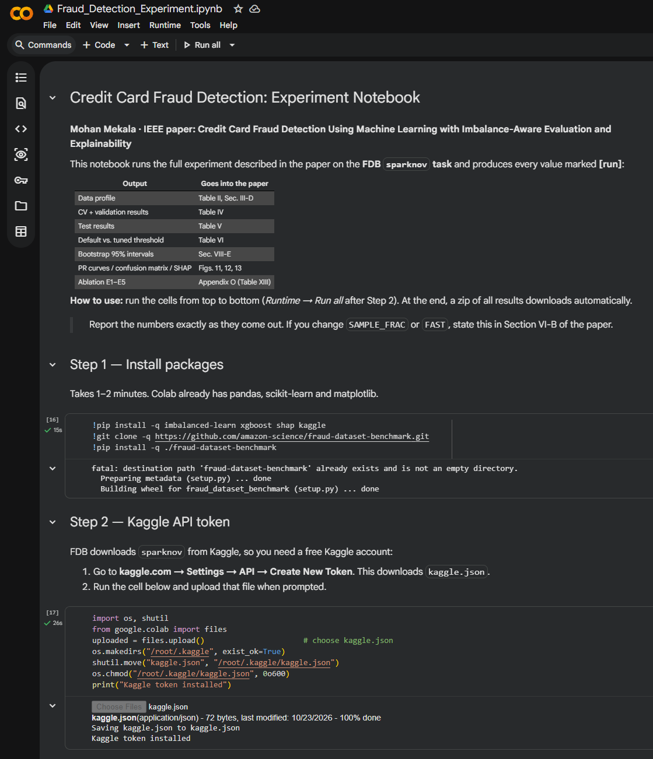
Fig. 2. Colab notebook used for the experiment: Step 1 installs the packages and the FDB loader; Step 2 installs the Kaggle API token.
The logical modules are implemented as functions within run_experiments.py. Data loading and validation are separated from feature processing so that the same checks run on training data and on new inputs at prediction time. Training, threshold selection and evaluation are distinct modules, which makes it difficult to tune on test data by accident. The trained pipeline and the chosen threshold are stored together in an artifacts folder; metrics, tables and figures go to a results folder.
B. Software stack
The experiment was run on Google Colab with Python 3.13 and scikit-learn 1.6.1, loading the data through the FDB loader. The implementation uses pandas and NumPy for data handling, scikit-learn for preprocessing, Logistic Regression, Random Forest, cross-validation and metrics, imbalanced-learn for pipelines that support resampling, the xgboost package for gradient boosting, the shap package for explanations, Matplotlib for figures and joblib for serialization. All versions are pinned in requirements.txt.
C. Command-line prototype
The prediction interface accepts either a single transaction supplied as arguments or a CSV file of transactions. It loads the saved pipeline and threshold, validates that the required columns are present, scores each row and prints the fraud-risk score with the resulting decision. Fig. 3 shows the prototype’s actual output in the Colab run. It loaded the saved XGBoost pipeline and its validation-selected threshold of 0.196 and scored five test transactions: the two frauds received scores of 0.6053 and 0.2327 and were flagged for review, while the three legitimate transactions scored 0.0002 or less and were passed. The output states explicitly that a flag is a model prediction and not a finding of fraud. Rows with missing required columns are rejected with a clear message rather than being scored with silently imputed values.
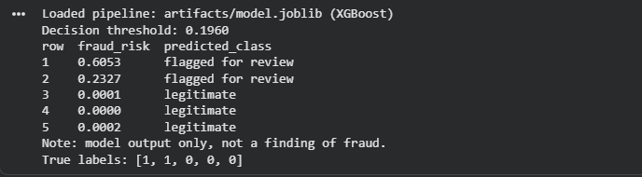
Fig. 3. Output of the prototype on five test transactions (two frauds, three legitimate) in the Colab run.
D. Reproducibility
The last notebook step packages the results and artifacts folders into fraud_results.zip and downloads it (Fig. 4). That archive is the source of every table and of Figs. 1, 6, 7 and 8.
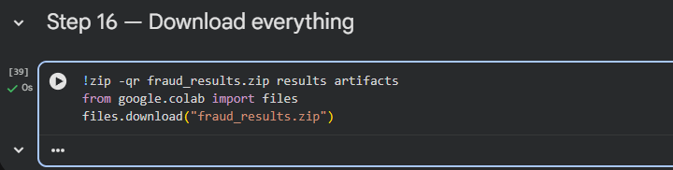
Fig. 4. Step 16 of the Colab notebook, which zips the results and artifacts and downloads fraud_results.zip.
A README documents the Python version, installation, dataset acquisition and the commands for training, evaluation and prediction. A single training run produces every artifact used in the paper, so tables and figures cannot come from mismatched runs. The random seed is fixed for splitting, resampling and model training. Appendix C lists the artifacts and the checks that confirm a reproduction matches the reported run.
VIII. Experimental Results
All results come from a single run of the Colab notebook on the FDB sparknov task, with seed 42, the 30% fitting subsample and the grid in Table III. Every value is taken directly from the saved result files. Fig. 5 shows the summary printed by the notebook at the end of the run, from which Tables VI and VII are taken, and Figs. 1, 6, 7 and 8 are the notebook’s own plots. The complete run, including the ablation experiments, took 82.6 minutes.
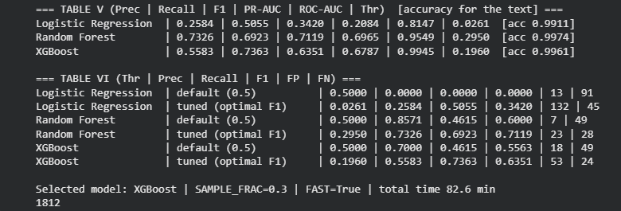
Fig. 5. Summary printed by the Colab notebook at the end of the run (test results and threshold comparison).
A. Cross-validation and validation selection
Table IV lists each model’s selected hyperparameters, its cross-validated PR-AUC on the fitting data and its PR-AUC on the validation partition. The two tree ensembles were far ahead of Logistic Regression on both measures. XGBoost had the highest validation PR-AUC (0.703) and was therefore selected under the pre-declared rule; Random Forest followed at 0.687. Fold-to-fold standard deviations were small (0.009–0.016), so the ranking was stable within the training data.
The grid search chose no class weighting for Logistic Regression and scale_pos_weight = 1 for XGBoost. In every compared pair, the unweighted version had the higher cross-validated PR-AUC; for XGBoost at depth 7 and learning rate 0.05, for example, the scores were 0.755 and 0.724. Only Random Forest selected balanced weights, and there the balanced and balanced_subsample variants differed by just 0.0004. Table V lists the cross-validated score of every grid setting.
TABLE IV.
Cross-Validation and Validation Results
Model | Selected parameters | CV PR-AUC (mean ± SD) | Val. PR-AUC
Majority reference | — | — | 0.0058
Logistic Regression | C = 0.1; no class weights | 0.2050 ± 0.0125 | 0.1998
Random Forest | 200 trees; no depth limit; leaf 1; balanced | 0.7323 ± 0.0087 | 0.6870
XGBoost (selected) | lr 0.05; depth 7; 300 trees; spw 1 | 0.7555 ± 0.0164 | 0.7029

TABLE V.
Cross-Validated PR-AUC of Every Grid Setting
Model | Setting | CV PR-AUC (mean ± SD) | Fit time (s)
LR | C 0.1, none | 0.2050 ± 0.0125 | 2.3
LR | C 0.1, balanced | 0.1509 ± 0.0111 | 1.8
LR | C 1, none | 0.2046 ± 0.0111 | 1.5
LR | C 1, balanced | 0.1491 ± 0.0108 | 3.1
RF | depth none, balanced | 0.7323 ± 0.0087 | 126.7
RF | depth 20, balanced | 0.6760 ± 0.0172 | 98.2
RF | depth none, bal. subsample | 0.7319 ± 0.0094 | 131.9
RF | depth 20, bal. subsample | 0.6813 ± 0.0183 | 100.1
XGB | lr 0.05, d 5, spw 1 | 0.7470 ± 0.0158 | 4.5
XGB | lr 0.05, d 5, spw 171.9 | 0.6851 ± 0.0124 | 4.5
XGB | lr 0.05, d 7, spw 1 | 0.7555 ± 0.0164 | 5.1
XGB | lr 0.05, d 7, spw 171.9 | 0.7239 ± 0.0123 | 5.6
XGB | lr 0.1, d 5, spw 1 | 0.7551 ± 0.0183 | 4.4
XGB | lr 0.1, d 5, spw 171.9 | 0.7150 ± 0.0140 | 4.5
XGB | lr 0.1, d 7, spw 1 | 0.7544 ± 0.0142 | 5.0
XGB | lr 0.1, d 7, spw 171.9 | 0.7333 ± 0.0082 | 5.6

B. Held-out test performance
Table VI reports test results at each model’s validation-selected F1 threshold. The test partition contains 20,000 transactions, 91 of them fraudulent (0.455%). The majority reference was 99.545% accurate while detecting no fraud. The tuned Logistic Regression caught half of the frauds, yet its accuracy (99.115%) was lower than the reference’s, which demonstrates the accuracy paradox described in Section I on real benchmark data. The two ensembles reached accuracies of 99.745% (Random Forest) and 99.615% (XGBoost).
The selected XGBoost model caught 67 of the 91 frauds (recall 0.736) while raising 53 false alarms (precision 0.558), so 120 of the 20,000 transactions, 0.6%, were flagged for review. Random Forest, which was not selected, achieved higher test precision (0.733), F1 (0.712) and PR-AUC (0.696 vs. 0.679), while XGBoost had higher recall and a much higher ROC-AUC (0.995 vs. 0.955). In line with Section V-B, the selection was not revised after these test results were seen. For the majority reference, precision is undefined because it never flags a transaction; its PR-AUC equals the test prevalence (0.00455) and its ROC-AUC is 0.5 by construction.
TABLE VI.
Held-Out Test-Set Results
Model | Prec. | Recall | F1 | PR-AUC | ROC-AUC | Thr.
Majority reference | — | 0.0000 | 0.0000 | 0.00455 | 0.5000 | —
Logistic Regression | 0.2584 | 0.5055 | 0.3420 | 0.2084 | 0.8147 | 0.026
Random Forest | 0.7326 | 0.6923 | 0.7119 | 0.6965 | 0.9549 | 0.295
XGBoost (selected) | 0.5583 | 0.7363 | 0.6351 | 0.6787 | 0.9945 | 0.196

C. Effect of threshold tuning
Table VII compares the default threshold of 0.5 with each model’s two validation-selected thresholds. Every tuned threshold was far below 0.5 (0.026–0.295), reflecting how rarely fraud occurs. At 0.5, Logistic Regression flagged only 13 transactions, none of them fraudulent, and both ensembles caught fewer than half of the frauds (recall 0.462). Tuning on validation data raised recall to 0.692 for Random Forest and 0.736 for XGBoost, and raised F1 by 0.112 and 0.079 respectively, at the cost of 16 and 35 additional false alarms.
A second operating point, chosen on validation data to reach a recall of at least 0.80, gave test recall of 0.824 (Random Forest) and 0.802 (XGBoost), with precision of 0.381 and 0.442 and 122 and 92 false alarms. For Logistic Regression, the same target required flagging 7,498 legitimate transactions.
TABLE VII.
Default, F1-Optimal and Recall-0.80 Thresholds on the Test Set
Model | Thr. | Prec. | Recall | F1 | FP | FN
Logistic Reg. | 0.500 | 0.0000 | 0.0000 | 0.0000 | 13 | 91
 | 0.026 | 0.2584 | 0.5055 | 0.3420 | 132 | 45
 | 0.004 | 0.0095 | 0.7912 | 0.0188 | 7,498 | 19
Random Forest | 0.500 | 0.8571 | 0.4615 | 0.6000 | 7 | 49
 | 0.295 | 0.7326 | 0.6923 | 0.7119 | 23 | 28
 | 0.075 | 0.3807 | 0.8242 | 0.5208 | 122 | 16
XGBoost | 0.500 | 0.7000 | 0.4615 | 0.5563 | 18 | 49
 | 0.196 | 0.5583 | 0.7363 | 0.6351 | 53 | 24
 | 0.080 | 0.4424 | 0.8022 | 0.5703 | 92 | 18

D. Precision–recall curves and confusion matrix
Fig. 6 shows the test precision–recall curves. Both ensembles keep precision at roughly 0.6 or more up to a recall of about 0.7, after which precision falls steeply. Their curves cross repeatedly: Random Forest is higher across most of the middle recall range and XGBoost at the highest recall levels. Logistic Regression never exceeds a precision of about 0.45. Fig. 7 gives the confusion matrix of the selected model at its tuned threshold: 19,856 true negatives, 53 false positives, 24 false negatives and 67 true positives.
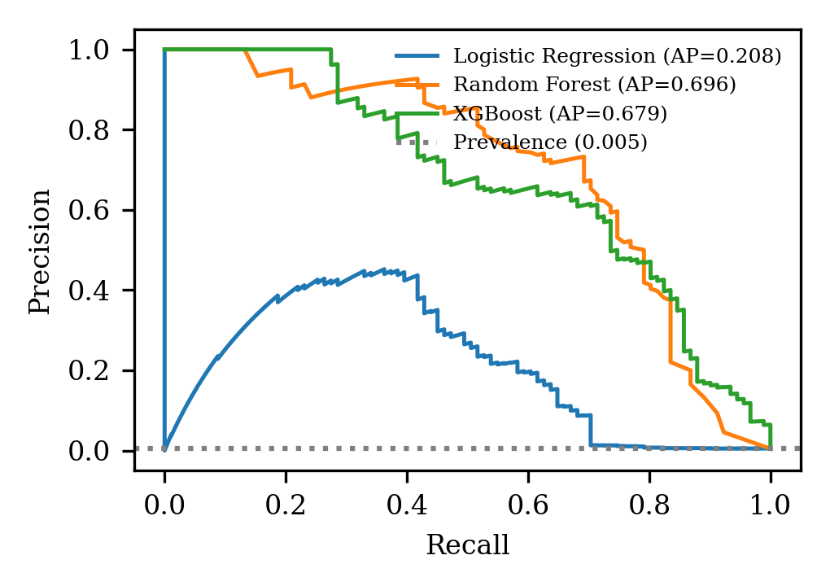
Fig. 6. Precision–recall curves on the held-out test set; the dotted line marks the fraud prevalence.
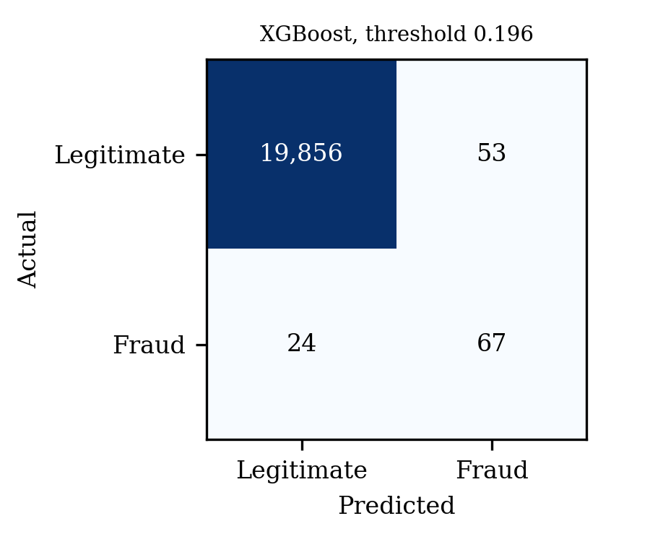
Fig. 7. Confusion matrix of the selected XGBoost model on the test set (threshold 0.196).
E. Uncertainty
A paired bootstrap with 1,000 resamples of the test predictions (Table VIII) gave 95% intervals for XGBoost of [0.5767, 0.7582] for PR-AUC and [0.5521, 0.7036] for F1. For Random Forest the intervals were [0.5985, 0.7877] and [0.6409, 0.7827], and for Logistic Regression they were [0.1427, 0.2966] and [0.2581, 0.4141]. The interval for the PR-AUC difference between Random Forest and XGBoost was [−0.0452, 0.0841], which includes zero, so the test set does not show a reliable difference between the two ensembles. The interval for Logistic Regression minus XGBoost was [−0.5540, −0.3701], confirming that both ensembles are clearly better than the linear model. The intervals are wide because the test set contains only 91 frauds.
TABLE VIII.
Paired-Bootstrap 95% Intervals on the Test Set
Model | PR-AUC | F1 | PR-AUC minus XGBoost
Logistic Regression | [0.1427, 0.2966] | [0.2581, 0.4141] | [−0.5540, −0.3701]
Random Forest | [0.5985, 0.7877] | [0.6409, 0.7827] | [−0.0452, 0.0841]
XGBoost | [0.5767, 0.7582] | [0.5521, 0.7036] | —

F. Explainability results
SHAP values were computed with a tree explainer for 1,000 test transactions. Fig. 8 and the mean absolute SHAP values in Table IX show that transaction amount dominates (mean |SHAP| 2.92), followed by the indicator for the gas_transport merchant category (2.30). The next most influential inputs, each with mean |SHAP| between 0.39 and 0.53, are the travel, grocery_pos and food_dining category indicators and the indicator for the state of Idaho. Merchant longitude (0.31), city population (0.18) and several more state indicators also appear among the top fifteen. The effect of amount is non-monotonic: some amount bands push scores strongly up and others strongly down, which matches the narrow fraud amount bands in Fig. 1.
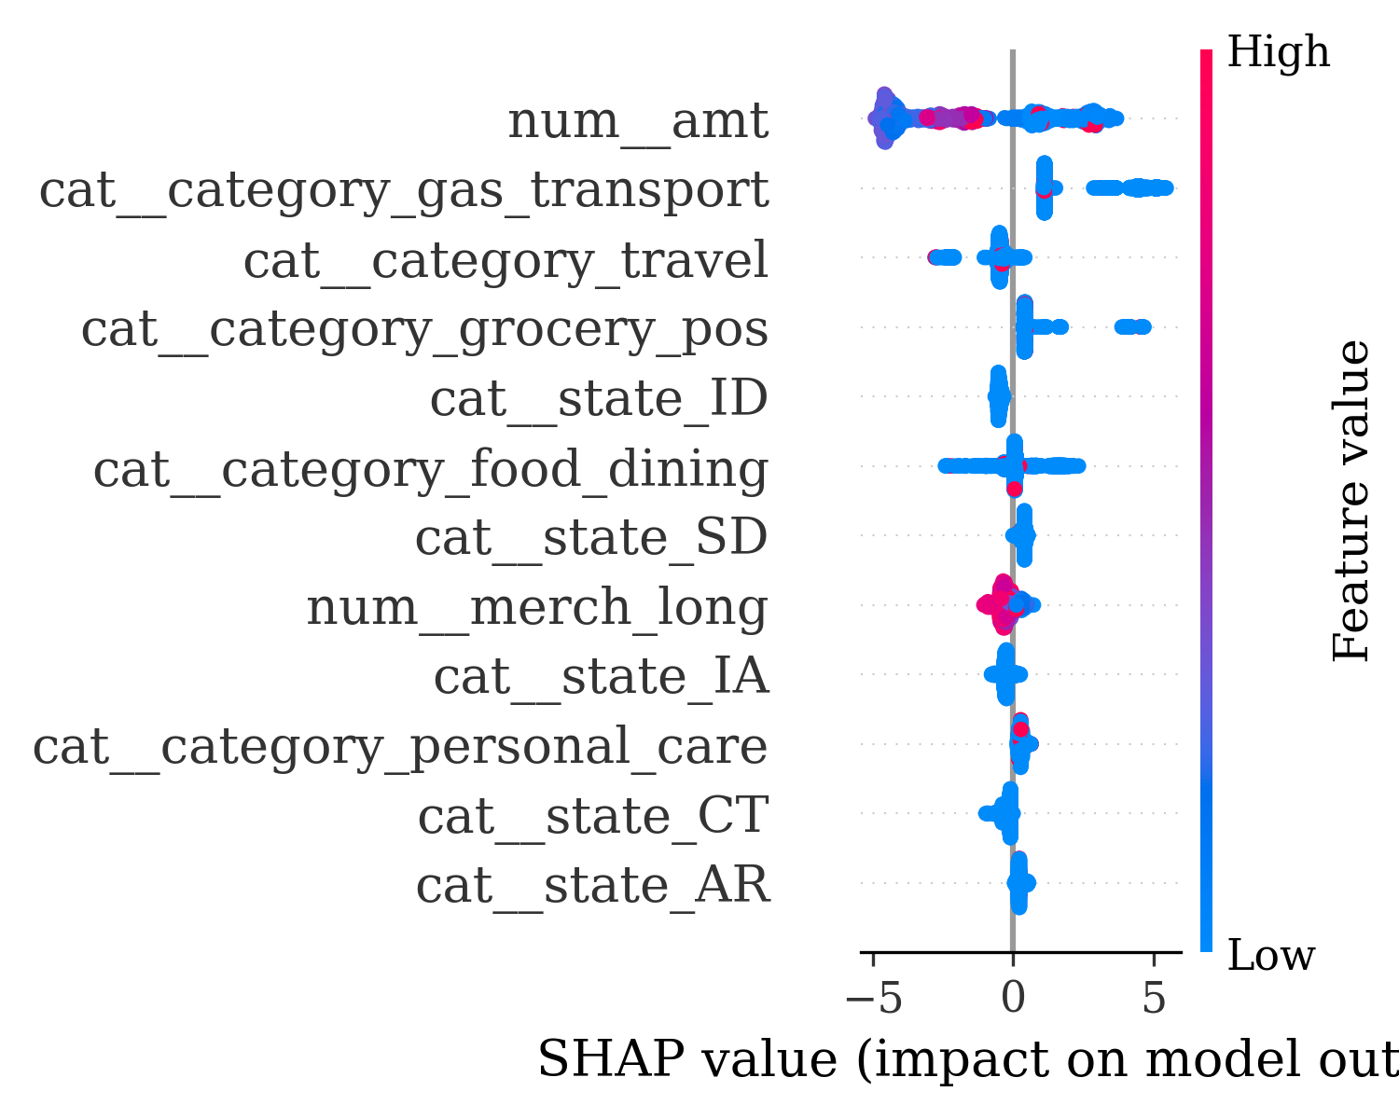
Fig. 8. SHAP summary for the selected XGBoost model (1,000 test transactions).
TABLE IX.
Inputs With the Largest Mean Absolute SHAP Value
Rank | Input | Mean |SHAP|
1 | amt | 2.9163
2 | category = gas_transport | 2.3042
3 | category = travel | 0.5269
4 | category = grocery_pos | 0.5249
5 | state = ID | 0.4991
6 | category = food_dining | 0.3877
7 | state = SD | 0.3397
8 | merch_long | 0.3113
9 | state = IA | 0.2786
10 | category = personal_care | 0.2750

IX. Discussion
A. Trade-offs observed
The results make the precision–recall trade-off concrete. At its tuned threshold, the selected XGBoost model flags 120 of every 20,000 transactions, and 56% of those alerts are genuine fraud. Moving to the recall-0.80 operating point would catch six more frauds at the cost of 39 more false alarms. Which point is better depends on the relative cost of a missed fraud and of a review (Appendix F).
The gap between ROC-AUC and PR-AUC also appears in practice. XGBoost’s ROC-AUC of 0.995 suggests near-perfect ranking, yet its PR-AUC is 0.679: legitimate transactions outnumber frauds by more than 200 to 1, so even a small false-positive rate produces many false alarms. This is examined further in Appendix B and confirms why PR-AUC was used for selection. As the literature suggests, the tree ensembles outperformed the linear model by a wide margin (PR-AUC of about 0.68–0.70 against 0.21), consistent with fraud signals that depend on interactions, such as particular amounts within particular merchant categories.
B. Answering the research questions
RQ1. Random Forest and XGBoost were clearly better than Logistic Regression on every fraud-sensitive metric. Between the two ensembles the evidence is mixed. XGBoost won on validation PR-AUC, test recall and test ROC-AUC; Random Forest won on test PR-AUC, precision and F1. The bootstrap interval for their PR-AUC difference includes zero. The validation-selected XGBoost is therefore a reasonable, but not uniquely best, choice.
RQ2. Threshold tuning was the most effective remedy: it raised F1 for all three models (Table VII and Appendix M). Class weighting did not improve ranking quality. It lowered PR-AUC for Logistic Regression (from 0.208 to 0.146) and XGBoost (from 0.679 to 0.661), left Random Forest essentially unchanged (from 0.694 to 0.696), and at the default threshold traded large gains in recall for collapses in precision. SMOTE gave mixed results. Compared with tuning alone, it lowered F1 for Logistic Regression and Random Forest, but for XGBoost it produced the highest test PR-AUC and F1 of any configuration (0.751 and 0.714). That configuration was only evaluated in the ablation, not chosen by the validation rule, so it is reported as a promising lead rather than a replacement for the selected model.
RQ3. SHAP shows that the selected model relies mainly on transaction amount and merchant category. Both are plausible fraud signals and match the separation visible in Fig. 1. The prominence of individual state indicators and merchant longitude is harder to explain as genuine fraud behavior. It may reflect how the Sparkov generator assigns fraud to particular customer profiles, and with only 91 test frauds such location effects should be treated with caution.
C. Comparison with prior work
For sparknov, FDB reports test ROC-AUC values of 0.906–0.995 for default-setting Random Forest, CatBoost, LightGBM and MLP models on raw features, and 0.995–0.998 for AutoML systems [9]. This project used the same official partitions, so its ROC-AUC values can be compared directly. XGBoost’s 0.9945 is at the top of the raw-feature range and close to the AutoML systems, Random Forest’s 0.955 lies within the range, and Logistic Regression’s 0.815 is below it. FDB does not report PR-AUC or F1, so those results cannot be compared with it, and studies on other datasets, such as most work on the European dataset [3], [5], are not numerically comparable.
D. Practical application
In practice a model of this kind would rank transactions so that analysts review the riskiest first. It should not block cards or accuse customers on its own authority. Reviewers need to see the transaction context and the main SHAP contributions behind a score, and they need a simple way to override the model and record why. Overrides are also valuable training signal for future versions.
E. Limitations
Reduced search. Models were fitted on a 30% subsample of the fitting data with a reduced grid. A full search on all training rows might select different hyperparameters and could change the narrow ranking between the two ensembles.
Feature encoding. ZIP code was treated as a numeric input, which imposes an arbitrary order on postal codes.
Simulated data. Sparkov transactions are generated by software rather than recorded from real cardholders, so fraud patterns may be cleaner than real ones; FDB itself warns that models trained on its datasets carry no information about real fraud and must not be used to make decisions about real people [9].
Representativeness. A public benchmark may not match the merchants, regions or fraud patterns of a particular issuer, so scores may not transfer.
Interpretability of features. Anonymized or transformed features limit what SHAP explanations can say in business terms.
Concept drift. Fraudsters adapt once blocked. A random split can overstate performance relative to a chronological one, and any deployed model would need monitoring and periodic retraining.
Label quality. Fraud labels come from chargebacks and investigations, which arrive late and can miss undetected fraud, so some “legitimate” records may be mislabeled.
Resampling side effects. Oversampling changes the effective class balance and inflates predicted probabilities; it is not a substitute for careful validation.
Causality. SHAP describes associations the model has learned. It does not show that a feature causes fraud.
F. Ethical considerations
Fraud models process financial data that can reveal where people shop, travel and live. The project uses only public benchmark data, collects no additional personal information and respects the dataset’s licence. Model errors may not fall evenly across customer groups: if some groups’ ordinary spending looks unusual to the model, they will face more declines and reviews. Fairness checks should therefore be run wherever lawful demographic or regional metadata exist. Decisions with real consequences, such as closing an account, must rest with a human reviewer, with a route for the customer to contest the outcome.
X. Conclusion and Future Work
This paper compared Logistic Regression, Random Forest and XGBoost on the FDB sparknov credit-card task under an imbalance-aware protocol. Both tree ensembles substantially outperformed Logistic Regression, with test PR-AUC of about 0.68–0.70 against 0.21. XGBoost, selected on validation PR-AUC, caught 67 of 91 test frauds with 53 false alarms among 20,000 transactions. Random Forest performed comparably, and the difference between the two ensembles was not statistically reliable. Tuning the decision threshold on validation data improved F1 for every model, class weighting did not improve PR-AUC, and SHAP identified transaction amount and merchant category as the main drivers. These findings support the paper’s central methodological point: on rare-event problems, the choice of metric, threshold and selection protocol matters as much as the choice of algorithm.
Future work includes repeating the search on the full training data with the full grid, confirming the promising SMOTE–XGBoost configuration through the validation rule, adding behavioral features such as transaction velocity and amount relative to a card’s history, calibrating scores, evaluating drift on later data and testing on real rather than simulated transactions.
Appendix A. Metric Definitions
A.1. Confusion matrix
Every evaluation in this paper starts from the confusion matrix; Fig. 7 shows the one for the selected model. With fraud as the positive class, TP counts fraud correctly flagged, FP counts legitimate transactions wrongly flagged, FN counts fraud missed and TN counts legitimate transactions correctly passed. In fraud work the two error cells have very different consequences: an FP costs review effort and customer goodwill, whereas an FN means the fraud loss is incurred.
A.2. Threshold-dependent metrics
Precision = TP / (TP + FP) (1)
Recall = TP / (TP + FN) (2)
F1 = 2 · Precision · Recall / (Precision + Recall) (3)
FPR = FP / (FP + TN) (4)
Accuracy = (TP + TN) / (TP + TN + FP + FN) (5)
Precision answers “of the transactions we flagged, how many were fraud?” Recall answers “of all the fraud, how much did we catch?” F1 is their harmonic mean and is low whenever either is low. The false-positive rate (FPR) is the share of legitimate transactions flagged. All four depend on the threshold.
A.3. Threshold-free metrics
PR-AUC summarizes precision across all recall levels. It is computed here as average precision, where Rₙ and Pₙ are recall and precision at the n-th threshold:
AP = Σₙ (Rₙ − Rₙ₋₁) · Pₙ (6)
ROC-AUC is the area under the curve of recall against FPR. It equals the probability that a randomly chosen fraud case receives a higher score than a randomly chosen legitimate transaction. A random model scores 0.5 on ROC-AUC but only the fraud prevalence on PR-AUC.
Appendix B. ROC Versus PR on the Test Results
Table VI sets each learner’s ROC-AUC beside its PR-AUC on the test set, where legitimate transactions outnumber frauds by about 219 to 1. All three ROC-AUC values look strong (0.815–0.995), but PR-AUC is far lower (0.208–0.696) and ranks the models differently: XGBoost has the highest ROC-AUC but Random Forest the highest PR-AUC. ROC-AUC stays high because even hundreds of false positives are a small fraction of 19,909 legitimate transactions, whereas PR-AUC measures precision against the alarms actually raised. The chance level of PR-AUC equals the fraud prevalence (0.00455), whereas that of ROC-AUC is 0.5.
Appendix C. Reproducibility and Artifacts
C.1. Reproducing a run
The reported run loaded the data through the FDB Python loader in Google Colab and ran the notebook from top to bottom once, with SAMPLE_FRAC = 0.3 and the reduced grid. To reproduce the reported numbers exactly, the FDB loader should be used, because FDB’s 20,000-row test sample cannot be regenerated from the Kaggle source files [21] without FDB’s sampling seed. That command performs validation, splitting, cross-validated tuning, threshold selection and test evaluation and writes all outputs. The evaluation and explanation commands can then be rerun from the saved artifacts without retraining. If code or data change, all artifacts are regenerated together so that no table or figure mixes runs.
C.2. Artifact inventory
Table X lists the files written by a run and where each is used.
TABLE X.
Output Artifacts Written by run_experiments.py
Artifact | Contents
artifacts/model.joblib | Fitted preprocessing pipeline and selected classifier
artifacts/threshold.json | Selected model, thresholds, feature lists, seed and run options
results/table_II_data_profile.csv | Rows, fraud cases, missing values and duplicates per partition
results/cv_results.csv | Every grid setting with fold scores
results/table_IV_cv_validation.csv | Table IV values
results/table_V_test.csv | Table VI values
results/table_VI_thresholds.csv | Table VII values
results/table_XIII_ablation.csv | Table XIV values (with --ablation)
results/bootstrap_ci.csv | 95% bootstrap intervals
results/test_predictions.csv | Test scores and labels
results/figures/ | Figs. 1, 6, 7 and 8
results/run_log.txt | Versions, seed, dropped columns and timings

C.3. Verification checks
A reproduction is accepted when partition sizes and fraud counts match the data profile, the selected hyperparameters and model name match threshold.json, and test metrics recomputed from test_predictions.csv match table_V_test.csv. If a score differs, the dataset version, package versions and seed are checked before any conclusion is drawn about the model. Serialized scikit-learn pipelines are not guaranteed to load across library versions, so the model should be loaded under the pinned versions or retrained.
Appendix D. Prototype Operation
D.1. Inputs and outputs
The prototype accepts a CSV file whose columns match the training schema, or a single record. It returns, for each row, the fraud-risk score, the decision at the selected threshold and a reminder that the decision is a model output. It does not request names, card numbers or any other personal identifiers beyond the benchmark features. Empty input, unknown columns or wrong data types produce an error message rather than a prediction.
D.2. Operational limitations
The prototype is a local tool. It has no authentication, no rate limiting, no monitoring and no automatic retraining. It does not detect drift in incoming data. These omissions are deliberate for a coursework prototype and would all need to be addressed, along with a security review, before any production use.
Appendix E. Requirement Traceability and Project Plan
Table XI maps each assignment requirement to the section that addresses it and its current status.
TABLE XI.
Requirement Traceability
Requirement | Where addressed | Status
Public dataset, 2020–2026 | Sec. III-B, Table II | Done
Three prior studies on dataset | Sec. III-B | Done
Data understanding / EDA | Sec. III-D | Done
Preprocessing | Sec. IV | Done
Train / validation / test split | Sec. V | Done
At least three models | Sec. VI | Done
Hyperparameter tuning | Sec. VI-B, Table III | Done
Evaluation metrics | Sec. VIII, App. A | Done
Results and discussion | Sec. VIII–IX | Done
Working prototype | Sec. VII, App. D | Done
Ethics and limitations | Sec. IX-C, IX-D | Done

Appendix F. Threshold Economics
F1 treats a missed fraud and a false alarm as equally bad, which is rarely true. If a false alarm costs cFP (an analyst’s review time) and a missed fraud costs cFN (the average fraud loss), the total cost at threshold t is:
Cost(t) = c_FP · FP(t) + c_FN · FN(t) (7)
Table XII evaluates this cost at the three operating points measured for the two ensembles (Table VII), for three cost ratios. When a missed fraud costs five times a review, the F1-optimal threshold is cheapest for both models (163 units for Random Forest, 173 for XGBoost). When it costs 20 or 50 times as much, the recall-0.80 threshold becomes cheapest (442 and 922 units for Random Forest, 452 and 992 for XGBoost), despite its extra false alarms. The default threshold of 0.5 is the most expensive option in every case. The “best” threshold is therefore a business decision, and if realistic costs can be estimated, the cost-optimal threshold should be chosen on validation data in the same way as the F1-optimal one.
TABLE XII.
Total Cost at the Measured Operating Points (Units of One False Positive)
Model | Threshold | FN = 5× FP | FN = 20× FP | FN = 50× FP
Random Forest | 0.500 | 252 | 987 | 2,457
 | 0.295 (F1) | 163 | 583 | 1,423
 | 0.075 (rec. 0.8) | 202 | 442 | 922
XGBoost | 0.500 | 263 | 998 | 2,468
 | 0.196 (F1) | 173 | 533 | 1,253
 | 0.080 (rec. 0.8) | 182 | 452 | 992

Appendix G. Error Analysis Plan
Aggregate metrics show how often the model errs but not why; the selected model produced 53 false positives and 24 false negatives on the test set. After testing, a structured review will sample a fixed number of false positives and false negatives from the test predictions using a recorded seed. For each sampled transaction, the reviewer will record the main SHAP contributions and assign one or more of the categories in Table XIII. Categories are defined before the review begins so that they are not invented to fit the examples.
TABLE XIII.
Planned Error-Analysis Categories
Category | Description
Atypical legitimate | Genuine purchase that is unusual for the feature profile, e.g., a large one-off amount
Mimicking fraud | Fraud whose features closely resemble normal spending
Feature gap | Signal likely exists but is not captured by available features
Possible label error | Label appears inconsistent with the record
Unclear | None of the above applies with confidence

Counts per category will be reported for false positives and false negatives separately. The review is descriptive: it suggests where future features or data could help, but it does not change any reported metric.
Appendix H. Scope of Valid Claims
The evidence supports statements of the following form. On the official sparknov test partition, the validation-selected XGBoost model achieved a PR-AUC of 0.679 and a recall of 0.736 at a threshold chosen on validation data. Threshold tuning raised F1 for every model, while class weighting did not improve PR-AUC. SHAP attributed the selected model’s scores mainly to amount and merchant category. The evidence does not establish that XGBoost is better than Random Forest on this task.
The evidence will not support claims that the model would perform similarly on another issuer’s transactions, that it is fair across customer groups, that it remains accurate as fraud tactics change, that SHAP-ranked features cause fraud, or that the model is ready to block transactions without human review. Stating these boundaries is part of reporting the result honestly.
Appendix I. Training Algorithm and Cross-Validation
The stratified 5-fold scheme is applied inside the fitting partition. In each of five iterations the pipeline is fitted on four folds and scored on the fifth, so every training example is used for scoring exactly once per hyperparameter setting. Stratification keeps the fraud rate in each fold close to that of the whole training partition, which matters when the number of fraud cases is small; an unstratified fold could contain almost no fraud and give a meaningless score.
Algorithm 1 states the complete selection procedure. Writing it down before running the experiment is what prevents the test partition from influencing any decision.

Algorithm 1. Model, threshold and final selection
Input: training set D_tr, validation set D_val, test set D_te; families M = {LR, RF, XGB}
for each family m in M do
for each setting h in grid(m) do
score(h) ← mean AP over 5 stratified folds of D_tr
hₘ ← best setting by score(h); fit pipeline Pₘ(hₘ) on all of D_tr
APₘ ← AP of Pₘ on D_val
tₘ ← threshold maximizing F1 on D_val predictions
m_sel ← family with highest APₘ (rule fixed before testing)
Report all Pₘ at tₘ on D_te once; deploy P(m_sel) with t(m_sel)

The two loops are deliberately separate. The inner loop compares settings of one model family using only training data. The outer comparison across families uses the validation partition, which none of the inner searches has seen. The test partition appears only on the final line.
Appendix J. Model Formulations
J.1. Weighted Logistic Regression
Logistic Regression estimates the fraud probability with the sigmoid of a linear score, where w and b are learned weights:
p(x) = 1 / (1 + exp(−(wᵀx + b))) (8)
Training minimizes the weighted cross-entropy with an L2 penalty. With class weights α₁ for fraud and α₀ for legitimate transactions, and C the inverse regularization strength from Table III:
L = Σᵢ αᵧᵢ · ℓ(yᵢ, pᵢ) + ‖w‖² / (2C) (9)
Setting class_weight = balanced makes α inversely proportional to class frequency, so the total weight of the fraud cases equals that of the legitimate cases.
J.2. Random Forest
Each tree splits nodes to reduce Gini impurity. For a node in which a fraction q of the samples are fraud, the impurity is:
Gini = 2q(1 − q) (10)
The forest’s fraud score is the average of the fraud fractions in the leaves that a transaction reaches across all trees. With balanced_subsample, class weights are recomputed inside each bootstrap sample, so trees built on samples with very few fraud cases still give them proportionate influence.
J.3. XGBoost
XGBoost adds trees fₖ one at a time to minimize a regularized objective, where T is the number of leaves and ω the leaf weights of a tree [11]:
Obj = Σᵢ l(yᵢ, ŷᵢ) + Σₖ (γT + ½λ‖ω‖²) (11)
The scale_pos_weight parameter multiplies the loss on fraud examples. A common starting value is N_neg/N_pos, which balances the total loss contribution of the two classes; Table III includes both this value and 1 so that the effect of weighting can be measured.
J.4. Shapley values
SHAP explains a prediction by distributing the difference between the model output and its average output across features [7]. For feature j among the full feature set N, with v(S) the expected model output when only the features in S are known:
φⱼ = Σ_{S ⊆ N∖{j}} ω(S) · [v(S ∪ {j}) − v(S)] (12)
where the weight ω(S) = |S|! (|N| − |S| − 1)! / |N|! averages the marginal contribution of feature j over every order in which features could be added.
The tree explainer computes these values exactly and efficiently for tree ensembles, which is why SHAP is applied to the tree-based model if it is selected. If Logistic Regression is selected, its standardized coefficients and a linear explainer serve the same purpose.
Appendix K. Probability Calibration
Class weighting and resampling make a model treat fraud as more common than it is, so its raw scores overstate the true fraud probability. A model trained on the natural class balance tends to produce scores that can be read as probabilities, whereas a model whose fraud odds are inflated by weighting or oversampling overstates them: a transaction scored at 0.8 may be fraudulent far less often than 80% of the time.
Miscalibration does not change the ranking of transactions, so PR-AUC and ROC-AUC are unaffected, and a threshold chosen on validation data still works. It does matter if a score is shown to analysts as a probability or used in the cost formula of Appendix F. If calibrated scores are needed, the selected model will be calibrated on the validation partition using Platt scaling or isotonic regression [16], or, for undersampling, the correction of Dal Pozzolo et al. [17], and the reliability diagram and Brier score will be reported. Calibration must not use test data. The selected XGBoost model was trained without positive-class weighting (scale_pos_weight = 1), so its scores are less distorted than a weighted model’s would be; a reliability diagram was not computed in this run.
Appendix L. Monitoring and Drift
A deployed fraud model degrades as spending habits and fraud tactics change. Although monitoring is outside the scope of this prototype, a minimal plan is recorded; the weekly fraud rate in Fig. 1 (bottom), which varied between about 0.1% and 1.6%, shows why so that the gap between a coursework model and a maintained system is explicit. The population stability index (PSI) compares the distribution of a feature or score in a recent window with its distribution in the training data, using bins with proportions eᵢ (expected, training) and aᵢ (actual, recent):
PSI = Σᵢ (aᵢ − eᵢ) · ln(aᵢ / eᵢ) (13)
A common rule of thumb treats PSI below 0.10 as stable, 0.10–0.25 as worth investigating and above 0.25 as a significant shift. Monitoring would track PSI for the score and the most important SHAP features, the share of transactions flagged and, as delayed labels arrive, precision and recall. A sustained alarm would trigger investigation and possibly retraining, which would itself require a fresh validation and test cycle.
Appendix M. Ablation Experiments
RQ2 asks how much each imbalance remedy contributes. Table XIV reports five configurations per learner. Each uses the family’s selected hyperparameters except for the imbalance setting. E1 uses no weighting and a threshold of 0.5. E2 uses class weights (scale_pos_weight = N_neg/N_pos for XGBoost) and a threshold of 0.5. E3 uses no weighting and the validation F1 threshold. E4 uses weighting and the validation threshold. E5 applies SMOTE inside the training data and uses the validation threshold. Because the grid search chose no weighting for Logistic Regression and XGBoost, their main configurations in Table VI correspond to E3; Random Forest’s corresponds to E4. All values are on the test set.
TABLE XIV.
Ablation Results on the Test Set
Exp. | Model | Prec. | Recall | F1 | PR-AUC
E1 | LR | 0.0000 | 0.0000 | 0.0000 | 0.2084
E2 | LR | 0.0302 | 0.7363 | 0.0580 | 0.1457
E3 | LR | 0.2584 | 0.5055 | 0.3420 | 0.2084
E4 | LR | 0.1957 | 0.6923 | 0.3051 | 0.1457
E5 | LR | 0.2079 | 0.6374 | 0.3135 | 0.1496
E1 | RF | 0.7797 | 0.5055 | 0.6133 | 0.6943
E2 | RF | 0.8571 | 0.4615 | 0.6000 | 0.6965
E3 | RF | 0.7333 | 0.7253 | 0.7293 | 0.6943
E4 | RF | 0.7326 | 0.6923 | 0.7119 | 0.6965
E5 | RF | 0.6117 | 0.6923 | 0.6495 | 0.6704
E1 | XGB | 0.7000 | 0.4615 | 0.5563 | 0.6787
E2 | XGB | 0.2020 | 0.8791 | 0.3285 | 0.6605
E3 | XGB | 0.5583 | 0.7363 | 0.6351 | 0.6787
E4 | XGB | 0.5156 | 0.7253 | 0.6027 | 0.6605
E5 | XGB | 0.7143 | 0.7143 | 0.7143 | 0.7505

Threshold tuning alone (E1 to E3) raised F1 for every learner: from 0.000 to 0.342 for Logistic Regression, from 0.613 to 0.729 for Random Forest and from 0.556 to 0.635 for XGBoost. Weighting (E1 to E2) did not improve PR-AUC for any learner. At the 0.5 threshold it shifted errors from misses to false alarms; XGBoost, for example, produced 316 false positives at a recall of 0.879. Combining weighting with tuning (E4) did not beat tuning alone (E3) for any learner. SMOTE (E5) was the best configuration for XGBoost (PR-AUC 0.751, F1 0.714) but not for the other two learners. These comparisons use the test set and were not used for selection, and differences of a few hundredths are within the bootstrap uncertainty reported in Section VIII-E.
Appendix N. Candidate Engineered Features
Many published fraud systems derive behavioral features that compare a transaction with the cardholder’s recent history. They require a stable card or customer identifier and timestamps, which anonymized benchmarks often omit but sparknov provides [9]. Table XV lists candidates that will be considered only if the data support them. Each would be computed strictly from transactions earlier than the one being scored, to avoid leakage.
TABLE XV.
Candidate Behavioral Features (Data Permitting)
Feature | Definition | Rationale
Amount ratio | Amount ÷ card’s mean amount over prior 30 days | Unusually large purchases
Velocity | Transactions on card in prior 1 hour | Rapid testing of stolen cards
New merchant | First purchase at this merchant | Unfamiliar spending
Hour of day | Local hour of transaction | Night-time activity
Distance jump | Change in location from previous transaction | Impossible travel

These features were not used in the reported run. Adding them would require a further experiment comparing the main configuration with and without them, so that their contribution is measured rather than assumed. They are not part of the main experiment and are recorded here as an extension.
Appendix O. Risk Register
Table XVI lists the main project risks, their likely impact and the planned mitigation. It was reviewed at each project milestone, and the final column records how each risk was handled.
TABLE XVI.
Project Risk Register
Risk | Impact | Mitigation
Chosen dataset fails recency rule | High | FDB 2022 / Kaggle 2020 source; confirm with lecturer
Too few fraud cases in test set (91) | Medium | Bootstrap intervals reported (Sec. VIII-E)
Data leakage via resampling or scaling | High | Single pipeline refitted per fold (Fig. 5)
Grid search too slow | Medium | 30% subsample and reduced grid; stated in Sec. VI-B
Library version mismatch | Medium | Pin versions; retrain if needed
Test results tempt reselection | High | Rule kept: XGBoost retained though RF scored higher
Anonymized features limit SHAP meaning | Low | Report honestly as a limitation
Licence restricts redistribution | Medium | Share code, not data

Appendix P. Glossary
Table XVII defines the main terms used in this paper.
TABLE XVII.
Glossary of Key Terms
Term | Meaning in this paper
Average precision (AP) | Recall-weighted mean of precision; used as PR-AUC
Calibration | Agreement between scores and observed fraud rates
Class weighting | Raising the loss penalty for errors on the minority class
Concept drift | Change over time in the relation between features and fraud
Data leakage | Use of information at training time that would not be available at prediction time
PSI | Population stability index, a measure of distribution shift
SHAP value | A feature’s additive contribution to one prediction
SMOTE | Synthetic minority oversampling by interpolation
Threshold | Score above which a transaction is flagged

Appendix Q. Data Governance and Privacy
Although benchmark data are public, they describe real payments, and governance obligations do not disappear because a dataset can be downloaded. The project follows four rules. First, the dataset’s licence and terms are read and recorded before use, and the raw data are not redistributed with the code unless the terms allow it; the README instead explains how to obtain them. Second, no attempt is made to re-identify cardholders, merchants or accounts, and no external data are joined to the benchmark for that purpose. Third, the paper and any presentation show aggregate statistics and feature-level explanations only, never individual raw records that could carry identifying details. Fourth, files containing raw data and test predictions stay on the author’s machine and are deleted or archived according to course rules when the project ends.
Data minimization also shapes the prototype. It requires only the benchmark features and rejects anything else, so it cannot quietly accumulate extra personal data; any use on real transactions would need a lawful basis, an impact assessment and a contest process for customers.
Appendix R. Submission Checklist
- Confirm with the lecturer that the Sparkov data (Kaggle 2020, FDB 2022; simulated) is acceptable for the 2020–2026 requirement.
- Pin package versions and record the seed (42).
- Run the full pipeline once and generate every table and figure from that run.
- Keep the exact notebook version and the results zip used for this paper with the submission.
- Verify each citation’s authors, title, venue, year, pages and DOI against the original source.
- Run a similarity check on the final text and complete the AI-use declaration required by the module.
Acknowledgment
The author thanks Dr. Zeyad Ahmed for his supervision and feedback. Claude, an AI assistant developed by Anthropic, was used to restructure and expand the paper in IEEE conference format, draft text, search for and verify bibliographic details and the selected dataset’s properties, write the experiment notebook and scripts, and draft the results and discussion from the saved outputs. The author ran the experiments in Google Colab, has reviewed this material, is responsible for confirming that every statement, number and citation is accurate, and has declared this assistance in line with the module’s AI-use policy.
References
[1] R. B. Sulaiman, V. Schetinin, and P. Sant, “Review of machine learning approach on credit card fraud detection,” Human-Centric Intelligent Systems, vol. 2, pp. 55–68, 2022, doi: 10.1007/s44230-022-00004-0.
[2] E. W. T. Ngai, Y. Hu, Y. H. Wong, Y. Chen, and X. Sun, “The application of data mining techniques in financial fraud detection: A classification framework and an academic review of literature,” Decision Support Systems, vol. 50, no. 3, pp. 559–569, 2011, doi: 10.1016/j.dss.2010.08.006.
[3] J. K. Afriyie et al., “A supervised machine learning algorithm for detecting and predicting fraud in credit card transactions,” Decision Analytics Journal, vol. 6, Art. no. 100163, 2023, doi: 10.1016/j.dajour.2023.100163.
[4] P. Gupta, A. Varshney, M. R. Khan, R. Ahmed, M. Shuaib, and S. Alam, “Unbalanced credit card fraud detection data: A machine learning-oriented comparative study of balancing techniques,” Procedia Computer Science, vol. 218, pp. 2575–2584, 2023, doi: 10.1016/j.procs.2023.01.231.
[5] J. L. Leevy, J. Hancock, and T. M. Khoshgoftaar, “Comparative analysis of binary and one-class classification techniques for credit card fraud data,” Journal of Big Data, vol. 10, Art. no. 118, 2023, doi: 10.1186/s40537-023-00794-5.
[6] V. Plakandaras, P. Gogas, T. Papadimitriou, and I. Tsamardinos, “Credit card fraud detection with automated machine learning systems,” Applied Artificial Intelligence, vol. 36, no. 1, Art. no. 2086354, 2022, doi: 10.1080/08839514.2022.2086354.
[7] S. M. Lundberg and S.-I. Lee, “A unified approach to interpreting model predictions,” in Proc. Advances in Neural Information Processing Systems, 2017, pp. 4765–4774.
[8] J. Biswas, A. A. Mridha, M. S. Hossain, A. S. Trisha, M. S. Ahmed, and M. I. Hossain, “Interpretable credit card fraud detection using machine learning leveraging SHAP,” in Proc. IEEE 6th Int. Conf. Electronic Information and Communication Technology (ICEICT), 2023, pp. 1206–1211, doi: 10.1109/ICEICT57916.2023.10245439.
[9] P. Grover, J. Xu, J. Tittelfitz, A. Cheng, Z. Li, J. Zablocki, J. Liu, and H. Zhou, “Fraud dataset benchmark and applications,” arXiv:2208.14417, 2022. [Online]. Available: https://arxiv.org/abs/2208.14417
[10] N. V. Chawla, K. W. Bowyer, L. O. Hall, and W. P. Kegelmeyer, “SMOTE: Synthetic minority over-sampling technique,” Journal of Artificial Intelligence Research, vol. 16, pp. 321–357, 2002, doi: 10.1613/jair.953.
[11] T. Chen and C. Guestrin, “XGBoost: A scalable tree boosting system,” in Proc. 22nd ACM SIGKDD Int. Conf. Knowledge Discovery and Data Mining, 2016, pp. 785–794, doi: 10.1145/2939672.2939785.
[12] L. Breiman, “Random forests,” Machine Learning, vol. 45, pp. 5–32, 2001, doi: 10.1023/A:1010933404324.
[13] R. J. Bolton and D. J. Hand, “Statistical fraud detection: A review,” Statistical Science, vol. 17, no. 3, pp. 235–255, 2002.
[14] J. Davis and M. Goadrich, “The relationship between precision-recall and ROC curves,” in Proc. 23rd Int. Conf. Machine Learning (ICML), 2006, pp. 233–240.
[15] T. Saito and M. Rehmsmeier, “The precision-recall plot is more informative than the ROC plot when evaluating binary classifiers on imbalanced datasets,” PLoS ONE, vol. 10, no. 3, Art. no. e0118432, 2015, doi: 10.1371/journal.pone.0118432.
[16] A. Niculescu-Mizil and R. Caruana, “Predicting good probabilities with supervised learning,” in Proc. 22nd Int. Conf. Machine Learning (ICML), 2005, pp. 625–632.
[17] A. Dal Pozzolo, O. Caelen, R. A. Johnson, and G. Bontempi, “Calibrating probability with undersampling for unbalanced classification,” in Proc. IEEE Symp. Series on Computational Intelligence (SSCI), 2015, pp. 159–166.
[18] J. Tittelfitz, “FPR estimation for fraud detection in the presence of class-conditional label noise,” arXiv:2308.02695, 2023.
[19] X. Zeng, Z. Bi, Y. Yang, H. Chen, and Q. Z. Sheng, “FraudBench: Protocol-sensitive benchmarking of adversarial robustness for financial risk assessment,” arXiv:2608.24551, 2026.
[20] B. Harris, “Sparkov data generation,” GitHub repository. [Online]. Available: https://github.com/namebrandon/Sparkov_Data_Generation
[21] K. Shenoy, “Credit card transactions fraud detection dataset,” Kaggle, Aug. 2020, CC0 licence. [Online]. Available: https://www.kaggle.com/datasets/kartik2112/fraud-detection

