**Food Availability and Access Predictor**

**(FAAP)**

**Team Members:V. Mohan Kalyan**

**T.Nikhil Yadav**

**1. Introduction**

**1.1 Overview: -**

The coronavirus pandemic will see more than a quarter of a billion people suffering from acute hunger by the end of the year. Risks faced my food security during the COVID-19 crisis have a major effect on disruptions in domestic food supply chains, other shocks affecting food production, and loss of incomes and remittances are creating strong tensions.

To solve this problem, we have created machine learning models that will predict the “Production” and “Demand” for crop yields considering the specified area and time. From the model predictions, one can estimate the demand and supply gap present in an area and will be able to take the required actions. As we can predict the future demand for products, it makes us control the supply chain and provide the products/goods at an affordable price to the consumers.

**1.2 Purpose: -**

The main purpose of the model is to predict the demand and supply gap of the specified crop at a particular period, this will make the agriculture sector administration aware of any upcoming shortage of the stock of any commodity in the market in COVID-19 crises. This will help to prevent any shortage of the necessary commodity in the state.

People are dependent on markets for buying food and hence more vulnerable to price fluctuations and potential availability of the commodity. A sudden and sharp increase in prices of essential commodities will have a major effect on food security. Our model helps to understand food security problem and how it is even got worst with COVID-19 pandemic (crises within the crises)

**2. LITERATURE SURVEY**

**2.1 Existing Problem: -**

The COVID-19 pandemic is a health and humanitarian crisis threatening the food security and nutrition of millions of people around the world. Hundreds of millions of people were already suffering from hunger and malnutrition before the virus hit. COVID19 outbreak is affecting the food supply chain by slowing harvests in some parts of the country, leaving millions of seasonal workers without livelihoods, while also constraining the transport of food to markets.

Due to lack of transport facilities, the demand for essential commodities will increase as there is a shortage of required food material in the market, which also results in an increase in prices of these commodities which will lead to reductions in food consumption and nutrition.

**2.2 Proposed Solution: -**

We have developed a machine learning model by considering various factors like productivity levels, demand levels, changes in prices, growth of population and income growth, etc. By this model, we can predict demand and supply gap, which is helpful to know which crop has how much demand in the future and helps to control the food security crisis and maintain balance in the demand-supply chain.

This model helps in understanding the demand patterns with the respective time and also predicts the future supply of commodities thereby providing complete monitoring over the demand-supply chain. It helps in mitigating food insecurity and makes sure that commodities are at an affordable price

**3. THEORITICAL ANALYSIS**

**3.1 Block Diagram**

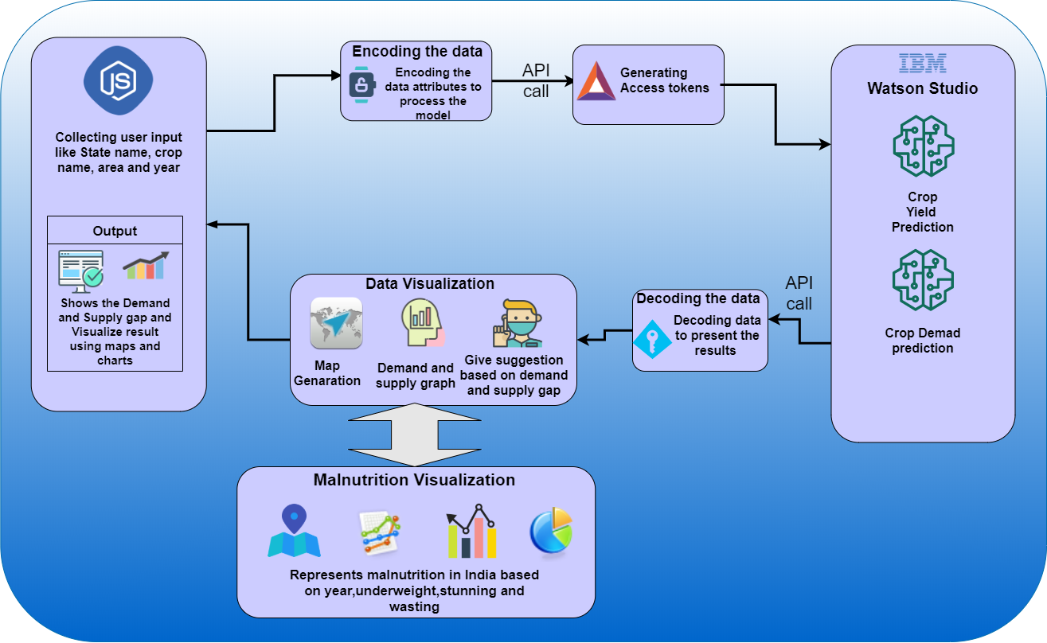

**Module 1: Crop yield model**

* In this model first we have collected data regarding crop production from various resources.
* After data is collected encoding and preprocessing of data are done followed by feature scaling.
* Then the data is divided into test and train data sets.
* After splitting of data, data is analyzed Deep Neural Network and prediction of crop yield is done.

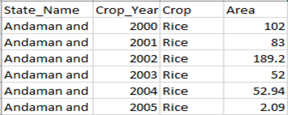

*Sample crop yield data*

* Here State name, crop year, crop name and area under cultivation are considered to predict crop yield.

**Module 2: Crop demand model**

* In this model first we have collected data regarding crop demand from various resources.
* After data is collected encoding and preprocessing of data are done followed by feature scaling.
* Then the data is divided into test and train data sets.
* After splitting of data, data is analyzed Deep Neural Network and prediction of crop demand is done.

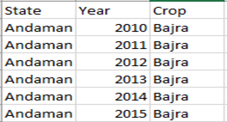 *Sample crop demand data*

* Here State name, crop year and crop name are considered to predict crop demand.

**Module 3: Demand and Supply gap and data visualization**

* After successfully deploying module 1 and module 2 we can estimate demand and supply gap of the certain crop in a specific area.
* The gap between demand and supply is represented by a graph and the Indian map is generated based on the demand of the selected crop which is indicated by color range.
* Users can also visualize malnutrition in India based on the year and other important attributes like underweight, stunting, wasting, and income level.
* User can also see the suggestion that which crop needed to import or export from other states based on demand
* JSON data used to create a map looks like:

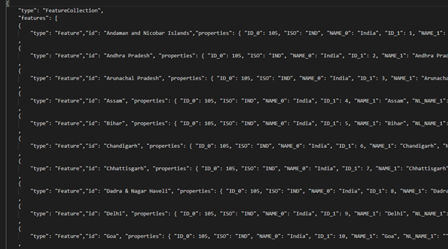

·

**3.2 Hardware/Software Designing**

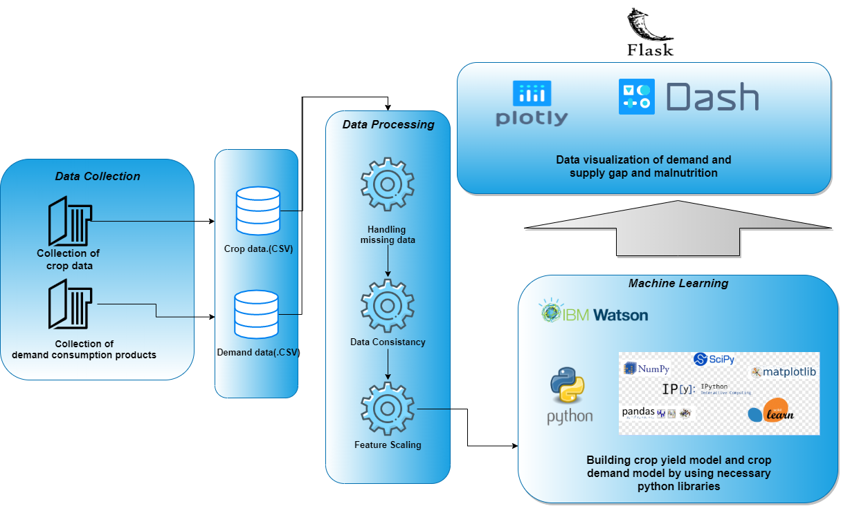

**Necessary Packages used:**

* **Pandas: -**Pandas is a software library written for the Python programming language for data manipulation and analysis. In particular, it offers data structures and operations for manipulating numerical tables and time series.
* **NumPy: -**NumPy is a library for the Python programming language, adding support for large, multi-dimensional arrays and matrices, along with a large collection of high-level mathematical functions to operate on these arrays.
* **Scikit Learn: -**Scikit-learn is a free machine learning library for Python. It features various algorithms like support vector machine, random forests, and k-neighbors, and it also supports Python numerical and scientific libraries like NumPy and SciPy.
* **Dash: -**Dash is an open-source Python framework used for building analytical web applications. It is a powerful library that simplifies the development of data-driven applications.
* **Requests: -**Requests is a Python HTTP library, released under the Apache License 2.0. The goal of the project is to make HTTP requests simpler and more human-friendly.
* **Urllib: -**Urllib module is the URL handling module for python. It is used to fetch URLs. It uses the url openfunction and is able to fetch URLs using a variety of different protocols.
* **Plotly: -**Plotly allows users to import, copy and paste, or stream data to be analyzed and visualized. For analysis and styling graphs, Plotly offers a Python sandbox, data grid, and GUI. Python scripts can be saved, shared, and collaboratively edited in Plotly.
* **JSON: -**The json library can parse JSON from strings or file. The library parses JSON into a Python dictionary or list. It can also convert Python dictionaries or lists into JSON strings.

**Technology Stack:**

* Programming Languages: Python
* App: Flask App
* Hosting Servers: IBM Cloud.
* Server Type: REST API Post
* Machine Learning Models Used: Deep Neural Network

**4. EXPERIMENTAL INVESTIGATIONS**

* At first, we have implemented a crop yield model by random forest regression and crop demand model by time series analysis.
* But random forest regression has shown the least importance to attribute year and high importance to state name, crop name, and the area which made the model limited to only one year of prediction.
* When working with time series analysis attributes other than the time was not given significant.
* ·So, we have used the Neural Network to analyze both crop yield model and crop demand model.
* By using Neural Network, we have successfully predicted the crop yield and crop demand with specific time and area.

**5. FLOWCHART**

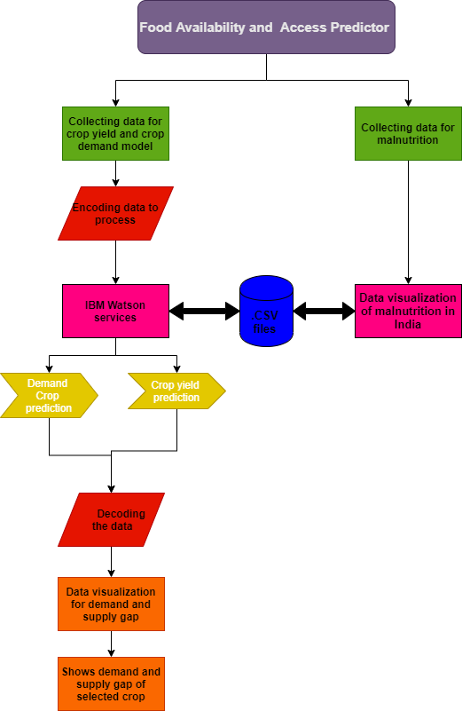

**6. RESULT**

* The application contains 2 tabs :

1. Demand and Supply Gap Predicotr
2. Malnutrition Dashboard
3. **Demand and Supply Gap Predictor**

* The user has to enter 4 inputs : 'State', 'Crop', 'Year' and 'Crop area which is under yield'.
* The first 3 inputs are same for both the modules (crop yield and crop demand) and the fourth input is considered by the Crop yield module.
* The inpust State,Crop,Year are sent to the module and demand for thtat particular corp is obtained
* Similarly State, Crop, Year, Area are sent to the crop yield module and yield of that crop is estimated.
* Based on the results, a India map containing all the states is rendered as the output.
* A "Demand-Supply Gap" graph is also rendered as the output which contains values of demand and supply for 2 consecutive years along with users's entered year.
* A Gauge Meter referring to "Risk of Food Insecurity" is rendered as output. Risk - 0 (supply greater than demand), Risk - 50 (approximately supply is equal to demand), Risk - 100 (demand is greater than supply).
* A Model Suggestion stating whether to import or export the commodity is also rendered.

**Tab - 1:**

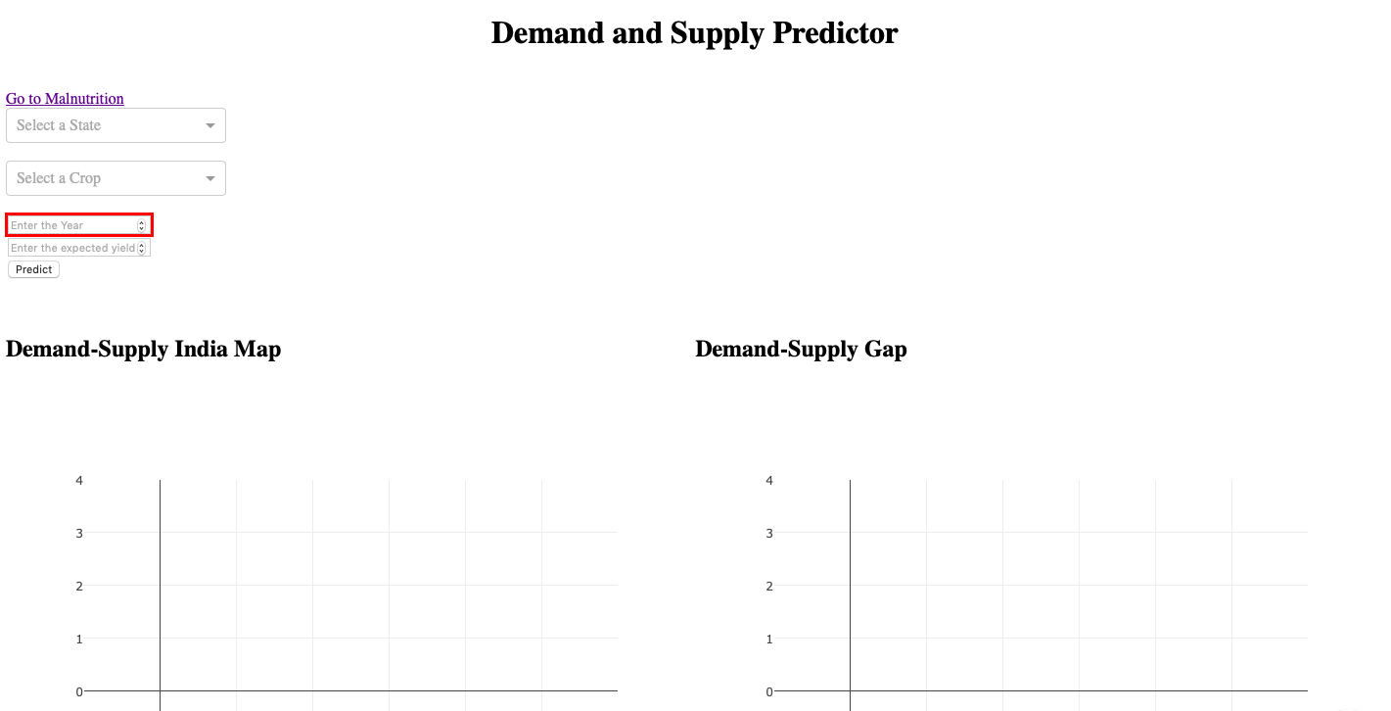

**Tab - 1 Output:**

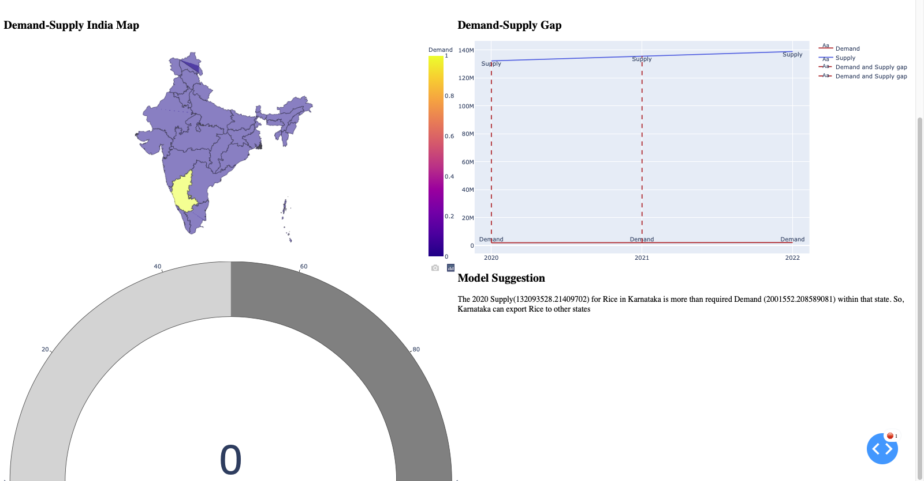

**2. Malnutrition Dashboard:**

* This tab has 4 visuliazation options.
* The first among thosse is a India map which represents the overall Malnutrition with repect to the states of India.
* User has the option to interact with India map by changing the year (input).
* A choropleth map is rendered as output determining the malnutrition levels.
* The Second visualization is a Line chart which refers to the values of "Stunting", "Underweight", "Wasting" of selcted state/states.
* Line chart provides user an option of comparsion of values between different states.
* The third visualization is a Donut chart which refers to the intensity of "Stunting"/ "Underweight"/"Wasting" on selected states.
* The fourth visualization is the bar graph which refers to the " Impact of Income level on Malnutrition".

**Tab - 2 Map:**

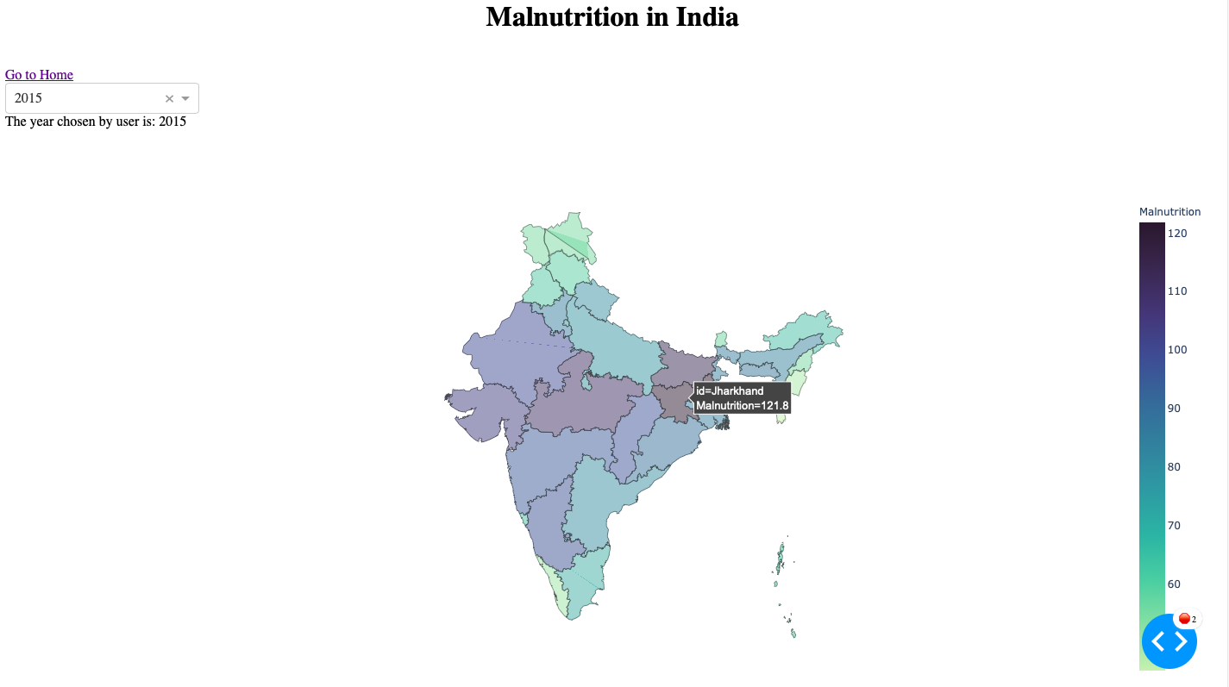

**Tab - 2 Charts :**

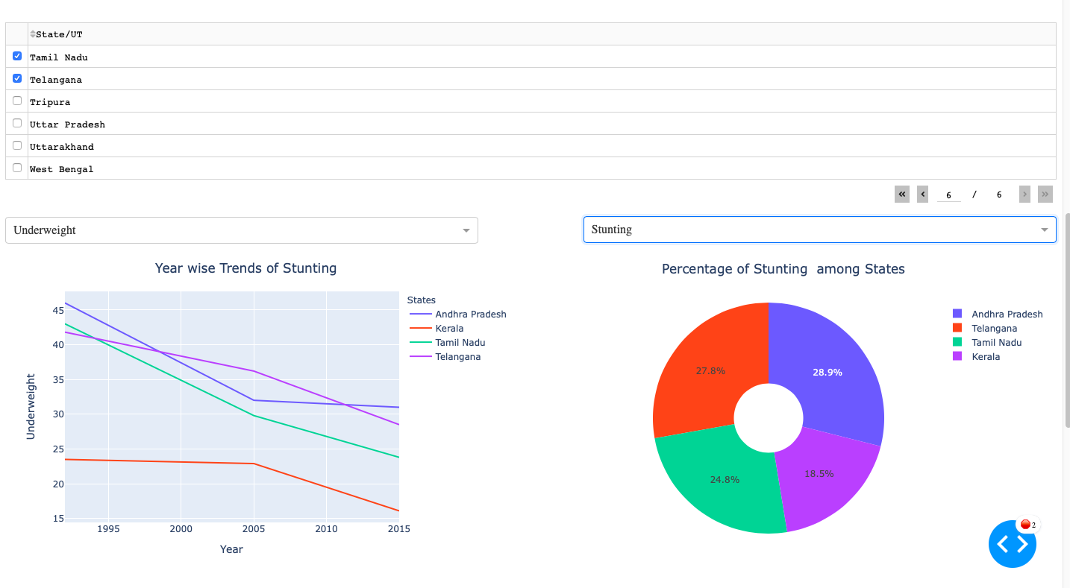

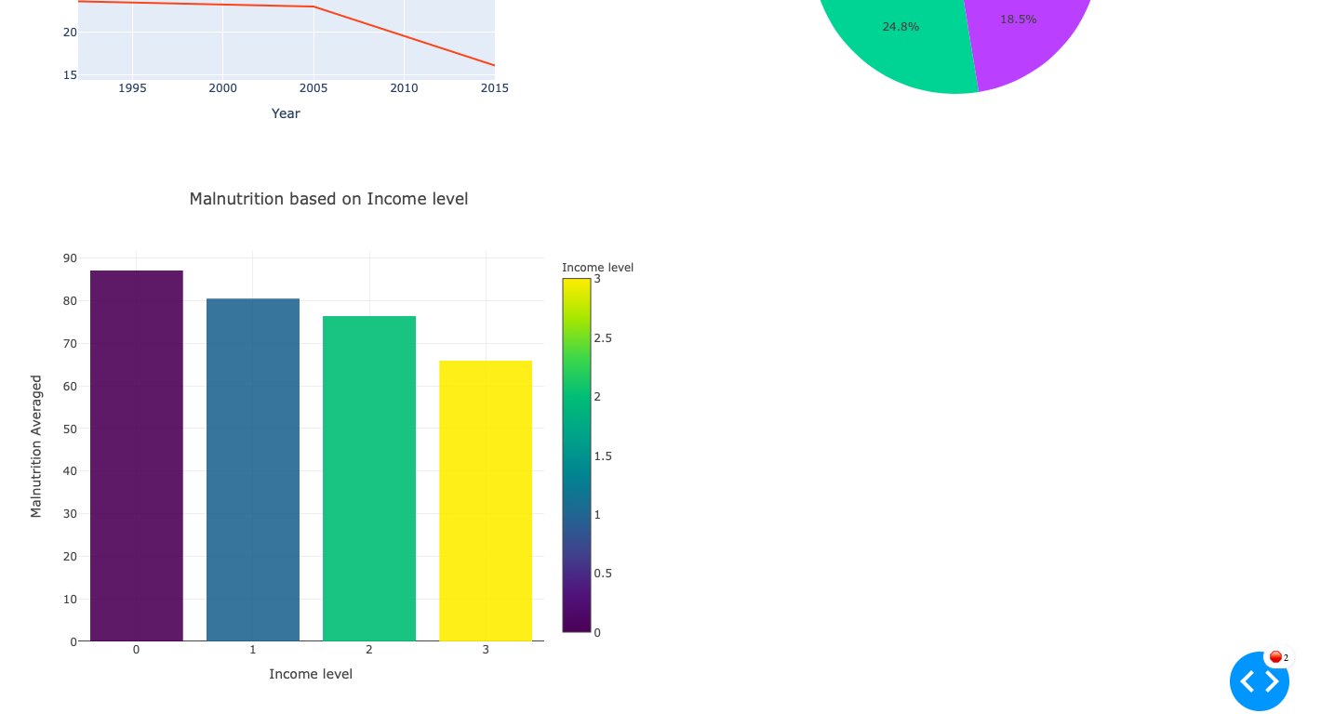

**7. ADVANTAGES AND DISADVANTAGES**

**Advantages: -**

* This model enables us to predict the demand and supply gap of a specific crop, which helps to prevent the shortage of food in that state.
* This model helps to prevent the breakdown of the food supply chain.
* Prevents unnecessary spike of prices in essential food commodities.
* This model suggests that which crop needed to import or export from other states based on demand
* Explains the food insecurity problem in India.

**Disadvantages: -**

* The developed model predicts the demand and supply gap which is limited to states of India and its essential food commodities.

**8. APPLICATIONS**

* This application helps agriculture sector administrators to predict the demand and supply gap of the specific crop to prevent a lack of essential food commodities in the state during crises.
* This application enables the user to understand malnutrition figures of every state in India based on income level, underweight, stunting, and wasting.
* This application balances the food supply chain and controls food security in India.

**9. CONCLUSION**

We have successfully developed the crop yield model and crop demand model by using Neural Network. By these models, we had expected production growth rates for rice, wheat, bajra, jowar, and other essential commodities exceeded or deceased based on the corresponding consumption demand rates and predicted demand and supply gap of the specified crop.

By this model, we have successfully demonstrated malnutrition status in India based on various factors and explained how food security has a major impact on the food supply chain. This application allows the government agriculture sector to avoid sudden spike of prices of necessary food materials and prevent scarcity of food in the state. Our application helps India to withstand COVID-19 crises against food insecurity and imbalance of the food supply chain

**10. FUTURE SCOPE**

In our present model, we have determined the demand and supply gap and food security problem in India concerning states. In the future we can develop this model worldwide by considering every district in that country, that is by predicting demand and supply gap district wise. By implementing this model worldwide we make the user use it on a large scale and helps the user understand food security problems and the importance of the food supply chain globally in COVID-19 crises

**11. BIBILOGRAPHY**

1. S. Bhanumathi, M. Vineeth, N. Rohit. "Crop Yield Prediction and Efficient use of Fertilizers", (2019) International Conference on Communication and Signal Processing (ICCSP).
2. <https://www.youtube.com/channel/UCqBFsuAz41sqWcFjZkqmJqQ>
3. https://www.wikipedia.org/
4. <https://www.youtube.com/results?search_query=smartbridge>