CC Mini Project Report

**Title:**

MyTube : Video streaming MEAN stack webapp.

**Abstract:**

The project implements Storage as a Service by storing the video objects in AWS S3 bucket.

Project is implemented using MEAN stack(MongoDb, ExpressJS,AngularJS,NodeJS.

Users can upload videos on Mytube and other users can stream it on their browsers.

The allowed video file format is MP4.At any point of time user can delete the videos uploaded by him.

**Introduction:**

The project is video streaming web application where users can upload videos and stream it at any point.The uploader is able to see how many users have viewed its videos.Users can like ,dislike the videos.only uploader can delete and edit the video title and description of video.

**Implementation details:**

The whole project is implemented in MEAN stack which are javascript frameworks .Mytube is hosted on Amazon Web Services.HTML is used to create basic template for website,angularjs is used for dynamicity in to website creating a single page web application.In backend MongoDB is used for storing users information and videos details.

File stack api is used to store videos on the cloud and retrieve the video from the cloud.

File stack provides CDN link for each video and the video cdn link along with other details of videos are stored in mongodb database.

MEAN stack web application is executed in amazon EC2(Elastic Cloud Computing) instance.

Mlabs mongodb instance is used as DAAS(Database as a Service).

**Github code link:** <https://github.com/sachdevnitin19/mytube.git>

**Code:**

Index.html

<!doctype html>  
<html lang="en" ng-app="yourtube">  
<head>  
 <meta charset="UTF-8">  
 <meta http-equiv="X-UA-Compatible" content="IE=edge">  
   
 <meta name="viewport" content="initial-scale=1, maximum-scale=1, user-scalable=no" />  
 <link rel="icon" href="/img/google-pushpin-md.png">  
 <link href='https://fonts.googleapis.com/css?family=Permanent+Marker|Montserrat:400,700|Open+Sans:300italic,400italic,600italic,700italic,400,300,600,700|Gentium+Book+Basic:400,400italic' rel='stylesheet' type='text/css'>  
 <base href="/">  
  
 <title>Mytube ::Youtube Clone</title>  
 <link href="favicon.png" rel="shortcut icon">  
 <link href="//fonts.googleapis.com/css?family=Roboto|Montserrat:400,700|Open+Sans:400,300,600" rel="stylesheet">  
 <link href="//maxcdn.bootstrapcdn.com/font-awesome/4.3.0/css/font-awesome.min.css" rel="stylesheet">  
 <link href="//code.ionicframework.com/ionicons/2.0.1/css/ionicons.min.css" rel="stylesheet">  
 <link href="//maxcdn.bootstrapcdn.com/bootstrap/3.3.0/css/bootstrap.min.css" rel="stylesheet">  
 <link href="//cdn.jsdelivr.net/animatecss/3.2.0/animate.css" rel="stylesheet">  
 <link rel="stylesheet" href="css/style.css">  
 <link rel="stylesheet" href="vendor/angular-toastr/dist/angular-toastr.css">  
 <link rel="stylesheet" href="vendor/angular-loading-bar/build/loading-bar.min.css">  
  
 <!-- JS -->  
 <script src="vendor/angular/angular.js"></script>  
 <script src="vendor/angular-route/angular-route.min.js"></script>  
 <script src="vendor/angular-bootstrap/ui-bootstrap-tpls.min.js"></script>  
 <script src="vendor/lodash/lodash.js"></script>  
   
 <script src="vendor/filepicker-js/filepicker.js"></script>  
 <script src="vendor/angular-filepicker/dist/angular_filepicker.js"></script>  
   
 <!-- cloudinary angular plugin -->  
 <script src="vendor/cloudinary-core/cloudinary-core.js"></script>  
 <script src="vendor/cloudinary_ng/js/angular.cloudinary.js"></script>  
 <script src="vendor/angular-cookies/angular-cookies.min.js"></script>  
 <script src="vendor/angular-toastr/dist/angular-toastr.tpls.js"></script>  
 <script src="vendor/angular-sanitize/angular-sanitize.min.js"></script>  
 <script src="vendor/angular-loading-bar/src/loading-bar.js"></script>  
 <script src="vendor/angular-animate/angular-animate.js"></script>  
 <script src="vendor/angular-messages/angular-messages.min.js"></script>  
 <script src="vendor/angular-aria/angular-aria.js"></script>  
 <script src="vendor/angular-utils-disqus/dirDisqus.js"></script>  
 <script src="vendor/ngstorage/ngStorage.min.js"></script>  
 <script src="vendor/moment/moment.js"></script>  
 <script src="vendor/angular-moment/angular-moment.js"></script>  
 <script src="vendor/satellizer/satellizer.js"></script>  
 <script src="vendor/angular-confirm-modal/angular-confirm.min.js"></script>  
 <script src="vendor/angular-bootstrap-confirm/dist/angular-bootstrap-confirm.js"></script>  
 <!-- angular file upload -->  
 <script src="vendor/ng-file-upload/ng-file-upload-shim.js"></script>  
 <script src="vendor/ng-file-upload/ng-file-upload.js"></script>  
  
  
 <!-- ANGULAR CUSTOM -->  
 <script src="js/app.js"></script>  
 <script src="js/routes.js"></script>  
 <script src="js/controllers/auth.client.controller.js"></script>  
 <script src="js/controllers/profile.client.controller.js"></script>  
 <script src="js/controllers/home.client.controller.js"></script>  
 <script src="js/controllers/upload.client.controller2.js"></script>  
 <script src="js/controllers/nav.client.controller.js"></script>  
 <script src="js/controllers/video.client.controller.js"></script>  
 <script src="js/controllers/transform.client.controller.js"></script>  
 <script src="js/controllers/logout.client.controller.js"></script>  
 <script src="js/services/user.client.service.js"></script>  
 <script src="js/services/video.client.service.js"></script>  
 <script src="js/services/view.client.service.js"></script>  
 <script src="js/filters/trustUrl.filter.js"></script>  
  
  
</head>  
  
<body>  
 <div ng-controller="NavbarCtrl" class="navbar navbar-default navbar-static-top">  
 <div class="navbar-header">  
 <a class="navbar-brand" href="/"><i class="ion-ios7-pulse-strong"></i> My <span class="tube">Tube</span> </a>  
 </div>  
 <ul class="nav navbar-nav">  
 <li ng-if="isAuthenticated()"><a href="/account">Profile</a></li>  
 <li ng-if="isAuthenticated()"><a href="/upload">Upload</a></li>  
 <li ng-if="isAuthenticated()"><a href="/my_videos">My Videos</a></li>  
 </ul>  
 <ul ng-if="!isAuthenticated()" class="nav navbar-nav pull-right">  
 <li><a href="/auth/login">Login</a></li>  
 <li><a href="/auth/signup">Sign up</a></li>  
 </ul>  
 <ul ng-if="isAuthenticated()" class="nav navbar-nav pull-right">  
 <li><a href="/logout">Logout</a></li>  
 </ul>  
 </div>  
  
<!-- ANGULAR DYNAMIC CONTENT -->  
<div ng-view>  
</div>  
<!-- END DYNAMIC CONTENT -->  
  
</body>  
</html>

**ScreenShots:**

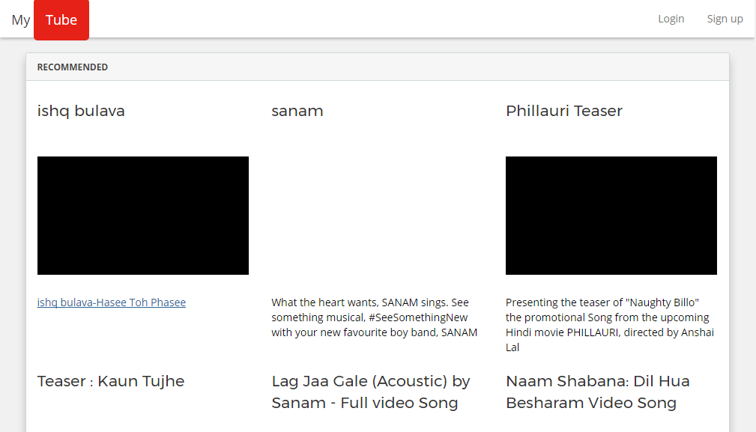

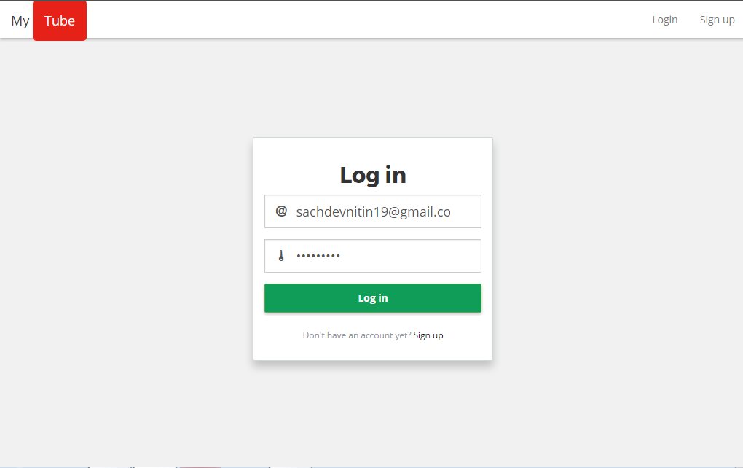

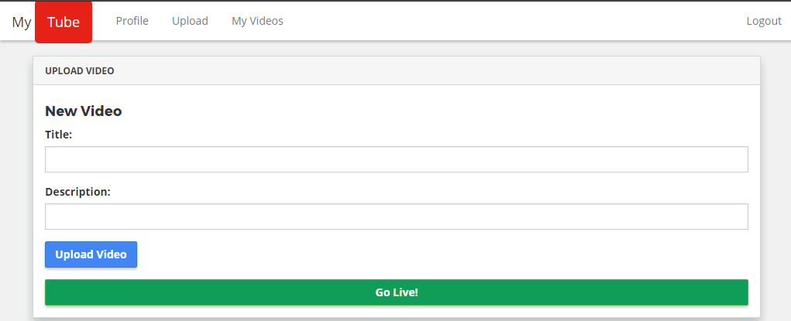

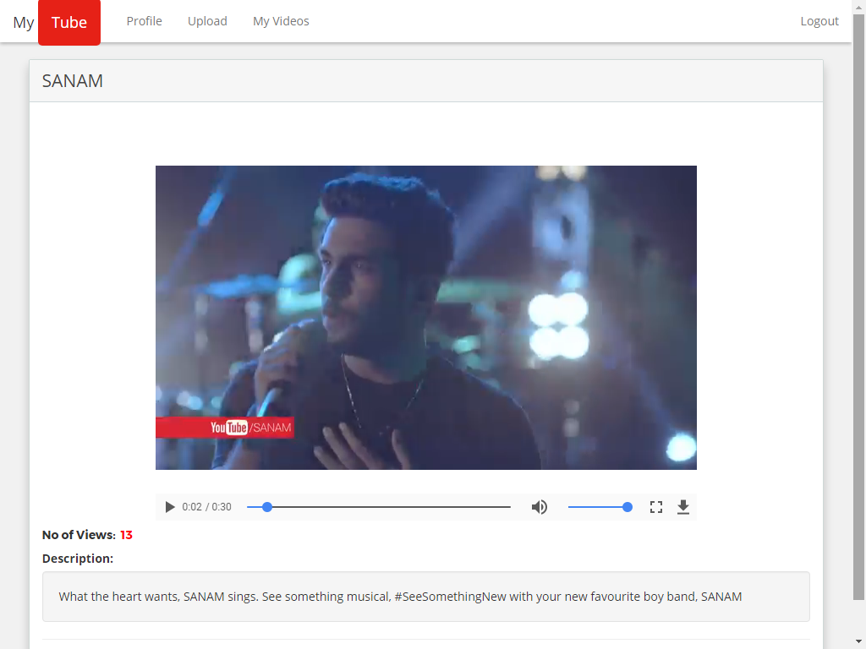

**AWS Link:**

https://ec2-52-221-249-243.ap-southeast-1.compute.amazonaws.com:3000

**Conclusion:**

A Cloud storage system for Video storage and streaming was successfully implemented and hosted on AWS Cloud services.