Applying AJAX

- To apply ajax in the application we need to use ScriptManager need to be called. Without the use of script manager ajax can’t be implemented.
<asp:ScriptManager ID="ScriptManager1" runat="server" EnablePartialRendering="true"></asp:ScriptManager>
- UpdatePanel is used to update the contents without page refresh.
- In the content template all the asp controls are placed, so that ajax will be applied to those controls.
- Triggers are used to trigger an event so that the ASP controls like listbox and the label will be updated without the page refresh.
- I have used ajax in StudentDetails.aspx for refreshing the email label. When a tutor name is selected from the listbox and show email button is clicked then the Asynchronous call is invoked. Tutor email is displayed in the label without page refresh.
<asp:UpdatePanel ID="UpdatePanel1" runat="server" UpdateMode="Conditional">
<ContentTemplate>
<asp:ListBox ID="lstTutors" runat="server" style="z-index: 1; left: 102px; top: 159px; position: absolute; height: 72px; width: 180px"></asp:ListBox>
<asp:Label ID="lblEmail" runat="server" Font-Italic="True" style="z-index: 1; left: 236px; top: 254px; position: absolute" Text="Email will appear here."></asp:Label>
</ContentTemplate>
<Triggers>
<asp:AsyncPostBackTrigger ControlID="btnShowEmail" EventName="Click" />
</Triggers>
</asp:UpdatePanel>
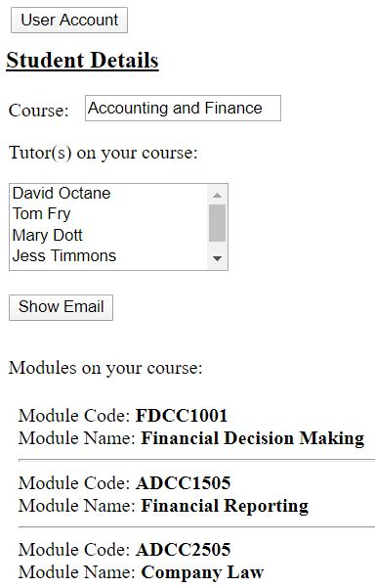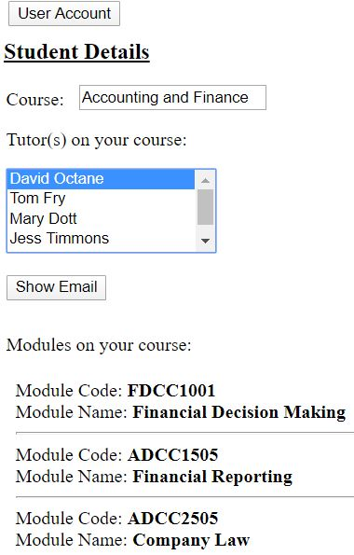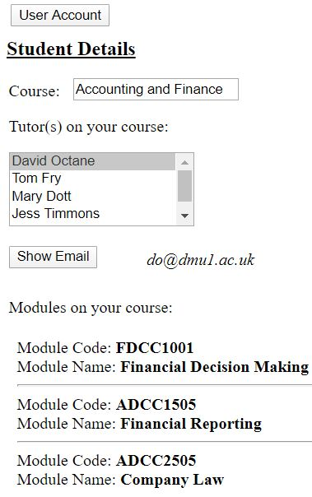
- I have used ajax in TutorDetails.aspx to display the success label when student is removed on button click. When remove student button is clicked then the ajax is applied as it triggers the event and the listbox is updated and the label is also displayed with the success label displaying whether the student is removed or not.
<asp:UpdatePanel ID="UpdatePanel1" runat="server" UpdateMode="Conditional">
<ContentTemplate>
<asp:ListBox ID="lstStudents" runat="server" style="z-index: 1; left: 102px; top: 159px; position: absolute; height: 72px; width: 180px"> </asp:ListBox>
<asp:Label ID="lblSuccess" runat="server" ForeColor="#009900" style="z-index: 1; left: 104px; top: 293px; position: absolute"></asp:Label>
</ContentTemplate>
<Triggers>
<asp:AsyncPostBackTrigger ControlID="btnRemoveStudent" EventName="Click" />
</Triggers>
</asp:UpdatePanel>


2.Secure Password Storage
I have used MD5CryptoServiceProvider algorithm to encrypt the password. Entered password is sent to the algorithm and the encrypted string is stored to the database while registering. While Login the entered password is checked with the hashed password stored in database. If both the hashed password is matched then the user will be logged in.
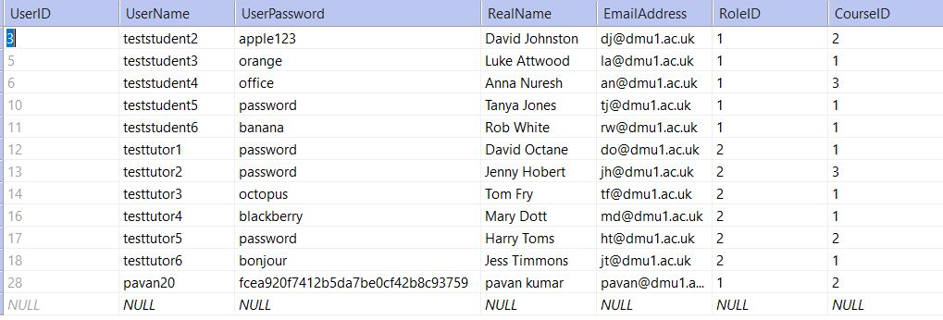
3.Additional Use Case
In the given registration design there is no way to differentiate student and teacher. If there is any data int the database related to the student and teacher, then there is possibility of running the application. Here I have used a dropdown to differentiate between them.
