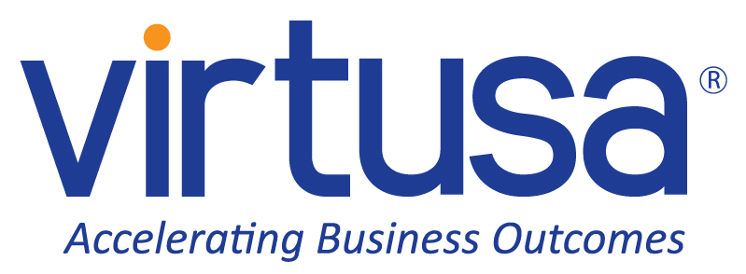

Architecture Document for
Sentinel

.........
<Project>-<Component>-AD-<Version>

Table of Contents

1 Introduction 1
1.1 Purpose 1
1.2 Scope 1
1.3 Definitions, Acronyms and Abbreviations 1
1.4 References 1
2 Architectural Goals and Constraints 2
2.1 Reusability 2
2.2 Scalability 2
2.3 Customizability 2
2.4 Extendibility 2
2.5 Use of Existing Business Logic 2
2.6 Time to Market 2
2.7 Portability 2
2.8 Availability 3
2.9 Performance 3
2.10 Any Other Critical Goals Applicable 3
3 Productization Assessment 4
3.1 Re-Usable Components 4
3.2 Analyze Architectural Frameworks in Repository 4
3.3 Identify and Analyze Open Source and COTS Products 4
4 System Architecture 4
4.1 Overview 4
4.2 Logical/Functional View 5
4.3 Use Case View 8
4.4 Implementation/System View 8
4.5 Process/Thread View 9
4.6 Deployment View 9
5 General Architecture for Core Technical Services 11
5.1 Persistence 11
5.2 Inter-process Communication 11
5.3 Authentication and Authorization 11
5.4 Error Handling 11
5.5 Logging 11
5.6 Transaction Management 11
5.7 Other Applicable Technical Services 12
6 Risks/Limitation 13
7 Alternative Solutions Considered 14
Appendix 15
1. Expected Software Response 15
2. Performance Bounds 15
3. Identification of Critical Components 15
4. Review Comments on Architectural POC 15
5. Justification of Changes to Existing Architecture (Optional) 15

Document Revisions
Date | Version | Description | Author

Note: These documents are strictly for specific Virtusa/client use only. They shall not be shared with an external party other than the client concerned. These documents should always be kept securely and employees shall use reasonable care protecting these documents from unauthorized use or disclosure to a third party. This category also covers client intellectual property where Virtusa has a non-disclosure agreement with the client.

Document Approval

Virtusa Corporation and Turing Machines have reviewed this document and hereby agree that the contents herein are accurate. Any changes to this document must be communicated in writing and signed-off by both parties.

Signature | Signature
Date: | Date:
Name: | Name:
Client: Turing Machines | Virtusa Corporation

Template User Notes:

Help Info is provided (in blue italics) to describe what each section should contain. Sample Text is provided (in green) in some sections to assist the author in standard wording for common documentation. Macro Buttons (in blue bold italics) must be replaced to match the project, e.g. <Project.

Note: Help Info and Sample Text are included to provide guidance to the author and should be deleted before publishing the document.

Introduction

Purpose

This document provides a comprehensive architectural overview of the Sentinel: A Multi-Agent Knowledge Ecosystem system, using a number of different architectural views to depict different aspects of the system. It is intended to capture and convey the significant architectural decisions, which have been made on the system.

Scope

This document covers the architecture of the Sentinel Multi-Agent Knowledge Ecosystem, an autonomous data governance and GraphRAG solution for banking operations. In scope: the Curator Agent for document ingestion, the Knowledge Graph (Neo4j + FAISS) for storage and relationship management, and the Co-Pilot Agent for retrieval and query resolution. Out of scope: end-user mobile interfaces, legacy core banking integration beyond API boundaries, and third-party vendor procurement.

Definitions, Acronyms and Abbreviations

RAG: Retrieval-Augmented Generation. GraphRAG: Graph-based Retrieval-Augmented Generation. LLM: Large Language Model. KYC: Know Your Customer. AML: Anti-Money Laundering. SOP: Standard Operating Procedure. Neo4j: Graph database used for storing regulatory relationships. FAISS: Facebook AI Similarity Search, used for semantic vector matching. Curator Agent: Autonomous ingestion agent responsible for parsing and structuring bank documents. Co-Pilot Agent: Query resolution agent that intercepts user prompts and retrieves validated answers from the Knowledge Graph. Ontology: A bank-approved taxonomy of fixed categories (e.g., KYC_AML, Retail_Loans) governing data structuring. SUPERSEDE_OLD: An action command issued by the Curator Agent to retire outdated policy versions.

References

1. Sentinel Project Pitch Deck v1.0 – Turing Machines, 2024. 2. Neo4j Graph Database Documentation, neo4j.com. 3. FAISS: A Library for Efficient Similarity Search, Facebook AI Research. 4. RBI AML Guidelines 2023 – Reserve Bank of India. 5. LangChain Multi-Agent Orchestration Framework Documentation.

Architectural Goals and Constraints

Sentinel is designed for Tier-1 banking environments where compliance, auditability, and zero-tolerance for hallucination are non-negotiable. Key architectural goals include privacy-preserving on-premise deployment, strict ontology-governed data structuring, and a modular multi-agent design. Constraints include the use of enterprise-grade LLMs only, mandatory human SME approval of the ontology, and compliance with RBI/AML regulatory frameworks. The system must operate without internet access for core document processing.

Reusability

The Curator Agent is intentionally designed to be model-agnostic: it orchestrates document ingestion and ontology enforcement through a structured pipeline that is decoupled from any specific LLM. Swapping the underlying model (e.g., from Llama-3.3-70B to a future model) requires no changes to the agent logic. This makes the Curator Agent directly reusable across different banking departments — HR (policy and handbook management), Legal (contract and regulatory filing management), and Retail Banking (loan limit and product guideline updates) — simply by configuring a department-specific ontology. The Co-Pilot Agent and GraphRAG query engine are equally reusable for any knowledge retrieval use case within the organization.

Scalability

A core architectural decision is the deliberate separation of the Knowledge Graph (Neo4j) from the Vector Database (FAISS). This decoupling allows each layer to scale independently: Neo4j handles the growth of regulatory relationships and policy supersession chains, while FAISS scales to accommodate increasing volumes of document embeddings — without either layer creating a bottleneck for the other. Multiple Curator Agent instances can process parallel document ingestion streams, and the Co-Pilot API layer scales horizontally behind a load balancer. The system is designed to handle thousands of regulatory documents per day with sub-second retrieval latency.

Customizability

The bank-approved ontology (taxonomy of regulatory categories) is fully customizable by SMEs without requiring code changes. New node types (e.g., Trade_Finance, FX_Limits) can be added via a configuration interface. The Co-Pilot Agent’s response templates and citation formats are configurable per department.

Extendibility

The multi-agent architecture supports the addition of new specialized agents (e.g., a Compliance Audit Agent, a Loan Drafting Agent) without disrupting existing components. The graph schema is extensible to support new relationship types as banking regulations evolve. The system is built for a phased rollout: Phase 1 (Curator + Knowledge Graph), Phase 2 (Co-Pilot retrieval), Phase 3 (Actionable execution agents).

Use of Existing Business Logic

Sentinel integrates with the bank’s existing document management portals and email systems via standard APIs (REST/SFTP). Existing AML rule sets and KYC validation logic within the bank’s core systems are treated as authoritative sources and are mapped into the graph ontology rather than replaced, preserving existing compliance investments.

Time to Market

The MVP focuses on the Curator Agent and Knowledge Graph core (Phase 1), targeting a 3-month delivery cycle. Technology choices (LangChain for orchestration, Neo4j for graph storage, FAISS for vectors, enterprise LLM APIs) were selected for developer productivity and availability of mature libraries, directly supporting rapid time to market.

Portability

Sentinel is containerized using Docker and deployable on any major cloud platform (AWS, Azure, GCP) or on-premise data centers. The system is OS-agnostic (Linux-first) and database-portable at the vector layer (FAISS can be swapped for Pinecone or Weaviate). Neo4j’s enterprise edition supports both cloud-managed and self-hosted deployments.

Availability

The system targets 99.9% uptime for the Co-Pilot Agent query interface. The Curator Agent pipeline is designed as an asynchronous, fault-tolerant queue-based system (using Kafka or RabbitMQ) so that ingestion failures do not impact query availability. Neo4j causal clustering provides automatic failover for the Knowledge Graph.

Performance

Sentinel uses Llama-3.3-70B served via the Groq API for LLM inference. Groq’s LPU (Language Processing Unit) hardware delivers ultra-low latency token generation, enabling the Curator Agent and Co-Pilot Agent to act in milliseconds rather than seconds — a critical requirement for banking operations where staff expect near-instant answers. End-to-end Co-Pilot query responses (intent optimization + graph traversal + LLM synthesis) are targeted at under 3 seconds. Curator Agent ingestion of a standard regulatory memo (up to 50 pages) is targeted at under 60 seconds. FAISS nearest-neighbor search is targeted at sub-100ms for a corpus of up to 1 million document chunks.

Any Other Critical Goals Applicable

Productization Assessment

Re-Usable Components

The following components of Sentinel are identified as reusable across the organization: (1) Ontology Management Module – configurable taxonomy engine applicable to any regulated domain; (2) Document Ingestion Pipeline – PDF/email/portal parser with classification logic; (3) GraphRAG Query Engine – the combination of graph traversal + semantic search can be applied to any knowledge management use case; (4) Audit Evidence Snapshot Generator – source-citation tracing module applicable to any AI-assisted decision system.

Analyze Architectural Frameworks in Repository

LangChain multi-agent orchestration framework is leveraged for agent coordination and tool-calling abstractions. LangGraph is used for stateful agent workflow management. Both frameworks are open-source, actively maintained, and widely used in enterprise AI projects, reducing development effort for agent lifecycle management.

Identify and Analyze Open Source and COTS Products

Neo4j (Community/Enterprise Edition) – Graph database; licensed under GPLv3 (Community) or commercial (Enterprise). Legal approval required for Enterprise deployment. FAISS – Open source (MIT License), no restrictions. LangChain / LangGraph – Open source (MIT License). Llama-3.3-70B (Meta) – Open-weight model served via Groq API; usage subject to Meta’s Llama Community License and Groq’s data processing agreement. A data residency and DPA review with Groq is required before production deployment. Groq API – Commercial inference API providing ultra-low-latency LPU-based token generation. All selected products have been evaluated for compatibility with banking data residency requirements.

System Architecture

This section describes the software architecture of the current system, and how it is represented. Out of the Logical, Use Case, Implementation, Process and Deployment views, it enumerates the views that are necessary, and for each view, explains the types of model elements it contains.

Models | XML compliant tool
Diagrams | .svg format

Overview

The application is comprised of several key architectural components that are independent functions related only via the defined interfaces.
The application is divided into three tiers: User Interface Services, Business Services and Data Services. Each layer is responsible for handling a well-defined area of the application.

Logical/Functional View

This sub-section describes the system architecture at a high-level. The aim is to provide a logical architecture diagram to document the:
- Logical components of the layers and partitions of the application
- Logical relationships between them

Sentinel’s architecture maps directly onto the standard three-tier model. Each tier is responsible for a well-defined area of the system and communicates with adjacent tiers only through defined interfaces, ensuring loose coupling and independent deployability.
User Interface Services (PoC: Streamlit Dashboard / Production: React Web App): The PoC interface is built with Streamlit, enabling rapid demonstration of the Co-Pilot Agent’s query and evidence snapshot capabilities. The production roadmap targets a React-based web application for enterprise deployment, integrated with the bank’s existing SSO and portal infrastructure.
Business Services (LangChain / LangGraph Orchestration — The Curator Agent and Co-Pilot Agent): The core intelligence layer is implemented using LangChain for tool-calling and LangGraph for stateful agent workflow management. The Curator Agent governs autonomous document ingestion, classification, and ontology enforcement. The Co-Pilot Agent handles query intent optimization, graph traversal coordination, and LLM response synthesis. All business logic is isolated in this layer and is accessible only via defined REST/gRPC interfaces.
Data Services (Neo4j Knowledge Graph + FAISS Vector Index): Neo4j serves as the persistent, SME-governed single source of truth for all regulatory relationships, policy versions, and supersession chains. FAISS provides the semantic vector search layer for document chunk retrieval. Source PDFs are stored in an encrypted on-premise object store. These two data stores are kept separate to allow independent scaling of relational (graph) and semantic (vector) workloads.

FIGURE 1: Sample Project Application Architecture Overview
Option 2: Package and Layering Diagram (preferred)

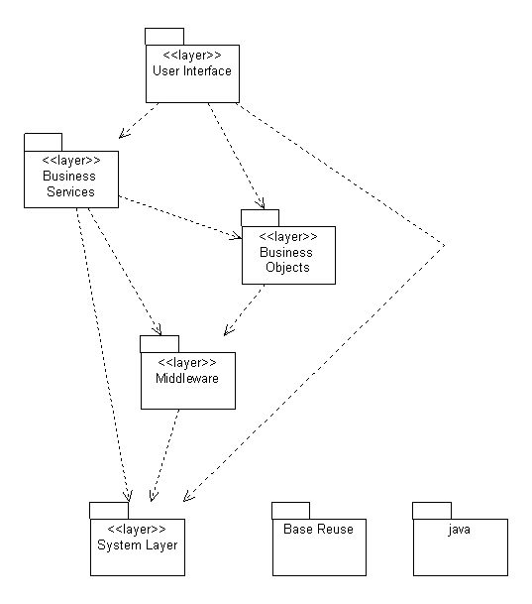

The application is divided into three tiers: User Interfaces Services, Business Services and Data Services. Each layer is responsible for handling a well-defined area of the application.

Use Case View

Key use cases include: (1) Policy Ingestion – Bank compliance officer uploads a new AML circular; Curator Agent parses, classifies, and supersedes the outdated version in the Knowledge Graph. (2) Compliance Query – Operations staff asks “What is the current PAN card limit for cash transactions?”; Co-Pilot Agent retrieves the single active truth with an evidence snapshot. (3) Audit Trail Request – Internal auditor requests provenance for a policy answer; system returns the source PDF, version history, and supersession chain.
Example diagram:
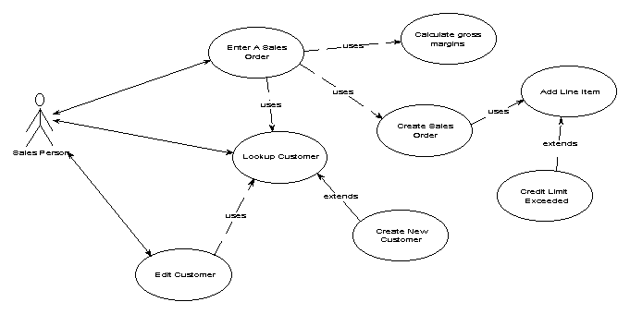

Implementation/System View

Sentinel is implemented as a Python-based microservices system. The Curator Agent service handles document ingestion via an async worker queue. The Knowledge Graph service wraps Neo4j and FAISS with a unified query API. The Co-Pilot Agent service exposes a REST API for frontend and integration consumption. Services communicate via internal REST/gRPC. The Ontology Configuration module is a separate admin service allowing SMEs to manage category definitions without code deployment.

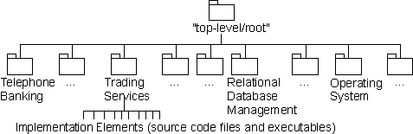

Process/Thread View

Ingestion Flow: Document arrives via file drop/API –> Curator Agent parses content –> LLM classifies and extracts structured JSON –> Ontology validator checks category –> SUPERSEDE_OLD command issued to Neo4j –> New vector embeddings stored in FAISS –> Ingestion confirmed. Query Flow: User query arrives at Co-Pilot Agent –> Intent optimization layer refines prompt –> Graph traversal identifies active policy node –> FAISS semantic search retrieves supporting chunks –> LLM synthesizes final answer with evidence snapshot –> Response returned to user.

Example diagram:
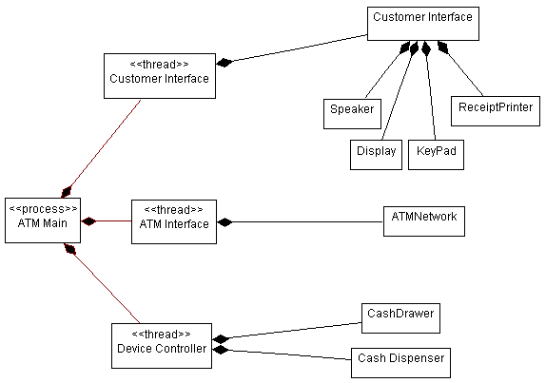

Deployment View

Sentinel is deployed as a containerized stack on-premise within the bank’s private data center (or private cloud VPC). Nodes include: (1) Document Ingestion Node – Curator Agent workers (Python, multi-instance); (2) Graph Database Node – Neo4j Enterprise cluster (3-node causal cluster for HA); (3) Vector Index Node – FAISS index server; (4) LLM Gateway Node – Proxies to enterprise LLM API with rate limiting and audit logging; (5) Co-Pilot API Node – REST API gateway (load-balanced); (6) Admin Node – Ontology management UI. All nodes communicate over an internal private network. No sensitive document data leaves the bank’s perimeter. Process View onto the physical nodes.

This section also describes the deployment environment.]

Example diagram:

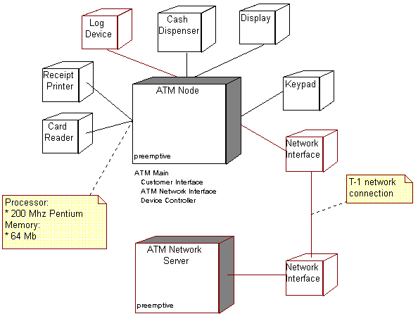

General Architecture for Core Technical Services

Sentinel’s core technical services are built around a Buy/Reuse-first strategy, leveraging mature open-source components for graph storage, vector search, and agent orchestration. Custom code is limited to the Curator Agent logic, ontology enforcement, and the Co-Pilot intent optimization layer. All services are designed for horizontal scaling and stateless operation where possible.

Persistence

Neo4j Knowledge Graph is the persistent, single source of truth for Sentinel’s SME-Governed Ontology. Every regulatory category, policy node, and supersession relationship is stored in Neo4j with full version history — making the graph the authoritative record of what is currently in force at any point in time. This is a deliberate architectural choice over a relational database: graph traversal natively expresses “Policy V2 SUPERSEDES Policy V1, which governed Rule R” in a single query, whereas a relational schema would require complex multi-table JOINs. FAISS provides the semantic vector index as a complementary layer for natural-language chunk retrieval. Source PDFs are retained in an encrypted on-premise object store (e.g., MinIO), enabling the full evidence snapshot (source citation back to the original document) that satisfies audit requirements.

Inter-process Communication

Agent services communicate via REST APIs for synchronous query flows and via a message queue (Kafka/RabbitMQ) for asynchronous document ingestion. This decoupling ensures that ingestion load spikes do not degrade query response times. Internal gRPC is used for high-frequency, low-latency communication between the Co-Pilot Agent and the Knowledge Graph service.

Authentication and Authorization

All API endpoints are protected via OAuth 2.0 / JWT tokens integrated with the bank’s existing Active Directory / LDAP identity provider. Role-based access control (RBAC) governs which users can query the Co-Pilot Agent, upload documents, and modify the ontology. SME-level access is required for ontology changes. All inter-service communication uses mutual TLS (mTLS). Data at rest in Neo4j and the object store is encrypted using AES-256.

Error Handling

Sentinel enforces a “Strict Retrieval Constraint” as a core error handling principle: the Co-Pilot Agent’s LLM is explicitly instructed that if no active, verified policy node is found in the Knowledge Graph for a given query, it must return a structured error response (“No verified policy found for this query”) rather than generating a speculative answer. This hard constraint is what distinguishes Sentinel from standard RAG systems — the LLM is forced to admit uncertainty rather than hallucinate a plausible but potentially outdated or fabricated banking policy. On the ingestion side, the Curator Agent routes documents that fall below the classification confidence threshold (e.g., <0.7) to a dead-letter queue for human SME review, ensuring that ambiguous circulars are never silently misclassified into the graph. All error events are logged with full context, agent decision trace, and timestamps for audit purposes.

Logging

Sentinel implements structured logging (JSON format) via a centralized logging service (ELK Stack or Splunk). Every document ingestion event, agent decision, ontology change, and query response is logged with timestamps, user IDs, and confidence scores. This supports the “100% Auditable” design goal. Logs are retained for a minimum of 7 years in compliance with RBI audit requirements. Sensitive policy content in logs is masked where required.

Transaction Management

Policy ingestion is treated as an atomic transaction: the SUPERSEDE_OLD command in Neo4j and the FAISS index update must both succeed or both roll back. Neo4j’s ACID transaction support ensures graph consistency. If a new policy node is written to the graph but FAISS indexing fails, the graph update is rolled back to prevent a state where the graph references a document that cannot be semantically retrieved.

Other Applicable Technical Services

Caching: The Co-Pilot Agent caches frequent query results (e.g., top-10 most common compliance questions) using Redis with a TTL of 1 hour, automatically invalidated upon new policy ingestion. Monitoring: Prometheus + Grafana dashboards track agent throughput, graph query latency, and LLM API usage. Alerting is configured for ingestion queue depth and LLM error rates. Rate Limiting: The Co-Pilot API enforces per-user rate limits to prevent abuse and control LLM API costs. other core technical services to be handled by the system such as the installation mechanism, failure prevention, fault tolerance, caching design, internationalization, validation framework, client and server initialization, error handling, etc.]

Risks/Limitation

1. LLM Dependency Risk: The Curator Agent’s classification quality is dependent on the enterprise LLM. Model degradation or API unavailability will impact ingestion. Mitigation: queue-based retry logic and fallback to human review. 2. Ontology Rigidity: The fixed ontology prevents the system from handling genuinely novel regulatory categories until an SME updates it. Mitigation: a monthly ontology review process. 3. Graph Scalability: Neo4j performance may degrade with very deep supersession chains (e.g., a policy revised 50+ times). Mitigation: archival strategy for aged-out nodes. 4. Confidence Score Calibration: The 0.95 confidence threshold demonstrated in the MVP may require tuning for edge-case documents (e.g., ambiguous circulars spanning multiple categories).

Alternative Solutions Considered

1. Standard Vector-Based RAG (The Primary Alternative Considered): The most obvious alternative was to build a standard RAG system using only FAISS or a similar vector database, without a Knowledge Graph. This approach was evaluated and rejected for a fundamental architectural reason: standard vector RAG is “append-only.” When a new policy is ingested, it is added to the vector index alongside all previous versions — there is no mechanism to explicitly record that the new document supersedes the old one. This creates “Policy Churn”: the system may retrieve an outdated 2021 AML circular alongside the current 2024 update and present both as valid, which is an unacceptable compliance and audit risk in a regulated banking environment. Sentinel’s Knowledge Graph architecture solves this directly: the SUPERSEDE_OLD relationship in Neo4j explicitly retires the old policy node, guaranteeing that only the single, active truth is ever surfaced to users. 2. Relational Database for Policy Storage: Considered storing policies in a PostgreSQL schema with foreign-key relationships for supersession. Rejected because multi-hop regulatory relationships (policy chains, cross-category dependencies) require complex recursive JOINs that are both slow and fragile to maintain as the regulatory corpus grows. 3. Manual Human-Curated Knowledge Base: Considered requiring compliance officers to manually update a structured database after each regulatory change. Rejected due to Policy Churn risk — the volume and frequency of RBI/AML updates makes manual curation unsustainable and introduces unacceptable lag between a regulation changing and the knowledge base reflecting that change. The Sentinel agentic GraphRAG approach was selected as the only architecture that simultaneously eliminates Policy Churn, enforces a single source of truth, and provides zero-latency compliance updates.

Appendix

[Present information that supplements the architecture specification.]

Expected Software Response

[Describe the expected results from testing.]

Performance Bounds

[Describe the special performance requirements.]

Identification of Critical Components

[Identify those components that are critical and demand particular attention during testing.]

Review Comments on Architectural POC
[If an architectural POC was developed and reviewed, elaborate the review comments for the POC.]

Justification of Changes to Existing Architecture (Optional)

[If any changes are made to an existing architecture to account for the new behavior, document those changes.]

