**1. Introduction**

* **Project Title:** SmartSDLC – AI-Enhanced Software Development Life Cycle
* **Team Leader:**
  + - Mohan N
* **Team Members:**

1. Mohanraj S
2. Nithish B
3. Nithish kumar S

**2. Project Overview:**

Purpose

The purpose of SmartSDLC is to enhance the traditional Software Development Life Cycle (SDLC) with Artificial Intelligence (AI), Machine Learning (ML), and Automation. SmartSDLC makes software development faster, more reliable, and cost-efficient by using AI in requirement analysis, design, coding, testing, deployment, and maintenance.

It reduces human errors, predicts risks, automates repetitive tasks, and improves collaboration between teams. This results in smarter, high-quality software solutions that adapt to real-world challenges.

Features

* **AI-Powered Requirement Analysis**
  + *Key Point:* NLP-driven requirement gathering
  + *Functionality:* Extracts requirements from client documents, chats, or feedback using AI.
* **Intelligent System Design**
  + *Key Point:* AI-generated architecture
  + *Functionality:* Creates UML diagrams, flowcharts, and predicts design flaws.
* **AI-Assisted Coding**
  + *Key Point:* Smart code generation
  + *Functionality:* Suggests and autocompletes optimized code snippets using AI assistants (e.g., Copilot, ChatGPT).
* **Automated Testing**
  + *Key Point:* AI-driven test cases
  + *Functionality:* Auto-generates test cases, predicts bug-prone areas, and performs regression testing.
* **Smart Deployment**
  + *Key Point:* Predictive CI/CD
  + *Functionality:* Optimizes deployment time, reduces downtime, and automates pipelines.
* **Predictive Maintenance**
  + *Key Point:* Continuous monitoring
  + *Functionality:* Uses AI for anomaly detection, predictive failure alerts, and automated patching.
* **User-Friendly Dashboard**
  + *Key Point:* Developer & manager support
* *Functionality:* Interactive interface for project tracking, performance KPIs, and reports.

**3. Architecture:**

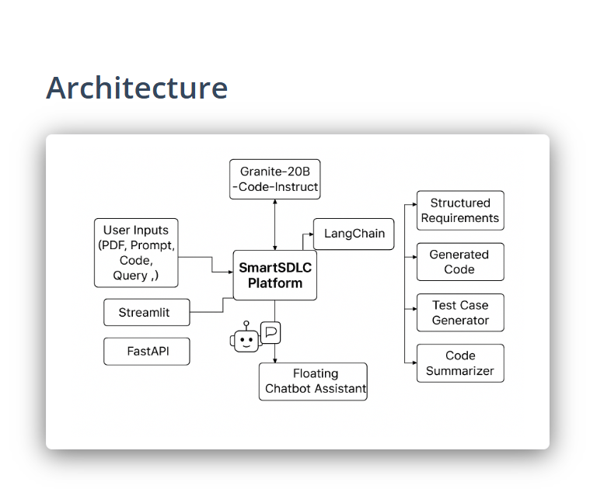

The architecture of the SmartSDLC – AI-Enhanced Software Development Life Cycle is designed to integrate AI models, automation frameworks, and user-friendly interfaces into every stage of software development.

Components of the Architecture

1. User Inputs
   * Accepts inputs such as PDF documents, prompts, source code, and queries.
   * These inputs are processed by the SmartSDLC platform for analysis.
2. Frontend Layer (Streamlit + FastAPI)
   * Streamlit provides an interactive web-based dashboard for developers, testers, and managers.
   * FastAPI serves as the backend REST framework, handling requests for requirement analysis, code generation, and test automation.
3. SmartSDLC Platform (Core Engine)
   * Central processing unit that coordinates between user inputs, AI models, and output modules.
   * Orchestrates requirement extraction, coding assistance, test case generation, and summarization.
4. AI Model Integration (Granite-20B Code Instruct)
   * A large language model (LLM) optimized for code generation, summarization, and automation.
   * Integrated through LangChain, which allows chaining multiple AI tasks together.
5. Floating Chatbot Assistant
   * An intelligent conversational assistant for real-time support.
   * Helps users with requirement clarification, debugging support, and documentation queries.
6. Output Modules
   * Structured Requirements: Automatically generates organized requirement documents.
   * Generated Code: Produces optimized and secure code

**4. Setup Instructions:**

**Prerequisites**

* Ensure Python (preferably 3.9+) and Git are installed.
* For web interface: Have Streamlit and FastAPI frameworks installed via pip.
* Confirm access to the required AI models (such as Granite-20B-Code-Instruct) and orchestration tools (such as LangChain).

**Installation Steps**

1. **Clone the Repository**
   * Use the command:

text

git clone <repository-url>

cd smart-sdlc

* + Replace <repository-url> with the official repo link from source.

1. **Install Dependencies**
   * Run:

text

pip install -r requirements.txt

* + This will install Python packages including Streamlit, FastAPI, and LangChain.

**3.Configure Environment**

* + Add API keys or model credentials to environment variables or a config file as instructed in the documentation.

**4.Start the Backend**

* + Run FastAPI server (usually):

text

uvicorn main:app --reload

* + For Streamlit interface:

text

streamlit run app.py

* + These commands launch the web app and backend API for user input.

1. **Connect and Test AI Models**
   * Make sure the platform can access Granite-20B-Code-Instruct and LangChain integrations.
   * Run test commands or provided examples to validate the model connections.
2. **Access and Use the Platform**
   * Open the web interface at the local address provided (default is [http://localhost:8501](http://localhost:8501/) for Streamlit).
   * Begin submitting user inputs, code, or prompts for processing and SDLC automation tasks.
3. **Folder Structure:**

app/ – Backend logic (Fast API, ML models, routes)

app/api/ – API routes (requirements, coding, testing, deployment)

ui/ – Frontend dashboards & forms

ai_coder.py – Handles AI-assisted coding tasks

test_generator.py – Generates automated test cases

deployment_manager.py – Manages CI/CD pipeline

bug_predictor.py – ML model for bug detection

report_generator.py – Creates AI-generated progress reports

**6. Running the Application**

Running the SmartSDLC or a mobile application involves the following general steps:

1. **Prerequisites**
   * Ensure all dependencies and environment setups are complete (see Setup Instructions).
   * Have necessary API keys and configurations in place.
   * Confirm network connectivity for cloud resources or AI model access.
2. **Start Backend Services**
   * Launch backend API using FastAPI or equivalent by running:

text

uvicorn main:app --reload

* + This will start the server to handle API requests from clients.

1. **Start Frontend Interface**
   * For Streamlit-based UI, run:

text

streamlit run app.py

* + This launches the web interface for user interaction.

1. **Access the Application**
   * Open a browser and go to the provided local URL, usually:
     + Backend API: http://localhost:8000
     + Frontend UI: http://localhost:8501
2. **Using the Application**
   * Input user data such as PDFs, prompts, or code into the interface.
   * The platform processes the input through AI models and orchestrators.
   * Review generated results including structured requirements, code snippets, or test cases.
   * Interact with the floating chatbot assistant for help or additional commands.

**7. API Documentation**

* POST /requirements/analyze → Extract requirements using NLP.
* POST /design/generate → Generate UML/architecture designs.
* POST /code/assist → AI-assisted code suggestions.
* POST /test/auto → Automated test case generation.
* GET /deploy/monitor → Monitor and optimize deployments.
* POST /maintenance/predict → Predict future failures/bugs.

**8. Authentication**

**Authentication** is a critical phase in the SmartSDLC process that ensures only legitimate users or systems can access the software application. In an AI-enhanced development lifecycle, authentication is strengthened using intelligent methods, making systems more secure and adaptive.

**Key Concepts:**

1. **Purpose:**
   * Verify the identity of users, devices, or systems before granting access.
   * Protect sensitive data and application resources.
2. **Types of Authentication in SmartSDLC:**
   * **Password-based Authentication:** Traditional method where users enter credentials. AI can help detect weak passwords and suggest improvements.
   * **Multi-Factor Authentication (MFA):** Combines two or more verification methods (e.g., password + OTP or biometric). AI can optimize MFA flows to reduce friction for legitimate users while increasing security.
   * **Biometric Authentication:** Uses fingerprints, facial recognition, or voice. AI improves accuracy and reduces false positives.
   * **Token-based Authentication:** Includes OAuth, JWT, and API tokens. AI can monitor token usage for anomalies.
3. **AI Enhancements in Authentication:**
   * **Behavioral Analysis:** AI tracks user behavior patterns (like typing speed, mouse movement) to detect unusual activity.
   * **Anomaly Detection:** Machine learning algorithms identify suspicious login attempts or potential attacks.
   * **Adaptive Authentication:** AI dynamically adjusts authentication requirements based on risk assessment (e.g., location, device, time of access).

**9. User Interface (UI):**

**User Interface (UI)**

**User Interface (UI)** is a crucial phase in the SmartSDLC process, focusing on how users interact with the software system. In an AI-enhanced SDLC, UI design leverages intelligent tools to create adaptive, intuitive, and user-friendly interfaces that improve user experience.

**Key Concepts:**

1. **Purpose:**
   * Facilitate easy interaction between the user and the system.
   * Ensure clarity, consistency, and efficiency in navigating the application.
2. **Components of UI in SmartSDLC:**
   * **Visual Design:** Colors, typography, layouts, and iconography that provide an aesthetically pleasing interface. AI can suggest optimal design elements based on user behavior and trends.
   * **Interactive Elements:** Buttons, menus, forms, sliders, and other controls. AI can personalize these elements based on user preferences.
   * **Feedback Mechanisms:** Tooltips, notifications, and error messages that guide users effectively. AI can dynamically adjust messages for clarity and relevance.
   * **Accessibility Features:** Ensures the software is usable by people with disabilities (e.g., screen readers, high contrast modes). AI can automatically test and suggest accessibility improvements.
3. **AI Enhancements in UI:**
   * **Personalized Interfaces:** AI analyzes user behavior to adapt layouts, content, and navigation for individual preferences.
   * **Predictive Input:** Suggests actions, auto-fills forms, or predicts user needs to streamline workflow.
   * **Usability Testing Automation:** AI can simulate user interactions to identify confusing or inefficient interface elements.
   * **Voice & Gesture Recognition:** Allows natural interaction methods powered by AI.
4. **Implementation in SmartSDLC:**

During the UI phase, designers collaborate with AI modules to create mockups, prototypes, and interactive designs. Feedback loops powered by AI ensure continuous improvement and optimization before final deployment.

**10. Testing:**

**Testing** is a critical phase in the SmartSDLC process that ensures the software system functions correctly, meets requirements, and is free of defects. In an AI-enhanced SDLC, testing leverages intelligent tools and automation to improve accuracy, efficiency, and coverage.

**Key Concepts:**

1. **Purpose:**
   * Identify and fix defects before deployment.
   * Verify that the software meets functional and non-functional requirements.
   * Ensure performance, security, and reliability of the application.
2. **Types of Testing in SmartSDLC:**
   * **Unit Testing:** Checks individual components or modules. AI can generate test cases automatically and predict potential weak spots.
   * **Integration Testing:** Ensures modules work together seamlessly. AI monitors data flows and detects inconsistencies.
   * **System Testing:** Validates the entire system’s behavior against requirements. AI can simulate real-world usage scenarios.
   * **Regression Testing:** Ensures that new changes don’t break existing functionality. AI automates repetitive tests efficiently.
   * **Performance & Load Testing:** Evaluates how the system behaves under stress. AI predicts bottlenecks and suggests optimizations.
   * **Security Testing:** Identifies vulnerabilities. AI-driven tools can perform dynamic vulnerability scanning and threat detection.

**11. Screenshots (To Add):**

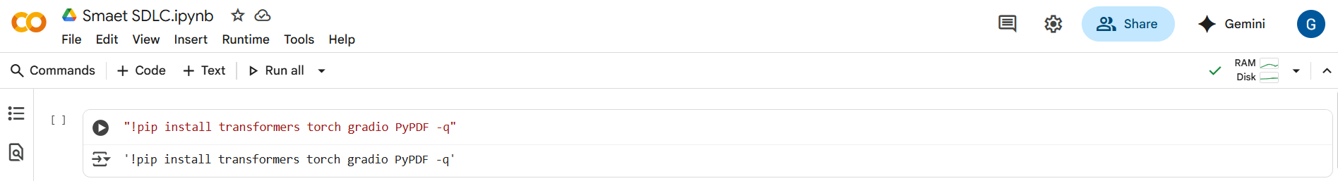

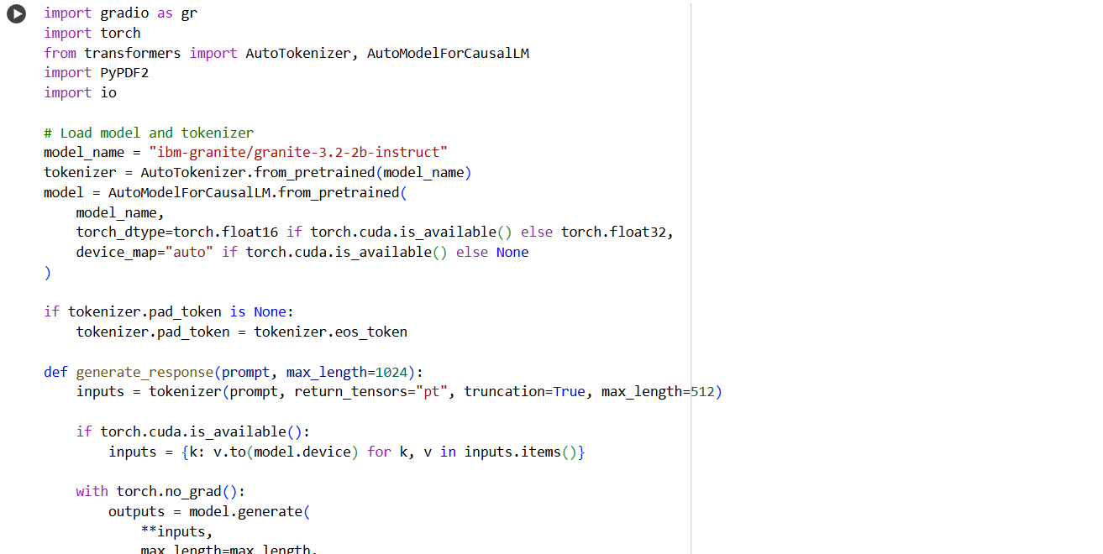

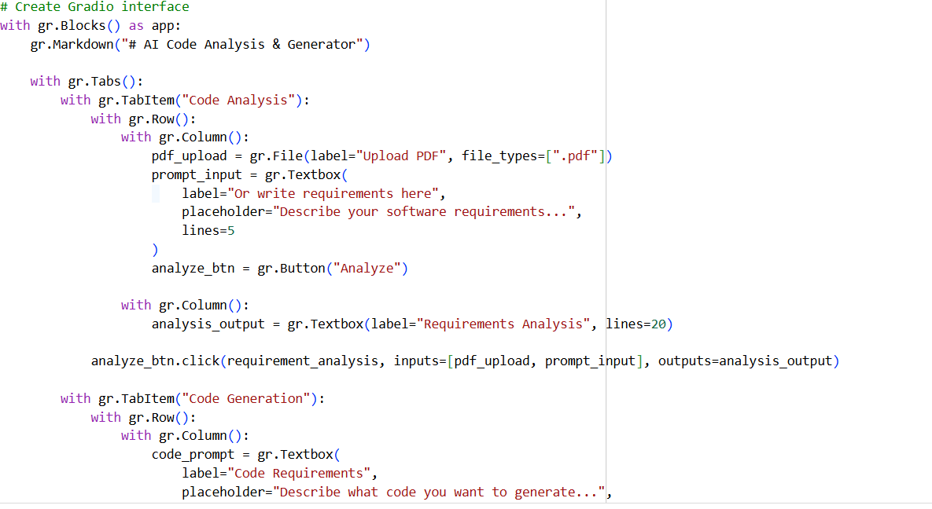

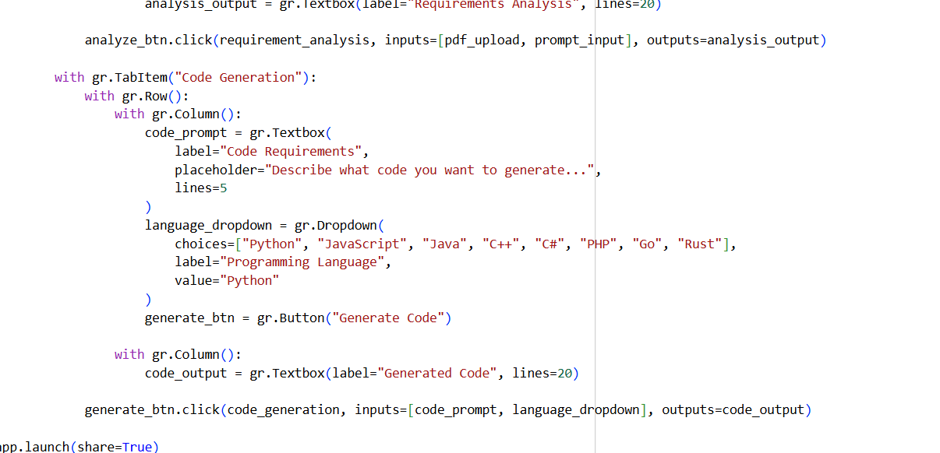

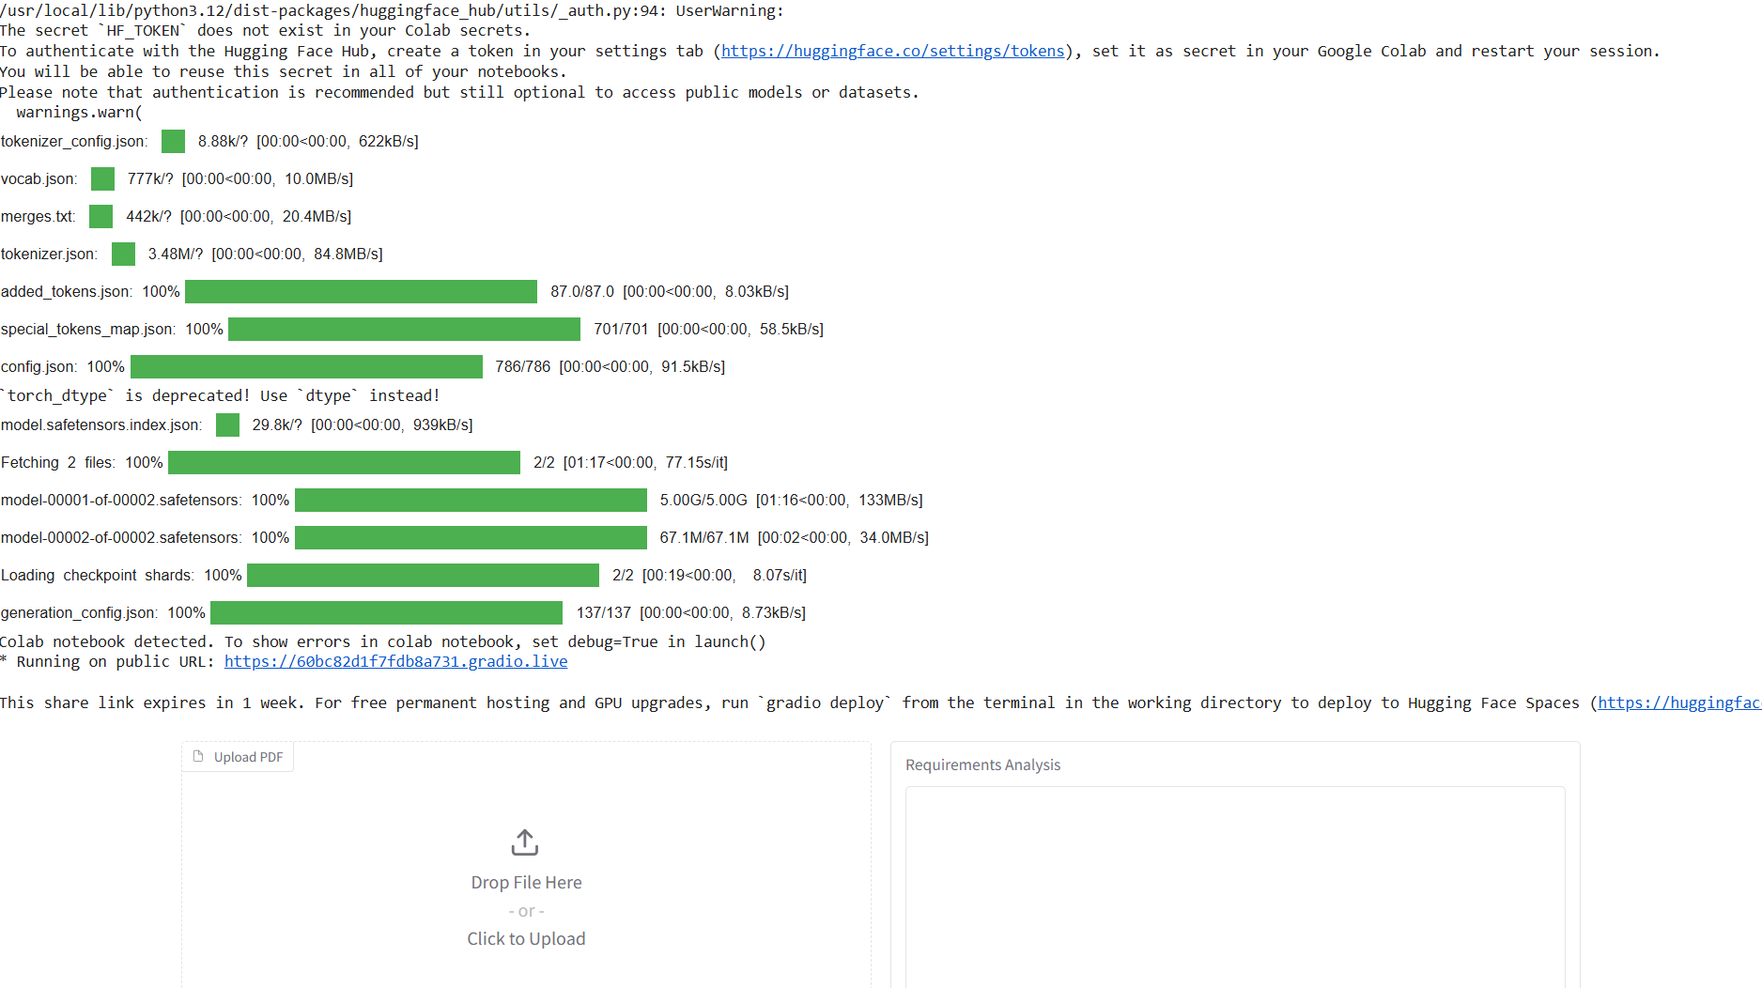

**12. Known Issues**

* Accuracy of AI suggestions may vary.
* Dependency on internet/cloud services.
* Learning curve for new users.

**13. Future Enhancements**

* Integration with **DevOps tools** (Jenkins, GitHub Actions).
* Support for **voice-based requirement analysis**.
* Advanced **self-healing software** (auto bug fixing).
* Deeper **predictive analytics** for project risk management.

**14.Conclusion**

SmartSDLC enhances the traditional software development process by using AI and automation to make it faster, smarter, and more reliable. It improves accuracy, reduces errors, and supports better collaboration across all SDLC phases. With future upgrades like DevOps integration and self-healing systems, SmartSDLC can become a fully intelligent and adaptive development platform.