Software Requirements Specification

Polygon

Version 1.0

Prepared by K. Mohan Sai

Polygon networks

13.09.2016

Table of Contents

Table of Contents ii

Revision History ii

1. Introduction 1

1.1 Purpose 1

1.2 Document Conventions 1

1.3 Intended Audience and Reading Suggestions 1

1.4 Product Scope 1

1.5 References 1

2. Overall Description 2

2.1 Product Perspective 2

2.2 Product Functions 2

2.3 User Classes and Characteristics 2

2.4 Operating Environment 2

2.5 Design and Implementation Constraints 2

2.6 User Documentation 2

2.7 Assumptions and Dependencies 3

3. External Interface Requirements 3

3.1 User Interfaces 3

13.2 Hardware Interfaces 3

3.3 Software Interfaces 3

3.4 Communications Interfaces 3

4. System Features 4

4.1 System Feature 1 4

5. Other Nonfunctional Requirements 4

5.1 Performance Requirements 4

5.2 Safety Requirements 5

5.3 Security Requirements 5

5.4 Software Quality Attributes 5

5.5 Business Rules 5

6. Other Requirements 5

Appendix A: Glossary 5

Appendix B: Analysis Models 5

Appendix C: To Be Determined List 6

Revision History

|  |  |  |  |
| --- | --- | --- | --- |
| **Name** | **Date** | **Reason For Changes** | **Version** |
|  |  |  |  |
|  |  |  |  |

# Introduction

## Purpose

*Mobile application Polygon system was made to beat the correspondence boundaries in universities in creative way. Polygon 1.0 adaptation will be accessible to every one of the understudies in a specific association (presently just for NIIT University). Polygon likewise has an enormous degree being a standout amongst the most inventive long range informal communication administration ever. The unpredictable geometric shape polygon with all diagonals associated speaks to the general population in various nations over the globe associated with each other with our system.*

## Document Conventions

Arial italic - standard type style used for most text, Times bold – used for headings and for index. The document doesn’t contain any special symbols. Every requirement statement in the document has its own priority.

## Intended Audience and Reading Suggestions

*The accompanying document is expected for documentation authors. Rest of the document contains insights about the idea and insights about the product and UI alongside the outline and execution limitations. The document should be read from the beginning and all sections based on the details mentioned above are much more important to understand the complete picture. Individuals to comprehend the UI can start with the third section and fourth part to know the system features.*

## Product Scope

*Polygon application can be utilized to know about the general population around you with only a single click, you simply require a photograph of the individual and you will get the he gave. We will likely let understudies of same interests in a college to know each other and make them work together. The general population cooperating can be more profitable furthermore they will learn working in group. Our application additionally can be used as an automatic student attendance system, college has to provide students with the app and one student can join other, our corporate goal is to reach to all the colleges across the country and to be in the hands of every student.*

## References

The SRS document has been prepared by taking IEEE830 document as a reference and the use case diagram has been prepared by referring to the standard social networking use case diagram.

Reference link: http://image.slidesharecdn.com/random-140623014539-phpapp01/95/social-networking-site-23-638.jpg?cb=1403487994

# Overall Description

## Product Perspective

*Polygon is another new product in this long range informal communication market which was made for students and educational organizations, the First step of the software occurred when the open door here was identified. The application requires an outsider application face-plus-plus support for face recognition algorithm and database support.*

## Product Functions

User should be able to send photo requests to the server and has to be able to receive their information.

## User Classes and Characteristics

Other classes includes the support we get from other outsider programming which we use for our face recognition algorithm. Those classes receive the photograph and send us back the values which we store in our database. This class relation is currently not shown in the above diagram. The most important class in the system is account class which holds details all the details about the user.

## Operating Environment

The application works in android smart phones and tablets with operating system above 4.2.2 which includes hardware requirements of front and rear cameras. These are the required specifications for the software to run Effectively

## Design and Implementation Constraints

. At present we are restricted to 2000 understudies and the accessible equipment couldn't deal with transfer bandwidth above 100GB.Face-plus-plus also provides limited amount of bandwidth which is not enough for multiple queries. The polygon networks’ organization is responsible for maintaining the Given software.

## User Documentation

The application utilizes extremely basic and easy to use User Interface which is outlined remembering User Experience UX. The application accompanies fundamental help and individuals who don't know how to utilize application can get assistance from that point. We don't find any need in preparing manual for Polygon. All the required terms and conditions are said while downloading the application which will accessible in Android application store.

## Assumptions and Dependencies

There are not very many accepted factors in the SRS report. We accepted that there will be no hackers assault over the database until it moves up to Azure cloud administration. On the off chance that that happens the data in the database will be lost. To overcome this sort of variable we should redesign before we achieve gigantic audience. The operational expense would increment furthermore the security issues will be raised if the supposition turns out badly. Polygon utilizes another web application which is documented and it can be utilized freely for non-commercial use, as long as polygon is growing it will be a non-commercial application.

# External Interface Requirements

## User Interfaces

The application contains login page at first to allow registered users to login to their wall. Login page also directs new users to signup page to create a new account, they need to upload their selfie and also needs to fill in the required data. The user activity area that comes after login allows the user to take photo or change or update their information.

## 

## 3.2 Hardware Interfaces

The application uses database which stores the information regarding the user’s information. If any new user cell is created the database fetches information from face-plus-plus site and stores it. If any request made from other user matches the values of face of other user, the details will be returned. The application is currently supported for android OS above 4.2.2 (Android Jelly Bean). The device requires dual cam front and rear and internet connection.

## 3.3 Software Interfaces

We are using face-plus-plus 1:1 face verification method to detect the face and also to store required face values. Polygon 1.0 also uses 000webhost.com database to store the user’s information. The photo of user is sent to face-plus-plus and the returned values are stored in our database. App currently works in android smart phones with operating system on or above version 4.2.2. Face-plus-plus provides free API support for non-commercial use and 000webhost also provides free database service until we reach 100GB storage. All the data is shared with 000webhost and all the photo requests are shared with face-plus-plus site.

## Communications Interfaces

The application requires communication to other servers and databases this includes web browser and also network server communication. Software uses hypertext transfer protocol and it also uses UTF 8 encoding and the database is also an encrypted database. We have 100GB bandwidth which can handle the current population.

# System Features

*Polygon is useful for the people who want to know details of an unknown person in a certain area. To know about these details we need to take his photo and search for the person. The app contains details of the user and we have a facility that one can also request for someone’s details.*

**4.1 System Feature**

**4.1.1 Description and Priority**

*Polygon is one of the unique application as it contains all the above features and not only that it has a special feature that allows some security notifications as if 1 person is uploading another persons’ photo then that another person will get one security alert.*

**4.1.2 Stimulus/Response Sequences**

*As if someone is photographed by the user then that photographed person will get immediate notification, at what time and at what place he or she had taken that pic. So that they can allow to share the details with the user.*

**4.1.3 Functional Requirements**

*REQ-1: user data storage*

*REQ-2: Photo request*

*REQ-3: notification request*

*REQ-4: Same interest person in locality request*

# Other Nonfunctional Requirements

## Performance Requirements

If a person requests for query the database fetches information from face-plus-plus site and starts its search in the database as long as the database is small the search algorithm finds the required data and returns the values, but if the database grows big enough it will take a lot of time which is not much reliable. So instead of standard search technique binary search or any better techniques has to be followed. The system is a real time system as the query is made real time and so the system should be more specific and more efficient. At present the database is built using MySQL.

## Safety Requirements

*The database must be more secured and for that subsequent to achieving 200 enlistments the database will be changed to Microsoft's azure and it will move down all the current information in two servers. By doing as such we will have the capacity to protect the information regardless of the fact that the server crashes. The database is exceptionally secured and any activities that are against the terms will be ended and essential moves will be made.*

## Security Requirements

*The application has few security issues with respect to taking of data of other individuals which have been considered and arranged the product remembering each perspective. Everybody who utilizes this application requires authentication and should agree to the terms of usage. Just issue is taking pictures of others without their authorization, we have had an answer for this issue, each client can keep all their data private and on the off chance that somebody takes their photograph a notification will be sent to that person that you have been photographed and details of the person who took will be also sent.*

## Software Quality Attributes

*This software is a next generation concept which needs some time for adaptation, it will be accessible for every student and staff in NIIT University by end of November. The completed adaptation of Polygon will be more exact and more Effective. It will be very easy to learn this software. The software will be robust and also portable in the sense that you can use it from any of your device with same account.*

## Business Rules

*Every one of the individuals in the operational group are required to take care of the rightness of the information that is being entered in the database furthermore watch the working of the servers. The management group ought to take care of the cash that is required to keep the framework running furthermore should create link with different colleges and organizations.*

# Other Requirements

Requirements of software includes few hardware requirements, memory to handle the current existing members, database for storage we need database servers which can handle population around the any area.

Appendix A: Glossary

All the words included in the document are very clearly pre-defined and no such shortcuts are used.

Appendix B: Analysis Models

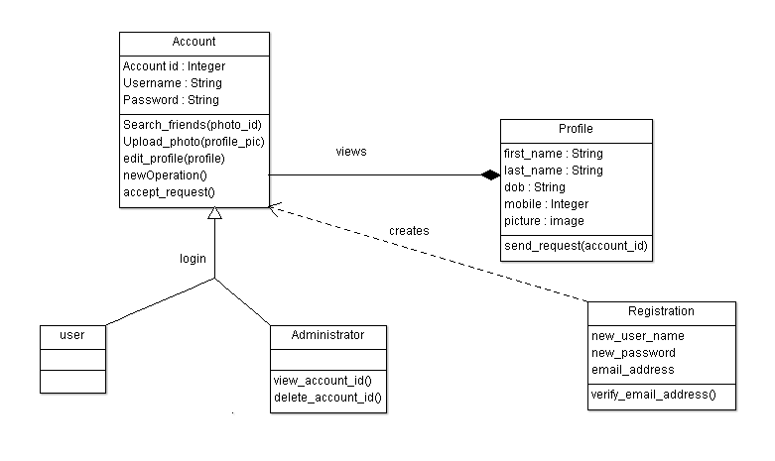

Appendix C: To Be Determined List

System features reference link: https://en.wikipedia.org/wiki/Software_feature/

Third Party application for face recognition: <http://www.faceplusplus.com/>

Database hosting server: <https://www.000webhost.com/>