Documentation & Guide
01.

Title: Automated DNS Reconnaissance & Enumeration Utility
Objective The objective of this project was to create a script that automates the discovery of public DNS records. In offensive cybersecurity, this is used to identify the "Attack Surface" of an organization. By finding Mail Servers (MX) or internal IP ranges (A/AAAA), a tester determines where to focus subsequent attacks.
Methodology & Code Logic The tool works by initializing a DNS resolver instance and iterating through a predefined list of record types.
- Input Handling: The script accepts a target domain and optional custom nameservers via command-line arguments.
- Resolution Loop: It iterates through record types (["A", "MX", "TXT", etc.]).
- Exception Management: The code uses try/except blocks specifically for dns.resolver.NoAnswer and dns.resolver.NXDOMAIN to differentiate between "No records found" and "Domain does not exist."
Key Code Segments (Highlight this in your PDF)
- The Resolver Setup:
Python
resolver = dns.resolver.Resolver()
if nameserver:
resolver.nameservers = [nameserver]
Explanation: This allows the tool to bypass local DNS caches and query specific upstream servers, useful for verifying split-horizon DNS.
- The Query Logic:
Python
answer = resolver.resolve(target_domain, record_type)
results[record_type] = [str(data) for data in answer]
Explanation: This fetches the raw answer and converts the object data into a readable string format for the user.

Screenshots
Help Menu:
  - Run: python project01.py -h
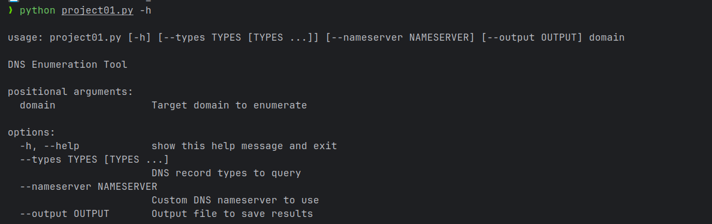

A Successful Scan (The "Money Shot"):
  - Run: python project01.py youtube.com (or use scanme.nmap)
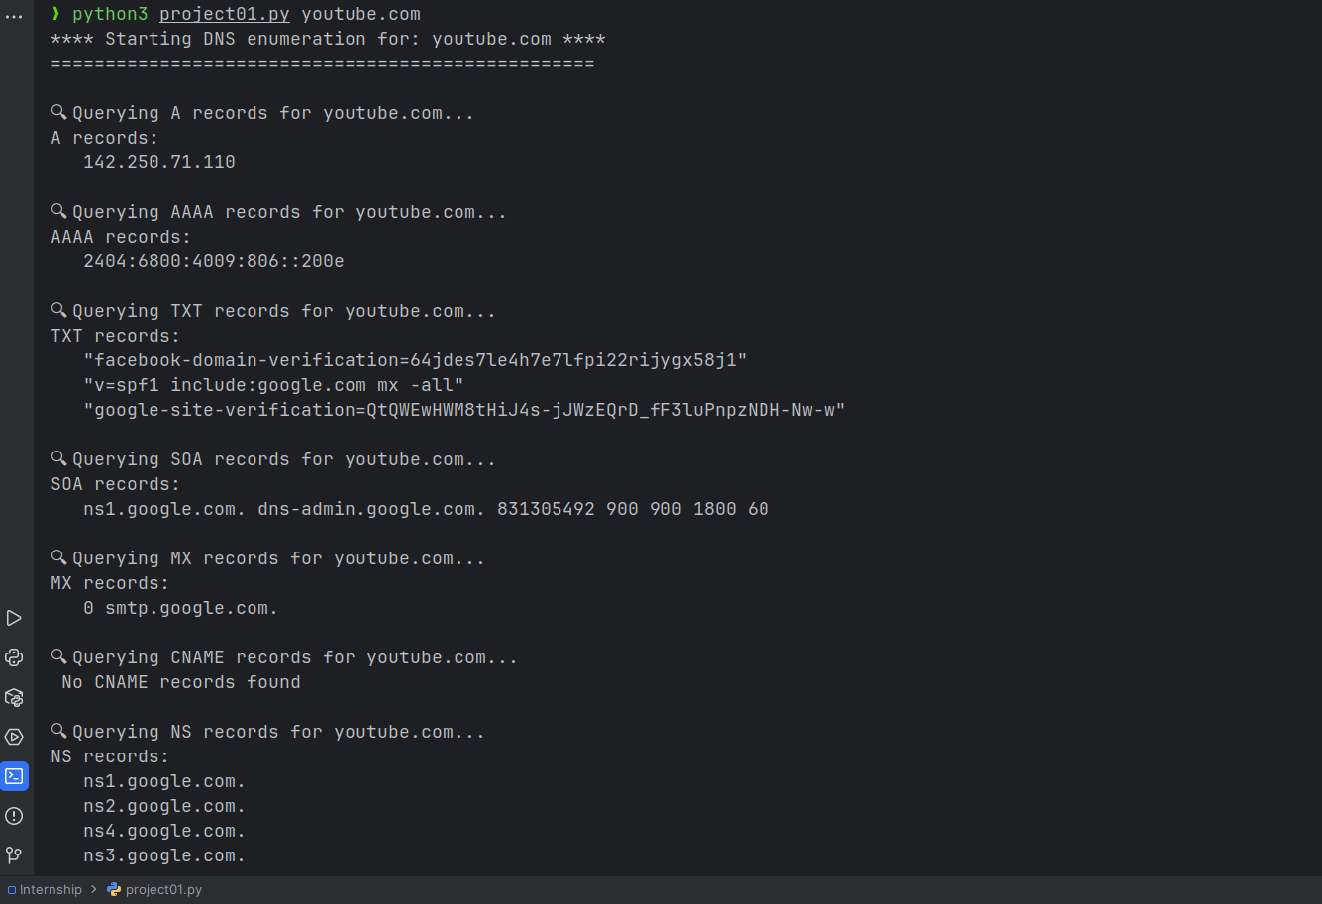

The Output File:
  - Run: python project01.py youtube.com --output results.txt
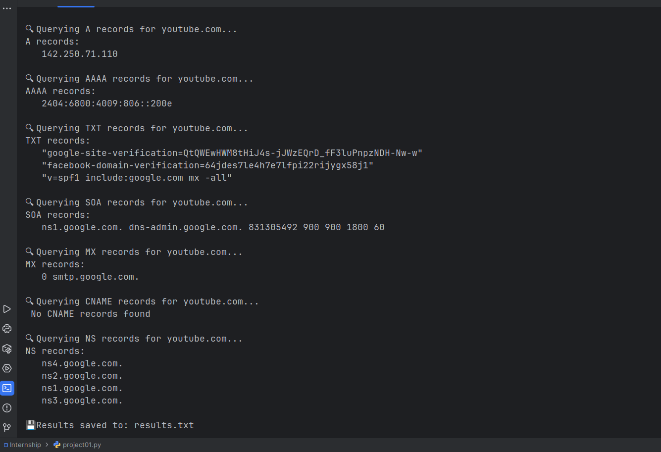
  - Then open results.txt in Notepad or cat results.txt in the terminal.

02.

Title: Multi-Threaded Subdomain Enumeration Tool

Objective The primary objective was to automate the discovery of subdomains (e.g., dev.target.com, admin.target.com) that are not publicly advertised. In a penetration test, this phase expands the scope of the audit, often revealing development servers or forgotten admin panels that are less secure than the main website.
Methodology & Code Logic The tool utilizes a "Dictionary Attack" approach:
- Input: Takes a target domain and a wordlist (a text file containing common subdomain names).
- Parallel Processing: Instead of checking one domain at a time, the script spins up a pool of worker threads.
- Verification: Each thread constructs a URL (http://sub.domain.com), sends a GET request, and analyzes the response code to determine if the site is active.
Key Code Segments
- Concurrency Implementation:
Python
with ThreadPoolExecutor(max_workers=self.threads) as executor:
future_to_subdomain = {
executor.submit(self.check_subdomain, subdomain): subdomain
for subdomain in subdomains
}
Explanation: This segment initializes the thread pool, allowing multiple network requests to happen at the exact same time, drastically speeding up the enumeration process.

- The Verification Logic:
Python
response = self.session.get(url, timeout=self.timeout)
if response.status_code < 400:
return url
Explanation: We strictly filter for status codes below 400. This ensures we don't report broken links (404) or server errors (500) as valid, discoverable assets.)

Screenshots
For this tool, we will need a "wordlist" file to make it work. Create a file named wordlist.txt and put these words inside it:
www
mail
remote
blog
webmail
server
help
secure
The Help Menu:
  - Run: python project02.py -h
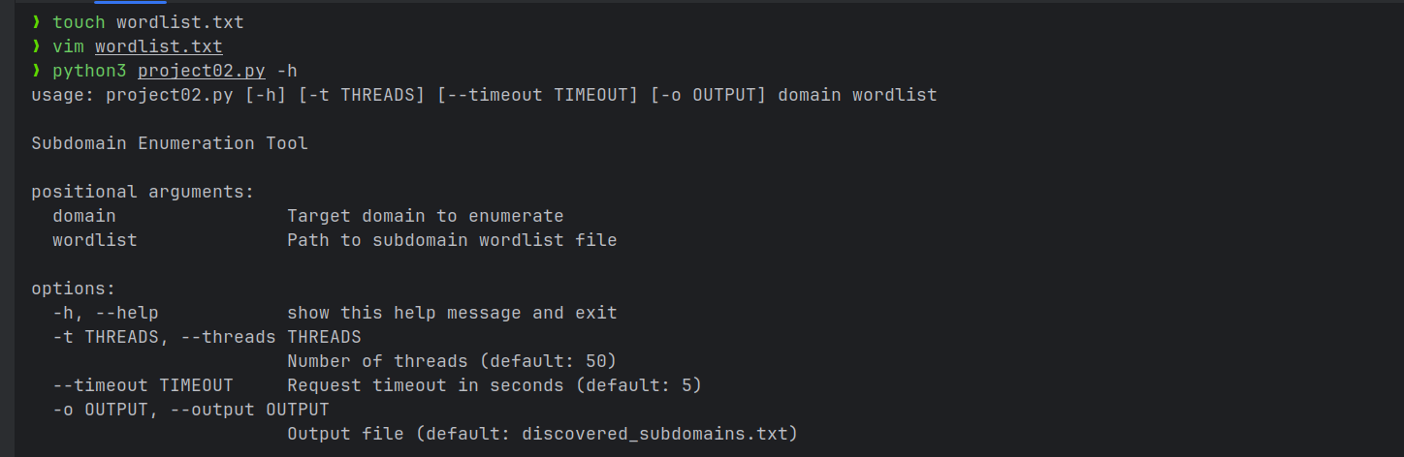

The Active Scan:
  - Run: python project02.py google.com wordlist.txt -t 20
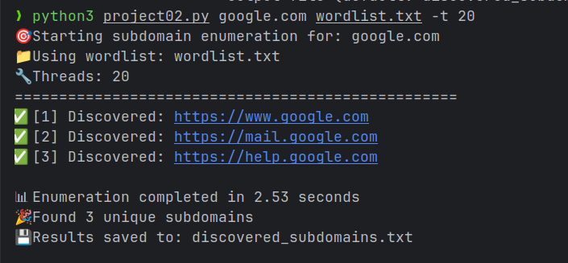

The Results File:
  - Open the generated discovered_subdomains.txt.
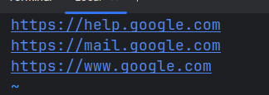

03.

Title: PDF Encryption & Data Loss Prevention (DLP) Tool
Objective The objective of this tool is to enforce Data Confidentiality. in a corporate environment, sensitive reports (like penetration test results) must be encrypted before being shared via email or stored on shared drives. This tool automates that security control.
Methodology & Code Logic The script follows a "Stream-based" approach:
- Stream Reading: It opens the target file in binary read mode (rb).
- Page Extraction: It extracts page objects from the source to ensure no content is lost.
- Cryptographic Wrapper: It creates a new PdfWriter object and applies the encrypt() method, which wraps the file content in a security layer requiring a password key.
- Binary Writing: Finally, it writes the encrypted stream to a new file in binary write mode (wb).
Key Code Segments
- The Encryption Implementation:
Python
pdf_writer = PyPDF2.PdfWriter()
# Copy all pages
for page in pdf_reader.pages:
pdf_writer.add_page(page)

# Encrypt with password
pdf_writer.encrypt(password)
Explanation: This is the core security logic. We migrate the data to a new writer instance and apply the encryption method before the file is ever saved to the disk.
- Binary File Handling:
Python
with open(input_pdf, 'rb') as file:
# ... processing ...
with open(output_pdf, 'wb') as output:
pdf_writer.write(output)
Explanation: Using 'rb' (read binary) and 'wb' (write binary) is critical to prevent encoding errors that could corrupt the PDF structure.

Screenshots
To demonstrate this, we need a dummy PDF. Create a simple PDF named hello.pdf (you can just save a Word doc as PDF).
The Validation Error:
  - Run: python project03.py hello1.pdf secure_hello.pdf zaq12wsx
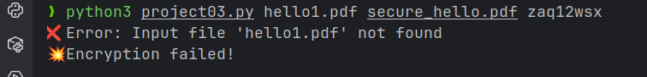
The Successful Encryption:
  - Run: python project03.py hello.pdf secure_hello.pdf SuperSecret123Pass
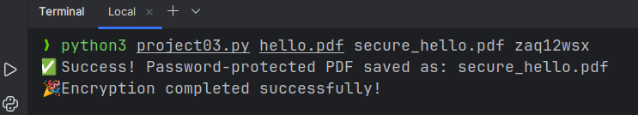
The Proof (Most Important):
  - Double-click protected.pdf to open it in a PDF viewer (like Chrome, Edge, or Adobe).
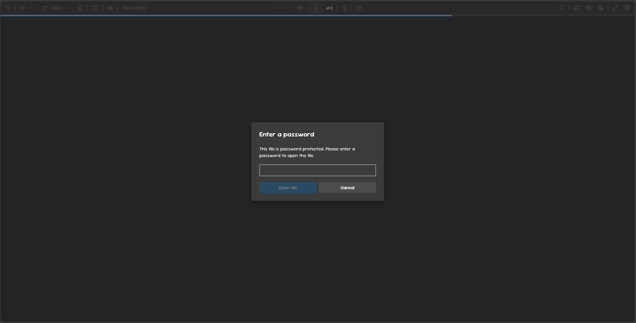

04.

Title: PDF Password Auditing & Recovery Utility
Objective The objective of this project is to demonstrate the vulnerability of weak passwords. In a security audit, this tool is used to verify if employees are using easily guessable passwords (like "password123" or short combinations) that fail to meet compliance standards.
Methodology & Code Logic The script employs two distinct algorithms:
- Dictionary Mode: It reads a text file containing thousands of common passwords and attempts them one by one. This mimics an attacker using a database of breached credentials.
- Brute-Force Mode: It mathematically generates every possible combination of characters (e.g., aa, ab, ac...) up to a specific length.
- Verification: It attempts to open the PDF with the generated string. If pikepdf does not raise a PasswordError, the tool confirms the password is correct.
Key Code Segments
- The Cracking Logic:
Python
try:
with pikepdf.open(pdf_file, password=password) as pdf:
return password
except pikepdf.PasswordError:
return None
Explanation: We attempt to open the file stream with the candidate password. The library throws a specific exception if the password is wrong, which we catch to continue the loop.
- The Permutation Logic (Brute Force):
Python
from itertools import product
for length in range(min_len, max_len + 1):
for pwd_tuple in product(charset, repeat=length):
passwords.append(''.join(pwd_tuple))
Explanation: This segment dynamically generates every possible character combination, ensuring 100% coverage of the search space for the defined length.

Screenshots
To demonstrate this, we need the protected pdf , so we will use that created in Project 03 (i.e. secure_hello.pdf ; set the password to something simple like abc for this test).
The Help Menu:
  - Run: python project04.py -h
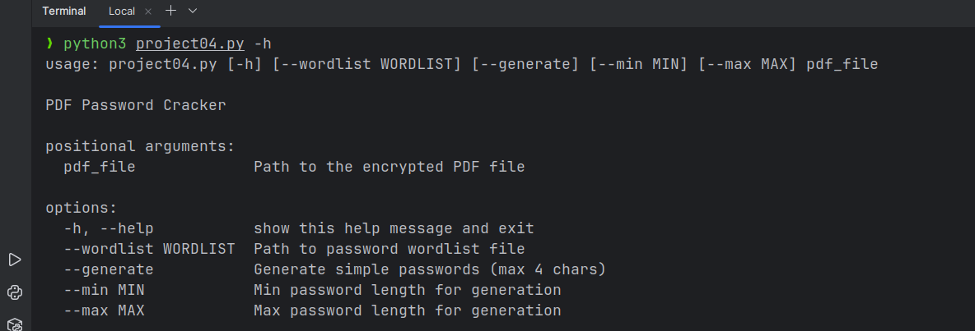

The Dictionary Attack (Simulation):
  - Create a file passwords.txt with random words and include the real password (abc) somewhere in the middle.
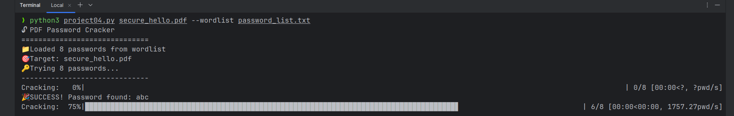
  - Run: python3 project04.py secure_hello.pdf --wordlist password_list.txt

The Brute Force Attack:
  - Run: python project04.py secure_hello.pdf --generate --max 3
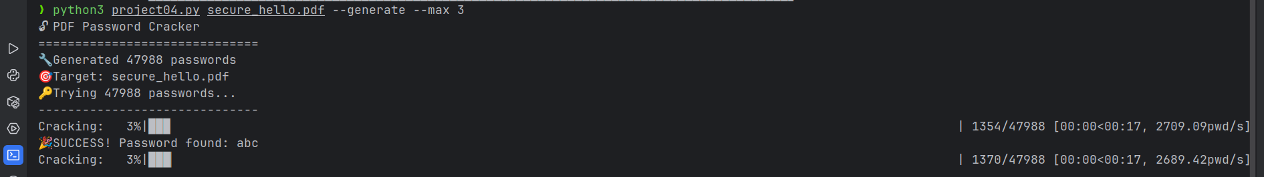

05.

Title: Multi-Threaded Network Infrastructure Mapping & Banner Grabbing tool

Objective The objective of this tool is to perform Active Reconnaissance. Before a penetration tester can exploit a system, they must know what "doors" (ports) are open and what software is running behind them. This tool automates the discovery of the "Attack Surface."
Methodology & Code Logic The script operates on the TCP protocol:
- Target Resolution: Converts the hostname to an IPv4 address.
- Threading Model: Instead of checking Port 1, waiting, then Port 2, it spins up a "Pool" of workers (threads) to check hundreds of ports simultaneously.
- TCP Handshake: It attempts a full TCP connection (socket.connect_ex). If the return code is 0, the port is OPEN.
- Data Extraction: If open, it sends a request and listens for a "Banner"—a string of text the server sends back identifying itself.
Key Code Segments
- The Banner Grabbing Logic:
Python
try:
sock.settimeout(0.5)
banner = sock.recv(1024).decode(errors='ignore').strip()
except:
pass
Explanation: This segment listens for the "Welcome Message" from the server. This data is critical for Version Detection, which helps hackers find specific exploits for that software version.
- The Threading Implementation:
Python
with concurrent.futures.ThreadPoolExecutor(max_workers=200) as executor:
future_to_port = {
executor.submit(scan_port, target_ip, port): port
for port in range(start_port, end_port + 1)
}
Explanation: This code creates 200 parallel threads. Without this, scanning all 65,535 ports would take hours; with this, it takes minutes.

Screenshots
Crucial Note: Do not scan random websites (like Google or Facebook). It is illegal or against their Terms of Service. Use scanme.nmap.org (a site specifically made for testing scanners) or your own localhost.
The Input/Scan Screen:
  - Run: python project05.py
  - Enter Target: scanme.nmap.org
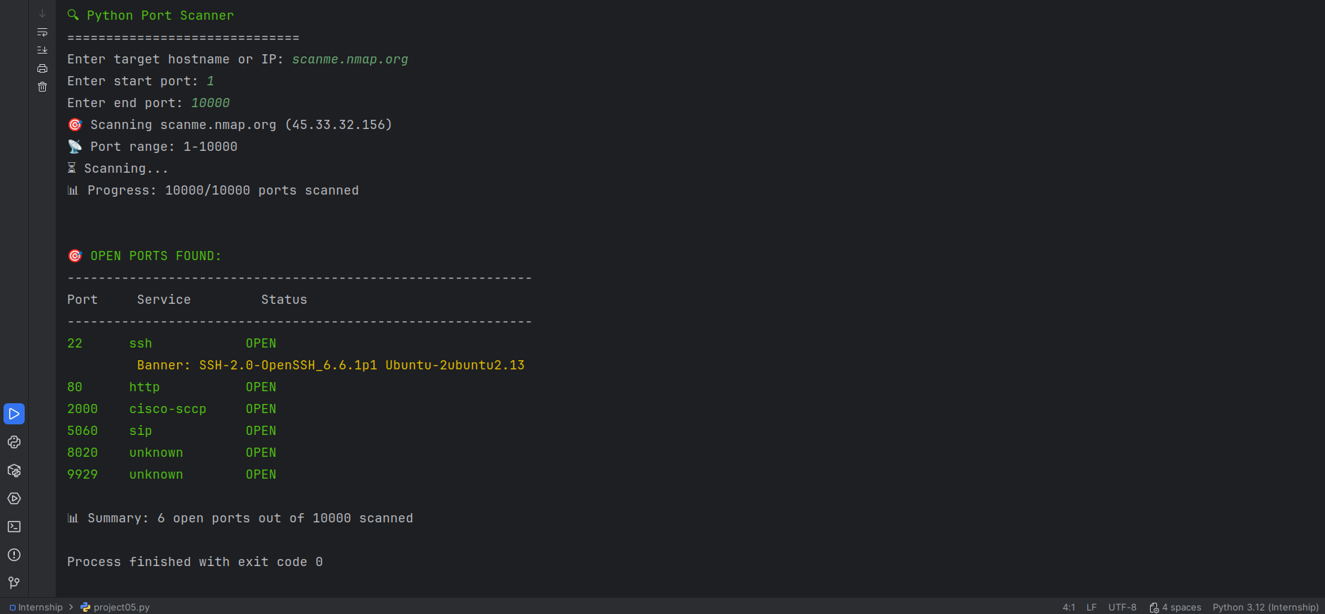

06.

Title: Offline Password Hash Auditing Tool
Objective The objective of this project is to simulate "Offline Password Attacks." When a database is breached, passwords are often stored as hashes. This tool tests whether those hashes can be reversed to reveal the original plaintext password, highlighting the need for "Salted" hashes and high-entropy passwords.
Methodology & Code Logic The tool works by "Forward Hashing":
- Concept: You cannot "decrypt" a hash. You must take a guess, hash the guess, and compare it to the stolen hash.
- Input: The target hash string and the algorithm type (e.g., MD5).
- Generation: The script generates candidates either from a wordlist or by mathematically creating every character combination (Brute Force).
- Comparison: if md5(guess) == target_hash: return True
Key Code Segments
- Dynamic Hashing Wrapper:
Python
hash_fn = getattr(hashlib, hash_type)
# ... later in the code ...
return hash_fn(password.encode()).hexdigest() == target_hash
Explanation: Instead of writing separate functions for MD5, SHA1, etc., we use Python's reflection capabilities to select the algorithm at runtime based on the user's CLI argument.
- The Brute Force Generator:
Python
def password_generator(min_length, max_length, characters):
for length in range(min_length, max_length + 1):
for password in itertools.product(characters, repeat=length):
yield "".join(password)
Explanation: This generator uses itertools.product to create a stream of password candidates without storing them all in RAM, making the tool memory efficient.

Screenshots
We first need to generate a hash to crack.
- Go to an online MD5 generator (or use Python: import hashlib; print(hashlib.md5(b"abc").hexdigest())).
- Let's use the hash for the password "abc".
- MD5 Hash for "abc": 900150983cd24fb0d6963f7d28e17f72

The Help Menu:
  - Run: python project06.py –help
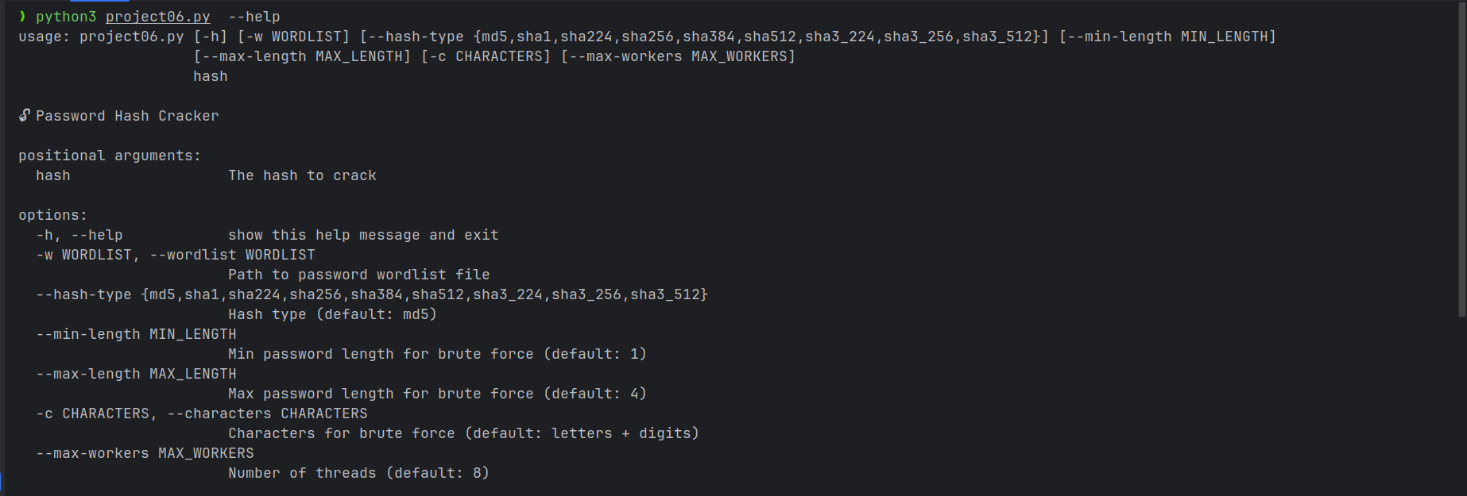
  - Shows the list of supported algorithms (MD5, SHA1, SHA256, etc.).
Successful Brute Force (MD5):
  - Run: python project06.py 900150983cd24fb0d6963f7d28e17f72 --hash-type md5 --max-length 3
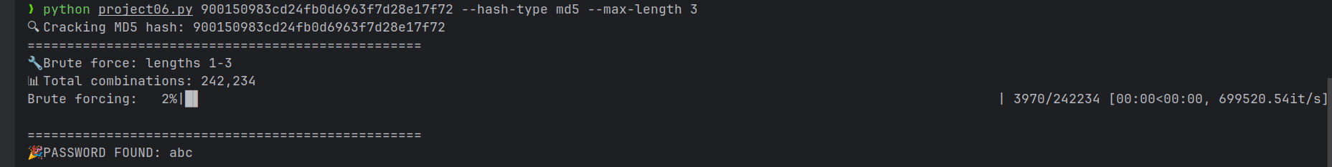
  - Why: It will quickly find "abc" and show the "🎉 PASSWORD FOUND" message.

Note: This program is not yet suitable for huge string password.

