PA Medicaid Exemption Workspace
Executive Proposal, Interactive Prototype Walkthrough (v4) & Technical Appendix
Prepared for: Penn Medicine Executive Leadership, the SMART Committee (Rich Paoliti & Mark Angelo, MD), and the Center for Healthcare Transformation and Innovation (CHTI).
Subject: Operationalizing the PA Medicaid Community Engagement (Work) Exemption Framework to protect patient coverage and mitigate system-wide revenue exposure.

Part 1 — Executive Summary

Strategic Rationale
The federal government and the Commonwealth of Pennsylvania are implementing a monthly 80-hour community engagement (work) requirement for Medicaid expansion enrollees (ages 19–64). Failure to comply or successfully file an exemption will result in immediate loss of Medicaid coverage.

Financial Exposure
At the Executive Advisory Board (EAB) meeting, it was flagged that roughly 40% of Penn Medicine patient revenue could be severely impacted if nothing is done. When vulnerable patients lose Medicaid coverage, they do not stop seeking care; they transition to the Emergency Department or inpatient units, shifting Penn Medicine payer mix toward uncompensated charity care and escalating bad debt.

Clinical Policy Gap
Federal CMS guidance introduced a challenging two-test standard for medical exemptions:
- Test 1: The patient must have a serious/complex medical condition, serious mental illness (SMI), or substance use disorder (SUD).
- Test 2: The condition must actively impair the patient ability to comply with the 80-hour work requirement.
Pennsylvania relies on retrospective billing claims data (sparse, lacking functional clinical depth) for automatic exemptions. Penn Medicine holds highly granular clinical data inside the EHR.

The Opportunity
By building a centralized administrative system to assess the Medicaid population for medical frailty and proactively pre-populate streamlined exemption documentation (PA-1663 / PA Medical Frailty Attestations), Penn Medicine can protect patient coverage, lower clinician administrative burden to near-zero, and insulate the health system from massive financial exposure.

Technical & Operational Approach
The proposed architecture bypasses the current Epic EHR build freeze (Doylestown consolidation through July/August) via a two-phase, dual-persona system:
- Phase 1 — Databricks Offline Registry: Daily replicated Epic Clarity data, UMLS SNOMED-to-ICD-10 mapping, tiered exemption logic, standalone Staff Dashboard.
- Phase 2 — SMART on FHIR Point-of-Care App (post-freeze): Single-patient chart context, editable attestation checkboxes, digital signature pad, HIO submission.
- Coordinated Patient Outreach: Community Health Workers use the dashboard with a Gemini AI outreach assistant to help patients upload completed forms to PA COMPASS.

Implementation Roadmap
- Month 1 — Databricks Engine & Mapping: Validate UMLS translations, 20-patient pilot, secure registry views.
- Month 2 — CHW Core Rollout: Deploy Standalone Staff Dashboard, connect registry datasets, initiate outreach campaigns.
- Month 3 — Epic SMART on FHIR Launch: Integrate point-of-care app, activate signature capture, route HIO/P3N transmissions.

Prototype Evolution (v4)
The interactive prototype has evolved from v3 (single-file ASCII wireframes) to v4: Engage Vivid staff UI, 3-panel outreach drawer, form mapping wizard, official DHS PDF pre-fill, and per-patient draft persistence. Deployable as a static site under prototype/v4/.
- Official forms only: PA 1663 export fills the bundled DHS PDF template (38 AcroForm fields). No synthetic PDFs.
- Medical Frailty: HTML questionnaire only until PA DHS publishes an official HR1 attestation PDF.
- Engage staff worklist: play button opens 3-panel drawer (patient context | outreach + forms | saved attempts).
- Outreach flow: Inbound call, Outbound call, or MPM; Call now placeholder when Outbound call selected.
- Form mapping wizard (form-mapping-wizard.html): EHR catalog → upload PDF → map fields → preview → save versions.
- FHIR Form Package tab: preview both forms; download official pre-filled PA 1663.

Part 2 — Screens & Walkthrough
The v4 interactive prototype demonstrates two physically separated deployment contexts via an Adaptive Enterprise Shell: the Independent Population Staff Dashboard and the SMART on FHIR Point-of-Care App embedded in a simulated Epic EHR layout. Screenshots capture key interaction states including the new form questionnaire and field mapping workflows.

2.1 Staff Dashboard — Engage Worklist
Used by CHWs and population health staff. Engage Vivid UI: collapsible navy sidebar, metric cards, filterable worklist with play button per row.
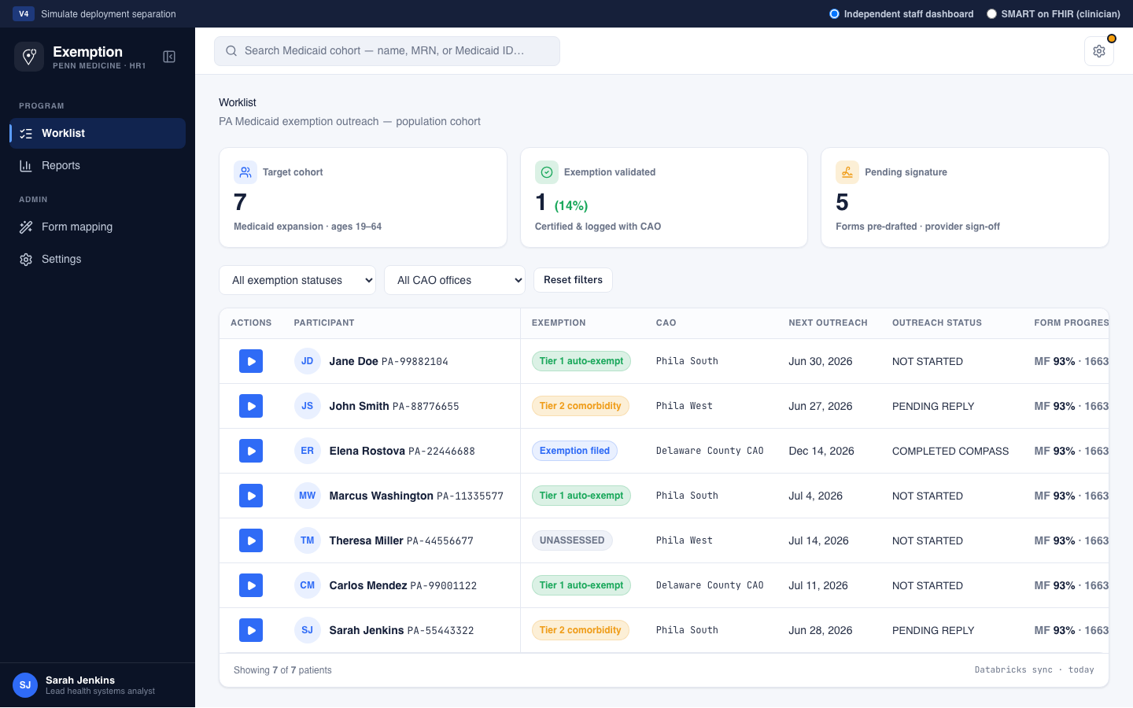
Figure 1 — Engage staff worklist with metric cards and play-button actions

Key Features
- Target metrics: cohort size, exemptions validated (%), forms pending provider signature.
- Worklist: exemption tier badges, CAO, next outreach date, form completion progress.
- Play button: opens 3-panel drawer without blocking the worklist; click another row to swap patients.

2.2 Patient Outreach Drawer (3-panel)
Center column follows Engage outreach pattern: outreach type (Inbound call, Outbound call, MPM), optional Call now for outbound calls, reached patient Yes/No, call notes, then exemption form fill when patient is reached.
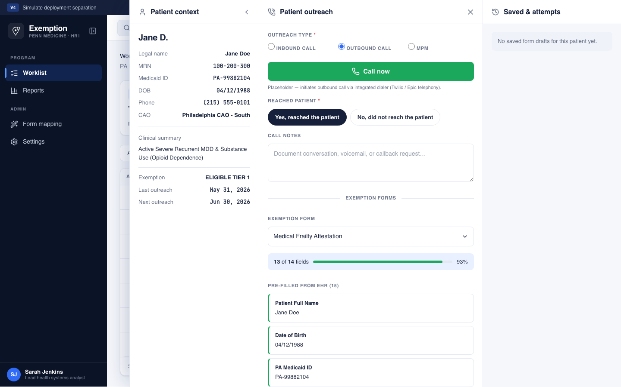
Figure 2 — Outreach drawer: form dropdown with pre-filled vs remaining fields
- Reached = Yes: select Medical Frailty or PA 1663; view EHR pre-fill vs fields still needed; save partial draft or download for print.
- Reached = No: log attempt, set next outreach date, close drawer.
- Right panel: saved form drafts and prior outreach attempts per patient.

2.3 Form Mapping Wizard
Admin wizard (form-mapping-wizard.html) maps official PDF AcroForm fields to EHR data with version history.
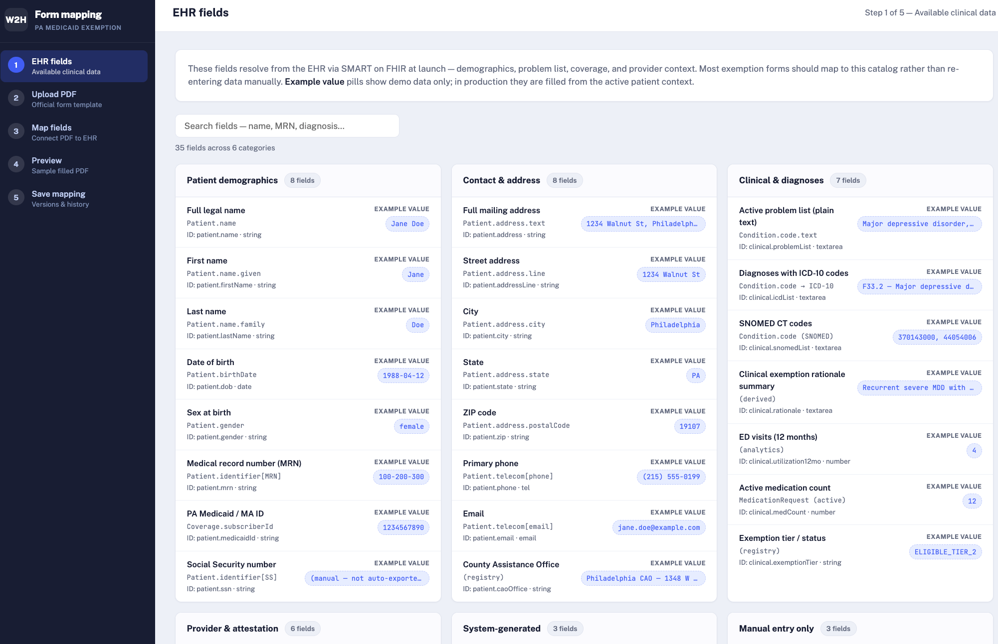
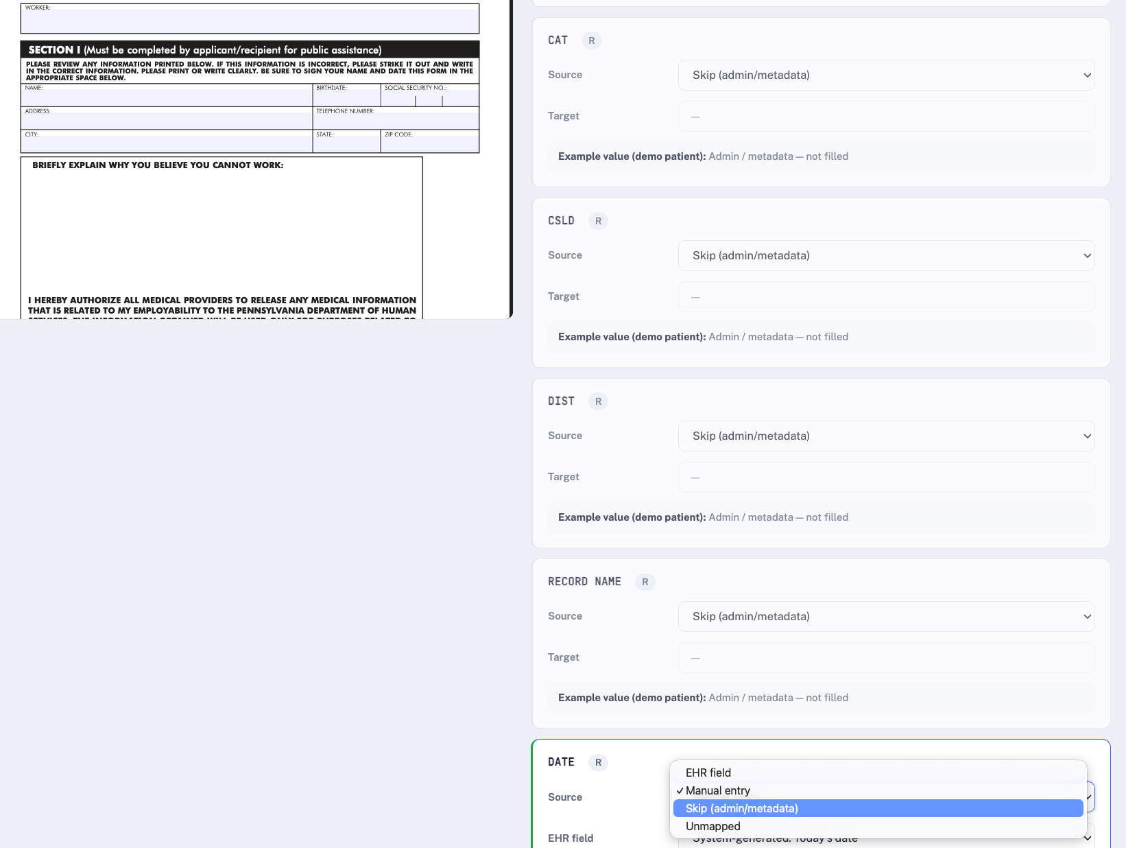
Figure 3 — Form mapping: PDF preview and field mapping
- Step 1: browse EHR field catalog (example values labeled, not live patient data).
- Steps 2–5: upload PDF, map fields side-by-side, preview sample fill, save mapping versions.

2.4 API Configuration
The settings panel allows optional Gemini API key configuration. When configured, the CHW Outreach Planner uses Google gemini-3-flash-preview for personalized scripts; otherwise a high-fidelity local simulator generates barrier-aware copy.
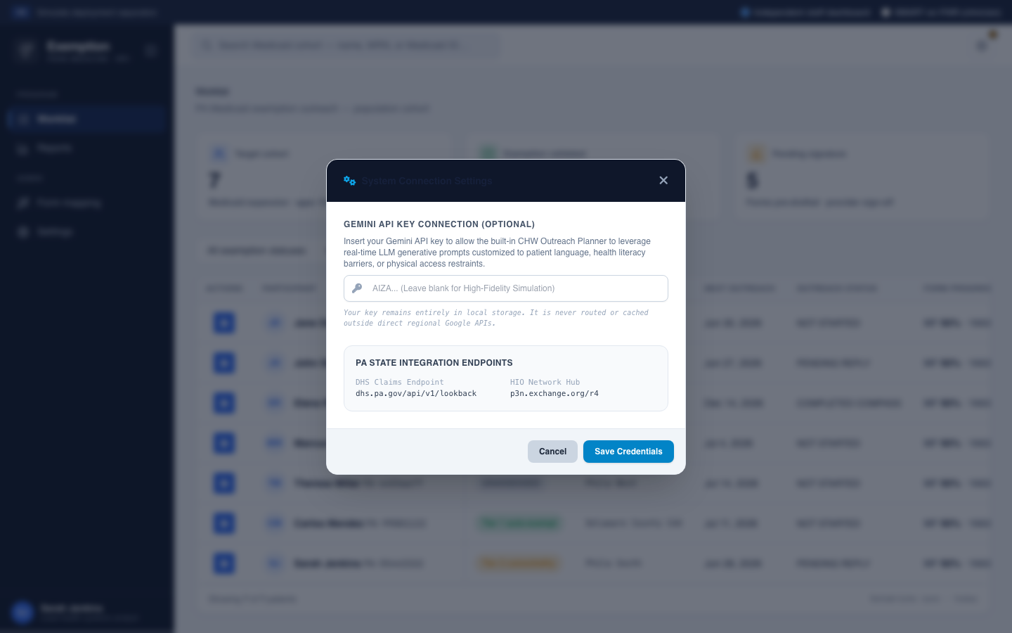
Figure 4 — API configuration modal for Gemini outreach assistant

2.5 SMART on FHIR Point-of-Care App
Selecting SMART on FHIR mode strips global staff controls and renders a sandboxed clinician app inside a simulated Epic sidebar layout. The Form Package tab previews both questionnaires with EHR pre-fill.
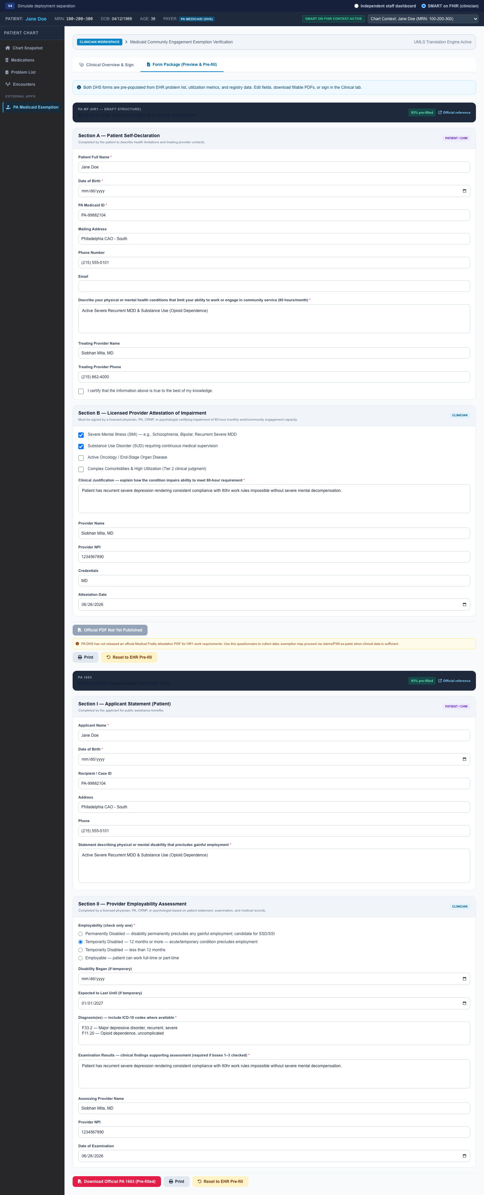
Figure 5 — FHIR Form Package tab: both DHS questionnaires pre-filled from clinical data
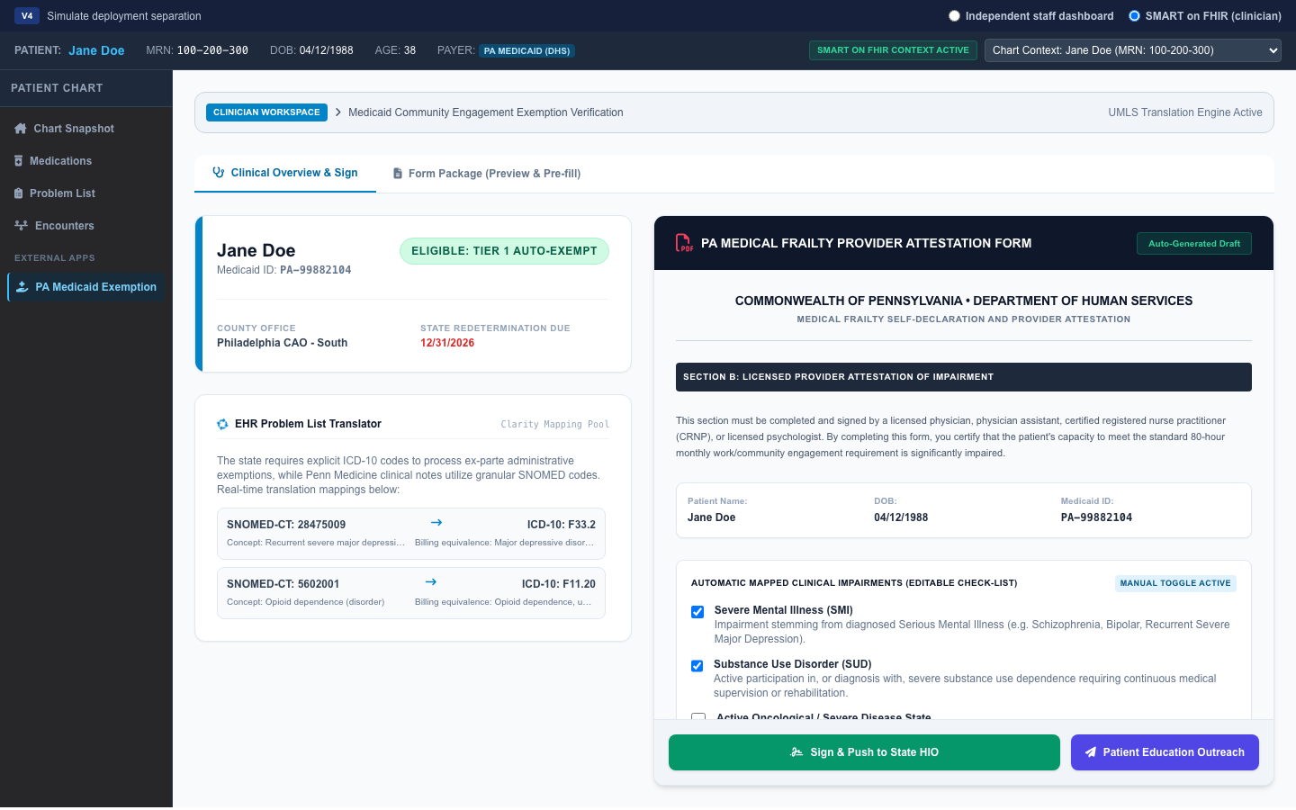
Figure 6 — Clinical Overview: Jane Doe, Tier 1 with SNOMED-to-ICD translation
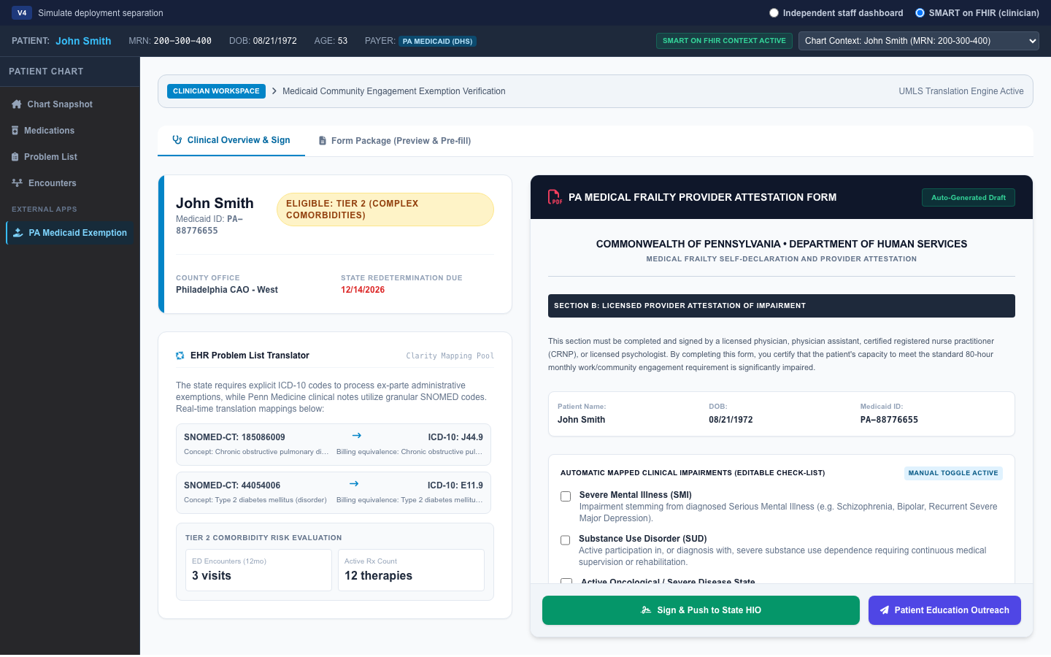
Figure 7 — Clinical Overview: John Smith, Tier 2 complex comorbidities

Key Features
- Epic Context Banner: Inherits MRN, DOB, payer via SMART on FHIR launch parameters.
- EHR Problem List Translator: Displays UMLS SNOMED-to-ICD-10 mapping with clinical transparency.
- Editable PA Medical Frailty Attestation: Interactive checkboxes, editable justification, signature canvas.
- One-Click HIO Integration: Signed certificate routes to Pennsylvania P3N health information exchange.

2.6 Clinician Signature & State Sync
Providers draw signatures on the HTML5 canvas pad. Submitting marks the patient EXEMPT_COMPLETED, embeds signature in official PDF export, and syncs status back to the staff dashboard.
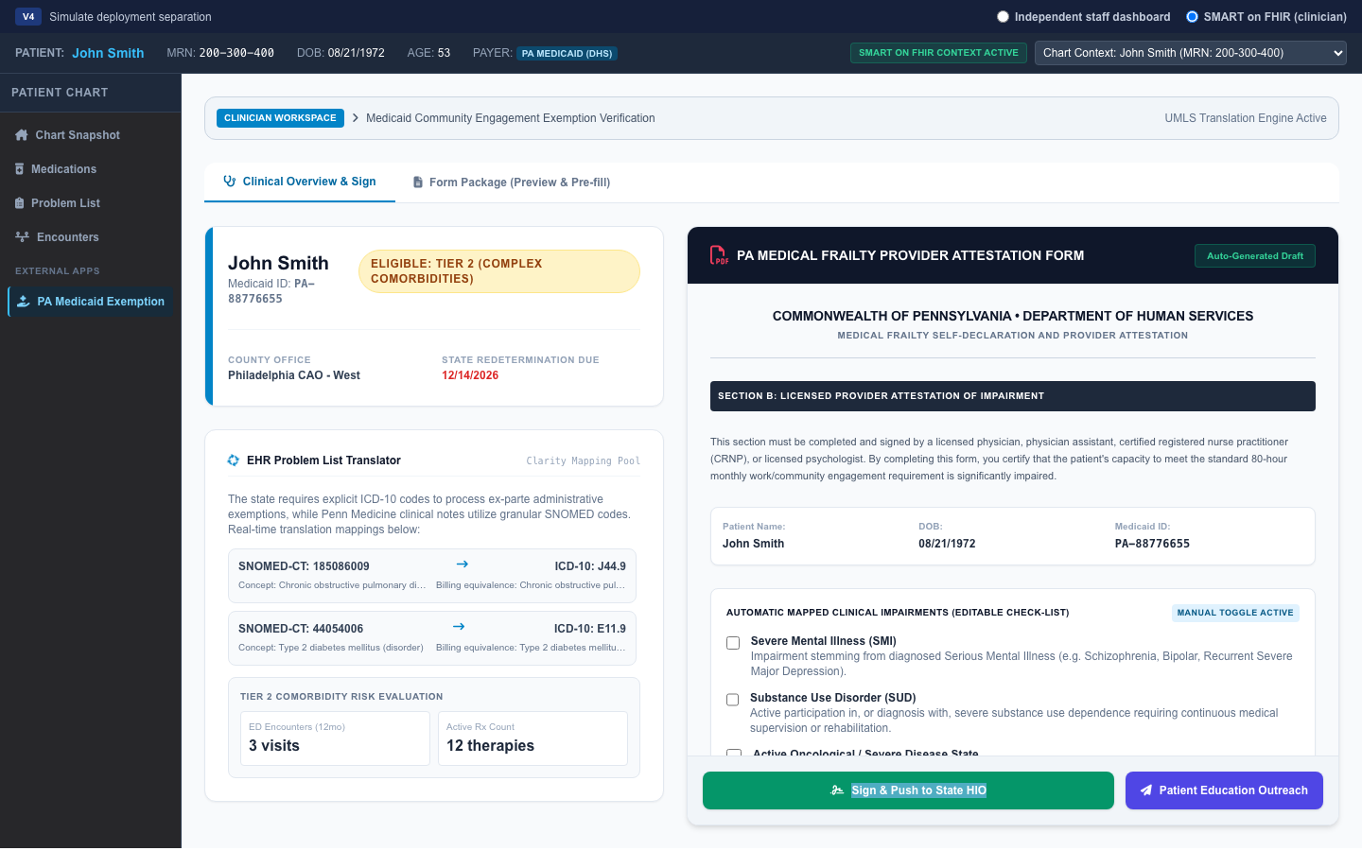
Figure 8 — Provider digital signature applied on attestation form
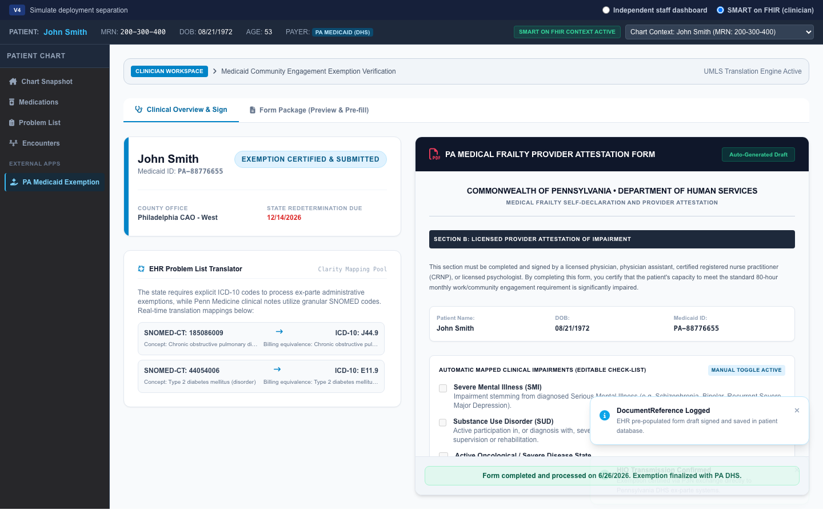
Figure 9 — Completed exemption: form locked, status badge updated
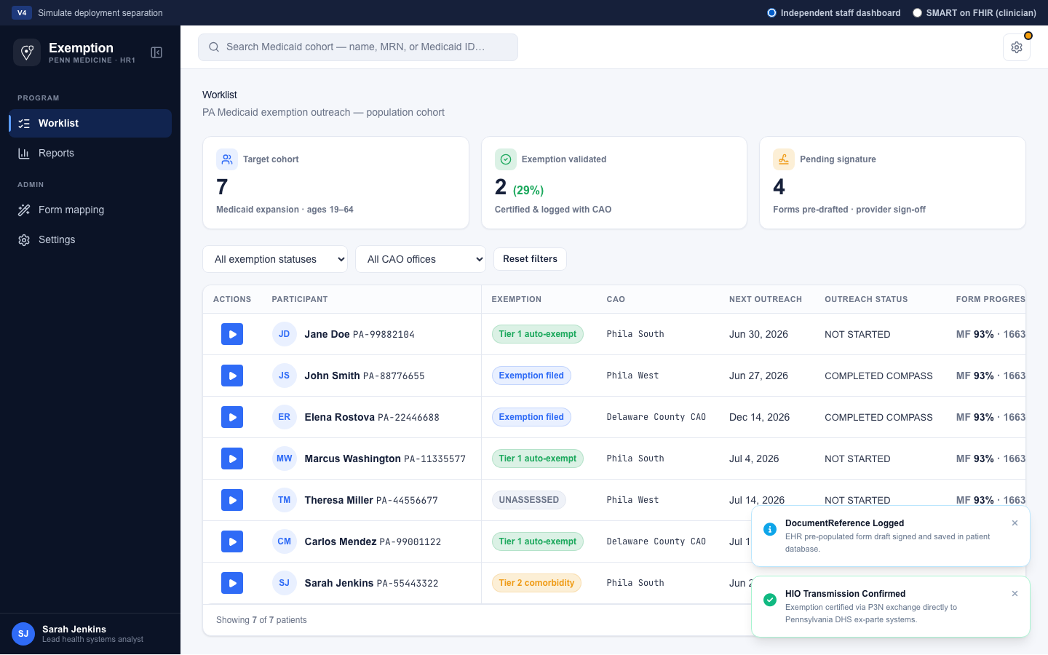
Figure 10 — Staff dashboard after clinical sign-off

2.8 Operational Interaction Checklist
- Staff mode: click play on a worklist row — select outreach type — Call now (outbound) — mark reached — fill exemption form — save or download.
- Staff mode: if not reached — log attempt and set next outreach date.
- Admin: Form Mapping Wizard — upload official PDF, map EHR fields, save version.
- FHIR mode: Form Package tab — review forms — Clinical tab — sign and push.
- Return to Staff Dashboard after signing — exemption metrics update.

Part 3 — Technical Appendix

3.1 Official Forms Policy
Form | Official PDF | Prototype behavior
PA 1663 Employability Assessment | Yes — DHS official (38 AcroForm fields) | Bundled template; export pre-fills official PDF only
Medical Frailty Attestation | Not published by PA DHS (HR1, June 2026) | HTML questionnaire; claims/P3N ex-parte primary path

The prototype never generates synthetic PDFs mimicking DHS forms. When DHS publishes the Medical Frailty PDF: add to assets/, update forms-manifest.json, add field map, re-scan on Form Mapping page.

3.2 Core Forms Required

PA Medical Frailty Self-Declaration & Provider Attestation
- Section A (Patient): Self-declared limitations and treating provider contact information.
- Section B (Provider): Licensed clinician certifies physical, mental, or SUD impairment of 80-hour monthly capacity.

PA 1663 (Employability Assessment Form)
Alternative pathway when patient qualifies for broader state cash or medical assistance exemptions. Requires Permanently Disabled or Temporarily Disabled (12+ months) in Section II.

3.3 Clinical Code Mapping & Tier Logic
Pipeline: EHR Problem List (SNOMED-CT) → UMLS Translation Engine → ICD-10 Equivalence Map → DHS Exemption Engine

Tier 1 — Slam-Dunk Auto-Exemptions
Category | ICD-10 | SNOMED-CT
Serious Mental Illness (SMI) | F20.9, F31.9, F33.2 | 58214004, 13746004, 28475009
Substance Use Disorders (SUD) | F11.20, F10.20 | 5602001, 28743005
Active Oncology | C50.919, C18.9 | 254837009, 126852002
End-Stage Organ Disease | N18.6, I50.9 | 432241000124101, 85232005

Tier 2 — Complex Comorbidities
- Comorbidity threshold: ≥2 complex chronic diseases (e.g., severe COPD J44.9 + insulin-dependent diabetes E11.9).
- Utilization proxy: ≥2 ED visits or ≥1 inpatient admission in trailing 12 months.
- Polypharmacy proxy: ≥10 unique active prescription entries.

3.4 v4 Prototype Component Structure
Read prototype/v4/context.md for full component map. Summary:
- index.html — main shell, patientRegistry, staff Engage UI + FHIR runtime
- js/staff-workflow.js — worklist, 3-panel outreach drawer, Call now placeholder
- form-mapping-wizard.html + js/mapping-wizard.js — admin PDF↔EHR mapping wizard
- js/form-schemas.js, form-engine.js, mapping-storage.js — questionnaires and drafts
- js/pa-1663-field-map.js, pdf-export.js — official PA 1663 fill only
- form-mapping.html — legacy developer gap-analysis page

3.5 Submission Pathways
- Administrative ex-parte (automated): Billing data pushed via P3N/HealthShare Exchange to state.
- Digital upload (PA COMPASS): Signed PDFs routed to MyChart; patient uploads to COMPASS portal.
- Physical/direct: Printed forms faxed to County Assistance Office (CAO).

3.6 Data Models

PatientRegistry
- patient_id, mrn, medicaid_id, demographics, contact info
- exemption_status: UNASSESSED | ELIGIBLE_TIER_1 | ELIGIBLE_TIER_2 | EXEMPT_COMPLETED | NON_EXEMPT
- state_due_date: community engagement compliance deadline

ClinicalExemptionScores
- tier_classification, matched_icd_codes, matched_snomed_codes
- utilization_count_12mo, medication_count, last_evaluated_at

ProviderAttestation
- form_type (PA_MF_ATT_B | PA_1663), form_data_json, signature_blob
- submission_status: PENDING_PATIENT | SUBMITTED_COMPASS | FAXED_TO_CAO | AUTO_EX_PARTE

3.7 API Specifications

FHIR R4 Integration
- GET /Patient/{id} — demographics and insurance
- GET /Condition?patient={id}&clinical-status=active — problem list
- GET /Encounter?patient={id} — utilization for Tier 2
- POST /DocumentReference — write signed PDF to Epic document storage

Custom Backend
- GET /api/v1/registry/worklist — paginated CHW worklist with filters
- POST /api/v1/forms/generate — pre-populate forms from Databricks
- POST /api/v1/forms/sign-and-submit — signature capture, Epic write-back, patient notification

3.8 Role-Based Access Control
Role | Primary Access
System Administrator | Rules engine, SNOMED mappings, integrations, audit logs
Clinician | SMART on FHIR app, eligibility flags, form review, digital signatures
CHW / Case Manager | Population worklist, outreach logging, CAO routing
Compliance / Revenue Integrity | Read-only dashboards, financial impact, submission audits

3.9 Intended Clinical Workflow
- Review patient active problem list in the EHR.
- Identify relevant SNOMED-CT concepts.
- Map concepts to ICD-10 billing codes used by DHS.
- Generate form package and support submission workflow.

