Gtweet

Introduction:
Gtweet is a twitter client library which communicates with twitter servers through v1.1 REST & STREAM APIs. However, it didn't cover all the API calls provided by twitter.
It also contains a javascript application called tweetclientgtk.js which is basically a front-end for libgtweet. It uses GObject Introspection to display widgets.

Tweetclientgtk.js:
A simple Gtk application to show tweets. Lets see how to setup & run this application.

Oauth Setup:
As every webapis, twitter requires Oauth for authentication. Oauth requires an App should be registered in Service Provider's website. In our case, we need to register a new App in Twitter. Twitter will allocate unique ConsumerKey and ConsumerSecret for every registered App. Gtweet is not an App, but a library which requires end users to create an App in twitter and pass ConsumerKey and ConsumerSecret to use. Its a one-time setup and gtweet stores provided ConsumerKey and ConsumerSecret in ~/.libgtweet file for later use.

Providing ConsumerKey and ConsumerSecret:
Gtweet will redirect you to dev.twitter.com and show instructions about howto create an App in twitter. You have to give ApplicationName, ConsumerKey and ConsumerSecret in this step.

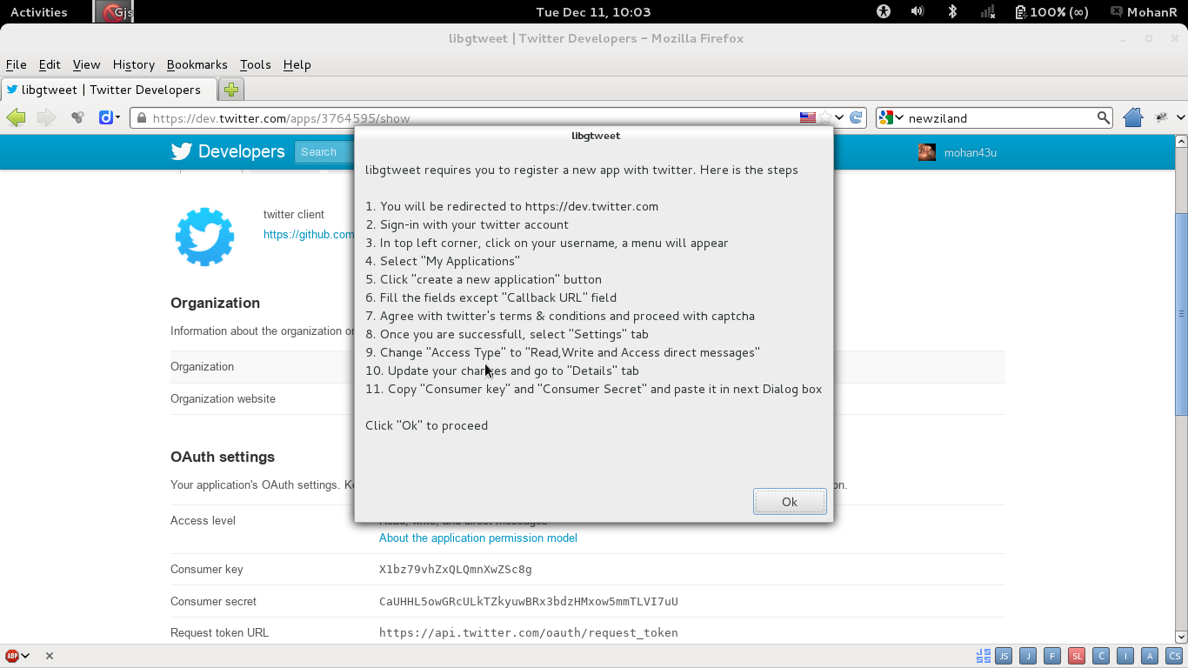

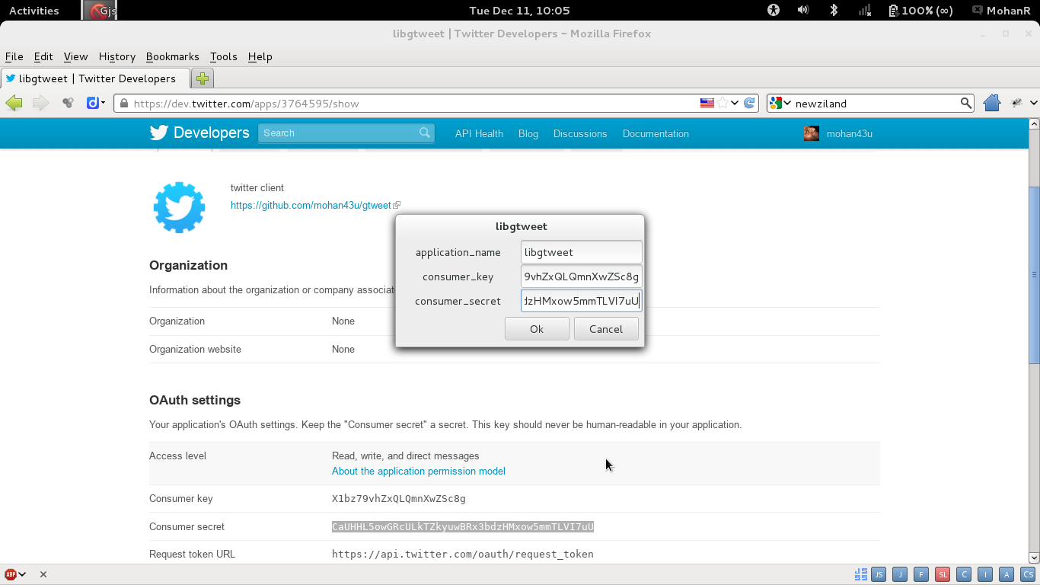

Providing Pin:
Once gtweet receives ConsumerKey and ConsumerSecret, it will redirect you to another page for Authorization. You have to Click 'Authorize App' button to get Pin from Twitter, then you need to provide it to gtweet.

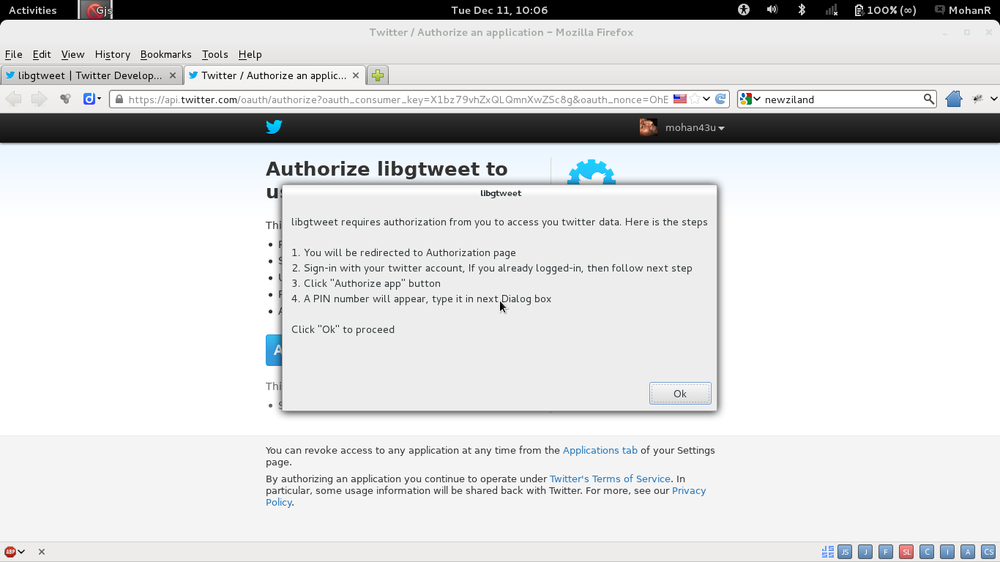

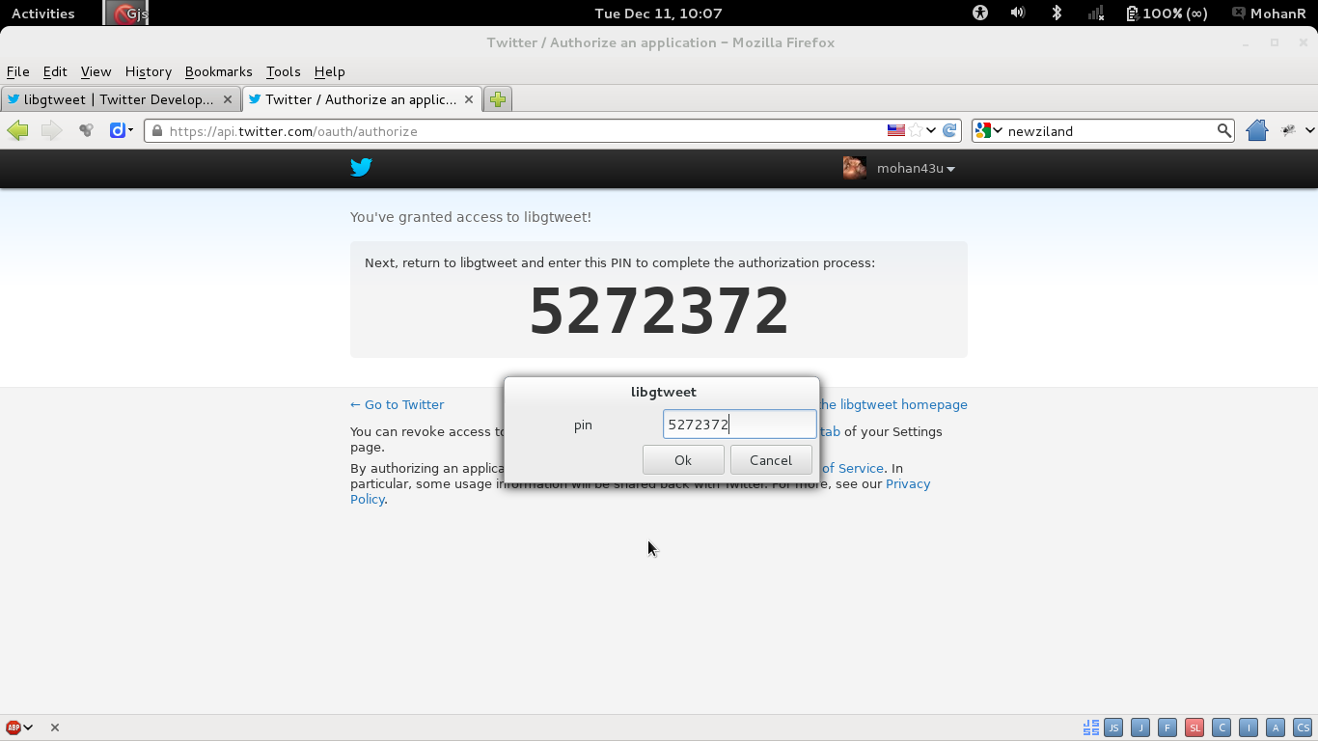

Home Timeline Screen:
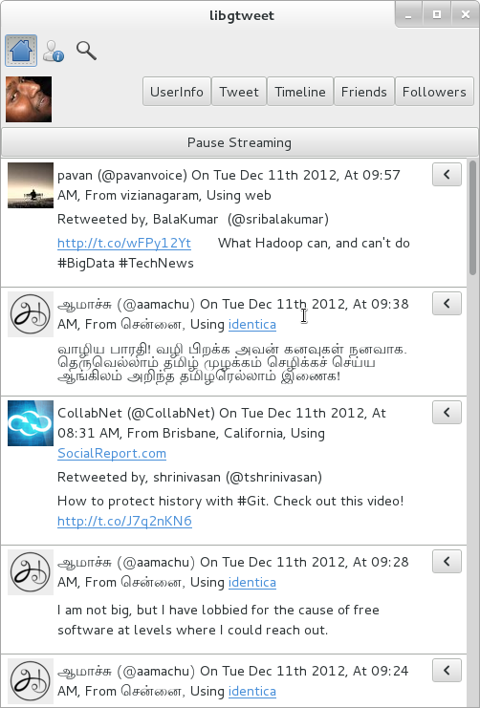

Once the Oauth Setup done, It will show a Window (it may take a few minutes to load). There will be three icons on the top, One is “Home Timeline”, second one is “User Search” and the last is “Tweet Search”.

Below those three Icons, Your Image will apper with following Buttons,
- UserInfo: will show your information.
- Tweet: Will show a text box to post tweets.
- Timeline: will show only your Timeline in “User Search” screen.
- Friends: will show your Friends list in “User Search” screen.
- Followers: will show your Followers list in “User Search” screen.
- Below, You will see yours and your friends tweets. “Pause Streaming” toggle button will pause real-time update.
Each tweets have its own buttons once your click the < arrow button.

User Search Screen:
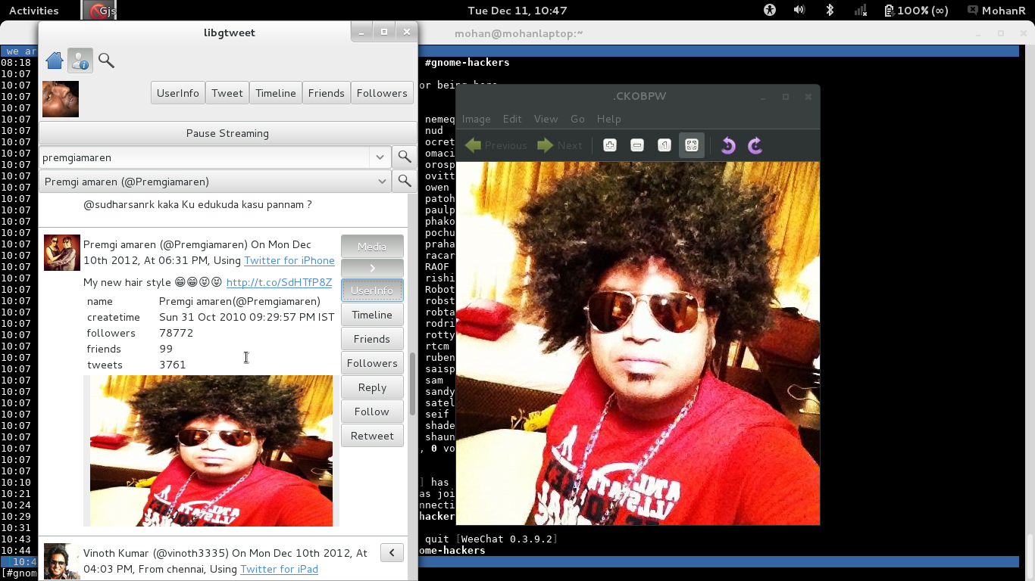
Once you click “User Search” toggle Icon, you will see the below screen
After “Pause Streaming” toggle button, you will see a ComboEntryBox which can take any user name. Once you click the right lens Icon, it will show matching users list in the below ComboBox. You can pick the right person from the list and then go for his timeline by clicking another right lens Icon.
In this above Example, I search “premgiamaren”, you can see his Twitter Handle appeared in below comboBox and his TimeLine.

Tweet Search Screen:
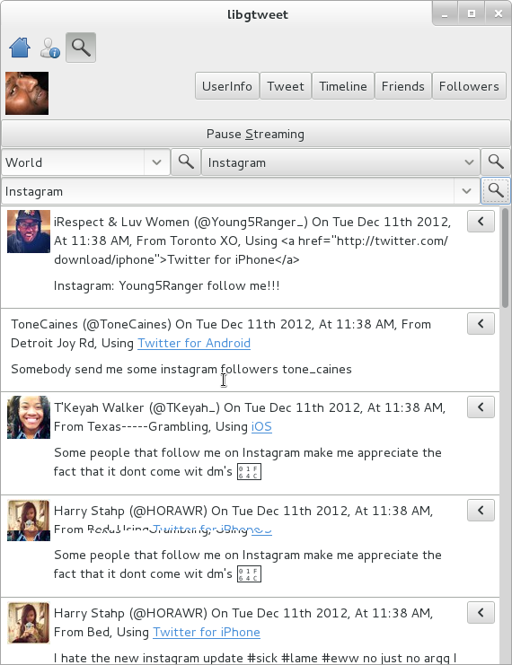

“Tweet Search” Icon will show this screen, In the above diagram, ComboEntryBox which contains “World” represents Trend Country. By clicking lens Icon, top 10 trends will appear in the next ComboBox.
By selecting one of the trending topics and clicking lens Icon next to it, it will appear in the bottom ComboEntryBox, clicking lens Icon will produce realtime tweets curresponding to that trend.
You can also provide whatever you want to search in the last ComboEntryBox and clicking the next lens Icon will produce tweets. Irrespective of whether it is trending or not. You can search for multiple words by seperating them using “,” (example: linux,unix,ubuntu,fedora,debian).

