REACT COMPONENTS (CARD AND BUTTON)

NAME : KAKI MOHAN MURALI
EMAIL : murali6069@gmail.com
PHONE NO : 9492010067
ROLL NO : 20T91A0535 (CSE)
COLLEGE NAME : GIET Engineering College

CARD COMPONENT:

SOURCE CODE:

CardComponent.jsx :

import React from 'react'

export default function Home({img, title, description}) {
return (
<div className='shadow-xl border-blue-500/30 border-2 m-11 rounded w-64 bg-white'>
<div className='h-48 '>
<img src={img} alt="placeholder" />
</div>
<div className='p-4'>
<h1 className='text-black font-bold '>{title}</h1>
<p className='text-black'>{description}</p>
</div>
</div>
)
}

Page.js:

import CardComponent from "@/components/CardComponent";

export default function Home() {
return (
<main className="flex min-h-screen flex-col items-center justify-between p-24">
<CardComponent
img="https://cdn.britannica.com/17/196817-159-9E487F15/vegetables.jpg"
title="Vegetables"
description="Vegetables are parts of plants that are consumed by humans or other animals as food. The original meaning is still commonly used and is applied to plants collectively to refer to all edible plant matter, including the flowers, fruits, stems, leaves, roots, and seeds."
/>
</main>
);
}

Output :
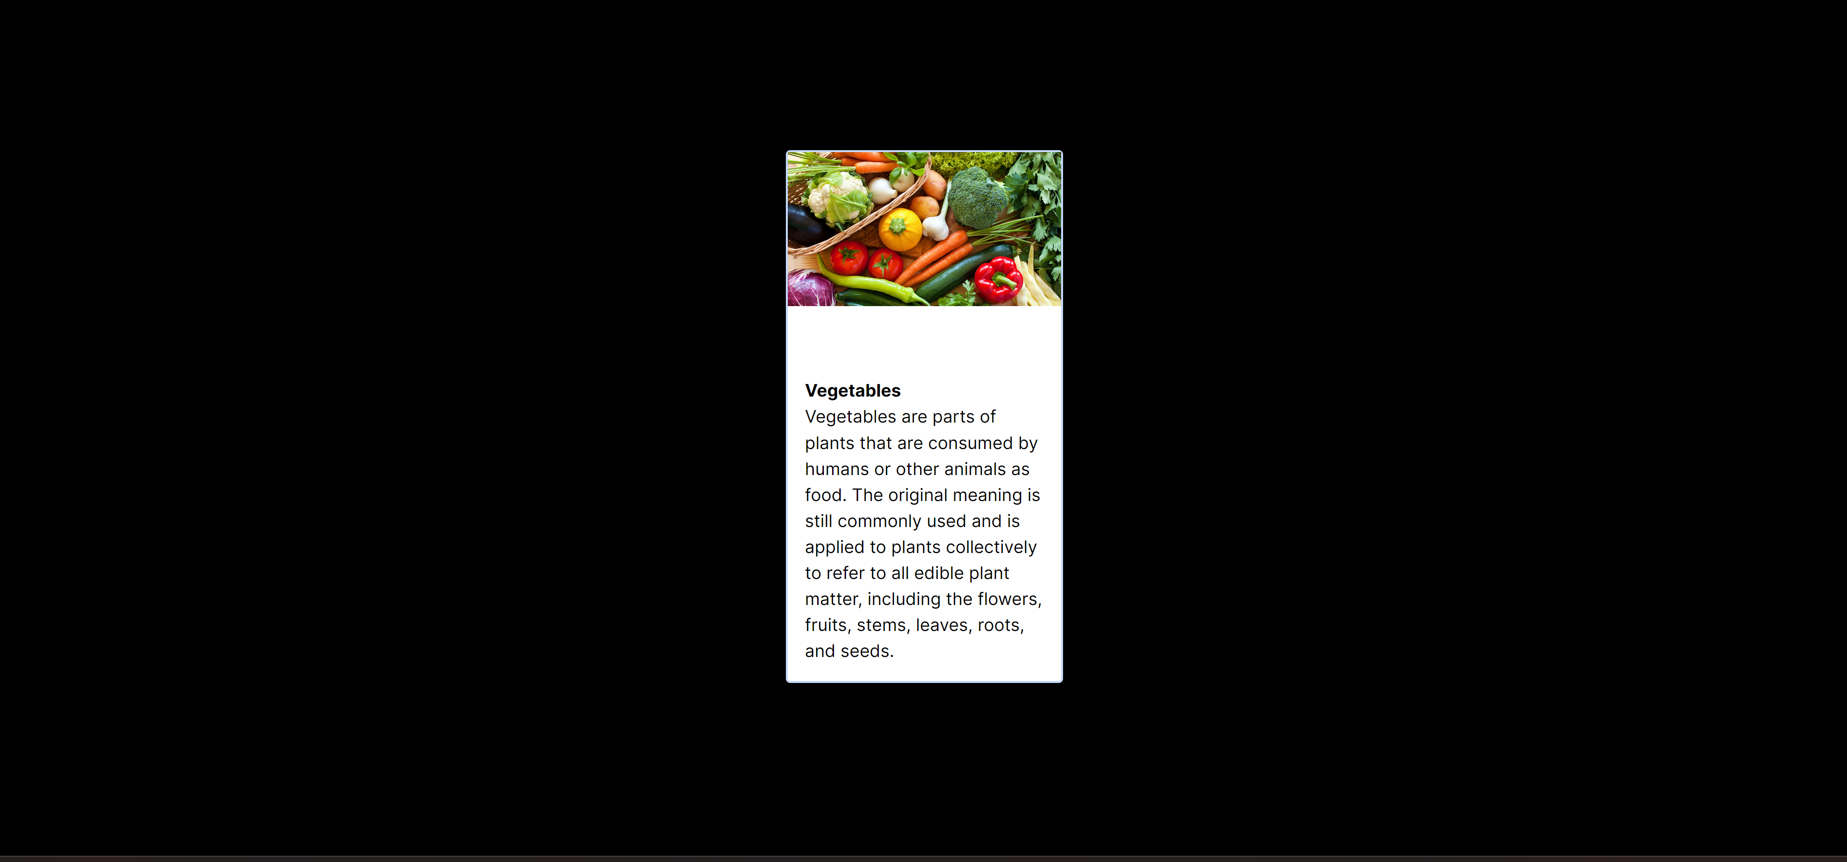
BUTTON COMPONENT:

SOURCE CODE:

Page.js :

import React from 'react'
import Button from './components/Button'

function page() {
return (
<div >
<Button >Hello</Button>
<Button >World</Button>
</div>
);
}

export default page;

Button.jsx:

import React from 'react'

function Button(props) {
const {children} = props
return (
<div>
<button className='text-black border border-white rounded m-5 bg-white '>{children}</button>
</div>
)
}
export default Button

Output:

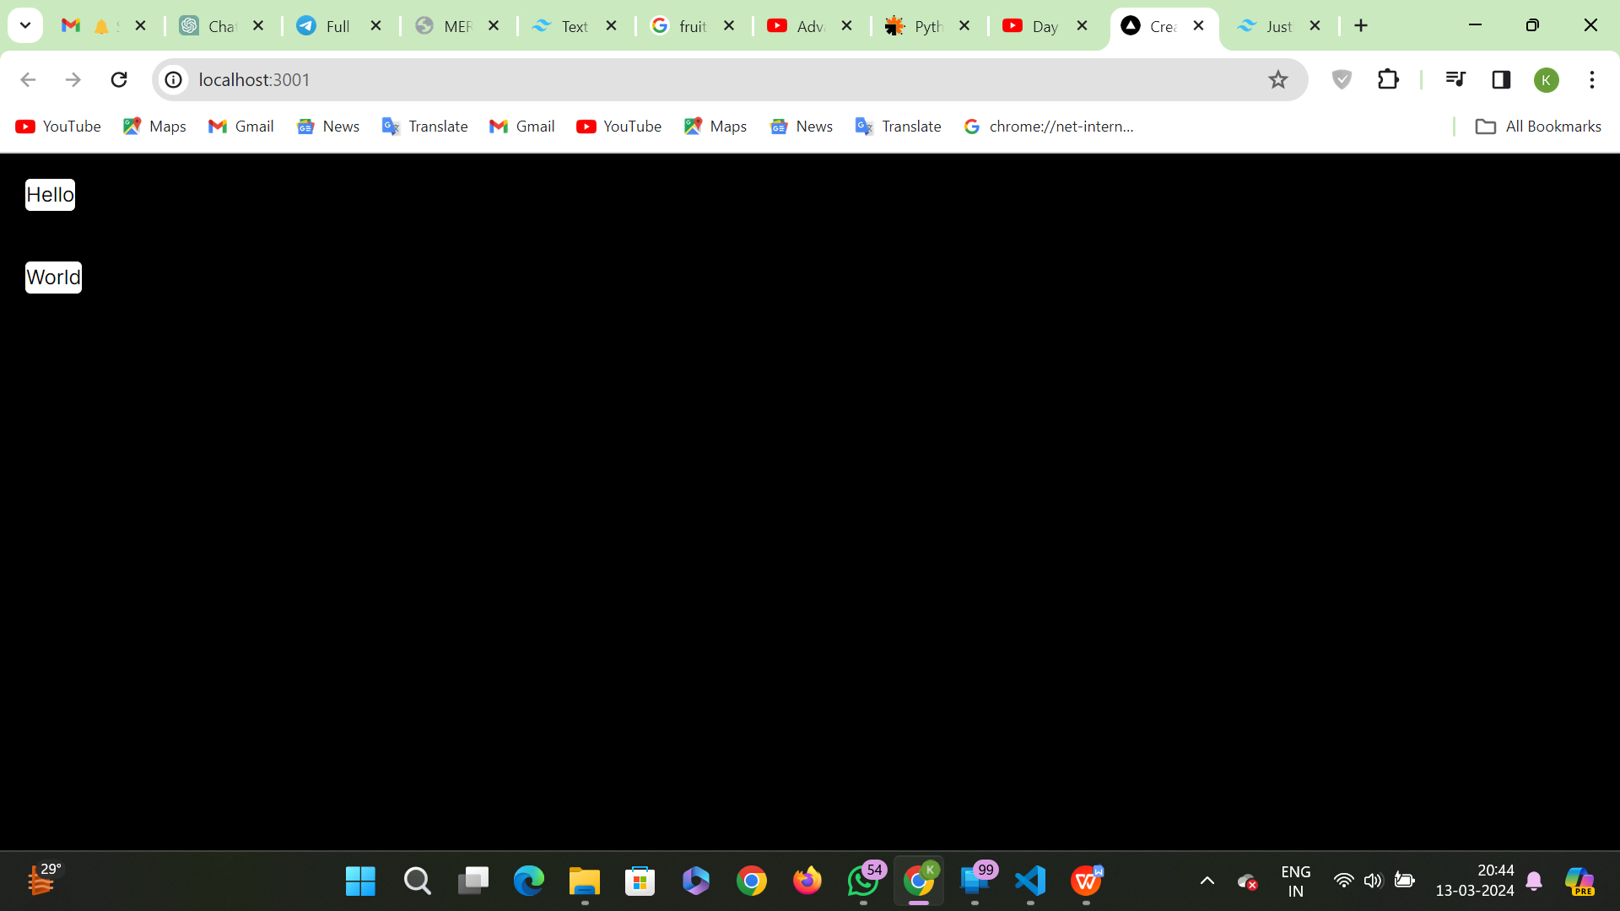

Component Integration:
Page.js:
"use client"
import CardComponent from "./components/CardComponent";
import Button from "./components/Button";
import { useState } from "react";
export default function Home(){
const [label, setlabel] =useState("continue");
const clickme = ()=> {
alert("Hello");
};
return (
<div>
<CardComponent
img="https://cdn.britannica.com/17/196817-159-9E487F15/vegetables.jpg"
title="Vegetables"
description="Vegetables are parts of plants that are consumed by humans or other animals as food. The original meaning is still commonly used and is applied to plants collectively to refer to all edible plant matter, including the flowers, fruits, stems, leaves, roots, and seeds."
/>
</div>
);}
CardComponent.jsx:
import React, { Children } from 'react'

export default function Home({img, title, description}) {
return (
<div className='shadow-xl border-blue-500/30 border-2 m-11 rounded w-64 bg-white'>
<div className='h-48 '>
<img src={img} alt="placeholder" />
</div>
<div className='p-4'>
<h1 className='text-black font-bold '>{title}</h1>
<p className='text-black'>{description}</p>
<button className='text-black border bg-yellow-200 border-black rounded m-3 px-2'> button 1</button><br />
<button className='text-black border bg-yellow-200 border-black rounded m-3 px-2 '> button 2</button>
</div>
</div>
);
}

Output:

