Anna University Regional Campus Coimbatore

Anna University: Chennai-600 025

DEPARTMENT OF ELECTRONICS AND COMMUNICATION ENGINEERING



IBM Naan Mudhalvan Phase 2 Submission

**Title**: **Covid-19 Vaccine Analysis**

Name :MOHANKUMAR D

Register Number: 710021106703

Department :ECE

Sem/year :5th SEM

Covid-19 Vaccine Analysis

**Objective:**

COVID-19 has severely affected almost every aspect of society worldwide. During the uncertainties of this pandemic, COVID-19 vaccines were a new hope. In particular, Covid's monitoring of the information, big data analysis played a major role. What started as the basic use of big data analysis is the core component of worldly initiatives Therefore, based on enlightening experiences of big data application for fighting the pandemic, this research focuses on the ethical objectives to be promoted in vaccine delivery, assessing the potential effect of big data analytics on reaching these goals by enabling people to receive a digital passport or certificate.

**Description of dataset:**

url: https://www.kaggle.com/datasets/gpreda/covid-world-vaccination-progress

This dataset contains 35310 rows and 15 columns which is really informaive to analysis. In this project,an attempt has been made to analyze various information of COVID-19 World Vaccination Progress such as country, total_Vaccinations, people_vaccinated, daily_vaccinations total_vaccinations_per_hundred, people_vaccinated_per_hundred, people_fully_vaccinated_per_hundred, vaccines and many more.

Explanation:

The demand for related information and situational awareness is unusually strong during a significant social crisis, according to the idea of media reliance, and the media are widely regarded to best provide these needs .Because of the rapid growth of data in modern society as a result of the development of multiple information technologies and the widespread use of social media the notion of big data arose to provide new meaning and value to a large amount of data already available .

Flow Chart for the proposed system



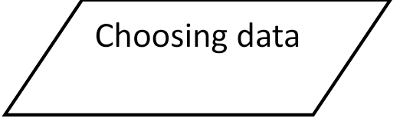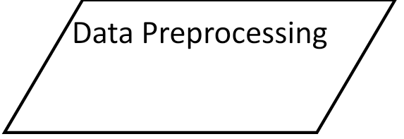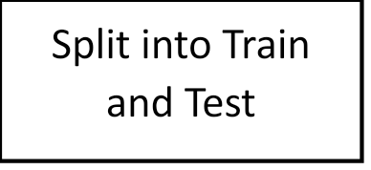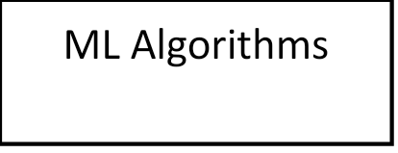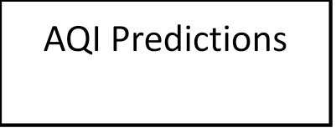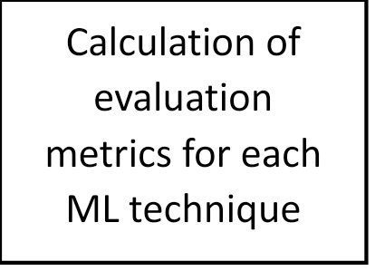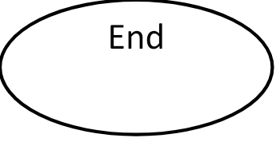

**Conclusion:**

Big data is an effective tool for assisting in the prevention and management of risk in vaccine assignments. Governments should allow full use of big data in an outbreak situation in all areas of prevention and control, and they can use big data analytics to enhance the epidemic prevention process. Data collection systems for the Internet of Things, mobile devices, navigation and search engines, social media, and large-scale gene banks can all be completely developed in terms of knowledge collection.