# PHASE-3

**Object creation and their Fields and Relationships:**

**Student Object:**

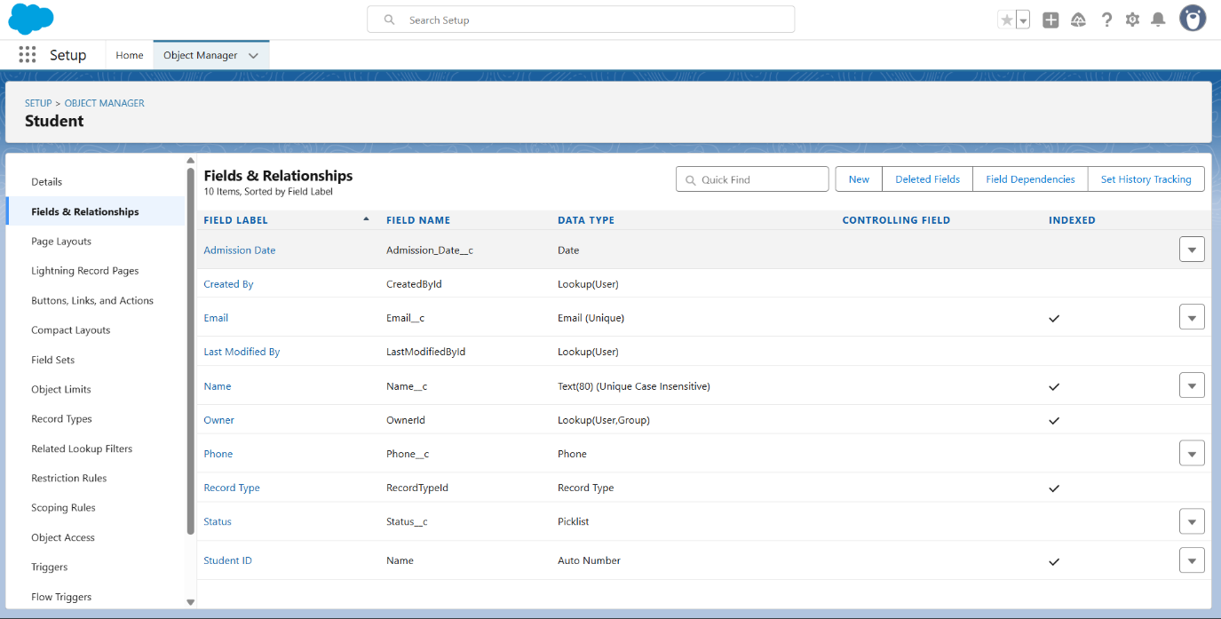

Record Types:

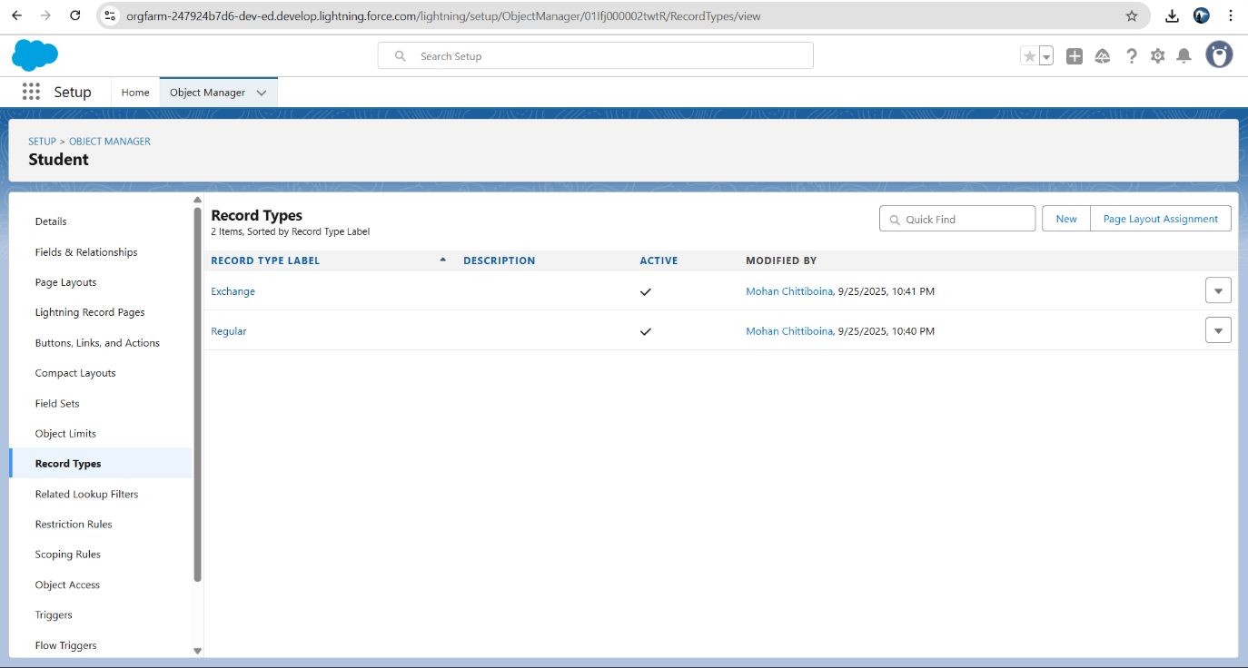

Page Layouts:

Faculty Object:

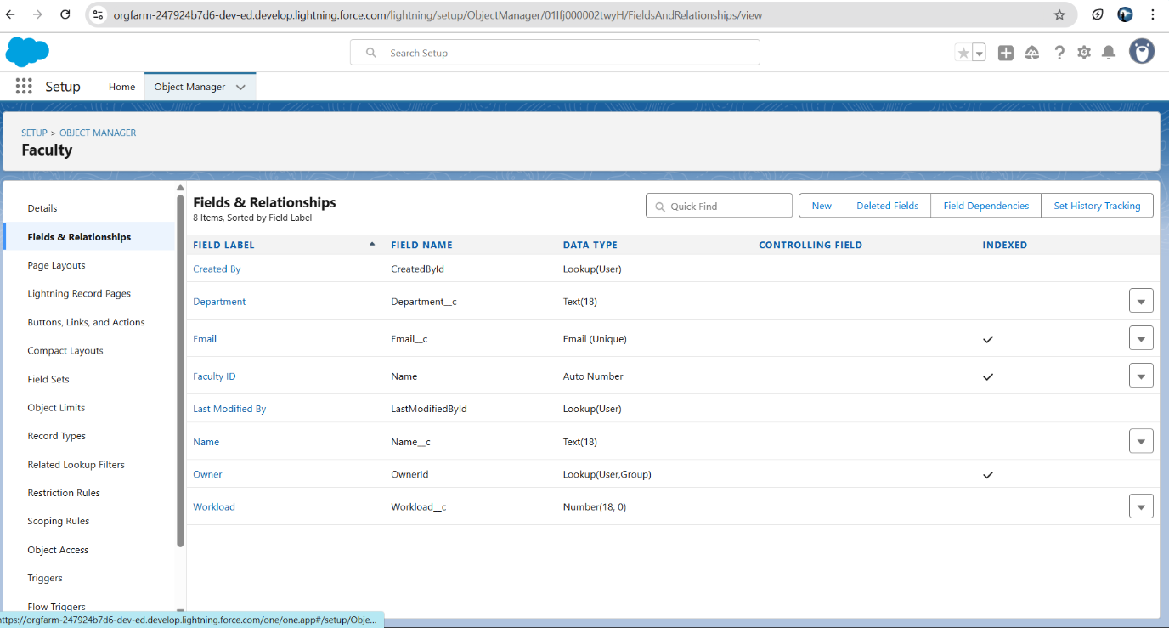

Record types:

Course Object:

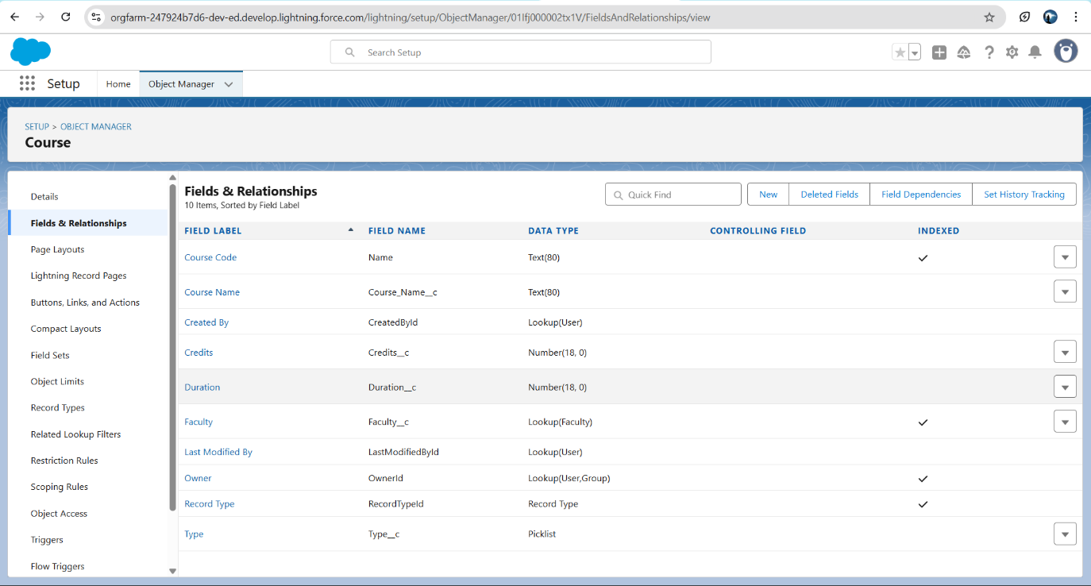

Page layout:

Record type:

Enrollment object:

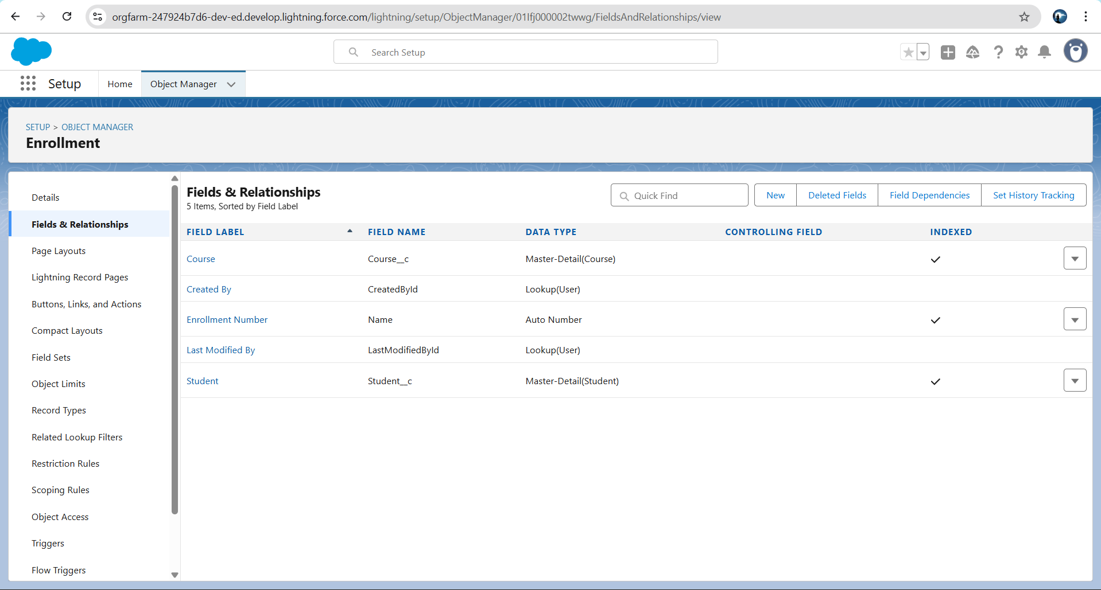

Page layout:

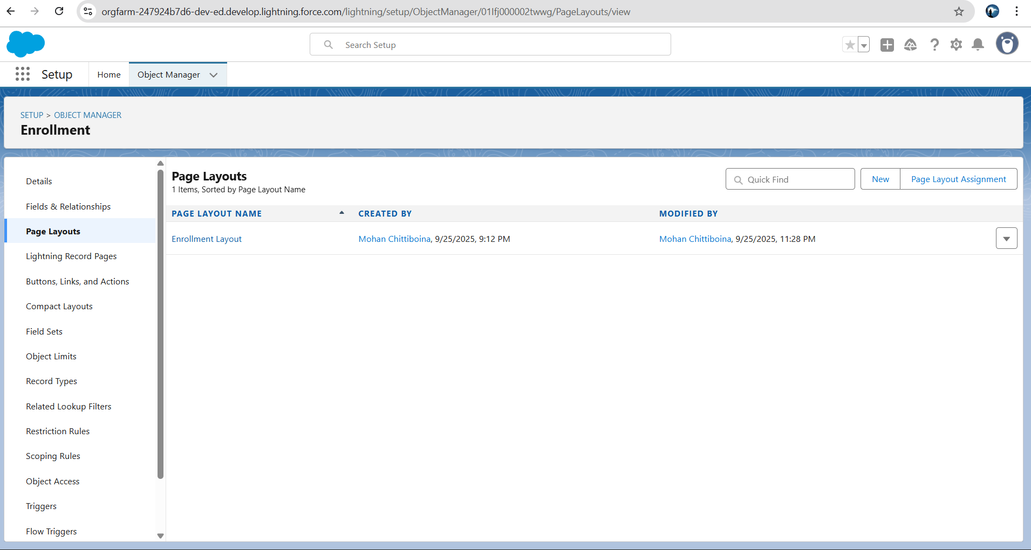

Alumni Object:

Page Layouts:

**Schema Builder used to confirm relationships:**

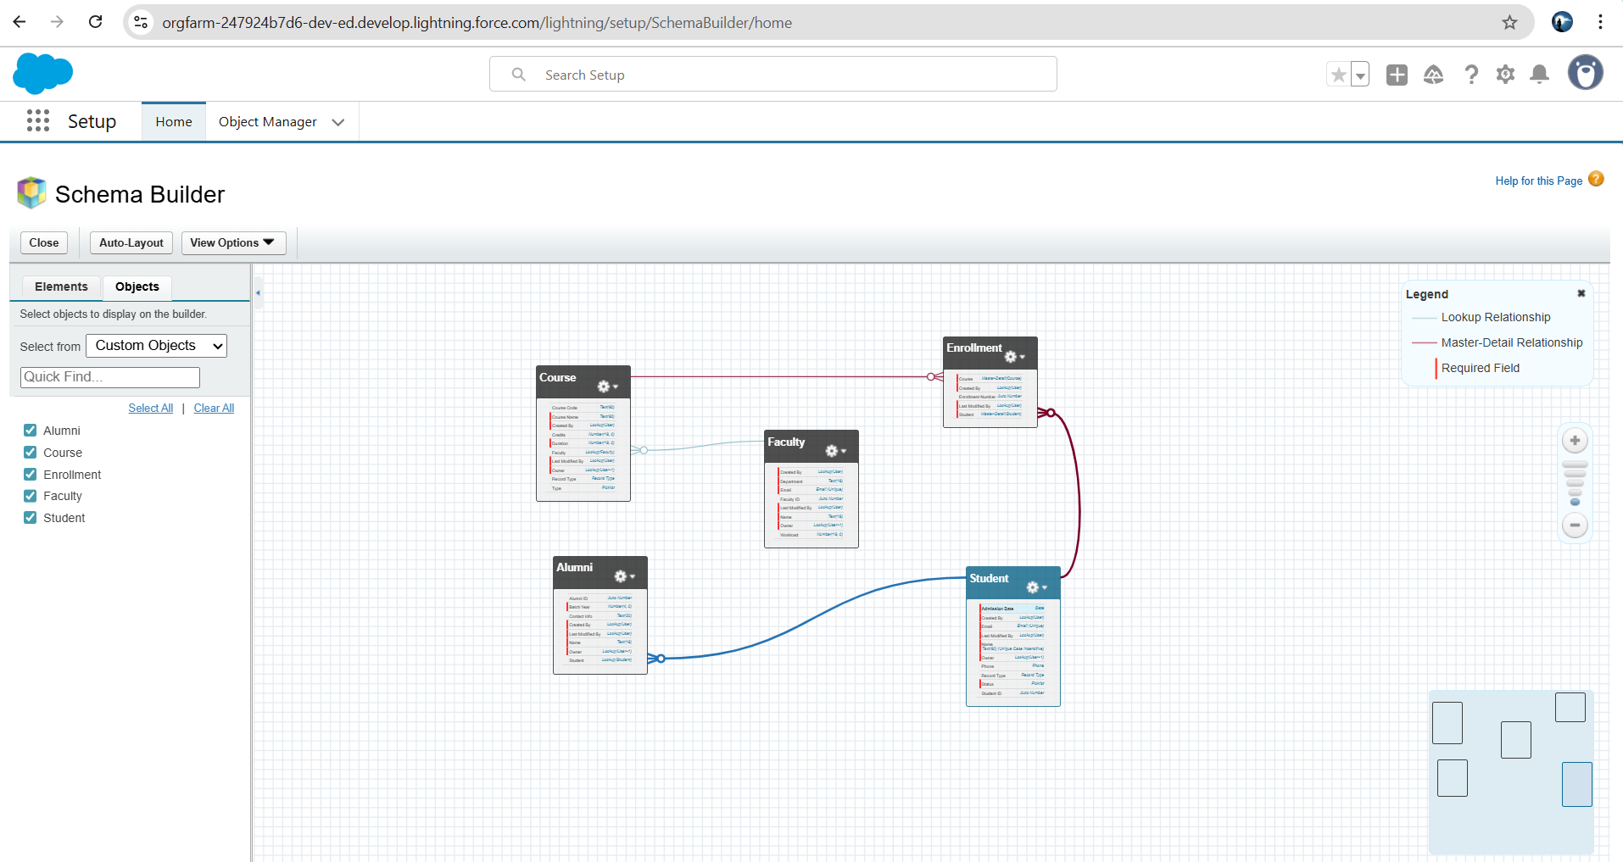

**Phase 3 Complete Checklist:**

* **Objects: Student, Course, Faculty, Alumni, Enrollment**
* **Fields created**
* **Record Types**
* **Page Layouts & Sections**
* **Relationships (Master-Detail & Lookup)**
* **Schema Builder used to confirm relationships**