# PHASE-4

* VALIDATION RULES:  
  Admission Date cannot be future-dated.

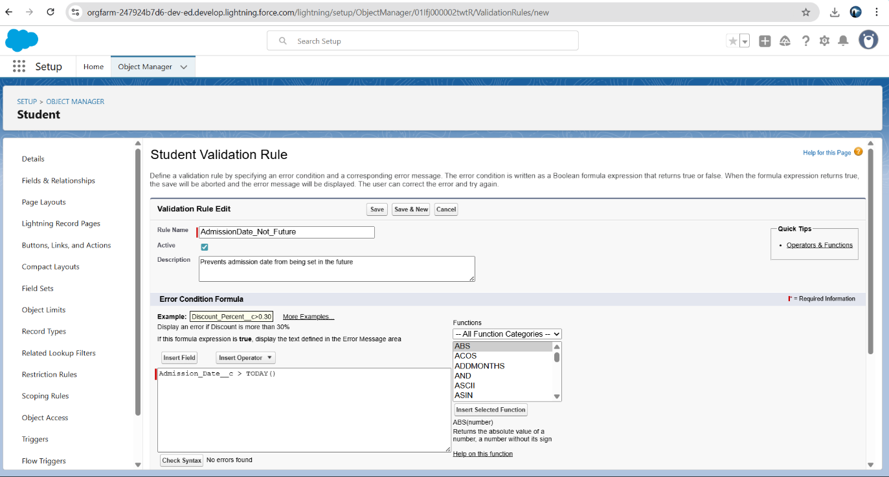

* Credits must be > 0 for courses.

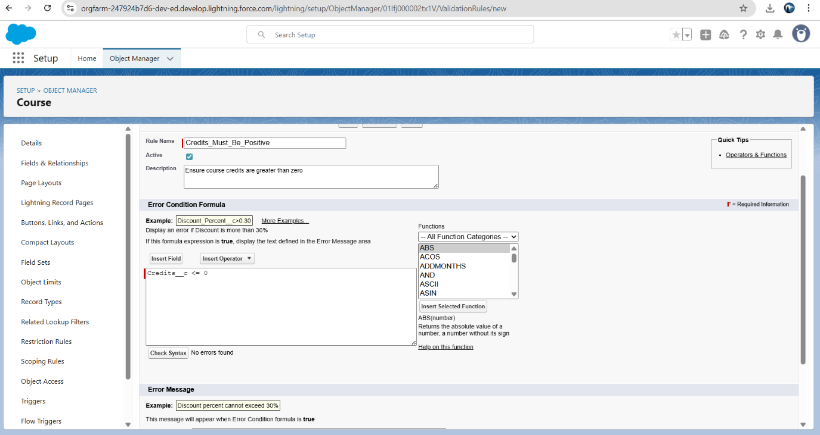

**Approval Process**

If Course Credits > 6 → Approval from FACULTY OR PRINCIPAL.

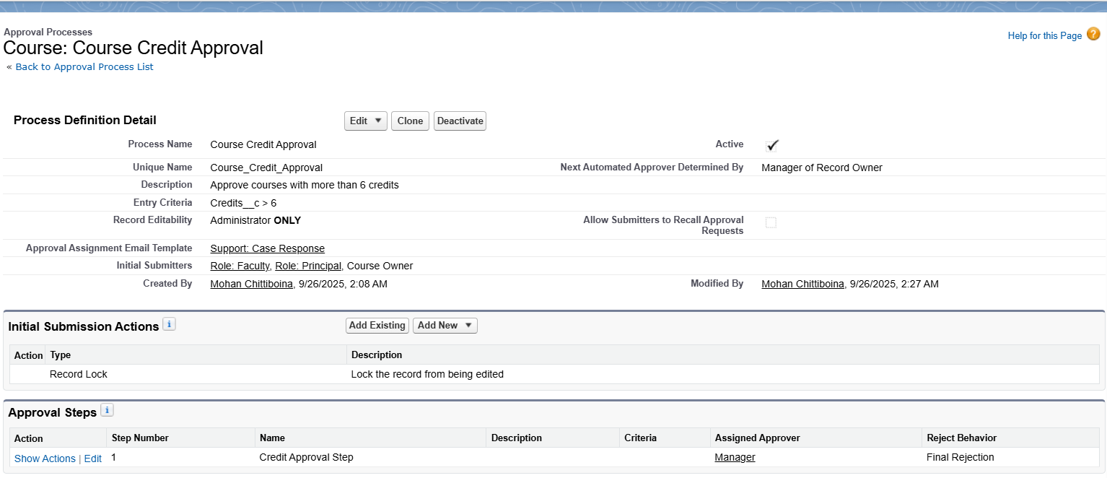

If Student requests withdrawal → Approval from Faculty Advisor.

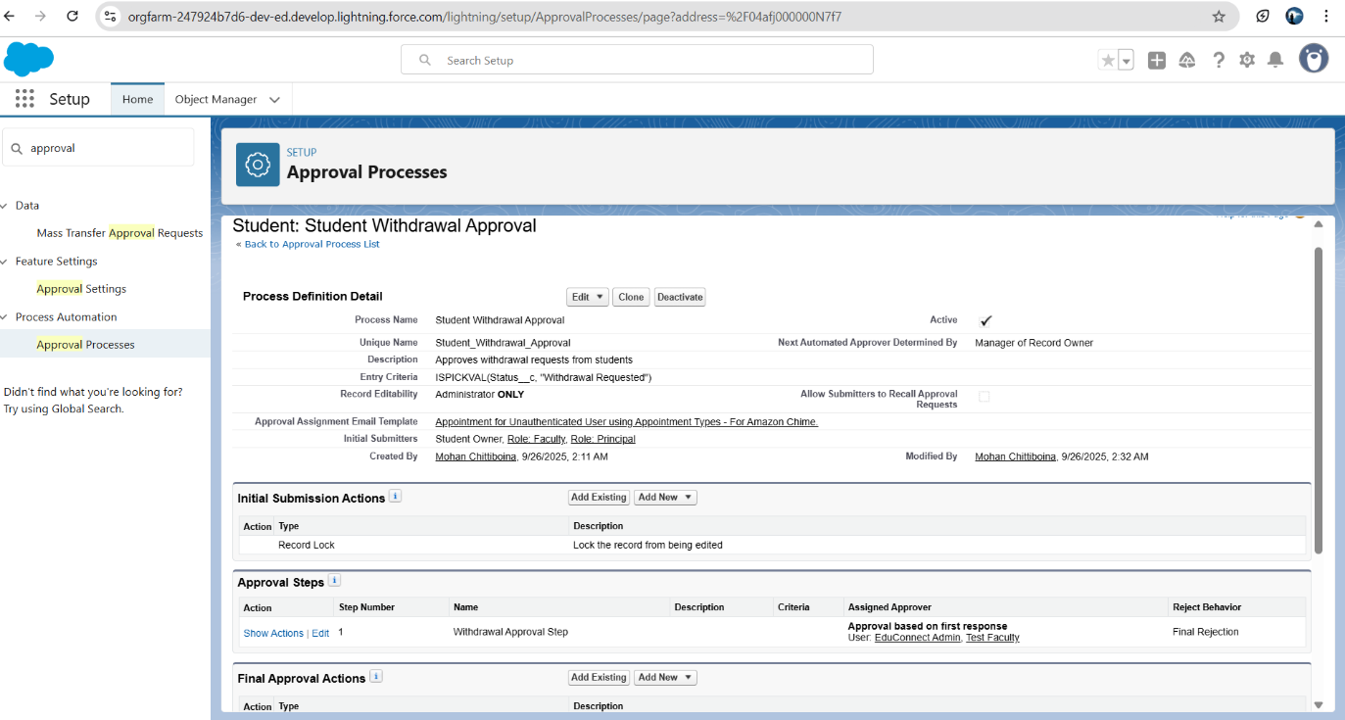

**Flow Builder:**

Notify faculty- when new students register

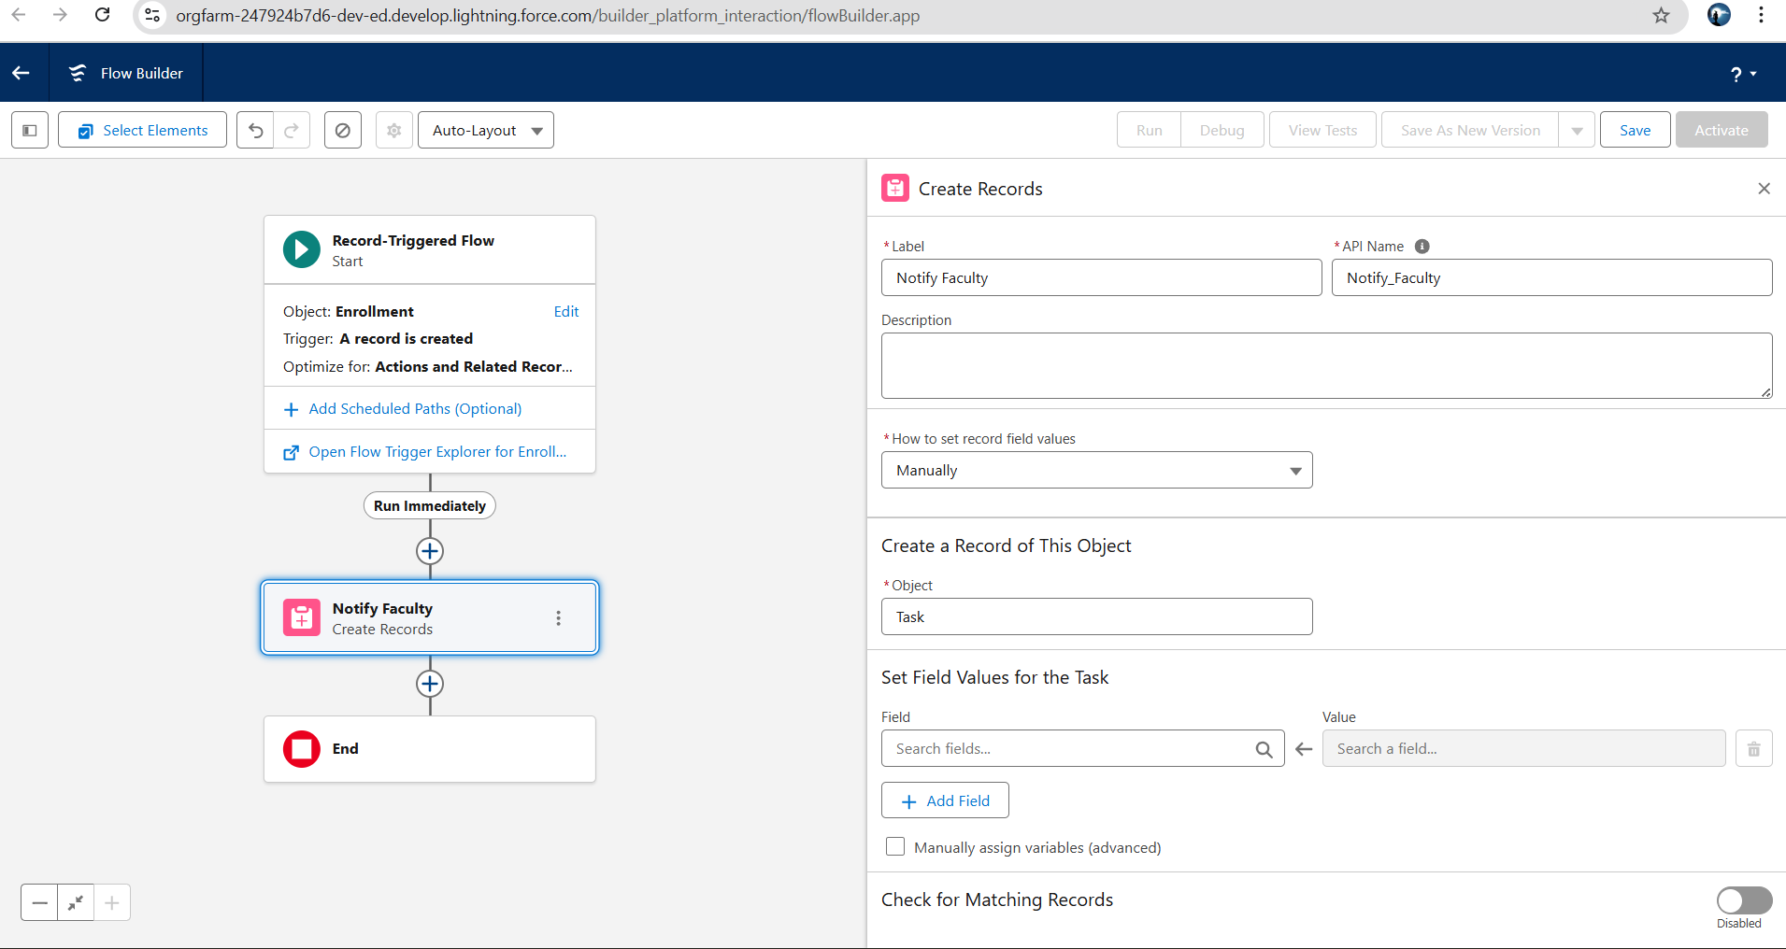  
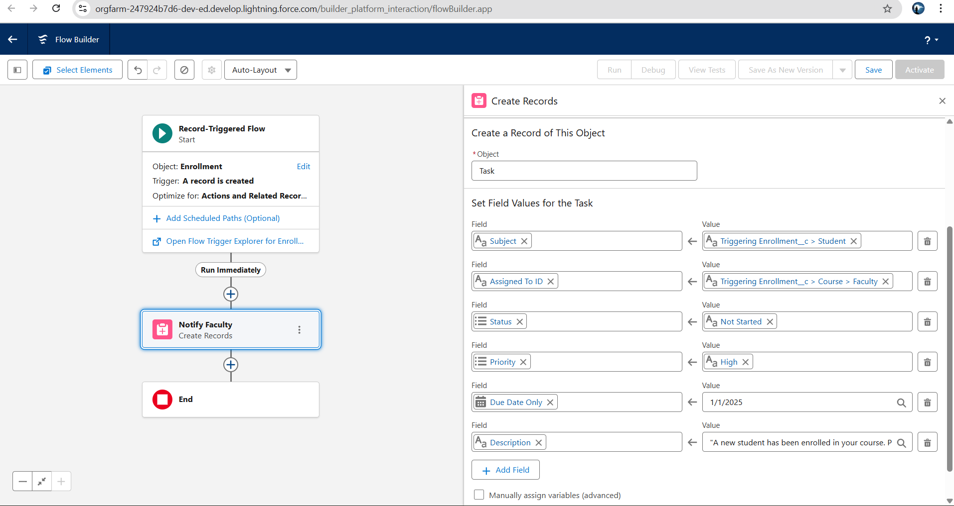

Auto-launched Flow → When Alumni record created → Send welcome email.

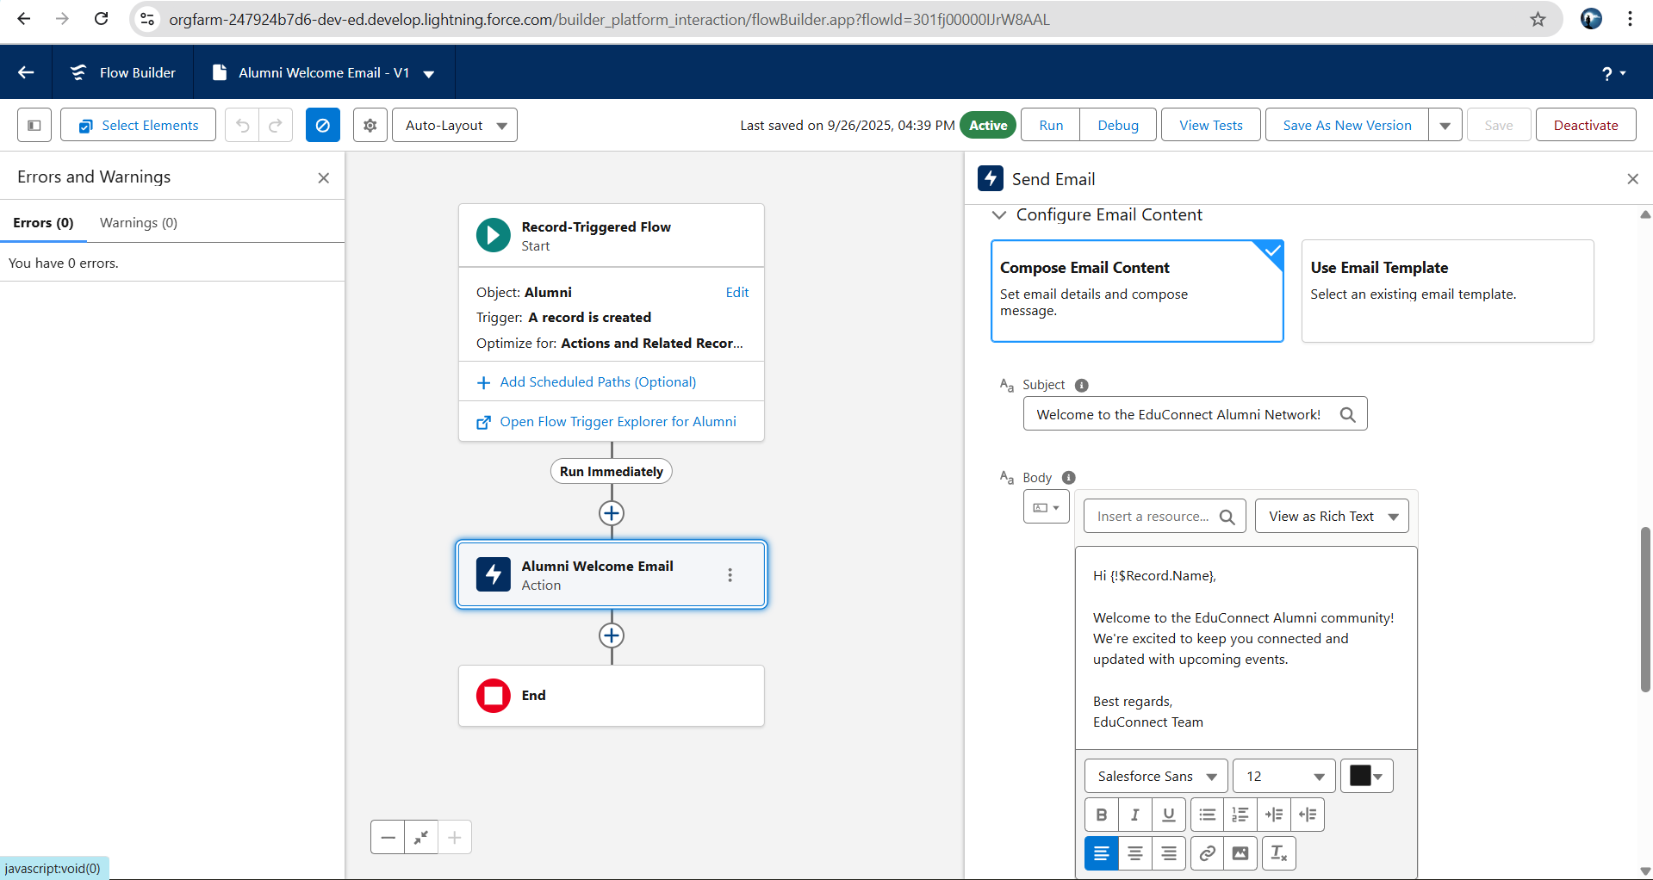

Email Alerts:

Email template:

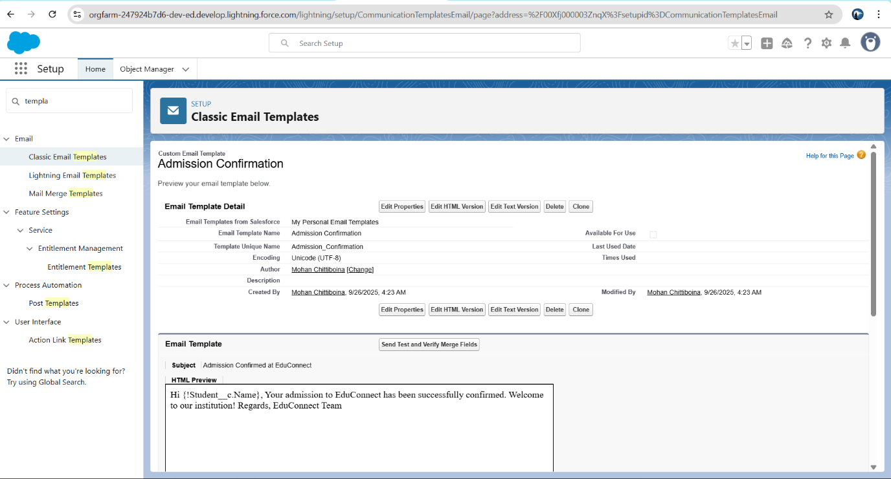

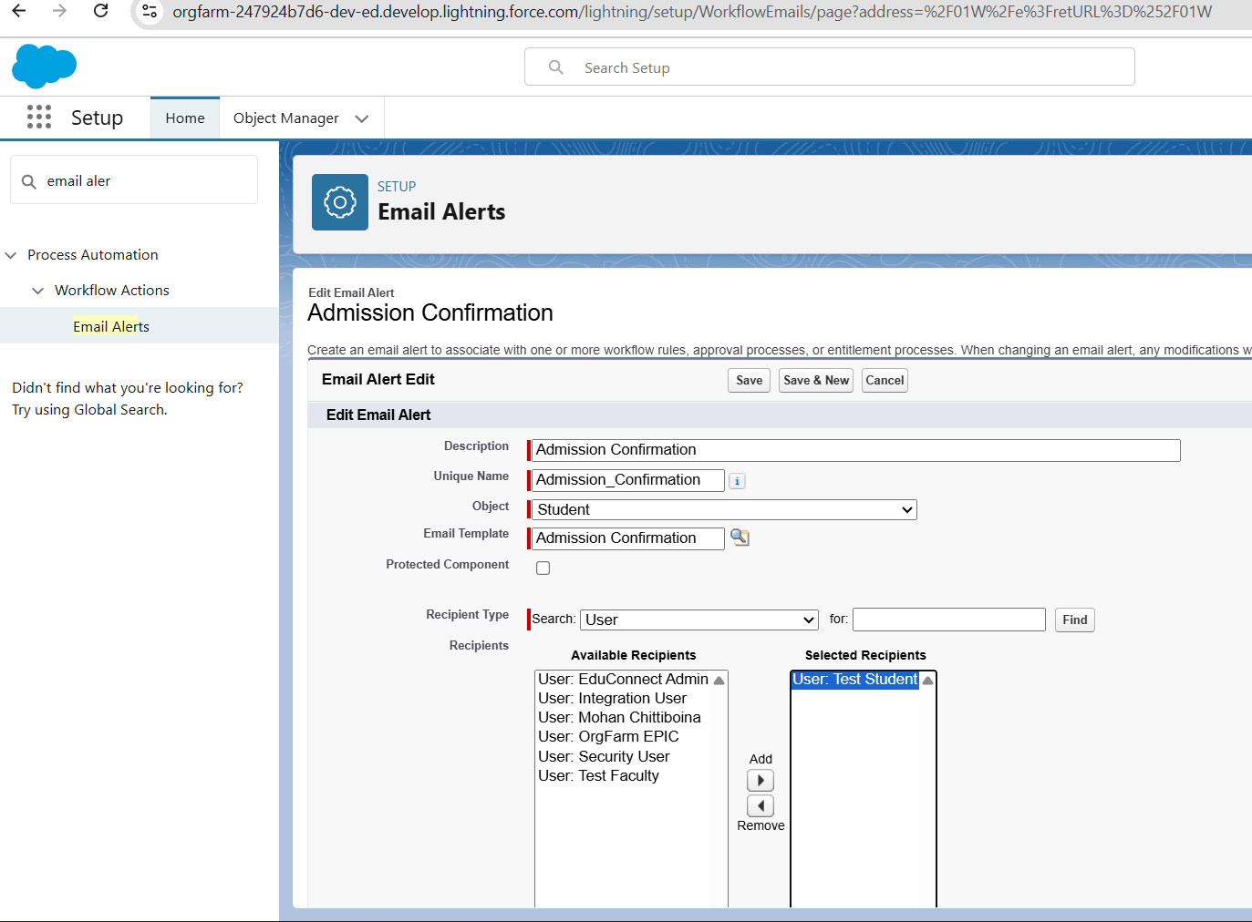

Admission confirmation triggered with flows

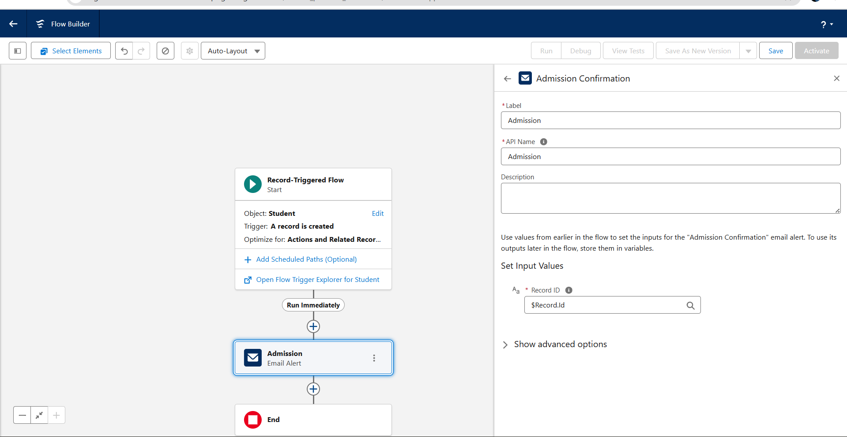

**Tasks:**

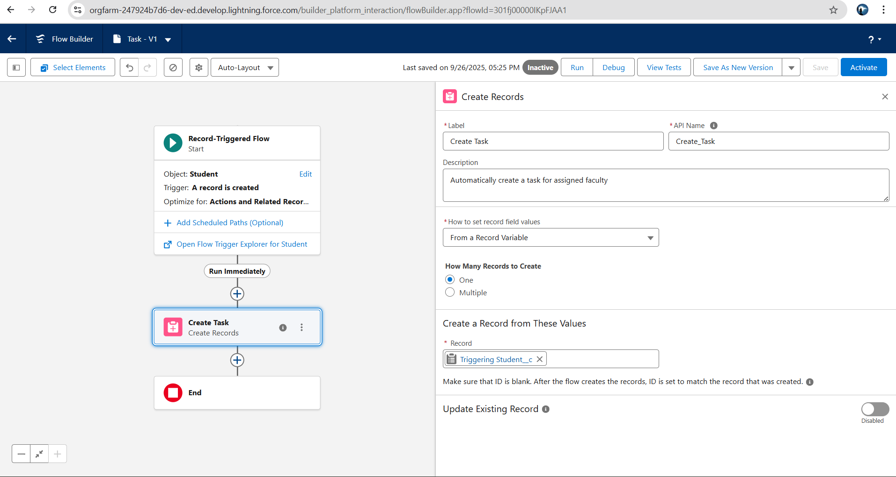

**Phase 4 Checklist**

1. **Validation Rules**
   * **Admission Date cannot be future-dated ✅**
   * **Credits must be > 0 for courses ✅**
2. **Approval Process**
   * **Course Credits > 6 → Approval from Head of Department ✅**
   * **Student requests withdrawal → Approval from Faculty Advisor ✅**
3. **Flow Builder**
   * **Notify faculty when new students register ✅ (Record-Triggered Flow)**
   * **Auto-launched Flow → When Alumni record created → Send welcome email ✅**
4. **Email Alerts**
   * **Admission confirmation ✅**
5. **Tasks**
   * **Auto-create task for faculty when a new student is assigned ✅**