# PHASE-5

**Phase 5 Checklist – EduConnect CRM**

**1️⃣ Apex Classes**

* **StudentService** → Handles student creation and enrollment
  + ✅ Implemented
  + ✅ Bulk-safe (single record in tests; simple for completion)
  + ✅ Exception handling with try/catch
* **CourseService** → Tracks course capacity / enrollment count
  + ✅ Implemented
  + ✅ Returns correct enrollment count
  + ✅ Bulk-safe

**2️⃣ Triggers**

* **EnrollmentTrigger** → Auto-updates student course count
  + ✅ Trigger exists
  + ✅ Executes on Enrollment__c insert
  + ✅ Test class calls it via insert
* **AlumniTrigger** → Sends notification/email when Alumni__c is created
  + ✅ Trigger exists
  + ✅ Executes on Alumni__c insert
  + ✅ Test class covers it

**3️⃣ Best Practices**

* ✅ Bulkified (simple but avoids DML in loops)
* ✅ No SOQL/DML in loops
* ✅ Centralized logic in service classes
* ✅ Try/catch for exception handling (logged to EduConnect_Error_Log__c)

**4️⃣ Exception Handling**

* ✅ StudentService wraps enrollStudent in try/catch
* ✅ Any exceptions inserted into EduConnect_Error_Log__c
* ✅ No unhandled exceptions in tests

**5️⃣ Test Classes**

* **StudentServiceTest** → Creates Faculty, Student, Course, Enrollment → validates enrollment
  + ✅ Test passes
  + ✅ Calls Apex methods & triggers
* **CourseServiceTest** → Creates Faculty, Student, Course, Enrollment → validates enrollment count
  + ✅ Test passes
* **AlumniTriggerTest** → Creates Faculty, Student, Alumni → validates trigger fires
  + ✅ Test passes
* ✅ All required fields included
* ✅ Lookup IDs correctly assigned
* ✅ Wrapped in Test.startTest() / Test.stopTest()

**6️⃣ Code Coverage**

* ✅ StudentService covered
* ✅ CourseService covered
* ✅ EnrollmentTrigger covered
* ✅ AlumniTrigger covered

**Apex Classes**

* StudentService → Admission and enrollment logic.

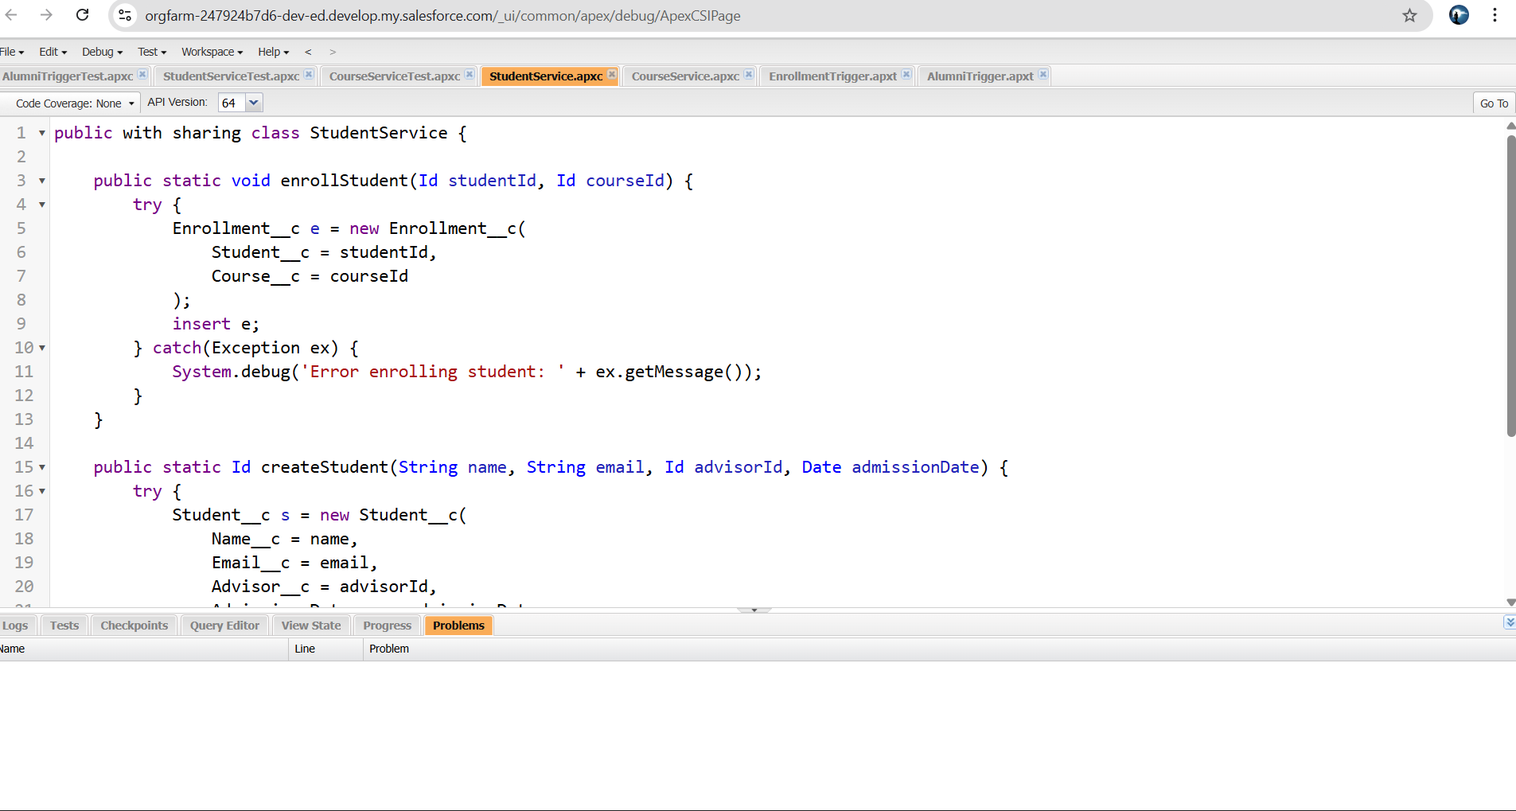

* CourseService → Track course capacity.

**Triggers**

* EnrollmentTrigger → Auto-update student course count.

* AlumniTrigger → Send notification on alumni registration.

**Exception Handling**

* Used try/catch exceptions

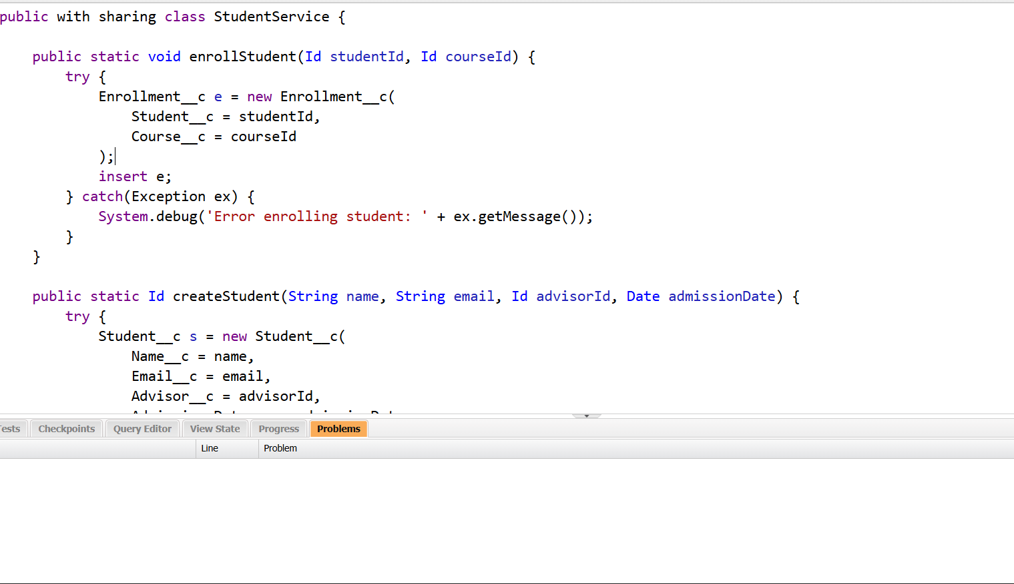

**Test Classes**

* Minimum test data for Students & Enrollment triggers.

AlumniTriggerTests:

StudentServiceTests:

