Multi-Environment Application Deployment Assessment

  - Submitted By: Nivedha S
  - ID: 13692
  - GitHub Repository:
  - https://github.com/nivedhasaibabaherovired-creator/MultienvApp.git
  - Date:
  - 14-Jun-2026

- FORKED AND THEN CLONE THE PROJECT:
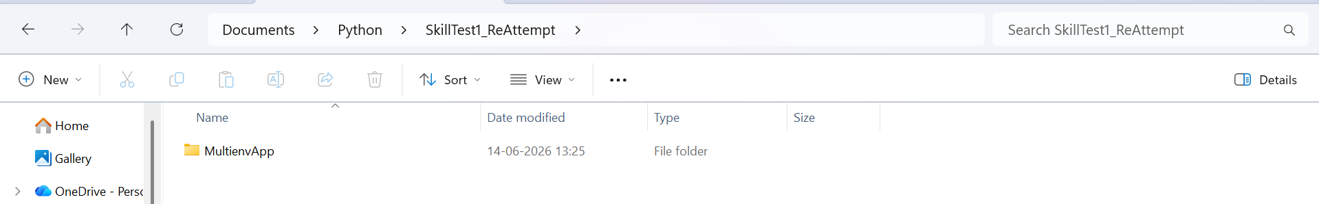
- CREATING DOCKER & ENVIRONMENT FILE IN ALL SERVICE:
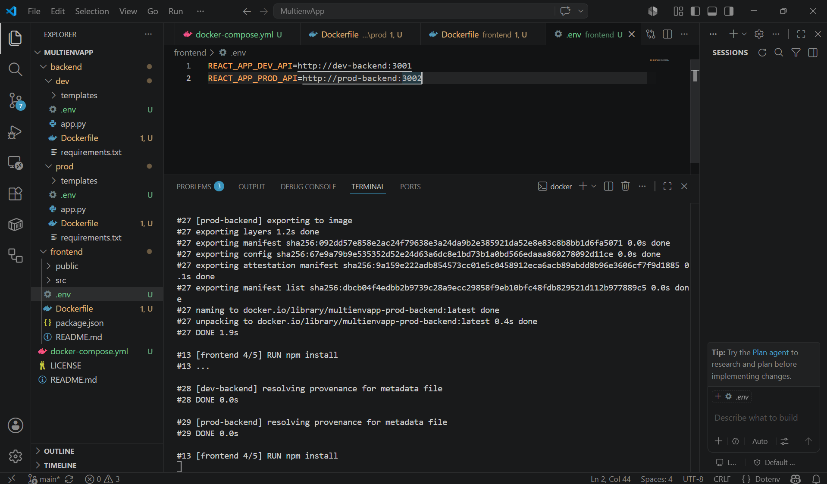
BACKEND:
dev/Dockerfile
“
FROM python:3.11-slim
WORKDIR /app
COPY requirements.txt .
RUN pip install --no-cache-dir -r requirements.txt
COPY . .
EXPOSE 3001
CMD ["python", "app.py"]
”
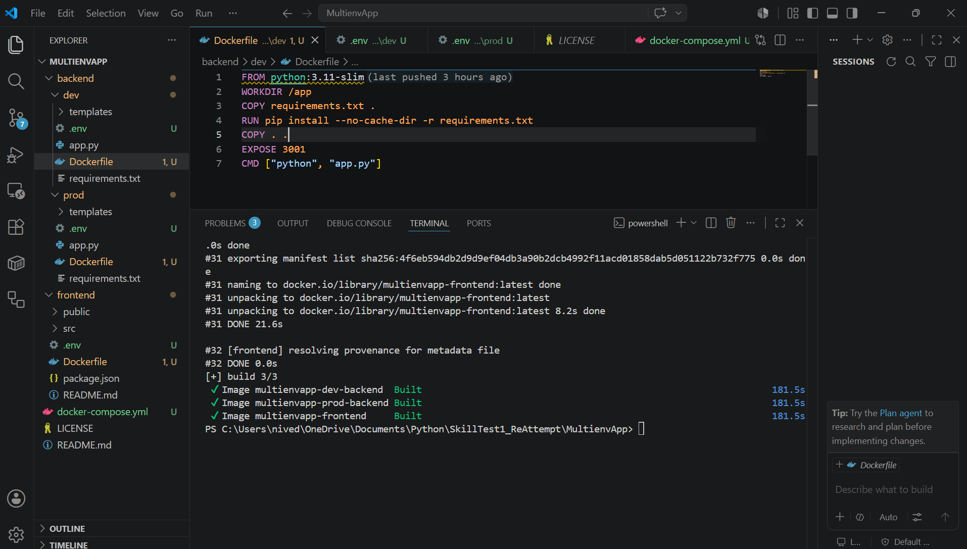
dev/.env
“
FLASK_ENV=development
PORT=3001
MONGO_URI=mongodb://mongodb:27017/devdb
”
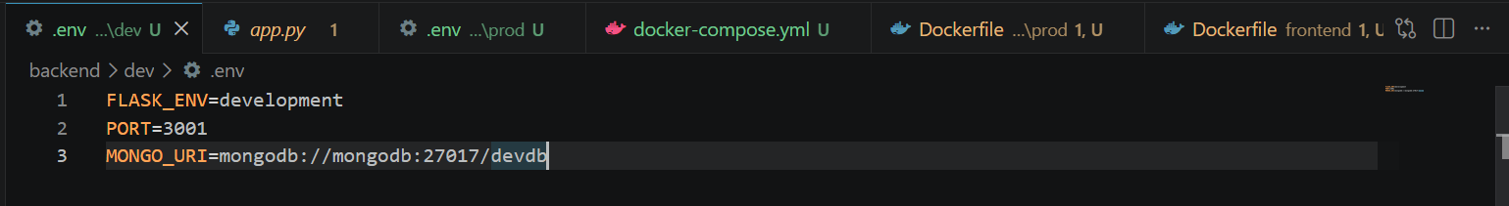
prod/Dockerfile
“
FROM python:3.11-slim
WORKDIR /app
COPY requirements.txt .
RUN pip install --no-cache-dir -r requirements.txt
COPY . .
EXPOSE 3002
CMD ["python", "app.py"]
”
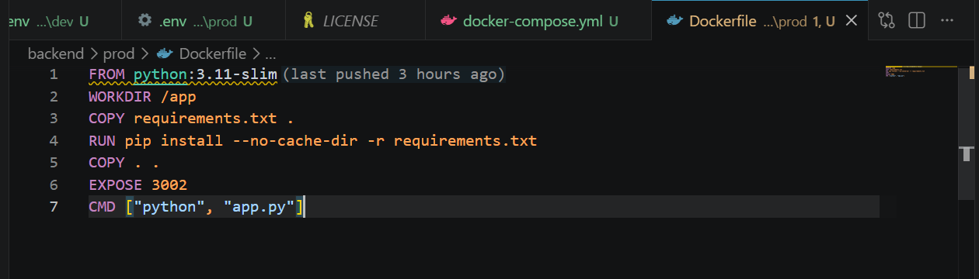
prod/.env
“
FLASK_ENV=production
PORT=3002
MONGO_URI=mongodb://mongodb:27017/proddb
”
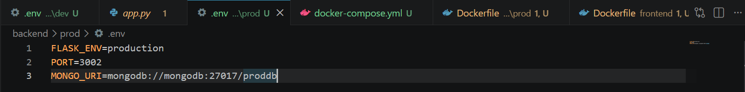
FRONTEND:
frontend/Dockerfile
“
FROM node:20-alpine
WORKDIR /app
COPY package*.json ./
RUN npm install
COPY . .
EXPOSE 3000
CMD ["npm", "start"]
”
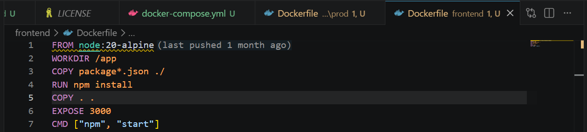
frontend/.env
“
REACT_APP_DEV_API=http://dev-backend:3001
REACT_APP_PROD_API=http://prod-backend:3002
”
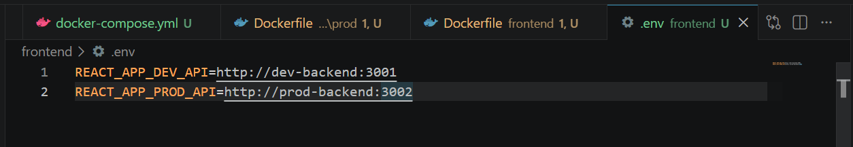
- CREATE docker-compose.yml:
“
services:

mongodb:
image: mongo:7
container_name: mongodb
restart: always
ports:
- "27017:27017"

dev-backend:
build: ./backend/dev
container_name: dev-backend
ports:
- "3001:3001"
env_file:
- ./backend/dev/.env
depends_on:
- mongodb

prod-backend:
build: ./backend/prod
container_name: prod-backend
ports:
- "3002:3002"
env_file:
- ./backend/prod/.env
depends_on:
- mongodb

frontend:
build: ./frontend
container_name: frontend
ports:
- "3000:3000"
depends_on:
- dev-backend
- prod-backend
”
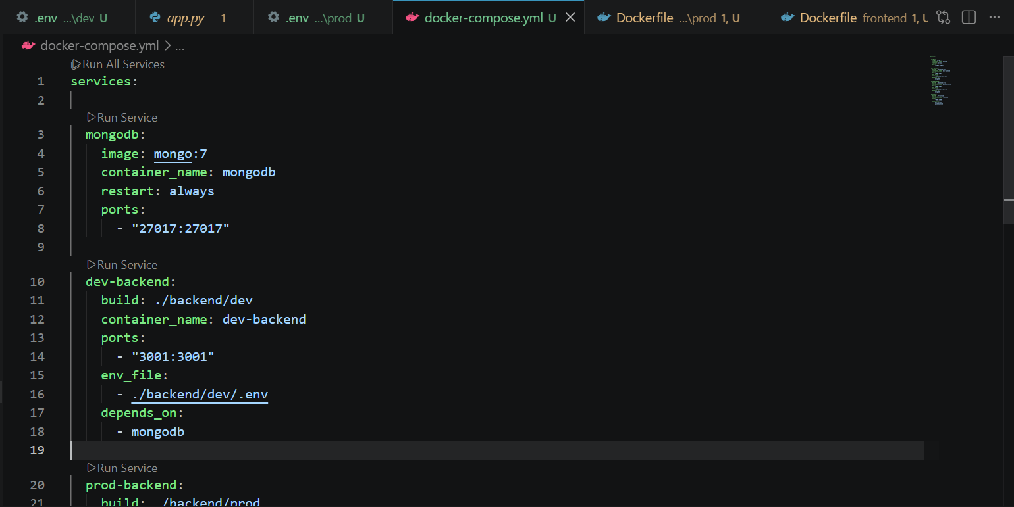

- Docker Build:
docker compose build
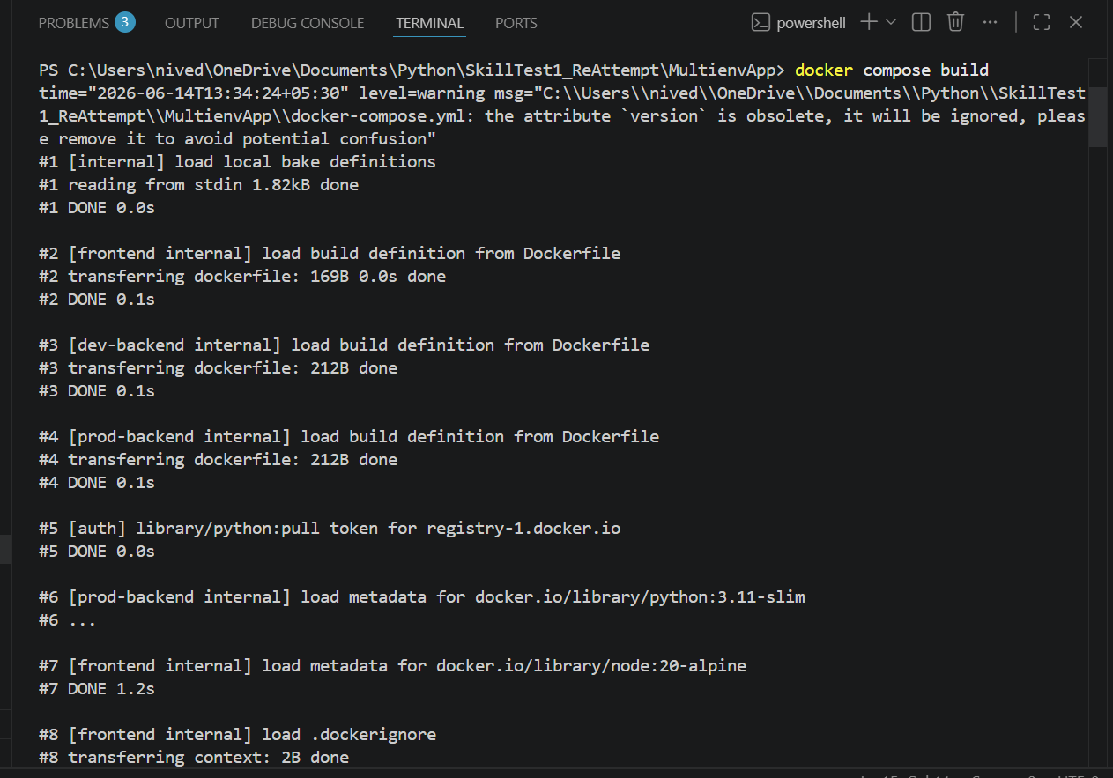
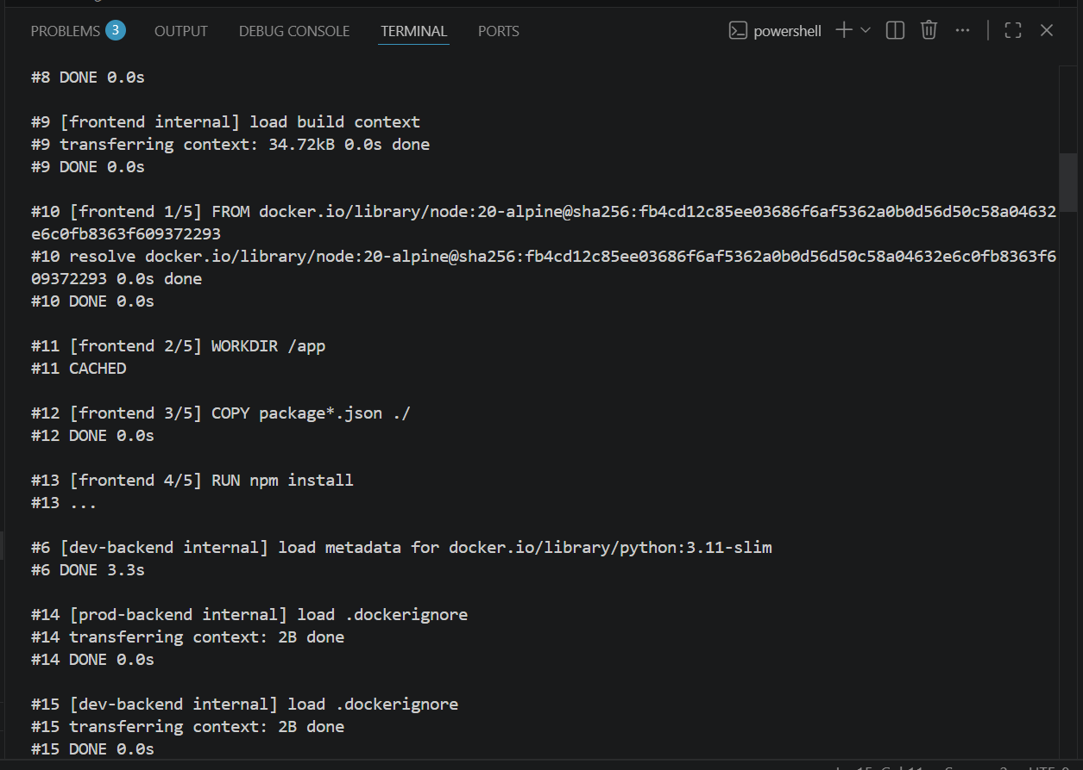
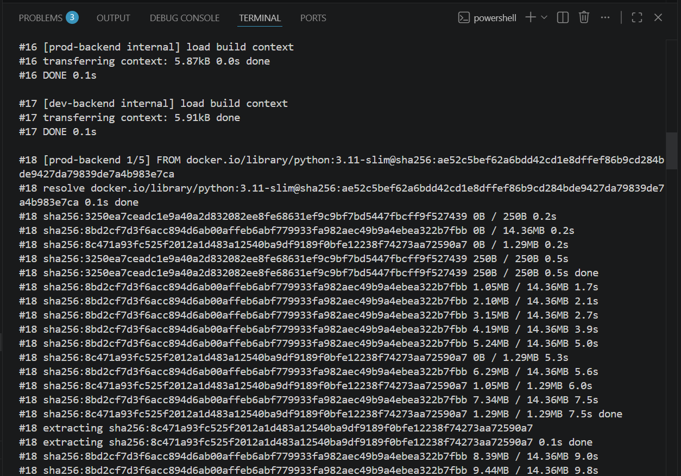
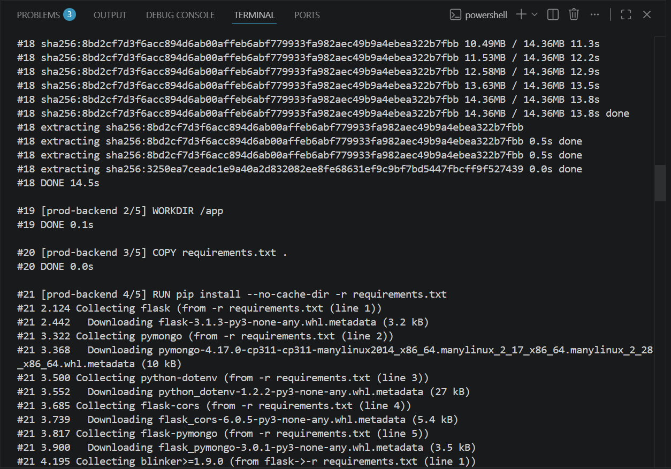
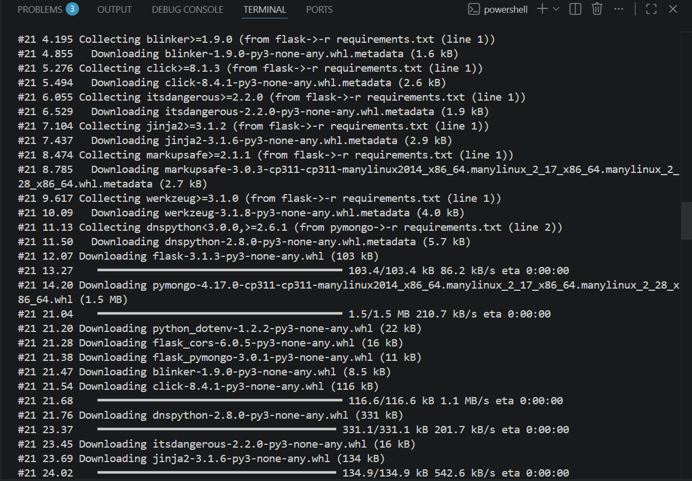
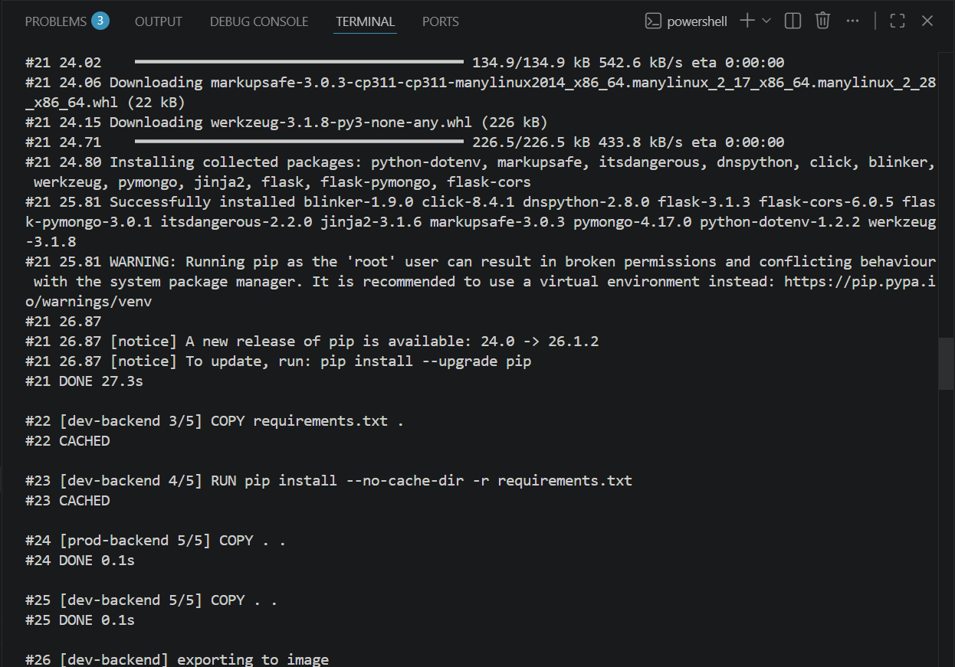
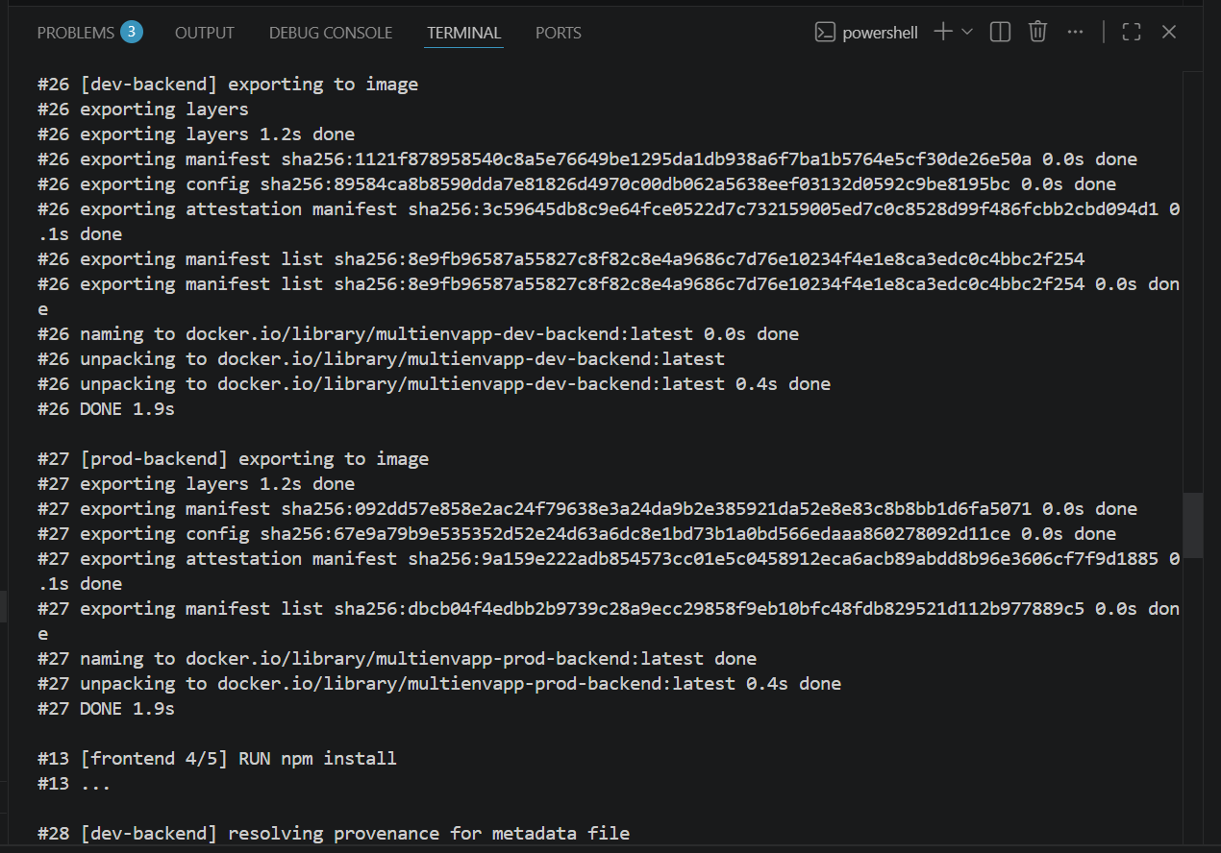
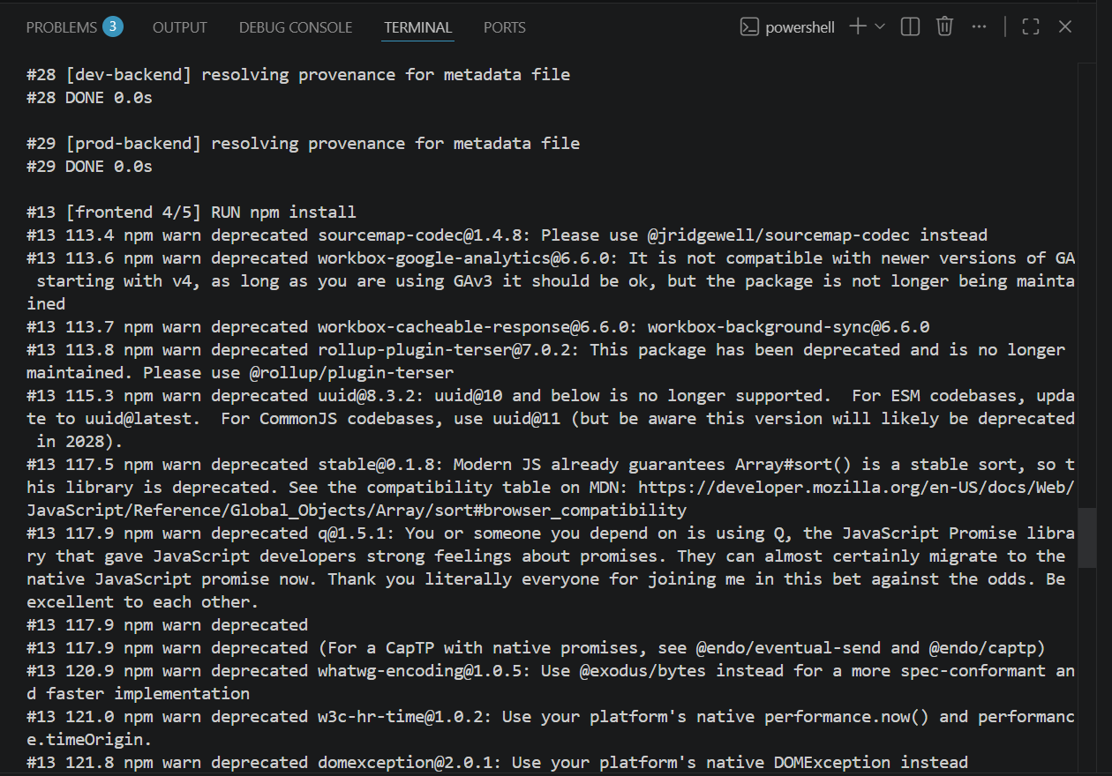
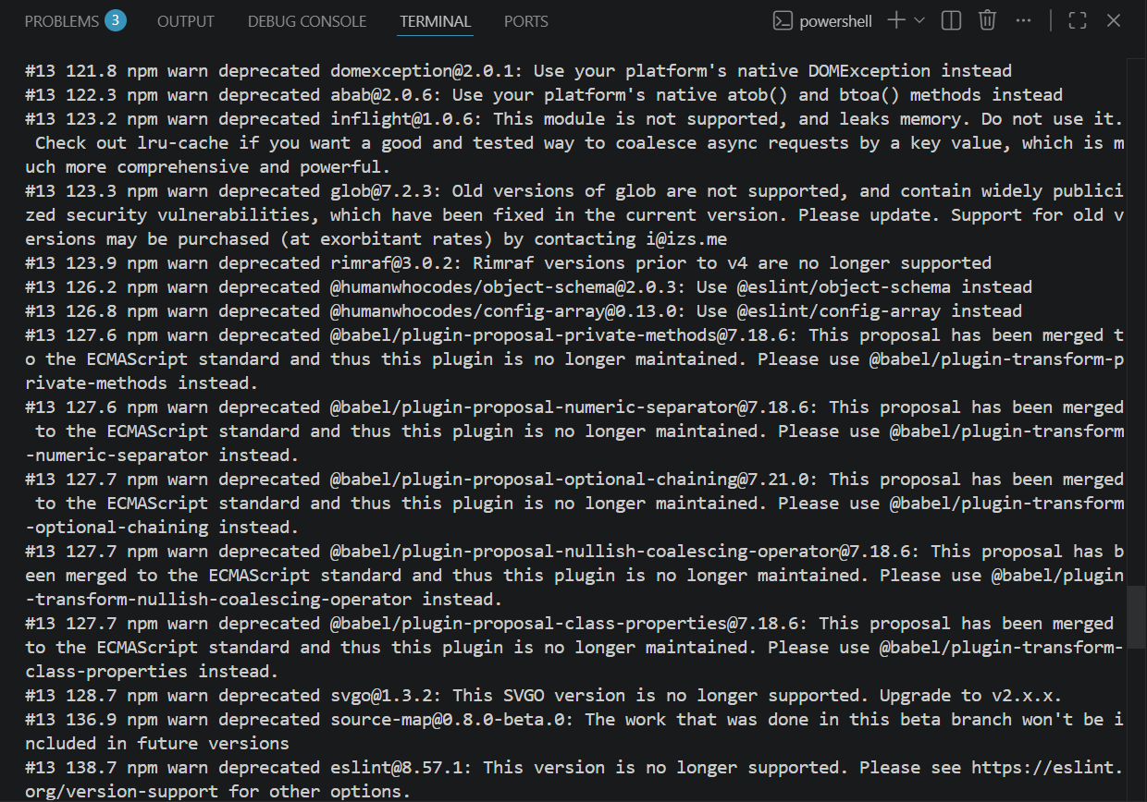
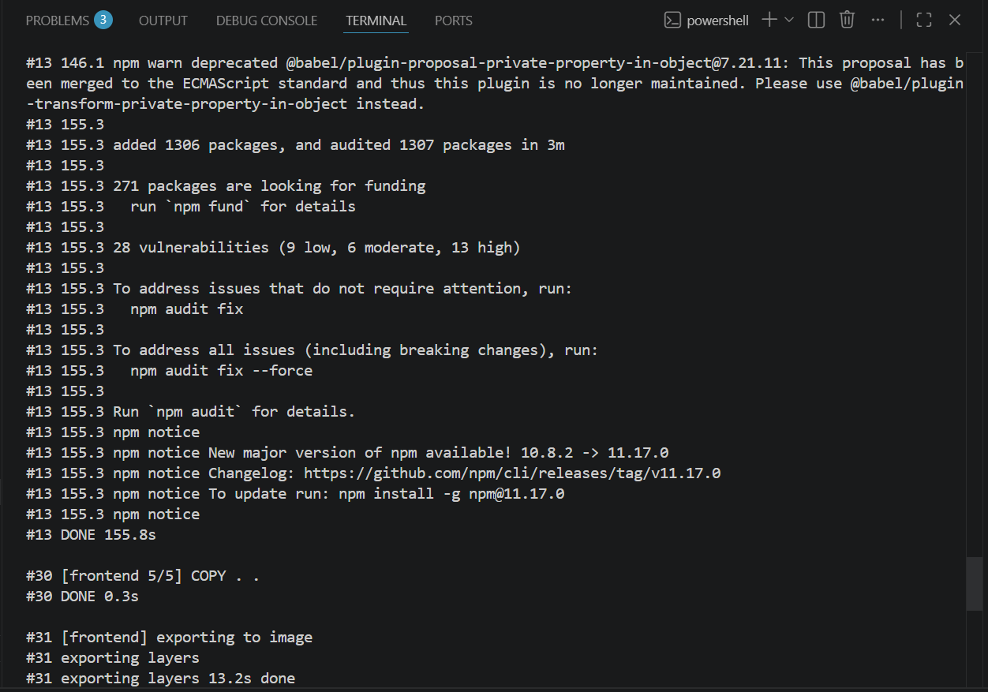
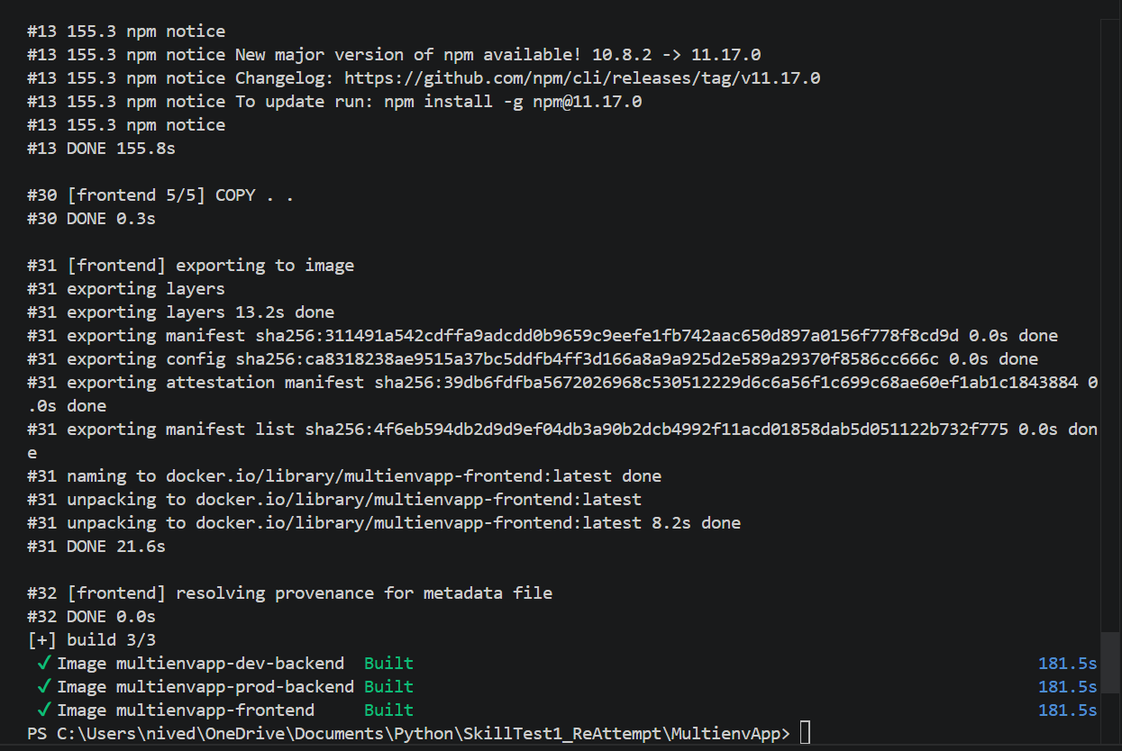
PS C:\Users\nived\OneDrive\Documents\Python\SkillTest1_ReAttempt\MultienvApp> docker compose build
time="2026-06-14T13:34:24+05:30" level=warning msg="C:\\Users\\nived\\OneDrive\\Documents\\Python\\SkillTest1_ReAttempt\\MultienvApp\\docker-compose.yml: the attribute `version` is obsolete, it will be ignored, please remove it to avoid potential confusion"
#1 [internal] load local bake definitions
#1 reading from stdin 1.82kB done
#1 DONE 0.0s

#2 [frontend internal] load build definition from Dockerfile
#2 transferring dockerfile: 169B 0.0s done
#2 DONE 0.1s

#3 [dev-backend internal] load build definition from Dockerfile
#3 transferring dockerfile: 212B done
#3 DONE 0.1s

#4 [prod-backend internal] load build definition from Dockerfile
#4 transferring dockerfile: 212B done
#4 DONE 0.1s

#5 [auth] library/python:pull token for registry-1.docker.io
#5 DONE 0.0s

#6 [prod-backend internal] load metadata for docker.io/library/python:3.11-slim
#6 ...

#7 [frontend internal] load metadata for docker.io/library/node:20-alpine
#7 DONE 1.2s

#8 [frontend internal] load .dockerignore
#8 transferring context: 2B done
#8 DONE 0.0s

#9 [frontend internal] load build context
#9 transferring context: 34.72kB 0.0s done
#9 DONE 0.0s

#10 [frontend 1/5] FROM docker.io/library/node:20-alpine@sha256:fb4cd12c85ee03686f6af5362a0b0d56d50c58a04632e6c0fb8363f609372293
#10 resolve docker.io/library/node:20-alpine@sha256:fb4cd12c85ee03686f6af5362a0b0d56d50c58a04632e6c0fb8363f609372293 0.0s done
#10 DONE 0.0s

#11 [frontend 2/5] WORKDIR /app
#11 CACHED

#12 [frontend 3/5] COPY package*.json ./
#12 DONE 0.0s

#13 [frontend 4/5] RUN npm install
#13 ...

#6 [dev-backend internal] load metadata for docker.io/library/python:3.11-slim
#6 DONE 3.3s

#14 [prod-backend internal] load .dockerignore
#14 transferring context: 2B done
#14 DONE 0.0s

#15 [dev-backend internal] load .dockerignore
#15 transferring context: 2B done
#15 DONE 0.0s

#16 [prod-backend internal] load build context
#16 transferring context: 5.87kB 0.0s done
#16 DONE 0.1s

#17 [dev-backend internal] load build context
#17 transferring context: 5.91kB done
#17 DONE 0.1s

#18 [prod-backend 1/5] FROM docker.io/library/python:3.11-slim@sha256:ae52c5bef62a6bdd42cd1e8dffef86b9cd284bde9427da79839de7a4b983e7ca
#18 resolve docker.io/library/python:3.11-slim@sha256:ae52c5bef62a6bdd42cd1e8dffef86b9cd284bde9427da79839de7a4b983e7ca 0.1s done
#18 sha256:3250ea7ceadc1e9a40a2d832082ee8fe68631ef9c9bf7bd5447fbcff9f527439 0B / 250B 0.2s
#18 sha256:8bd2cf7d3f6acc894d6ab00affeb6abf779933fa982aec49b9a4ebea322b7fbb 0B / 14.36MB 0.2s
#18 sha256:8c471a93fc525f2012a1d483a12540ba9df9189f0bfe12238f74273aa72590a7 0B / 1.29MB 0.2s
#18 sha256:3250ea7ceadc1e9a40a2d832082ee8fe68631ef9c9bf7bd5447fbcff9f527439 250B / 250B 0.5s
#18 sha256:3250ea7ceadc1e9a40a2d832082ee8fe68631ef9c9bf7bd5447fbcff9f527439 250B / 250B 0.5s done
#18 sha256:8bd2cf7d3f6acc894d6ab00affeb6abf779933fa982aec49b9a4ebea322b7fbb 1.05MB / 14.36MB 1.7s
#18 sha256:8bd2cf7d3f6acc894d6ab00affeb6abf779933fa982aec49b9a4ebea322b7fbb 2.10MB / 14.36MB 2.1s
#18 sha256:8bd2cf7d3f6acc894d6ab00affeb6abf779933fa982aec49b9a4ebea322b7fbb 3.15MB / 14.36MB 2.7s
#18 sha256:8bd2cf7d3f6acc894d6ab00affeb6abf779933fa982aec49b9a4ebea322b7fbb 4.19MB / 14.36MB 3.9s
#18 sha256:8bd2cf7d3f6acc894d6ab00affeb6abf779933fa982aec49b9a4ebea322b7fbb 5.24MB / 14.36MB 5.0s
#18 sha256:8c471a93fc525f2012a1d483a12540ba9df9189f0bfe12238f74273aa72590a7 0B / 1.29MB 5.3s
#18 sha256:8bd2cf7d3f6acc894d6ab00affeb6abf779933fa982aec49b9a4ebea322b7fbb 6.29MB / 14.36MB 5.6s
#18 sha256:8c471a93fc525f2012a1d483a12540ba9df9189f0bfe12238f74273aa72590a7 1.05MB / 1.29MB 6.0s
#18 sha256:8bd2cf7d3f6acc894d6ab00affeb6abf779933fa982aec49b9a4ebea322b7fbb 7.34MB / 14.36MB 7.5s
#18 sha256:8c471a93fc525f2012a1d483a12540ba9df9189f0bfe12238f74273aa72590a7 1.29MB / 1.29MB 7.5s done
#18 extracting sha256:8c471a93fc525f2012a1d483a12540ba9df9189f0bfe12238f74273aa72590a7
#18 extracting sha256:8c471a93fc525f2012a1d483a12540ba9df9189f0bfe12238f74273aa72590a7 0.1s done
#18 sha256:8bd2cf7d3f6acc894d6ab00affeb6abf779933fa982aec49b9a4ebea322b7fbb 8.39MB / 14.36MB 9.0s
#18 sha256:8bd2cf7d3f6acc894d6ab00affeb6abf779933fa982aec49b9a4ebea322b7fbb 9.44MB / 14.36MB 9.8s
#18 sha256:8bd2cf7d3f6acc894d6ab00affeb6abf779933fa982aec49b9a4ebea322b7fbb 10.49MB / 14.36MB 11.3s
#18 sha256:8bd2cf7d3f6acc894d6ab00affeb6abf779933fa982aec49b9a4ebea322b7fbb 11.53MB / 14.36MB 12.2s
#18 sha256:8bd2cf7d3f6acc894d6ab00affeb6abf779933fa982aec49b9a4ebea322b7fbb 12.58MB / 14.36MB 12.9s
#18 sha256:8bd2cf7d3f6acc894d6ab00affeb6abf779933fa982aec49b9a4ebea322b7fbb 13.63MB / 14.36MB 13.5s
#18 sha256:8bd2cf7d3f6acc894d6ab00affeb6abf779933fa982aec49b9a4ebea322b7fbb 14.36MB / 14.36MB 13.8s
#18 sha256:8bd2cf7d3f6acc894d6ab00affeb6abf779933fa982aec49b9a4ebea322b7fbb 14.36MB / 14.36MB 13.8s done
#18 extracting sha256:8bd2cf7d3f6acc894d6ab00affeb6abf779933fa982aec49b9a4ebea322b7fbb
#18 extracting sha256:8bd2cf7d3f6acc894d6ab00affeb6abf779933fa982aec49b9a4ebea322b7fbb 0.5s done
#18 extracting sha256:8bd2cf7d3f6acc894d6ab00affeb6abf779933fa982aec49b9a4ebea322b7fbb 0.5s done
#18 extracting sha256:3250ea7ceadc1e9a40a2d832082ee8fe68631ef9c9bf7bd5447fbcff9f527439 0.0s done
#18 DONE 14.5s

#19 [prod-backend 2/5] WORKDIR /app
#19 DONE 0.1s

#20 [prod-backend 3/5] COPY requirements.txt .
#20 DONE 0.0s

#21 [prod-backend 4/5] RUN pip install --no-cache-dir -r requirements.txt
#21 2.124 Collecting flask (from -r requirements.txt (line 1))
#21 2.442 Downloading flask-3.1.3-py3-none-any.whl.metadata (3.2 kB)
#21 3.322 Collecting pymongo (from -r requirements.txt (line 2))
#21 3.368 Downloading pymongo-4.17.0-cp311-cp311-manylinux2014_x86_64.manylinux_2_17_x86_64.manylinux_2_28_x86_64.whl.metadata (10 kB)
#21 3.500 Collecting python-dotenv (from -r requirements.txt (line 3))
#21 3.552 Downloading python_dotenv-1.2.2-py3-none-any.whl.metadata (27 kB)
#21 3.685 Collecting flask-cors (from -r requirements.txt (line 4))
#21 3.739 Downloading flask_cors-6.0.5-py3-none-any.whl.metadata (5.4 kB)
#21 3.817 Collecting flask-pymongo (from -r requirements.txt (line 5))
#21 3.900 Downloading flask_pymongo-3.0.1-py3-none-any.whl.metadata (3.5 kB)
#21 4.195 Collecting blinker>=1.9.0 (from flask->-r requirements.txt (line 1))
#21 4.855 Downloading blinker-1.9.0-py3-none-any.whl.metadata (1.6 kB)
#21 5.276 Collecting click>=8.1.3 (from flask->-r requirements.txt (line 1))
#21 5.494 Downloading click-8.4.1-py3-none-any.whl.metadata (2.6 kB)
#21 6.055 Collecting itsdangerous>=2.2.0 (from flask->-r requirements.txt (line 1))
#21 6.529 Downloading itsdangerous-2.2.0-py3-none-any.whl.metadata (1.9 kB)
#21 7.104 Collecting jinja2>=3.1.2 (from flask->-r requirements.txt (line 1))
#21 7.437 Downloading jinja2-3.1.6-py3-none-any.whl.metadata (2.9 kB)
#21 8.474 Collecting markupsafe>=2.1.1 (from flask->-r requirements.txt (line 1))
#21 8.785 Downloading markupsafe-3.0.3-cp311-cp311-manylinux2014_x86_64.manylinux_2_17_x86_64.manylinux_2_28_x86_64.whl.metadata (2.7 kB)
#21 9.617 Collecting werkzeug>=3.1.0 (from flask->-r requirements.txt (line 1))
#21 10.09 Downloading werkzeug-3.1.8-py3-none-any.whl.metadata (4.0 kB)
#21 11.13 Collecting dnspython<3.0.0,>=2.6.1 (from pymongo->-r requirements.txt (line 2))
#21 11.50 Downloading dnspython-2.8.0-py3-none-any.whl.metadata (5.7 kB)
#21 12.07 Downloading flask-3.1.3-py3-none-any.whl (103 kB)
#21 13.27 ━━━━━━━━━━━━━━━━━━━━━━━━━━━━━━━━━━━━━━━━ 103.4/103.4 kB 86.2 kB/s eta 0:00:00
#21 14.20 Downloading pymongo-4.17.0-cp311-cp311-manylinux2014_x86_64.manylinux_2_17_x86_64.manylinux_2_28_x86_64.whl (1.5 MB)
#21 21.04 ━━━━━━━━━━━━━━━━━━━━━━━━━━━━━━━━━━━━━━━━ 1.5/1.5 MB 210.7 kB/s eta 0:00:00
#21 21.20 Downloading python_dotenv-1.2.2-py3-none-any.whl (22 kB)
#21 21.28 Downloading flask_cors-6.0.5-py3-none-any.whl (16 kB)
#21 21.38 Downloading flask_pymongo-3.0.1-py3-none-any.whl (11 kB)
#21 21.47 Downloading blinker-1.9.0-py3-none-any.whl (8.5 kB)
#21 21.54 Downloading click-8.4.1-py3-none-any.whl (116 kB)
#21 21.68 ━━━━━━━━━━━━━━━━━━━━━━━━━━━━━━━━━━━━━━━━ 116.6/116.6 kB 1.1 MB/s eta 0:00:00
#21 21.76 Downloading dnspython-2.8.0-py3-none-any.whl (331 kB)
#21 23.37 ━━━━━━━━━━━━━━━━━━━━━━━━━━━━━━━━━━━━━━━ 331.1/331.1 kB 201.7 kB/s eta 0:00:00
#21 23.45 Downloading itsdangerous-2.2.0-py3-none-any.whl (16 kB)
#21 23.69 Downloading jinja2-3.1.6-py3-none-any.whl (134 kB)
#21 24.02 ━━━━━━━━━━━━━━━━━━━━━━━━━━━━━━━━━━━━━━━ 134.9/134.9 kB 542.6 kB/s eta 0:00:00
#21 24.06 Downloading markupsafe-3.0.3-cp311-cp311-manylinux2014_x86_64.manylinux_2_17_x86_64.manylinux_2_28_x86_64.whl (22 kB)
#21 24.15 Downloading werkzeug-3.1.8-py3-none-any.whl (226 kB)
#21 24.71 ━━━━━━━━━━━━━━━━━━━━━━━━━━━━━━━━━━━━━━━ 226.5/226.5 kB 433.8 kB/s eta 0:00:00
#21 24.80 Installing collected packages: python-dotenv, markupsafe, itsdangerous, dnspython, click, blinker, werkzeug, pymongo, jinja2, flask, flask-pymongo, flask-cors
#21 25.81 Successfully installed blinker-1.9.0 click-8.4.1 dnspython-2.8.0 flask-3.1.3 flask-cors-6.0.5 flask-pymongo-3.0.1 itsdangerous-2.2.0 jinja2-3.1.6 markupsafe-3.0.3 pymongo-4.17.0 python-dotenv-1.2.2 werkzeug-3.1.8
#21 25.81 WARNING: Running pip as the 'root' user can result in broken permissions and conflicting behaviour with the system package manager. It is recommended to use a virtual environment instead: https://pip.pypa.io/warnings/venv
#21 26.87
#21 26.87 [notice] A new release of pip is available: 24.0 -> 26.1.2
#21 26.87 [notice] To update, run: pip install --upgrade pip
#21 DONE 27.3s

#22 [dev-backend 3/5] COPY requirements.txt .
#22 CACHED

#23 [dev-backend 4/5] RUN pip install --no-cache-dir -r requirements.txt
#23 CACHED

#24 [prod-backend 5/5] COPY . .
#24 DONE 0.1s

#25 [dev-backend 5/5] COPY . .
#25 DONE 0.1s

#26 [dev-backend] exporting to image
#26 exporting layers
#26 exporting layers 1.2s done
#26 exporting manifest sha256:1121f878958540c8a5e76649be1295da1db938a6f7ba1b5764e5cf30de26e50a 0.0s done
#26 exporting config sha256:89584ca8b8590dda7e81826d4970c00db062a5638eef03132d0592c9be8195bc 0.0s done
#26 exporting attestation manifest sha256:3c59645db8c9e64fce0522d7c732159005ed7c0c8528d99f486fcbb2cbd094d1 0.1s done
#26 exporting manifest list sha256:8e9fb96587a55827c8f82c8e4a9686c7d76e10234f4e1e8ca3edc0c4bbc2f254
#26 exporting manifest list sha256:8e9fb96587a55827c8f82c8e4a9686c7d76e10234f4e1e8ca3edc0c4bbc2f254 0.0s done
#26 naming to docker.io/library/multienvapp-dev-backend:latest 0.0s done
#26 unpacking to docker.io/library/multienvapp-dev-backend:latest
#26 unpacking to docker.io/library/multienvapp-dev-backend:latest 0.4s done
#26 DONE 1.9s

#27 [prod-backend] exporting to image
#27 exporting layers 1.2s done
#27 exporting manifest sha256:092dd57e858e2ac24f79638e3a24da9b2e385921da52e8e83c8b8bb1d6fa5071 0.0s done
#27 exporting config sha256:67e9a79b9e535352d52e24d63a6dc8e1bd73b1a0bd566edaaa860278092d11ce 0.0s done
#27 exporting attestation manifest sha256:9a159e222adb854573cc01e5c0458912eca6acb89abdd8b96e3606cf7f9d1885 0.1s done
#27 exporting manifest list sha256:dbcb04f4edbb2b9739c28a9ecc29858f9eb10bfc48fdb829521d112b977889c5 0.0s done
#27 naming to docker.io/library/multienvapp-prod-backend:latest done
#27 unpacking to docker.io/library/multienvapp-prod-backend:latest 0.4s done
#27 DONE 1.9s

#13 [frontend 4/5] RUN npm install
#13 ...

#28 [dev-backend] resolving provenance for metadata file
#28 DONE 0.0s

#29 [prod-backend] resolving provenance for metadata file
#29 DONE 0.0s

#13 [frontend 4/5] RUN npm install
#13 113.4 npm warn deprecated sourcemap-codec@1.4.8: Please use @jridgewell/sourcemap-codec instead
#13 113.6 npm warn deprecated workbox-google-analytics@6.6.0: It is not compatible with newer versions of GA starting with v4, as long as you are using GAv3 it should be ok, but the package is not longer being maintained
#13 113.7 npm warn deprecated workbox-cacheable-response@6.6.0: workbox-background-sync@6.6.0
#13 113.8 npm warn deprecated rollup-plugin-terser@7.0.2: This package has been deprecated and is no longer maintained. Please use @rollup/plugin-terser
#13 115.3 npm warn deprecated uuid@8.3.2: uuid@10 and below is no longer supported. For ESM codebases, update to uuid@latest. For CommonJS codebases, use uuid@11 (but be aware this version will likely be deprecated in 2028).
#13 117.5 npm warn deprecated stable@0.1.8: Modern JS already guarantees Array#sort() is a stable sort, so this library is deprecated. See the compatibility table on MDN: https://developer.mozilla.org/en-US/docs/Web/JavaScript/Reference/Global_Objects/Array/sort#browser_compatibility
#13 117.9 npm warn deprecated q@1.5.1: You or someone you depend on is using Q, the JavaScript Promise library that gave JavaScript developers strong feelings about promises. They can almost certainly migrate to the native JavaScript promise now. Thank you literally everyone for joining me in this bet against the odds. Be excellent to each other.
#13 117.9 npm warn deprecated
#13 117.9 npm warn deprecated (For a CapTP with native promises, see @endo/eventual-send and @endo/captp)
#13 120.9 npm warn deprecated whatwg-encoding@1.0.5: Use @exodus/bytes instead for a more spec-conformant and faster implementation
#13 121.0 npm warn deprecated w3c-hr-time@1.0.2: Use your platform's native performance.now() and performance.timeOrigin.
#13 121.8 npm warn deprecated domexception@2.0.1: Use your platform's native DOMException instead
#13 122.3 npm warn deprecated abab@2.0.6: Use your platform's native atob() and btoa() methods instead
#13 123.2 npm warn deprecated inflight@1.0.6: This module is not supported, and leaks memory. Do not use it. Check out lru-cache if you want a good and tested way to coalesce async requests by a key value, which is much more comprehensive and powerful.
#13 123.3 npm warn deprecated glob@7.2.3: Old versions of glob are not supported, and contain widely publicized security vulnerabilities, which have been fixed in the current version. Please update. Support for old versions may be purchased (at exorbitant rates) by contacting i@izs.me
#13 123.9 npm warn deprecated rimraf@3.0.2: Rimraf versions prior to v4 are no longer supported
#13 126.2 npm warn deprecated @humanwhocodes/object-schema@2.0.3: Use @eslint/object-schema instead
#13 126.8 npm warn deprecated @humanwhocodes/config-array@0.13.0: Use @eslint/config-array instead
#13 127.6 npm warn deprecated @babel/plugin-proposal-private-methods@7.18.6: This proposal has been merged to the ECMAScript standard and thus this plugin is no longer maintained. Please use @babel/plugin-transform-private-methods instead.
#13 127.6 npm warn deprecated @babel/plugin-proposal-numeric-separator@7.18.6: This proposal has been merged to the ECMAScript standard and thus this plugin is no longer maintained. Please use @babel/plugin-transform-numeric-separator instead.
#13 127.7 npm warn deprecated @babel/plugin-proposal-optional-chaining@7.21.0: This proposal has been merged to the ECMAScript standard and thus this plugin is no longer maintained. Please use @babel/plugin-transform-optional-chaining instead.
#13 127.7 npm warn deprecated @babel/plugin-proposal-nullish-coalescing-operator@7.18.6: This proposal has been merged to the ECMAScript standard and thus this plugin is no longer maintained. Please use @babel/plugin-transform-nullish-coalescing-operator instead.
#13 127.7 npm warn deprecated @babel/plugin-proposal-class-properties@7.18.6: This proposal has been merged to the ECMAScript standard and thus this plugin is no longer maintained. Please use @babel/plugin-transform-class-properties instead.
#13 128.7 npm warn deprecated svgo@1.3.2: This SVGO version is no longer supported. Upgrade to v2.x.x.
#13 136.9 npm warn deprecated source-map@0.8.0-beta.0: The work that was done in this beta branch won't be included in future versions
#13 138.7 npm warn deprecated eslint@8.57.1: This version is no longer supported. Please see https://eslint.org/version-support for other options.
#13 146.1 npm warn deprecated @babel/plugin-proposal-private-property-in-object@7.21.11: This proposal has been merged to the ECMAScript standard and thus this plugin is no longer maintained. Please use @babel/plugin-transform-private-property-in-object instead.
#13 155.3
#13 155.3 added 1306 packages, and audited 1307 packages in 3m
#13 155.3
#13 155.3 271 packages are looking for funding
#13 155.3 run `npm fund` for details
#13 155.3
#13 155.3 28 vulnerabilities (9 low, 6 moderate, 13 high)
#13 155.3
#13 155.3 To address issues that do not require attention, run:
#13 155.3 npm audit fix
#13 155.3
#13 155.3 To address all issues (including breaking changes), run:
#13 155.3 npm audit fix --force
#13 155.3
#13 155.3 Run `npm audit` for details.
#13 155.3 npm notice
#13 155.3 npm notice New major version of npm available! 10.8.2 -> 11.17.0
#13 155.3 npm notice Changelog: https://github.com/npm/cli/releases/tag/v11.17.0
#13 155.3 npm notice To update run: npm install -g npm@11.17.0
#13 155.3 npm notice
#13 DONE 155.8s

#30 [frontend 5/5] COPY . .
#30 DONE 0.3s

#31 [frontend] exporting to image
#31 exporting layers
#31 exporting layers 13.2s done
#31 exporting manifest sha256:311491a542cdffa9adcdd0b9659c9eefe1fb742aac650d897a0156f778f8cd9d 0.0s done
#31 exporting config sha256:ca8318238ae9515a37bc5ddfb4ff3d166a8a9a925d2e589a29370f8586cc666c 0.0s done
#31 exporting attestation manifest sha256:39db6fdfba5672026968c530512229d6c6a56f1c699c68ae60ef1ab1c1843884 0.0s done
#31 exporting manifest list sha256:4f6eb594db2d9d9ef04db3a90b2dcb4992f11acd01858dab5d051122b732f775 0.0s done
#31 naming to docker.io/library/multienvapp-frontend:latest done
#31 unpacking to docker.io/library/multienvapp-frontend:latest
#31 unpacking to docker.io/library/multienvapp-frontend:latest 8.2s done
#31 DONE 21.6s

#32 [frontend] resolving provenance for metadata file
#32 DONE 0.0s
[+] build 3/3
✔ Image multienvapp-dev-backend Built 181.5s
✔ Image multienvapp-prod-backend Built 181.5s
✔ Image multienvapp-frontend Built
- START Containers: docker compose up -d
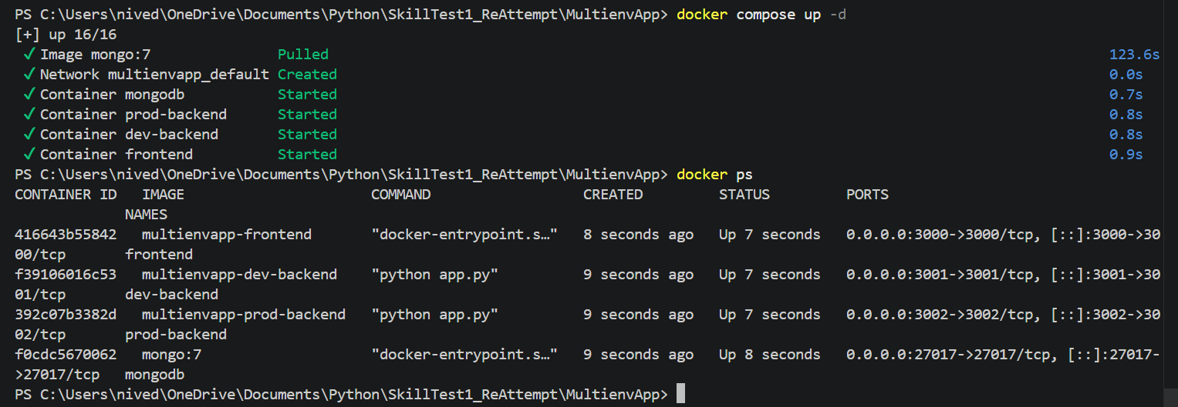
- APPLICATION STARTED:
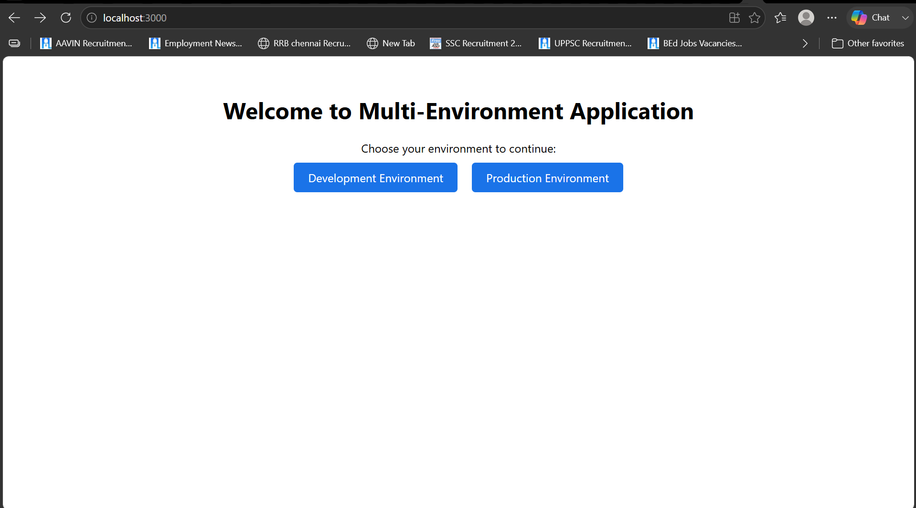
DEV ENV:
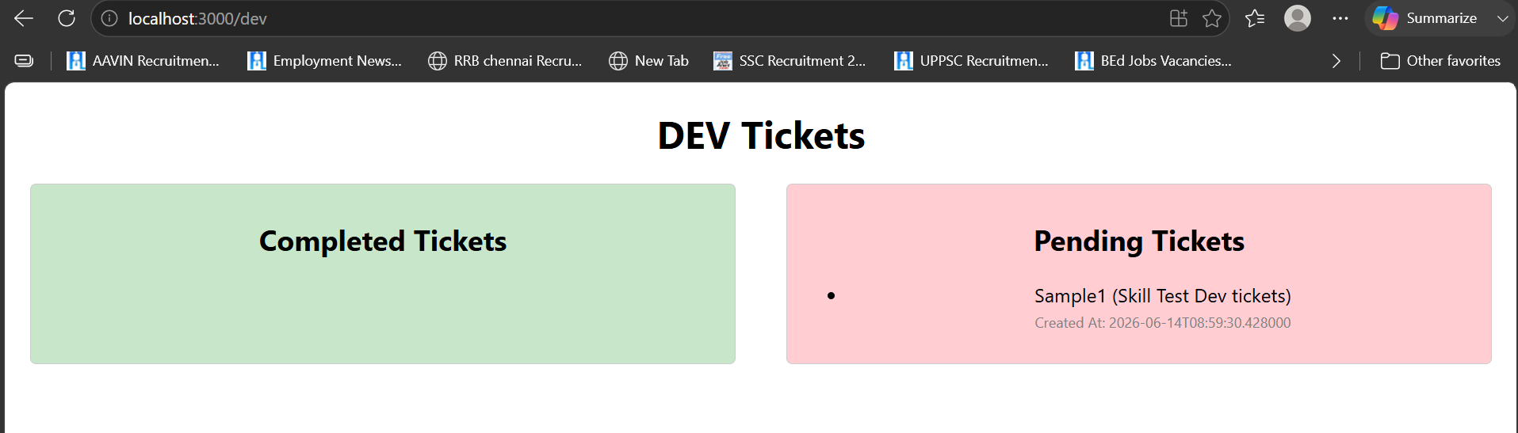
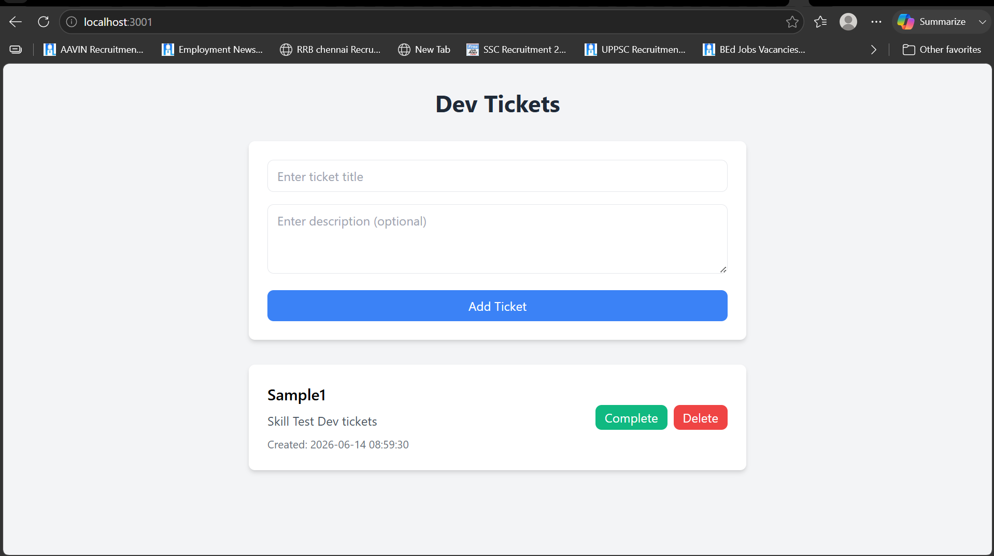
PROD ENV:
