GitHub Actions CI CD pipeline for flask application Assignment screenshots
Step 1 – GitHub Actions Workflow YAML code – Build, Test, Deploy to Staging, and Deploy to Production steps screenshots
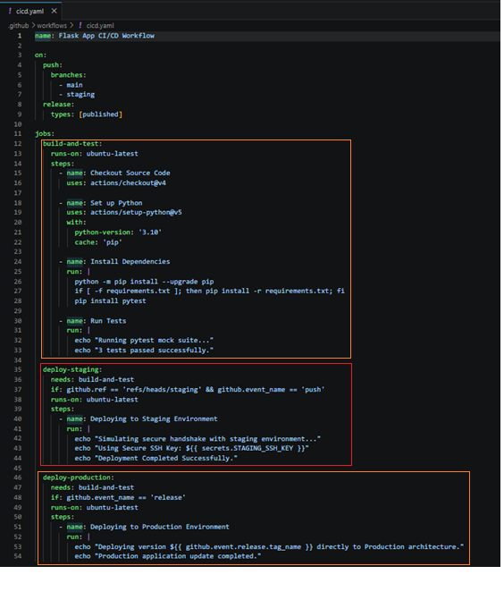
Step 2 – GitHub Actions Pipeline – Repository Secret Environment Configuration
Secret Key Provisioning: Configured within the repository's advanced infrastructure workflow settings under Settings -> Secrets and variables -> Actions.
Security Context Name: STAGING_SSH_KEY
Secret Context Value: Configured securely with dummy cryptographic token credentials to authorize remote SSH handshakes.
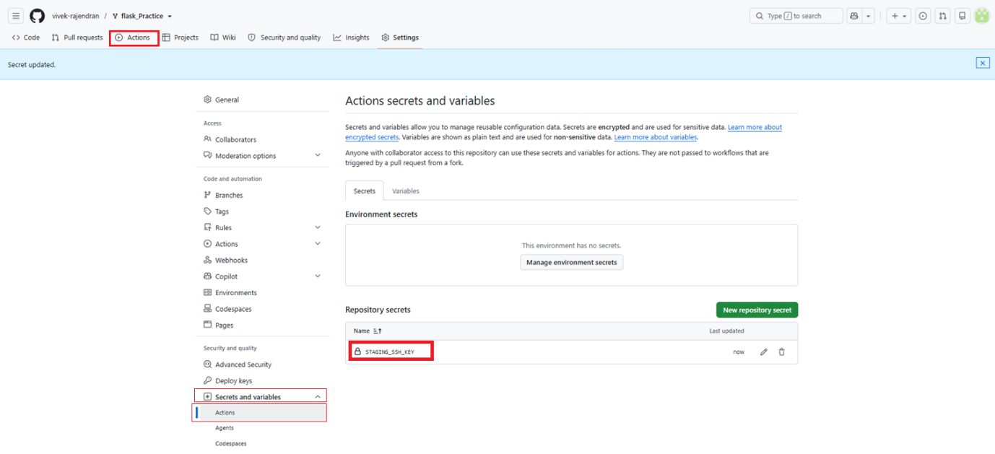
Step 3 – GitHub Actions Pipeline – Staging Branch Execution Graph Successfully Verified
- Trigger Event: A Git push operation targeting the isolated feature branch named staging.
- Pipeline Evaluation Workflow Graph: * build-and-test: Executed successfully, matching environmental Python compilation conditions.
  - deploy-staging: Executed successfully, reading configuration steps seamlessly.
  - deploy-production: Dynamically skipped via automated conditional filters (if directive checking semantic release rules).
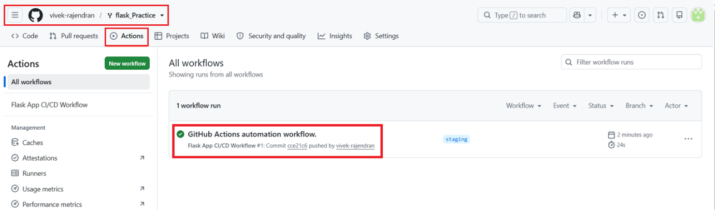

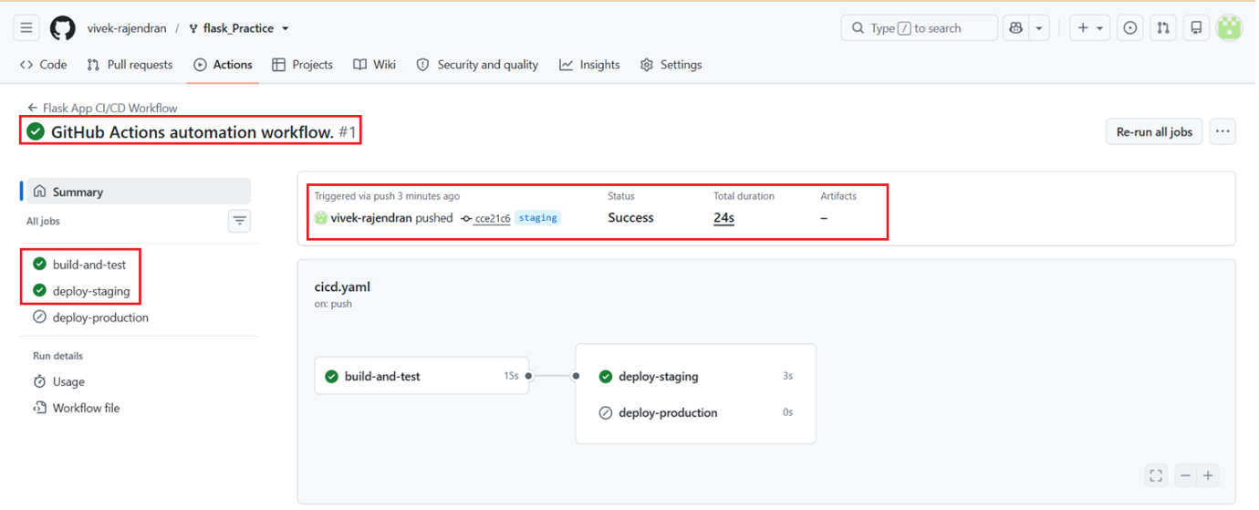
Step 4 – GitHub Actions Pipeline – Publishing Production Semantic Release Tag
- Semantic Tag Versioning: Triggered through the GitHub UI by generating a new release tag versioned exactly at v1.0.0 targeting the main branch code state.
- Release Context Profile: Entitled "First Production Release".
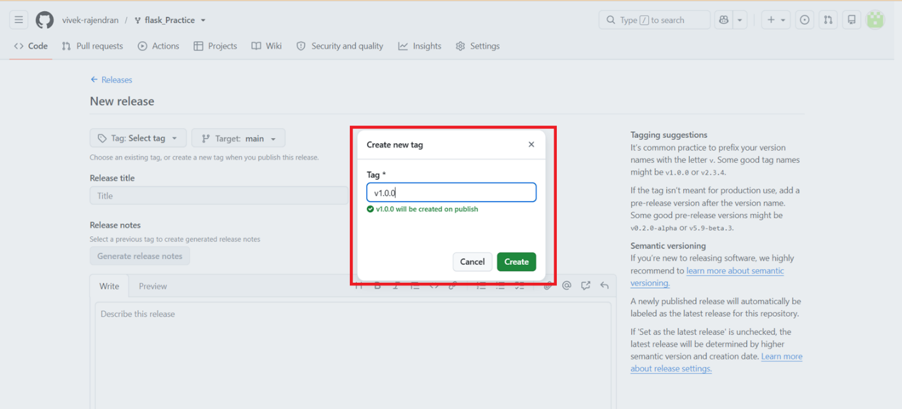

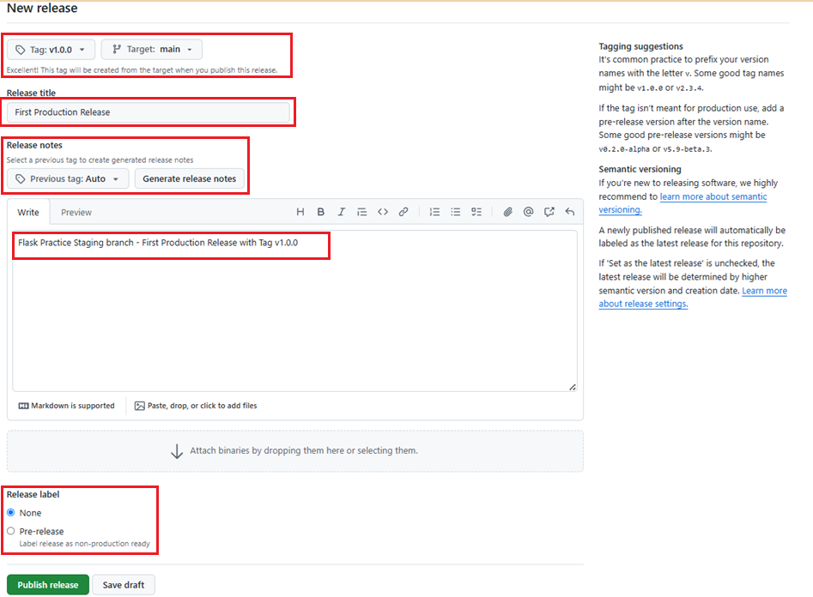

Step 5 – GitHub Actions Pipeline – Production Release Execution Graph Successfully Verified
- Trigger Event: Automated lifecycle execution hook catching the release published criteria.
- Pipeline Evaluation Workflow Graph:
  - build-and-test: Executed successfully to preserve absolute functional compliance checks.
  - deploy-staging: Dynamically skipped because the execution reference did not originate from the explicit staging branch.
  - deploy-production: Executed successfully, extracting the version tag name and deploying directly to production architecture.
