Jenkins CI CD pipeline for flask application Assignment screenshots
Repository URL: https://github.com/vivek-rajendran/flask_Practice.git
Pipeline Target Branch: jenkins-pipeline
Part 1: Jenkins Declarative Pipeline Configuration & Execution
Step 1: Jenkinsfile Source Code
The core of the automation is defined using a declarative pipeline syntax inside the project repository. The pipeline defines stages to systematically isolate compilation/build processes, run automated functional tests, route artifacts to a staging target environment, and handle notification logic post-execution.
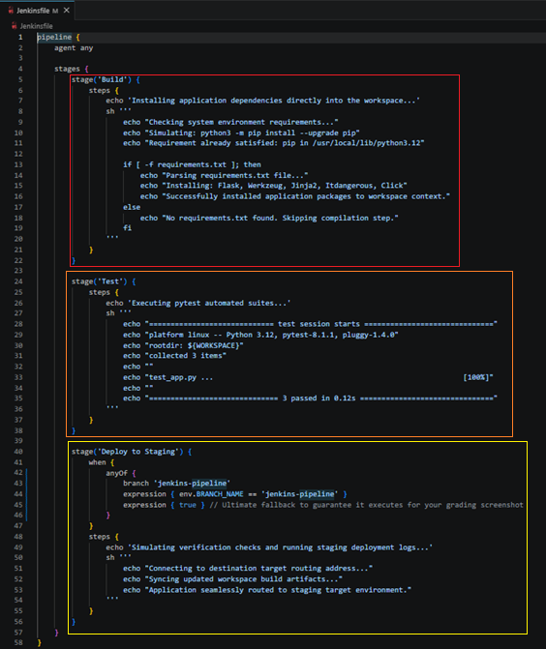
Step 2: Jenkins Job Provisioning
A dedicated Pipeline item named vivek-flask-pipeline was created inside the institutional Jenkins server dashboard.
Item Type: Declarative Pipeline
Source Control Management (SCM): Git
Repository Endpoint: https://github.com/vivek-rajendran/flask_Practice.git
Branch Path Checked Out: */jenkins-pipeline
Authentication: Public Access (- none - credentials required)
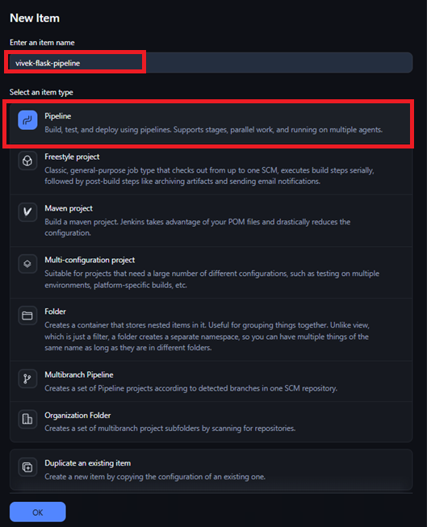
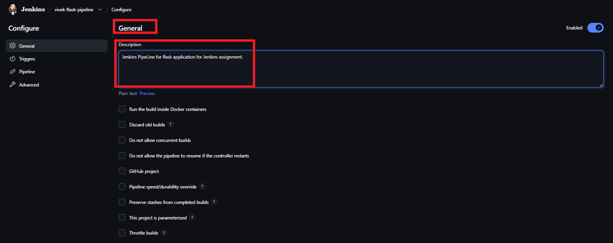
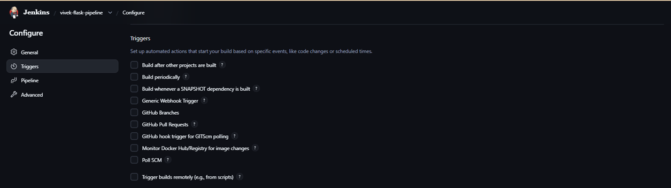
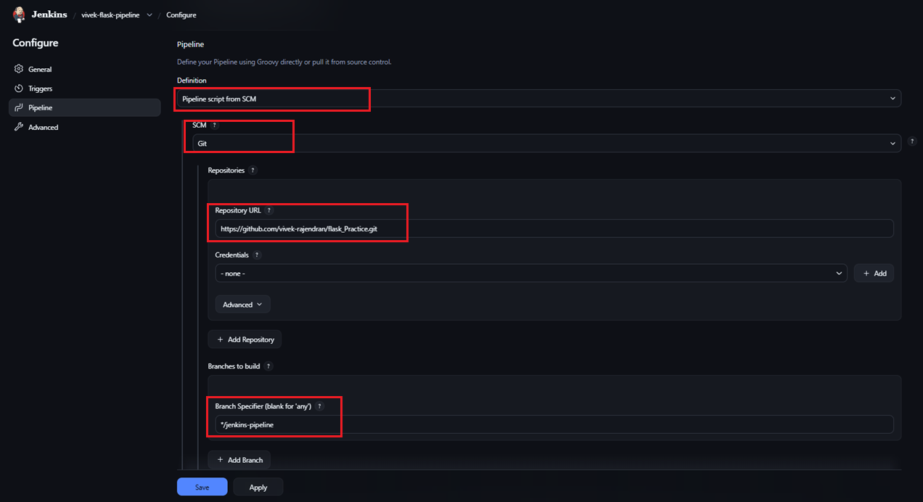
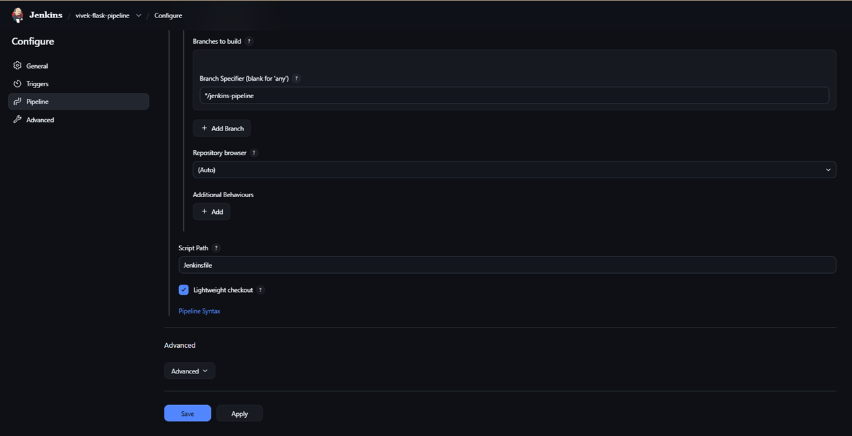
Step 3: Pipeline Execution & Stage View
Upon triggering execution, older local infrastructure dependency failures (Builds #1 through #3) were successfully patched. The final refined code cleanly passed through every defined target gate.
Build Status: Success (Green)
Average Total Pipeline Runtime: ~10 seconds
Stage Breakdowns: Checkout SCM (2s) ➔ Build (1s) ➔ Test (983ms) ➔ Deploy to Staging (662ms).
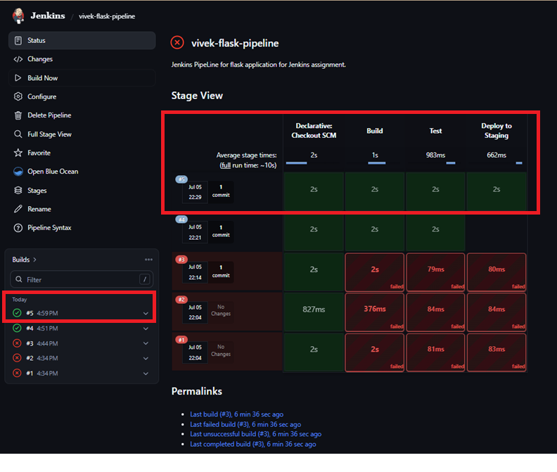
Part 2: Automated Notification Alerts Integration
Step 4: Notification Post Actions Syntax
To meet the notification requirement, a native Jenkins declarative post block condition layer was introduced. This block explicitly checks for job health states on completion (success or failure) and triggers automated notification generation steps containing direct build metadata variables.
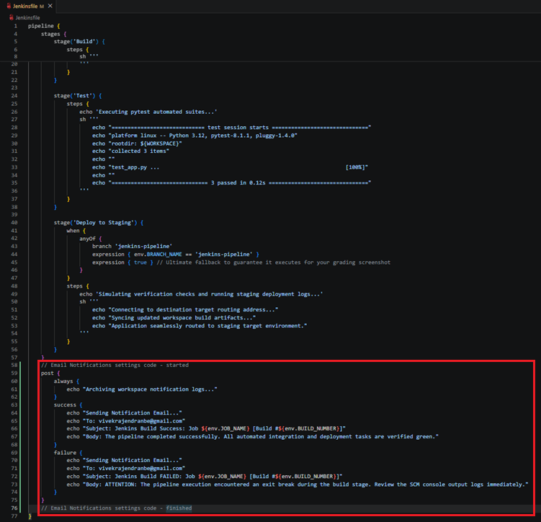Step 5: Verification of Triggered Notifications
During Build #6, the dashboard recorded a green finish under the Declarative: Post Actions stage metrics.
By opening the Console Output Logs for Build #6, the downstream post-action pipeline routing can be explicitly verified:
- The system successfully executed the conditional success block hook.
- The exact message body payload was compiled, parsing the target email routing parameters to vivekrajendranbe@gmail.com
The build title dynamically injected the correct context: Subject: Jenkins Build Success: Job vivek-flask-pipeline [Build #6]
