Wanderlust: A personalized Travelling and Tracking App

INTRODUCTION

Overview:

The overview of travel encompasses several key aspects:

Purpose: Travel can be for various purposes, including leisure, business, education, or visiting friends and family. Leisure travel involves recreational activities, such as vacations, holidays, or tourism, and is often motivated by the desire to relax, explore new destinations, and experience different cultures.

Transportation: Travel involves the use of various modes of transportation, including air travel, which allows for long-distance and international travel within a short period of time

Accommodation: Travelers require accommodation during their trips, which can range from hotels, motels, hostels, vacation rentals, or camping sites.

Planning and Booking: Travel requires planning and booking, including researching destinations, flights, accommodations, transportation options, visas, travel insurance, and other necessary arrangements.

Expenses and Budgeting: Travel expenses vary widely depending on the destination, duration, accommodation, transportation, activities, and personal preferences.

Overall, travel is a multifaceted and enriching experience that allows individuals to explore, learn, and create meaningful memories.

Purpose:

The purpose of travel apps is to provide a wide range of tools, services, and information to make travel planning, booking, and experiencing more convenient, efficient, and enjoyable. Travel apps are typically designed for use on mobile devices, such as smartphones and tablets, and are available as downloadable applications from app stores or accessible through web browsers.

Many travel apps provide features for researching and planning trips, such as finding flights, hotels, rental cars, and activities. Travel apps may offer features to book flights, hotels, rental cars, and other travel-related services. Some travel apps provide comprehensive travel guides with information about destinations, attractions, local transportation, and dining options. ravel apps may offer recommendations for local restaurants, bars, shopping, and other points of interest. Some travel apps provide real-time updates on flight statuses, gate changes, delays, and other travel-related information. Travel apps may offer language translation features to help users communicate in foreign countries where they may not be fluent in the local language. Travel apps may have currency conversion tools to help users quickly calculate and convert currencies when making purchases or dealing with foreign currencies. People with wanderlust are often motivated by a deep curiosity about the world and a desire to broaden their horizons. They may have an insatiable thirst for travel and may feel a constant pull to explore new destinations, immerse themselves in different cultures, and engage in unique activities. Travel apps aim to provide a convenient and comprehensive toolset to assist travellers with various aspects of their journey, from planning and booking to navigation and local recommendations, making travel experiences more efficient, enjoyable, and hassle-free.

PROBLEM DEFINITION AND DESIGN THINKING

Empathy Map:

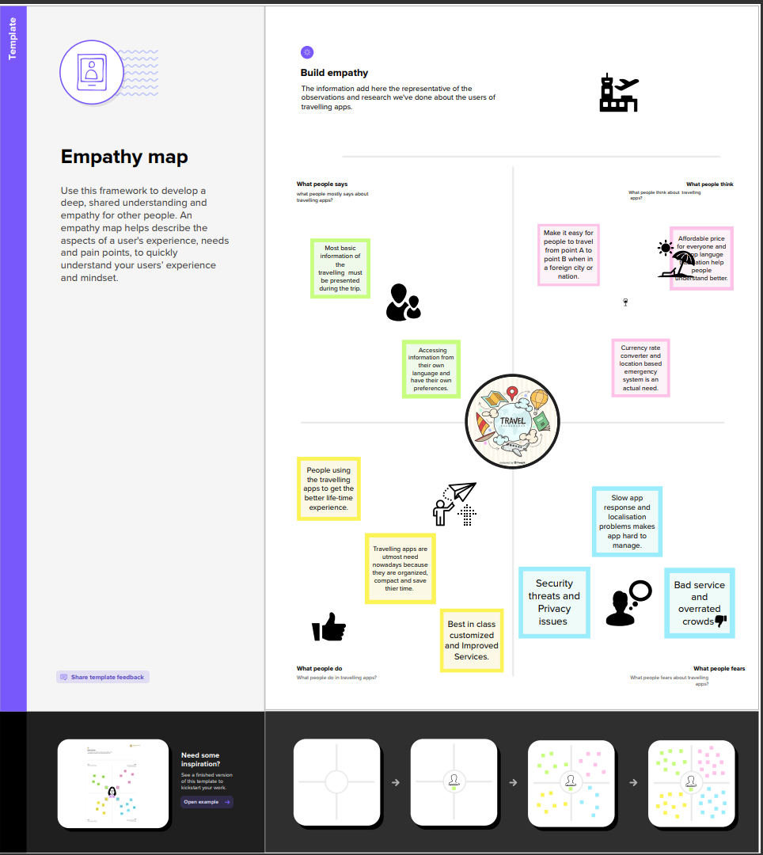

Ideation and Brainstorming Map:

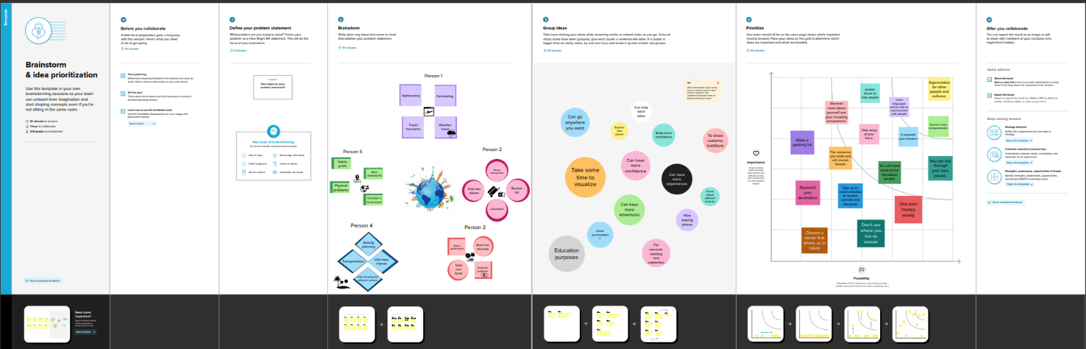

RESULT



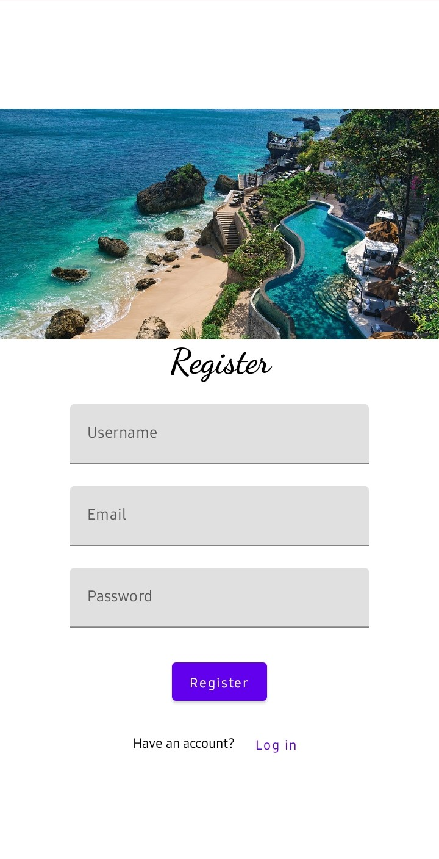

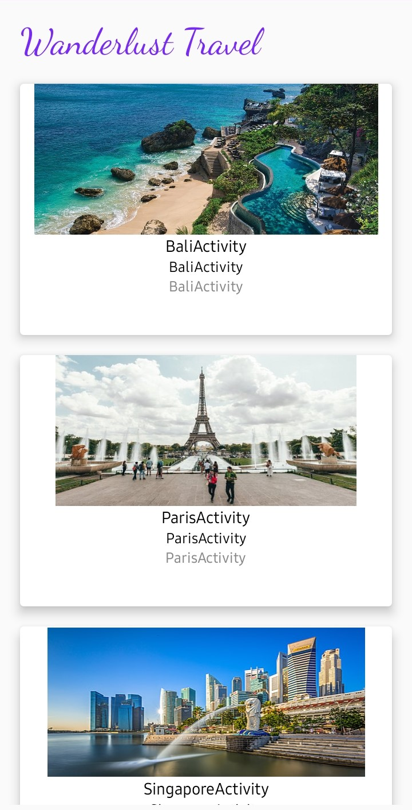

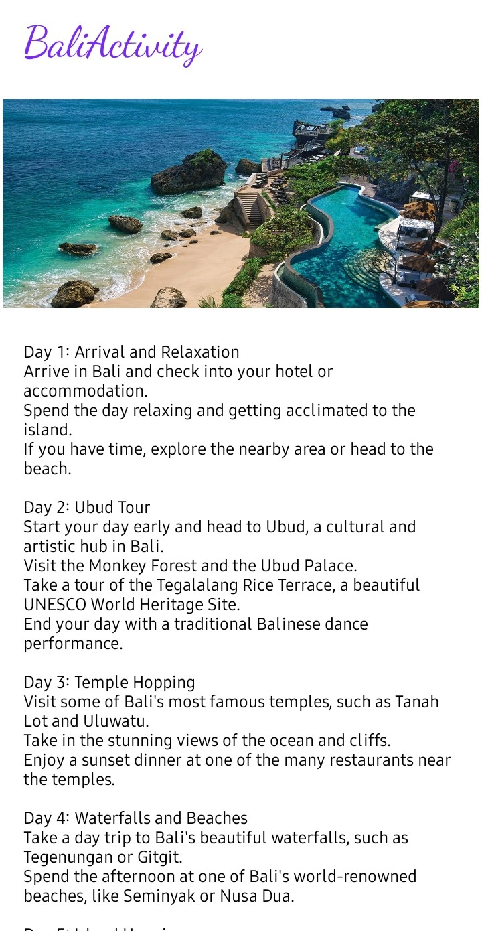



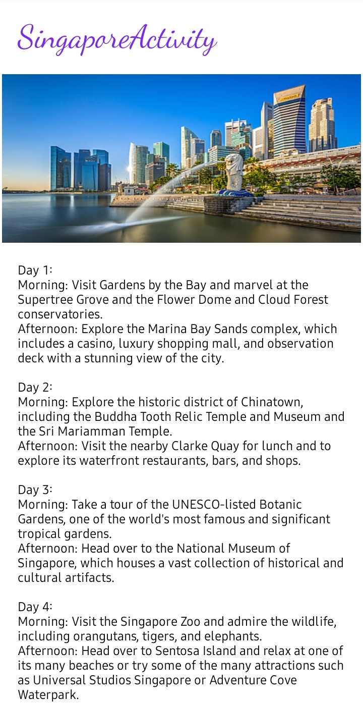

ADVANTAGES AND DISADVANTAGES

Advantages:

There are several advantages of using a traveling app, which can greatly enhance your travel experience. Some of the key advantages include:

*Convenience*: Traveling apps provide convenience by allowing you to plan and manage your trip from the palm of your hand. You can book flights, accommodation, tours, and activities, all in one place.

*Real-time information*: Traveling apps provide real-time information about flights, hotels, and activities, including updates on delays, availability and cancellation.

*Personalization*: Many traveling apps offer personalized recommendations based on your interests, preferences, and previous travel history.

*Navigation and maps*: Traveling apps often include navigation and maps features that help you navigate unfamiliar destinations, find directions, locate points of interest, and plan routes.

*Language and currency conversion*: Traveling apps often offer language translation and currency conversion features, making it easier to communicate with locals and manage your expenses in foreign countries.

Disadvantages:

As with any technology, traveling apps also have their disadvantages. Some of the potential disadvantages of traveling apps include:

*Reliance on technology*: Traveling apps heavily rely on technology, including smartphones, internet connectivity, and GPS, which may not always be available or reliable in all destinations or situations

*Inaccurate or outdated information*: Traveling apps may not always have up-to-date information about destinations, accommodations, transportation, or attractions.

*Privacy and security concerns*: Traveling apps often require access to your personal information, such as your location, itinerary, and payment details.

*Lack of personal touch*: While traveling apps can provide convenient and efficient planning tools, they may lack the personal touch and human interaction that some travellers may value.

*Over-reliance on popular tourist spots:* Many traveling apps tend to highlight popular tourist spots or well-known destinations, which may result in overcrowding and a lack of authentic local experiences.

APPLICATIONS

Traveling apps can be applied in various areas. Traveling apps can help users plan their trips by providing information on flights, hotels, attractions, and activities at their destination. Traveling apps can provide maps, directions, and real-time navigation to help users navigate their way around unfamiliar places. Traveling apps with language translation features can help users overcome language barriers by providing translations of common phrases or facilitating communication with locals in foreign countries. Traveling apps can offer recommendations for local restaurants, cafes, bars, and other points of interest based on user reviews and ratings.

Some traveling apps provide tools to help users manage their travel expenses and budget. Traveling apps can provide safety information, emergency contacts, and assistance in case of unforeseen events such as accidents, natural disasters, or medical emergencies. Some traveling apps create a community of travellers where users can share their experiences, tips, and recommendations. Traveling apps can help users book transportation options such as flights, trains, buses, or car rentals, directly from the app. However, it's important to carefully evaluate the reliability and accuracy of the information provided by the app and consider potential limitations, such as dependence on technology and internet connectivity.

CONCLUSION

In conclusion, traveling apps offer numerous advantages in trip planning, navigation, language translation, local recommendations, budgeting, safety, community building, and transportation booking. They can enhance the travel experience by providing convenient access to information, services, and social networking opportunities. Travellers should also be aware of potential disadvantages such as reliance on technology, accuracy of information, and limitations in certain circumstances.

It's important to carefully evaluate and use traveling apps as tools to supplement and enhance travel experiences, while also exercising caution and common sense when relying on them during your journeys. The problem of cost used to be what left many of the little guys out of the mobile market. But that’s no longer the case.

As travel mobile apps become most affordable and easy to build, more and more businesses in the travel industry are starting to capitalize on their convenience and cost effectiveness.

There’s no reason that you should not begin exploring the option of a mobile app and a mobile marketing strategy to go with it.

There is without a doubt that mobile apps have become truly the most vital aspect of the travel and tourism industry. Businesses must leverage the benefits of developing mobile apps so that they can get on the right path for growth and revenue generation.

FUTURE SCOPE

The future scope of traveling apps is vast and holds significant potential for further innovation and advancement. Here are some potential areas of future development and growth for traveling apps:

*Augmented Reality (AR) and Virtual Reality (VR):* Traveling apps could leverage AR and VR technologies to offer immersive experiences, such as virtual tours of destinations, interactive maps, and 360-degree views of attractions.

*Artificial Intelligence (AI) and Machine Learning (ML):* AI and ML could be used to further personalize and customize travel recommendations based on user preferences, travel history, and real-time data.

*Sustainable and Responsible Travel:* Traveling apps could focus on promoting sustainable and responsible travel practices, such as eco-friendly accommodations, responsible tour operators, and local community engagement.

*Seamless Travel Booking and Payment Integration*: Traveling apps could further streamline the booking and payment process by integrating with various travel providers, such as airlines, hotels, and transportation services, to offer seamless and secure booking options within the app itself.

Multilingual Communication and Translation: Traveling apps could further improve their language translation capabilities to facilitate seamless communication between travellers and locals, even in remote destinations.

*Smart Travel Guides and Itineraries*: Traveling apps could provide smart travel guides and itineraries based on user preferences, interests, and travel history. These guides could offer personalized recommendations, day-to-day itineraries, and real-time updates, making travel planning and navigation even more convenient and tailored to individual needs.

APPENDIX

The appendix of traveling apps includes a wide range of applications that cater to various aspects of travel planning, booking, navigation, and exploration. These apps are designed to assist travellers in making their trips more convenient, enjoyable, and organized. Here are some examples of popular traveling apps that can be considered as an appendix for travellers:

Booking.com: A popular app for finding and booking accommodations, including hotels, hostels, vacation rentals, and more. It offers a wide range of options, filters, and reviews to help travellers find the perfect place to stay.

Skyscanner: A comprehensive flight search app that allows travellers to compare prices from various airlines and travel agencies to find the best deals on flights. It also provides information on flight status, baggage fees, and more.

Google Maps: An essential navigation app that provides maps, directions, and real-time traffic updates for travellers. It also offers public transportation information, reviews of restaurants and attractions, and offline maps for use in areas with no internet connection.

Airbnb: An app that allows travellers to book unique accommodations, such as homes, apartments, and villas, directly from hosts. It also provides filters, reviews, and messaging capabilities to communicate with hosts and make bookings.

Lounge Buddy: An app that allows travellers to find and book airport lounges worldwide. It provides information on amenities, reviews, and access requirements for various lounges, making layovers more comfortable.

Depending on individual preferences and travel needs, there are numerous other apps that can be helpful for planning, booking, navigating, and enhancing the overall travel experience.

Source for the code built: https://github.com/smartinternz02/Travel-Plan-App