Homework 5:

Gene Functional Enrichment
In this assignment, I worked with the output file from my Cuffdiff analysis, which contains data about differentially expressed genes (DEGs) between two conditions or samples. My goal was to identify the top 200 genes with the smallest p-values, which are the most statistically significant.
Step-by-Step:
- I opened the file in Excel
First, I opened the Cuffdiff results file using Excel (or another spreadsheet program) so I could easily view and organize the data.
- I found the p-value column
I located the column that contains the p-values for each gene. This column tells me how statistically significant each gene’s expression change is.
- I sorted the genes by p-value (ascending order)
I sorted the entire table based on the p-value column, from smallest to largest. This allowed me to see the most significant genes at the top of the list.
- I selected the top 200 genes
After sorting, I looked at the first 200 rows in the list—these represent the 200 genes with the smallest (most significant) p-values.
- I copied the gene symbols
From those 200 rows, I copied only the gene names or symbols from the appropriate column. These are the genes I will use in the next step for functional enrichment analysis.

Functional Enrichment Analysis – Step-by-Step Guide (DAVID + Cytoscape)
Introduction
Functional enrichment analysis helps me understand what biological roles my top genes play. I’ve already identified the top 200 differentially expressed genes (DEGs) from my Cuffdiff analysis (based on small p-values). Now, I want to find out:
- What biological processes they're involved in.
- What cellular parts they’re linked to.
- What molecular functions they serve.
- And what known pathways they may participate in.
I used two tools for this:
- DAVID – for easy online functional annotation.
- Cytoscape with the BiNGO plugin – for advanced visualization of Gene Ontology results.

PART 1: Using the DAVID Database
Steps I Followed:
- Visited the DAVID Website
I went to the official DAVID website: https://david.ncifcrf.gov
- Uploaded My Gene List
On the homepage, I used the "Upload" or "Gene List" option to paste or upload my list of the top 200 gene symbols I had previously selected from my Cuffdiff analysis.
- Selected Functional Annotation Categories
I navigated to the “Functional Annotation Tool” section and selected these categories:
  - Under Gene Ontology (GO):
    - GOTERM_BP_ALL → for Biological Processes
    - GOTERM_CC_ALL → for Cellular Components
    - GOTERM_MF_ALL → for Molecular Functions
  - Under Pathways:
    - KEGG_PATHWAY → to analyze known biological pathways.
- Performed Functional Annotation Clustering
After selecting the categories, I clicked the “Functional Annotation Clustering” button. This started the enrichment analysis.
- Reviewed My Results
Once the results were ready, DAVID gave me a list of enriched terms that is, functions or processes that were overrepresented in my list of DEGs. These helped me understand which biological themes are most relevant in my data.
- Repeated the Process for Each Analysis Type
I went back and repeated steps 3–5 to make sure I got results for each GO category and KEGG pathway individually, to keep things organized and easy to interpret.
PART 2: Using Cytoscape + BiNGO Plugin for Visualizing GO Terms
Why I Used Cytoscape
I wanted to go beyond just lists and see graphs of the enriched terms for better presentation and understanding. Cytoscape, with the BiNGO plugin, allowed me to do this.
Steps I Followed:
- Installed BiNGO in Cytoscape
  - I opened Cytoscape.
  - From the top menu, I went to "Apps" → "App Manager".
  - I searched for BiNGO, then installed it.
- Imported My Gene List
I loaded my 200 gene symbols into Cytoscape using the import function.
- Ran BiNGO for Each GO Category
  - I opened BiNGO from the "Apps" menu.
  - I ran GO enrichment analysis three times, once for each category:
    - GO_BP → Biological Process
    - GO_MF → Molecular Function
    - GO_CC → Cellular Component
  - BiNGO ran the analysis and created network graphs showing which GO terms were enriched and how they were connected.
- Downloaded the Graphs
  - Once the analysis was done, I right clicked each graph and chose the save/export option.
  - I saved the graphs for GO_BP, GO_MF, and GO_CC separately.
- Edited the Figures for Better Presentation
  - I opened each graph in Cytoscape and used its editing tools to improve the look:
    - Changed node colors, shapes, and font sizes.
    - Adjusted layout to make the network cleaner.
    - Added titles and labels for clarity.
  - Finally, I saved the edited, polished graphs to include them in my report or presentation.

GOTERM_BP_ALL
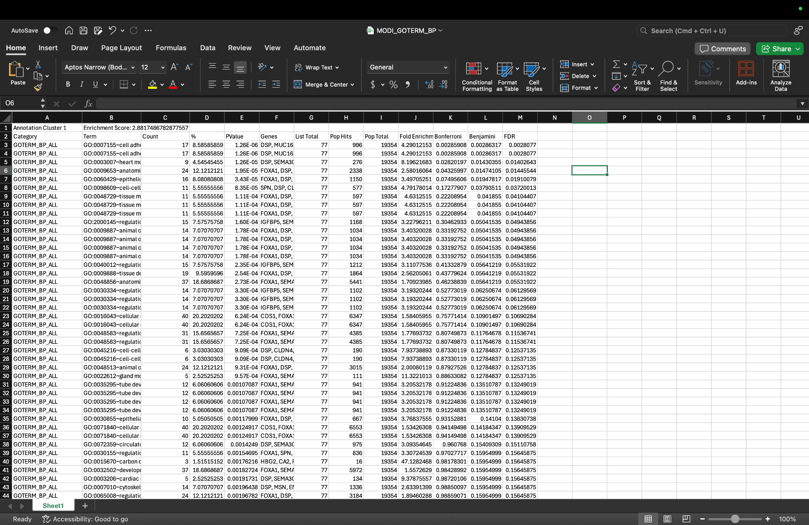

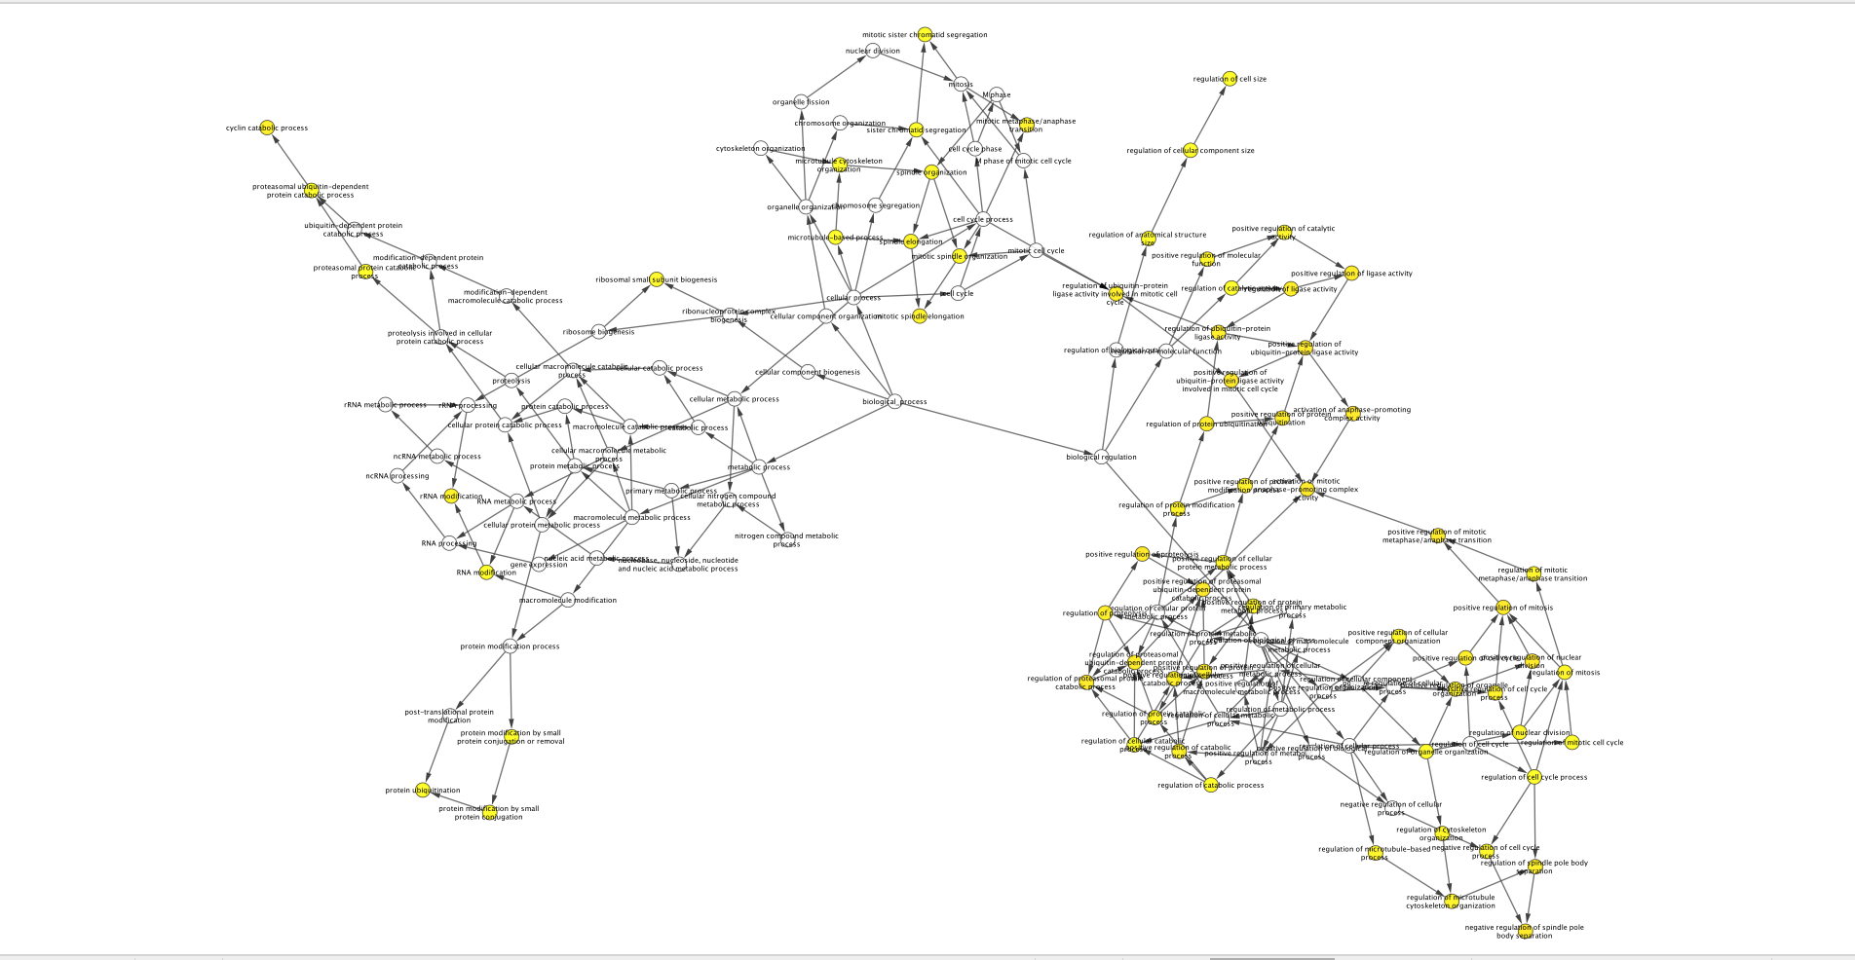

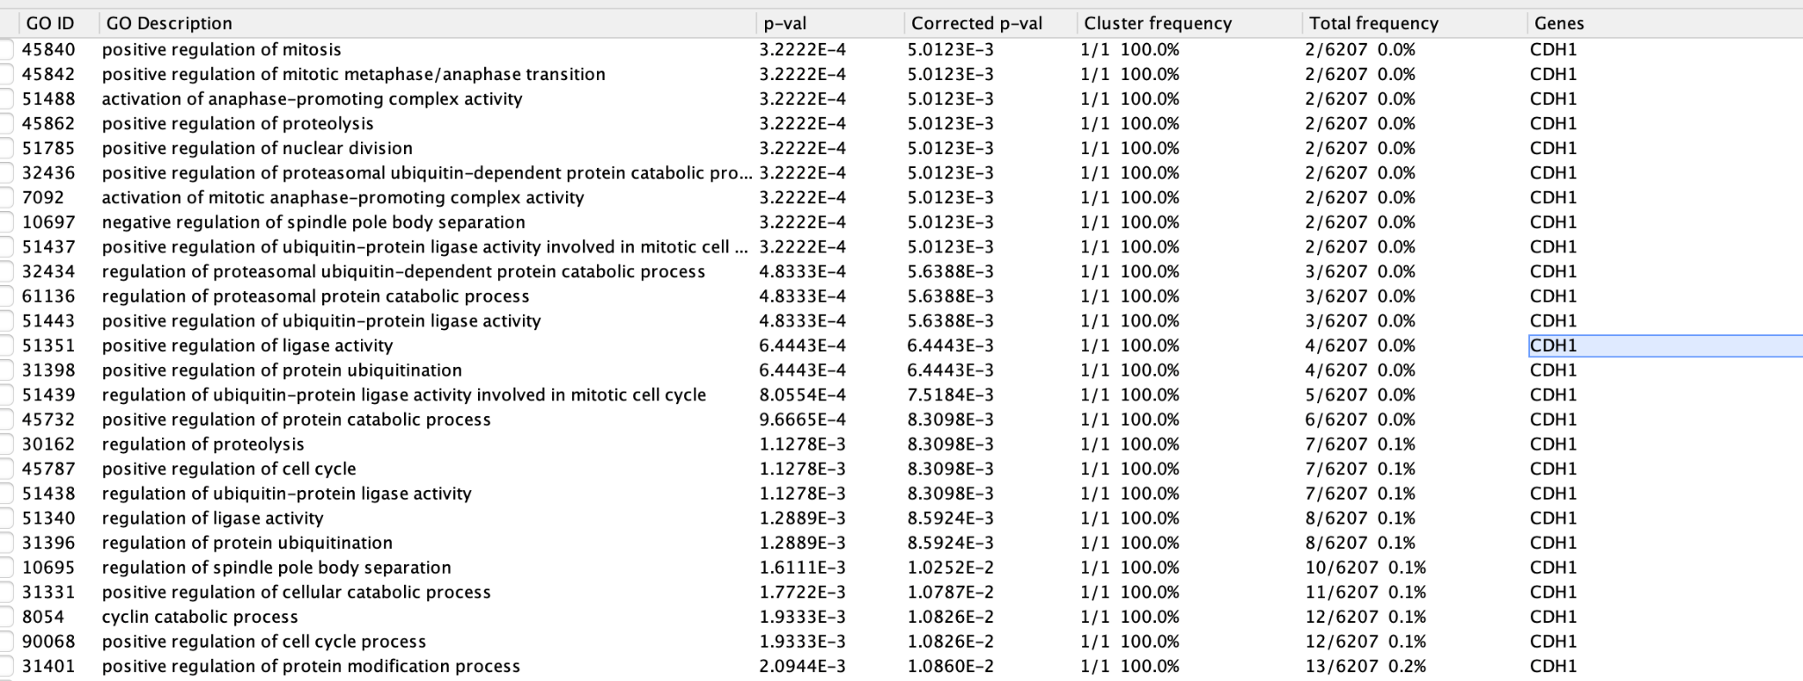

CC_PATHWAY

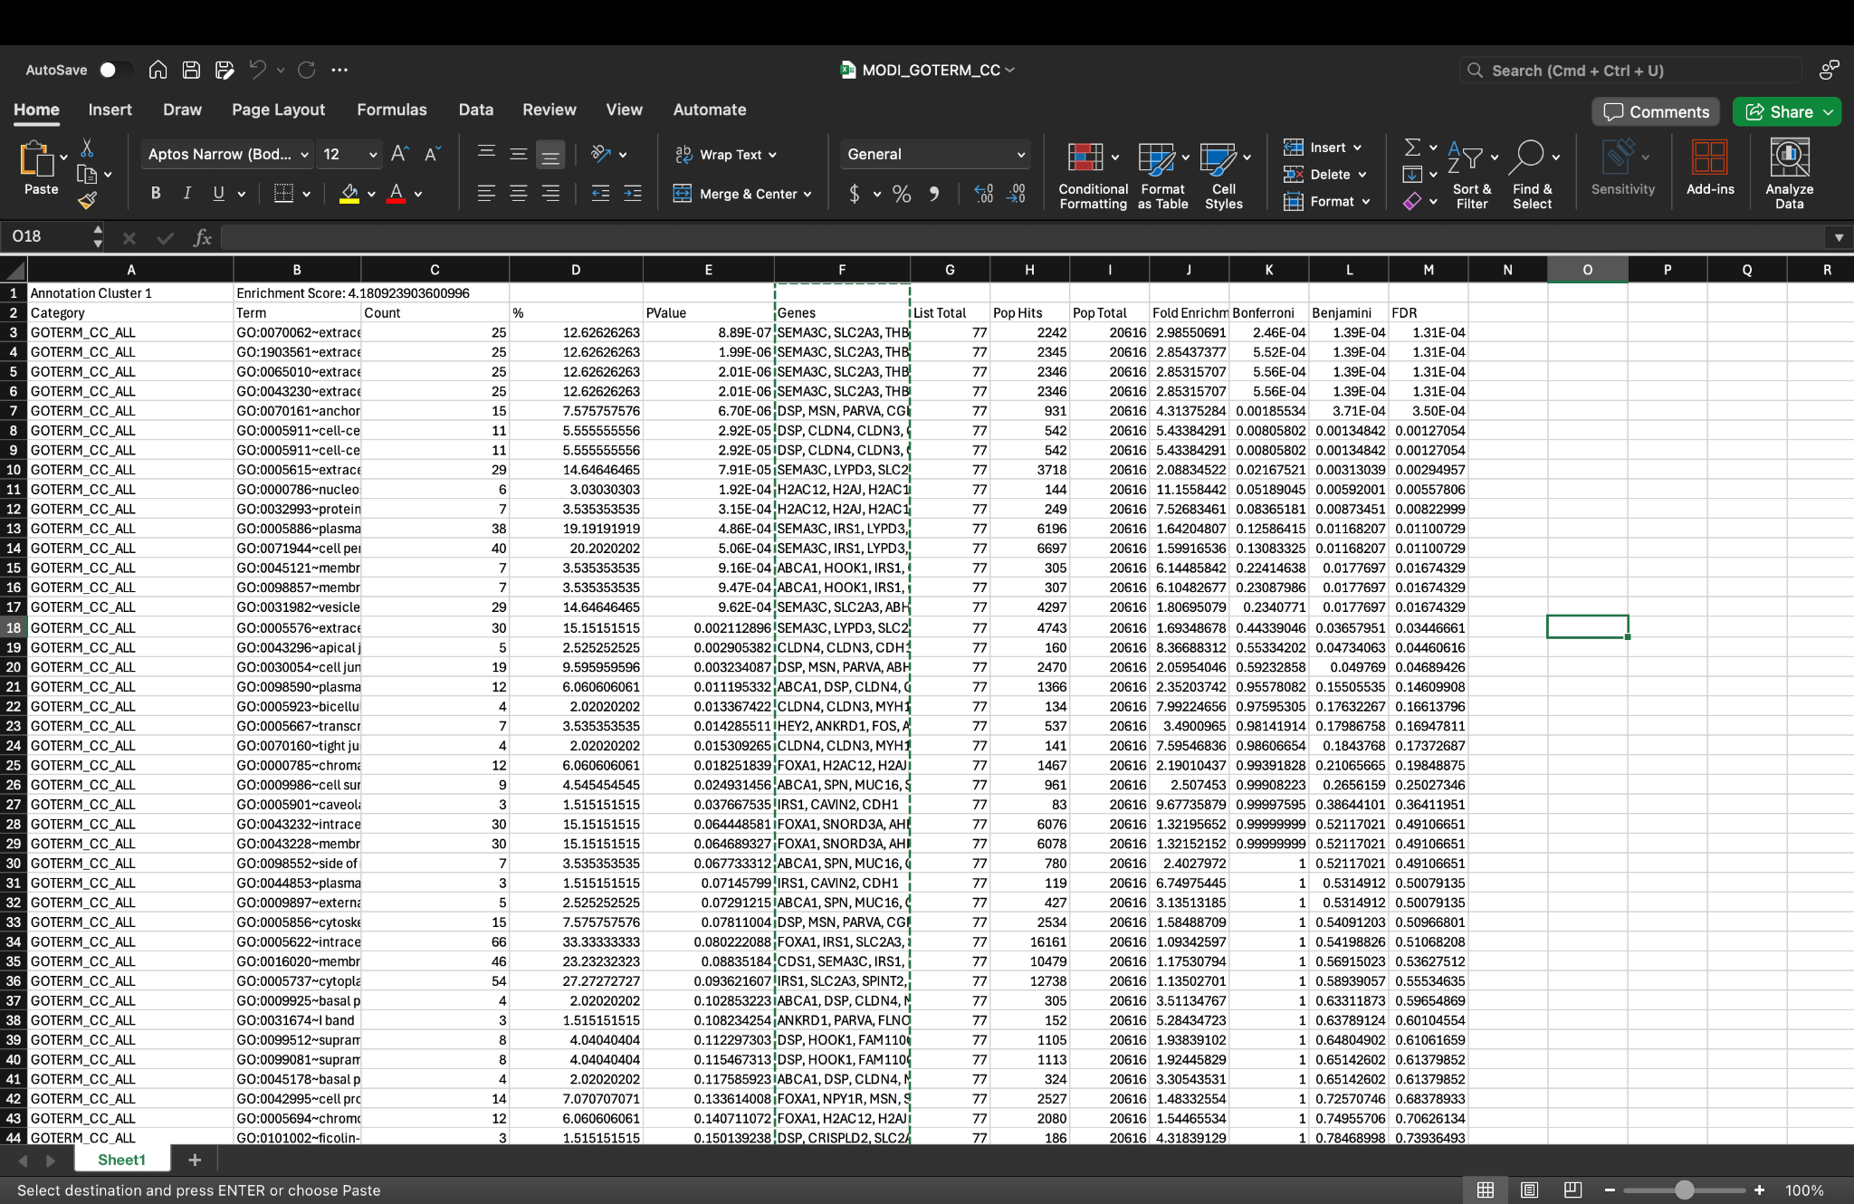

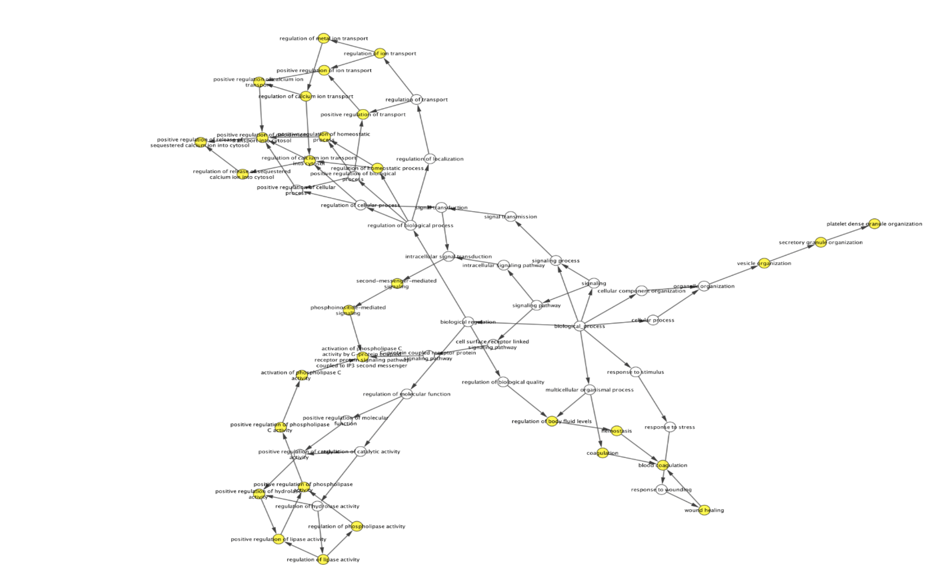

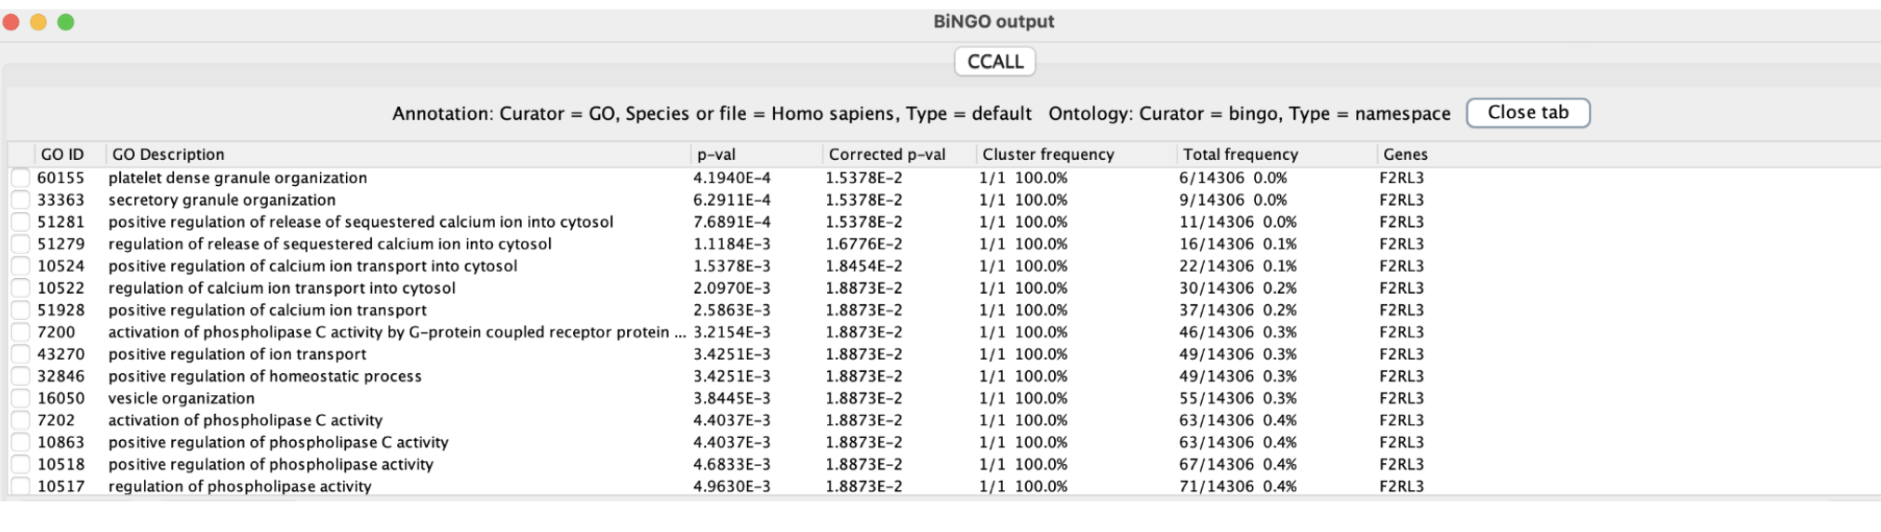

MF_ALL

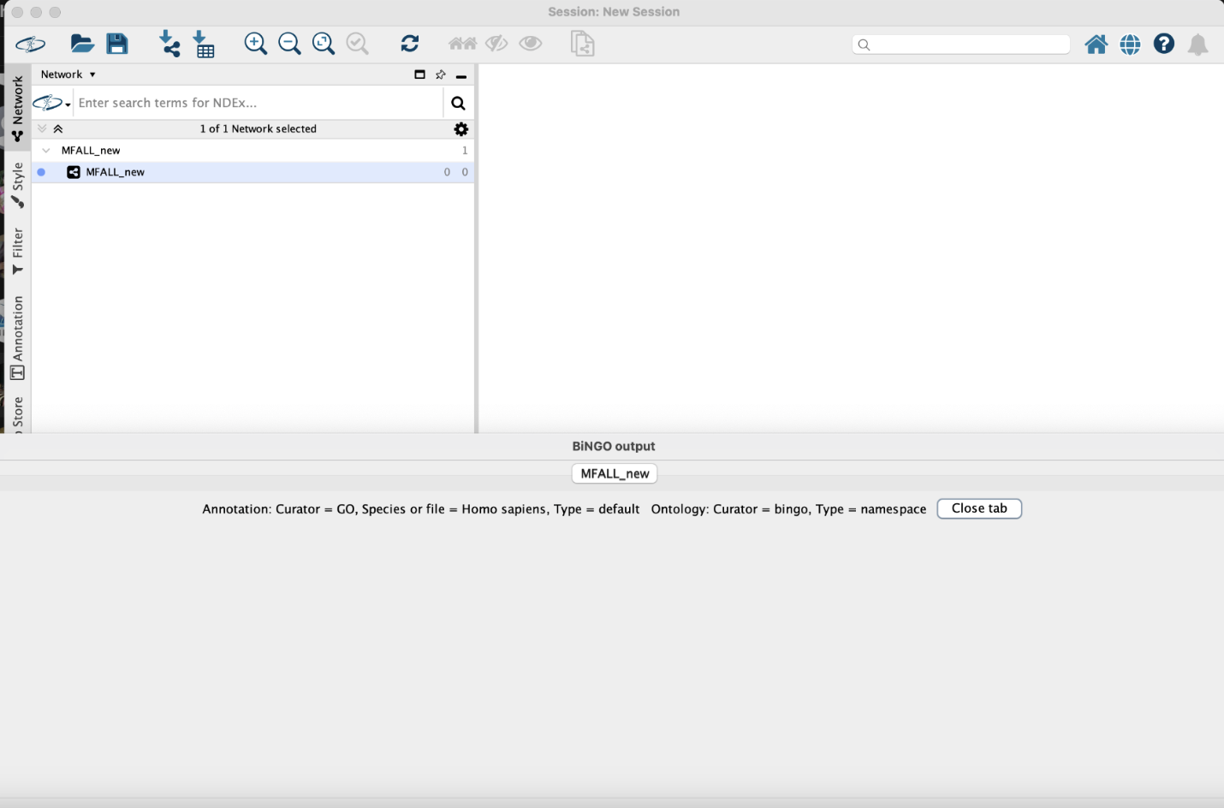

My Functional Enrichment Analysis – What I Discovered
After performing functional enrichment analysis using Gene Ontology (GO) terms and KEGG pathways, I uncovered several important biological insights based on the top 200 differentially expressed genes (DEGs) from my dataset. I used a strict p-value threshold of < 0.01 to make sure the results were statistically significant and reliable.

1. GO Biological Processes – Communication and Regulation Are Key
- Cell Communication & Signaling:
Many of the genes in my list are involved in cell communication and signaling pathways. Terms like ‘cell communication’ and ‘signal transduction’ appeared frequently. This suggests that my DEGs are highly active in helping cells send and receive signals, which is essential for coordinating biological responses.
- Regulation of Processes:
A large number of genes are tied to regulating biological processes, especially regulation of signaling. This shows that these genes are not just passive players—they help control how signals are turned on or off, making sure the cells stay balanced and respond appropriately to changes in their environment.

2. GO Cellular Components – Focus on Neurons and the Extracellular Matrix
- Synaptic and Neuronal Structures:
The analysis showed strong enrichment in terms like ‘postsynaptic density’ and ‘neuron-to-neuron synapse’. This tells me that many of the genes are located in or function around synaptic areas, hinting at a possible role in neurological processes or brain function.
- Extracellular Matrix (ECM) Involvement:
Genes were also linked to components of the extracellular matrix, including the ‘basement membrane’. This suggests these genes are involved in activities outside the cell, such as cell adhesion, migration, and maintaining tissue structure. The ECM plays a vital role in how cells interact with their surroundings.
3. GO Molecular Functions – Gene Activity and Enzyme Control
- Molecular Function Regulators:
A good number of genes fell into the category of ‘molecular function regulators’. This means these genes help control the activity of other molecules, showing their importance in keeping the cell’s internal processes well-regulated and stable.
- Enzyme Modulation and GTPase Activity:
I also found enrichment in genes involved in enzyme activation and GTPase activity. These functions are crucial for energy transfer, signaling, and molecular communication inside the cell. It shows that my DEGs are active in modulating key biochemical reactions.

4. KEGG Pathways – Links to Heart Health and Cell Behavior
- Cardiomyopathy Connections:
Some genes were linked to cardiomyopathy-related pathways. This suggests that these DEGs might play a role in heart muscle function and possibly cardiovascular diseases. It’s a significant finding if the study is related to heart biology or disease.
- ECM-Receptor Interaction & Focal Adhesion:
Pathways like ‘ECM-receptor interaction’ and ‘Focal adhesion’ were also enriched. These are important for how cells stick to surfaces, move, and communicate with the environment. It shows that these genes are deeply involved in cell-matrix interactions, which are essential in processes like wound healing, cell migration, and tissue development.
Conclusion
By using both GO and KEGG enrichment analyses with a strict p-value cutoff (< 0.01), I was able to confidently identify the most meaningful biological patterns in my dataset. My results point to important roles in:
- Signaling and regulation
- Neuronal activity
- Extracellular matrix involvement
- Enzyme activity
- Cardiovascular pathways
These findings give a solid foundation for understanding what the differentially expressed genes are doing and how they might be impacting the biological system I’m studying.

