FOOD DELIVERY ANALYSIS DASHBOARD
USING TABLEAU
Project Report
Submitted as part of the Final Project Documentation
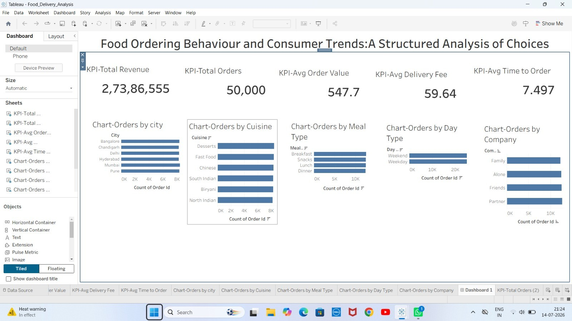
Figure 0: Food Delivery Analysis — Tableau Dashboard Overview
Tools Used: Tableau Desktop | Tableau Public | Microsoft Excel | GitHub
GitHub Repository: https://github.com/mohanabhavyavattikuti-214/Food_Delivery_Analysis.git
Project Demo Video: https://drive.google.com/drive/folders/1j6EjEtxDiDqTo_tV54i4PqgKaoEd3LgQ?usp=sharing

TABLE OF CONTENTS

1. INTRODUCTION

1.1 Project Overview
The Food Delivery Analysis Dashboard is an interactive business intelligence project developed using Tableau. With the rapid growth of online food ordering platforms, businesses today generate massive volumes of transactional data every single day. This data holds valuable insights about customer ordering behavior, delivery efficiency, and revenue patterns, but it is often too large and unstructured to interpret manually. This project addresses that challenge by transforming raw food delivery data into a single, interactive dashboard that summarizes business performance through clear visual analytics.
The dashboard consolidates Key Performance Indicators (KPIs) such as Total Revenue, Total Orders, Average Order Value, Average Delivery Fee, and Average Time to Order into one view. It further breaks down order data by city, cuisine type, meal type, day type (weekday/weekend), and delivery company, allowing stakeholders to quickly identify patterns that would otherwise remain hidden inside spreadsheets or database tables.
By using Tableau's drag-and-drop visualization capabilities, the project demonstrates how modern BI tools can be used to build professional, decision-ready dashboards without the need for extensive programming, making data analysis accessible to both technical and non-technical business users.

1.2 Purpose
The core purpose of this project is to convert raw, unorganized food delivery data into meaningful, actionable business insights. Specifically, the dashboard is designed to:
- Provide a real-time-style summary of business performance through KPI cards.
- Help stakeholders understand which cities and cuisines drive the most revenue.
- Reveal customer ordering patterns across different meal types and times of day.
- Compare weekday versus weekend ordering behavior to support resource and staffing decisions.
- Support faster, evidence-based decision-making instead of relying on static, manually generated reports.
Ultimately, the purpose of the project is to bridge the gap between raw operational data and strategic business decision-making by presenting information in a format that is fast to read, easy to interpret, and visually engaging.
Beyond its immediate analytical function, the dashboard is also intended to serve as a reusable template for future data analysis efforts within the organization. Because it is built on standard KPI structures and common dimensions such as city, cuisine, and meal type, the same design pattern can be adapted to other datasets or business domains with minimal modification.
Tableau was chosen specifically because of its widespread adoption in the industry, its intuitive visual interface, and its ability to handle reasonably large datasets — such as the 50,000-order dataset used here — without requiring specialized database infrastructure.

2. IDEATION PHASE

2.1 Problem Statement
Food delivery companies collect large volumes of customer and order data on a daily basis, including details such as order value, delivery time, cuisine preferences, and city-wise demand. However, without a proper analytical framework, it becomes extremely difficult for business teams to identify meaningful trends, monitor performance, or understand customer preferences in a timely manner.
Traditional reporting methods, such as static spreadsheets or manually compiled reports, are time-consuming to produce and difficult for stakeholders to interpret at a glance. Important trends can be missed entirely, and decision-making is delayed as a result. There is therefore a clear need for an interactive, visual dashboard that can present business-critical insights in real time and allow users to explore the data from multiple angles.

2.2 Empathy Map Canvas
To better understand the needs of the end users of this dashboard — primarily business managers, operations teams, and marketing analysts — an empathy mapping exercise was carried out considering what these users typically think, feel, say, and do when dealing with delivery performance data.
Dimension | Insight
Says / Thinks | Business users often say they “don't have time to dig through raw data” and think that decisions are being delayed due to lack of clarity in existing reports.
Does / Feels | Managers frequently resort to requesting ad-hoc reports from analysts and feel frustrated when insights arrive too late to act on. They feel more confident and in control when they can visually see performance trends themselves.
Pain Points | Delayed reporting, difficulty comparing performance across cities and cuisines, and lack of a single consolidated view of business health.
Gains Expected | A single dashboard that answers key business questions instantly, without needing technical support each time a new question arises.

2.3 Brainstorming
A brainstorming session was conducted to identify the most relevant metrics and visualizations that would deliver maximum value to end users. The following ideas emerged as priorities for the dashboard:
- Consolidate all major KPIs (Revenue, Orders, AOV, Delivery Fee, Time to Order) into a single summary view.
- Break down performance by geography (city-wise orders) to identify high-performing and underperforming regions.
- Analyze cuisine-wise and meal-type-wise demand to guide menu and marketing strategy.
- Compare weekday vs weekend ordering patterns to support staffing and delivery-resource planning.
- Include company-wise breakdown to evaluate delivery partner performance.
These ideas were prioritized using a simple impact-versus-effort framework. High-impact, low-effort ideas — such as building KPI summary cards and city-wise breakdowns — were prioritized for the first iteration of the dashboard. Ideas considered valuable but more complex to implement, such as predictive demand forecasting, were deferred and instead captured under the Future Scope of this project.
This structured brainstorming approach ensured that the limited project timeline was used efficiently, focusing effort on the visualizations that would deliver the greatest immediate value to business stakeholders, while still documenting longer-term ideas for future iterations of the dashboard.

3. REQUIREMENT ANALYSIS

3.1 Customer Journey Map
Understanding the customer's journey — from browsing the food delivery app to receiving their order — helps contextualize the data being analyzed in the dashboard. The typical customer journey consists of the following stages:
1. App / Website Browsing
↓
2. Cuisine & Restaurant Selection
↓
3. Order Placement
↓
4. Payment
↓
5. Order Preparation
↓
6. Delivery Dispatch
↓
7. Order Receipt

Each stage of this journey generates data points that feed into the dataset used for this project — for example, the 'time to order' metric reflects the browsing-to-checkout stage, while delivery fee and delivery company fields reflect the dispatch and delivery stage. Mapping this journey ensured that the dashboard's KPIs and visualizations align with real points of business value along the customer experience.

3.2 Solution Requirement
Based on the problem statement and brainstorming outcomes, the following functional and non-functional requirements were defined for the dashboard solution:
- Functional: Display consolidated KPIs (Total Revenue, Total Orders, Average Order Value, Average Delivery Fee, Average Time to Order).
- Functional: Provide visual breakdowns of orders by city, cuisine, meal type, day type, and delivery company.
- Functional: Allow filtering and drill-down interaction within the dashboard.
- Non-Functional: The dashboard must load and render visuals quickly for a smooth user experience.
- Non-Functional: The interface must be intuitive enough for non-technical business users to interpret without training.
- Non-Functional: The solution must be built using accessible, well-documented tools (Tableau) to ensure maintainability.

3.3 Data Flow Diagram
The data flow for this project follows a linear pipeline: raw data is collected, cleaned, imported into Tableau, transformed using calculated fields, and finally rendered as interactive worksheets that are combined into the final dashboard.
Raw Dataset (CSV / Excel, 50,000 records)
↓
Data Cleaning & Preprocessing
↓
Import into Tableau Desktop
↓
Calculated Fields & Aggregations
↓
Individual Worksheets (City, Cuisine, Meal Type, Day Type, Company)
↓
Combined Interactive Dashboard
↓
Published Output (Tableau Public / GitHub)

3.4 Technology Stack
- Tableau Desktop — for building and designing the interactive dashboard.
- Tableau Public — for publishing and sharing the dashboard online.
- Microsoft Excel / CSV — as the source format for the dataset.
- GitHub — for version control and hosting project documentation/demo links.
Tableau Desktop served as the primary development environment, providing the drag-and-drop interface used to build calculated fields, individual worksheets, and the final combined dashboard. Tableau Public was used as the publishing platform, allowing the finished dashboard to be shared with viewers through a web browser without requiring them to install any software.
Microsoft Excel and CSV formats were used to store and pre-process the raw dataset before import, taking advantage of Excel's familiar spreadsheet interface for initial data inspection and light cleaning prior to loading the data into Tableau. GitHub was used to host project documentation, maintain a record of project progress, and provide a central link to the published dashboard and dataset for reviewers and stakeholders.
This combination of tools was chosen deliberately to keep the technology stack lightweight and accessible, avoiding the overhead of setting up a full database server or backend application, which was unnecessary given the scope and dataset size of this project.

4. PROJECT DESIGN

4.1 Problem Solution Fit
The problem identified was the lack of a fast, visual way to interpret large volumes of food delivery data. The proposed solution — an interactive Tableau dashboard — directly fits this problem by replacing static, manually-generated reports with a dynamic, always-up-to-date visual summary that any business stakeholder can explore independently.
This fit is validated by the fact that the dashboard's KPIs and charts map directly onto the pain points identified during the empathy mapping exercise: delayed insights are solved through instant visual summaries, and difficulty comparing performance is solved through side-by-side city, cuisine, and company breakdowns.

4.2 Proposed Solution
The proposed solution is a single-page, interactive Tableau dashboard containing five KPI summary cards and five supporting visualizations (Orders by City, Orders by Cuisine, Orders by Meal Type, Orders by Day Type, and Orders by Company). Users can interact with the dashboard to filter and drill into specific segments of the data, enabling self-service analysis without requiring support from a data analyst for every question.
The dashboard was designed with clarity and simplicity in mind — using consistent color schemes, clearly labeled axes, and an intuitive layout that places the most important KPIs at the top, followed by supporting detail charts below.

4.3 Solution Architecture
At a high level, the solution architecture consists of three layers: the Data Layer (the cleaned dataset in CSV/Excel format), the Processing Layer (Tableau's calculated fields and aggregation engine), and the Presentation Layer (the interactive dashboard interface consumed by end users).
PRESENTATION LAYER — Interactive Tableau Dashboard (KPI cards + charts)
↓
PROCESSING LAYER — Calculated Fields & Aggregations (AOV, Avg Delivery Fee, Avg Time to Order)
↓
DATA LAYER — Cleaned Order-Level Dataset (CSV / Excel, 50,000 records)

This layered architecture ensures a clean separation between raw data, business logic (calculated KPIs), and the final visual presentation, making the dashboard easier to maintain and extend with new data or additional metrics in the future.
The Data Layer is responsible solely for storing the cleaned order-level records, including fields such as order ID, city, cuisine type, meal type, delivery company, order value, delivery fee, and order timestamp. Keeping this layer independent from the visualization logic means the underlying dataset can be refreshed or replaced without needing to rebuild the dashboard from scratch.
The Processing Layer performs all necessary calculations, including the derivation of Average Order Value, Average Delivery Fee, and Average Time to Order using Tableau's calculated field functionality. This layer also handles aggregation logic for grouping orders by city, cuisine, meal type, day type, and company.
The Presentation Layer is the interactive dashboard itself, combining KPI cards and charts into a single cohesive view. This layer is what end users directly interact with, and it was designed with careful attention to layout, color consistency, and readability to ensure that insights can be absorbed quickly and accurately.

5. PROJECT PLANNING & SCHEDULING

5.1 Project Planning
The project was executed in a structured, phase-wise manner to ensure timely completion and quality output. The overall plan followed the methodology outlined below:
- Phase 1 — Data Collection: Gathering the raw food delivery dataset.
- Phase 2 — Data Cleaning: Removing inconsistencies, duplicates, and formatting issues from the dataset.
- Phase 3 — Tableau Import & Setup: Importing the cleaned dataset into Tableau Desktop.
- Phase 4 — Calculated Fields: Creating derived metrics such as Average Order Value and Average Time to Order.
- Phase 5 — Worksheet Design: Building individual visualizations for each business dimension (city, cuisine, meal type, day type, company).
- Phase 6 — Dashboard Assembly: Combining all worksheets and KPI cards into a single interactive dashboard.
- Phase 7 — Testing & Validation: Verifying calculation accuracy and interactivity of filters.
- Phase 8 — Publishing: Publishing the final dashboard to Tableau Public and documenting the project on GitHub.
This phase-wise plan ensured that each stage of the project — from raw data to a polished, interactive dashboard — was completed methodically, reducing rework and ensuring the final deliverable met the defined requirements.

6. FUNCTIONAL AND PERFORMANCE TESTING

6.1 Performance Testing
Once the dashboard was built, it was tested for both functional correctness and performance responsiveness. Functional testing involved verifying that each KPI card, chart, and filter displayed accurate values consistent with the underlying dataset. Sample calculations were cross-checked manually against the raw data to confirm the accuracy of Tableau's aggregations.
Performance testing focused on how quickly the dashboard loaded and responded to user interactions such as filtering and drilling down into specific charts. Given the dataset size of 50,000 orders, the dashboard was evaluated to ensure that visual rendering and filter response times remained smooth and did not introduce noticeable lag for end users.
Test Area | Result
KPI Accuracy (Revenue, Orders, AOV, etc.) | Matched underlying dataset calculations
Chart Rendering (City / Cuisine / Meal / Day / Company) | Rendered correctly across all dimensions
Filter Interaction Responsiveness | Smooth, no significant lag observed
Dashboard Load Time | Acceptable for dataset of 50,000 records

Overall, the testing phase confirmed that the dashboard performs reliably and accurately, and is ready for demonstration and further real-world use.
In addition to KPI and chart validation, usability testing was informally conducted by having a small group of prospective users navigate the dashboard without prior explanation. Feedback from this exercise was used to refine label placement, color contrast, and the ordering of visual elements on the dashboard, ensuring that the most important KPIs remained the first thing a viewer would notice.
Edge cases were also considered during testing, such as verifying that KPI calculations remained accurate even when certain filters reduced the visible dataset to a very small subset of records. This helped confirm that the underlying calculated fields were built correctly at the row level rather than relying on any hard-coded totals.

7. RESULTS

7.1 Output Screenshots
The final dashboard output displays the following consolidated Key Performance Indicators, summarizing the overall business performance captured in the dataset:
KPI | Value
Total Revenue | ₹2,73,86,555
Total Orders | 50,000
Average Order Value | ₹547.7
Average Delivery Fee | ₹59.64
Average Time to Order | 7.497 Minutes


Figure 7.1: Complete Dashboard — KPI Cards & Chart Overview
In addition to the KPI summary, the dashboard includes visual breakdowns of orders by city, cuisine, meal type, day type, and delivery company, as shown below.
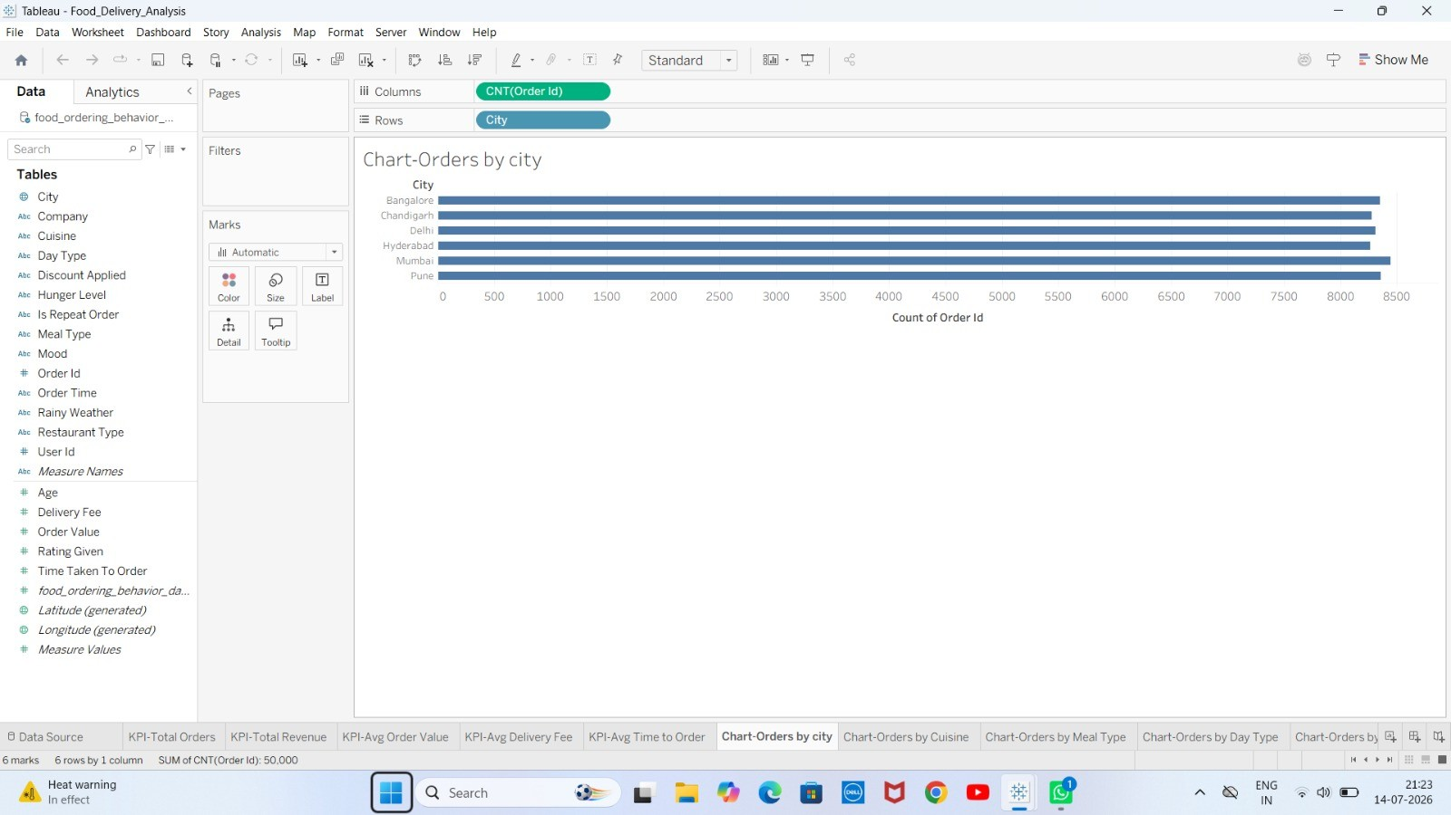
Figure 7.2: Orders by City
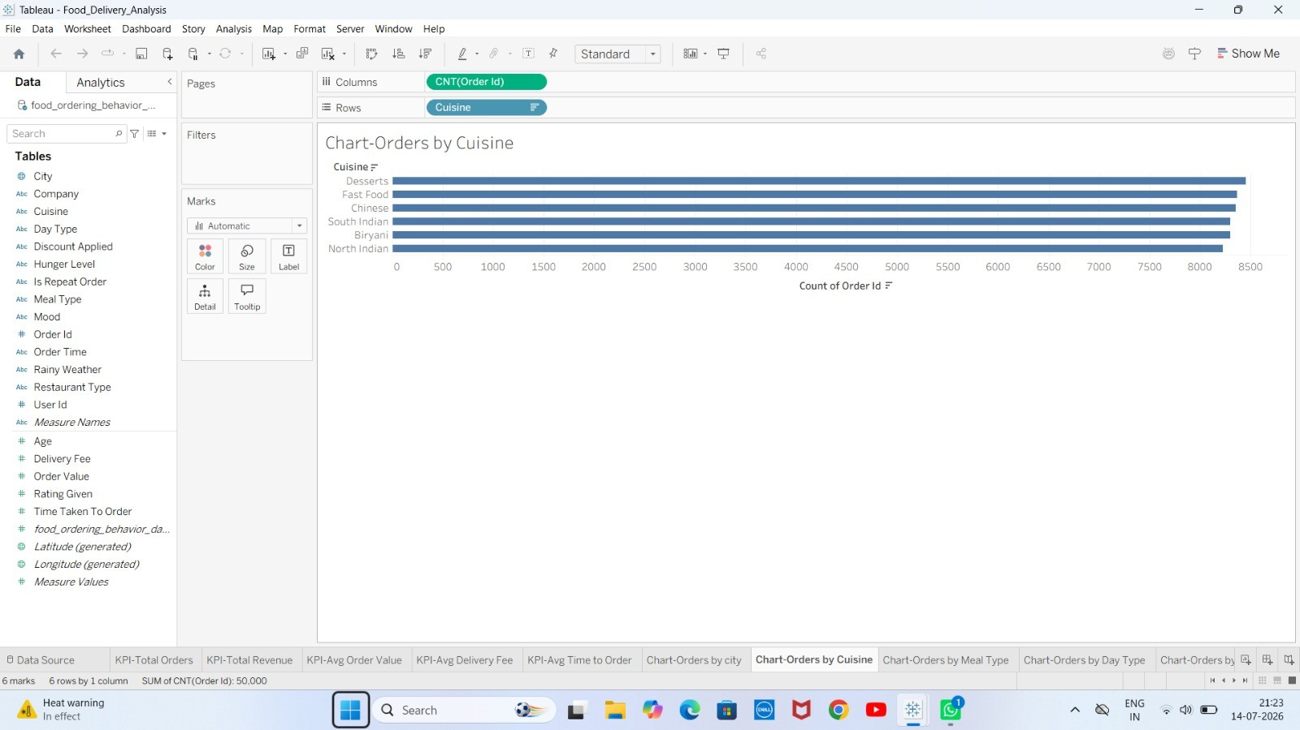
Figure 7.3: Orders by Cuisine
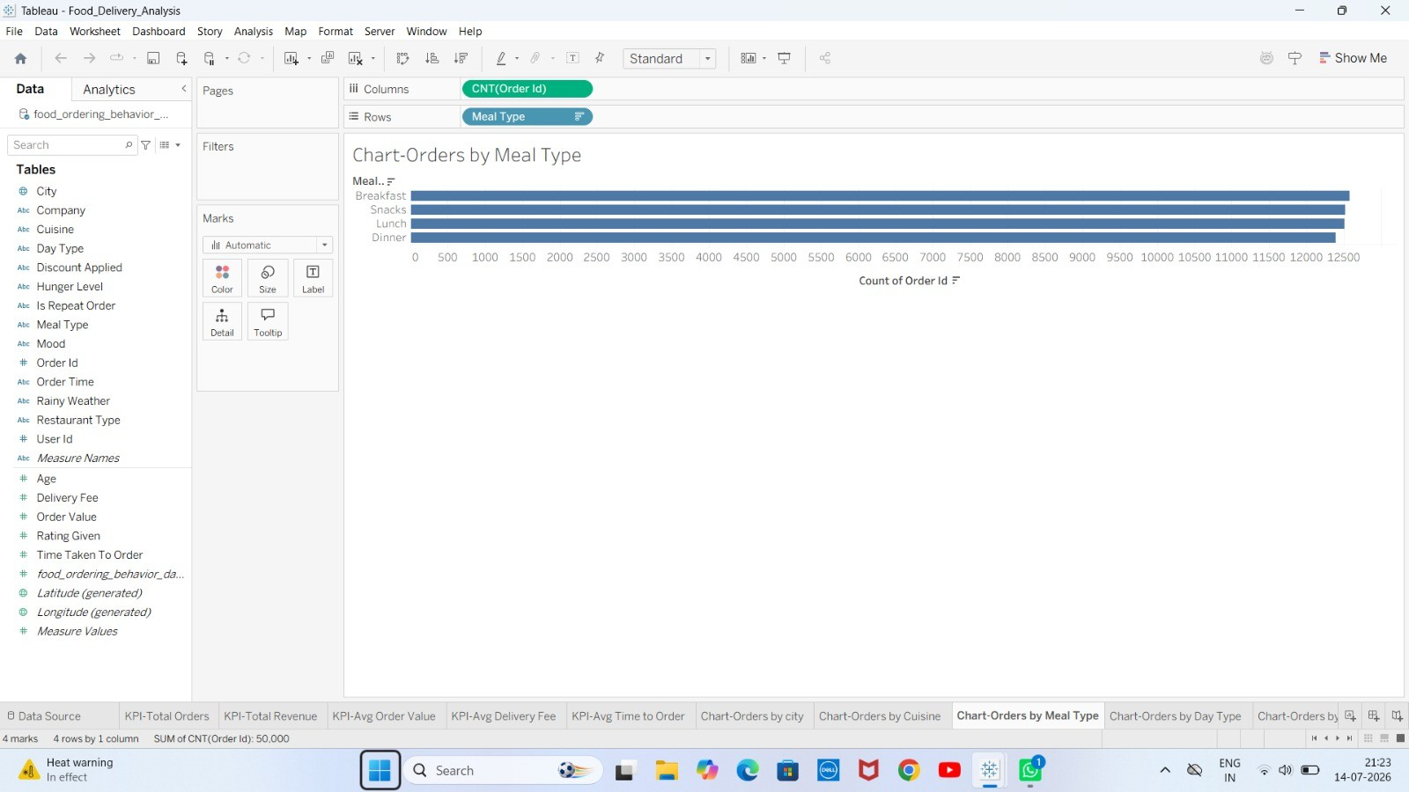
Figure 7.4: Orders by Meal Type
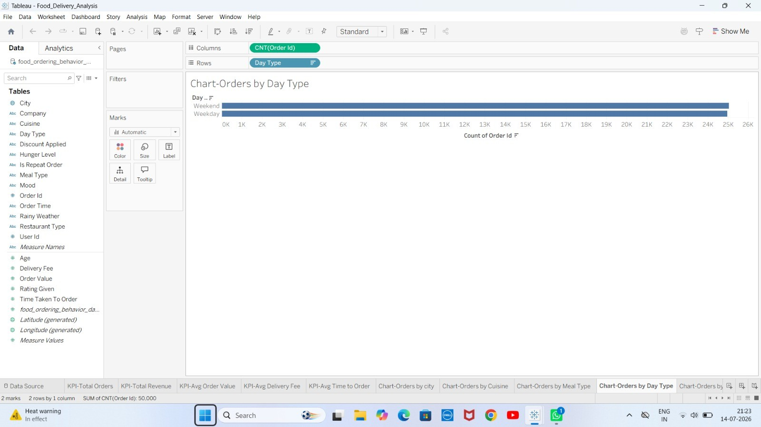
Figure 7.5: Orders by Day Type (Weekday vs Weekend)
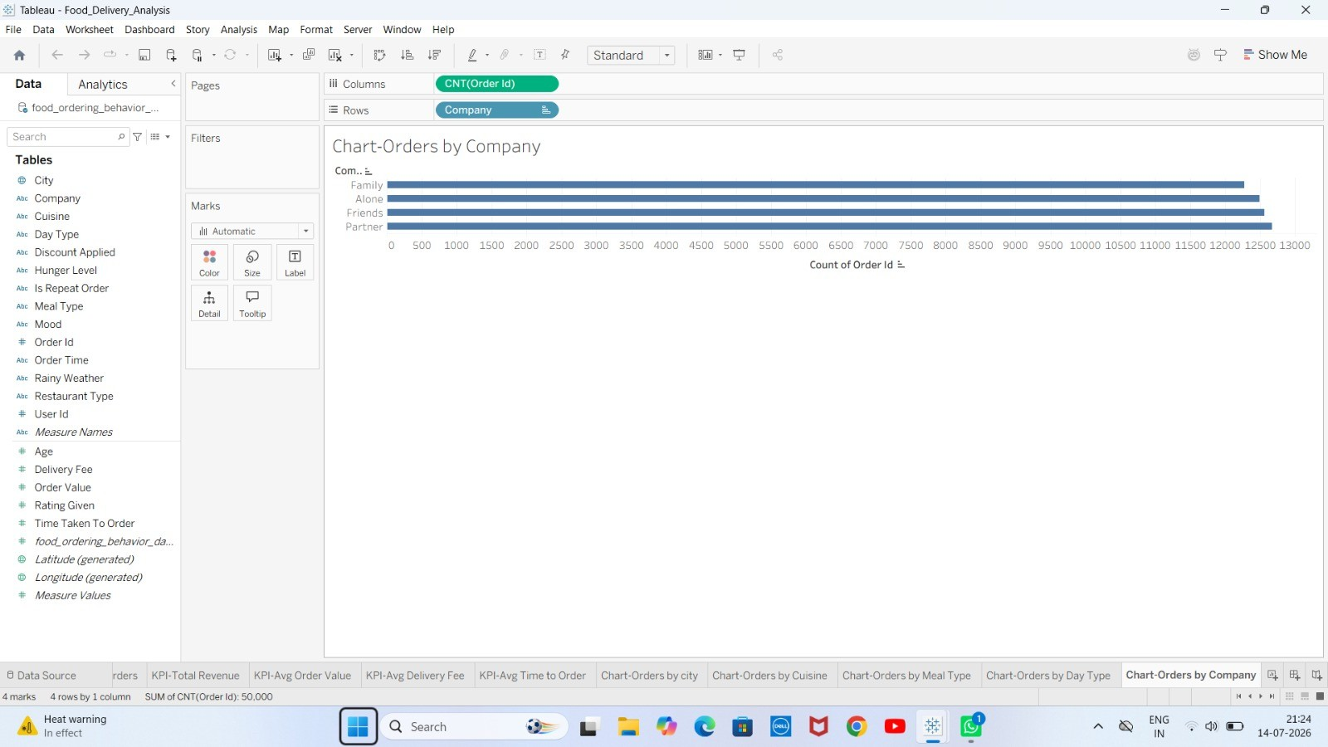
Figure 7.6: Orders by Company (Order Context)
The analysis derived from these visuals shows that customer ordering behavior differs meaningfully across cities and cuisines, with certain cuisines consistently receiving a higher volume of orders. Meal-type analysis highlights clear customer preferences across different times of day, while the weekday-versus-weekend comparison offers useful insight for planning delivery resources more efficiently. Together, these KPI cards and charts provide a quick, at-a-glance summary of business performance that supports faster, more confident decision-making.
The city-wise breakdown in particular highlights that order volumes are not evenly distributed across regions, suggesting that marketing and delivery-fleet resources could be reallocated toward higher-demand cities for greater operational efficiency. Similarly, the cuisine-wise breakdown provides direct input for menu planning and promotional campaigns, since cuisines with consistently higher order counts represent stronger customer demand.
The comparison between the Average Order Value and Average Delivery Fee also offers a useful lens on profitability per order, while the Average Time to Order metric gives an indication of how quickly customers are able to complete the ordering process — a metric that can be tracked over time to evaluate the impact of future app or website improvements.

8. ADVANTAGES & DISADVANTAGES
Every analytical solution involves trade-offs between the depth of insight it provides and the complexity required to build and maintain it. The following section outlines the key advantages this dashboard delivers to its intended users, as well as the current limitations that should be considered when interpreting or extending the project.

Advantages
- Easy to understand — the dashboard presents complex data in a simple, visual format.
- Interactive — users can filter and explore the data without needing technical assistance.
- Quick business insights — key metrics are visible at a glance through KPI cards.
- Supports better decision-making — data-driven insights replace guesswork.
- Saves analysis time — reduces the need for manual report generation.
- User-friendly visualization — clean layout suitable for both technical and non-technical stakeholders.

Disadvantages / Limitations
- Uses a sample dataset rather than live, continuously updated data.
- No real-time data integration — the dashboard reflects a static snapshot of data.
- Limited filtering options compared to a fully custom-built analytics application.
- Depends heavily on the accuracy and completeness of the underlying dataset.

9. CONCLUSION
The Food Delivery Analysis Dashboard successfully demonstrates how Tableau can be used to transform raw, unstructured food delivery data into meaningful, actionable visualizations. By consolidating key performance indicators and providing detailed breakdowns across city, cuisine, meal type, day type, and delivery company, the dashboard equips business stakeholders with a fast and intuitive tool to monitor revenue, understand customer preferences, and evaluate delivery performance.
Through this project, it becomes evident that even without complex programming or predictive modeling, well-designed business intelligence dashboards can significantly improve the speed and quality of business decision-making. The project fulfills its intended objective of enabling data-driven decisions that can enhance operational efficiency and overall customer satisfaction within the food delivery domain.

10. FUTURE SCOPE
While the current dashboard provides valuable insights based on a static dataset, there are several opportunities to extend and enhance this project in the future:
- Integrating live, continuously updated databases instead of a static sample dataset.
- Implementing predictive analytics to forecast future order volumes and revenue trends.
- Using Artificial Intelligence and Machine Learning techniques for demand forecasting and personalized recommendations.
- Developing a mobile-friendly version of the dashboard for on-the-go business monitoring.
- Creating personalized customer recommendation features based on ordering history and preferences.
These enhancements would further increase the practical business value of the dashboard, moving it from a descriptive analytics tool toward a more predictive and prescriptive decision-support system.

11. APPENDIX

Source Code
This project was developed primarily using Tableau's visual interface; therefore no traditional source-code repository is required beyond the Tableau workbook (.twbx) file itself, which contains all calculated fields, worksheets, and dashboard layout. The workbook and supporting files are hosted in the GitHub repository linked below.

Dataset
The dataset used for this project is food_ordering_behavior_dataset.csv, containing 50,000 order-level records across 19 fields, including order_id, user_id, age, city, order_time, day_type, cuisine, meal_type, restaurant_type, order_value, discount_applied, delivery_fee, time_taken_to_order, rating_given, is_repeat_order, mood, hunger_level, company, and rainy_weather. The dataset is included in the project's GitHub repository.

GitHub Repository
GitHub Repository: https://github.com/mohanabhavyavattikuti-214/Food_Delivery_Analysis.git

Project Demo Video
Demo Video (Google Drive): https://drive.google.com/drive/folders/1j6EjEtxDiDqTo_tV54i4PqgKaoEd3LgQ?usp=sharing

REFERENCES
- Tableau Documentation — https://help.tableau.com
- GitHub Documentation — https://docs.github.com
- Microsoft Excel Documentation — https://support.microsoft.com/excel
- Data Visualization Best Practices — Industry guidelines and standards for dashboard design

