Environmental Niche Modelling of Invasive *Nyctereutes Procyonoides* Species

Mohanad Hussein, Istanbul Technical University

20 January 2024

Table of Contents

# INTRODUCTION

Invasive species are considered one of the greatest threats to biodiversity and economics. Natively habituating eastern Siberia, northern China, North Vietnam, Korea and Japan, the Raccoon dog “Nyctereutes procyonoides” is a species that belongs to the Canid family and are closely related to foxes. The species was introduced to Europe in the last century when around 9000 individuals were introduced as a source of fur production. Since then, its expansion has widely increased from Nordic countries down towards central Europe since the first report in France. Moreover, hunting statistics showed dramatic increase in hunting records by the end of 90s (Weber et al. 2004).

Together with other non-native rodent species, Raccoon dogs have a wide spectrum of preys and can easily adapt, which makes them livable in almost any natural habitat, threatening indigenous species such as reptiles and ground-nesting birds. The first occurrence for this species in Turkey was reported in 2019 near the Sarıkamış region (Naderi et al. 2020). It is, therefore, of importance to model and predict its spread in the near future.

Ironically, a nature article postulated that the recently occurring COVID-19 pandemic might have been transferred through raccoon dogs in the Wuhan market. Despite the irony, this raises concerns regarding the transmissiblity of infections and viruses zoonoses by means of close interactions with this species (Mallapaty 2023). The aim here is to investigate their current occurrence given specific climatic variables and future spread in Turkey and roughly discuss their biological potential towards environment, economy and humans.

# METHODS

## Data

### Acquiring Species Occurrence Data

The occurrence data used to model the distribution of Nyctereutes procyonoides was obtained from Global Biodiversity Information Facility (GBIF) by filtering occurrence records for human observations in 10 countries only: Korea, Republic of Estonia, Finland, Denmark, Sweden, Russian Federation, Germany, Japan, France and Netherlands. Out of 21,545 human-observed occurrence entries, only 400 data points are expected to be sufficient for covering the major occurrence regions and considering the projection range (Wright et al. 2006).

### Formating Data for biomod2

The response variable is the coordinates of which projection data will be presented depending on the explanatory variable, in this case is a collection of several bio-climatic variables. These variables are selected based on relevance of the parameter to the species and its effect on the distribution and behavior or even viability. Since the raccoon dog is ground-level habitant and lives in temporal climate, a set of 8 parameters are reported to be bio02: mean diurnal range, bio04: temperature seasonality, bio05: maximum temperature of the warmest month, bio06: minimum temperature of the coldest month, bio14: minimum precipitation of the driest month, bio15: precipitation seasonality, bio18: precipitation of warmest quarter, and bio19: precipitation of coldest quarter (Kochmann, Cunze, and Klimpel 2021). In order to run the projection for Turkey, an external shapefile was required to cut formulate the projection towards that region, the result is shown in the following Figure 1.

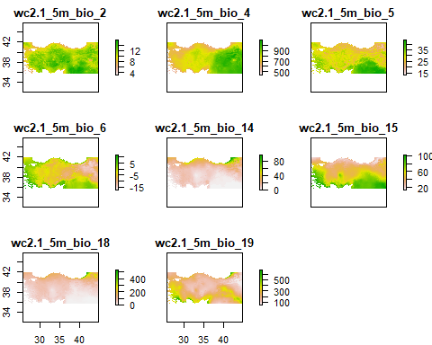

### Acquiring Historical & Future Bioclimatic Variables

[Historical bioclimatic variables](https://www.worldclim.org/data/worldclim21.html) were acquired from WorldClim website with 5 minutes spatial resolution for the period between 1970-2000 (Fick and Hijmans 2017).The first occurrence of the species in the modeled region was towards the end of the 19th century and it is, therefore adequate to use data from an approximate range. The same data is used for the current projection as it provides reaonal approximation and capture a long term average.

[Future bioclimatic variables](https://www.worldclim.org/data/cmip6/cmip6_clim5m.html) were acquired from WorldClim website with 5 minutes spatial resolution for 2041-2060 time period and CMCC-ESM2 estimations for SSP585 (Swart et al., n.d.). For the selection of General Circulation Models (GCMs), a recently published tool (GCM CompareR) helps in assessing the differences and decide ion which GCM to use (Fajardo et al. 2020). The selected model provides accurate simulations of temperature, including minimum temperatures and cold extremes which are important factors for the Raccoon dog species.

## Modeling

Among the many modelling algorithms available out there, comparative studies have shown that despite showing high performance when implemented on training data, only a handful of them can produce both extrapolative and interpolative results, such as MaxEnt (Ahmadi et al. 2022). For simplicity and avoiding replication of analysis done in other papers over the same species using MaxEnt, MaxNet is implemented as it is a new alternative for MaxEnt influenced by understanding the link between MaxEnt and Poisson point process models (Valavi et al. 2022). Model replication is decided to optimal at 5-10 depending on the data amount and confining the modelling to one model is sought to be sufficient.

## Projections

Both projections were done by **BIOMOD_Projection** function of **biomod2** R package.

### Current Projection

Using the bio-climatic variables data for the interval between 1970-2000, the current distribution of the species is estimated. Projection is done by projecting all the variables to the world map then using Turkey’s coordinated from an external shapefile (shp). By limiting the output to only 5 variables as the most important, the less impacting bio-climatic variables are eliminated. The codes are shown below:

### Future Projection

The Raccoon dog has a high ability of dispersal, this enforces observing its distribution in a distant time range for more variance in the projection. Here, the future projection is performed using bio-climatic variables modeled by the CMCC-ESM2 downscale under SSP585 scenario between 2041-2060. The future projection was performed in a similar manner by considering the exact same 8 variables as current projection for consistency and direct comparison of results.

#future projection 2 4 5 6 14 15 18 19  
abio <- raster::stack("wc2.1_5m_bioc_CMCC-ESM2_ssp585_2041-2060.tif")  
a_bio2 <- subset(abio,2)  
a_bio4 <- subset(abio,4)  
a_bio5 <- subset(abio,5)  
a_bio6 <- subset(abio,6)  
a_bio14 <- subset(abio,14)  
a_bio15 <- subset(abio,15)  
a_bio18 <- subset(abio,18)  
a_bio19 <- subset(abio,19)  
  
myExplFuture <- stack(a_bio2, a_bio4, a_bio5, a_bio6, a_bio14,a_bio15,a_bio18,a_bio19)  
names(myExplFuture) = names(myExpl)  
#plot(myExplFuture)

#future projection for turkey  
turkey_shape <- getData("GADM", country = "Turkey", level = 0)  
myExplFut_turkey <- crop(myExplFuture, turkey_shape) # Crop the explanatory variables to the extent of Turkey  
myExplFut_turkey_stack <- stack(myExplFut_turkey) # convert into RasterStack required by BIOMOD  
  
  
myBiomodProjFut <- BIOMOD_Projection(bm.mod = myBiomodModelout,  
 new.env = myExplFut_turkey_stack,  
 proj.name = 'future',  
 models.chosen = 'all',  
 metric.binary = c('ROC', 'TSS'),  
 compress = TRUE,  
 clamping.mask= F)  
#plot(myBiomodProjFut)

# RESULTS

## Present Projection

Considering the given bio-climatic variables, the distribution of the Raccoon dog is observed to be limited to northern Turkey, its first observation in Turkey was observed in Sarıkamış near the Allahuekber Mountains in the east, this suggests reliability of the projection of distribution under current bio-climatic variables.

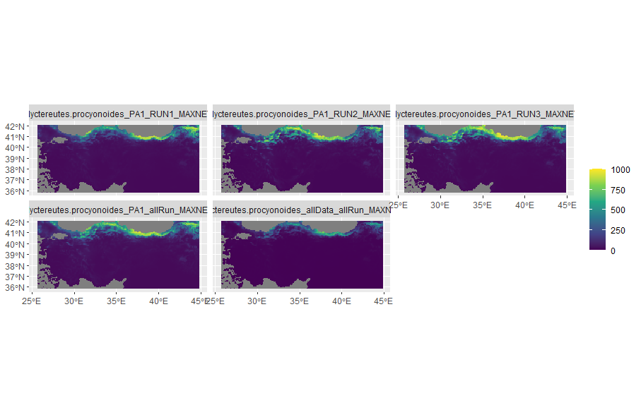

**Figure 2:** Current distribution of Raccoon dog using 8 bio-climatic variables shortlisted to 5 upon impotrance of variables

## Future Projection

Upon modelling the raccoon dog’s distribution in the worst SSP scenario, the model shows slight difference between the near present and future distribution. It is obvious that the Raccoon dog will be less observed in the central north and its occurrence might slightly increase in the northeastern boarder. This suggests that, despite the expected temperature fluctuation under SSP585 scenario, the invasive species will still have the ability to spread, inferring its adaptability and survivability.

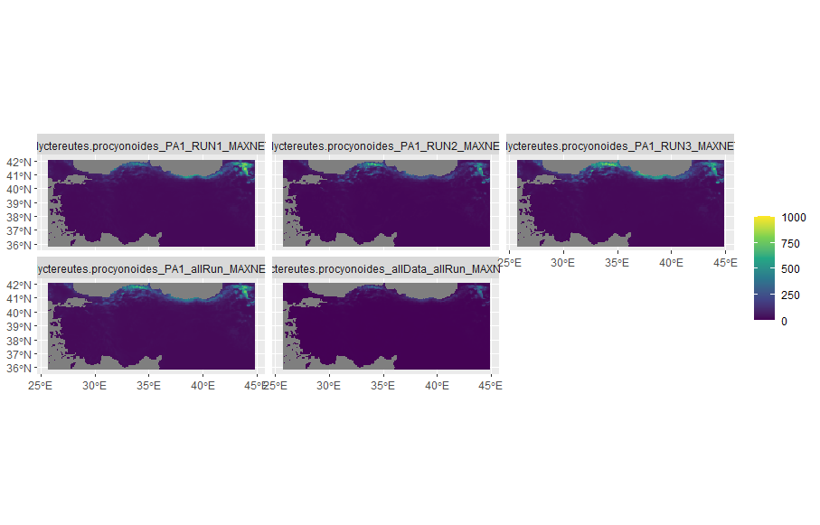

**Figure 3:** Future distribution of Raccon dog using 8 bioclimatic variables shortlisted to 5 upon impotrance of variables

## Assessing Model Performances

For the evaluation of the implemented model and its predictability, the sensitivity of the model was 98.125%. This high value indicates that the model correctly identifies almost all of true positive cases. It’s excellent at detecting the presence of the condition or outcome when it’s truly there. The specificity of the model suggests that 90.933% of true negative cases are correctly identified. There’s a small chance of false positives, but overall, the model is reliable in ruling out the condition when it’s not present.The calibration of the model reflects strong agreement between predicted probabilities and observed outcomes and its validation value indicates its consistent performance on unseen data without over-fitting. Although data was subset for evaluation, the model didn’t store the evaluation results, but with deeper investigation to the structure of the model, it was ensured that the models.failed variable contains no failed models.

myBiomodModelEval= get_evaluations(myBiomodModelout)  
myBiomodModelEval

## full.name PA run algo  
## 1 Nyctereutes.procyonoides_PA1_RUN1_MAXNET PA1 RUN1 MAXNET  
## 2 Nyctereutes.procyonoides_PA1_RUN1_MAXNET PA1 RUN1 MAXNET  
## 3 Nyctereutes.procyonoides_PA1_RUN2_MAXNET PA1 RUN2 MAXNET  
## 4 Nyctereutes.procyonoides_PA1_RUN2_MAXNET PA1 RUN2 MAXNET  
## 5 Nyctereutes.procyonoides_PA1_RUN3_MAXNET PA1 RUN3 MAXNET  
## 6 Nyctereutes.procyonoides_PA1_RUN3_MAXNET PA1 RUN3 MAXNET  
## 7 Nyctereutes.procyonoides_PA1_allRun_MAXNET PA1 allRun MAXNET  
## 8 Nyctereutes.procyonoides_PA1_allRun_MAXNET PA1 allRun MAXNET  
## 9 Nyctereutes.procyonoides_allData_allRun_MAXNET allData allRun MAXNET  
## 10 Nyctereutes.procyonoides_allData_allRun_MAXNET allData allRun MAXNET  
## metric.eval cutoff sensitivity specificity calibration validation evaluation  
## 1 ROC 305.5 98.077 91.600 0.984 0.979 NA  
## 2 TSS 302.0 98.077 91.467 0.897 0.917 NA  
## 3 ROC 294.5 98.077 91.733 0.981 0.988 NA  
## 4 TSS 293.0 98.077 91.733 0.898 0.878 NA  
## 5 ROC 418.0 96.795 93.200 0.982 0.981 NA  
## 6 TSS 418.0 96.795 93.200 0.900 0.897 NA  
## 7 ROC 253.0 98.077 91.700 0.984 NA NA  
## 8 TSS 256.0 98.077 91.700 0.898 NA NA  
## 9 ROC 79.5 98.077 91.700 0.984 NA NA  
## 10 TSS 81.0 98.077 91.700 0.898 NA NA

# DISCUSION

The overall evaluation of the model suggests correct implementation of the Environmental Niche Modelling concept. That is supported by results obtained from previous studies on the same species where its distribution in Europe showed a prediction for the north coast of Turkey extending to the norther-east (Kochmann, Cunze, and Klimpel 2021) 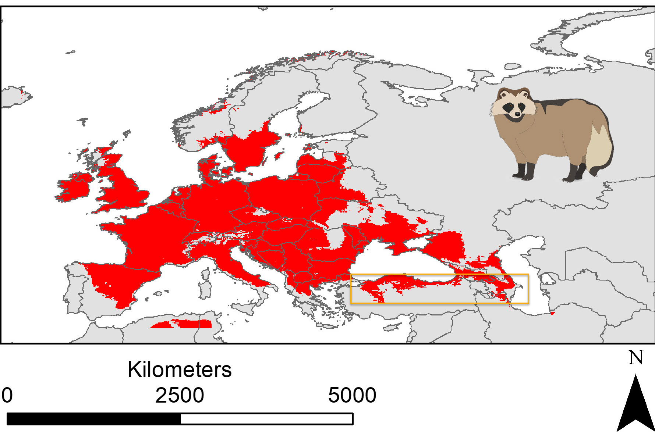

# LEARNING OBJECTIVES

The objectives and learning outcome of this project is extremely wide as it included the introduction to Species Distribution Modelling (SDM) and using bio-climatic variables in the past and future accompanied with socioeconomic pathways (SSPs). Moreover, it provided the necessary understanding for spatial data structure and importance in applying geo-ecological studies and Environmental Niche Modelling (ENM).

# DATA AVAILABILITY

All codes, documentations, figures, data files used and obtained in this analysis can be found on my Github repository for this project (<https://github.com/mohanadhussein>).

# REFERENCES

Ahmadi, Mohsen, Mahmoud-Reza Hemami, Mohammad Kaboli, and Farzin Shabani. 2022. “MaxEnt Brings Comparable Results When the Input Data Is Being Completed; Model Parameterization and Background Manipulation of Four Species Distribution Models.” <https://doi.org/10.22541/au.166358351.13231963/v1>.

Fajardo, Javier, Derek Corcoran, Patrick R. Roehrdanz, Lee Hannah, and Pablo A. Marquet. 2020. “GCM Compare R: A Web Application to Assess Differences and Assist in the Selection of General Circulation Models for Climate Change Research.” Edited by Darren Kriticos. *Methods in Ecology and Evolution* 11 (5): 656–63. <https://doi.org/10.1111/2041-210X.13360>.

Fick, Stephen E., and Robert J. Hijmans. 2017. “WorldClim 2: New 1-Km Spatial Resolution Climate Surfaces for Global Land Areas.” *International Journal of Climatology* 37 (12): 4302–15. <https://doi.org/10.1002/joc.5086>.

Kochmann, Judith, Sarah Cunze, and Sven Klimpel. 2021. “Climatic Niche Comparison of Raccoons *Procyon Lotor* and Raccoon Dogs *Nyctereutes Procyonoides* in Their Native and Non-Native Ranges.” *Mammal Review* 51 (4): 585–95. <https://doi.org/10.1111/mam.12249>.

Mallapaty, Smriti. 2023. “COVID-Origins Study Links Raccoon Dogs to Wuhan Market: What Scientists Think.” *Nature* 615 (7954): 771–72. <https://doi.org/10.1038/d41586-023-00827-2>.

Naderi, Morteza, Emrah Çoban, Josip Kusak, Mübeccel Çisel Kemahli AytekiṄ, Mark Chynoweth, İsmail Kayahan Ağirkaya, Neslihan Güven, Ayşegül Çoban, and Çağan Hakkı Şekercioğlu. 2020. “The First Record of Raccoon Dog ( Nyctereutes Procyonoides ) in Turkey.” *TURKISH JOURNAL OF ZOOLOGY* 44 (2): 209–13. <https://doi.org/10.3906/zoo-1910-29>.

Swart, Neil Cameron, Jason N. S. Cole, Viatcheslav V. Kharin, Mike Lazare, John F. Scinocca, Nathan P. Gillett, James Anstey, et al. n.d. “CCCma CanESM5 Model Output Prepared for CMIP6 ScenarioMIP.” <https://doi.org/10.22033/ESGF/CMIP6.1317>.

Valavi, Roozbeh, Gurutzeta Guillera-Arroita, José J. Lahoz-Monfort, and Jane Elith. 2022. “Predictive Performance of Presence-Only Species Distribution Models: A Benchmark Study with Reproducible Code.” *Ecological Monographs* 92 (1): e01486. <https://doi.org/10.1002/ecm.1486>.

Weber, J-M, D Fresard, S Capt, and C Noel. 2004. “First Records of Raccoon Dog, Nyctereutes Procyonoides (Gray, 1834), in Switzerland.” *Revue Suisse de Zoologie.* 111: 935–40. <https://doi.org/10.5962/bhl.part.80278>.

Wright, Jessica W., Kendi F. Davies, Jennifer A. Lau, Andrew C. McCall, and John K. McKay. 2006. “EXPERIMENTAL VERIFICATION OF ECOLOGICAL NICHE MODELING IN A HETEROGENEOUS ENVIRONMENT.” *Ecology* 87 (10): 2433–39. <https://doi.org/10.1890/0012-9658(2006)87[2433:EVOENM]2.0.CO;2>.