**Cairo University  
Faculty of Computers and Artificial Intelligent** 

**CS251**

**Software Engineering I**

Parking Garage application

Software Design

El-Sayes

Winter 2022

**Contents**

Team 3

Document Purpose and Audience 3

System Models 3

I. Class diagrams 3

II. Sequence diagrams 5

Class - Sequence Usage Table 6

Ownership Report 6

Policy Regarding Plagiarism: 7

# Team : El Sayes

| **ID** | **Name** |
| --- | --- |
| **20190457** | **Mohamad abd Elnasser shehata** |
| **20190561** | **Mohanad El-Areaf Bellah Mohammed** |

# Document Purpose and Audience

* **This document is a simple and well organized document which holds requirements specification for parking garage application.**
* **The target audience to read this document is { the customer who needs to have an application, senior software engineer, lead software engineer, the manager of a software company} .**

# System Models

## I. Class diagrams

* **You should provide your class diagram. In case on diagram is so complex, divide it to several ones of reasonable size or draw separate ones, each for one of the components on the system decomposition diagram.**
* **Class diagram is a static diagram and should not represent any dynamic flow of events.**
* **Put stereotypes of the classes to give more information. UML predefines some stereotypes like: <<interface>>, <<type>>, <<implementationClass>>, <<enumeration>>, etc. and you create your own also.**
* **Put Relationships between classes and the types of the relationships.**
* **Put multiplicity.**
* **Put relationship name (e.g. faculty "offer" course).**
* **Put attributes in the classes.**
* **Put functions & Put parameters.**
* **Put data types of each attributes and the parameters.**
* **Make sure to include all domain (entity), boundary and control classes needed to implement the system.**
* **Highly perfered: Each class has a corresponding interface**
  + **Let all objects parameters and returns be of interface type.**
  + **See Shopping Cart Case Study**
* **Following is Shopping Cart Component class diagram.**

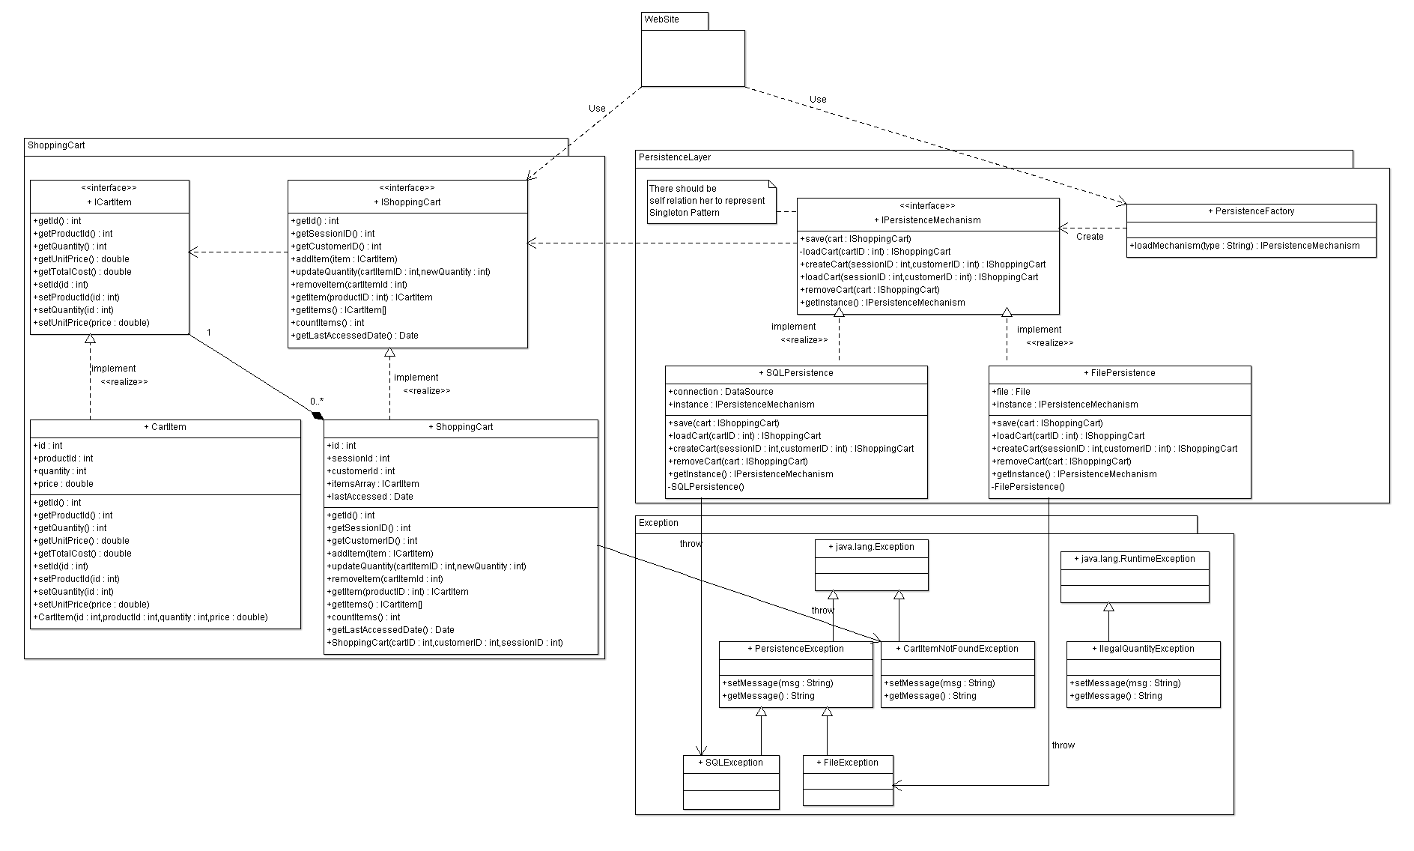

**List down your classes and describe them**

## 

## 

## 

## 

## 

## 

## II. Sequence diagrams

**#1**

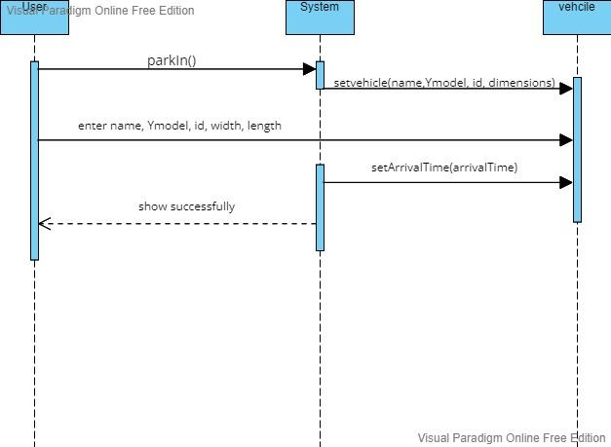

**#2**

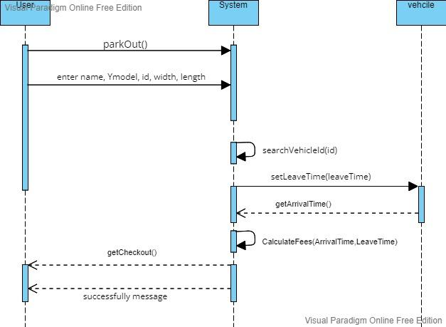

**#3**

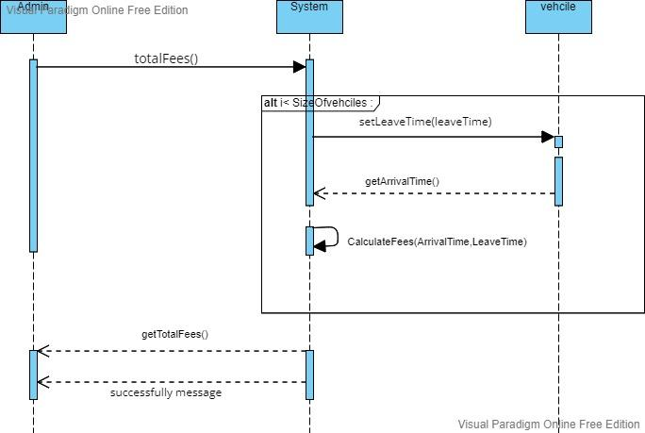

#4

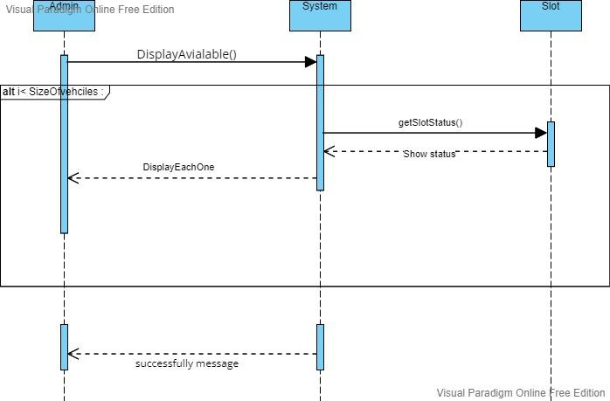

### 

### 

### 

### 

### 

### 

### 

### 

### 

### 

### 

# Ownership Report

| **Item** | **Owners** |
| --- | --- |
| Sequence, class diagram | *Mohammed Abd El-Nasser shehata* |
| Sequence, class diagram | *Mohanad El-Areaf Bellah Talat* |

# Policy Regarding Plagiarism:

**Students have collective ownership and responsibility of their project. Any violation of academic honesty will have severe consequences and punishment for ALL team members.**