WINDOWS ENDPOINT
THREAT DETECTION
AND INVESTIGATION
Using Wazuh SIEM and Sysmon

Hands-on SOC Analyst L1 Lab Project
Environment: VMware Workstation Pro • Windows 11 endpoint • Wazuh SIEM
Evidence collected: 16 October 2026

Prepared as a practical learning project report

Contents
- 1. Executive summary
- 2. Objectives and scope
- 3. Lab architecture and environment
- 4. Implementation completed
- 5. Evidence and screenshot walkthrough
- 6. Example alert investigation
- 7. SOC L1 investigation workflow
- 8. Results, limitations, and next steps
- 9. Conclusion
- Appendix A — Key configuration

1. Executive summary
This project builds a small, isolated security monitoring lab. A Windows 11 virtual machine named SOCWIN11 runs Sysmon and the Wazuh agent. Sysmon records detailed endpoint activity, including process creation and termination. The Wazuh agent forwards Windows event-channel records to a separate Wazuh server, where events can be searched and reviewed in Threat Hunting.
The screenshots provide evidence of local Sysmon Event ID 1 and Event ID 5 records, events from SOCWIN11 in Wazuh, and Sysmon-specific fields in a Wazuh event document. The evidence also includes Wazuh detections mapped to MITRE ATT&CK. Alerts are leads for investigation; they do not by themselves prove a system is compromised.

Project status at a glance
Component | Observed status
Windows endpoint | Windows 11 VM; hostname SOCWIN11
Sysmon | Installed; local Operational log contains Event IDs 1 and 5
Wazuh agent | Version 4.14.8; agent ID 003 appears in event details
Wazuh server | Wazuh 4.14.8; hostname wazuh-server
Sysmon forwarding | Confirmed by Wazuh document fields for Microsoft-Windows-Sysmon/Operational, Event ID 1
Alert investigation | Example detections captured; legitimacy requires contextual validation

2. Objectives and scope
- Create a Windows endpoint VM without collecting endpoint telemetry from the host PC.
- Install Sysmon to collect detailed process telemetry.
- Install and connect the Wazuh agent to the existing Wazuh server.
- Forward the Sysmon Operational event channel to Wazuh.
- Verify events in Wazuh Threat Hunting and inspect event fields and rule metadata.
- Practice a careful SOC L1 investigation using process, command-line, timestamp, rule, and MITRE ATT&CK context.
Scope note: This is a controlled learning lab. No claim is made that malware was executed or that the endpoint was compromised.

3. Lab architecture and environment
Event flow: Windows activity → Sysmon Operational event log → Wazuh agent on SOCWIN11 → Wazuh manager/indexer → Threat Hunting event search and alert review.
System | Configuration | Purpose
Host computer | Windows 11 Pro; 16 GB RAM | Runs VMware and the VMs
SOCWIN11 endpoint | Windows 11 Pro VM; 8 GB RAM; 2 vCPU; 64 GB disk; NAT; IP shown as 192.168.219.131 | Generates and forwards endpoint logs
Wazuh-SIEM | Amazon Linux 2023; Wazuh 4.14.8; hostname wazuh-server; NAT IP shown as 192.168.219.130 | Receives, indexes, and displays events
Wazuh agent | Version 4.14.8; agent ID 003 in event details | Forwards endpoint logs to the server
Sysmon | Sysmon Operational channel | Provides process-level telemetry
The IP addresses above are the values visible in the captured lab session. They may change after a VM restart if the network assigns a new address.

4. Implementation completed

4.1 Windows endpoint VM
Created and used the Windows 11 endpoint VM in VMware Workstation Pro. The guest hostname is SOCWIN11. The lab targets the VM, not the host Windows installation.

4.2 Sysmon installation and verification
Sysmon is installed and running. In Event Viewer, the path is Applications and Services Logs → Microsoft → Windows → Sysmon → Operational. Captures show Event ID 1 (Process Create) and Event ID 5 (Process Terminated).

4.3 Wazuh agent connection
The Wazuh agent is installed on SOCWIN11 and configured for the Wazuh server. The screenshots show agent.name SOCWIN11 and agent.id 003 in Wazuh event details.

4.4 Sysmon event-channel collection
The Windows agent configuration contains a localfile entry for the Sysmon event channel. After saving the configuration, the Wazuh agent service was restarted. Wazuh documents then showed Sysmon-specific fields, confirming that at least Sysmon Event ID 1 reached the SIEM.

4.5 Event search and investigation
Threat Hunting Events displays endpoint records, rule IDs, descriptions, event fields, and MITRE ATT&CK metadata. Event detail panels were captured for later analysis.

5. Evidence and screenshot walkthrough
The following figures use screenshots supplied during the lab. Some screenshots show adjacent scroll positions in the same event details; they are included selectively to preserve the most useful evidence.
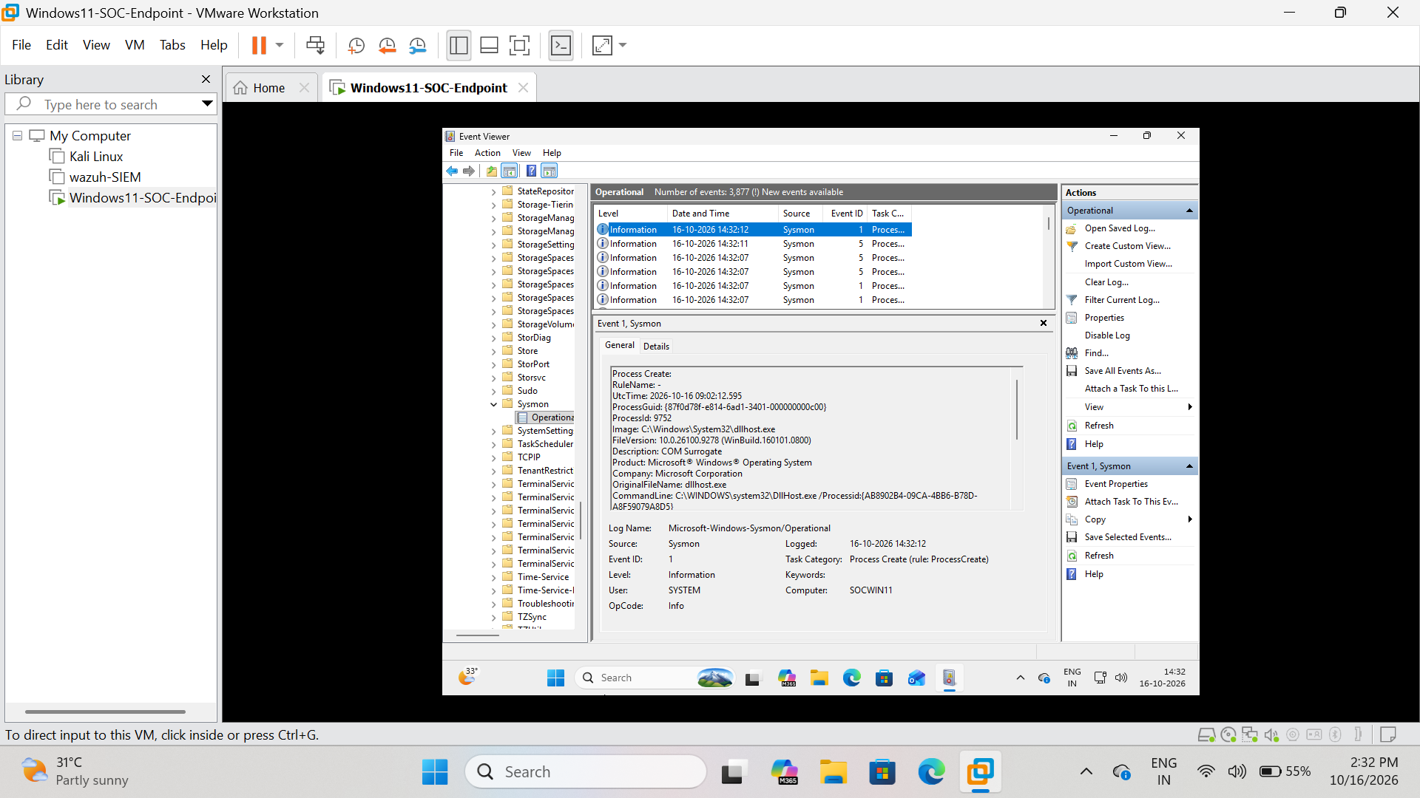
Figure 1. Sysmon Event ID 1 — Process Create in Windows Event Viewer
Evidence note: This screenshot records the observed interface state during the lab session.
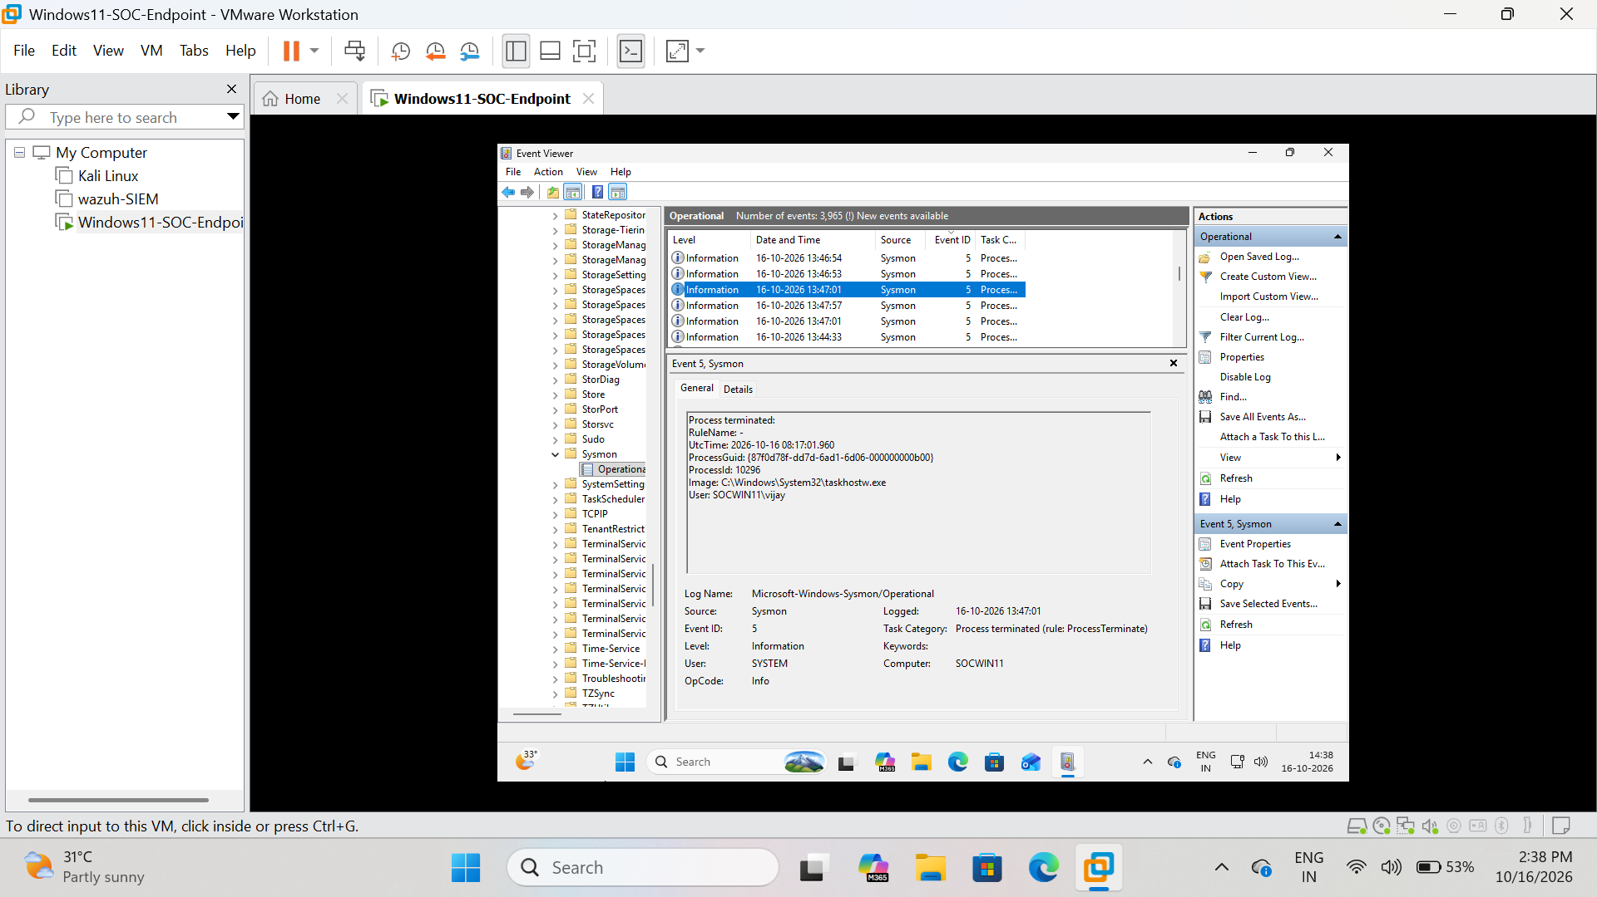
Figure 2. Sysmon Event ID 5 — Process Terminate in Windows Event Viewer
Evidence note: This screenshot records the observed interface state during the lab session.

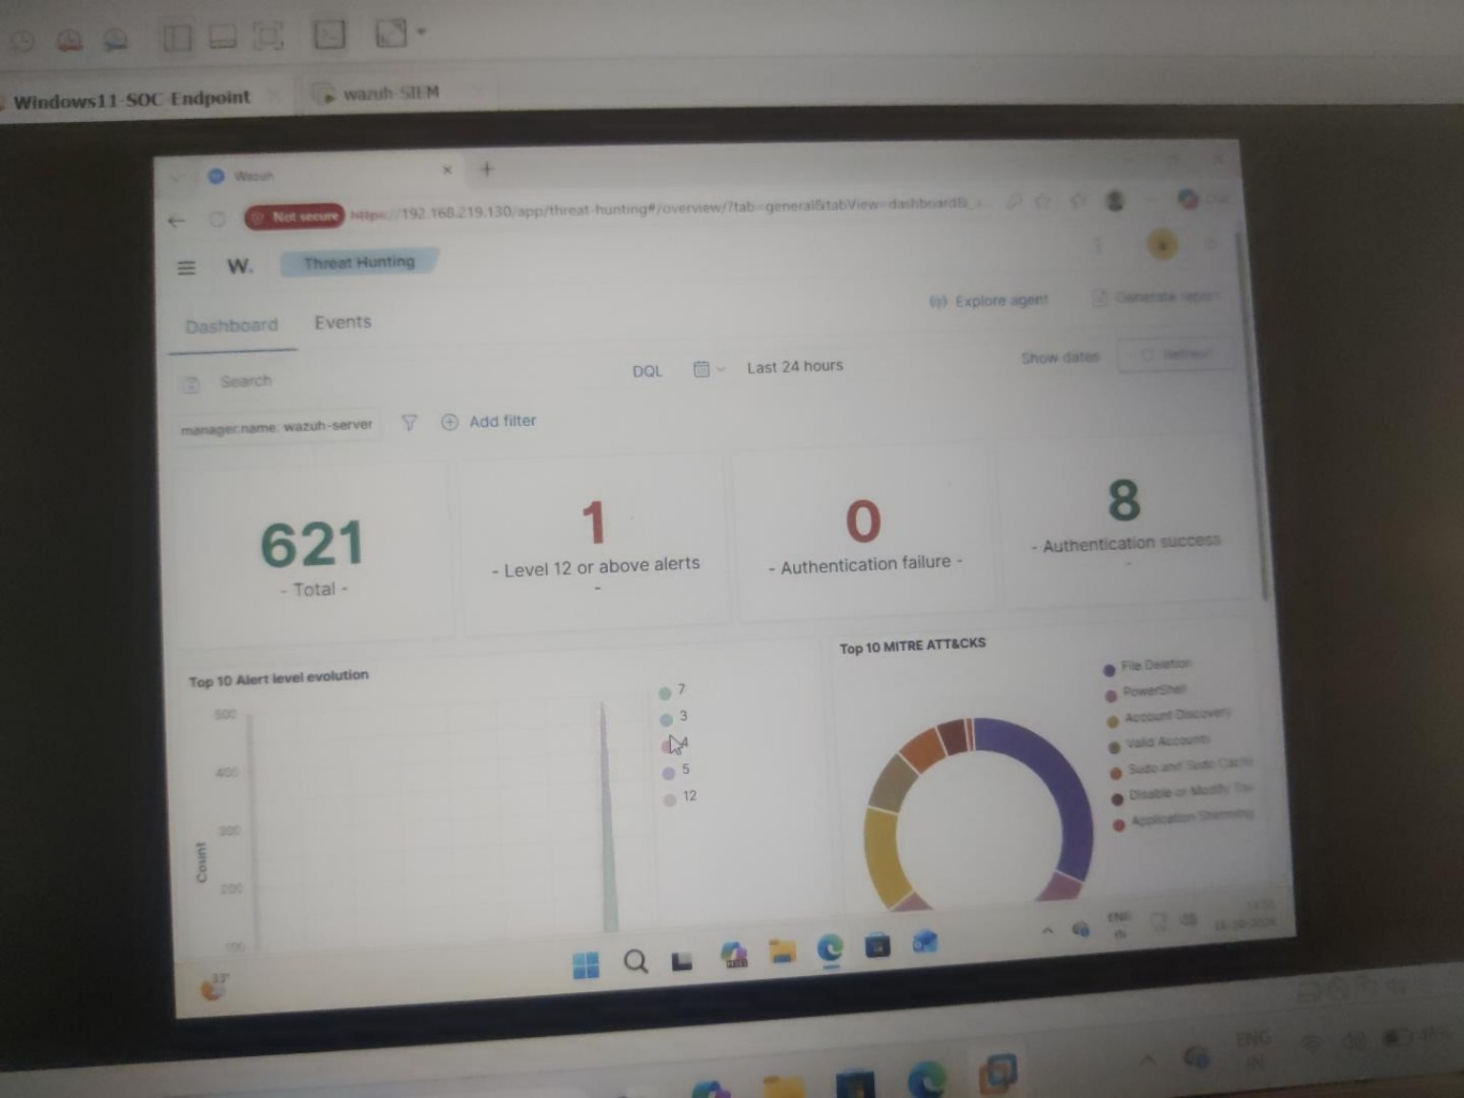
Figure 3. Wazuh Threat Hunting overview dashboard (captured earlier)
Evidence note: This screenshot records the observed interface state during the lab session.
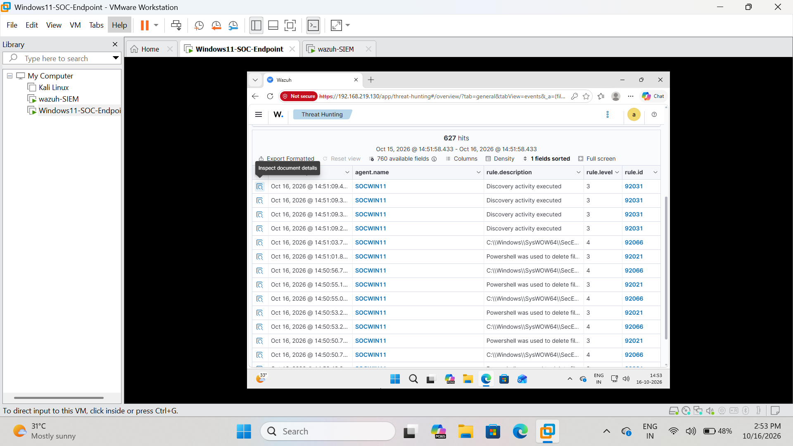
Figure 4. Wazuh Threat Hunting event table showing events from SOCWIN11
Evidence note: This screenshot records the observed interface state during the lab session.

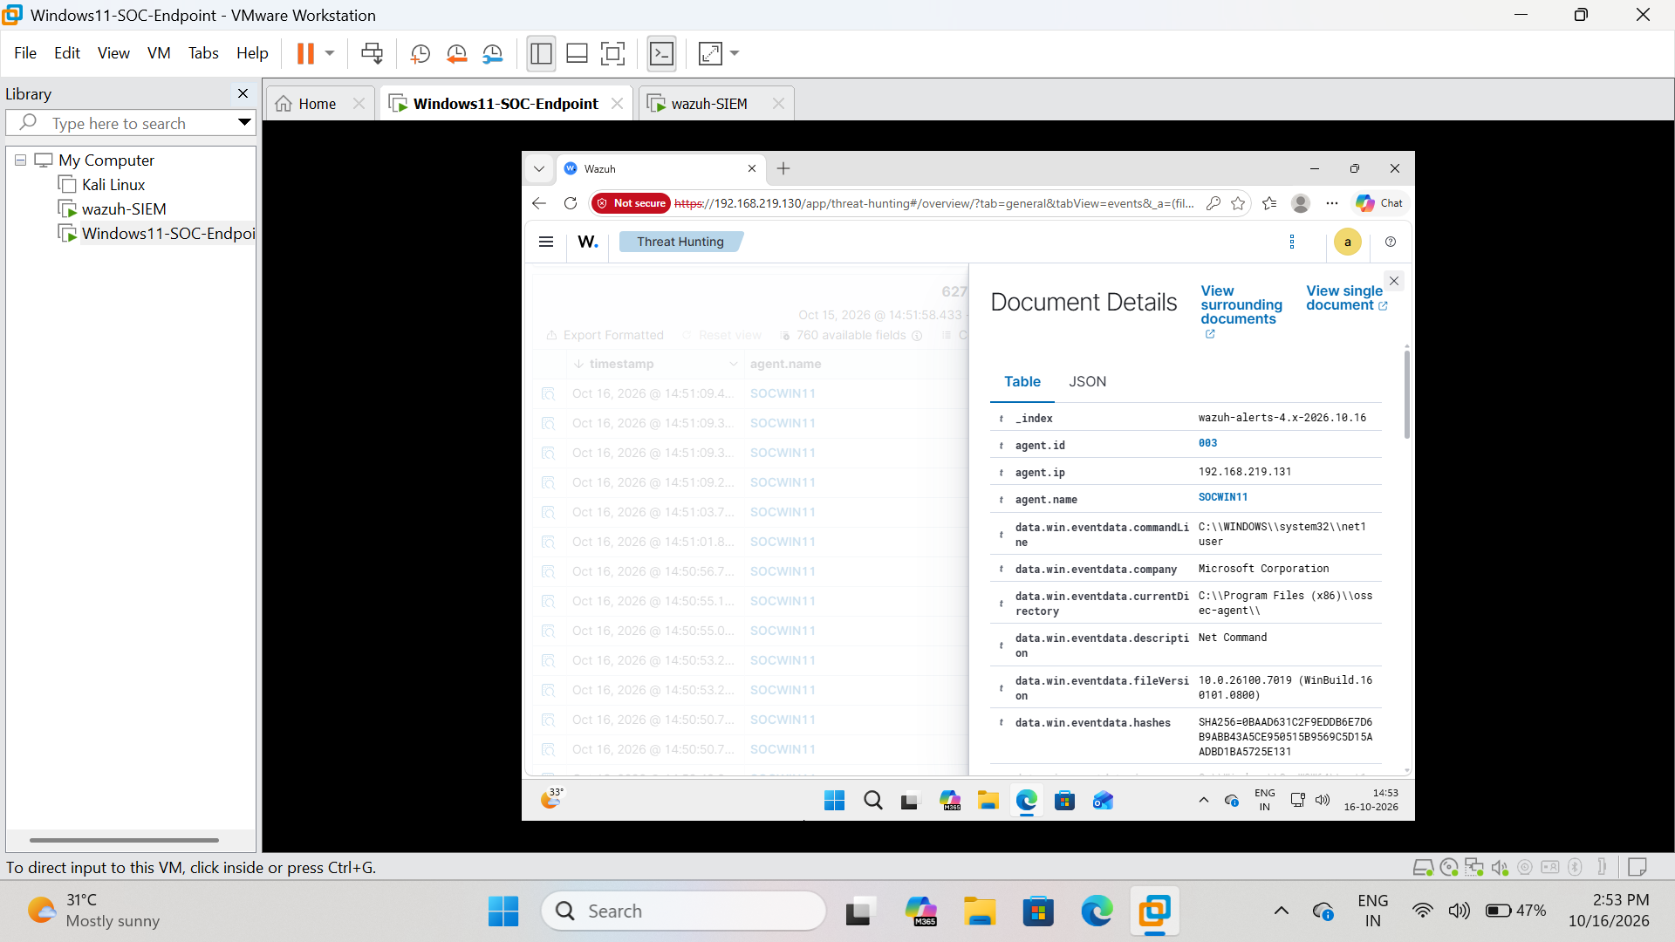
Figure 5. Wazuh document details — endpoint command-line telemetry
Evidence note: This screenshot records the observed interface state during the lab session.
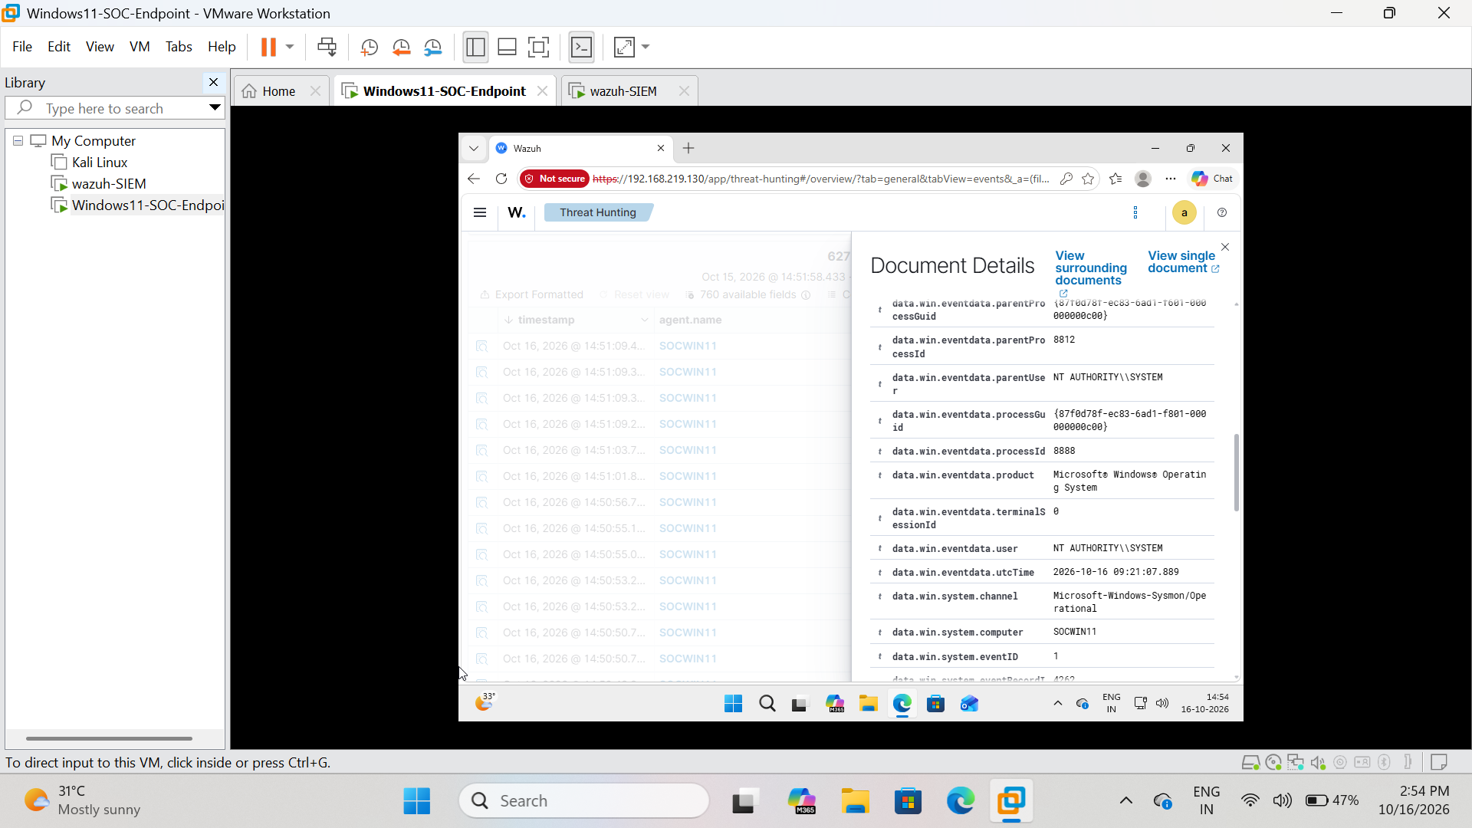
Figure 6. Wazuh document details — Sysmon channel and Event ID 1
Evidence note: This screenshot records the observed interface state during the lab session.

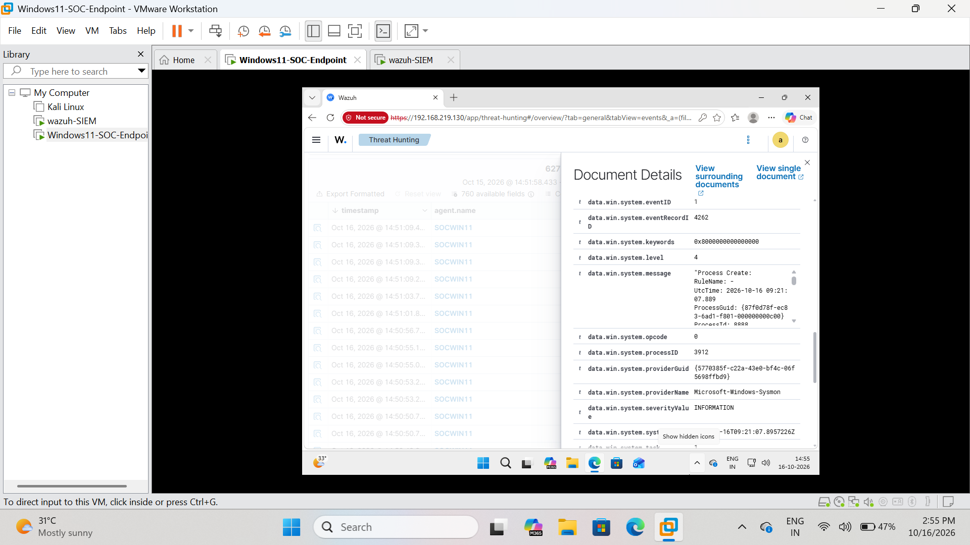
Figure 7. Wazuh detection details — Rule 92066 and MITRE PowerShell mapping
Evidence note: This screenshot records the observed interface state during the lab session.
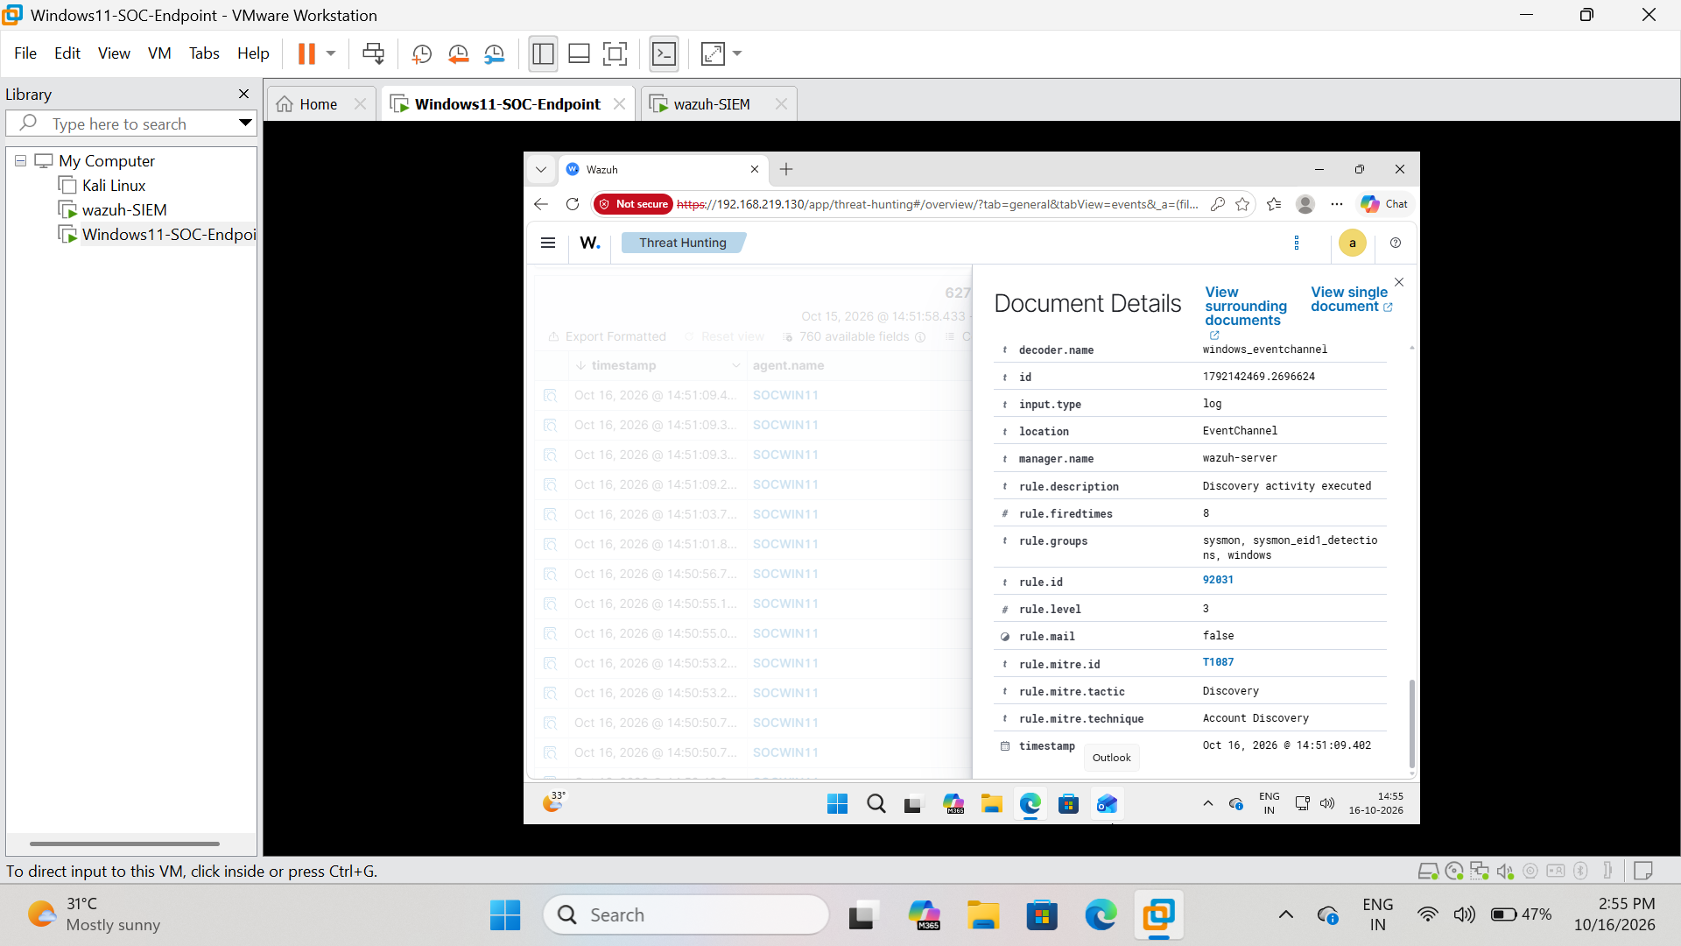
Figure 8. Wazuh event details — SOCWIN11 agent identity and Windows fields
Evidence note: This screenshot records the observed interface state during the lab session.

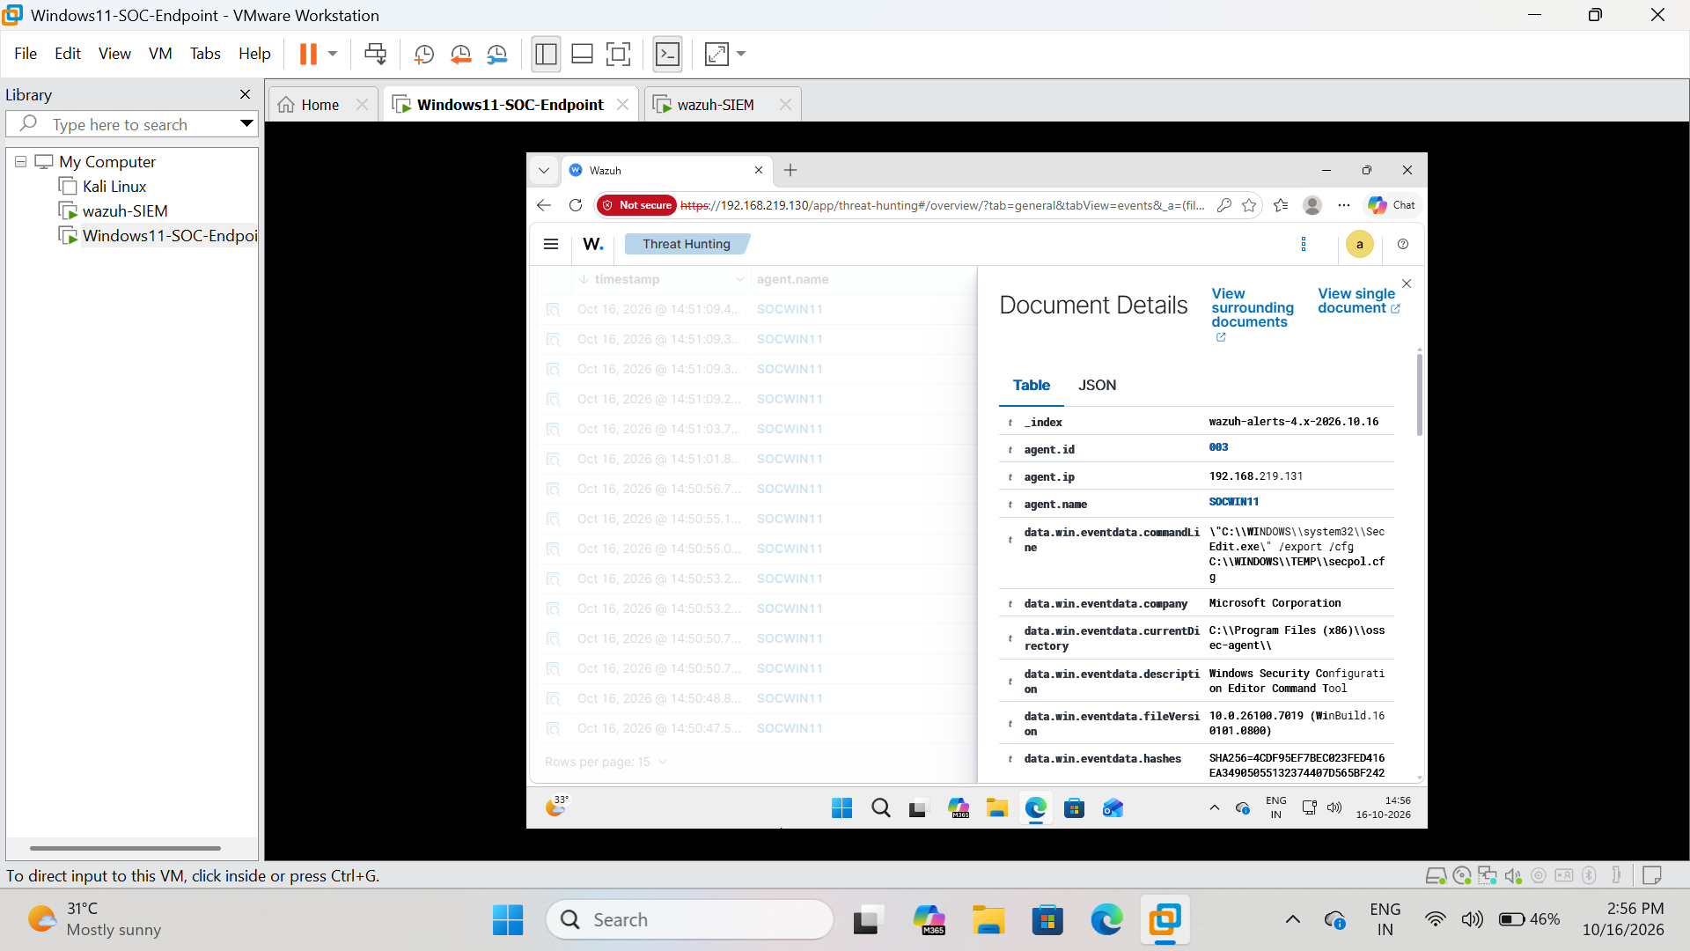
Figure 9. Wazuh detection details — Rule 92058 and MITRE T1546.011
Evidence note: This screenshot records the observed interface state during the lab session.
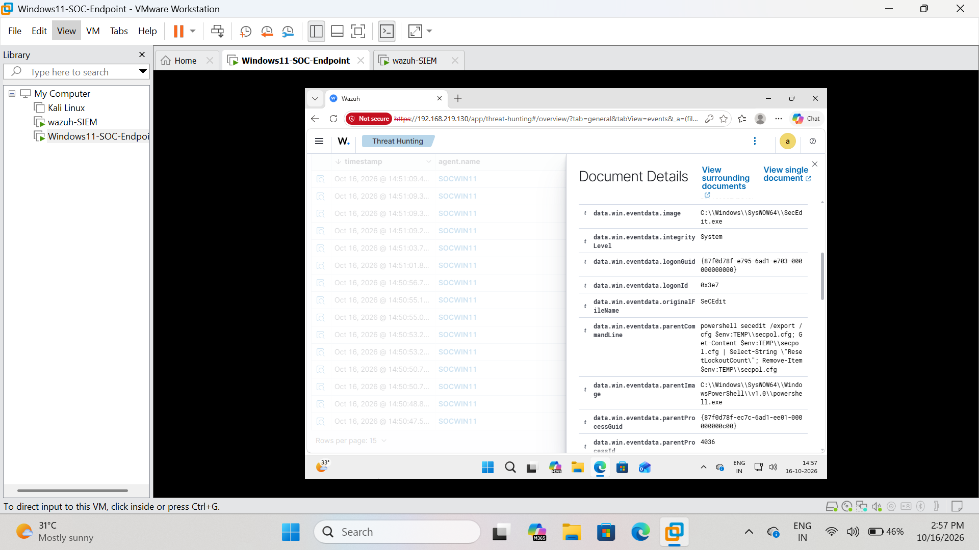
Figure 10. Wazuh event detail — event from the endpoint
Evidence note: This screenshot records the observed interface state during the lab session.

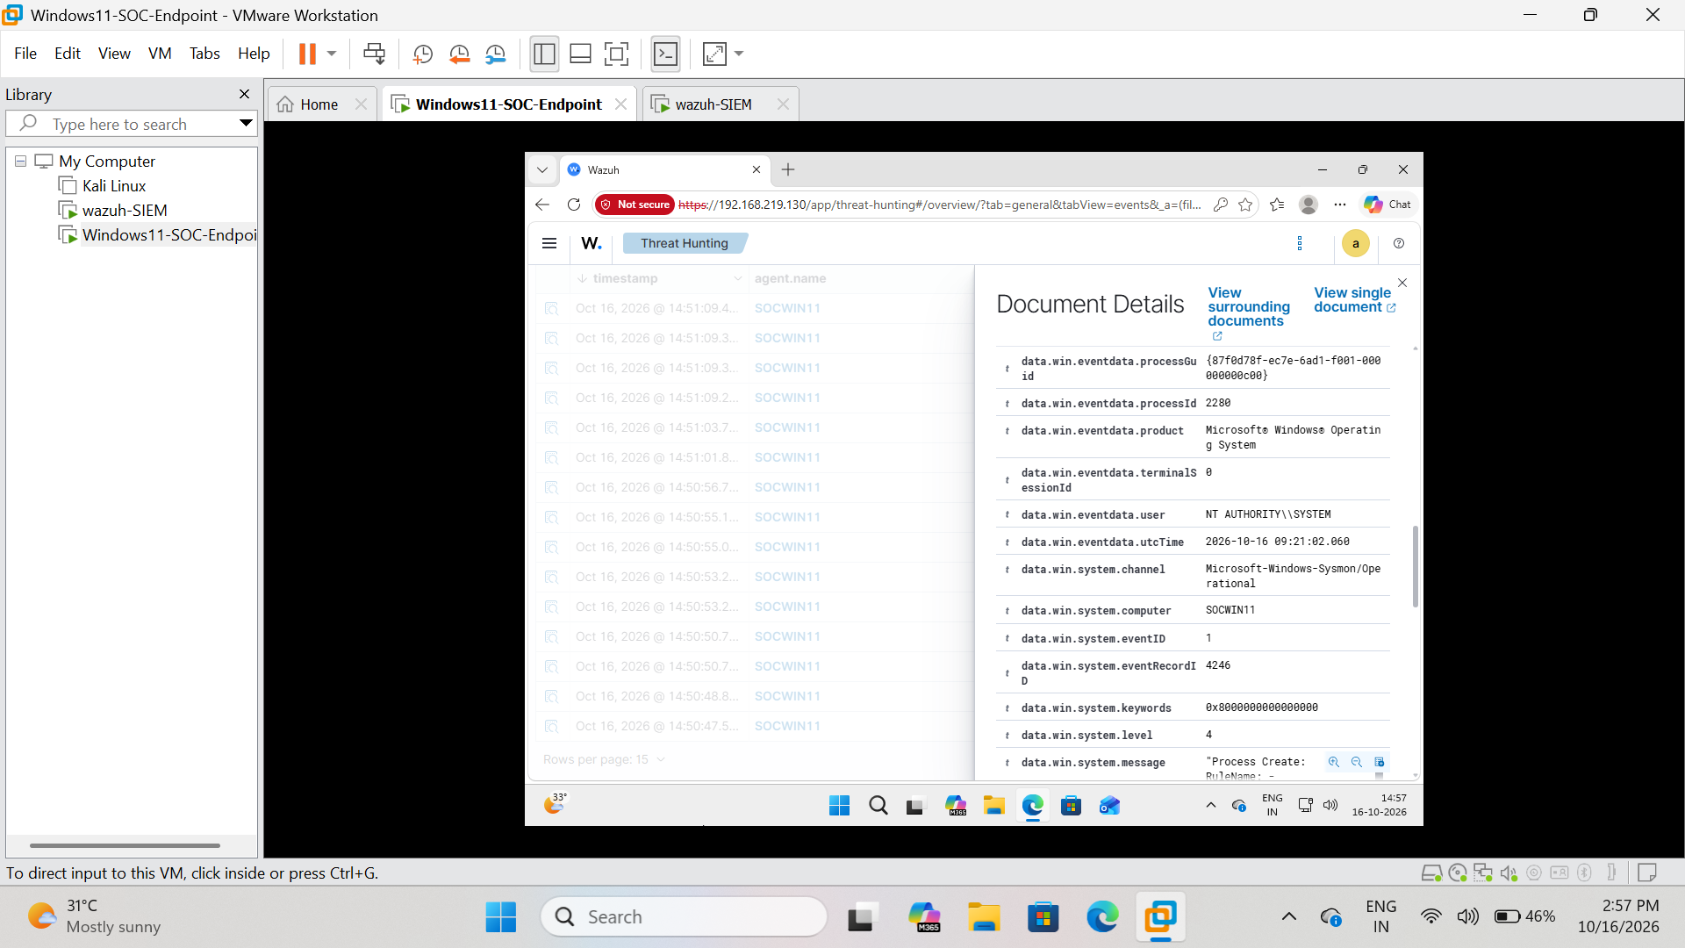
Figure 11. Wazuh event detail — event metadata
Evidence note: This screenshot records the observed interface state during the lab session.
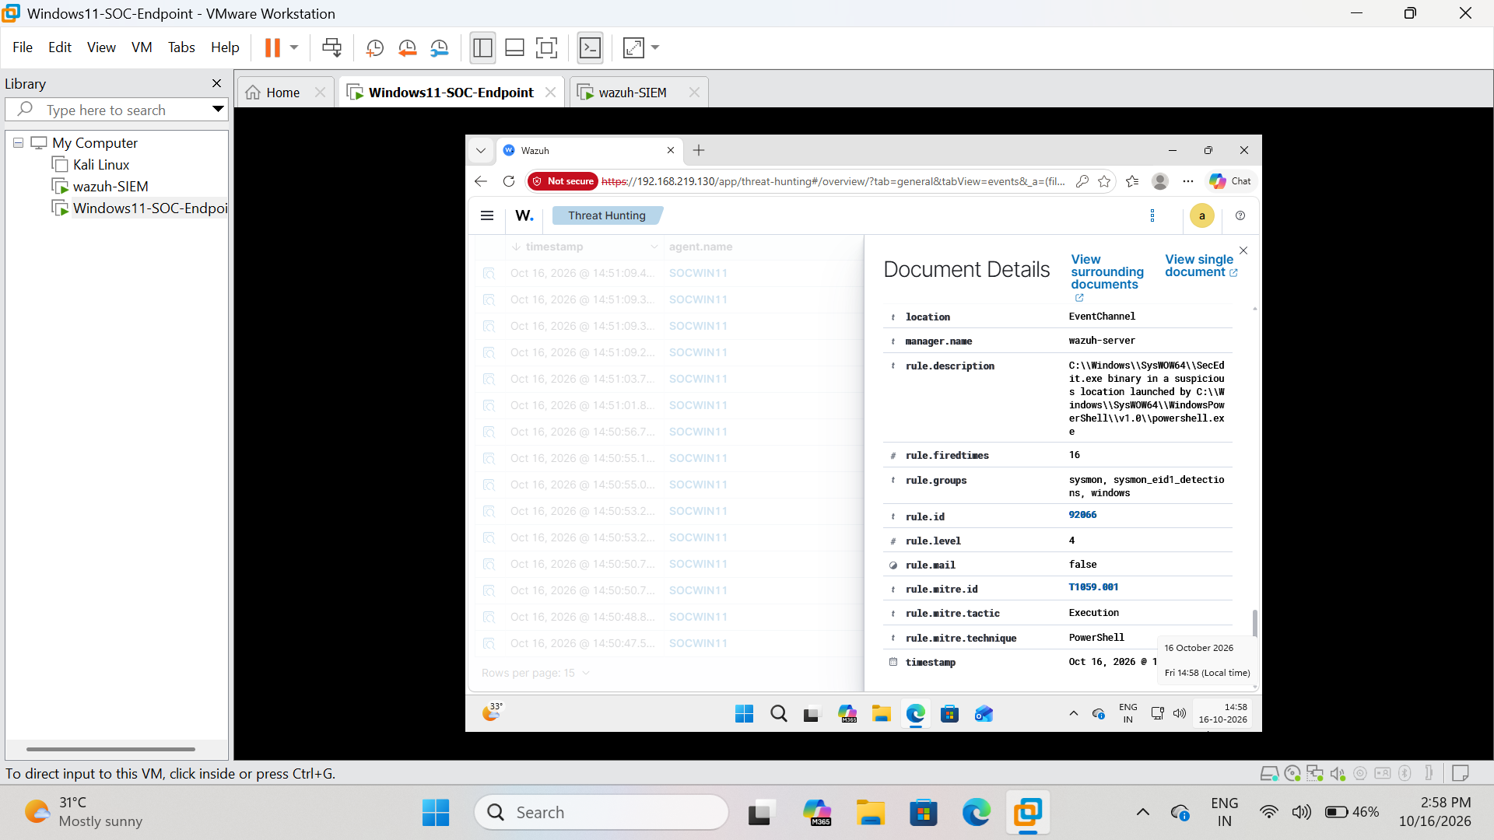
Figure 12. Wazuh event detail — additional rule context
Evidence note: This screenshot records the observed interface state during the lab session.

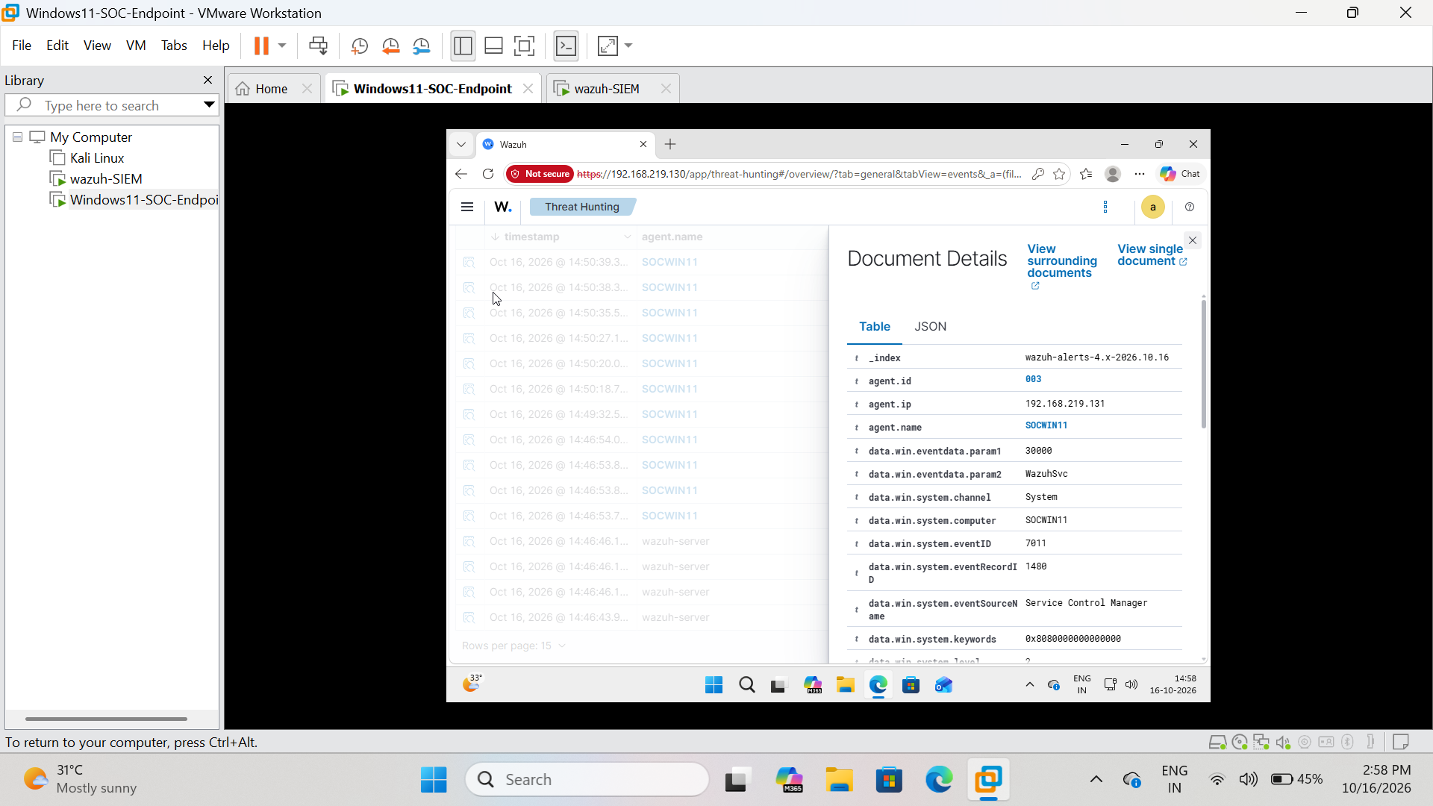
Figure 13. Wazuh event detail — rule and timestamp
Evidence note: This screenshot records the observed interface state during the lab session.
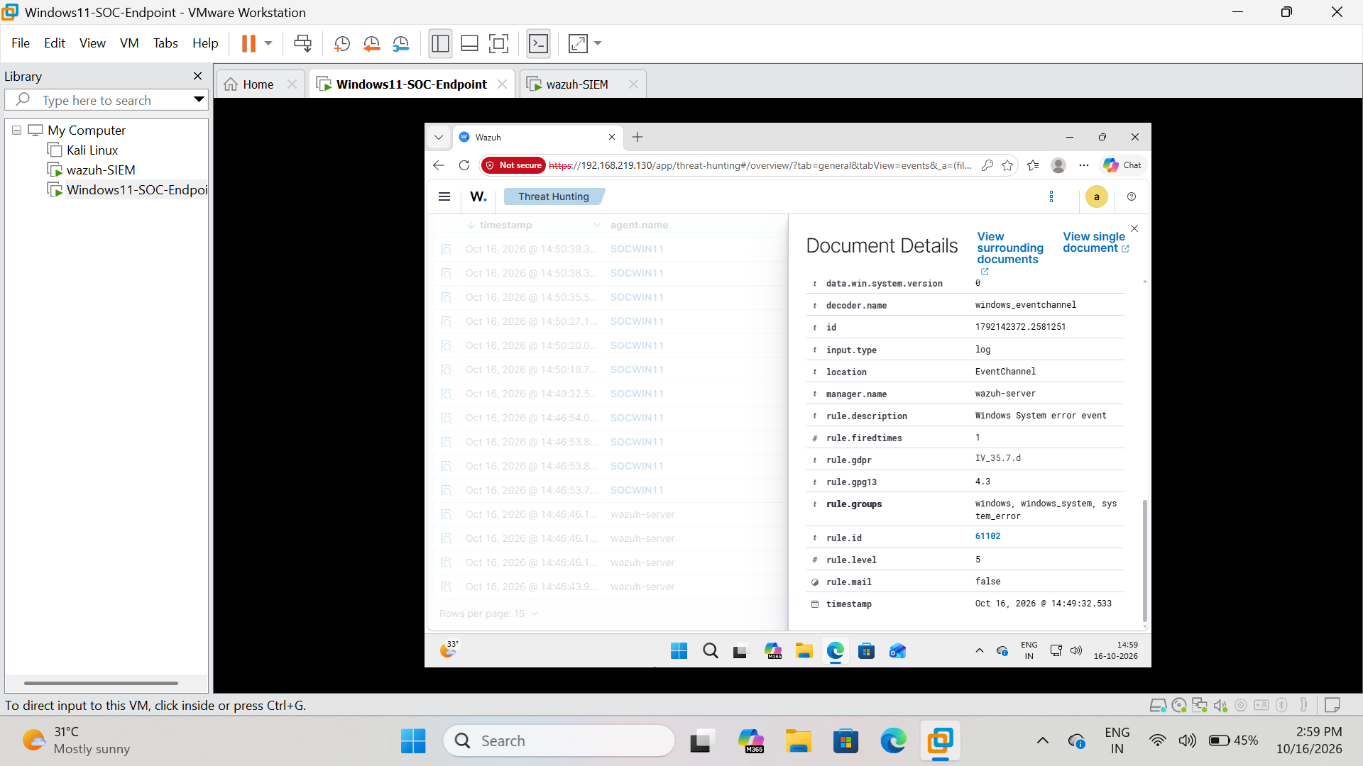
Figure 14. Wazuh event detail — SOCWIN11 agent information
Evidence note: This screenshot records the observed interface state during the lab session.

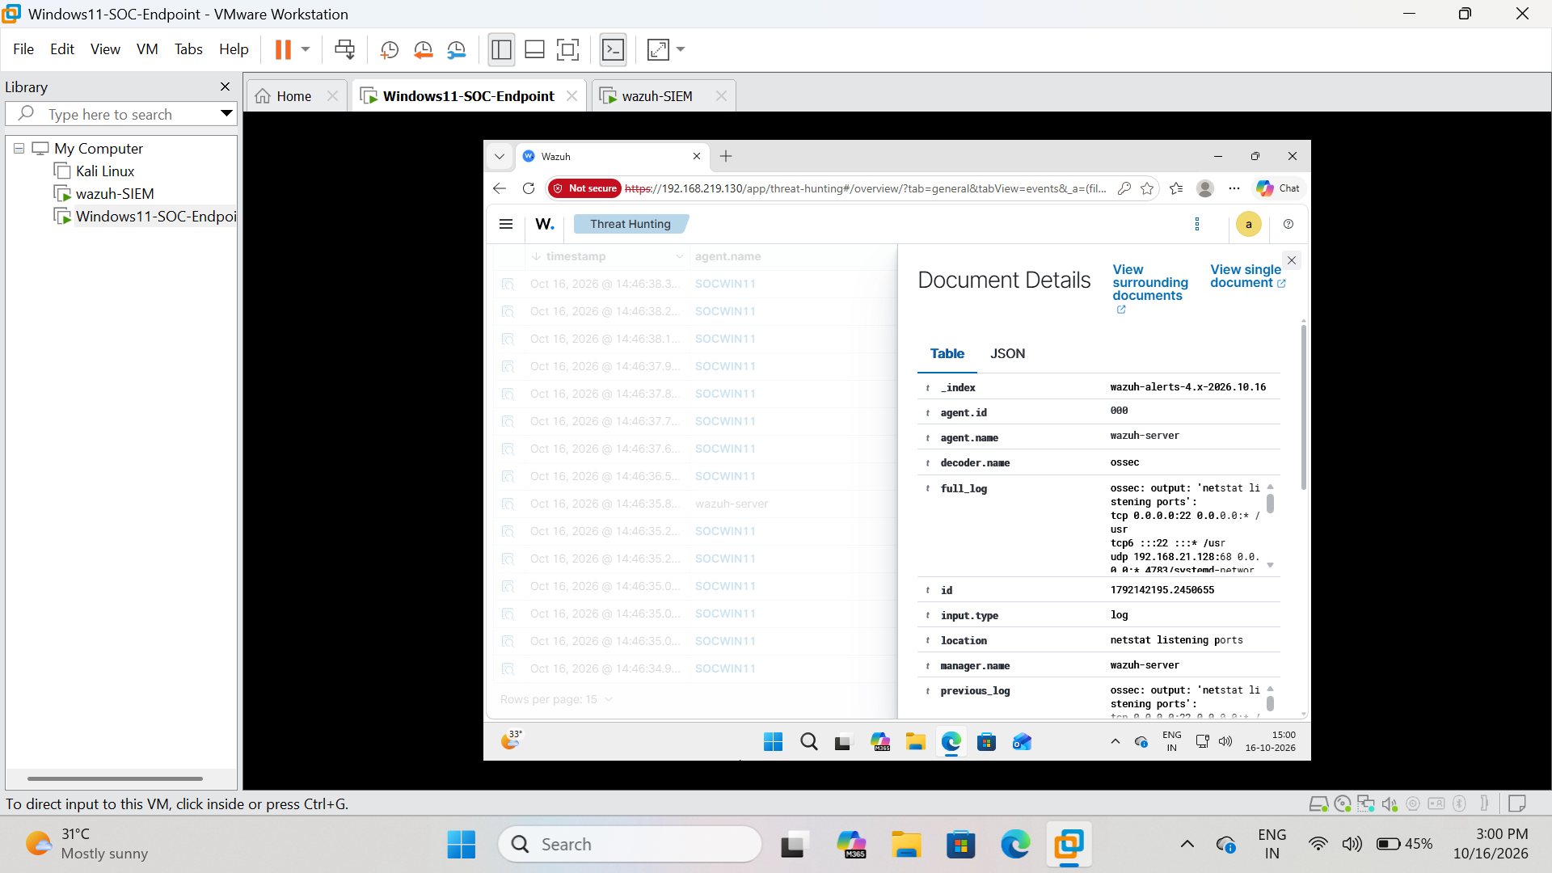
Figure 15. Wazuh event detail — Windows command line
Evidence note: This screenshot records the observed interface state during the lab session.
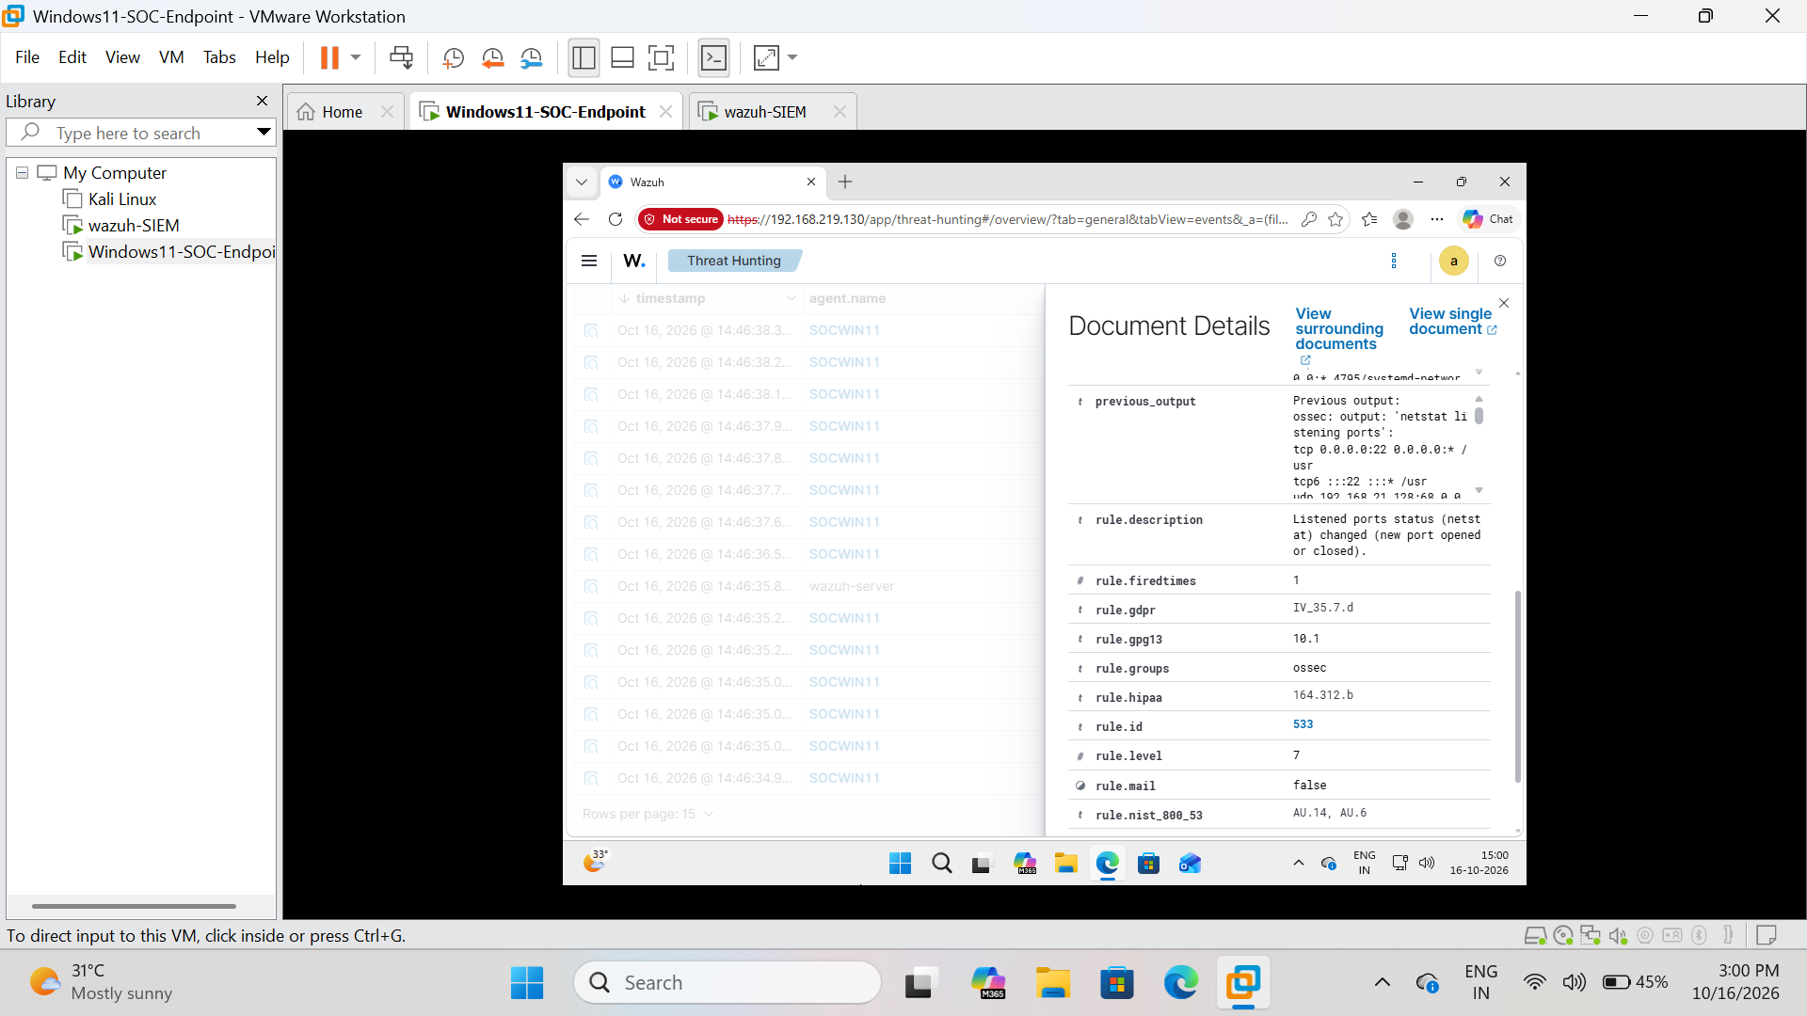
Figure 16. Wazuh event detail — Sysmon event fields
Evidence note: This screenshot records the observed interface state during the lab session.

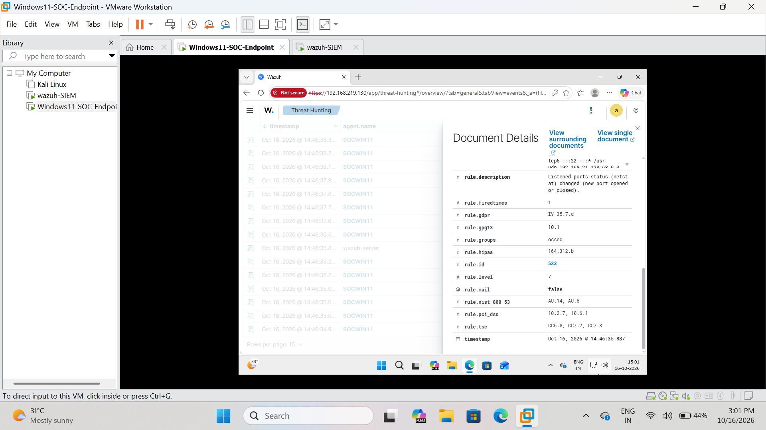
Figure 17. Wazuh event detail — additional event fields
Evidence note: This screenshot records the observed interface state during the lab session.
Figure 18. Wazuh event detail — MITRE ATT&CK mapping
Evidence note: This screenshot records the observed interface state during the lab session.

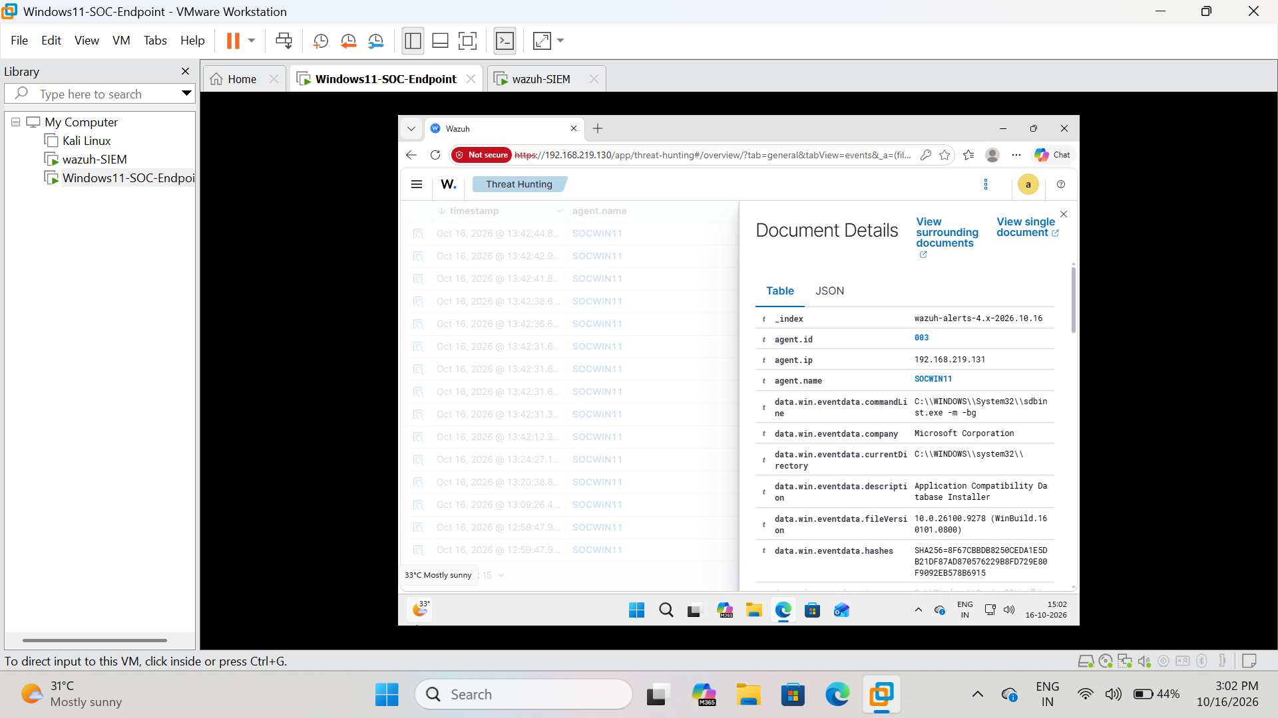
Figure 19. Wazuh event detail — application compatibility detection
Evidence note: This screenshot records the observed interface state during the lab session.
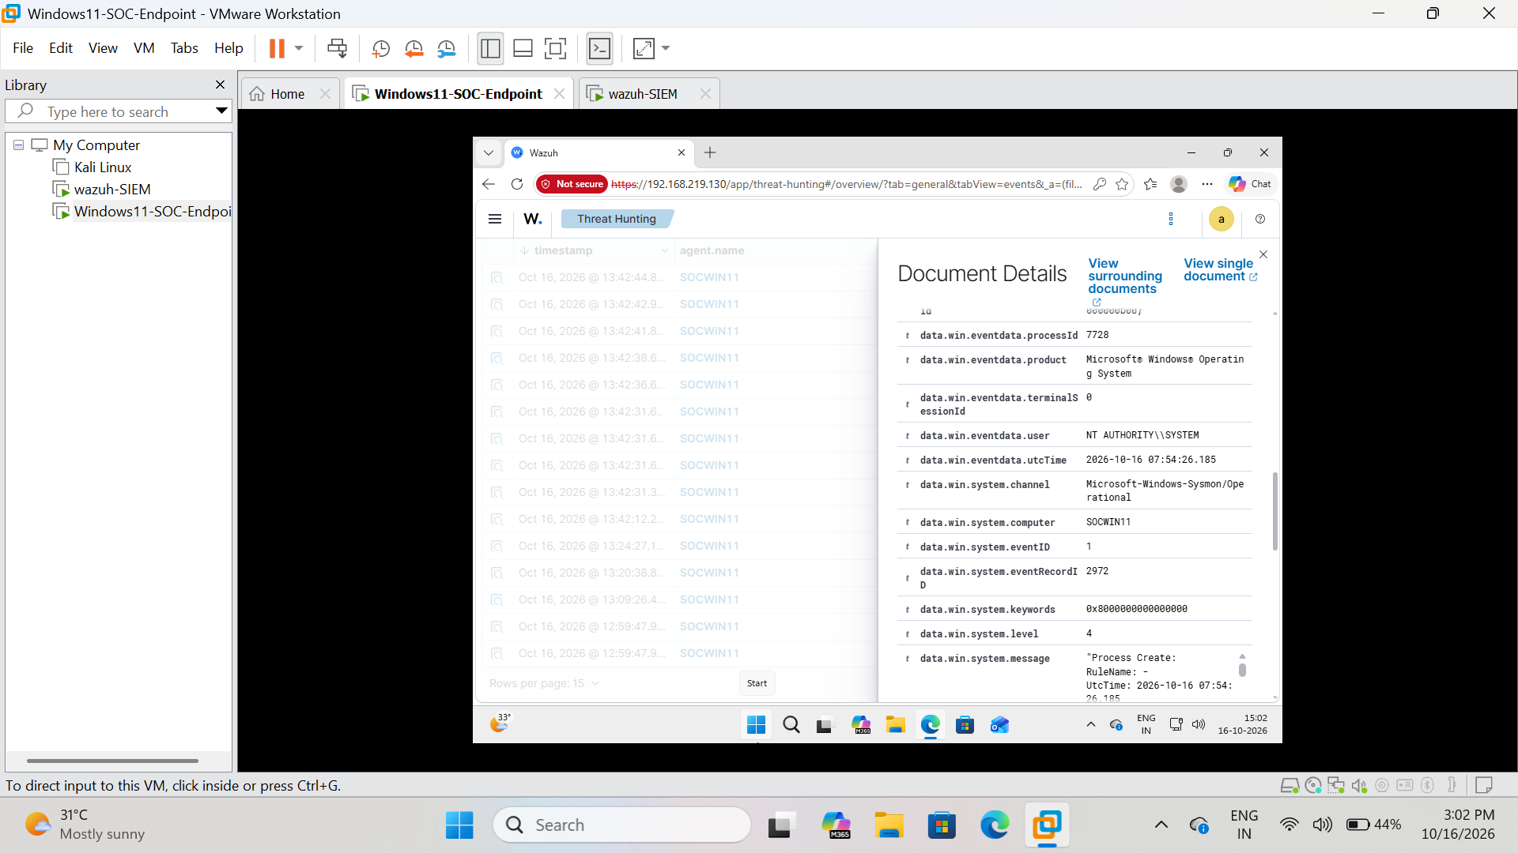
Figure 20. Wazuh event detail — Windows endpoint telemetry
Evidence note: This screenshot records the observed interface state during the lab session.

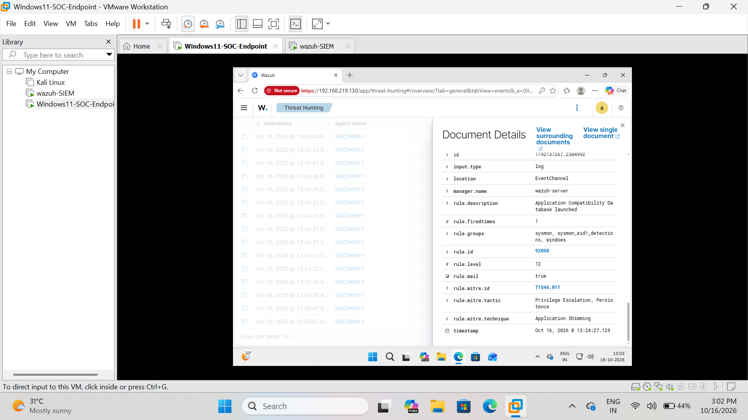
Figure 21. Wazuh event detail — event record and process data

6. Example alert investigation
A useful event in the supplied evidence is Wazuh rule 92066. The visible description flags SecEdit.exe running from a location described as suspicious and indicates PowerShell as the parent process. The event details also show MITRE ATT&CK T1059.001 (PowerShell), tactic Execution, and rule level 4.

Initial interpretation
PowerShell is a legitimate Windows administration tool, and SecEdit.exe is a legitimate Windows security configuration utility. Their use is not automatically malicious. The combination of a script interpreter launching a security utility from an unusual path can be worth investigating because attackers may use built-in tools to change local security policy or carry out post-compromise actions.

Recommended SOC L1 checks
- Validate the exact timestamp and confirm the event belongs to SOCWIN11 (agent ID 003).
- Review the complete Image, CommandLine, ParentImage, ParentCommandLine, user, process ID, and parent process ID fields.
- Check the executable path. Compare it with the expected Windows system location and determine whether the file is signed and trusted.
- Review the file hash and reputation using approved tools; do not upload sensitive files to public services without permission.
- Search nearby events for preceding PowerShell activity, script execution, file creation, persistence, or changes to security settings.
- Ask whether the activity was part of an expected administrator action or lab configuration.
- Record the evidence and escalate according to the organization's procedure if the activity cannot be explained.
Disposition: Suspicious-looking activity requiring validation. The screenshot alone does not establish malware or a confirmed incident.

Other visible detections
Rule ID | Visible description / mapping | Level | SOC interpretation
92031 | Discovery activity executed; MITRE T1087 — Account Discovery; tactic Discovery | 3 | Review the process and command line to determine whether account enumeration was expected.
92066 | SecEdit.exe in a suspicious location launched by PowerShell; MITRE T1059.001 — PowerShell; tactic Execution | 4 | Inspect parent/child process relationship, executable path, command line, and nearby events.
92058 | Application Compatibility Database Installer launched; MITRE T1546.011 — Application Shimming; tactic shown as Privilege Escalation / Persistence | 12 | Higher-priority alert. Validate the process path, parent, command line, signature, and whether shimming activity was authorized.
Rule levels are Wazuh rule severity levels, not a final incident verdict. A level 12 alert deserves prompt review, but it must still be validated against context.

7. SOC L1 investigation workflow
- Alert triage — identify the rule, severity, affected endpoint, and event time.
- Validate source — confirm agent.name SOCWIN11 and check that the event is from the intended lab endpoint.
- Collect context — inspect process image, command line, parent process, user, hashes, and surrounding events.
- Correlate — compare Sysmon events with Windows system/security events and any related Wazuh alerts.
- Classify — expected activity, benign-but-unusual activity, suspicious activity, or confirmed incident based on evidence.
- Document — record what was observed, what was checked, conclusion, and remaining uncertainty.
- Escalate — follow the defined procedure when activity is high severity or cannot be explained.

8. Results, limitations, and next steps

Results supported by the screenshots
- Sysmon is producing local Event ID 1 and Event ID 5 records on SOCWIN11.
- Wazuh Threat Hunting displays events associated with SOCWIN11.
- A Wazuh event document contains data.win.system.channel = Microsoft-Windows-Sysmon/Operational and data.win.system.eventID = 1, demonstrating Sysmon event forwarding.
- Event details expose process and command-line telemetry, rule metadata, and MITRE ATT&CK mappings.
- Several detections were captured for hands-on triage practice.

Limitations and responsible interpretation
- The screenshots show selected events from one lab session; they do not prove complete coverage of every Sysmon event type.
- Some screenshots are photographs or VM-window captures rather than tightly cropped native screenshots; the final report retains the supplied evidence.
- Alert descriptions indicate why an event matched a rule, not proof that the activity was malicious.
- Rule severity, MITRE mapping, and the event itself must be interpreted together with command-line and process context.
- Dashboard hit totals vary with the time range and data arriving during the session.

Recommended next steps
- Save the original screenshots with clear names and keep the final report in the project repository.
- Capture the Wazuh Agents page showing SOCWIN11 as Active if that separate screenshot is available.
- Investigate the level 12 Rule 92058 event first, then review Rules 92066 and 92031.
- Build a short timeline around each selected event and record the process path, parent, command line, user, and conclusion.
- Add a README with setup overview, architecture, evidence images, findings, and lessons learned.

9. Conclusion
This project demonstrates a basic end-to-end Windows endpoint monitoring workflow: Sysmon records detailed process activity, the Wazuh agent forwards event-channel logs, and Wazuh Threat Hunting makes the events searchable for investigation. The captured Sysmon Event ID 1 document in Wazuh is particularly important because it verifies that Sysmon telemetry is reaching the SIEM, not merely remaining in the local Event Viewer.
The main SOC lesson is to investigate context rather than label every alert as an attack. Process lineage, command lines, paths, hashes, user context, and related events are needed to determine whether a detection is expected, suspicious, or malicious.

Appendix A — Key configuration
The Windows Wazuh agent configuration includes this event-channel collection block inside the ossec_config root element:
<localfile>
<location>Microsoft-Windows-Sysmon/Operational</location>
<log_format>eventchannel</log_format>
</localfile>
File location used in the lab: C:\Program Files (x86)\ossec-agent\ossec.conf. This block should appear before the closing </ossec_config> tag. The screenshots and observed Wazuh event fields indicate that Sysmon Event ID 1 is being collected.

Glossary
SIEM: Security Information and Event Management platform used to collect, search, and correlate security events.
Sysmon: Windows system service that logs detailed system activity, including process creation.
Wazuh agent: Endpoint component that collects and forwards selected logs to the Wazuh manager.
Event ID 1: Sysmon Process Create event.
Event ID 5: Sysmon Process Terminated event.
MITRE ATT&CK: A knowledge base of adversary tactics and techniques used to describe and map behaviors.
Parent process: The process that started another process.
False positive: An alert that matches a detection rule but is not a genuine security threat in context.

Additional Section — SOC Alert Case Studies and Timeline
This section summarizes three Wazuh detections visible in the supplied screenshots. These are triage exercises, not confirmed incidents. The available screenshots provide rule metadata and selected event fields, but they do not establish that any activity was malicious.

Case Study 1: Rule 92066 — PowerShell associated with SecEdit.exe
Observed evidence: Wazuh rule 92066, reported rule level 4, associates PowerShell activity with SecEdit.exe. The visible command-line fragment begins with C:\Windows\SysWOW64\secE... and the event is mapped to MITRE ATT&CK T1059.001 (PowerShell, Execution). The fragment is truncated, so the full command line and process lineage cannot be confirmed from the visible text.
Analyst interpretation: PowerShell and SecEdit.exe are legitimate Windows tools. An unusual process relationship or path can merit review, but the alert alone does not prove misuse.
Recommended checks: validate the complete image path, command line, parent image and parent command line, user, timestamp, signature/hash, and nearby process or security-configuration events.
Current disposition: Inconclusive; requires contextual validation.

Case Study 2: Rule 92058 — Application Compatibility Database Installer launched
Observed evidence: The screenshot shows rule 92058 at level 12 and a mapping to MITRE ATT&CK T1546.011 (Application Shimming).
Analyst interpretation: Application compatibility mechanisms have legitimate uses and can also be abused. A high rule level warrants prompt review, but the rule match itself is not proof of persistence or compromise.
Recommended checks: validate the executable path and signature, parent process, command line, user, timestamp, relevant compatibility database or registry changes, and whether software installation or administration was expected.
Current disposition: Prioritize review; no confirmed compromise based on the screenshot alone.

Case Study 3: Rule 92031 — Discovery activity executed
Observed evidence: The screenshot shows rule 92031, level 3, described as “Discovery activity executed,” mapped to MITRE ATT&CK T1087 (Account Discovery).
Analyst interpretation: Account discovery can be part of routine administration or attacker reconnaissance. The visible rule metadata does not identify enough context to classify the activity.
Recommended checks: identify the process and complete command line, user, timestamp, scope of account queries, and nearby events; compare with expected administrative activity.
Current disposition: Low-severity triage lead; requires context before classification.

Evidence-based timeline
Stage | Evidence observed | What it establishes
1. Endpoint telemetry | Sysmon Event ID 1 and Event ID 5 visible in Windows Event Viewer | Sysmon is recording process creation and termination locally.
2. Agent ingestion | Wazuh event details identify SOCWIN11, agent ID 003 | Events are associated with the intended endpoint agent.
3. Sysmon forwarding | Wazuh document shows channel Microsoft-Windows-Sysmon/Operational and Event ID 1 | At least one Sysmon process-creation event reached Wazuh.
4. Detection triage | Rules 92031, 92066, and 92058 visible in Wazuh screenshots | Wazuh produces detections and MITRE metadata for analyst review.
5. Disposition | Command-line and process context are incomplete in available evidence | No alert should be labeled malicious without further validation.

Final case-study conclusion
The lab demonstrates the end-to-end collection and initial triage of Windows endpoint telemetry. The strongest technical verification is the Wazuh event document that identifies the Sysmon Operational channel and Event ID 1 for SOCWIN11. The three alert examples demonstrate how rule metadata and MITRE ATT&CK mappings guide investigation. The current evidence supports “detected and reviewed,” not “confirmed malicious.”

