**USER MANUAL**

The project was developed on Eclipse (Version: Neon.2 Release (4.6.2)) using Java version 1.8.

To run the file, follow the below instructions:

1. Extract the compressed folder DavisBase (Downloaded from eLearning).
2. Import the project folder into the Eclipse IDE.
3. Run the **DavisBase.java** file to start Davisbase.

(or)

1. Extract the compressed folder DavisBase (Downloaded from eLearning).
2. Open Command Prompt.
3. Navigate to the path where the folder has been extracted.
4. Navigate to the src\database folder and compile all the files using the below command.

**C:\Users\Mohanakrishna\workspace\DavisBase\src\database>javac *.java**

1. Navigate to the parent directory (\src folder).
2. Run the DavisBase file.

**C:\Users\Mohanakrishna\workspace\DavisBase\src>java database.DavisBase**

**FEATURES**

1. **CREATE DATABASE:** Creates a new database schema, i.e. a new empty database.

Syntax: CREATE DATABASE <DATABASE_NAME>;

Example: CREATE DATABASE Emkae;

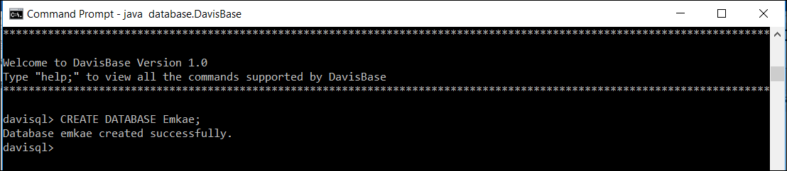

1. **SHOW DATABASE:** Displays a list of all databases in DavisBase.

Syntax: SHOW DATABASES;

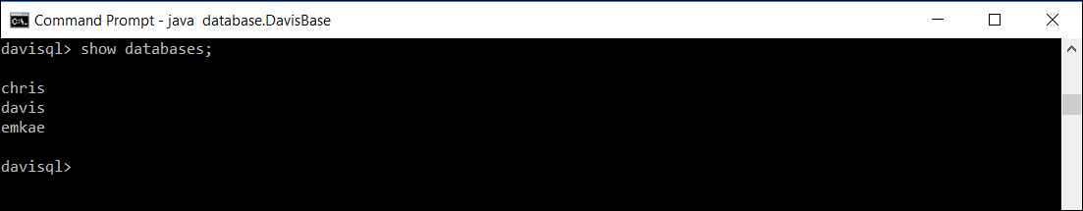

1. **DROP DATABASE:** Remove a database schema, and all its contained tables.

Syntax: DROP DATABASE <DATABASE_NAME>;

Example: DROP DATABASE davis;

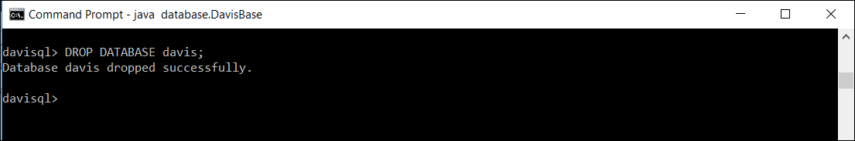

1. **USE DATABASE:** Selects a database for use.

Syntax: USE <DATABASE_NAME>;

Example: USE Emkae;

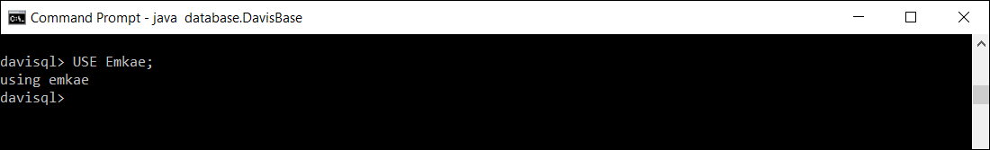

1. **CREATE TABLE:** Creates a table of the given name. The PRIMARY KEY must be (a) a single column, (b) the first column listed in the CREATE statement, and (c) an INT data type.

Syntax: CREATE TABLE <TABLE_NAME> ( <COLUMN_NAME> <DATA_TYPE> …..);

Example:

CREATE TABLE Widgets (

row_id INT,

model TEXT,

color TEXT,

price FLOAT);

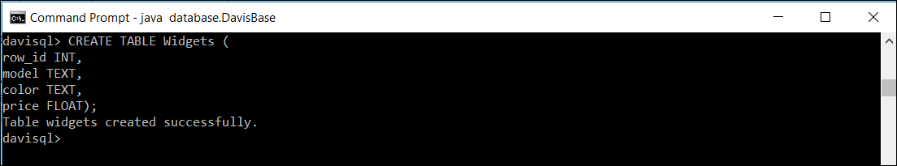

1. INSERT ROW INTO TABLE: Inserts a row into the table.

Syntax: INSERT INTO <TABLE_NAME> (<VALUES>);

Example:

INSERT INTO Widgets VALUES (1,alpha,red,9.50);

INSERT INTO Widgets VALUES (2,beta,blue,8.99);

INSERT INTO Widgets VALUES (3,gamma,green,11.25);

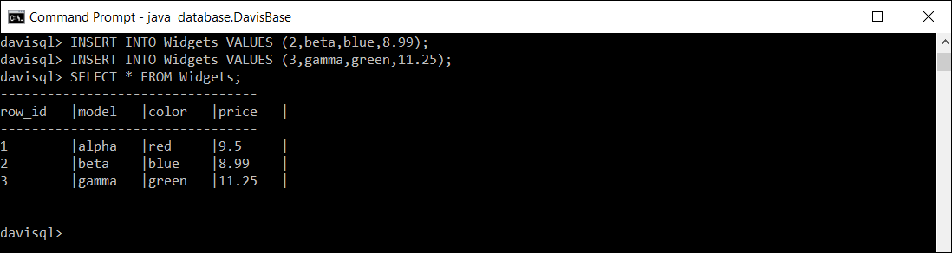

1. QUERY TABLE:

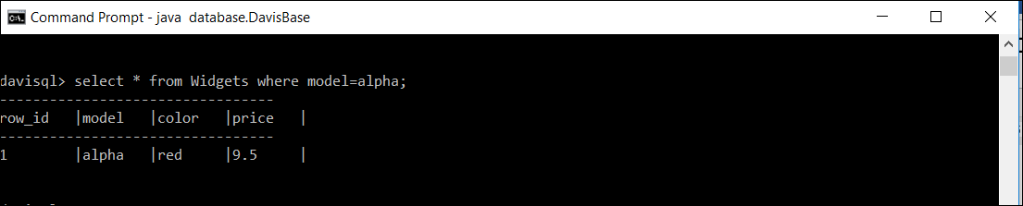

1. SHOW TABLES:

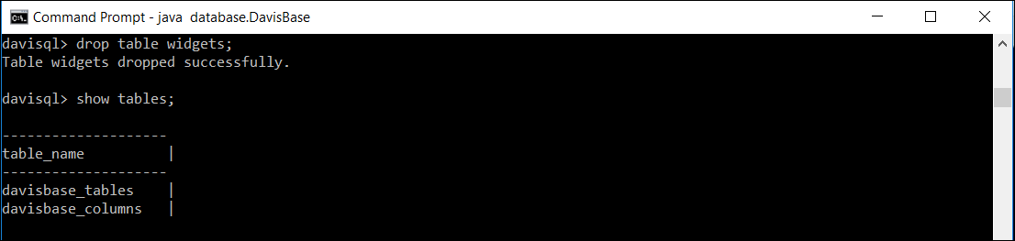

1. DELETE ROW:

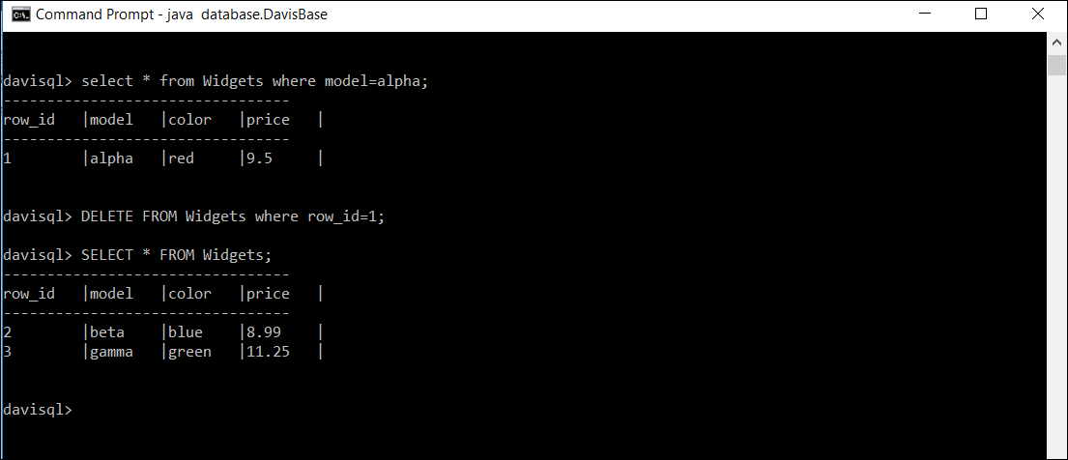

10. DROP TABLE:

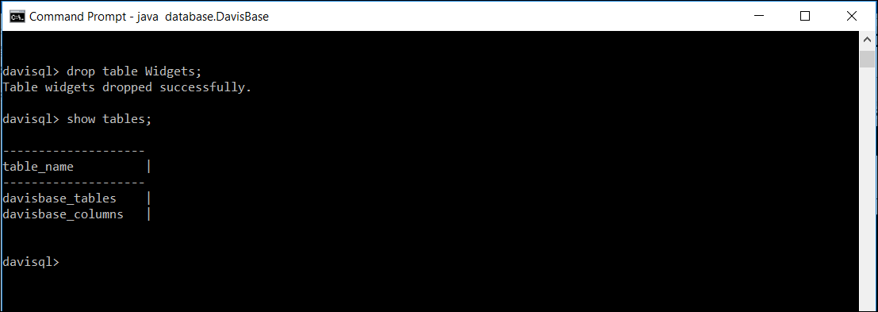

1. META-DATA:

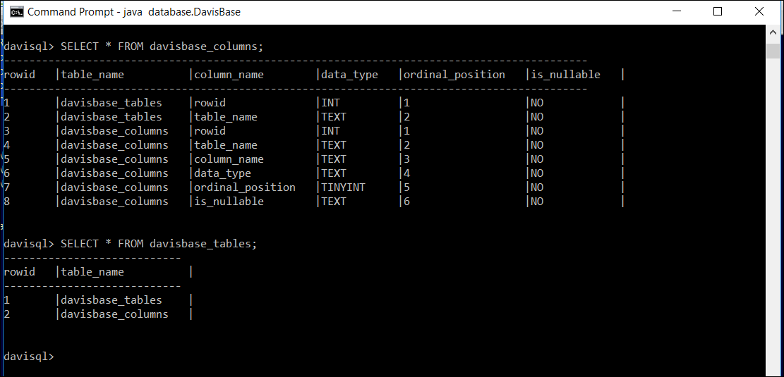

After Insert into the table, creation of index happens.

File Structure:

