Language-guided robot navigation in the hospital scene
What was found, what was changed, and how it performs on the running simulator
NVIDIA Isaac Sim 6.0 | ROS 2 Humble | Nav2 | GroundingDINO scene graph | Qwen2.5-VL-3B brain | RTX 5080

1. Summary
A simulated Nova Carter robot is given natural-language commands ("go to the wheelchair", "what do you see?"). Qwen2.5-VL turns each sentence into a command, the code looks up where the named object is in a semantic scene graph, and Nav2 drives there. This report covers the hospital scene, using the map and the object detections that were already saved (nothing was re-mapped or re-detected), and two pieces of work: making the system robust on the running stack, and making the object list small and trustworthy instead of hundreds of duplicate detections.
Check | Result
Unit and ROS-level tests (fake Nav2, fake TF, synthetic recording) | 239 pass (238 where python-docx is not installed), flake8 clean; 139 at the start
Live smoke test: relative move, named goal, STOP, goal after STOP | 4 of 4
Live: 5 typed commands through Qwen -> Nav2 -> robot | 5 of 5 (run twice)
Live: 5 easy + 5 medium + 5 hard destinations (3 m to 56 m) | 15 of 15; mean goal error 0.22 m; 353 m driven
... of those, destinations that are real objects (simulator ground truth) | 12 of 15
Scene graph: entries, precision, recall (raw, walls excluded) | 125, 0.38, 0.22
Scene graph: entries, precision, recall (consolidated) | 46, 0.61, 0.18

Read the "real objects" row with care: a destination passes when the robot does what it was told, but three of the fifteen entries it drove to were look-alike detections rather than real objects. Navigation is not the weak point; the recall and precision of the detections are.
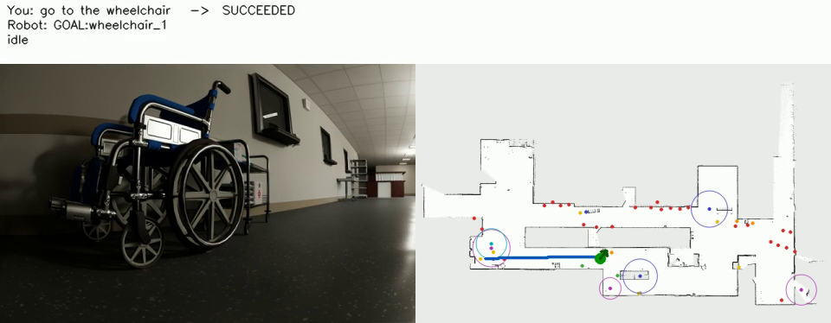
A frame from the recorded demo (docs/media/hospital_demo.gif): the typed command and Qwen's reply, the robot's camera, and its position and trail on the saved map.

2. Setup
- Scene: the hospital scene (lit rooms, two wander bots), streamed from NVIDIA's public asset bucket by Isaac Sim.
- Saved results used as they are: the lidar occupancy map (5 cm cells) and 149 GroundingDINO detections with map-frame locations. The map frame equals the simulator world frame: sliding the map over the scene's wall geometry gives the best fit at a shift of 0.0 m and 0 degrees, and the live lidar lands on the map (100 % of scan endpoints within 0.15 m).
- Localisation: the slam_toolbox pose graph was not saved, so the saved map is served directly with an identity map->odom transform (exact here because the robot starts at the map origin and simulated odometry does not drift).
- Speed: the simulator ran at about 0.25 to 0.7 times real time; Qwen shared the GPU with Isaac Sim and was partly offloaded to the CPU. Wall-clock times are longer than the simulated ones.
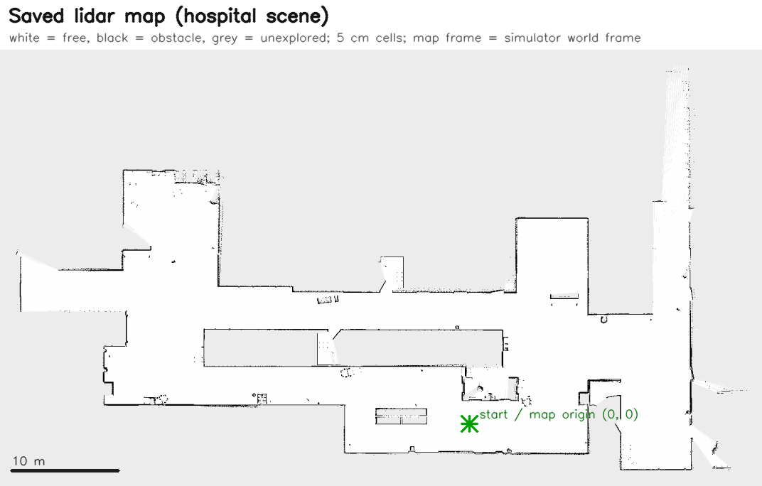
The saved lidar map. White is free, black is obstacle, grey is unexplored.

3. Step 1: robustness fixes found on the live stack
The approach (name -> lookup -> stand-off goal -> planner check) was kept. Running the real stack exposed these problems, each now covered by a test:
Problem found | Fix
Nav2 was served the saved map with no unexplored space: the map's free threshold (0.25) makes map_server read the grey "unknown" pixels as free (0 % unknown instead of 67 %). | The launch file serves a corrected copy of the yaml (the original is untouched); the same rule is used by the brain.
The saved map could not be used without the slam_toolbox pose graph. | New static mode: map_server plus an identity map->odom; a script checks alignment against the live scan.
Multi-word classes: the model writes "vending_machine_3", "the trash cans" or "beds" and got "unknown object". | One name normalisation (case, underscores, articles, plurals) in the parser and the scene graph.
Goals could land inside walls or unexplored space and were then aborted. | With the map, stop points are chosen on known free cells with wall clearance (roomy ones first); a relative move that ends in a wall is shortened to the last free point or refused with a message.
A 3B model answers "take me to the cart" with an arbitrary cart_1 (26 m away, the nearest was 4.4 m). | A class named by the user means the nearest one; an id the user typed beats a different id from the model.
The prompt lists only the nearest 6 objects per class, so "door_13" was hidden and the model said it did not know it. | Objects the user names are always listed.
Two destinations aborted after 1.4 m ("collision ahead", "failed to make progress"): the plan hugged a chair whose low base is below the 2-D lidar plane, and the progress checker ignored turning. | Costmap inflation 0.5 -> 0.9 m (plan 0.3 m longer, 0.77 m instead of 0.51 m from mapped obstacles); a progress checker that counts rotation; roomy stop points preferred.
STOP relied only on the Nav2 cancel chain; a failing model call ended the session; a malformed graph entry made the file unloadable. | STOP also publishes a zero velocity; errors are reported and the chat continues; bad entries are skipped and counted.
Setup was manual: open the scene, press Stop, press Play. | A launcher opens the scene, waits for its streamed assets and presses Play; it can remove prims (the low test obstacles) from the loaded stage without editing the file.

4. Step 2: why detection produced hundreds of objects, and the new approach
The saved detections were scored against the simulator's real objects (ground truth extracted from the scene: 14 beds, 28 carts, 21 chairs, 12 desks, 48 doors, 11 trash cans, 2 vending machines, 4 wheelchairs). What was found:
- Duplicate boxes counted as evidence. GroundingDINO returns several overlapping boxes per object and the code never suppressed them, so one frame could count as "seen twice"; 45 of 149 entries had exactly the minimum of 2.
- One object, several names. Classes were clustered separately: 54 of the 125 non-wall entries had a different-class entry within 1 m.
- Confidence does not separate real from look-alike. The one correct vending-machine cluster scored like the 17 false ones (real vending machines: 2; entries: 18). What does help: evidence, agreement between nearby detections, and the map (an entry 1 m or more from every mapped obstacle was 85 % wrong).
- Structure was listed as objects: 24 of 149 entries were walls.
- Piles became box_1 ... box_20 instead of "many boxes here".
The approach has two layers. At detection time (for future recordings): per-frame suppression of duplicate boxes within and across classes, evidence counted in distinct camera views, far observations weighed less (stereo depth error grows with range squared) and ignored beyond 8 m, and raw observations saved so nothing needs the bag again. After detection (works on the saved graph today): a consolidation step that drops structure, merges duplicates, lets classes on one spot compete by evidence, collapses piles of identical things into one group entry with a size (twenty stacked boxes become one "group of boxes here"), ranks entries by class weight x evidence x plausibility on the saved map, and keeps only the important ones; every detected class keeps its best guess. The brain applies it automatically to any raw graph it loads.
class | real objects | raw entries | consolidated | precision | recall
bed | 14 | 14 | 3 | 0.29 -> 0.33 | 0.14 -> 0.07
cart | 28 | 12 | 3 | 0.25 -> 0.33 | 0.07 -> 0.04
chair | 21 | 10 | 2 | 0.40 -> 1.00 | 0.24 -> 0.14
desk | 12 | 23 | 3 | 0.13 -> 0.33 | 0.42 -> 0.50
door | 48 | 38 | 27 | 0.74 -> 0.70 | 0.31 -> 0.27
trash can | 11 | 9 | 1 | 0.22 -> 1.00 | 0.18 -> 0.09
vending machine | 2 | 18 | 6 | 0.11 -> 0.33 | 1.00 -> 1.00
wheelchair | 4 | 1 | 1 | 1.00 -> 1.00 | 0.25 -> 0.25
all | 156 | 125 | 46 | 0.38 -> 0.61 | 0.22 -> 0.18

An entry counts as real when a real object of its class lies within 1.5 m of its footprint. Consolidation removes about two thirds of the entries and raises precision from 0.38 to 0.61 at a small cost in recall; recall is limited by the saved detections themselves (the raw graph covers 34 of the 156 real objects).
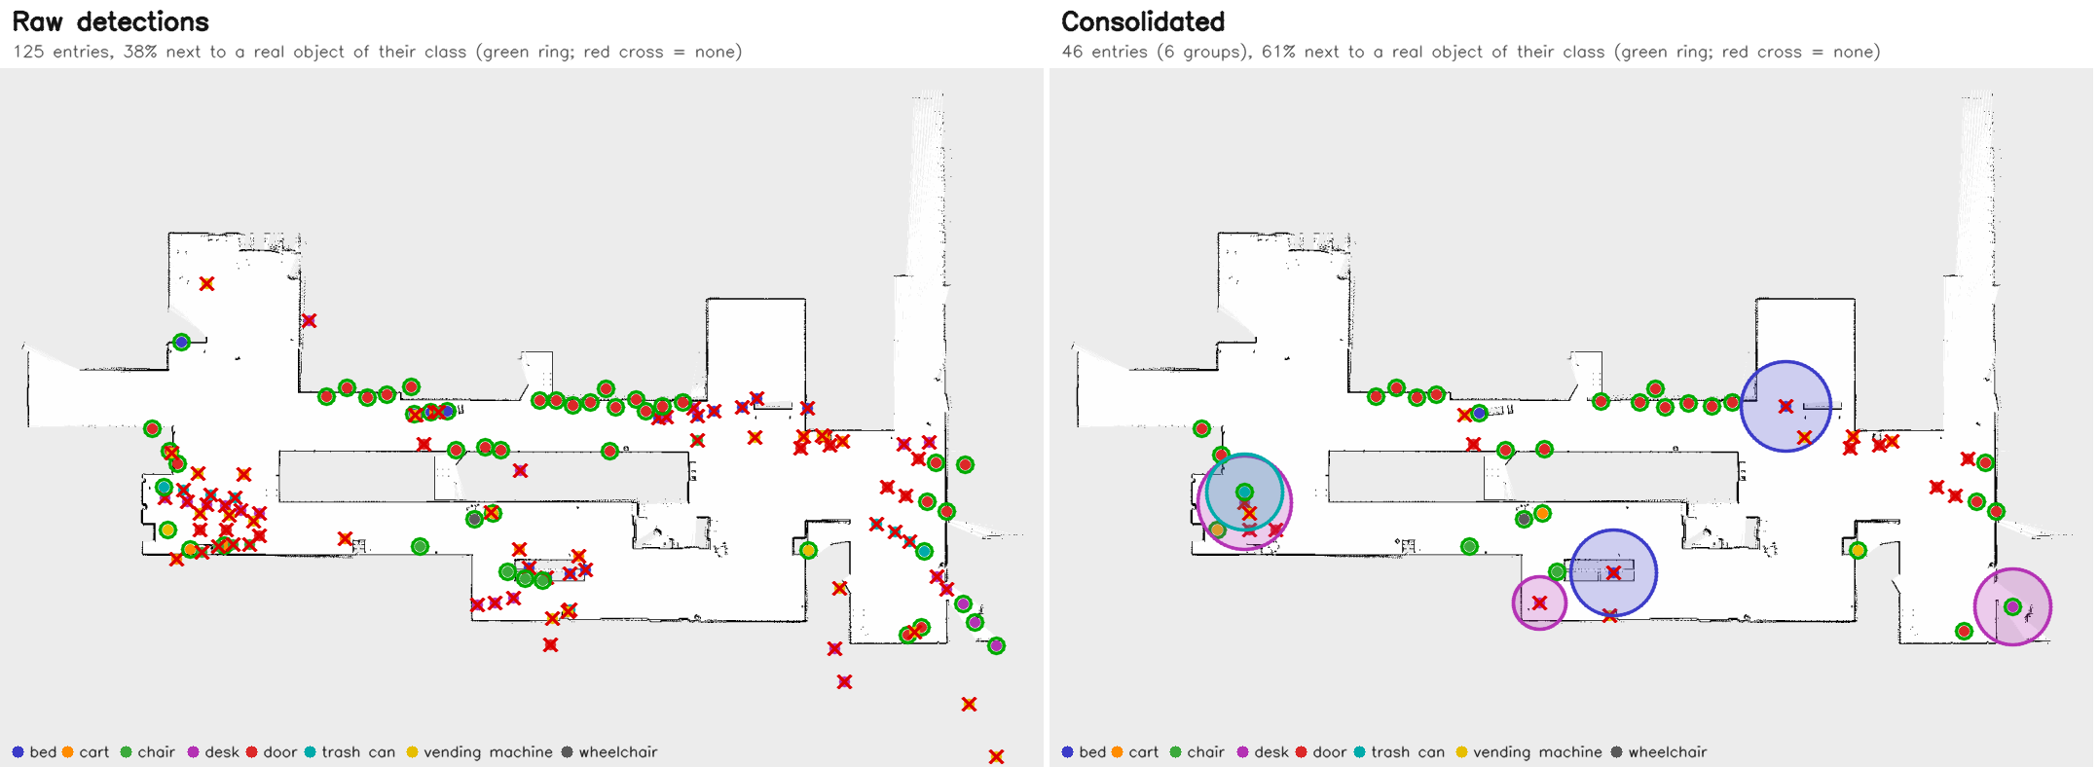
Raw detections (left) and the consolidated graph (right) on the saved map. Green ring: a real object of that class is within 1.5 m. Red cross: none is. Groups are drawn at their size.

5. Live results

5.1 Five typed commands
Command | Model reply | Outcome
go forward 2 meters | MOVE:forward 2 | SUCCEEDED, moved 1.84 m forward
go to the wheelchair | GOAL:wheelchair_1 | SUCCEEDED, 0.83 m from it, facing error 3 deg
what do you see? | a description of the camera picture | answered in words; robot did not move
go to the spaceship | "I don't know an object called spaceship." | no goal sent; robot did not move
go to desk_1 (a group, 3.7 m wide) | GOAL:desk_1 | SUCCEEDED, 2.83 m from the group centre (its edge plus stand-off)

5.2 Fifteen destinations
Difficulty is the length of the path Nav2's planner finds from where the robot stands when the destination is chosen: easy 3-12 m, medium 12-30 m, hard over 30 m. Each destination is typed to Qwen as a sentence. It passes when Nav2 reports SUCCEEDED, the robot ends within 0.6 m of its goal point, faces the object, and went to the object that was asked for.
# | tier | you said | planned m | driven m | sim s | goal err m | result | real object
1 | easy | go to door_21 | 3.8 | 3.7 | 14 | 0.21 | PASS | yes
2 | easy | take me to door_8 | 10.5 | 10.3 | 32 | 0.2 | PASS | yes
3 | easy | navigate to the bed | 4.8 | 4.6 | 14 | 0.21 | PASS | yes
4 | easy | head to trash_can_1 | 11.1 | 11.0 | 37 | 0.2 | PASS | yes
5 | easy | go to vending_machine_6 | 3.5 | 3.2 | 9 | 0.24 | PASS | no
6 | medium | go to door_2 | 18.6 | 18.5 | 58 | 0.21 | PASS | yes
7 | medium | take me to bed_2 | 16.0 | 15.8 | 46 | 0.21 | PASS | no
8 | medium | navigate to the wheelchair | 29.6 | 29.2 | 76 | 0.25 | PASS | yes
9 | medium | head to vending_machine_3 | 21.3 | 21.0 | 55 | 0.21 | PASS | yes
10 | medium | go to desk_1 | 22.6 | 22.5 | 68 | 0.21 | PASS | no
11 | hard | go to desk_2 | 34.1 | 33.7 | 93 | 0.25 | PASS | yes
12 | hard | take me to door_27 | 55.9 | 55.4 | 148 | 0.24 | PASS | yes
13 | hard | navigate to vending_machine_2 | 54.2 | 53.8 | 143 | 0.24 | PASS | yes
14 | hard | head to chair_2 | 32.4 | 31.9 | 90 | 0.2 | PASS | yes
15 | hard | go to door_4 | 39.0 | 38.6 | 104 | 0.2 | PASS | yes

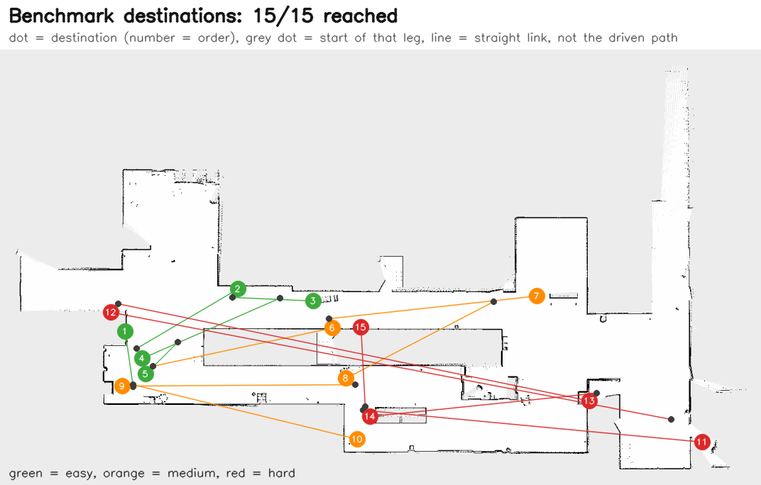
The 15 destinations on the map (dots), each joined to where that leg started by a straight line (not the driven path). Green easy, orange medium, red hard.
An earlier attempt, on the code before the fixes in section 3, was stopped after 8 destinations because it exposed real problems (3 of those 8 failed: a hidden object id and two aborts beside a chair). After the fixes the whole benchmark was re-run from a fresh simulator start; its raw results, and those of the first attempt, are stored in the repository.

6. Limits and what was not verified
- Recall of the scene graph (about 0.18 of the real objects) can only improve with new observations; three of the fifteen benchmark destinations were false detections that the robot reached exactly as told.
- The new per-frame box filtering, view counting and range weighting were covered by unit tests and a synthetic recording only; GroundingDINO was not run on new data.
- The unexplored-space penalty in the consolidation is a judgement call: removing it changes the result only slightly (56 instead of 46 entries, precision 0.57 instead of 0.61).
- Objects below the 2-D lidar plane (chair bases, cart shelves, forks) are still invisible to the map; wider inflation keeps plans further from their mapped parts but does not detect what the lidar cannot see.
- The camera-only pipeline (RTAB-Map) was not run; it received only the progress-checker change.

7. Reproducing it
scripts/launch_isaac.sh # open the scene and press Play
scripts/pipeline.sh start # saved map (static mode) + Nav2
python3 scripts/check_map_alignment.py # must say ALIGNED
~/qwen_env/bin/python scripts/live_command_test.py # 5 typed commands
~/qwen_env/bin/python scripts/destination_benchmark.py # 5 easy + 5 medium + 5 hard
python3 scripts/eval_scene_graph.py saved_state/hospital/scene_graph.json saved_state/hospital/scene_graph.consolidated.json

Everything the numbers rest on (scene dump, ground truth, raw results, analysis scripts) is in evaluation/; the saved map and detections are in saved_state/hospital/; the change log is CHANGELOG.md and the same results in Markdown are in docs/EVALUATION.md.

